**Dorylus Database (29AUG2017)**

**Login Information**

Super Admin

<https://dorylus.knack.com/dorylus-test-2017-04-29-a#projects/>

Email: testsuperadmin@test.com

Password: test

**Bug Request**

1. Is it possible to maintain the “per page” count after the page is refreshed?

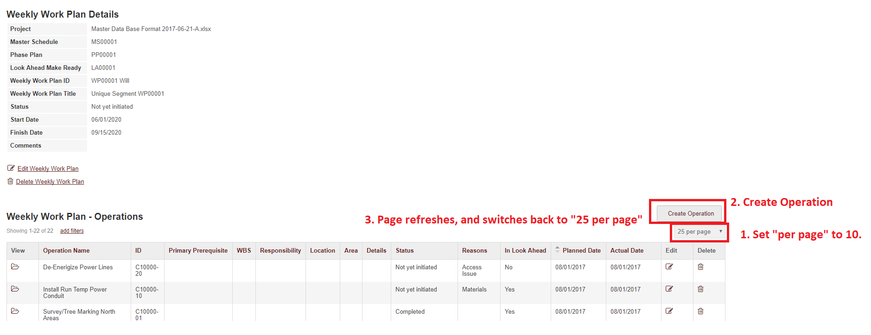

**Cancelled.**

**Requests**

1. Is it possible to add an additional ‘save’ button to the top right of the following pop-up views:

<https://dorylus.knack.com/dorylus-test-2017-04-29-a#projects/view-project-details/5965c2bf909ecc53268d670a/view-master-schedule-details/5965c61d0c6f855478e77e05/create-activity/5965c61d0c6f855478e77e05/>

<https://dorylus.knack.com/dorylus-test-2017-04-29-a#projects/view-project-details/5965c2bf909ecc53268d670a/view-phase-plan-details/5965d034cf8f0454f0555fb1/create-activity2/5965d034cf8f0454f0555fb1/>

<https://dorylus.knack.com/dorylus-test-2017-04-29-a#projects/view-project-details/5965c2bf909ecc53268d670a/view-look-ahead-make-ready-details/5965e610c3db3b51e8174864/create-activity3/5965e610c3db3b51e8174864/>

<https://dorylus.knack.com/dorylus-test-2017-04-29-a#projects/view-project-details/5965c2bf909ecc53268d670a/view-weekly-work-plan-details/5965e64a92d657543ed4615f/create-activity4/5965e64a92d657543ed4615f/>

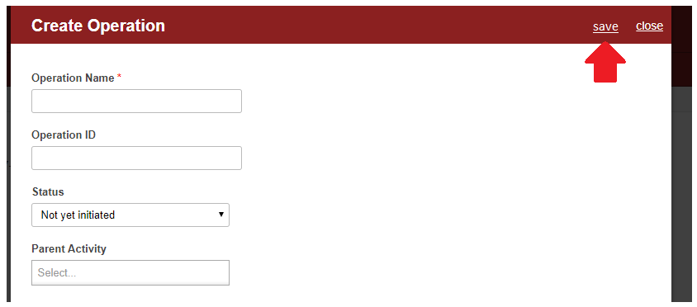

1. The existing Copy functions on the Project Details view, uses Knack functionality to copy the Segment record.

The client would like it so the Copy function has an option to also copy all child Activity records and apply them to the newly made Segment record.

<https://dorylus.knack.com/dorylus-test-2017-04-29-a#projects/view-project-details/5965c2bf909ecc53268d670a/>

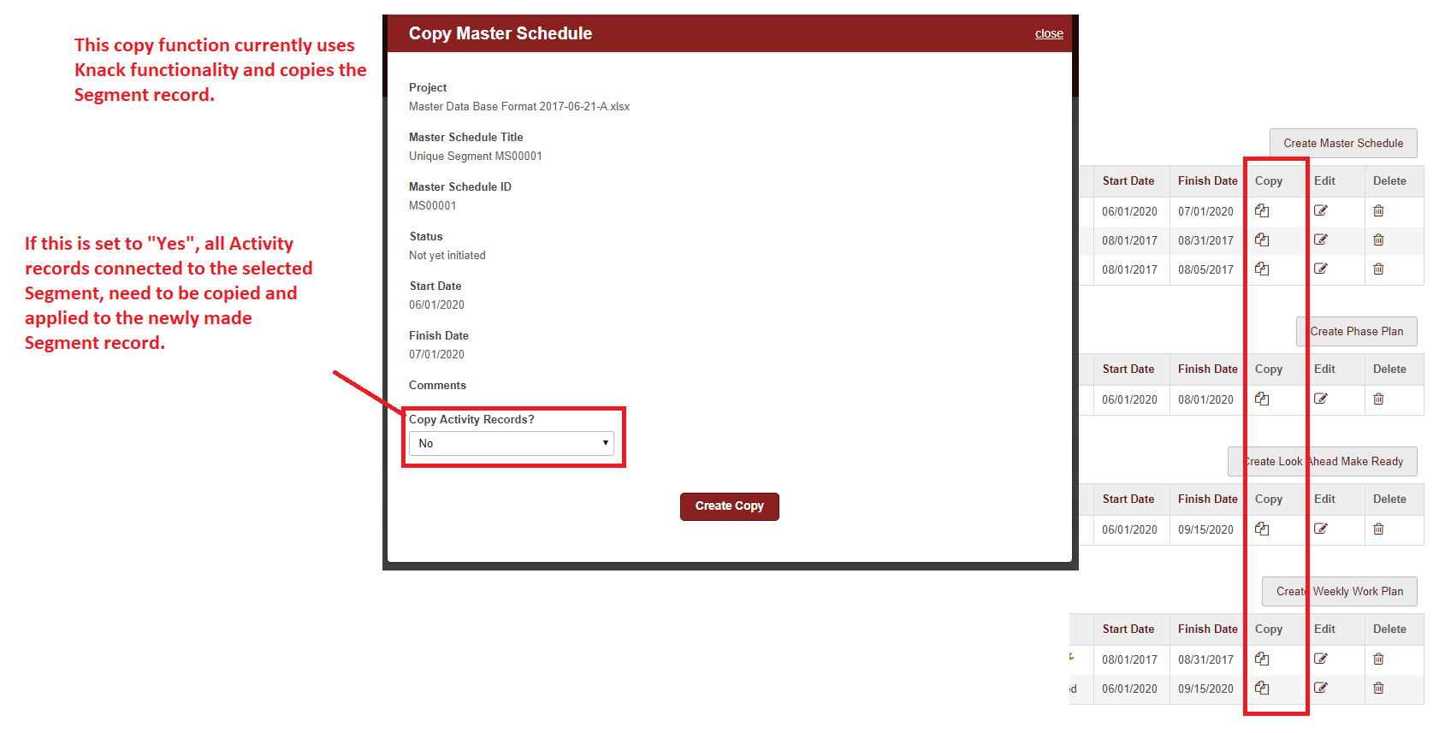

1. Client would like a CSV upload button, for each Segment’s details view, to upload Activity Records for that segment.

<https://dorylus.knack.com/dorylus-test-2017-04-29-a#projects/view-project-details/5965c2bf909ecc53268d670a/view-master-schedule-details/5965c61d0c6f855478e77e05/>

<https://dorylus.knack.com/dorylus-test-2017-04-29-a#projects/view-project-details/5965c2bf909ecc53268d670a/view-phase-plan-details/5965d034cf8f0454f0555fb1/>

<https://dorylus.knack.com/dorylus-test-2017-04-29-a#projects/view-project-details/5965c2bf909ecc53268d670a/view-look-ahead-make-ready-details/5965e610c3db3b51e8174864/>

<https://dorylus.knack.com/dorylus-test-2017-04-29-a#projects/view-project-details/5965c2bf909ecc53268d670a/view-weekly-work-plan-details/5965e64a92d657543ed4615f/?view_137_view=agendaWeek&view_137_date=%222017-08-29T18%3A17%3A52.414Z%22>

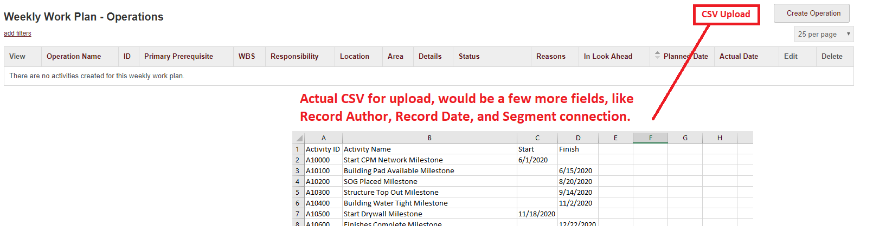

1. The client would like a button on each segment details, with the functionality to Move OR Copy the Activity records connected to the given segment, to another segment of the same type.

<https://dorylus.knack.com/dorylus-test-2017-04-29-a#projects/view-project-details/5965c2bf909ecc53268d670a/view-master-schedule-details/5965c61d0c6f855478e77e05/>

<https://dorylus.knack.com/dorylus-test-2017-04-29-a#projects/view-project-details/5965c2bf909ecc53268d670a/view-phase-plan-details/5965d034cf8f0454f0555fb1/>

<https://dorylus.knack.com/dorylus-test-2017-04-29-a#projects/view-project-details/5965c2bf909ecc53268d670a/view-look-ahead-make-ready-details/5965e610c3db3b51e8174864/>

<https://dorylus.knack.com/dorylus-test-2017-04-29-a#projects/view-project-details/5965c2bf909ecc53268d670a/view-weekly-work-plan-details/5965e64a92d657543ed4615f/?view_137_view=agendaWeek&view_137_date=%222017-08-29T18%3A17%3A52.414Z%22>

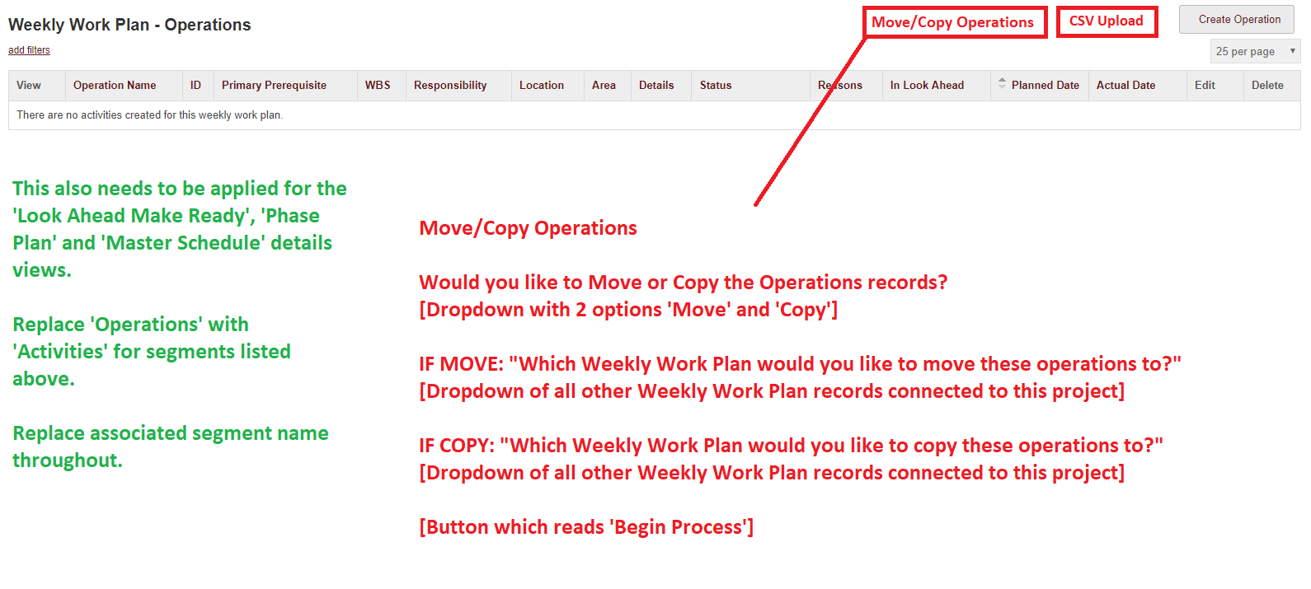

1. The following views (pop-up) need to ensure a “Start Date” is provided. If not, display the following text:

A Start Date is required.

<https://dorylus.knack.com/dorylus-test-2017-04-29-a#projects/view-project-details/5965c2bf909ecc53268d670a/view-master-schedule-details/5980808d13ee26566eb84800/create-activity/5980808d13ee26566eb84800/>

<https://dorylus.knack.com/dorylus-test-2017-04-29-a#projects/view-project-details/5965c2bf909ecc53268d670a/view-master-schedule-details/5980808d13ee26566eb84800/edit-activity/598084312b093e508e1a0838/>

<https://dorylus.knack.com/dorylus-test-2017-04-29-a#projects/view-project-details/5965c2bf909ecc53268d670a/view-phase-plan-details/5965d034cf8f0454f0555fb1/create-activity2/5965d034cf8f0454f0555fb1/>

<https://dorylus.knack.com/dorylus-test-2017-04-29-a#projects/view-project-details/5965c2bf909ecc53268d670a/view-phase-plan-details/5965d034cf8f0454f0555fb1/edit-activity/599f028df0535c2948d8e6cd/>

<https://dorylus.knack.com/dorylus-test-2017-04-29-a#projects/view-project-details/5965c2bf909ecc53268d670a/view-look-ahead-make-ready-details/5965e610c3db3b51e8174864/create-activity3/5965e610c3db3b51e8174864/>

<https://dorylus.knack.com/dorylus-test-2017-04-29-a#projects/view-project-details/5965c2bf909ecc53268d670a/view-look-ahead-make-ready-details/5965e610c3db3b51e8174864/edit-activity/5968eef55b755b4f096fe99b/>