

Genomic Health

.  
.  
.  
.  
.  
..  
.  
.  
.



..........

Requirements Specification for   
SARP Requisition Data Entry

Document Number: ERD-OP-IT-05-007-D

Revision Number: 5.0

Effective Date: 07-Jan-2011

The following reviewers have approved this document.

See DCO for signatures and approval dates.

|  |
| --- |
| **Name and Department** |
| **Betsy Mooney AUTHOR, IT SOFTWARE ENGINEERING** |
| **Leslie Marquez CUSTOMER SERVICE** |
| **Robert Gupta IT SOFTWARE ENGINEERING** |
| **Steve Strener IT QUALITY ENGINEERING** |
| **David Lebsack IT SOFTWARE ENGINEERING** |
| **DCO-ERD-OP-IT-05-007-D-5** |

Table of Contents

1 Introduction 4

1.1 Document Objectives & Scope 4

1.2 References 4

1.3 Revision History 4

1.4 Requirements implementation details 5

2 Functional Requirements 6

2.1 Requisition List 6

2.2 New Requisition 7

2.2.1 Test Type Selection 7

2.2.2 Barcode Validation 8

2.2.3 Search 9

2.2.4 Create New 10

2.2.5 Copying requisitions 14

2.3 Requisition Form 14

2.3.1 UI conventions 14

2.3.2 Requisition tab 16

2.3.3 Patient tab 22

2.3.4 Billing tab 27

2.3.5 Primary tab 28

2.3.6 Secondary tab 30

2.3.7 BI tab 31

2.3.8 Specimen tab 32

2.3.9 Pathology tab 39

2.3.10 Materials tab 39

2.3.11 Status tab 41

2.4 Save behavior 43

2.4.1 tblRequisition 43

2.4.2 tblPatient 44

2.4.3 tblSpecimen 44

2.4.4 tblInsurance 45

2.4.5 tblRequisitionAlignment 47

2.4.6 tbSpecimen_BreastRC 47

2.4.7 tblSpecimen_ColonRC 47

2.4.8 tblRequisitionRole 47

2.4.9 tblRequisitionEntity 47

2.4.10 tblRequisitionAddress 48

2.4.11 tblReportPrefs 49

2.4.12 tblBenefitsInvestigation 50

2.5 Actions menu 50

2.5.1 Cancel Requisition 50

2.5.2 Customer Service Case 50

2.5.3 Intake Complete 50

2.5.4 Data Entry Complete 61

2.5.5 Exclusions Check 61

2.5.6 Requisition PDF 61

2.5.7 View Original Requisition Fax 63

2.5.8 Verification Complete 63

2.5.9 Initiate Specimen Retrieval 63

2.5.10 Create And Send Fax 69

2.6 Requisition Activity History and Events 76

2.6.1 Requisition History 76

2.6.2 Requisition Activity List 78

2.6.3 Requisition Activity Windows 80

2.7 Reporting requirements 84

3 Use Cases 84

3.1 Standard Operating Procedures 84

3.2 Workflow 84

3.3 Reporting 84

3.4 Administration 84

4 Process Requirements 85

4.1 Standard Operating Procedures 85

4.2 Workflow 85

4.3 Reporting 85

4.4 Administration 85

# Introduction

This document outlines the requirements of the SARP Requisition Data Entry project.

The purpose of the SARP Requisition Data Entry project is to provide storage and workflow tracking of test orders.

## Document Objectives & Scope

The objective of this document is to define support for requisition data entry in SARP. This document describes an existing system rather than a project. This document is currently partially complete; for example, there is full documentation of the Specimen tab and no documentation for the Ordering tab. As SARP continues to change, or as time permits, documentation of additional features will be added. The objective is to keep the documentation up to date with the system.

## References

The following documents are related to or referenced by the Requirements Specification. They are all available on Sharepoint here: http://bentley/GenomicHealth/Documents/Information%20Technology/Commercial/05-007_SARP/

|  |  |
| --- | --- |
| **Document Name** | **Document Number** |
| SARP Accessioning ERD | ERD-OP-IT-05-007-B.doc |
| SARP Requisition Validation Rules | SARP Requisition Validation Rules.xls |
| [SARP Workflow Diagrams](http://bentley/GenomicHealth/Documents/Information%20Technology/Commercial/05-007_SARP/FRM-OP-IT-05-007-A-1.vsd) | FRM-OP-IT-05-007-A-1.vsd |
| PDF Stamping Requirements | FRM-OP-IT-05-007-B.xls |

**Table <1> Related Documentation**

## Revision History

|  |  |  |  |
| --- | --- | --- | --- |
| **Name** | **Change Description** | **Date** | **Version** |
| Betsy Mooney | Initial Version | 17-Dec-2009 | 1.0 |
| Nathaniel Slater | Medicare DOS updates | 20-May-2010 | 2.0 |
| Betsy Mooney | Updates for Commercial Seaborgium: pod name tracking. Added requirements for future releases per table in section 1.4 | 24-Sep-2010 | 3.0 |
| Betsy Mooney | Added requirements for the Canned Fax Tool (section 2.5.10) and the Initiate Specimen Retrieval button (section 2.5.9). Note that the Initiate Specimen Retrieval requirements are still in draft mode for this revision of the document. | 04-Dec-2010 | 4.0 |
| Betsy Mooney | Finalized the Initiate Specimen Retrieval requirements (section 2.5.9) | 07-Jan-2011 | 5.0 |
| Betsy Mooney | Modified for Commercial Mercury (DCIS / MMR release)  Updated requirements to support new concept of orderable test type  Added/updated requirements for test type selector on the New Requisition screen.  Added requirements for test type selector on the Requisition tab  Updated requirements for breast specimen critieria to include DCIS  Updated requirements for colon specimen criteria to document a field rename  Newly documented ICD-9 codes including DCIS codes  Updated clinical experience case requirements to support Mercury functionality  Updated New York Case requirements to make it generic for any orderable  Documented existing functionality of patient tab and minor label renames  Updated PDF stamping requirements  Modified requisition activity requirements for billing activities  Removed FR-133. | 01-Jul-2011 | 6.0 |

## Requirements implementation details

Unless otherwise indicated, requirements reflect current behavior:

|  |  |  |
| --- | --- | --- |
| **Section** | **Functional Requirement** | **Modified In (Introduced/Changed)** |
| various | Updated requirements to support new concept of orderable test type (FR-152, FR-1506, FR-1510-FR-1515, FR-413, FR-555) | Mercury |
| 2.2.1 | Added/updated requirements for test type selector on the New Requisition screen.(FR-1448, FR-1443, FR-1444) | Mercury |
| 2.3.2.1 | Added requirements for test type selector on the Requisition tab (FR-461, FR-460,FR-2001-FR-2034 (note some numbering gaps)) | Mercury |
| 2.3.3 | Speculative future requirements to support territory alignment changes (FR-2057, FR-2058) | Vanadium |
| 2.3.4 | Documented existing functionality of patient tab and minor label renames (FR-3001-FR-3016) | Mercury |
| 2.3.5 | Newly documented ICD-9 codes including DCIS codes (FR-3051-FR-3095) | Mercury |
| 2.3.9 | Updated requirements for breast specimen critieria to include DCIS (FR-1420, FR-522, FR-530(was FR-503 b/c of a typo), FR-538, FR-532a, FR-531a, FR-531b FR-533a, FR-536a, Fr-536b, FR-536c, FR-537a, FR-538a)  Updated requirements for colon specimen criteria to document a field rename (FR-551, FR-559) | Mercury |
| 2.3.10 | Speculative future requirements to support territory alignment changes (FR-2107, FR-2108) | Vanadium |
| 2.5.3.2 | Updated clinical experience case requirements to support Mercury functionality (FR-629, FR-2200-FR-2211, FR-2220) | Mercury |
| 2.5.3.4 | Updated New York Case requirements to make it generic for any orderable (FR-650, FR-656, FR-658-FR-663) | Mercury |
| 2.5.6 | Updated PDF stamping requirements for Mercury (FR-903, FR-904)  Moved PDF stamping field mapping requirements to new document (FR-910-FR-1010, FR-1250) | Mercury |
| 2.6 | Modified requisition activity requirements for billing activities (FR-1851-FR-1859, FR-1881-FR-1888, FR-2301-FR-2320) | Mercury |
| 2.3.2 | FR-419 – 420  FR-462 | Potassium |

# Functional Requirements

## Requisition List

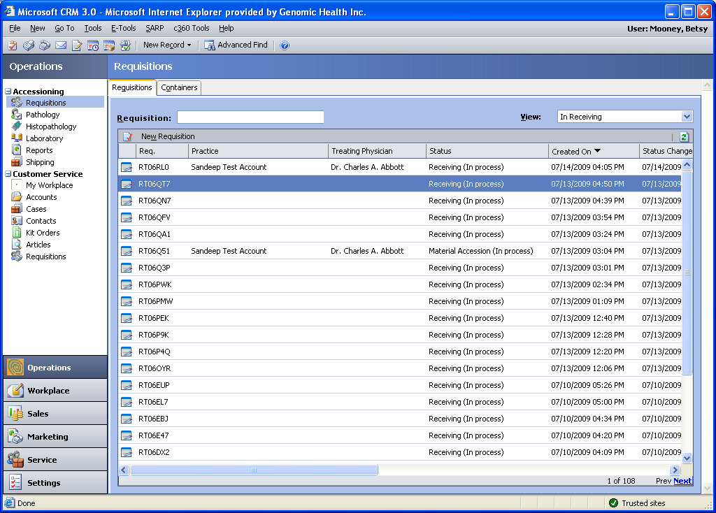

Full specification will be completed at a future date.

FR-1300. This requirement removed.

## New Requisition

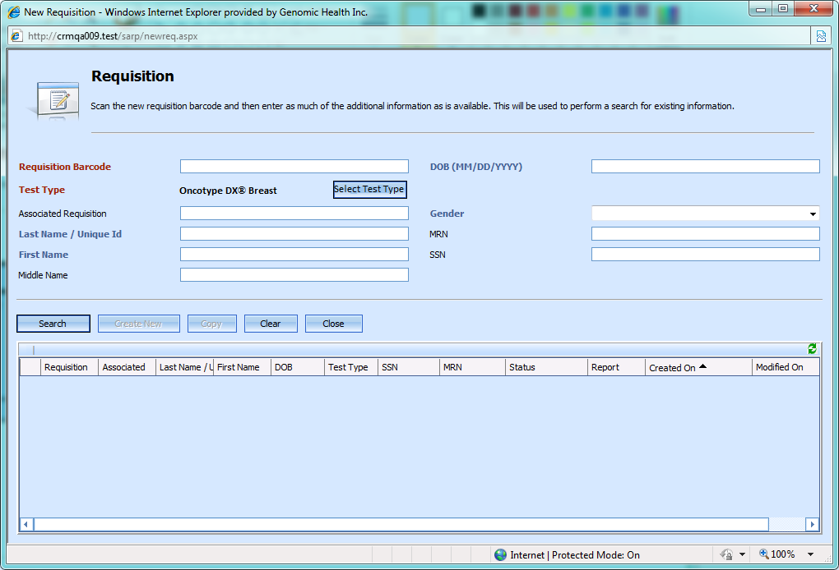



### New Requisition Screen UI Requirements

Field requirements:

|  |  |  |  |
| --- | --- | --- | --- |
| **Req #** | **Field Name** | **Meaning** | **Default value** |
| FR-101 | Requisition Barcode | A unique identifier for the requisition. | Blank |
| FR-102 | Test Type | The test ordered for this requisition (orderable) | Unknown test type. |
| FR-103 | Associated Requisition | The barcode for one previous requisition processed for the same patient. | Blank |
| FR-104 | Last Name/Unique ID | The patient’s last name | Blank |
| FR-105 | First Name | The patient’s first name | Blank |
| FR-106 | Middle Name | The patient’s middle name | Blank |
| FR-107 | DOB | The patient’s date of birth, entered as MM/DD/YYYY | Blank |
| FR-108 | Gender | The patient’s gender | Blank |
| FR-109 | MRN | The patient’s medical record number. | Blank |
| FR-110 | SSN | The patient’s social security number. | Blank |

FR-1445. The Clear button resets the fields on the New Requisition screen to their defaults.

FR-1446. Default requirements merged into FR-101-FR-110 above.

FR-1447. The Close button on the New Requisition screen closes the window.

The columns in the search results are as follows:

| FR-# | Column name | Description | Database column |
| --- | --- | --- | --- |
| 1450 | Requisition | Requisition barcode | tblRequisition.RequisitionBarcode |
| 1451 | Associated | Associated requisition | tblRequisition.AssociatedBarcode |
| 1452 | Last Name / Unique ID | Patient’s last name | tblPatient.LastName |
| 1453 | First Name | Patient’s first name | tblPatient.FirstName |
| 1454 | DOB | Patient’s date of birth | tblPatient.DOB |
| 1455 | Test Ordered | Orderable of the found requisition | tblOrderable.ShortName (via tblRequisition.OrderableID) |
| 1456 | SSN | Patient’s social security number | tblPatient.SSN |
| 1457 | MRN | Patient’s medical record number | tblPatient.MedicalRecordNumber |
| 1458 | Status | Long requisition status; i.e. Pathology Review (In Process) | tblRequisitionStatus.ReqState and tblRequisitionStatus.ReqQueue |
| 1459 | Report | If a report exists, whether it was a failure report or a result report | tblReport.ReportType and tblEnumeration where groupid = 25 |
| 1460 | Created On | Requisition creation date | tblRequisition.CreatedOn |
| 1461 | Modified On | Requisition modification date | tblRequisition.ModifiedOn |

### Test Type Selection

The test type selector tool is designed to prevent accidental changes to test types. For consistency of user experience, the same tool is used for test type selection on both the New Requisition screen and on the Requisition tab. See section 2.3.2.1 for detailed requirements for this tool. Note that the requirements about requisition state and specimen criteria do not apply to test type selection on the New Requisition screen.

FR-1448. The test type selector on the New Requisition screen will always default to Unknown.

FR-1449. Test type selection requirements moved to section 2.3.2.1.

### Barcode Validation

Background: Each requisition form is printed with a unique requisition barcode on it. Valid requisition barcodes are allocated before requisition forms are printed. They are stored, along with an associated form version, in tblBarcodeCatalog.

FR-111. A valid requisition barcode begins with R and contains 5 alphanumeric digits followed by a checksum digit.

FR-112. The checksum digit can be checked using the following algorithm:

sCheckSummable is the checksummable portion of the string; ChkSum is the checksum digit.

for ( var i = 0; i < sCheckSummable.length; i++ )

{

ChkSum += ( ( i + 1 ) * sCheckSummable.charAt( i ).toUpperCase().charCodeAt( 0 ) );

}

ChkSum = ChkSum % 36;

if ( ChkSum <= 9 )

{

ChkSum = String.fromCharCode( ChkSum + 48 );

}

else

{

ChkSum = String.fromCharCode( ( ChkSum - 10 ) + 65 );

}

FR-113. The requisition barcode field performs validation once 7 characters have been entered into it.

FR-114. If the user specifies an invalid barcode, the following confirmation message appears, “Invalid barcode: <barcode>”, and the requisition barcode field immediately clears itself.

FR-115. If the user specifies a previously used barcode, the barcode is initially accepted.

FR-116. If the user specifies a barcode not listed in tblBarcodeCatalog which nonetheless has a valid format and checksum digit, the barcode is initially accepted.

### Search

FR-117. When the user presses the Search button, a search is done in the database for other requisitions that might match this one.

FR-118. If the user has specified a previously used barcode and presses Search, the following message appears: “A requisition already exists with the indicated barcode”. The search then proceeds.

FR-119. If there is no barcode entered and the user presses Search, the following message appears: “A new requisition barcode must be entered.” The search does not proceed.

FR-120. If the user has not filled in the patient’s first name, last name, or date of birth, and presses Search, the following message appears: “Patient name and DOB should be entered, if available”. The search then proceeds.

FR-121. If the user has specified a previously used barcode in the requisition barcode field, the search brings back only information about that barcode.

FR-122. If the user has specified a valid, not previously used, barcode in the barcode field, and has specified a first name, last name, or date of birth, the search brings back information about any requisition in the database whose first name, last name, and date of birth match the ones specified.

FR-123. The firstname search is a wildcard match on the first 5 letters of the patient’s first name.

FR-124. The lastname search is a wildcard match on the first 7 letters of the patient’s last name.

FR-125. The date of birth search looks for an exact match on the day, month, and year of the patient’s birthdate.

FR-126. If the user has specified a valid, not previously used, barcode in the barcode field and a social security number in the SSN field, the search will bring back any requisitions with a patient’s social security number that exactly matches the one entered.

FR-127. The social security number search and the firstname, lastname, birthdate search are combined with OR.

FR-128. If no information is specified about the patient, no results are returned.

FR-129. Sources of patient information include both tblPatient and patient contact information held in CRM.

### Create New

FR-130. Once the user has run one search, the Create New button is activated.

FR-131. When the user clicks the Create New button for a barcode that is valid, but not listed in tblBarcodeCatalog, an error should be generated (Note that right now, you get a SARP error).

FR-132. When the user clicks the Create New button for a valid requisition barcode, a new requisition is entered into SARP. See the 150-level requirements for information about new requisition creation.

FR-133. This requirement removed.

Note on the data insert requirements below: FR-150-FR-162 describe data values that vary depending on the values filled in to the New Requisition page. The remaining requirements describe the default values inserted into other columns in other tables.

FR-150. When a new requisition is created, data is inserted into tblRequisition, tblRequisitionStatus, tblRequisitionAlignment, tblPatient, tblRequisitionActivity, and tblSpecimen.

|  |  |  |  |
| --- | --- | --- | --- |
| FR-# | Field name | Database table | Database column |
| FR-151 | Requisition Barcode | tblRequisition | RequisitionBarcode |
| FR-152 | Test Type | tblRequisition | OrderableID |
| FR-153 | Test Type | tblSpecimen | Specimentypeenumid. Determined by inspecting the specimenttypeenumid associated with the orderable selected for the test. |
| FR-154 | Associated Requisition | tblRequisition | AssociatedBarcode |
| FR-155 | Last Name | tblPatient | LastName |
| FR-156 | First Name | tblPatient | FirstName |
| FR-157 | Middle Name | tblPatient | MiddleName |
| FR-158 | DOB | tblPatient | DOB |
| FR-159 | Gender | tblPatient | Gender |
| FR-160 | MRN | tblPatient | MedicalRecordNumber |
| FR-161 | SSN | tblPatient | SSN |

Defaults in tblRequisition

| FR-# | Table | Column | Default value | Meaning |
| --- | --- | --- | --- | --- |
| FR-162 | tblRequisition | Billing Type | 0 | Unknown |
| FR-163 | tblRequisition | SubmissionType | 1 | First submission |
| FR-164 | tblRequisition | SignatureVerified | 0 | Not verified |
| FR-165 | tblRequisition | SignatureDate | NULL |  |
| FR-166 | tblRequisition | KitTrackingNumber | NULL |  |
| FR-167 | tblRequisition | RequisitionNotes | NULL |  |
| FR-168 | tblRequisition | CreditCardNumber | NULL |  |
| FR-169 | tblRequisition | CreditCardExpiration | NULL |  |
| FR-170 | tblRequisition | CreditCardName | NULL |  |
| FR-171 | tblRequisition | CheckName | NULL |  |
| FR-172 | tblRequisition | CheckNumber | NULL |  |
| FR-173 | tblRequisition | CheckAmount | NULL |  |
| FR-174 | tblRequisition | MedicareABN | 0 | Unset |
| FR-175 | tblRequisition | AssociatedBarcode | NULL |  |
| FR-176 | tblRequisition | ProcessingCode | NULL |  |
| FR-177 | tblRequisition | BillingNotes | NULL |  |
| FR-178 | tblRequisition | WireRefNumber | NULL |  |
| FR-179 | tblRequisition | WireAmount | NULL |  |
| FR-180 | tblRequisition | WirePaymentStatusEnumID | 0 | Unset |
| FR-193 | tblRequisition | CurrentPodId | 0 | Unknown |

Defaults in tblPatient

|  |  |  |  |  |
| --- | --- | --- | --- | --- |
| FR-# | Table | Column | Default value | Meaning |
| FR-181 | tblPatient | Address1 | NULL |  |
| FR-182 | tblPatient | Address2 | NULL |  |
| FR-183 | tblPatient | City | NULL |  |
| FR-184 | tblPatient | State | NULL |  |
| FR-185 | tblPatient | Postal Code | NULL |  |
| FR-186 | tblPatient | Country | NULL |  |
| FR-187 | tblPatient | Phone | NULL |  |
| FR-188 | tblPatient | MedicalRecordNumber | NULL |  |
| FR-189 | tblPatient | SSN | NULL |  |
| FR-190 | tblPatient | HospitalizationStatus | NULL |  |
| FR-191 | tblPatient | Phone2 | NULL |  |
| FR-192 | tblPatient | Phone3 | NULL |  |

Defaults in tblSpecimen

| FR-# | Table | Column | Default value | Meaning |
| --- | --- | --- | --- | --- |
| FR-194 | tblSpecimen | SurgeryDate | NULL |  |
| FR-195 | tblSpecimen | SpecimenSource | NULL |  |
| FR-196 | tblSpecimen | SpecimenNumber | NULL |  |
| FR-197 | tblSpecimen | SpecimenNumber2 | NULL |  |
| FR-198 | tblSpecimen | SpecimenNumber3 | NULL |  |
| FR-199 | tblSpecimen | SpecimenNumber4 | NULL |  |
| FR-1301 | tblSpecimen | SubmittingDiagnosis | NULL |  |
| FR-1302 | tblSpecimen | DiagnosisID | NULL |  |
| FR-1303 | tblSpecimen | SurgeryType | 0 | Unknown |
| FR-1304 | tblSpecimen | FixativeType | 0 | Unknown |
| FR-1305 | tblSpecimen | FixativeOther | NULL |  |
| FR-1306 | tblSpecimen | BlockArchiveRetrievalDate | NULL |  |
| FR-1307 | tblSpecimen | HospitalDischargeDate | NULL |  |
| FR-1308 | tblSpecimen | SpecimenContents | NULL |  |
| FR-1309 | tblSpecimen | ReportAttachmentEnumID | 0 | Unset |
| FR-1310 | tblSpecimen | SpecimenRetrievalEnumID | 0 | Unset |
| FR-1311 | tblSpecimen | PrimariesEnumID | 0 | Unset |
| FR-1312 | tblSpecimen | ExceptionCriteria | NULL |  |

Defaults in tblInsurance

FR-1313. No rows are entered in tblInsurance by default.

FR-1314. When the first piece of insurance information is filled in to the requisition, a row is entered in tblInsurance. See the Save Requisition section, especially FR-1170 to FR-1194.

Defaults in tblRequisitionAlignment

|  |  |  |  |  |
| --- | --- | --- | --- | --- |
| FR-# | Table | Column | Default value | Meaning |
| FR-1315 | tblRequisitionAlignment | CreditTerritoryID | NULL |  |
| FR-1316 | tblRequisitionAlignment | CreditManagerID | NULL |  |
| FR-1317 | tblRequisitionAlignment | CurrentTerritoryID | NULL |  |
| FR-1318 | tblRequisitionAlignment | CurrentManagerID | NULL |  |

Initial Data in tblRequisitionStatus

| FR-# | Table | Column | Default value | Meaning |
| --- | --- | --- | --- | --- |
| FR-1319 | tblRequisitionStatus | ReqState | 1 | Receiving |
| FR-1400 | tblRequisitionStatus | ReqQueue | 2 | In Process |
| FR-1401 | tblRequisitionStatus | ReqStatus | 1 | Active |
| FR-1402 | tblRequisitionStatus | PathologyStatus | 0 | Unknown |
| FR-1403 | tblRequisitionStatus | FailureID | NULL |  |
| FR-1404 | tblRequisitionStatus | WorkflowVersion | 3 | ? |
| FR-1405 | tblRequisitionStatus | WorkflowPath | 0 | Unknown |
| FR-1406 | tblRequisitionStatus | CurrentReportIndex | NULL |  |
| FR-1407 | tblRequisitionStatus | ReportDate | NULL |  |
| FR-1408 | tblRequisitionStatus | VerificationStatus | 1 | Unverified |
| FR-1409 | tblRequisitionStatus | DataEntryCompleted | NULL |  |
| FR-1410 | tblRequisitionStatus | FirstShippingCompleted | NULL |  |
| FR-1411 | tblRequisitionStatus | IntakeCompleted | NULL |  |
| FR-1412 | tblRequisitionStatus | EstimatedShippingDate | NULL |  |
| FR-1413 | tblRequisitionStatus | ExternalReqStatus | 1 | Order Received |
| FR-1414 | tblRequisitionStatus | ESDLastUpdated | Requisition create date |  |
| FR-1415 | tblRequisitionStatus | MaterialProcessingType | 0 | Unknown / Unset |
| FR-1416 | tblRequisitionStatus | SlidesOrdered | 0 | Unordered |

Note that information in the specimen table is related to the specimen type, not the orderable, of the requisition. Here is a mapping table which specifies which orderables map to which specimen types:

|  |  |
| --- | --- |
| Orderable short name | Specimen type |
| IBC | Breast |
| DCIS | DCIS |
| Colon | Colon |
| MMR | Colon |
| Colon/MMR Seq | Colon |

FR-1420. When a new breast or DCIS requisition is created, information is inserted into tblSpecimen_BreastRC.

|  |  |  |  |  |
| --- | --- | --- | --- | --- |
| FR-# | Table | Column | Default value | Meaning |
| FR-1421 | tblSpecimen_BreastRC | ERStatus | 0 | Unset |
| FR-1422 | tblSpecimen_BreastRC | NodeStatus | 0 | Unset |
| FR-1423 | tblSpecimen_BreastRC | ClinicalStageEnumID | 0 | Unset |
| FR-1424 | tblSpecimen_BreastRC | NodeStatusDeterminationEnumID | 0 | Unset |

Note that the information above is not converted into default values based on the req form version until after the requisition is saved the first time.

FR-1430. When a new colon requisition is created, information is inserted into tblSpecimen_Colon.

|  |  |  |  |  |
| --- | --- | --- | --- | --- |
| FR-# | Table | Column | Default value | Meaning |
| FR-1431 | tblSpecimen_Colon | ClinicalStageEnumID | 0 | Unset |
| FR-1432 | tblSpecimen_Colon | T4EnumID | 0 | Unset |
| FR-1433 | tblSpecimen_Colon | MSIMMREnumID | 0 | Unset |

### Copying requisitions

FR-1436. If a new requisition is created as a copy of an old requisition, a new row is created in tblPatient that duplicates the previous row with the exception of the Medical Record Number (which is null in the new record) and the Hospitalization Status (which is 0 in the new record). Note that the Medical Record Number is new because this can change if the patient is hospitalized at a different hospital.

FR-1437. If a new requisition is created as a copy of an old requisition, the initial values in tblRequisitionStatus should be identical to a new requisition; see requirements FR-1319 – FR-1416.

FR-1438. If a new requisition is created as a copy of an old requisition, the initial values in the following columns of tblRequisition are identical to the copied requisition:

|  |
| --- |
| Column name |
| BillingType |
| CreditCardName |
| CreditCardNumber |
| CreditCardExpiration |
| CheckName |
| CheckNumber |
| CheckAmount |
| BillingNotes |

Note that the other columns are populated with default values as specified in FR-162-180, FR-193

FR-1439. If a new requisition is created as a copy of an old requisition, a new row is created in tblInsurance which duplicates the contents of the old row, with the exception of the columns AuthorizationNumber (which is null in the new row) and PriorAuthAttachmentEnumID (which is 0 in the new row)

FR-1440. If a new requisition is created as a copy of an old requisition, the new requisition gets default values in tblSpecimen, tblSpecimen_BreastRC, and tblSpecimen_Colon. See FR-194-FR-199,FR-1301-1312 and FR-1420-1433.

FR-1441. If a new requisition is created as a copy of an old requisition, there is no information entered in tblRequisitionAlignment.

FR-1442. If a new requisition is created as a copy of an old requisition, the SubmissionType field is set to 2, Resubmission.

FR-1443. If a new requisition is created as a copy of an old requisition, the new requisition gets the Unknown orderable test type.

FR-1444. If a new requisition is created as a copy of an old requisition, no information is copied about requisition contacts such as the ordering physician or the pathologist.



## Requisition Data Entry

FR-200. The RDE screens support all released versions of the requisition data entry form, including domestic and international forms.

### UI conventions

FR-1500. Fields in red (see the Patient tab for an example) are required. The requisition will not save unless these files are populated.

FR-1501. Fields in blue, such as the tracking number above, are validated. Logic may be run at save time to check the values of these fields.

Common icons: (Icons used on only one page will be documented with the requirements for that page)

|  |  |  |
| --- | --- | --- |
| FR-# | Icon | Action |
| 1502 |  | Looks up a CRM contact or account to fill into a nearby field or set of fields. |
| 1503 |  | Edits the CRM contact or account information in a nearby field or set of fields |
| 1504 |  | Clears the CRM contact or account information from a nearby field or set of fields. |

FR-1505. The requisition barcode appears in the upper right corner of the requisition screen.

FR-1506. A shortened string referring to the ordered test appears in the upper right corner of the requisition screen.

The orderable test types map to shortened strings in the following manner. In addition, there is a canonical display order and color for each orderable. These are documented here and will be used consistently throughout the application.

|  |  |  |  |  |
| --- | --- | --- | --- | --- |
| FR-# | Long orderable name | Short name | Display Order | Color |
| FR-1510 | Oncotype DX Colon Cancer Assay | Colon | 4 | #0000FF (blue) |
| FR-1511 | MMR Assay for Recurrence Risk Assessment | MMR | 5 | #0000FF (blue) |
| FR-1512 | Sequential Assays; MMR then Oncotype DX Colon Cancer if MMR is Proficient | MMR/Colon Seq | 3 | #0000FF (blue) |
| FR-1513 | Oncotype DX Breast Cancer Assay for Invasive Breast Cancer Patient | IBC | 2 | #FFA500 (orange) |
| FR-1514 | Unknown | Unknown | 6 | #FF0000 (red) |
| FR-1515 | Oncotype DX Breast Cancer Assay for Ductal Carcinoma In Situ Patient | DCIS | 1 | #FFA500 (orange) |

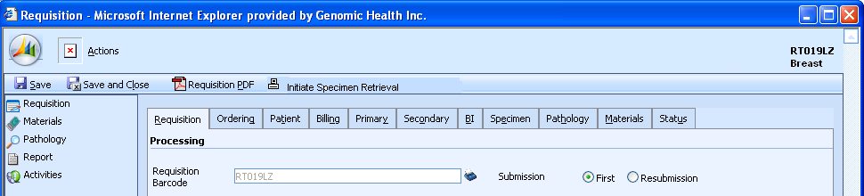

### Requisition tab

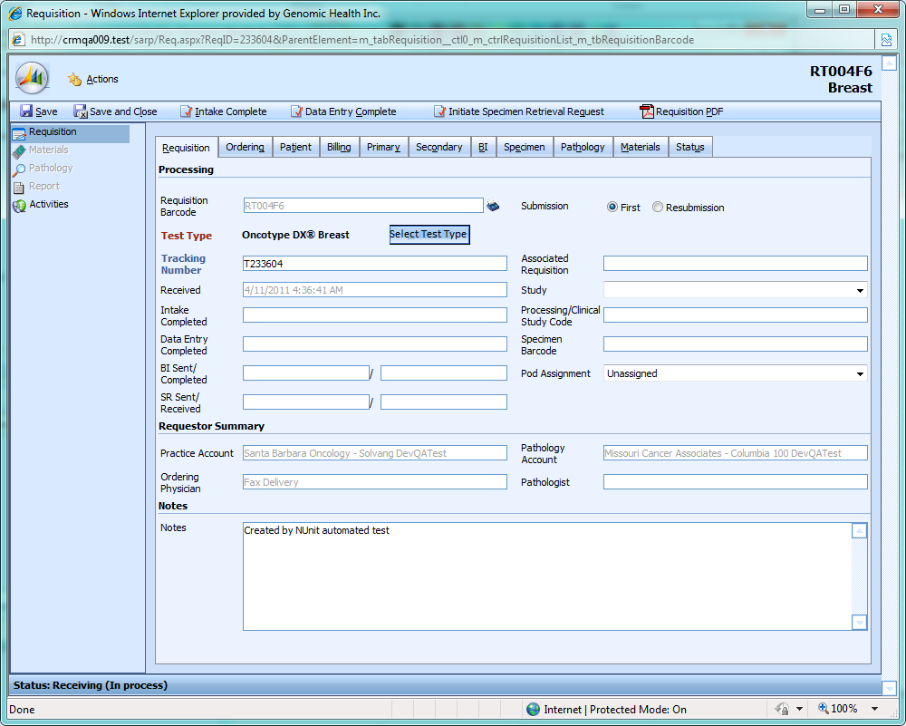

|  |  |  |  |  |  |
| --- | --- | --- | --- | --- | --- |
| **Req #** | **Field Name** | **Initially Editable?** | **Meaning** | **Database column** | **Data source** |
| FR-401 | Requisition Barcode | N | A unique identifier for the requisition. | tblRequisition.RequisitionBarcode | Requisition barcodes are pregenerated when requisition forms are printed. A list of the pregenerated barcodes and req form versions is in |

|  |  |  |  |  |  |
| --- | --- | --- | --- | --- | --- |
| **Req #** | **Field Name** | **Initially Editable?** | **Meaning** | **Database column** | **Data source** |
| FR-402 | Tracking Number | Y | The Fed Ex tracking number for the package in which the specimen(?) arrived. | tblRequisition.KitTrackingNumber | This is the fed ex tracking number, and users would like this to properly truncate to the correct 12 digits so that it can be scanned. |
| FR-403 | Received | N | The date the requisition was entered into SARP | tblRequisitionStatus.CreatedOn? | This is automatically populated when the requisition is created. |
| FR-404 | Intake Completed | N | The date the intake complete action was run. | tblRequisitionStatus.IntakeCompleted |  |
| FR-405 | Data Entry Completed | N | The date the data entry complete action was run. | tblRequisitionStatus.DataEntryCompleted |  |
| FR-406 | BI Sent | N | The date benefits investigation was initiated | tblBenefitsInvestigation.StartDate |  |
| FR-407 | BI Completed | N | The date benefits investigation was completed | tblBenefitsInvestigation.EndDate |  |
| FR-408 | Submission | Y | Whether this is the first attempt at generating test results for this patient. | tblRequisition.SubmissionType | The requisition form contains a checkbox. |
| FR-409 | Associated Requisition | Y | If a previous requisition has been submitted for the same patient, its number is here. | tblRequisition.AssociatedBarcode |  |
| FR-410 | Study | Y | A clinical trial that the patient is participating in. | tblRequisitionEntity.EntityName for the entity associated with the Study (roleEnumID = 6) role in tblRequisitionRole. |  |
| FR-411 | Processing / Clinical Study Code | Y | A unique identifier within the clinical trial for this specimen | tblRequisition.ProcessingCode |  |

| **Req #** | **Field Name** | **Initially Editable?** | **Meaning** | **Database column** | **Data source** |
| --- | --- | --- | --- | --- | --- |
| FR-412 | Specimen Barcode | Y | The GHI-generated S-barcode associated with this requisition | tblSpecimenBarcode.SpecimenBarcode | S-barcodes are generated with ordering kits. See FR- |
| FR-413 | Test Type | See 2.3.2.1 for informationon how this field works. | Which test was ordered | tblRequisition.OrderableID | This information is on the requisition form. |
| FR-414 | Practice Account | N | The account name of the doctor who ordered the test | tblRequisitionEntity.EntityName for the tblRequisitionEntity entry for entity type Account or Payer and requisition role type Treating | This information is entered on the Ordering tab. |
| FR-415 | Ordering Physician | N | The name of the doctor who orderd the test | tblRequisitionEntity.EntityName for the tblRequisitionEntity entry for entity type Contact and requisition role type Treating | This information is entered on the Ordering tab. |
| FR-416 | Pathology Account | N | The account name of the pathologist who submitted the specimen | tblRequisitionEntity.EntityName for the tblRequisitionEntity entry for entity type Account or Payer and requisition role type Pathology | This information is entered on the Pathology tab. |
| FR-417 | Pathologist | N | The name of the pathologist who submitted the specimen | tblRequisitionEntity.EntityName for the tblRequisitionEntity entry for entity type Contact and requisition role type Pathology | This information is entered on the Pathology tab |
| FR-418 | Notes | Y | A free-text field containing information about the requisition | tblRequisition..Notes | Pathology and customer service notes often end up in this field. |
| FR-419 | SR Sent | N | The date specimen retrieval was initiated. | tblSpecimen.SpecimenRetrievalStartDate | This field is always editable. The formatting rules that are implemented on the Signature date should apply. |
| FR-420 | SR Completed | Y | The date the specimen arrived | tlbSpecimen.SpecimenArrivalDate | This field is always editable.The formatting rules that are implemented on the Signature date should apply. |
| FR-421 | Pod Name | Y | A dropdown box containing the assigned pod name | tblRequisition.CurrentPodID? | Pod name options should come from tblPod.. Current production pod names are Juno, Gold, Omaha, Sword, Utah and Normandy |

|  |  |  |
| --- | --- | --- |
| FR-# | Icon | Action |
| FR-430 |  | Prints a requisition barcode |

FR-431. The requisition barcode label has this appearance:

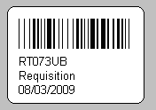

FR-432. The first line of the label is a scannable barcode encoding the requisition barcode.

FR-433. The second line of the label is a human-readable representation of the barcode text.

FR-434. The third line of the label is the word “Requsition”.

FR-435. The fourth line of the label is the date the requisition was created.

FR-440. If there is a GHI-generated S-barcode in the Specimen Barcode field, then this barcode can be used to accession specimens for this requisition.

**Open question**: When is the S-barcode validated? I know we check to make sure it’s valid and not associated with another requisition; is this at Save time?

FR-450. The Study dropdown has the following options: blank (not set),TAILORx, Loyola Study

FR-451. The Study dropdown is populated by querying the names of all the accounts in CRM with an entity type of ‘Study’.

FR-452. If the requisition form version is version 10 or below, the TestType radio buttons are disabled and default to IBC.

FR-453. If the study field is set to Loyola University, the Bill To field becomes GHI, the GHI Account becomes Loyola University Study, and the materials return contact is set to <need to fill in production person here>.

FR-454. If the study field is set to TAILORx, the user is prompted to enter a code in the Processing / Clinical Study code field with the following message: “A processing code in the format 'PACT-1 nnnnn' is required.” The requisition cannot be saved until a code in this format is entered.

FR-455. If the study field is set to TAILORx, the materials return contact is set to <production contact>.

FR-460. Refer to section 2.3.2.1 for information on test type selection.

FR-461. Refer to section 2.3.2.1 for information on test type selection. This requirement is now FR-2012.

FR-462. When text is entered in the tracking number field, the SR Received box should populate automatically with today’s date and time.

#### Test Type Selector Tool

FR-2001. The radio buttons display the short name for each orderable test. See FR-1510-FR-1514 for a table of short and long names for each test and the order in which they should be displayed (right to left) in the test type selector.



FR-2002. When the user selects a test type from the radio buttons, the buttons collapse and are replaced by a colored text representation of the short name of the selected test. See FR-1510-FR-1514 for a table of short and long names for each test and for the color of the text representation.

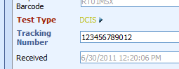

FR-2003-FR-2008. These requirement numbers unused.

FR-2009. The color / background relationship will be checked to ensure that a colorblind individual can still read the test name when the test type selector is in its collapsed form.

FR-2010. When the tool is in its collapsed state and the Intake Complete button has not yet been pressed, a small button with an arrow on it is visible.

FR-2011. When the user clicks on the arrow button, the text representation disappears and the radio buttons appear again. The previously selected test is checked.

FR-2012. If the requisition is past Intake Complete, the radio buttons are no longer editable. (was FR-461)

FR-2013. When the requisition tab is reloaded from the database, the tool is reloaded in its collapsed form.

FR-2014. When the user selects an orderable test type from the radio buttons, the specimen criteria fields in the specimen tab (section 2.3.9) are reset to the defaults for the specimen associated with the orderable if and only if the new orderable and the old orderable are associated with different specimen types.

FR-2014a. If the orderable changes but the specimen type does not change (for example, the orderable changes from Colon to Colon/MMR Seq), then the specimen critieria is unchanged.

FR-2015. Note that when the specimen criteria fields are reset, no user notification is required.

FR-2016. The test type selector will only allow ordering of options orderable on the requisition form version associated with the requisition. For example, if a requisition came in on a v9 req form, the test type selector for that req form should only allow the user to select ‘IBC’.

FR-2017. When the specimen critieria fields are reset per FR-2014, the ICD-9 code in the Billing tab is reset to blank if it is no longer appropriate for the new orderable.

FR-2018-FR-2019. These requirement numbers unused.

Here is a mapping of req form versions to allowable test types:

|  |  |  |
| --- | --- | --- |
| FR-# | Req form version(s) | Orderable test options (short name) |
| FR-2020 | 1-10 | IBC |
| FR-2021 | 11-13 | IBC, Colon, Unknown |
| FR-2022 | 14 | IBC, Colon, MMR, MMR/Colon Seq, DCIS, Unknown |

FR-2023-FR-2029. These requirement numbers unused.

FR-2030. If there is only one orderable test option for a given requisition form version, the test type selector will default to that test option.

FR-2031. This requirement number unused.

FR-2032. The test type selector will present an Unknown option for all req form versions above v10.

FR-2033. Changing the test type will automatically cause the test type and specimen criteria information to update in the database. Note that the entire requisition data will not be saved.

FR-2034. When the test type is changed, any entered information (such as the billing notes) should not disappear from the requisition data entry UI, even if that information has not yet been persisted in the database

|  |  |  |  |  |
| --- | --- | --- | --- | --- |
|  |  |  |  |  |
|  |  |  |  |  |
|  |  |  |  |  |
|  |  |  |  |  |
|  |  |  |  |  |
|  |  |  |  |  |
|  |  |  |  |  |
|  |  |  |  |  |
|  |  |  |  |  |
|  |  |  |  |  |
|  |  |  |  |  |
|  |  |  |  |  |
|  |  |  |  |  |
|  |  |  |  |  |
|  |  |  |  |  |
|  |  |  |  |  |
|  |  |  |  |  |
|  |  |  |  |  |

### Ordering tab

Note that the Address and Owner fields (FR-2057, FR-2058) are future requirements. These will be implemented in conjunction with the territory alignment release (Vandadium).

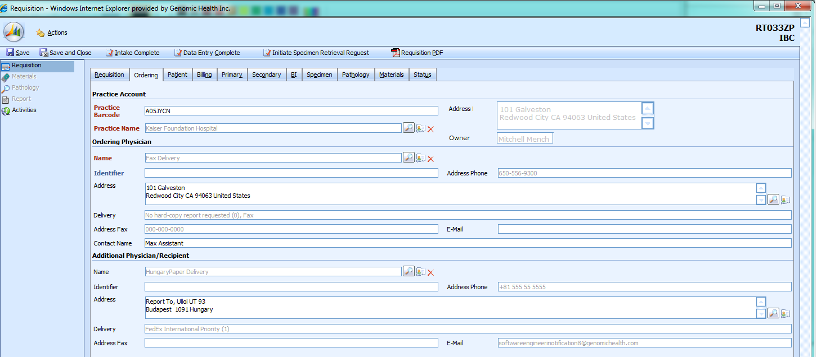

See section 2.4, Save Behavior for requirements about how information on this tab is persisted into the database.

#### Practice Account section

The Practice Account section displays information from CRM about the practice account associated with the requisition.

FR-2050. When the user enters a practice barcode into the Practice Barcode field, the remaining information in this section is populated.

FR-2051. When the user selects a CRM account as the ordering account using the magnifying glass icon (see FR-1502 to FR-1504), the information in this section is populated from that account.

FR-2052. When the user clicks on the red X next to the practice name, all information in this section is cleared.

FR-2053. When the user clicks on the index card icon next to the practice name, the CRM account screen appears in a popup. The user is able to edit the account; if he makes changes, they are automatically reloaded in the requisition when the CRM popup is closed.

FR-2054. This requirement number unused.

|  |  |  |  |  |
| --- | --- | --- | --- | --- |
|  |  |  |  |  |
| FR-2055 |  | Account barcode for the account from which this requisition originated. | tblRequisitionEntity. EntityReferenceID | SARP (copied from CRM on requisition save) |
| FR-2056 |  | Account name for the account from which this requisition originated. | tblRequisitionEntity. EntityName | SARP (copied from CRM) |
| FR-2057 | Address | The account address, in the format:  Street 1  Street 2 (if exists)  City State Zip Country | Not copied into SARP; this is display-only information from CRM | CRM primary address for account |
| FR-2058 | Owner | The account owner from CRM. Format is developer’s choice but should include the first and last name. | Not copied into SARP; this is display-only information from CRM | CRM account owner |

#### Ordering Physician section

This section not completely documented

|  |  |  |  |  |
| --- | --- | --- | --- | --- |
| **Req #** | **Field Name** | **Meaning** | **Database column** | **Data source** |
|  | Physician Name |  |  |  |
|  | Physician Identifier |  |  |  |
|  | Physician Address Phone |  |  |  |
|  | Physician Address |  |  |  |
|  | Physician Delivery |  |  |  |
|  | Physician Address Fax |  |  |  |
|  | Physician Email |  |  |  |
|  | Physician Contact Name |  |  |  |

#### Additional Physician / Recipient section

This section not completely documented

|  |  |  |  |  |
| --- | --- | --- | --- | --- |
| **Req #** | **Field Name** | **Meaning** | **Database column** | **Data source** |
|  | Physician Name |  |  |  |
|  | Physician Identifier |  |  |  |
|  | Physician Address Phone |  |  |  |
|  | Physician Address |  |  |  |
|  | Physician Delivery |  |  |  |
|  | Physician Address Fax |  |  |  |
|  | Physician Email |  |  |  |

### Patient tab

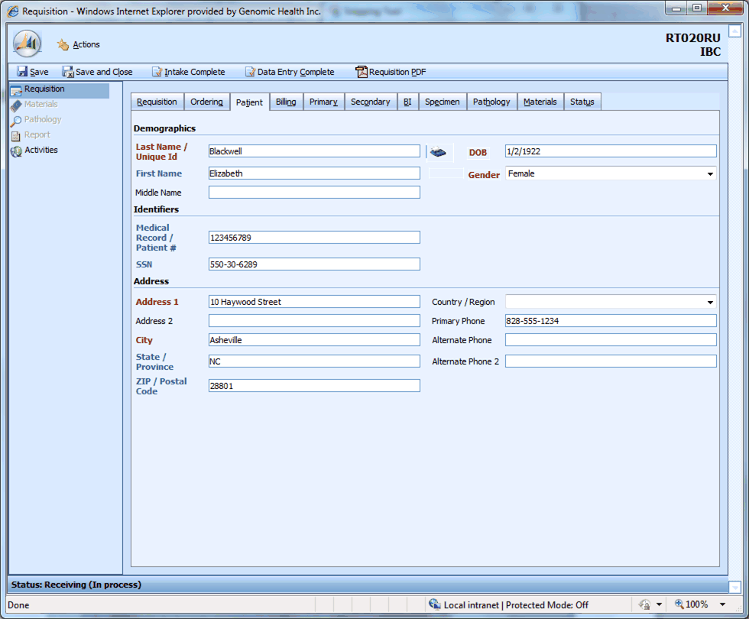

|  |  |  |  |  |  |
| --- | --- | --- | --- | --- | --- |
| **Req #** | **Field Name** | **Meaning** | **Database column** | **Data format enforced by UI** | **Data source** |
| FR-3001 | Last Name / Unique ID | Patient’s last name. If the submittor provides only a unique ID for the patient, it is entered here | tblPatient. LastName |  | Requisition form |
| FR-3002 | DOB | Patient’s date of birth | tblPatient. DOB | MM/DD/YYYY | Requisition form |
| FR-3003 | First Name | Patient’s first name | tblPatient. FirstName |  | Requisition form |
| FR-3004 | Gender | Patient’s sex | tblPatient. Gender | “Male” or “Female” | Requisition form |
| FR-3005 | Middle Name | Patient’s middle name | tblPatient. MiddleName |  | Requisition form. Note that we ask only for middle initial on the form. |
| FR-3006 | Medical Record / Patient # | A value (often numeric) that will identify the patient in the submitting physician’s medical record systems. | tblPatient. MedicalRecordNumber |  | Requisition form |
| FR-3007 | SSN | Patient’s social security number | tblPatient. SSN | xxx-xx-xxxx | Requisition form |
| FR-3008 | Address 1 | Patient’s street address | tblPatient. Address1 |  | Requisition form |
| FR-3009 | Address 2 | Second line of patient street address information. An apartment number might go here. | tblPatient. Address2 |  | Requisition form |
| FR-3010 | City | The city component of the patient’s address | tblPatient. City |  | Requisition form |
| FR-3011 | State / Province | The state or province component of the patient’s address | tblPatient. State |  | Requisition form |
| FR-3012 | ZIP / Postal Code | The postal code component of the patient’s address | tblPatient. ZIP |  | Requisition form |
| FR-3013 | Country / Region | The country component of the patient’s address | tblPatient. Country | Refer to FRM-OP-PA-03-001-F for a list of the standard country names used by Genomic Health Inc. | Requisition form |
| FR-3014 | Primary Phone | The phone at which the patient would like to be contacted | tblPatient. Phone | xxx-xxx-xxxx for US addresses only | Requisition form |
| FR-3015 | Alternate Phone | An alternate phone at which the patient can be contacted | tblPatient. Phone2 | xxx-xxx-xxxx for US addresses only | Requisition form |
| FR-3016 | Alternate Phone 2 | A second alternate phone at which the patient can be contacted | tblPatient. Phone3 | xxx-xxx-xxxx for US addresses only | Requisition form (note that this is not on v14+) |

|  |  |  |
| --- | --- | --- |
| FR-# | Icon | Action |
| FR-3017 |  | Prints a patient label |

FR-3017. The patient label has this appearance:

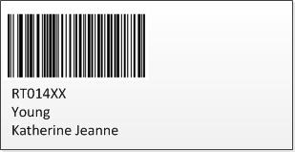

FR-3018. The first and second lines below the barcode will show the requisition number and patient last name respectively. (Note that long last names run the risk of being cut off which is acceptable to the business).

FR-3019. The last line on the label will show the patient first name followed the patient middle name (concatenated by a space).

FR-3020. First name should be trimmed to 15 characters; Middle name should be printed in the remaining space and can trail off.

FR-3021. Label will be printed with as much information as available in SARP (fields: Last Name/Unique ID, First Name and Middle Name). There will be no exception handling for, for example, missing data

FR-3022. The print icon will be always visiable and available to all users (as per the existing security and access control rules).

FR-3023. The tooltip text will be "Print a patient label".

FR-3024. Clicking on the print button prior to IC or DEC will auto-save the requisition data entered up until that point.

FR-3025. Clicking on the print button post IC or DEC will also auto-save the requisition data provided all SARP validation rules have passed. Any exceptions will neither save the requisition data or print the label. User must resolve all exceptions before attempting to reprint the label.

FR-3026. The print button will receive focus receive after the Middle Name field when traversed using the TAB key.

FR-3027-FR-3050. These requirement numbers unused.

### Billing tab

This screen not fully documented.

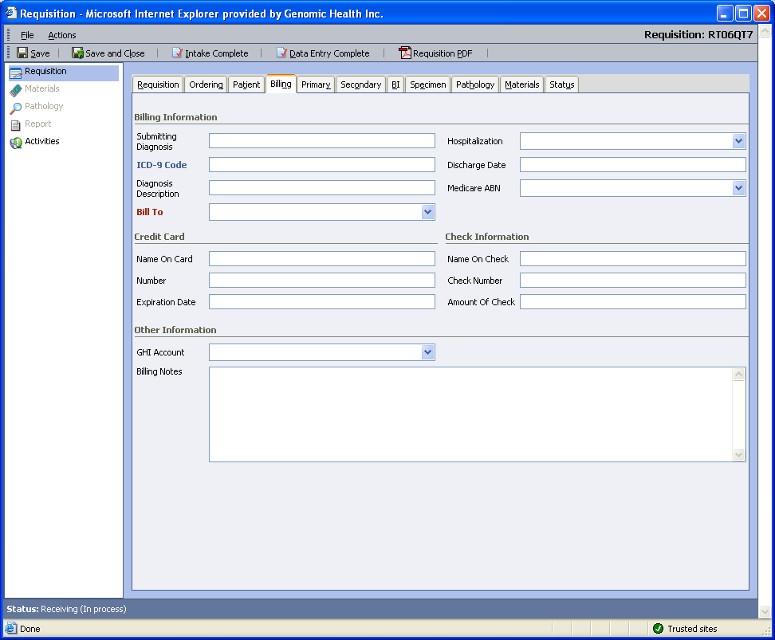

|  |  |  |  |  |
| --- | --- | --- | --- | --- |
| **Req #** | **Field Name** | **Meaning** | **Database column** | **Data source** |
|  | Submitting Diagnosis |  |  |  |
|  | Hospitalization |  |  |  |
|  | ICD-9 Code |  |  |  |
|  | Discharge Date |  |  |  |
|  | Diagnosis Description |  |  |  |
|  | Medicare ABN |  |  |  |
|  | Bill To |  |  |  |
|  | Credit Card - Name On Card |  |  |  |
|  | Credit Card – Number |  |  |  |
|  | Credit Card – Expiration Date |  |  |  |
|  | Check Information – Name On Check |  |  |  |
|  | Check Information – Check Number |  |  |  |
|  | Check Information – Amount Of Check |  |  |  |
|  | GHI Account |  |  |  |
|  | Billing Notes |  |  |  |
|  |  |  |  |  |

FR-3051. The ICD-9 code field accepts only certain codes for each specimen type.

FR-3052. Given that an ICD-9 code is not on the accepted list for the specimen type associated with the req, when the user enters that code in the field and navigates away from the field, then the following error message appears: “Diagnosis code not found: {0}” where {0} is replaced by the diagnosis code the user has entered.

FR-3053. Given that the ICD-9 code matches an accepted code for the specimen type associated with the req, when the user enters a diagnosis code and then navigates away from the field, then the Diagnosis Description box is populated with a text description of that diagnosis code.

FR-3054-3059. These requirement numbers unused.

The valid diagnosis codes and descriptions for each specimen type are as follows:

|  |  |  |  |
| --- | --- | --- | --- |
| Requirement number | Code | Description | Specimen |
| FR-3060 | 174.0 | Malignant neoplasm of female breast, Nipple and areola | Breast |
| FR-3061 | 174.1 | Malignant neoplasm of female breast, Central portion | Breast |
| FR-3062 | 174.2 | Malignant neoplasm of female breast, Upper-inner quadrant | Breast |
| FR-3063 | 174.3 | Malignant neoplasm of female breast, Lower-inner quadrant | Breast |
| FR-3064 | 174.4 | Malignant neoplasm of female breast, Upper-outer quadrant | Breast |
| FR-3065 | 174.5 | Malignant neoplasm of female breast, Lower-outer quadrant | Breast |
| FR-3066 | 174.6 | Malignant neoplasm of female breast, Axillary tail | Breast |
| FR-3067 | 174.8 | Malignant neoplasm of female breast, Other specified sites | Breast |
| FR-3068 | 174.9 | Malignant neoplasm of female breast, Other unspecified sites | Breast |
| FR-3069 | 175.0 | Malignant neoplasm of male breast, Nipple and areola | Breast |
| FR-3070 | 175.9 | Malignant neoplasm of male breast, Other unspecified sites | Breast |
| FR-3071 | 153.0 | Malignant neoplasm of colon, Hepatic flexure | Colon |
| FR-3072 | 153.1 | Malignant neoplasm of colon, Transverse colon | Colon |
| FR-3073 | 153.2 | Malignant neoplasm of colon, Descending colon | Colon |
| FR-3074 | 153.3 | Malignant neoplasm of colon, Sigmoid colon | Colon |
| FR-3075 | 153.4 | Malignant neoplasm of colon, Cecum | Colon |
| FR-3076 | 153.5 | Malignant neoplasm of colon, Appendix | Colon |
| FR-3077 | 153.6 | Malignant neoplasm of colon, Ascending colon | Colon |
| FR-3078 | 153.7 | Malignant neoplasm of colon,Splenic flexure | Colon |
| FR-3079 | 153.8 | Malignant neoplasm of colon, Other specified sites of large intestine | Colon |
| FR-3080 | 153.9 | Malignant neoplasm of colon, Colon, unspecified | Colon |
| FR-3081 | 154.0 | Malignant neoplasm of rectum, rectosigmoid junction, and anus, Rectosigmoid junction | Colon |
| FR-3082 | 154.1 | Malignant neoplasm of rectum, rectosigmoid junction, and anus, Rectum | Colon |
| FR-3083 | 154.8 | Malignant neoplasm of rectum, rectosigmoid junction, and anus, Other | Colon |
| FR-3084 | 174.0 | Malignant neoplasm of female breast, Nipple and areola | DCIS |
| FR-3085 | 174.1 | Malignant neoplasm of female breast, Central portion | DCIS |
| FR-3086 | 174.2 | Malignant neoplasm of female breast, Upper-inner quadrant | DCIS |
| FR-3087 | 174.3 | Malignant neoplasm of female breast, Lower-inner quadrant | DCIS |
| FR-3088 | 174.4 | Malignant neoplasm of female breast, Upper-outer quadrant | DCIS |
| FR-3089 | 174.5 | Malignant neoplasm of female breast, Lower-outer quadrant | DCIS |
| FR-3090 | 174.6 | Malignant neoplasm of female breast, Axillary tail | DCIS |
| FR-3091 | 174.8 | Malignant neoplasm of female breast, Other specified sites | DCIS |
| FR-3092 | 174.9 | Malignant neoplasm of female breast, Other unspecified sites | DCIS |
| FR-3093 | 175.0 | Malignant neoplasm of male breast, Nipple and areola | DCIS |
| FR-3094 | 175.9 | Malignant neoplasm of male breast, Other unspecified sites | DCIS |
| FR-3095 | 238.3 | Neoplasm of uncertain behavior of breast | DCIS |
| FR-3096 | 233.0 | Carcinoma in situ of breast | DCIS |
| FR-3097 | 232.5 | Carcinoma in situ of skin of trunk except scrotum | DCIS |

### Primary tab

This screen not fully documented.

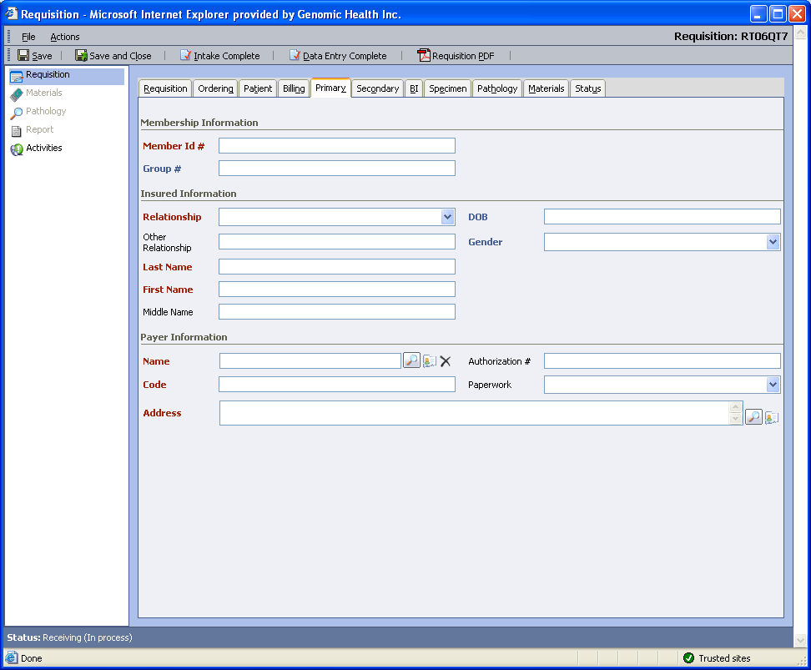

This tab represents information about the patient’s primary insurance coverage.

|  |  |  |  |  |
| --- | --- | --- | --- | --- |
| **Req #** | **Field Name** | **Meaning** | **Database column** | **Data source** |
|  | Member ID # |  |  |  |
|  | Group # |  |  |  |
|  | Relationship |  |  |  |
|  | Other Relationship |  |  |  |
|  | DOB |  |  |  |
|  | Gender |  |  |  |
|  | Last Name |  |  |  |
|  | First Name |  |  |  |
|  | Middle Name |  |  |  |
|  | Payer Name |  |  |  |
|  | Authorization # |  |  |  |
|  | Code |  |  |  |
|  | Paperwork |  |  |  |
|  | Address |  |  |  |
|  |  |  |  |  |

Note that when the payer contact is removed from the tab and the requisition is saved, all information on the tab is cleared.

### Secondary tab

This screen not fully documented.

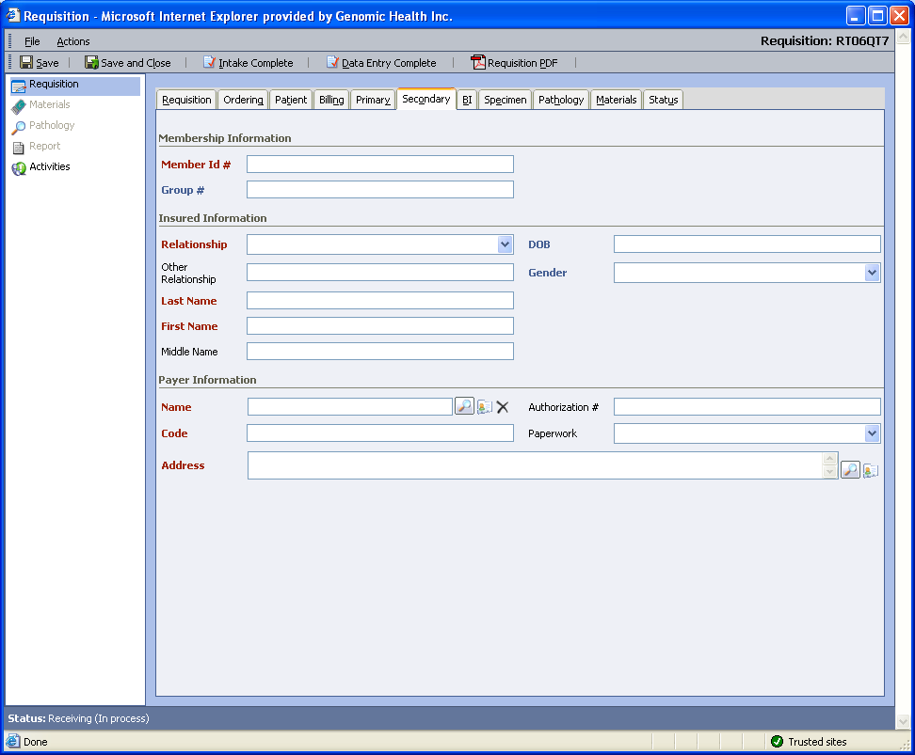

This tab represents information about the patient’s seconary insurance coverage.

|  |  |  |  |  |
| --- | --- | --- | --- | --- |
| **Req #** | **Field Name** | **Meaning** | **Database column** | **Data source** |
|  | Member ID # |  |  |  |
|  | Group # |  |  |  |
|  | Relationship |  |  |  |
|  | Other Relationship |  |  |  |
|  | DOB |  |  |  |
|  | Gender |  |  |  |
|  | Last Name |  |  |  |
|  | First Name |  |  |  |
|  | Middle Name |  |  |  |
|  | Payer Name |  |  |  |
|  | Authorization # |  |  |  |
|  | Code |  |  |  |
|  | Paperwork |  |  |  |
|  | Address |  |  |  |

### BI tab

This screen not fully documented.

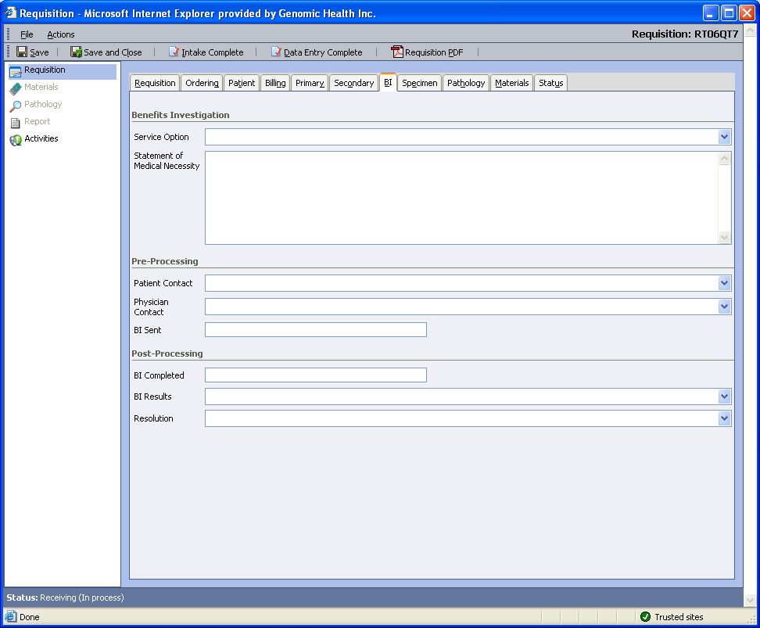

|  |  |  |  |  |
| --- | --- | --- | --- | --- |
| **Req #** | **Field Name** | **Meaning** | **Database column** | **Data source** |
|  | Service Option |  |  |  |
|  | Statement of Medical Necessity |  |  |  |
|  | Patient Contact |  |  |  |
|  | Physician Contact |  |  |  |
|  | BI Sent |  |  |  |
|  | BI Completed |  |  |  |
|  | BI Results |  |  |  |
|  | Resolution |  |  |  |

If you enter a ‘t’ in the BI Sent field, today’s date is filled in.

If you enter a ‘t’ in the BI Completed field, today’s date is filled in.

### Specimen tab

Screen shot with IBC or DCIS specimen criteria visible: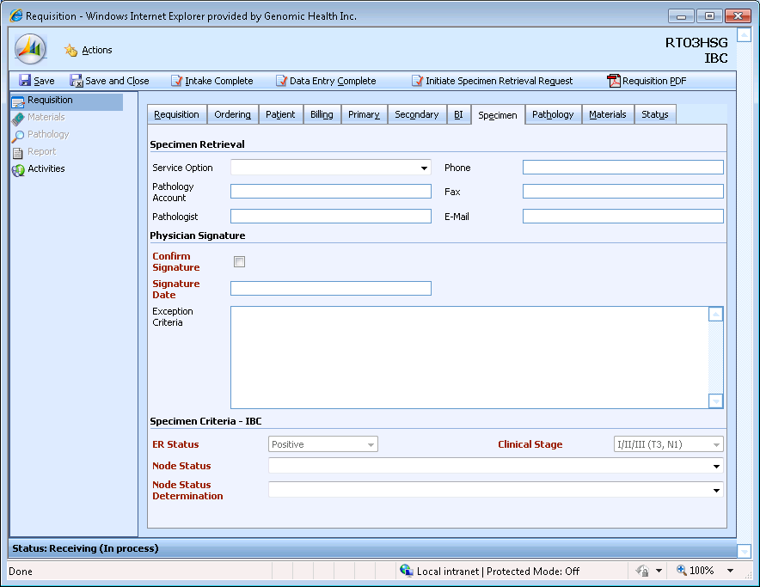

Screen shot with Colon specimen critieria visible:

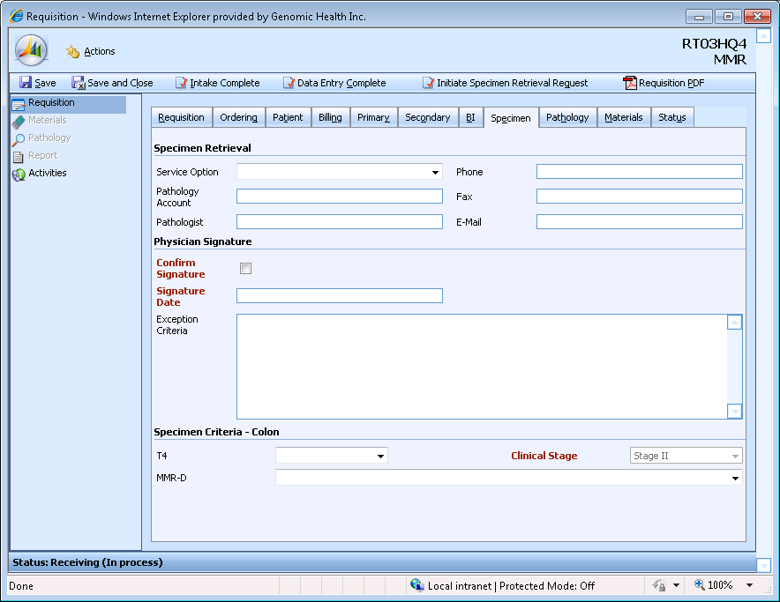

|  |  |  |  |  |
| --- | --- | --- | --- | --- |
| **Req #** | **Field Name** | **Meaning** | **Database column** | **Data source** |
| FR-501 | Service Option | Determines whether Genomic Health will contact the pathologist’s office and ask them to send us the tumor sample or whether the submitting physician will arrange for the tumor sample to be sent. | tblSpecimen..SpecimenRetrievalEnumID | Boxes numbered 1. and 2. in the Specimen Retrieval section of the req form. |
| FR-502 | Phone | The pathologist’s phone number | tblRequisitionAddress.Phone for the pathology role | Entered in the Pathology tab and read-only here. |
| FR-503 | Pathology Account | The pathologist’s CRM account | tblRequisitionEntity.EntityName for pathology / payer or account | This is selected in the Pathology tab. |
| FR-504 | Fax | The pathologist’s fax number | tblRequisitionAddress.Fax for the pathology role | Entered in the Pathology tab and read-only here. |
| FR-505 | Pathologist | The pathologist’s name | tblRequisitionEntity.EntityName for pathology / contact | Entered in the Pathology tab and read-only here. |
| FR-506 | E-Mail | A contact email for the pathologist | tblReportPrefs.EmailAddress for the Pathology role | Entered in the Pathology tab and read-only here. |
| FR-507 | Confirm Signature | A checkbox to note that a customer service rep has checked the signature on the req form | tblRequisition..SignatureVerified | The customer service rep checks this box after he or she has confirmed the signature on the req form |
| FR-508 | Signature Date | The date the physician signed the order form | tblRequisition..SignatureDate | Date in the Physician Signature & Tumor Type Confirmation section of the req form. |
| FR-509 | Exception Criteria | Free-text describing the ways in which this submission does not meet our submission criteria | tblSpecimen..ExceptionCriteria | ExceptionCriteria box in the Physician Signature & Tumor Type Confirmation section of the req form. |

FR-520. The Service Option dropdown will have the following two options: 1. Genomic Health to request specimen, 2. Physician to request specimen.

Note that the Service Option dropdown is left blank when the specimen and req form arrive together.

FR-521. If the requisition’s orderable test type is not set or is set to Unknown, no specimen criteria section will appear in the Specimen tab.

FR-529-FR-530. These requirement numbers unused.

#### Specimen Criteria Fields for Invasive Breast Cancer and DCIS

Example screen shot:

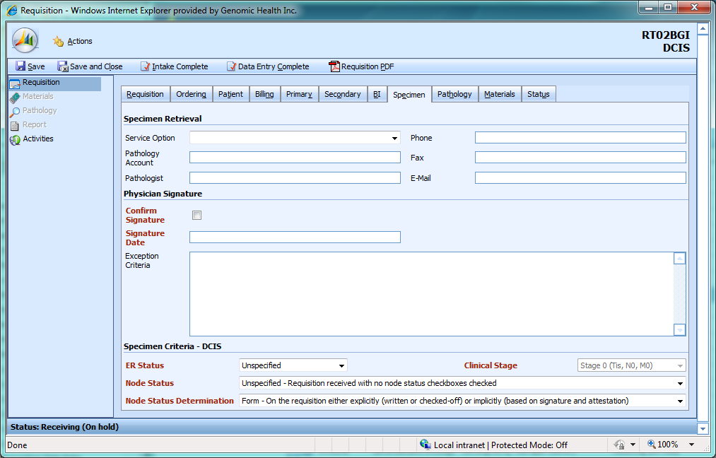

FR-522. If the requisitions’s orderable test type is Invasive Breast Cancer or DCIS, fields to capture breast specimen criteria will appear in the Specimen tab . Fields to capture colon-specific criteria will not be visible.

FR-523. When Oncotype DX Breast is ordered, the specimen criteria label will be “Specimen Critieria – IBC”.

FR-524. When Oncotype DX DCIS is ordered, the specimen criteria label will be “Specimen Critieria – DCIS”.

|  |  |  |  |  |
| --- | --- | --- | --- | --- |
| **Req #** | **Field Name** | **Meaning** | **Database column** | **Data source** |
| FR-525 | ER Status | Whether the patient’s cancer is estrogen-receptor positive or negative. We support ER Positive breast cancer. | tblSpecimen_BreastRC. ERStatus | Checkboxes on some requisition form versions; in others, may be written in the Exception Criteria field.. |
| FR-526 | Clinical Stage | The cancer’s clinical stage. For breast cancer, we support stages I, II, and III, as long as the cancer is T3 N1 or less. For DCIS, we support Stage 0 breast cancer. | tblSpecimen_BreastRC. ClinicalStageEnumID | May be written in the Exception Criteria on the req form. |
| FR-527 | Node Status | How many lymph nodes (out of 12) the cancer appeared in. We support node-negative and low node-positive breast cancer. | tblSpecimen_BreastRC. NodeStatus | Checkbox on the req form. |
| FR-528 | Node Status Determination | How the node status information was determined at GHI; from the req form, from a doctor reading a pathology report, etc. | tblSpecimen_BreastRC. NodeStatusDeterminationID | Filled in by accessioners as status is updated. |

FR-540. When data is entered in the Exception Criteria field for a breast or DCIS req, the breast/DCIS Node Status, ER Status and Clinical Stage dropdowns will become enabled if they were disabled.

##### IBC-specific specimen criteria requirements

The following requirements apply when the orderable test type is Oncotype Breast for Invasive Breast Cancer.

|  |  |  |  |  |  |
| --- | --- | --- | --- | --- | --- |
| FR-# | Field name | Values visible | Default value | Enabled or disabled if exception criteria is blank? | Form version(s) |
| FR-532 | Clinical Stage | blank, 0, I/II/III(T3, N1), III, IV, Unspecified | I/II/III(T3, N1) | Disabled | 4,9-14 |
| FR-537 | Clinical Stage | blank, 0, I/II/III(T3, N1), III, IV, Unspecified | blank | Enabled | 5-8 |
| FR-533 | Node Status | blank, Positive, Positive 1-3, Positive 4+, Negative, Micromets, Unspecified, Uncertain, Indeterminable | Negative | Disabled | 4,9 |
| FR-538 | Node Status | blank, Positive, Positive 1-3, Positive 4+, Negative, Micromets, Unspecified, Uncertain, Indeterminable | Blank | Enabled | 5-8, 10 |
| FR-534 | Node Status | blank, Positive 1-3, Positive 4+, Negative, Micromets, Unspecified, Uncertain, Indeterminable | Blank | Enabled | 11-14 |
| FR-535 | Node Status Determination | blank, Form, Phone Call, Pathology Report (clinically obtained), Pathology Report (not clinically obtained), Other / Unobtainable | Blank | Enabled | 4-14 |
| FR-531 | ER Status | blank, Positive, Negative, Unspecified, Inconclusive by IHC, Uncertain, Unknown | Positive | Disabled | 4,9-13 |
| FR-536 | ER Status | blank, Positive, Negative, Unspecified, Inconclusive by IHC, Uncertain, Unknown | Blank | Enabled | 5-8 |
| FR-539 | ER Status | blank, Positive, Negative, Unspecified, Inconclusive by IHC, Unknown | Positive | Enabled | 14 |

##### DCIS-specific specimen criteria requirements

The following requirements apply when the orderable test type is Oncotype Breast for Ductal Carcinoma In Situ.

|  |  |  |  |  |  |
| --- | --- | --- | --- | --- | --- |
| FR-# | Field name | Values visible | Default value | Enabled or disabled if exception criteria is blank? | Form version(s) |
| FR-541 | Clinical Stage | Stage 0 (Tis, N0, M0)  T1mi, N0, M0 (microinvasive)  Tis, N1, M0 | Stage 0 (Tis, N0, M0) | Disabled | 14 |
| FR-542 | Node Status | Positive 1-3, Positive 4+, Negative, Micromets, Unspecified | Unspecified | Enabled | 14 |
| FR-543 | Node Status Determination | blank, Form, Phone Call, Pathology Report (clinically obtained), Pathology Report (not clinically obtained), Other / Unobtainable | Form | Enabled | 14 |
| FR-544 | ER Status | Positive, Negative, Unspecified, Inconclusive by IHC, Unknown | Unspecified | Enabled | 14 |

FR-545-FR-549. These requirements numbers unused.

#### Specimen Criterial Fields for Colon orderables

Note that the requirements below apply to all three Colon orderables: Colon ODX, MMR/Colon Seq, and MMR alone. Example screen shot:

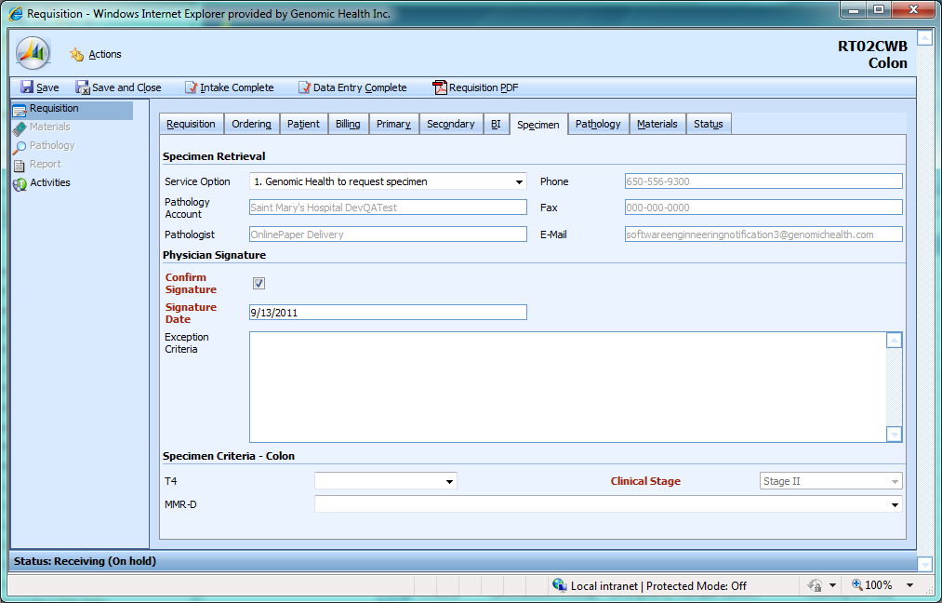

|  |  |  |  |  |
| --- | --- | --- | --- | --- |
| **Req #** | **Field Name** | **Meaning** | **Database column** | **Data source** |
| FR-550 | Clinical Stage | The cancer’s clinical stage. Typical stages are I, II, III, IV. We fully support stage II, and may run Stage III or Stage IV based on consultation with the submitting physician. | tblSpecimen_Colon.  ClinicalStageEnumID | Clinical stage information entered in the exception criteria on the req form. |
| FR-551 | MMR-D | If the patient is tested to be MMR-D, he/she has a lower likelihood of recurrence. | tblSpecimen_Colon.  MSIMMREnumID | Checkbox on req form |
| FR-552 | T4 | T4 indicates that he cancer has grown through the wall of the colon and into nearby tissues or organs | tblSpecimen_Colon.  T4EnumID | Checkbox on req form |

FR-553. This requirement number unused.

FR-554. If Oncotype DX Colon, MMR Alone or Sequential MMR / Oncotype DX Colon testing is ordered, the specimen criteria label on the specimen tab will read “Specimen Criteria – Colon”

FR-555. If Oncotype DX Colon, MMR Alone or Sequential MMR / Oncotype DX Colon testing is ordered, colon-specific specimen criteria will be visible and the breast-specific specimen criteria will be invisible.

FR-556. The colon clinical stage dropdown will have the following options: blank, Stage I, Stage II, Stage III, Stage IV, Unspecified.

FR-557. The colon clinical stage dropdown will default to Stage II and will initially be disabled.

FR-558. When data is entered in the Exception Criteria field for colon reqs, the colon clinical stage dropdown will be enabled.

FR-559. The colon MMR-D dropdown will have the following options: Yes, No, Not Set(appears as blank), Unknown. The Unknown box will be used when the submitter checks “Unknown” on the req form. “Not Set” is used to model the case where the MSH-I / MMR-D dropdown has not been entered into the database yet.

FR-560. The colon T4 dropdown will have the following options: Yes, No, Not Set (appears as blank), Unknown. The Unknown box will be used when the submitter checks “Unknown” on the req form. “Not Set” is used to model the case where the T4 dropdown has not been entered into the database yet.

FR-561. When you enter a ‘t’ into the Signature Date field, the ‘t’ is automatically replaced by today’s date in the format m/d/yyyy.

FR-562. If the signature date is older than 40 days before the current date, a warning box with the text, “Warning: The date is more than 40 days old” will appear.

### Pathology tab

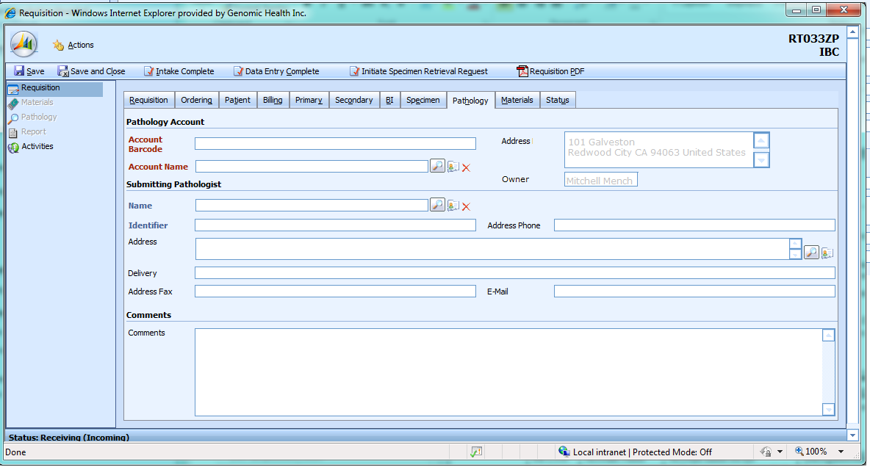



#### Pathology Account section

Note that the Address and Owner fields (FR-2107, FR-2108) are future requirements. These will be implemented in conjunction with the territory alignment release (Vandadium).

The Pathology Account section displays information from CRM about the practice account associated with the requisition.

FR-2100. When the user enters a practice barcode into the Account Barcode field, the remaining information in this section is populated.

FR-2101. When the user selects a CRM account as the pathology account using the magnifying glass icon (see FR-1502 to FR-1504), the information in this section is populated from that account.

FR-2102. When the user clicks on the red X next to the practice name, all information in this section is cleared.

FR-2103. When the user clicks on the index card icon next to the account name, the CRM account screen appears in a popup. The user is able to edit the account; if he makes changes, they are automatically reloaded in the requisition when the CRM popup is closed.

FR-2104. This requirement number unused.

|  |  |  |  |  |
| --- | --- | --- | --- | --- |
| **Req #** | **Field Name** | **Meaning** | **Database column** | **Data source** |
| FR-2105 | Account Barcode | Account barcode for the pathology account from which the specimen for this requisition was obtained | tblRequisitionEntity. EntityReferenceID | SARP (copied from CRM on requisition save) |
| FR-2106 | Account Name | Account name for the pathology account from which the specimen for this requisition was obtained | tblRequisitionEntity. EntityName | SARP (copied from CRM) |
| FR-2107 | Address | The account address, in the format:  Street 1  Street 2 (if exists)  City State Zip Country | Not copied into SARP; this is display-only information from CRM | CRM primary address for account |
| FR-2108 | Owner | The account owner from CRM. Format is developer’s choice but should include the first and last name. | Not copied into SARP; this is display-only information from CRM | CRM account owner |

#### Submitting Pathologist section

This section not documented.

#### Comments section

This section not documented.

### Materials tab

This screen not fully documented.

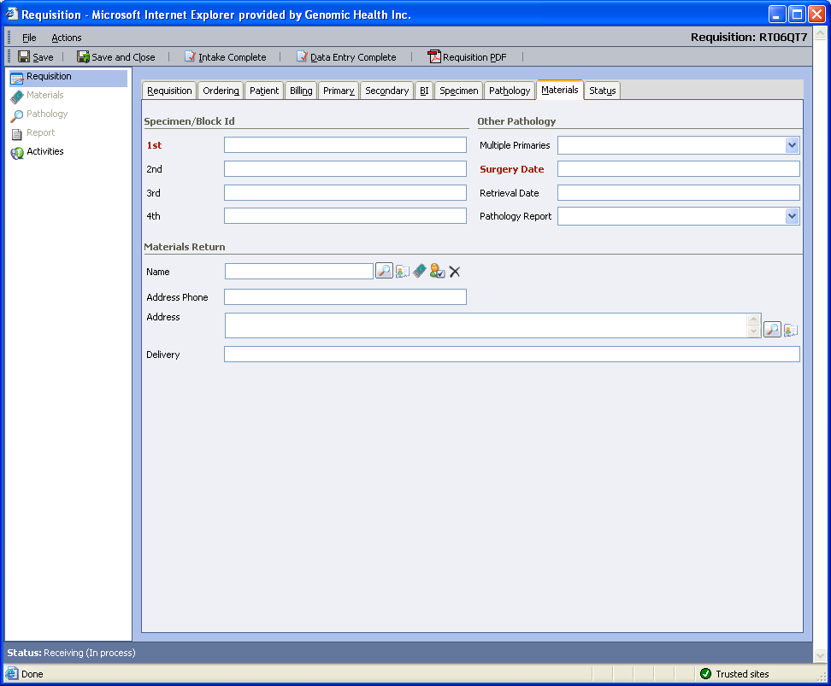

|  |  |  |  |  |
| --- | --- | --- | --- | --- |
| **Req #** | **Field Name** | **Meaning** | **Database column** | **Data source** |
|  | 1st |  |  |  |
|  | 2nd |  |  |  |
|  | 3rd |  |  |  |
|  | 4th |  |  |  |
|  | Multiple Primaries |  |  |  |
|  | Surgery Date |  |  |  |
|  | Retrieval Date |  |  |  |
|  | Pathology Report |  |  |  |
|  | Name |  |  |  |
|  | Address Phone |  |  |  |
|  | Address |  |  |  |
|  | Delivery |  |  |  |

### Status tab

This screen not fully documented.

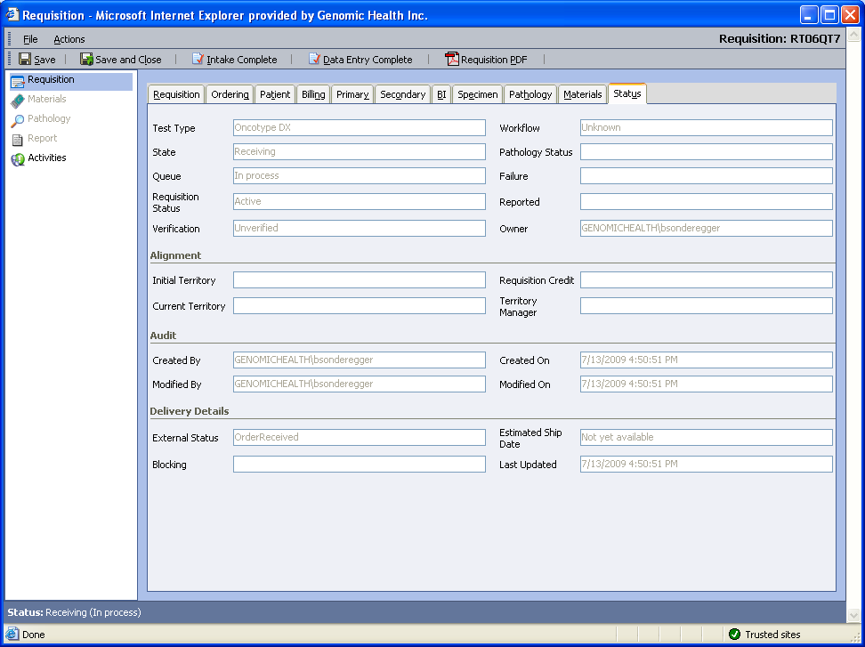

|  |  |  |  |  |
| --- | --- | --- | --- | --- |
| **Req #** | **Field Name** | **Meaning** | **Database column** | **Data source** |
|  | Test Type |  |  |  |
|  | Workflow |  |  |  |
|  | State |  |  |  |
|  | Pathology Status |  |  |  |
|  | Queue |  |  |  |
|  | Failure |  |  |  |
|  | Requisition Status |  |  |  |
|  | Reported |  |  |  |
|  | Verification |  |  |  |
|  | Owner |  |  |  |
|  | Initial Territory |  |  |  |
|  | Current Territory |  |  |  |
|  | Requisition Credit |  |  |  |
|  | Territory Manager |  |  |  |
|  | Created By |  |  |  |
|  | Created On |  |  |  |
|  | Modified By |  |  |  |
|  | Modified On |  |  |  |
|  | External Status |  |  |  |
|  | Estimated Ship Date |  |  |  |
|  | Blocking |  |  |  |
|  | Last Updated |  |  |  |

## Save behavior

FR-1101. When a requisition is saved, data is inserted or updated in tblRequisition, tblRequisitionStatus, tblRequisitionRole, tblRequisitionEntity,tblReportPrefs, tblRequisitionAddress, tblRequisitionAlignment, tblPatient, tblSpecimen, tblInsurance, tblBenefitsInvestigation, and one of tblSpecimen_BreastRC or tblSpecimen_Colon.

### tblRequisition

|  |  |  |  |  |
| --- | --- | --- | --- | --- |
| FR-# | Table | Column | Requisition tab | Field name |
| 1110 | tblRequisition | RequisitionBarcode | Requisition | Requisition Barcode  Note that this should never be updated |
| 1111 | tblRequisition | TestTypeID | Requisition | Test Type |
| 1112 | tblRequisition | AssociatedBarcode | Requisition | Associated Requisition |
| 1113 | tblRequisition | Billing Type | Billing | Bill To |
| 1114 | tblRequisition | SubmissionType | Requisition | Submission |
| 1115 | tblRequisition | SignatureVerified | Specimen | Confirm Signature |
| 1116 | tblRequisition | SignatureDate | Specimen | Signature Date |
| 1117 | tblRequisition | KitTrackingNumber | Requisition | Tracking Number |
| 1118 | tblRequisition | RequisitionNotes | Requisition | Notes |
| 1119 | tblRequisition | CreditCardNumber | Billing | Number |
| 1120 | tblRequisition | CreditCardExpiration | Billing | Expiration Date |
| 1121 | tblRequisition | CreditCardName | Billing | Name On Card |
| 1122 | tblRequisition | CheckName | Billing | Name On Check |
| 1123 | tblRequisition | CheckNumber | Billing | Check Number |
| 1124 | tblRequisition | CheckAmount | Billing | Amount Of Check |
| 1125 | tblRequisition | MedicareABN | Billing | Medicare ABN |
| 1126 | tblRequisition | ProcessingCode | Requisition | Processing / Clinical Study Code |
| 1127 | tblRequisition | BillingNotes | Billing | Billing Notes |
| 1128 | tblRequisition | WireRefNumber |  |  |
| 1129 | tblRequisition | WireAmount |  |  |
| 1130 | tblRequisition | WirePaymentStatusEnumID |  |  |

### tblPatient

|  |  |  |  |  |
| --- | --- | --- | --- | --- |
| FR-# | Table | Column | Requisition tab | Field name |
| 1131 | tblPatient | LastName | Patient | Last Name |
| 1132 | tblPatient | FirstName | Patient | First Name |
| 1133 | tblPatient | MiddleName | Patient | Middle Name |
| 1134 | tblPatient | DOB | Patient | DOB |
| 1135 | tblPatient | Gender | Patient | Gender |
| 1136 | tblPatient | MedicalRecordNumber | Patient | Medical Record / Patient # |
| 1137 | tblPatient | SSN | Patient | SSN |
| 1138 | tblPatient | Address1 | Patient | Address 1 |
| 1139 | tblPatient | Address2 | Patient | Address 2 |
| 1140 | tblPatient | City | Patient | City |
| 1141 | tblPatient | State | Patient | State |
| 1142 | tblPatient | Postal Code | Patient | ZIP / Postal Code |
| 1143 | tblPatient | Country | Patient | Country / Region |
| 1144 | tblPatient | Phone | Patient | Home Phone |
| 1145 | tblPatient | HospitalizationStatus | Billing | Hospitalization |
| 1146 | tblPatient | Phone2 | Patient | Work Phone |
| 1147 | tblPatient | Phone3 | Patient | Cell Phone |

### tblSpecimen

|  |  |  |  |  |
| --- | --- | --- | --- | --- |
| FR-# | Table | Column | Requisition tab | Field name |
| 1148 | tblSpecimen | SurgeryDate | Materials | Surgery Date |
| 1149 | tblSpecimen | SpecimenSource |  |  |
| 1150 | tblSpecimen | SpecimenNumber | Materials | 1st |
| 1151 | tblSpecimen | SpecimenNumber2 | Materials | 2nd |
| 1152 | tblSpecimen | SpecimenNumber3 | Materials | 3rd |
| 1153 | tblSpecimen | SpecimenNumber4 | Materials | 4th |
| 1154 | tblSpecimen | SubmittingDiagnosis | Billing | Submitting Diagnosis |
| 1155 | tblSpecimen | DiagnosisID (note that this is an FK to a row in tblDiagnosis uniquely identified by the ICD-9 code) | Billing | ICD-9 Code |
| 1156 | tblSpecimen | SurgeryType |  |  |
| 1157 | tblSpecimen | FixativeType |  |  |
| 1158 | tblSpecimen | FixativeOther |  |  |
| 1159 | tblSpecimen | BlockArchiveRetrievalDate | Materials | Retrieval Date |
| 1160 | tblSpecimen | HospitalDischargeDate | Billing | Discharge Date |
| 1161 | tblSpecimen | SpecimenContents |  |  |
| 1162 | tblSpecimen | ReportAttachmentEnumID | Materials | Pathology Report |
| 1163 | tblSpecimen | SpecimenRetrievalEnumID | Specimen | Service Option |
| 1164 | tblSpecimen | PrimariesEnumID | Materials | Multiple Primaries |
| 1165 | tblSpecimen | ExceptionCriteria | Specimen | Exception Criteria |
| 1166 | tblSpecimen | specimentypeenumid | Requisition | Test Type |
| 1167 | tblSpecimen | SpecimenArrivalDate | Requisition | SR Completed |
| 1168 | tblSpecimen | SpecimenRetrievalStartDate | Requisition | SR Sent |

FR-1169. This requirement has been deferred from Potassium and is now tracked in SRS 75022.

### tblInsurance

FR-1170. The information in tblInsurance populates both the Primary and Secondary tabs, which have identical fields.

FR-1171. Each tab is represented by one row in tblInsurance; a requisition can have as many as two rows in tblInsurance.

FR-1172. If the information comes from the Primary tab, it goes in a row in tblInsurance with CoverageResponsibility=1.

FR-1173. If the information comes from the Secondary tab, it goes in a row in tblInsurance with CoverageResponsibility=2.

|  |  |  |  |  |  |
| --- | --- | --- | --- | --- | --- |
| FR-# | Table | Column | Requisition tab | Description | Field name |
| 1180 | tblInsurance | PayerID | Primary / Secondary | The CRM GUID (for example, 87CB5675-1AC9-DC11-B365-005056B06E72) for the payer | Not displayed |
| 1181 | tblInsurance | PayerCode | Primary / Secondary | The CRM barcode (for example, A004D6P) for the payer | Code |
| 1182 | tblInsurance | PayerName | Primary / Secondary | The name of the insurance company, also copied from CRM. | Name |
| 1183 | tblInsurance | PayerAddressID | Primary / Secondary | The CRM GUID for the payer address. Note that one payer may have multiple addresses. | Not displayed. |
| 1184 | tblInsurance | PayerAddressName | Primary / Secondary | The address name for the payer. This is frequently (about 50% of the time) the same as the payer name | Not displayed |
| 1185 | tblInsurance | PayerAddressReferenceID | Primary / Secondary | The mailing address for the payer | Address |
| 1186 | tblInsurance | MembershipNumber | Primary / Secondary |  | Member ID # |
| 1187 | tblInsurance | GroupNumber | Primary / Secondary |  | Group # |
| 1188 | tblInsurance | AuthorizationNumber | Primary / Secondary |  | Authorization # |
| 1189 | tblInsurance | SubscriberLastName | Primary / Secondary |  | Last Name |
| 1190 | tblInsurance | SubscriberFirstName | Primary / Secondary |  | First Name |
| 1191 | tblInsurance | SubscriberMiddleName | Primary / Secondary |  | Middle Name |
| 1192 | tblInsurance | RelationshipToPatient | Primary / Secondary |  | Relationship |
| 1193 | tblInsurance | RelationshipOther | Primary / Secondary |  | Other Relationship |
| 1194 | tblInsurance | SubscriberDOB | Primary / Secondary |  | DOB |

### tblRequisitionAlignment

|  |  |  |  |  |
| --- | --- | --- | --- | --- |
| FR-# | Table | Column | Requisition tab | Field name |
| 1195 | tblRequisitionAlignment | CreditTerritoryID |  |  |
| 1196 | tblRequisitionAlignment | CreditManagerID |  |  |
| 1197 | tblRequisitionAlignment | CurrentTerritoryID |  |  |
| 1198 | tblRequisitionAlignment | CurrentManagerID |  |  |

### tbSpecimen_BreastRC

|  |  |  |  |  |
| --- | --- | --- | --- | --- |
| FR-# | Table | Column | Requisition tab | Field name |
| 1200 | tblSpecimen_BreastRC | ERStatus | Specimen | ER Status |
| 1201 | tblSpecimen_BreastRC | NodeStatus | Specimen | Node Status |
| 1202 | tblSpecimen_BreastRC | ClinicalStageEnumID | Specimen | Clinical Stage |
| 1203 | tblSpecimen_BreastRC | NodeStatusDeterminationEnumID | Specimen | Node Status Determination |

### tblSpecimen_Colon

|  |  |  |  |  |
| --- | --- | --- | --- | --- |
| FR-# | Table | Column | Requisition tab | Field name |
| 1204 | tblSpecimen_Colon | ClinicalStageEnumID | Specimen | Clinical Stage |
| 1205 | tblSpecimen_Colon | T4EnumID | Specimen | T4 |
| 1206 | tblSpecimen_Colon | MSIMMREnumID | Specimen | MSI-H or MMR-D |

### tblRequisitionRole

1210. Entries in tblRequisitionRole, tblRequisitionEntity, and tblRequisitionAddress hold information about the people, studies, and addresses (the CRM entities) associated with the requisition.

1211. Entries in tblRequisitionRole are associated with exactly one of the following six roles: Pathology, Treating, Additional Recipient, Materials Return, GHI Billing, and Study.

1212. Each entry in tblRequisitionEntity is associated with an entity type, which can be one of the following: Account or Payer, Contact, Incident or Subject, Order.

1213. Each entry in tblRequisitionAddress is associated with an address type, which can be one of the following: Bill To, Ship To, Primary, Other, Report To, Materials Return, Medicare Billing.

### tblRequisitionEntity

| FR-# | Requisition tab | Field name | Table | Column | Role | Entity Type |
| --- | --- | --- | --- | --- | --- | --- |
| 1220 | Ordering | Treating Physician.Name | tblRequisitionEntity | EntityName | Treating | Contact |
| 1221 | Ordering | Treating Physician Identifier | tblRequisitionEntity | EntityReferenceID | Treating | Contact |
| 1222 | Ordering | Practice Barcode | tblRequisitionEntity | EntityReferenceID | Treating | Account or Payer |
| 1223 | Ordering | Practice Name | tblRequisitionEntity | EntityName | Treating | Account or Payer |
| 1224 | Ordering | Additional Physician Name | tblRequisitionEntity | EntityName | Additional Recipient | Contact |
| 1225 | Ordering | Additional Physician Identifier | tblRequisitionEntity | EntityReferenceID | Additional Recipient | Contact |
| 1226 | Pathology | Account Barcode | tblRequisitionEntity | EntityReferenceID | Pathology | Account or Payer |
| 1227 | Pathology | Account Name | tblRequisitionEntity | EntityName | Pathology | Account or Payer |
| 1228 | Pathology | Name | tblRequisitionEntity | EntityName | Pathology | Contact |
| 1229 | Pathology | Identifier | tblRequisitionEntity | EntityReferenceID | Pathology | Contact |
| 1230 | Materials | Name | tblRequisitionEntity | EntityName | Materials Return | Contact |
| 1231 | Requisition | Study | tblRequisitionEntity | EntityName | Study | Account or Payer |

### tblRequisitionAddress

|  |  |  |  |  |  |  |
| --- | --- | --- | --- | --- | --- | --- |
| FR-# | Requisition tab | Field name | Table | Column | Role | Address Type |
| 1232 | Ordering | Treating Physician Address | tblRequisitionAddress | AddressLine1, AddressLine2, AddressLine3, AddressCity, AddressStateOrProvince, AddressPostalCode | Treating | Report To |
| 1233 | Ordering | Treating Physican Address Phone | tblRequisitionAddress | AddressPhone | Treating | ReportTo |
| 1234 | Ordering | Treating Physician Address Fax | tblRequisitionAddress | AddressFax | Treating | Report To |
| 1235 | Ordering | Additional Physician Address | tblRequisitionAddress | AddressLine1, AddressLine2, AddressLine3, AddressCity, AddressStateOrProvince, AddressPostalCode | Additional Recipient | Report To |
| 1236 | Ordering | Additional Physican Address Phone | tblRequisitionAddress | AddressPhone | Additional Recipient | ReportTo |
| 1237 | Ordering | Additional Physician Address Fax | tblRequisitionAddress | AddressFax | Additional Recipient | Report To |
| 1238 | Pathology | Address | tblRequisitionAddress | AddressLine1, AddressLine2, AddressLine3, AddressCity, AddressStateOrProvince, AddressPostalCode | Additional Recipient | Report To |
| 1239 | Pathology | Address Phone | tblRequisitionAddress | AddressPhone | Additional Recipient | ReportTo |
| 1240 | Pathology | Address Fax | tblRequisitionAddress | AddressFax | Additional Recipient | Report To |
| 1241 | Materials | Address | tblRequisitionAddress | AddressLine1, AddressLine2, AddressLine3, AddressCity, AddressStateOrProvince, AddressPostalCode | Materials Return | Materials Return |
| 1242 | Materials | Address Phone | tblRequisitionAddress | AddressPhone | Materials Return | Materials Return |

### tblReportPrefs

Entries in tblReportPrefs hold information about the delivery preferences of the contacts in tblRequisitionRole

|  |  |  |  |  |  |
| --- | --- | --- | --- | --- | --- |
| FR-# | Requisition tab | Field name | Table | Column | Role |
| 1243 | Pathology | Delivery | tblReportPrefs | Summarized from Portal ID, PostToPortalFlag, FaxReportFlag, NumCopies, EmailNotificationFlag  Note that these fields can be set in the Communication tab from the contact editing screen in CRM. | Pathology |
| 1244 | Pathology | E-Mail | tblReportPrefs | EMailAddress | Pathology |
| 1245 | Ordering | Treating Physician Delivery | tblReportPrefs | Summarized from Portal ID, PostToPortalFlag, FaxReportFlag, NumCopies, EmailNotificationFlag | Treating |
| 1246 | Order | Treating Physician Email | tblReportPrefs | EMailAddress | Treating |
| 1247 | Ordering | Additional Physician Delivery | tblReportPrefs | Summarized from Portal ID, PostToPortalFlag, FaxReportFlag, NumCopies, EmailNotificationFlag | Additional Recipient |
| 1248 | Ordering | Additional Physician Email | tblReportPrefs | EMailAddress | Additional Recipient |

### tblBenefitsInvestigation

|  |  |  |  |  |
| --- | --- | --- | --- | --- |
| FR-# | Table | Column | Requisition tab | Field name |
| 1250 | tblBenefitsInvestigation | ServiceOptionEnumID | BI | Service Option |
| 1251 | tblBenefitsInvestigation | StmtOfMedicalNecessity | BI | Statement of Medical Necessity |
| 1252 | tblBenefitsInvestigation | PatientContactEnumID | BI | Patient Contact |
| 1253 | tblBenefitsInvestigation | PhysicianContactEnumID | BI | Physician Contact |
| 1254 | tblBenefitsInvestigation | BIResolutionEnumID | BI | Resolution |
| 1255 | tblBenefitsInvestigation | InvestigationResultsEnumID | BI | BI Results |
| 1256 | tblBenefitsInvestigation | StartDate | BI | BI Sent |
| 1257 | tblBenefitsInvestigation | EndDate | BI | BI Completed |

FR-1260. The BI Sent, BI Completed, BI Results, and Resolution fields in tblBenefitsInvestigation are editable from the UI, but are also filled in by automated communication from Quadax, our benefits investigation provider.

## Actions menu

### Cancel Requisition

Requirements not yet documented.

### Customer Service Case

Requirements not yet documented.

### Intake Complete

The Intake Complete process finishes when sufficient information has been entered for a benefits investigation, if required.

The Intake Complete process is not always invoked; for example, for Medicare patients, more information is required than the Intake Complete validation checks for, and so accessioners only use Data Entry Complete.

FR-601. The Intake Complete process is invoked by selecting Intake Complete from the actions menu.

FR-602. The Intake Complete process performs requisition data validation; refer to SARP Requisition Validation Rules.xls for the checks that should be performed at Intake Complete.

The Intake Complete process basically follows the following flow chart:



#### Medicare 14-day rule case

The Medicare 14 day rule stipulates that a hospital (rather than a test provider like GHI) must bill Medicare for tests that are perfomed within 14 days of a patient being treated in that hospital. GHI is prohibited by law from counseling hospitals or doctors to send tests in later in order to avoid this rule; however, we do want to cancel requisitions from hospitals that have failed to pay us in the past. In addition, we would like to place outreach calls to explain our billing policy and the danger of cancellation unless we know that the hospital involved has a good payment record.

Here is a flowchart (for reference only) which describes how these cases will be created and processed:



FR-710. We need to generate cases at Intake Complete for specimens that may run into “the Medicare 14-day rule”. This case should be triggered immediately after validation rules run, before Clinical Experience cases are generated.

##### Configuration for listing studies where Medicare DOS is required

In general, we want to suppress Medicare DOS cases when a requisition is associated with a study. However, there may be certain studies that require DOS processing.

3

FR-711. The app.config file will contain a list of study accounts that need Medicare DOS cases created.

FR-712. If a requisition is associated with a study not on that list, then no Medicare DOS cases (missing data or courtesy call or cancellation) will be created for that requisition.

##### Configuration For Mapping Pathology Accounts to Call Type

We will attach campaign codes in CRM to hospital and pathology accounts to indicate their payment status. These campaign codes should dictate whether the account is should receive no call, a courtesy call to explain our billing rules, or whether requisitions from this hospital or pathology account should be cancelled. In order to ensure maxiumum policy flexibility, we would like to be able to change which codes cause which system behaviors as a configuration change rather than a code change. There may be multiple campaign codes that map to the same behavior. The default behavior, if an account has no code, is initially a courtesy call, but we may change this in the future.

In addition, we need to be able to specify different behaviors for different test types. Here is a sample app.config that would carry out the requirements below. Note that the real app.config does not need to be identical to this; this is just for explanation:

<add key=”MedicareDOS.Breast.DOSCX” value = “Cancellation Call”>

<add key=”MedicareDOS.Colon.DOSCX” value = “Cancellation Call”>

<add key=”MedicareDOS.Breast. default” value = “Courtesy Call”>

<add key=”MedicareDOS.Colon. default” value = “Courtesy Call”>

<add key=”MedicareDOS.Breast. DOSOKBREAST” value = “No Call”>

<add key=”MedicareDOS.Colon. DOSOKCOLON” value = “No Call”>

<add key=”MedicareDOS.Breast. AMBULATORY” value = “No Call”>

<add key=”MedicareDOS.Colon. AMBULATORY” value = “No Call”>

FR-715. For any given campaign code, we need to be able to specify a Medicare DOS behavior: No Call, Courtesy Call, Cancellation.

FR-716. We need to be able to specify a default behavior for accounts with no Medicare DOS campaign codes. (Note that an account might have a campaign code indicating, for example, that they have been informed about our policies for submitting male breast cancer samples, but no campaign codes that have meaning for Medicare DOS. That account should trigger the default DOS behavior.)

FR-717. If an account is tagged with a set of campaign codes that would imply multiple behaviors, then the behavior is chosen with Cancellation most preferred, then Courtesy Call, and then No Call.

FR-718. Initially, hospitals and pathology accounts that have a good colon payment record under the Medicare 14-day rule will be flagged in CRM with a the following campaign code: DOSOKCOLON. This campaign code will map to the No Call behavior.

FR-719. Initially, ambulatory surgery accounts will be flagged in CRM with the following campaign code: AMBULATORY. This campaign code will map to the No Call behavior for both breast and colon. Note that ambulatory surgery accounts are not subject to the DOS rule and therefore we can bill Medicare for requisitions whose pathology account is an ambulatory surgery account.

FR-720. Initially, hospitals and pathology accounts that have a poor payment record under the Medicare 14-day rule will be flagged in CRM with the following campaign code: DOSCX. This campaign code will map to the Cancellation behavior for both breast and colon

FR-721. Initially, hospitals and pathology accounts that have a good breast payment record under the Medicare 14-day rule will be flagged in CRM with a the following campaign code: DOSOKBREAST. This campaign code will map to the No Call behavior.

FR-722. Initially, the default behavior for accounts with no campaign code will be Courtesy Call for both breast and colon.

##### Medicare Date of Service Missing Data Case

FR-723. We need the following pieces of data in order to know whether or not to trigger a DOS case: Block Archive Retrieval Date, Surgery Date, Hospitalization Status (Inpatient, Outpatient, Non-hospital patient), Signature Date, Discharge Date (Inpatient only).

FR-724. Given that the requisition is not associated with a study (or is associated with a study on our list of Medicare DOS studies), and the Bill To value is Medicare and we are missing any of the data mentioned in FR-723, when the user presses Intake Complete, then we will open up a DOS Missing Data case

FR-725. The DOS Missing Data case will appear in a queue specified in the application configuration file. The production queue will be the Omaha Missing Data queue.

FR-726. The DOS Missing Data case’s subject will be specified in the application configuration file. The production subject will be the the CRM subject “Missing Data”.

FR-727. The DOS Missing Data case message will indicate which pieces of data from the list in FR-723 are missing.

FR-728. The DOS Missing Data case message will also contain the following text: “Please record in the requisition notes:

1. Hospital Name
2. Is this hospital flagged for DOS billing issues?”.

FR-729. The DOS Missing Data case title will be “Medicare DOS Missing Data: requisition {0}” where {0} is replaced by the requisition barcode.

FR-730. The DOS Missing Data case will be a holding case. Intake Complete cannot finish if a DOS Missing Data was created.

FR-731. If we have an existing resolved DOS Missing Data case, but we are still missing data mentioned in FR-723, we should open a new Missing Data case and not finish Intake Complete.

FR-732. The CRM contact for the Missing Data case should be the Pathology Account.

FR-733-FR-739. These requirement numbers unused.

##### Medicare Date of Service Rule

FR-740. Given that the Bill To value is Medicare, and the pathology account is a cancellation or courtesy call account, and the requisition is not associated with a study (or is associated with a study on our list of Medicare DOS studies) and the following conditions are met, we should open a Medicare DOS cancellation or courtesy call case:

If (([BlockAchieve Retrieval Date] - [Surgery Date]) < 30) {

If ([Hospital Status] = "In Patient")

{

If (([Signature Date] - [Discharge Date]) < 14)

<< Create DOS Rule Case >>

}

else if ([Hospital Status] = "Out Patient")

{

If (([Signature Date] - [Surgery Date]) < 14)

<< Create DOS Rule Case >>

}

}

Note that there is a third option for Hospitalization Status, “Non-Hospital Patient”. If this option is selected, no Medicare DOS case will be created.

FR-740a. The case will be a Medicare DOS cancellation case if the pathology account is a cancellation account. (see FR-715-FR-722)

FR-740b. The case will be a Medicare DOS courtesy call if the pathology account is a courtesy call account (see FR-715-FR-722)

##### Medicare Date Of Service Cancellation Case

FR-741. The Medicare DOS cancellation case will appear in a queue specified in the application configuration file. The production queue will be the Reimbursement Support queue.

FR-742. The CRM subject of the Medicare DOS cancellation case will be specified in the application configuration file. The production subject will be “Medicare 14-day”.

FR-743. The message text of the Medicare DOS cancellation case will be the following, “Patient falls within Medicare 14-day rule. Hospital responsible for billing Medicare. This hospital may have been flagged for reimbursement issues and cancellation of the requisition may be required.”

FR-744. The Medicare DOS cancellation case title will be “Medicare 14-day rule: requisition {0}”, where {0} is replaced by the requisition barcode.

FR-745. The Medicare DOS cancellation case will be a hold case.

FR-746. If we have an existing resolved Medicare cancellation DOS case, do not open a new one. Allow Intake Complete to proceed.

FR-747. The contact for the Medicare DOS cancellation case will be the ordering (treating) physician.

FR-748. This requirement number unused.

##### Billing Policy Courtesy Call Case

FR-749. The billing policy courtesy call case will appear in in a queue specified in the application configuration file. The production queue will be the Reimbursement Support queue.

FR-750. The CRM subject of the billing policy courtesy call case will be specified in the application configuration file. The production subject will be Medicare Billing Policy Courtesy Call (we need to create this subject).

FR-751. The message text of the billing policy courtesy call case will be:

1. “Notify account of GHI billing policies around Medicare 14-day rule.
2. Hospitalization Status: {0}
3. Hospital Discharge Date: {1}
4. Requisition Signature Date: {2}
5. Signature Date – Surgery Date: {3}”

FR-752. In the case text, {0} is replaced by the requisition hospitalization status: Inpatient or Outpatient

FR-753. In the case text, {1} is replaced by the hospital discharge date for inpatient procedures, or by the surgery date for outpatient. Date format is MM/DD/YYYY; for example, 01/31/2010.

FR-754. In the case text, {2} is replaced by the requisition signature date, in the date format MM/DD/YYYY.

FR-755. In the case text, {3} is replaced by the number of days between the signature date and the surgery date. Note that this date will be 0 if the signature date and the surgery date are the same.

FR-756. The billing policy courtesy call case title will be “Medicare 14 day billing policy: requisition {0}”. {0} should be replaced by the requisition barcode.

FR-757. The billing policy courtesy call case will be a Continue Processing case.

FR-758. If we have an existing resolved billing policy courtesy call case, do not open up a new one.

FR-759. The contact for the billing policy courtesy call case will be the requisition pathologist.

#### Clinical Experience Cases

FR-603. If the validation rules and Medicare DOS criteria pass, the Intake Complete process evaluates the requisition to see if we need to create a clinical experience case.

The following are the clinical experience case criteria:

|  |  |  |  |  |  |  |
| --- | --- | --- | --- | --- | --- | --- |
| FR-# | Field | Case type | Hold or Continue? | Value | Description for CRM case | Test Type |
| FR-614 | NodeStatus | Node | Continue | Unspecified | Determine node status {0} | Breast |
| FR-615 | NodeStatus | Node | Continue | Uncertain | Determine node status {0} | Breast |
| FR-616 | NodeStatus AND BillingType | CE | Hold | Positive AND Medicare | Medicare node-positive status | Breast |
| FR-617 | NodeStatus AND BillingType | CE | Hold | Positive4+ AND Medicare | Medicare node-positive status (4+ nodes) | Breast |
| FR-618 | ClinicalStage - Breast | CE | Hold | Stage_0 | incompatible clinical stage | Breast |
| FR-619 | ClinicalStage - Breast | CE | Hold | Stage_III | incompatible clinical stage | Breast |
| FR-620 | ClinicalStage - Breast | CE | Hold | Stage_IV | incompatible clinical stage | Breast |
| FR-621 | ClinicalStage - Colon | CE | Hold | Stage_I | incompatible clinical stage | Colon |
| FR-622 | ClinicalStage - Colon | CE | Hold | Stage_III | incompatible clinical stage | Colon |
| FR-623 | ClinicalStage - Colon | CE | Hold | Stage_IV | incompatible clinical stage | Colon |
| FR-624 | Gender | CE | Hold | Male | male patient | Breast |
| FR-625 | Exception Criteria | CE | Hold | Not blank | Exception criteria: {0} | All |
| FR-626 | ICD-9 code | CE | Hold | indicates rectal or appendiceal cancer | incompatible diagnosis | Colon |
| FR-627 | ER Status | CE | Hold | Uncertain | ER Status Uncertain | Breast |
| FR-628 | ER Status | CE | Hold | Unspecified | ER Status Unspecified | Breast |
| FR-2200 | ER Status | CE | Hold | Unknown | ER Status Unknown | Breast |
| FR-2201 | ICD-9 code | CE | Hold | 174.0-174.9, 175.0, 175.9 | incompatible diagnosis | DCIS |
| FR-2202 | ICD-9 code | CE | Hold | 232.5 | incompatible diagnosis | DCIS |
| FR-2203 | ICD-9 code | CE | Hold | 238.3 | incompatible diagnosis | DCIS |
| FR-2204 | Clinical Stage – DCIS | CE | Hold | T1mi, N0, M0 (microinvasive) | incompatible clinical stage | DCIS |
| FR-2205 | Clinical Stage – DCIS | CE | Hold | Tis, N1, M0 | incompatible clinical stage | DCIS |
| FR-2206 | NodeStatus | CE | Hold | Positive1-3 | incompatible node status | DCIS |
| FR-2207 | NodeStatus | CE | Hold | Positive4+ | incompatible node status | DCIS |
| FR-2208 | NodeStatus | CE | Hold | Micromets | incompatible node status | DCIS |
| FR-2209 | Gender | CE | Hold | Male | male patient | DCIS |

Campaign codes are associated with the treating physician who requested the test. They are used to denote that the physician has been educated about Genomic Health’s policies with respect to a specific test criteria. For example, CE-MALE means that we have already had a conversation with this physician about male breast cancer patients.

FR-629. The Gender clinical experience case for invasive breast cancer (FR-624) will be suppressed by the campaign code CE-MALE.

FR-2220. The Gender clinical experience case for DCIS (FR-2210) will be suppressed by the campaign code DCIS-Male

FR-630. If the correct campaign code has been associated with the treating physician for a req, that clinical experience case will be suppressed. For example, if a physician is associated with CE-MALE, then the Male Patient CRM case will not be generated for an invasive breast cancer requisition.

FR-631. If there are no clinical experience cases open at the end of case creation, the Intake Complete process finishes successfully. Note that this means that if a CE case has been opened manually, it must be closed (or set to Continue Processing; see FR-641) for Intake Complete to complete.

FR-632. Once all clinical experience cases are resolved, the user must re-select Intake Complete to run the Intake Complete action again.

FR-633. At Intake Complete, a single Clinical Experience case is opened to cover all triggered criteria.

FR-634. The Clinical Experience case queue is “Clinical Experience”.

FR-635. The case customer is the treating physician for the requisition.

FR-636. The case title is Clinical Experience: <specimen type> Requisition <barcode>

FR-637. If any of the criteria that have triggered the case are listed as ‘Hold’ criteria, the case is a holding case. If none of them are Hold, the case is a Continue Processing case.

FR-638. The case subject is “Clinical Experience”.

FR-639. The case description is a concatenation of all the text in the “Description for CRM Case” columns of the table above. For example, if we have a request for a male, node-positive patient, the description will be “Male patient. Node positive status.”

FR-640. Each criterion description in the case description is on its own line.

FR-641. If the user presses Intake Complete and there is an open Clinical Experience case with status set to Continue Processing, Intake Complete continues as though the clinical experience case has been previously closed.

FR-642. The ICD-9 codes that indicate rectal or appendiceal cancer are the following: 153.5, 154,0, 154.1, 154.8.

#### Requisition Receipt Activity and Intake Complete Event

FR-670. When Intake Complete finishes successfully, a Requisition Receipt activity is recorded in tblRequisitionActivity.

FR-671. When Intake Complete finishes successfully, the current date and time is recorded as the IntakeCompleted column in tblRequisitionStatus.

FR-672. When Intake Complete finishes successfully, a row is entered in tblRequisitionEvent.

FR-673. The event type for the event is 18, “Intake Complete”.

FR-674. The entry type ID for the event is 1, “Standalone”.

FR-675. The state ID for the event is 1, “Receiving”.

#### Requirements for per-state Hold Case

Clinical approval of our tests in some US states may lag approval by the rest of the US. For example, this situation often occurs with New York, which has a stronger regulatory system than other states. In order to enable product launches, we need the ability to create a case at Intake Complete to prompt Customer Service to cancel orders that originate in a specific state for products unapproved in that state. The case needs to be enabled or disabled for each orderable test type via configuration. Once we receive approval from that state, we modify the configuration parameter to allow processing of orders for these products.

FR-650. We need to generate a case at Intake Complete and Requisition Data Entry Complete for submissions for orderables / state pairs indicated via the configuration mechanism.

FR-651. This case should be a holding case

FR-652. Unfortunately, different states use different criteria to assess whether the submission rules apply to them. The rules for New York and Florida are listed below. Note that it is possible that one patient might be considered regulated by both New York and Florida per the rules below:

|  |  |  |
| --- | --- | --- |
| FR-# | Case needed in state(s) | Criteria for creating case |
| FR-652-001 | FL | The patient’s address is in the US, and has a state code of FL |
| FR-652-002 | NY | The pathology account associated with the requisition has a primary address in the US with a state code of NY. Note that this is the same business rule used to assess whether a lab director needs to approve the patient report |

FR-653. The subject of this case is “Unapproved Submission For State Regulatory Reasons”. Note that this subject should be renamed from the previous “New York Unapproved Submission”

FR-654. The title of this case is “Unapproved Submission in {0}: requisition {1}”, where {0} is replaced by the two-letter state code and {1} is replaced by the requisition barcode.

FR-655. This case appears in the Customer Service queue.

FR-656. The message on this case says the following:

“{0} submission received from {1}; unapproved for processing. Outreach required. Do not contact patient directly. Contact MD.” {0} is replaced by the short name of the orderable. {1} is replaced by the two-letter state code.

FR-657. The holding case should be able to be enabled or disabled via a configuration file parameter or database setting; we may need to turn this holding case off quickly and without a software release.

The initial settings for Commercial Mercury are below:

|  |  |  |
| --- | --- | --- |
| FR-# | Orderable Test Type | Case needed in state(s) |
| FR-658 | IBC | No case |
| FR-659 | Colon | No case |
| FR-660 | MMR Alone | FL |
| FR-661 | Colon / MMR Seq | FL |
| FR-662 | DCIS | NY |

FR-663. When the holding case appears, a warning message also appears to alert the user that a holding case has been created. The warning message text is “This requisition is for a {0} submission from the state of {1}. A holding case has been created and must be resolved in order for requisition processing to proceed." {0} is replaced by the orderable test type short name and {1} by the state name.

#### Requirements for MMR Continue Processing Case

In order to process requisitions for which MMR was ordered (MMR Alone or MMR/Colon seq requisitions), the laboratory will need an MMR case. This case will need to be created as part of the accessioning process. Intake Complete is an appropriate time to do this.

FR-680. We need to generate a case at Intake Complete for MMR Alone or MMR/Colon seq requisitions. (Note that this case should also generate at Data Entry Complete if Intake Complete was not pressed).

FR-681. This case should be a continue processing case

FR-682. The subject of this case is specified in the app.config file. The production subject will be “MMR”.

FR-683. The title of this case is “MMR: requisition {0}”, where {0} is replaced by the requisition barcode.

FR-684. This case appears in a queue specified in the app.config file. The production queue is “MMR 1: Pre-lab”.

FR-685. The message on this case is blank

FR-686. The customer on this case is the ordering physician.

FR-687. Given that there exists a case associated with this requisition and the subject MMR, when the user presses Intake Complete, a second case will generate. Note that this condition should be fairly rare; this would require the users to create a manual case.

FR-688. The creation of the MMR case should be one of the final steps in the Intake Complete process. It should not be created if a Clinical Experience or New York case is created.

FR-689. The user does not need to be notified when the MMR case is created and the case does not need to pop up.

FR-690. If the MMR case creation fails, the user should be notified but the Intake Complete process should be allowed to finish. (optional requirement)

### Data Entry Complete

FR-701. The Data Entry Complete process is invoked by selecting Data Entry Complete from the actions menu.

FR-702. The Data Entry Complete process performs requisition data validation; refer to SARP Requisition Validation Rules.xls for the checks that should be performed at Data Entry Complete.

FR-703. If the Intake Complete action has not been performed, then Intake Complete is run before the Data Entry Complete validation checks begin. All the Intake Complete actions are run except for recording the Intake Complete date in tblRequisition (FR-671) and entering the IntakeComplete row in tblRequisitionEvent (FR-672-FR-675).

FR-704. When Data Entry Complete finishes successfully, the current date and time is recorded as the DataEntryCompleted column in tblRequisitionStatus.

FR-705. When Data Entry Complete finishes successfully, the requisition state is advanced from Receiving (In Process) to Receiving (Outgoing).

FR-706. When Data Entry Complete finishes successfully, the Material tab becomes active and users are allowed to begin material accessioning.

### Exclusions Check

Requirements will be documented later.

### Requisition PDF

The Requisition PDF activity is run when an accessioner needs to generate a requisition form to send to a pathologist to request a specimen. It adds fields to a stampable PDF template to produce a PDF copy of our requisition form with information from SARP filled into the fields on the form.

Note that we need the ability to associate a specific form version with a specific test type. This is both to support staggering software and form version release, and to support the future possibility of test-specific forms.

The following screen shot of the requisition PDF will be helpful in understanding the requirements below:

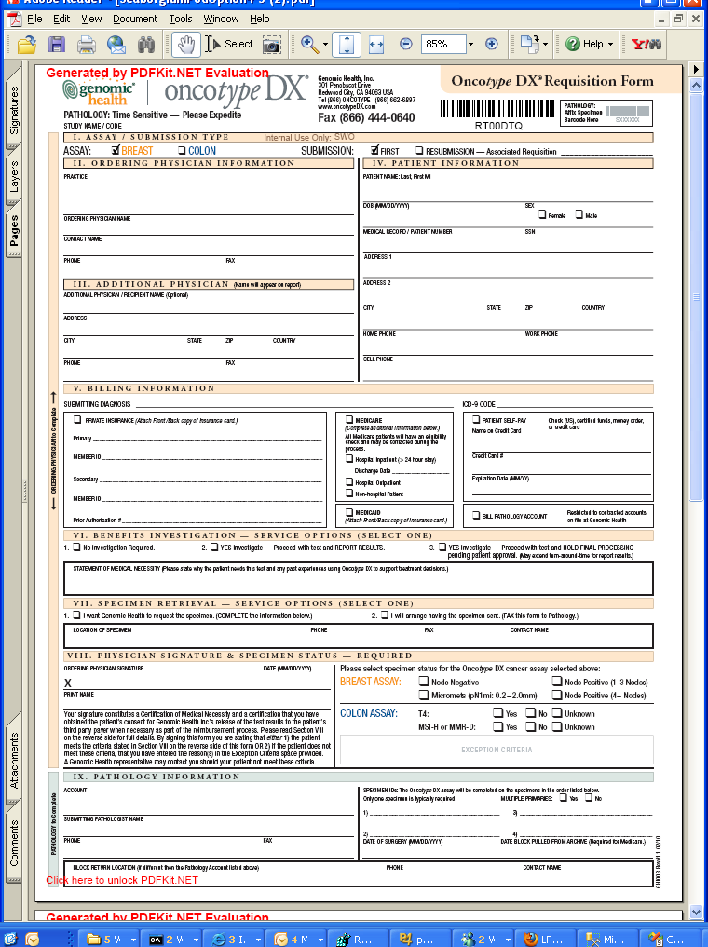

FR-901. The Requisition PDF process is invoked by selecting Requisition PDF from the actions menu.

FR-902. The Requisition PDF process produces a PDF version of the requisition in the most recent version of the req form.

FR-903. Configuration file parameters will allow a specific form version to be set for a specific orderable test type. This feature is used when we are releasing new products. During the “mock run” time period, we usually want to operate with new products on a new version of the req form, and existing products on the current version of the req form. For example, for the colon mock run, breast requisitions were stamped in version 10 and colon requisitions in version 11.

FR-904. For the Mercury release, the Breast and Colon orderables will use requisition form version 13; the MMR Alone, Colon/MMR Seq, and DCIS orderables will use version 14.

FR-905. If there exists a specific form version parameter for the test type, the stamper will use that version.

FR-906. If there is no specific form version or the test type is unset, the stamper will throw an error.

FR-907. Unused requirement number

FR-908. If there are uncommitted changes in the requisition data, the stamper should warn the user before it stamps.

See FRM-OP-IT-05-007-B, PDF Stamping Requirements for the mapping from SARP requisition data into PDF fields.











FR-1251. Unstamped fields can be edited in the resulting PDF, but changes cannot be saved or emailed. The PDF document can be printed with the edited values.

FR-1252. Stamped fields cannot be edited in the resulting PDF.

### View Original Requisition Fax

Requirements not yet documented.

### Verification Complete

Verification is a manual process of comparing the paper req form to the data entered in SARP. When verification is finished for a requisition, then the Verification Complete activity is run.

FR-801. The Verification Complete process is invoked by selecting Verification Complete from the actions menu.

FR-802. When Verification Complete finishes successfully, the current date and time is recorded as the VerificationCompleted column in tblRequisitionStatus.

FR-803. Report generation is put on hold if verification has not completed.

### Initiate Specimen Retrieval

The Specimen Retrieval process is invoked when GHI gets a requisition form that is not accompanied by a specimen. Customers can choose to request the specimen themselves or have GHI perform the specimen request from a pathology lab. This choice is documented in the Service Option dropdown on the Specimen tab. If the customer has chosen to request the specimen, a customer service representative opens a case to follow up if the specimen has not arrived within 8 days of the requisition form. If the customer has opted for GHI to retrieve the specimen, then a customer service representative sends a fax request to the pathology lab storing the specimen, and creates a case to follow up if the specimen has not arrived within 3 days of the fax.

The following flowcharts document how this process will work with the changes detailed below. Note that they are intended to give a general idea of overall flow, not to be system requirements.





#### The Initiate Specimen Retrieval Request Button

FR-1701. The Initiate Specimen Retrieval button appears in the button bar with the Data Entry Complete and Intake Complete buttons as in the screen shot below:



FR-1703. Initiate Specimen Retrieval Request appears on the Actions menu as in the screen shot below:

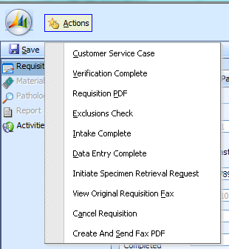

FR-1704 . The Initiate Specimen Retrieval Request item does not appear on the Actions menu or the button bar if the Initiate Specimen Retrieval process has been run previously or if the specimen has arrived at Genomic Health. The technical criteria for this requirement are in FR-1705 and FR-1706.

FR-1705. The Initiate Specimen Retrieval Request item and button are hidden if the Specimen Arrival Date (SR Received) is not null.

FR-1706. The Initiate Specimen Retrieval Request item and button are hidden if there is an open specimen retrieval case associated with the requisition.

FR-1707. The Initiate Specimen Retrieval Request item and button are hidden if the requisition test type is Unknown.

FR-1708. The Initiate Specimen Retrieval Request item and button are hidden if the requisition is cancelled.

#### Specimen Retrieval Validation

When a user presses the Initiate Specimen Retrieval button, a validation process runs. See the validation rules spreadsheet, ERD-OP-IT-05-007. The rules are listed in the spreadsheet as the SpecimenRetrieval validation rules. Note that the rules prohibit running Specimen Retrieval if the specimen retrieval option is set to blank.

FR-1711. If the requisition fails specimen retrieval validation, an error window appears.

FR-1712. The error window contains one message for each failed validation rule.

FR-1713. The user is able to copy text onto the clipboard from the error window.

FR-1714. When the user dismisses the error window, a fax is not sent, a case is not opened, and the specimen retrieval intiation date is not set. The Initiate Specimen Retrieval button remains available.

#### Specimen Retrieval Option 1, I want Genomic Health to request the specimen

FR-1720. If the requisition passes validation and the Specimen Retrieval option is “1. I want Genomic Health to request the specimen.”, then SARP initiates the process of sending a fax to the pathology account.

FR-1721. SARP will launch the Create And Send PDF tool, with the specimen retrieval option selected.

FR-1722. This requirement unused.

FR-1723. If the user selects ‘Close’ from the Create And Send PDF tool, no changes are made to the requisition.

FR-1724. If the user selects ‘Send’ from the Create And Send PDF tool, specimen retrieval proceeds: the specimen retrieval initiation date is set, a specimen retrieval case is created and a fax is queued.

FR-1725. If the user selects a non-Specimen Retrieval fax type and then selects ‘Send’ from the Create And Send PDF tool, an error message will appear and specimen retrieval will not proceed.

##### Specimen Retrieval Initiation Date

See FR-419 for the UI requirements for the SR initiation date.

FR-1730. When the specimen retrieval initiation date is set, it is set to the current day’s date.

FR-1731. Once the specimen retrieval initiation date is set, the Initiate Specimen Retrieval button is no longer visible. (Users can still send faxes and open cases, but they must use other tools).

FR-1732. When the specimen retrieval initiation date is set, SARP will add a requisition event in the event history. The event name will be ‘Specimen Retrieval Initiated’.

##### Specimen Retrieval Case

FR-1761. The subject of the specimen retrieval case is set in the application configuration file. In production, the subject should be Specimen Retrieval.

FR-1762. The case should go into the Specimen Retrieval queue for the requisition’s pod. These queues are set in the application configuration file; in production, the queue names are Specimen Retrieval (Juno), Specimen Retrieval (Gold), etc.

FR-1763. The description of the case will be the following: “Specimen retrieval fax attn: {0} to fax number {1} queued at {2}.” where {0} is the contact person to whose attention it was sent, {1} is the outbound fax number, {2} is the date and time it entered the fax queue.

FR-1764. The specimen retrieval cases are Hold cases.

FR-1765. The specimen retrieval case customer will be the pathology account on the requisition.

FR-1766. The case title will be “Specimen Retrieval by GHI (): requisition {1}” where {1} is the requisition barcode. The () provides a space for the user to enter an indication of the account timezone so that Customer Service can organize callbacks by timezone.

FR-1767. If an open specimen retrieval case already exists for this requisition, SARP will display an error message, “Automatic specimen retrieval case not generated for requisition {0} because an open specimen retrieval case already exists”. {0} is replaced by the requisition barcode. Note that in this case, the fax will still be sent and the specimen retrieval initiation date will still be set.

FR-1768. If a closed specimen retrieval case already exists for this requisition, SARP will create a new specimen retrieval case.

FR-1769. The follow-up date on the specimen retrieval case is set to the current date plus a configurable number of business days.

FR-1770. The default number of business days will be set in the application configuration file. It will initially be set to 3. Example: if today is Thursday, March 10, the follow-up date will be Tuesday, March 15.

FR-1771. If the pathology account for the requisition has the Specimen Retrieval Followup Interval property set to a number, then the follow-up date on the case is set to the current date plus that number of business days. For example, if the pathology account’s Specimen Retrieval Followup Inter val is set to 5, then the follow-up date on the case will be one week after the current date.

FR-1772. The case will pop up in the foreground.

FR-1773. If there is an error that prevents the case from opening, an error message will appear indicating why the case opening failed. The error message will be suffixed by the following text: “Please open the specimen retrieval case manually. Fax has been sent.”

#### Specimen Retrieval Option 2, I will arrange having the specimen sent

If the ordering physician has indicated that he or she will arrange for a specimen, then we do not need to send a fax. We do need to open a case to follow up with the ordering physician.

FR-1774. If the requisition passes validation and the Specimen Retrieval option is “2. I will arrange having the specimen sent.”, then SARP sets the specimen retrieval initation date as in requirements FR-1730 - FR-1732.

FR-1775. After the initiation date is set, then SARP automatically opens a specimen retrieval case.

FR-1776. The subject of the case is set in the application configuration file. In production, the subject should be Specimen Retrieval.

FR-1777. The case should go into the Specimen Retrieval queue for the requisition’s pod. These queues are set in the application configuration file; in production, the queue names are Specimen Retrieval (Juno), Specimen Retrieval (Gold), etc.

FR-1778. The case description will be “Ordering physician will arrange for specimen. Follow up with {0} at phone {1}” where {0} is the contact name or ordering physician contact name if there is no contact name and {1} is the phone number on the report to address selected with the ordering physician..

FR-1779. The case title will be “Specimen Retrieval by MD (): requisition {1}” where {1} is the requisition barcode. See FR-1766 for an explanation of the ().

FR-1780. The specimen retrieval cases are Hold cases.

FR-1781. The specimen retrieval case customer will be the ordering physician on the requisition.

FR-1782. The follow-up date on the specimen retrieval case is set to the current date plus a configurable number of business days.

FR-1783. The default number of business days will be set in the application configuration file. It will initially be set to 8. Example: if today is Monday, March 10, the follow-up date will be Wednesday, March 20.

FR-1784. This requirement number unused.

FR-1785. If an open specimen retrieval case already exists for this requisition, SARP will display an error message, “Automatic specimen retrieval case not generated for requisition {0} because an open specimen retrieval case already exists”. {0} is replaced by the requisition barcode.

FR-1786. If a closed specimen retrieval case already exists for this requisition, SARP will create a new specimen retrieval case.

FR-1787. The case will pop up in the foreground.

### Create And Send Fax

Users in Customer Service often need to send faxes to treating physicians or pathology offices in the process of preparing a requisition to be ready for work in the lab. Note that fax is considered a secure medium for transmission of patient information, which is why we use it instead of email, which is not secure unless a special secured channel has been set up between GHI and the email recipient.

This tool is designed only for domestic use, not for international.

was designed toall belowUse cases 1, 2, and 3 below are currently implemented. 4 and 5 are potential future uses of this tool.

| Fax use case # | Use case name | Description | Fax recipient | % of current requisitions | Current fax method |
| --- | --- | --- | --- | --- | --- |
| FAXUC-1 | Specimen Retrieval Request | These faxes go out to pathology labs to request that they send a specific tumor sample to Genomic Health. Right now, we send a stamped copy of the requisition form to the lab; in the future, we may create a special form containing a subset of the information on the requisition form. | Pathology office | 65% | SARP fax tool |
| FAXUC-2 | Signature Request | The requisition form has some legalese, called the attestation, that the ordering physician needs to sign to order the test. This attestation has changed between requisition form versions. When we get a requisition form with an out of date attestation (pre v9 for breast and pre v11 for colon), a Customer Service rep creates a copy of the order on the latest requisition form. She then faxes this form to the ordering physician with a cover sheet asking her to sign it and fax it back. At the moment, CS reps frequently highlight or circle the signature area to direct the physician’s attention to it. In the future, we may create a special form for these faxes, with just the necessary information to satisfy legal requirements. | Ordering physician office | 15% | SARP fax tool |
| FAXUC-3 | Order Confirmation | Users currently update a Word document with the patient’s first and last name and send the fax back to the ordering doctor’s office. Because this is so manual and time-consuming, customer service only does it now for requisitions that don’t also receive a follow-up call from Quadax (BI 1). They would like to be able to expand to doing some form of acknowledgement for every requisition except for online orders. | Ordering physician office. | 25% currently; 75% if we acknowledged every eligible requisition this way. | SARP fax tool |
| FAXUC-4 | Report faxing | We sometimes need to send a copy of the requisition report to a contact who was not one of the original requisition contacts. | Physician not on original requisition | 5% | Paper |
| FAXUC-5 | Financial assistance application (also called economic hardship) | When patients apply for financial assistance from GHI, we need the treating physician’s office to sign an additional form. We would like to automatically fill out this form with information from the requisition to make it as easy as possible for the physician. | Ordering physician office | 7% | Paper |

#### User Interface

FR-1600. The Fax Tool is triggered by selecting the “Create And Send Fax PDF” item from the Actions menu in the Requisitions window.

FR-1600a. This menu item should be available from all SARP requisition screens: Requisition, Materials, Pathology, Report, and Activities.

FR-1600b. If the Create And Send Fax PDF window is open and the user attempts to open it again from the Actions menu, the following error will appear: “A Canned Fax Tool window is already open. Please close the existing window before attempting to open the window again.”

#### UI Elements

When the user chooses Create And Send Fax from the Actions menu, a window with the following UI elements appears:

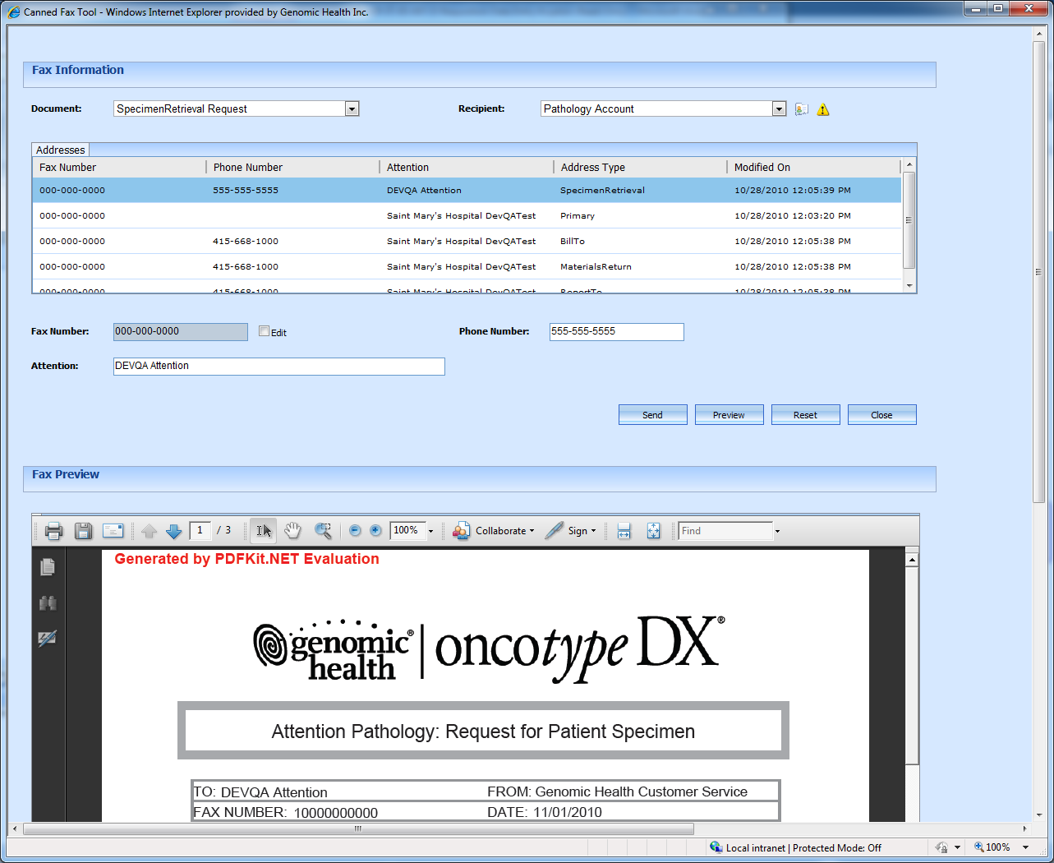

|  |  |  |  |  |
| --- | --- | --- | --- | --- |
| FR-# | Element label | Element type | Tab order | Comments |
| FR-1601 | Document | Dropdown list | 2 |  |
| FR-1602 | Attention | Text box | 8 | Editable |
| FR-1603 | Recipient | Dropdown list | 3 |  |
| FR-1604 | Fax Number | Text box | 5 |  |
| FR-1605 | Edit | Checkbox | 6 | Controls whether the Fax Number textbox is editable; see FR-1653 and FR-1654 for more details. Default is unchecked. |
| FR-1606 | Preview | Button | Cannot tab here | Populates the Fax Preview frame. |
| FR-1607 | Close | Button | Cannot tab here |  |
| FR-1608 | Reset | Button | Cannot tab here |  |
| FR-1609 | Send | Button | 1 |  |
| FR-1610 | Fax preview | iFrame | No need to tab into this frame | This frame makes a callout to Adobe Acrobat. |
| FR-1611 | Addresses | Selectable grid (no multiple selection allowed) | 4 | See FR-1630 and following for the address grid requirements. The box should be scrollable and display no more than 4 fax numbers at a time. |
| FR-1612 | Phone Number | Textbox | 7 | Editable. Note that this will appear on the coversheet but has no functional significance. |
| FR-1612a | Lookup | Clickable icon | Cannot tab here | Uses the Rolodex card icon that also appears on the Requsition Ordering and Pathology tabs.See FR-1618 for functionality. |
| FR-1612b | Alert | Icon | Cannot tab here | Only visible if the associated contact or account has an alert; see FR-1619 for functionality. |

FR-1613. The Fax preview frame is blank when the form is initially loaded.

FR-1614. This requirement has been converted to SRS 74338.

FR-1615. When the page is loaded or when the “Reset” button is pressed, focus should end up on the Send button so that the user can just press the Enter key to send the fax.

FR-1616. The user should be able to navigate this UI using the tab key to move between elements. Tab order is noted in specific UI element requirements above.

FR-1617. The dialog box should not be modal; that is, you should be able to pull up other CRM windows simultaneously. A good use case here would be to try to copy and paste information out of a case associated with the requisition into the fax tool.

FR-1618. Clicking on the Lookup icon (small picture of a Rolodex card) will launch the CRM window associated with the selected recipient (contact or account). For example, if the submitting pathologist is selected, then a CRM Contact window will appear with the pathologist information. If the pathology account is selected, a CRM Account window will appear. Note that if an alert exists on the contact or account, we expect the alert to appear when this button is pressed as well.

FR-1619. The Alert icon (picture of a yellow triangle) will be visible if and only if the contact or account indicated by the Recipient dropdown has a c360 alert on it.

FR-1620. This requirement number unused.

#### Document and Recipient dropdowns

FR-1621. The Document dropdown contains the following list of available documents to send (in this order): Specimen Retrieval Request, Signature Request, Order Confirmation

FR-1622. The initial setting for the Document dropdown will be Specimen Retrieval Request.

FR-1623. The Recipient dropdown provides the following options (in this order): blank (no selection), Pathology Account, Ordering Physician, Submitting Pathologist, Practice Account, Additional Physician

FR-1623a. The Recipient dropdown contains only the contact and account options that are available on that requisition; for example, if a requisition has only the ordering information filled in, the options that will be available are blank, Ordering Physician, Practice Account.

FR-1623b. The blank option will always be available.

FR-1624. When the setting for the Document dropdown changes, the setting for the Recipient dropdown changes as specified in FR-1625-FR-1627. Note that the Recipient dropdown can be changed by the user independently of the Document dropdown as well.

|  |  |  |
| --- | --- | --- |
| FR-# | Document dropdown value | Recipient dropdown value |
| FR-1625 | Specimen Retrieval Request | Pathology Account |
| FR-1626 | Signature Request | Ordering Physician |
| FR-1627 | Order Confirmation | Ordering Physician |

FR-1628 - FR-1629. These requirement numbers saved for additional fax types.

#### Addresses Grid

FR-1630. When the Recipient dropdown changes, CRM-stored addresses for that recipient appear in the Addresses window.

The sort order of the addresses in the addresses window is determined by a combination of the document dropdown and the Recipient dropdown, as specified below:

|  |  |  |  |
| --- | --- | --- | --- |
| FR-# | Document dropdown value | Recipient dropdown value | Sort Algorithm |
| FR-1631 | Specimen Retrieval | Pathology Account or Ordering Account | All Specimen Retrieval addresses for the account are at the top of the list, followed by the account’s Primary address. Other addresses for the account are included after the Primary address, ordered by the ModifiedOn date with the most recent date at the top of the list |
| FR-1632 | Signature Request | Pathology Account or Ordering Account | The account’s Primary address is at the top of the list. Other addresses for the account are included after the Primary address, ordered by the ModifiedOn date with the most recent date at the top of the list |
| FR-1633 | Order Confirmation | Pathology Account or Ordering Account | The account’s Primary address is at the top of the list. Other addresses for the account are included after the Primary address, ordered by the ModifiedOn date with the most recent date at the top of the list |
| FR-1634 | Any | Ordering Physician, Submitting Pathologist, or Additional Physician | The Report To: address selected in SARP is at the top of the list. No other addresses are provided as an option. |
| FR-1635 |  |  | Requirement number unused |
| FR-1636 | Any | Blank | The addresses window contains column headers but no address data. |

FR-1637-FR-1638. These requirements numbers reserved for additional address sorting requirements

FR-1639. Addresses of address type “Other” do not appear in the address window. (Our users use “Other” to deprecate addresses).

FR-1640. Only domestic addresses appear in the addresses window. Domestic addresses are determined by a SARP standard algorithm which parses the Country field of an address, matching for various forms of ‘USA’. A null or blank country is also considered a domestic address.

The addresses box has the following columns:

|  |  |  |  |
| --- | --- | --- | --- |
| FR-# | Column Name | Description | Source |
| FR-1641 | Fax Number | The number to send the fax to. | In CRM, the Fax field of the selected address. |
| FR-1641a. | Phone Number | The phone number that will appear on the fax coversheet. | In CRM, the Phone field of the selected address. |
| FR-1642 | Attention | The addressee for the fax. | In CRM, the Attention field of the selected address. If the Attention field is blank, use the Account name for accounts and Contact Full Name for contacts. |
| FR-1643 | Address Type | The CRM address type of this address. | In CRM, the Address Type field of the selected address. |
| FR-1644 | Modified On | The date that this address was last modified. | In CRM, the Last Modified date of the contact or account. |

FR-1645 – FR-1647. These requirement numbers unused.

FR-1648. When the addresses box is populated (for example, when the Recipient dropdown is changed), the first row in the box is selected.

FR-1649-FR-1650. These requirements unused.

#### Attention, Fax Number, Edit, and Phone Number

FR-1651. When a row in the addresses box is selected, the Phone Number, Attention: and Fax Number: fields are populated with the Phone Number, Attention and Fax Number values from the selected row in the grid.

FR-1652. The Attention field is always editable by the user.

FR-1653. The Fax Number field is only editable by the user if the Edit checkbox is checked.

FR-1654. When the Edit checkbox is checked, then unchecked, the value of the Fax Number field should revert to the Fax Number in the selected grid. This requirement ensures that the value of the Edit checkbox can be used to audit whether the fax number was manually edited.

FR-1654a. If the address is reselected in the address grid, the Edit box should become unchecked again.

FR-1655. The Phone Number field is always editable by the user.

FR-1656. If the Addresses box is empty (for example, when the blank recipient is selected), then the Attention, Fax Number, Edit, and Phone Number elements are blank and the user is not allowed to interact with them.

FR-1657. Fax numbers are expected to have the following format: xxx-xxx-xxxx.

FR-1658. If a user inputs a string containing 10 digits and no letters, the UI will automatically reformat the number in the format in FR-1657 (the 10 digits go in the xes in the format).

FR-1659. This requirement number unused.

FR-1659a. If SARP attempts to reformat the fax number and fails because the string contains the wrong number of digits or contains letters, the following error dialog pops up: “Warning: The entered value is not correctly formatted. Expected format is XXX-XXX-XXXX.” The invalid number remains in the fax number field.

#### Buttons

FR-1660. If the user presses Close, then she is returned to the requisition screen with no further consequences.

FR-1661. If the user chooses Reset, data from SARP and CRM is reloaded and the Document dropdown is reset to its initial selection. This should cause the other UI elements to cascade to their initial selections as well.

FR-1661a. When the user chooses Reset, the Preview window is cleared.

FR-1662. If the blank recipient is selected or if there are no addresses in the Addresses grid, the Send button is disabled.

FR-1663. If the user chooses Send, a validation routine runs to verify that the fax number has the correct format.

FR-1664 – FR-1666. These requirements unused.

FR-1667. If the user chooses Send and the fax number does not match the format in FR-1657, the following error appears: “Fax number is not correctly formatted (e.g. XXX-XXX-XXXX). Fax cannot be sent. Please select another fax number and retry.” A fax is not attempted.

FR-1668. If the fax number is in an acceptable format, a fax activity is queued to send the fax that the user previewed.

FR-1669. The fax activity will record the fax number, attention, and whether or not the fax number was manually edited (the state of the Edit checkbox) for auditing purposes.

FR-1670. After the fax activity is successfully queued, the Fax Tool window closes.

FR-1671. If changes have happened to SARP or CRM data (for example, by the user going into SARP and associating a new contact) while the Fax Tool window is open, the user must press Reset to see those changes.

FR-1672-FR-1674. These requirements unused.

FR-1675. When the user presses Preview, the SARP client generates the fax, including the coversheet, and displays it to the user.

FR-1676. The preview window should default to p.2 of the fax, the requisition form. The user will need to scroll up to see the coversheet and down to see the “back page” of the req form.

FR-1677. If the user presses Preview and the fax number does not match the format in FR-1657, the following error appears: “Fax number is not correctly formatted (e.g. XXX-XXX-XXXX). Fax cannot be previewed. Please select another fax number and retry.” The preview does not appear.

FR-1678-FR-1679. These requirements unused.

#### Preview window

FR-1680. Whenever UI elements at the top of the page are manipulated, the Preview window will go blank. This prevents the Preview window from displaying a stale coversheet.

FR-1681-FR-1699. These requirement numbers unused.

## Requisition Activity History and Events

### Requisition History

The requisition history tab displays a history of specific requisition events. These events are created throughout SARP; for example, finishing the Intake Complete process adds an Intake Completed event to the requisition history. Requirements for when events are created are documented with the activities that create the event (for example, see FR-672-FR-675).

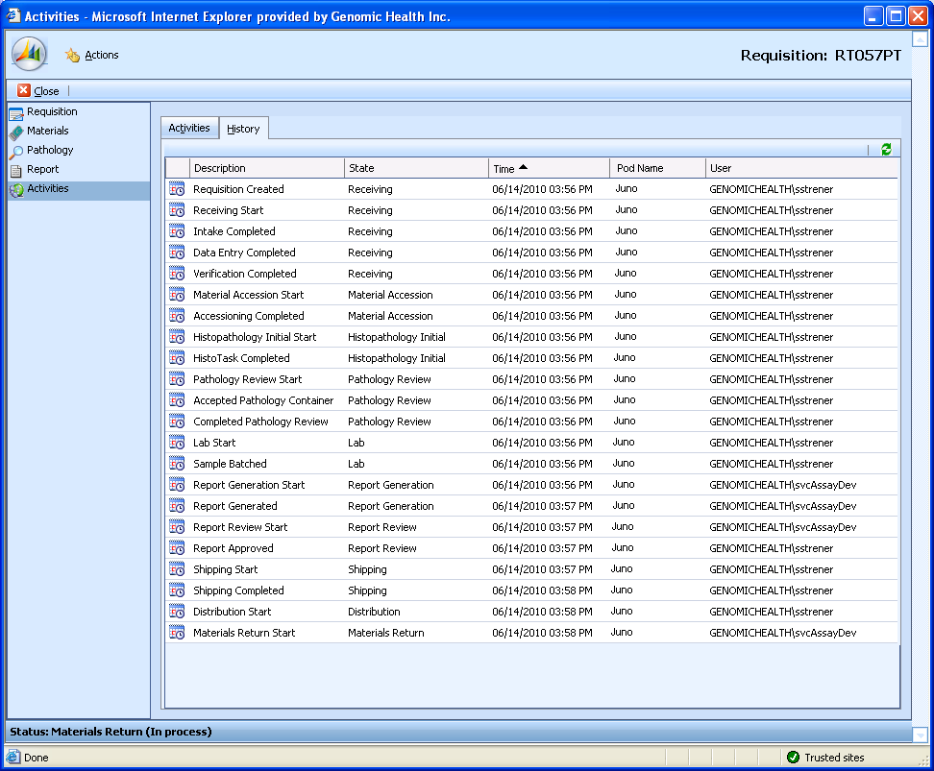

Grid fields:

|  |  |  |  |
| --- | --- | --- | --- |
| FR-# | Name | Description | Source |
| FR-1801 | Description | The event name. | tblRequisitionEvent.EventTypeID. The human-readable names come from tblEnumeration, from enumeration group 46, Requisition Event Type |
| FR-1802 | State | The state the requisition was in at the time the event was logged | tblRequisitionEvent.StateID The human-readable state names come from tblEnumeration, from enumeration group 14, Requisition State |
| FR-1803 | Time | The date and time the event was logged |  |
| FR-1804 | Pod Name | The pod the requisition was in at the time the event was logged | tblRequisitionEvent.PodId. This field is resolvable to a pod name via tblPod. |
| FR-1805 | User | The user who performed the event. |  |

### Requisition Activity List

Requisitions can spawn requests for events processed not by SARP, but by external processes such as the Billing Service or the Report Delivery Service. Examples include sending a requisition receipt to Quadax to begin the benefits investigation process for a requisition, or sending a report fax to a customer. These events are modeled as requisition activities. They are processed asynchronously, and their success or failure is logged in the Activities screen for a requisition.

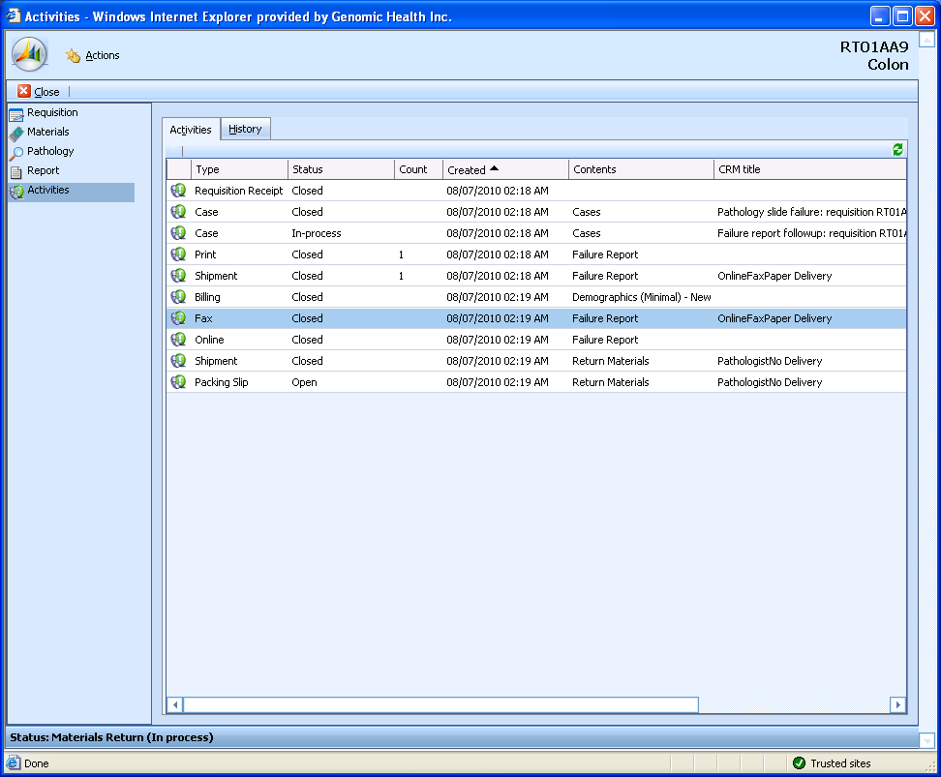

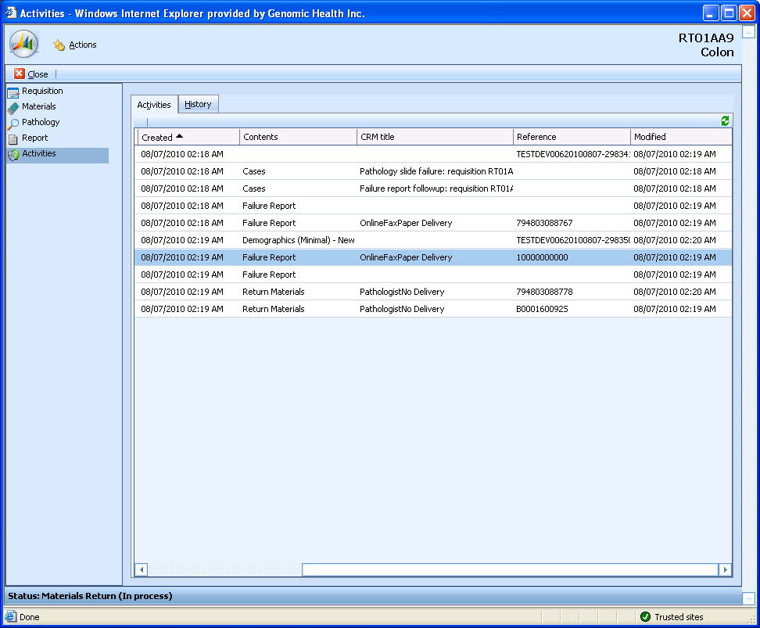

List population requirements for all activities:

| FR-# | Column name | Database source | Notes |
| --- | --- | --- | --- |
| FR-1851 | Type | tblRequisitionActivity.TypeID, resolved to human-readable text through enumeration group 17 |  |
| FR-1852 | Status | tblRequisitionActivity.Status, resolved to human-readable text through enumeration group 23 |  |
| FR-1854 | Created | tblRequisitionActivity.CreatedOn |  |
| FR-1858 | ModifiedBy | tblRequisitionActivity.ModifiedBy | The userid of the user who last updated the activity record. |
| FR-1859 | Modified | tblRequisitionActivity.ModifiedOn |  |

Population requirements for non-billing, non-fax activities:

| FR-# | Column name | Database source | Notes |
| --- | --- | --- | --- |
| FR-1853 | Count | tblRequisitionActivity.Copies | Filled in for Print, Online, Packing Slip and Shipment activities. (Note that this value may be null for Material Return shipments; that’s not ideal but liveable) |
| FR-1855 | CRM title | tblRequisitionActivity.CRMName | Human-readable name of a CRM object associated with the activity. For case activities, this is the case title; for activities that involve a contact (Shipment, Email, PackingSlip), this is the contact full name. |
| FR-1856 | Reference | tblRequisitionActivity.ReferenceID | A catchall column containing an additional identifier associated with the activity. For shipping activities, this is the Fed Ex tracking number. |
| FR-1857 | Contents |  | Structured detail information about the activity. |

Population requirements for fax activities:

| FR-# | Column name | Database source | Notes |
| --- | --- | --- | --- |
| FR-1881 | Count |  | This is blank for fax activities |
| FR-1882 | CRM title | tblFaxRequisitionActivity.FaxAttention | For fax activities from the fax tool, this is the Attention field. |
| FR-1883 | Reference | tblFaxRequisitionActivity.FaxNumber | For fax activities, this is the fax number. |
| FR-1884 | Contents |  | For faxes, this will be one of Failure Report, Result Report, Specimen Retrieval, Order Confirmation, Signature Request. |

Population requirements for billing activities:

| FR-# | Column name | Database source | Notes |
| --- | --- | --- | --- |
| FR-1885 | Count | tblHL7RequisitionActivityTestType | The number of entries in this table for this particular billing activity |
| FR-1886 | CRM title |  | This field is blank for billing activities |
| FR-1887 | Reference | tblHL7RequisitionActivity.HL7FileName | This field contains the name of the HL7 file that transmitted the message generated by this billing activity. |
| FR-1888 | Contents | tblHL7RequisitionActivityTestType, tblHL7EventType | This should be a summary of the messages transmitted for each test for this activity, in the format {Test Name}: {Message Type}. For example, for a claim for a MMR sequential test, this field would read MMR: Claim; Colon: Claim. |

FR-1870. Double-clicking on an activity in the list brings you to a detailed window about that activity. The windows are specified in section 2.6.3.

### Requisition Activity Windows

#### Fax Activity Window

##### UI

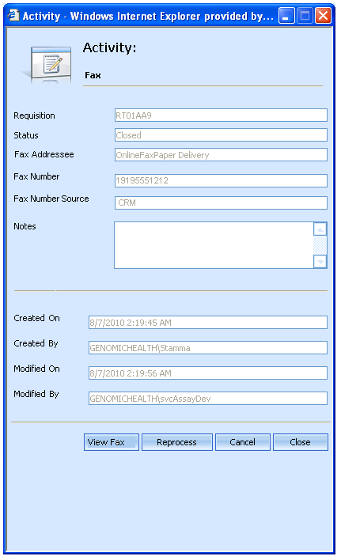

|  |  |  |  |
| --- | --- | --- | --- |
| FR-# | Column name | Database source | Notes |
| FR-1901 | Requisition | tblRequisitionActivity.requisitionID, resolved to barcode through tblRequisition |  |
| FR-1902 | Status | tblRequisitionActivity.Status, resolved to human-readable text through enumeration group 23 |  |
| FR-1903 | Fax Addressee | tblFaxRequisitionActivity.FaxAddressee | This is created by the fax tool from the attention field; for report faxes, this is the first name and last name of the contact to whom we are faxing. |
| FR-1904 | Fax Number | tblFaxRequisitionActivity.FaxNumber | The fax number we sent the fax to. Note that this is the fax number the application entered into the database table, so it may not be formatted identically to the fax numbers visible in CRM. |
| FR-1904a. | Fax Number Source | tblFaxRequisitionActivity.FaxNumberSourceID, resolved to human-readable text through enumeration group 83 | Whether we edited the fax number (“Manual”) or took it directly from CRM (“CRM”). |
| FR-1905 | Notes | tblRequisitionActivity.ActivityMessage | If the fax service throws an error processing the fax, the error will be recorded here. |
| FR-1906 | Created On | tblRequisitionActivity.CreatedOn |  |
| FR-1907 | Created By | tblRequisitionActivity.CreatedBy |  |
| FR-1908 | Modified On | tblRequisitionActivity.ModifiedOn | Note that the Modified columns usually end up being populated by the service that performs the activity. |
| FR-1909 | Modified By | tblRequisitionActivity.ModifiedBy |  |

##### Buttons

FR-1921. The Cancel button will cancel the fax activity. The activity will be marked “Cancelled” in the database and the fax will not be sent.

FR-1922. When a user presses the Cancel button, an additional window pops up to capture the cancellation reason.

FR-1923. If the fax activity has been cancelled previously, the Cancel and Reprocess buttons will not be available.

FR-1924. The Close button will close the window without affecting the activity.

FR-1925- FR-1926. These requirements not used.

FR-1927. When a user presses the Reprocess button, the fax activity will be requeued. The report delivery service will reattempt to process the fax, using the same contact name and fax number as the original fax. (Note that this is a change in functionality from earlier releases; in the past, the report delivery service would requery the base CRM object for the contact name and fax number).

FR-1928. When the user presses the View Fax button, the sent fax appears in an Adobe Acrobat window. If we have sent multiple faxes (for example, if we have sent multiple reports), the item that appears is the fax that was sent by this activity, not the item that was sent the most recently.

FR-1929. If the sent fax was a report fax, it will appear in View Fax without a coversheet; all other faxes will appear with a coversheet.

FR-1930. This requirement not used.

The Reprocess button is available only under certain circumstances:

|  |  |  |  |
| --- | --- | --- | --- |
| FR-# | Condition | Availability | Comments |
| FR-1931 | Fax status is not “Closed” or “Error” | No. |  |
| FR-1932 | Fax originated from the Fax Tool | No. |  |
| FR-1933 | Fax is for a report that is not the lastest report | No. | For example, the fax activity is for sending the original copy of a report when an amended/ corrected report exists |
| FR-1934 | Requisition is in a state prior to Distribution (Report Review or earlier) | No. |  |
| FR-1935 | Fax status is “Closed” or “Error” and fax is for the latest report for a requisition in Distribution or later | Yes. |  |

#### Billing Activity Windows

##### UI

The screen shot below describes the UI that appears when you double-click on a billing activity:

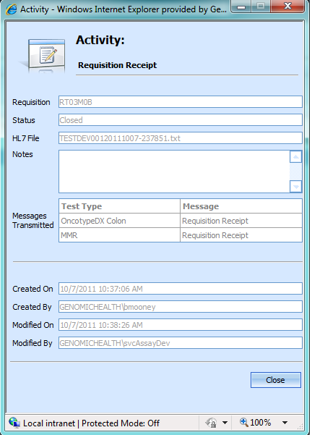

|  |  |  |  |
| --- | --- | --- | --- |
| FR-# | Column name | Database source | Notes |
| FR-2301 | Requisition | tblRequisitionActivity.requisitionID, resolved to barcode through tblRequisition |  |
| FR-2302 | Status | tblRequisitionActivity.Status, resolved to human-readable text through enumeration group 23 |  |
| FR-2303 | HL7 File | tblHL7RequisitionActivity.HL7FileName | This field should not be populated unless the activity status is Closed. |
| FR-2304 | Notes | tblRequisitionActivity.ActivityMessage |  |
| FR-2305 | Messages Transmitted |  | Note: one entry in table per entry in tblHL7RequisitionActivityTestType |
| FR-2306 | Messages Transmitted: Test Type | tblHL7RequisitionActivityTestType. TestTypeEnumID, resolved to human-readable text through tblTestTypeEnum.Name |  |
| FR-2307 | Messages Transmitted: Message | tblHL7RequisitionActivityTestType. HL7EventTypeID, resolved to human-readable text through tblHL7EventType. HL7EventName |  |
| FR-2308 | Created On | tblRequisitionActivity.CreatedOn |  |
| FR-2309 | Created By | tblRequisitionActivity.CreatedBy |  |
| FR-2310 | Modified On | tblRequisitionActivity.ModifiedOn | Note that the Modified columns usually end up being populated by the service that performs the activity. |
| FR-2311 | Modified By | tblRequisitionActivity.ModifiedBy |  |

##### Buttons

FR-2320. The Close button will close the activity window.

FR-2321. If the activity status is Error, a Cancel button and a Reprocess button will appear.

FR-2322. When a user clicks the cancel button, a dialog box appears. The user is prompted to enter a free-text cancellation reason.

FR-2323. When the user has finished entering the cancellation reason and presses OK, the activity in the database is cancelled.

FR-2324. If the user clicks the Reprocess button, the activity status is reset to Open. The activity will be tried again at the next billing cycle.

## Reporting requirements

# Use Cases

## Standard Operating Procedures

## Workflow

Requirements not yet documented.

## Reporting

Requirements not yet documented.

## Administration

Requirements not yet documented.

# Process Requirements

## Standard Operating Procedures

Requirements not yet documented.

## Workflow



## Reporting

Requirements not yet documented.

## Administration

Requirements not yet documented.