

**Genomic Health**

.  
.  
.  
.  
.  
..  
.  
.  
.

Business Requirements for MMR Accessioning Processes

Document Number: BRS-OP-PA-05-007-D

Revision Number: 1.0

Effective Date: 18-May-2010

Author: Kaylen Jacobson

**The following reviewers have approved this document.**

**See DCO for signatures and approval date**

|  |
| --- |
| **Name and Department** |
| **Kaylen Jacobson**  **AUTHOR, COMMERCIAL OPERATIONS** **PLANNING** |
| **Stephanie Butler**  **COMMERCIAL OPERATIONS PLANNING & REGULATORY (CLIA)** |
| **Leslie Marquez**  **CUSTOMER SERVICE & ACCESSIONING** |
| **Denise Hahn**  **ACCESSIONING** |
| **Betsy Mooney**  **SOFTWARE ENGINEERING** |
| **Robert Gupta**  **SOFTWARE ENGINEERING** |
| **Julie Ballard, CLS or Rory O’Brien, CLS**  **CLINICAL LABORATORY QA** |
| **Patrick Joseph, M.D.**  **CLINICAL LABORATORY DIRECTOR** |
| **DCO-BRS-OP-PA-05-007-D-1** |

**TABLE OF CONTENTS**

1 Introduction 4

1.1 Document Objectives & Scope 4

1.2 Revision History 4

1.3 Related Documents 4

1.4 Styles Used in This Document 4

1.5 SARP UI Modifications Review 5

1.5.1 Display SARP test types 5

1.5.2 Requisition Data Entry 6

1.5.2.1 New Requisition Tab change table 6

1.5.3 Requisition Review Tab 7

1.5.4 Ordering Tab 8

1.5.4.1 Ordering Tab Change Table 8

1.5.5 Patient Tab 9

1.5.5.1 Patient Tab Change Table 9

1.5.6 Billing Tab 10

1.5.6.1 Billing Tab Change Table 10

1.5.7 Primary Tab 10

1.5.7.1 Primary Tab No Change 10

1.5.8 Secondary Tab 11

1.5.8.1 Secondary Tab No Change 11

1.5.9 BI Tab 11

1.5.9.1 BI Tab Change Table 12

1.5.10 Specimen Tab 12

1.5.10.1 Specimen Tab Change Table 13

1.5.11 Pathology Tab 13

1.5.11.1 Pathology No Change 13

1.5.12 Materials Tab 14

1.5.12.1 Materials Tab Change Table. 14

1.6 Status Tab 14

1.7 Status Tab Change Table 15

2 managing specimens and continers 15

2.1 Specimen Labeling 15

2.1.1 New label convention to support Orderable Test Types in SARP. 15

2.1.2 Labels currently display “CO1” or “BR1” to enhance QC for accessioning, histopathology. 15

2.1.2.1 Add new label convention to support test type specific processing. 15

2.2 Label Naming Convention for Specimen Barcodes 15

2.3 Container Management 15

2.3.1 No Change. Histology requested to add container to accessioning process for specimen type specific collection. 15

3 ESD Estimated Ship date 15

3.1 Estimated Ship Date 16

3.1.1 New ESD Models 16

3.1.1.1 Required for Mercury 16

3.1.2 New Model Requirements for MMR and Sequential Testing ESD: 16

3.1.2.1 MMR Alone Model 16

NEW - Sequential Testing MMR/ODX 16

3.1.2.2 16

3.1.3 BI Report Impact: 16

3.1.3.1 The data must be updated per the Business Intelligence Department. 16

3.1.4 Portal ESD Impact 16

3.1.4.1 Testing is required to ensure that the ESDs are coming through portal accurately. 16

4 Managing Sequential testing failures 16

4.1 MMR Path failures 16

5 Other requirements 16

5.1 Standard Operating Procedures 17

5.2 Training 17

5.3 User Testing and User Acceptance Testing 17

# Introduction

This document contains the content for the Genomic Health, Inc. accessioning business requirements to support the MMR launch. In October 2011, Genomic Health will begin offering mismatch repair (MMR) testing by immunohistochemistry (IHC). This test will be offered independently (MMR Alone), or in conjunction with the Oncotype DX Colon Cancer Assay if the patient is found to be MMR-Proficient (MMR/ODX Sequential testing). In order to support the new test type options, the accessioning system must be equipped to capture this information. In addition to this, changes have been made to the requisition form which also requires modifications to the interface. Some changes requested may be deferred to a future release.

This document also defines one change that will be made to the existing Oncotype DX Colon Cancer Assay which may be deffered to a future release and is not gating:

* Include support for Clinical Experience case generation for Colon Multiple Primaries.

## Document Objectives & Scope

The objective of this document is to define requirements of the Accessioning Requisition Processing workflow and related SARP (Sample Accessioning and Requisition Processing) requirements. Changes have been defined based on the requirements to support the new orderable test type options, and specimen criteria. Requirements for Requisition version 14 have also been included. Reference BRS-OP-PA-05-007-A *Business Requirements for MMR Requisition Version 14*.

The intended audience for this document includes Accessioning, Customer Support Software Engineering, Software Quality Assurance, Commercial Operations, Regulatory, and all project team members.

This document does not describe any engineering or project management details.

## Revision History

| **Name** | **Change Description** | **Date** | **Version** |
| --- | --- | --- | --- |
| K. Jacobson | Initial Version. Mercury Release. | 18-May-2010 | 1.0 |

## Related Documents

|  |  |
| --- | --- |
| **Document Number** | **Document Name** |
| BRS-OP-PA-05-007-B | Business Requirements for MMR Histology Processes |
| BRS-OP-PA-05-007-D | Business Requirements for MMR Requisition Version 14 |
| ERD-OP-IT-05-007-D | Requirements specification for SARP Requisition Data Entry |
| SOP-OP-PA-03-001 | Requisition Processing |
| SOP-OP-PA-03-018 | Managing Specimen Clinical Requirements for the Oncotype DX Breast Cancer Assay |

## Styles Used in This Document

The following styles are used in this document:

* Screen shots of the current SARP interface to describe content
* Explanatory tables and text to provide more information about the content requirements.

**General UI content requirements**

|  |  |  |
| --- | --- | --- |
| **CONTENT**  **OWNERS** | **Department** | **Responsible Person** |
| Commercial Operations | Kaylen Jacobson |
| Accessioning | Denise Hahn |
| Software Engineering | Betsy Mooney |
| **PURPOSE** | To support the launch of the MMR worldwide | |

## SARP UI Modifications Review

### Display SARP test types

The following test type options will be supported:

|  |  |
| --- | --- |
| BRS-# | Test Type Options |
| BRS-100 | Breast |
| BRS-101 | Colon |
| BRS-102 | MMR/Colon Seq |
| BRS-103 | MMR |

BRS-104. Use options listed in table above for test type selection

Note: Display all test type options for user to select at New Requisition Data Entry. When Test type has been locked down, display only the selected test type name in the New Requisition screen and Requisition Tab.

BRS-105. Allow user to make changes to the test type any time prior to selecting Intake Complete.

### Requisition Data Entry

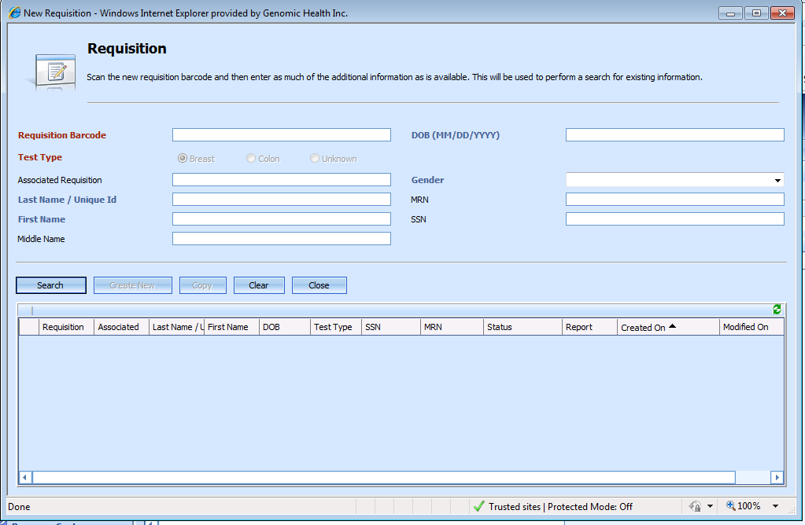

#### New Requisition Tab change table

| Information displayed in the table below details the current test types available, and specifications for new test type selections.**BRS #** | **Field** | **Specification** | **Implementation** |
| --- | --- | --- | --- |
| BRS-110 | Colon | MMR, Colon, MMR/Colon Seq | Required for Mercury |

BRS-111. The user can select only one test type.

BRS-112. An Unknown selection is provided.

BRS-113. If the user needs to change the test type, the current system model will remain consistent.

BRS-114. A user is notified through a warning when changing the test type that the specimen criteria will be reset. This warning will be removed for Mercury.

BRS-115. When a user selects the test type, the other selections will be hidden so that the selected test type stands alone.

BRS-116. For requisitions version 10, the default test type will be set to breast. For all versions 11+, there will be no default test type set.

### Requisition Review Tab

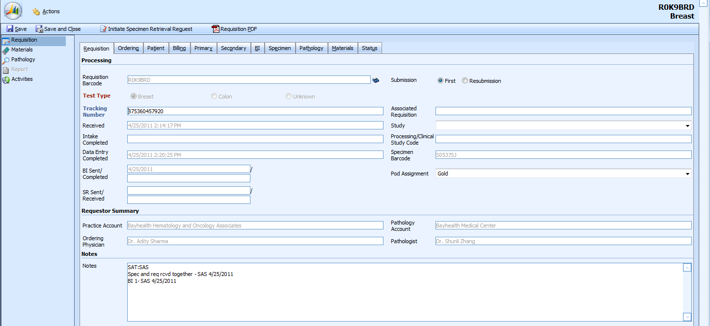

BRS-120. Test type display and behavior is the same as indicated in Section 2.1.2.1.

BRS-122. Test type selected is displayed in upper right hand corner of SARP UI.

BRS-123. Color display for test type Colon / Breast and applicable ordering types associated is highly preferred.

Note: The current color scheme for breast (orange) and colon (blue) is recommended.

### Ordering Tab

#### 

#### Ordering Tab Change Table

| **BRS #** | **Field** | **Specification** | **Implementation** |
| --- | --- | --- | --- |
| BRS-130 | Contact Phone | New Feature displayed next to the Contact Name | Not Required for Mercury |

BRS-131. Contact phone may be considered for a future release. The information will be maintained in the MD Report To information.

### Patient Tab

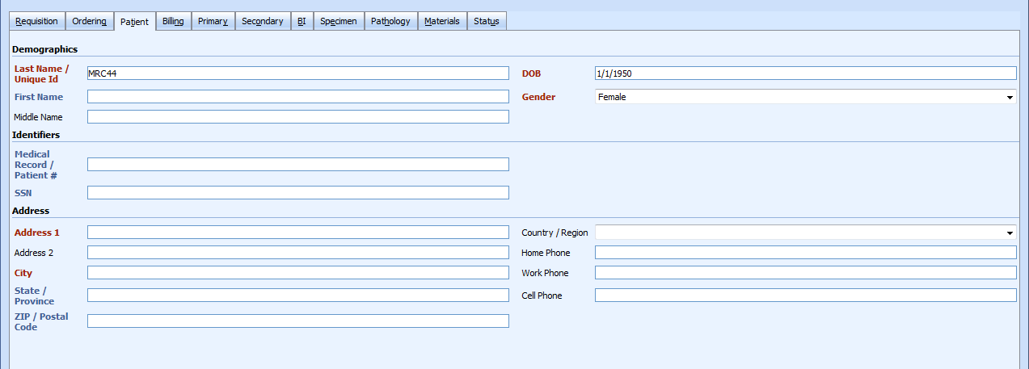

#### Patient Tab Change Table

| **BRS #** | **Field** | **Specification** | **Implementation** |
| --- | --- | --- | --- |
| BRS-140 | Home Phone | Rename to Primary Phone | Required for Mercury |
| BRS-141 | Work Phone | Rename to Alternate Phone | Required for Mercury |
| BRS-142 | Cell Phone | Rename to Alternate Phone 2 | Required for Mercury |
| BRS-143 | Hospitalization | Move from Billing Tab to Patient Tab | Low Priority- Ergo Project |
| BRS-144 | Discharge Date | Move from Billing Tab to Patient Tab | Low Priority-Ergo Project |
| BRS-145 | Multiple Primaries | Move from Materials Tab to Patient Tab | Low Priority-Ergo Project |

BRS-146. For all Colon test type submissions, if Multiple Materials is marked “YES”, a clinical experience case must generate.

Note: The volume of this occurrence is minimal. This process is being managed manually and quality controlled through the verification processes in place in accessioning. Should this feature need to be differed to a future release, this is not gating.

BRS-147. Alternate Phone 2 is included to accommodate older versions of the requisition form where 3 phone numbers are provided.

### Billing Tab

#### Billing Tab Change Table

|  |  |  |  |
| --- | --- | --- | --- |
| **BRS #** | **Field** | **Specification** | **Implementation** |
| BRS-160 | Hospitalization | Move to Patient Tab | Low Priority-Ergo Project |
| BRS-161 | Discharge Date | Move to Patient Tab | Low Priority-Ergo Project |

### Primary Tab

#### Primary Tab No Change

### Secondary Tab

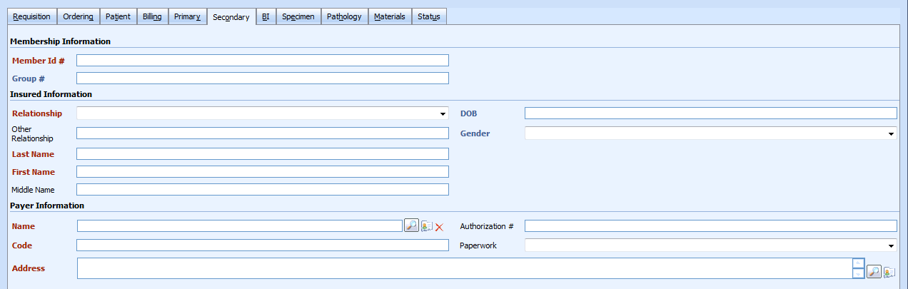

#### Secondary Tab No Change

### BI Tab

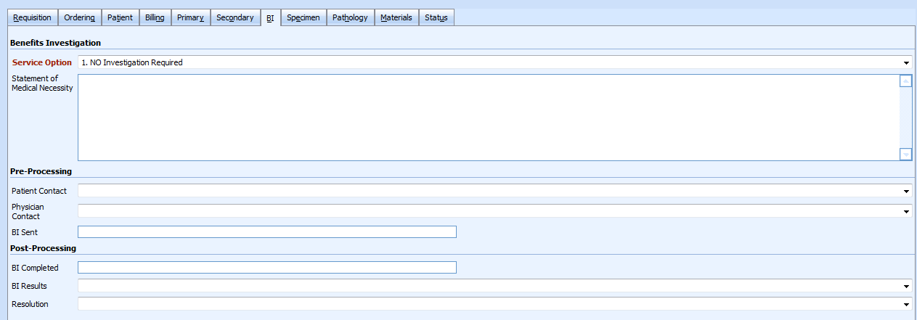

#### BI Tab Change Table

|  |  |  |  |
| --- | --- | --- | --- |
| **BRS #** | **Field** | **Specification** | **Implementation** |
| BRS-170 | Service Option | Rename 1. Investigation not required | Low Priority-Ergo Project |
| BRS-171 | Service Option | Rename 2. Investigate- Proceed with test and REPORT RESULTS | Low Priority-Ergo Project |
| BRS-172 | Service Option | Rename 3. Investigate- Proceed with test and HOLD FINAL PROCESSING pending patient approval | Low Priority-Ergo Project |
| BRS-173 | Patient Contact | Grey out and pull out of tab | Low Priority-Ergo Project |
| BRS-174 | Physician Contact | Grey out and pull out of tab | Low Priority-Ergo Project |

BRS-175. Benefits Investigation is not required for MMR Alone. In the future, when MMR is selected, the service option should default to 1. Investigation notrRequired.

Note: Patient and Physician Contact fields support requisition versions 5-8, which have been pulled from circulation and are not necessary.

### Specimen Tab

### 

#### Specimen Tab Change Table

|  |  |  |  |
| --- | --- | --- | --- |
| **BRS #** | **Field** | **Specification** | **Implementation** |
| BRS-180 | Service Option | Rename 1. Genomic Health to request specimen from Pathology | Low Priority-Ergo Project |
| BRS-181 | Service Option | Rename 2. Ordering Physician to request specimen from Pathology | Low Priority-Ergo Project |
| BRS-182 | ER Status Option: Unspecified | Rename: Unknown | Required for Mercury |
| BRS-183 | ER Status Option: Uncertain | Rename: Inconclusive by IHC | Required for Mercury |

BRS-184. For version 14+ of the form, selections for ER status must be enabled, even if

Exception criteria is blank. For version 14+, ER status defaults to Positive.

BRS-185. ER case behavior must be mapped to support the new fields. ER case behavior does not change.

Note: ER Status field name changes will be updated in document SOP-OP-PA-03-018, *Managing Specimen Clinical Requirements for the Oncotype DX Breast Cancer Assay*.

BRS-186. Colon MSI-H or MMR-D Field name will be renamed to MMR-D..

### Pathology Tab

#### Pathology No Change

### Materials Tab

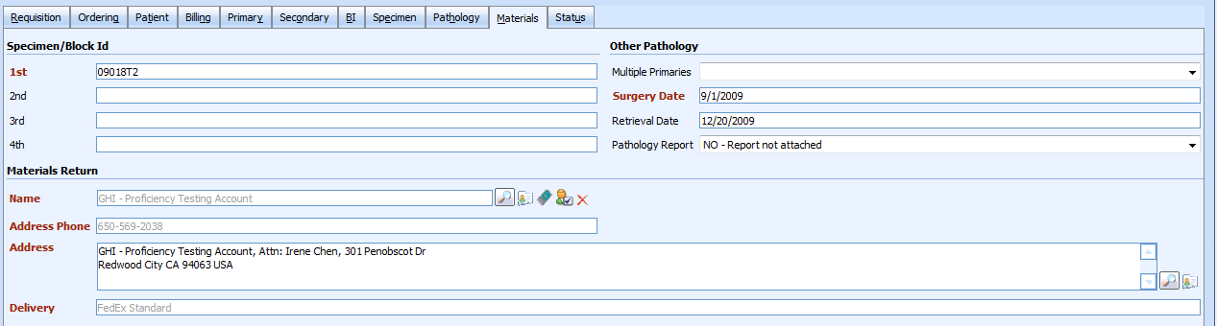

#### Materials Tab Change Table.

|  |  |  |  |
| --- | --- | --- | --- |
| **BRS #** | **Field** | **Specification** | **Implementation** |
| BRS-200 | Multiple Primaries | Move to Patient Tab | Low Priority-Ergo Project |

BRS-201. BRS-OP-PA-05-007-A details the specimen field updates to include 2 specimen IDs vs. 4. The 3rd and 4th fields in SARP will remain to allow for write-ins and other special cases. Removal of these fields will be assessed at a later time.

## Status Tab

## Status Tab Change Table

|  |  |  |  |
| --- | --- | --- | --- |
| **BRS #** | **Field** | **Specification** | **Implementation** |
| BRS-210 | Estimated Ship Date | MMR Alone & Sequential Test Type Selections require updated models | Required for Mercury |

Note: Business Requirements defined in section 4.0

# managing specimens and conatiners

## Specimen Labeling

### New label convention to support Orderable Test Types in SARP.

### Labels currently display “CO1” or “BR1” to enhance QC for accessioning, histopathology.

Note: Product information is listed on the block labels to enhance the QC process during material verification and processing in histology. Including test type specific information on the specimen label will enhance QC for verifying the correct specimen type has been selected in SARP before routing to histology and lab.

#### Add new label convention to support test type specific processing.

## Label Naming Convention for Specimen Barcodes

|  |  |  |  |
| --- | --- | --- | --- |
| **COLON** | | **BREAST** | |
| C01 | Colon ODX | BR1 | ODX Breast |
| C02 | MMR/ODX Reflex | _________________ | _________________ |
| C03 | MMR Alone | _________________ | _________________ |

Note: Examples are subject to change based on character limitations.

Note: Duplicate tube labels created in the lab will not be updated with the new test type naming convention. Duplicate tubes labels generated by the LIMS system will display the current label test type model and will not be changed for Mercury.

## Container Management

### No Change. Histology requested to add container to accessioning process for specimen type specific collection.

Note: This request is no longer valid as future requirements will support the automated separation of specimens in the histology workflow.

# ESD Estimated Ship date

## Estimated Ship Date

### New ESD Models

#### Required for Mercury

##### New ESD Model for MMR Alone

##### New ESD Model for MMR/ ODX

### New Model Requirements for MMR and Sequential Testing ESD:

Note: MMR QC step adds an additional 24 hours to the Histology/ Pathology TAT.

Note: Lab process running colon samples 2xs per week.

#### MMR Alone Model

##### The MMR alone model will be similar to the colon model up to pathology review, plus 1 day for the MMR QC step.

#### NEW - Sequential Testing MMR/ODX

##### The MMR/ODX sequential testing model should be similar to the colon model plus one day for the MMR QC step

### BI Report Impact:

#### The data must be updated per the Business Intelligence Department.

### Portal ESD Impact

#### Testing is required to ensure that the ESDs are coming through portal accurately.

# Managing Sequential testing failures

## MMR Path failures

Note: Histology will be responsible for the notification to customer service for MMR Sequential Testing Failures. See BRD-OP-PA-05-007-B *Business Requirements for MMR Histopathology Processes.*

# Other requirements

## Standard Operating Procedures

The following SOPs may need to be updated due to changes in SARP UI software for this release.

|  |  |
| --- | --- |
| **Document Number** | **Document Name** |
| SOP-OP-PA-03-001 | Requisition Processing |
| SOP-OP-PA-03-019 | Online Ordering Requisition Processing |
| SOP-OP-PA-02-021 | International Requisition Processing |

## Training

Training will be provided to all applicable parties.

## User Testing and User Acceptance Testing

User Acceptance Testing is performed as a “smoke test” on the QA Test system prior to the deployment of a new version of SARP software. Appropriate participants are selected based on the changes made to the SARP software.

User Acceptance testing is performed as a “smoke test” on the production system after the deployment of the new version of SARP software. Appropriate participants are selected based on the changes made to the SARP software.