



|  |
| --- |
| **PR Activity- August 2021** |

**PR Activity August 2021**

|  |
| --- |
| **Highlights of the month:**   1. We have received total 41 coverages- 15 print, 26 online. 2. We have received, 17 SIPM coverage, and 24 Suguna Foods coverage in total. 3. The press release on the topic “A pathway to a successful career in Agro Food Industry-Suguna Institute of Poultry Management” was carried across publications pan India. 4. The press release on the topic “Farm to Feed: a healthy journey from the house of Suguna Foods” was carried across publications pan India. 5. Our influencer and Nutritionist Dr. Muthulakshmi’s article on the importance of Protein was carried in Dinakaran, a leading Tamil news daily which enjoys high readership. 6. Chairman, Mr. Soundarajan’s quote was carried in Indian Express for the story on the soyameal imports. |

**Name of the Media:** Dinakaran

**Date:** 06.08.2021

**Region**: Tamil Nadu

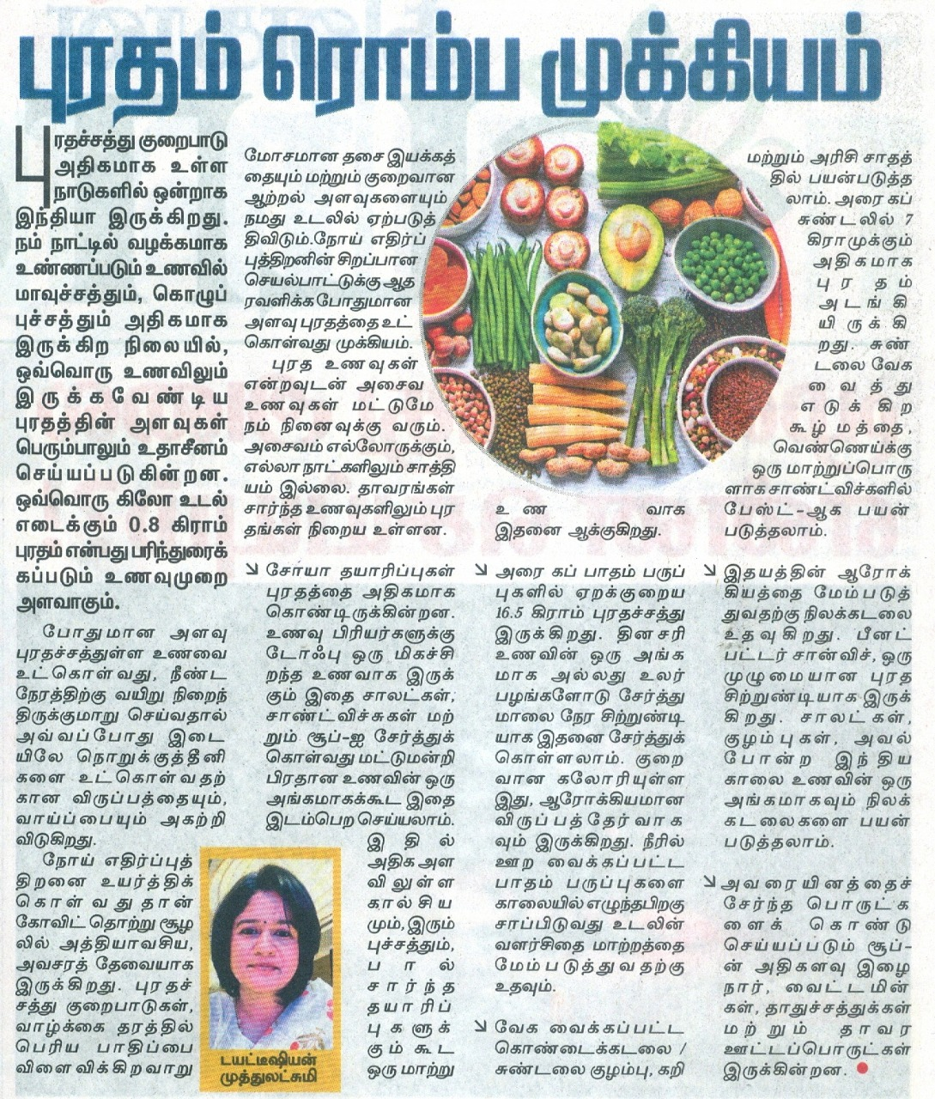

**Name of the Media:** Thozhil Nesan

**Date:** 12.08.2021

**Region**: Tamil Nadu

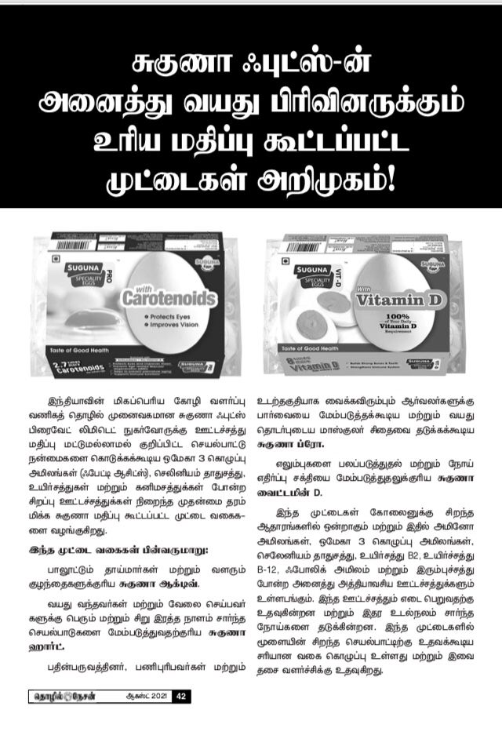

**Name of the Media:** Shivner

**Date:** 20.08.2021

**Region**: Maharashtra

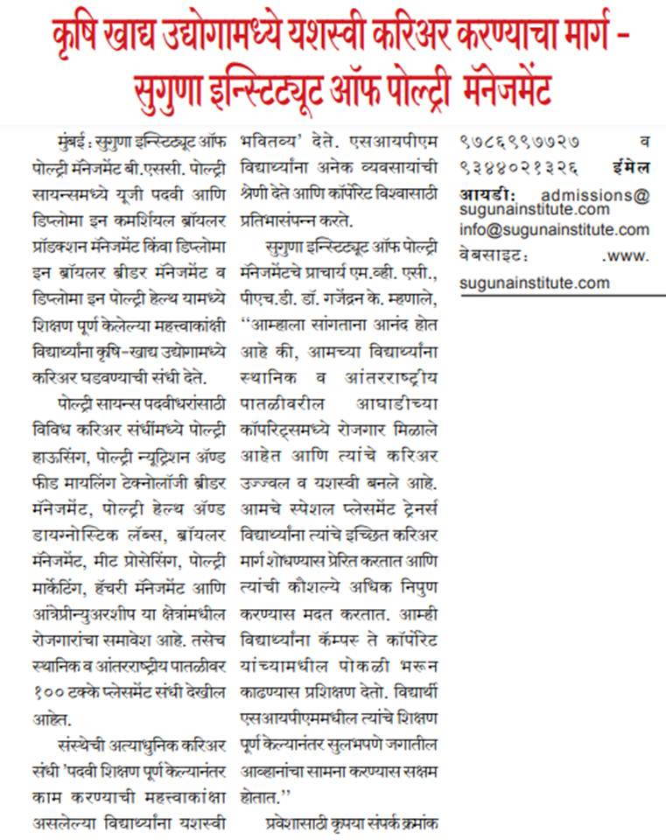

**Name of the Media:** Uttar Shakthi

**Date:** 20.08.2021

**Region**: Maharashtra

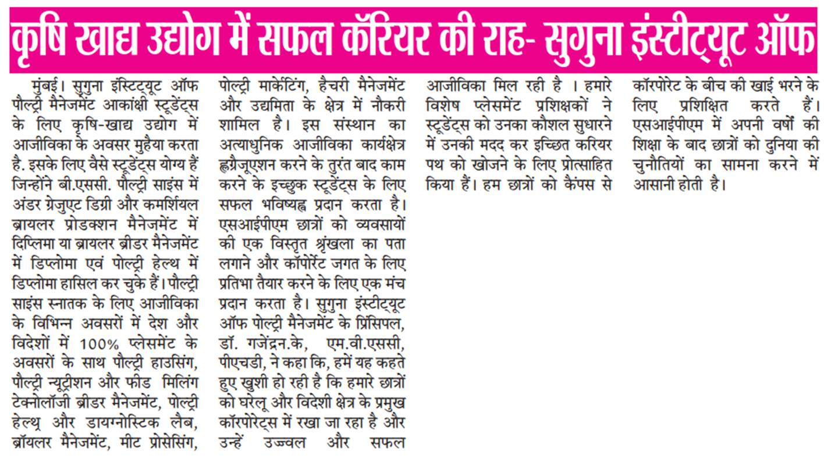

**Name of the Media:** Amrit India

**Date:** 22.08.2021

**Region**: New Delhi

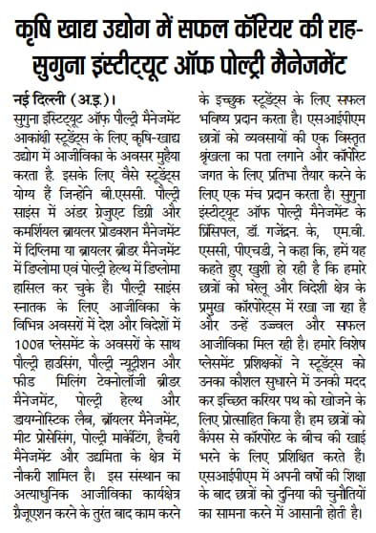

**Name of the Media:** Deshbandhu

**Date:** 22.08.2021

**Region**: New Delhi

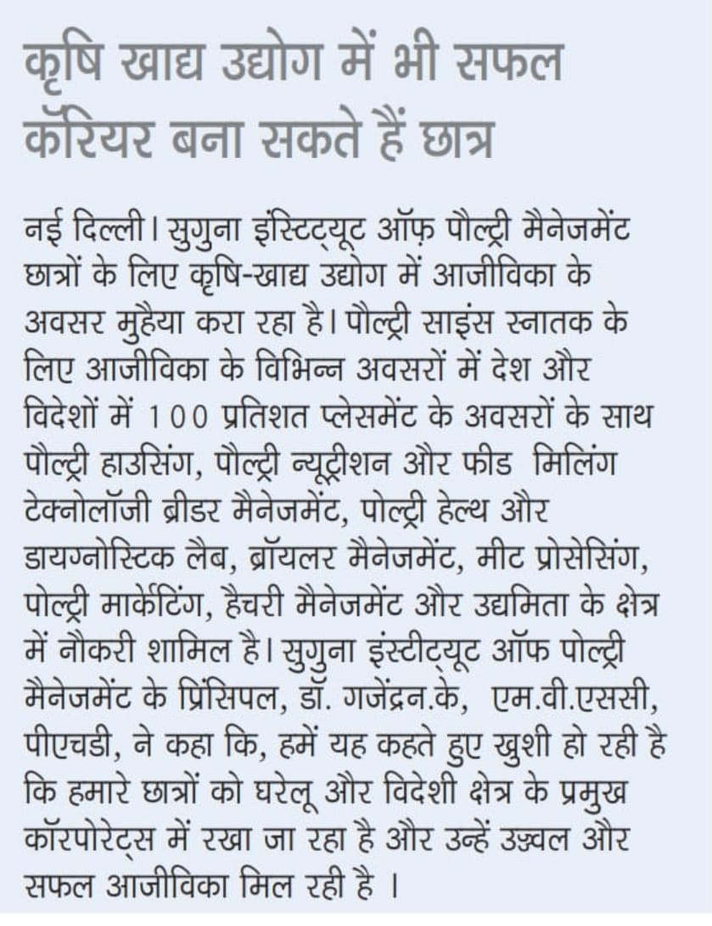

**Name of the Media:** Gurgaon Today

**Date:** 22.08.2021

**Region**: New Delhi

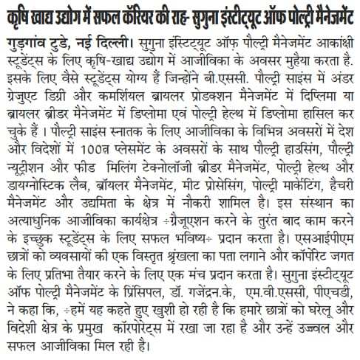

**Name of the Media:** Veer Arjun

**Date:** 22.08.2021

**Region**: New Delhi

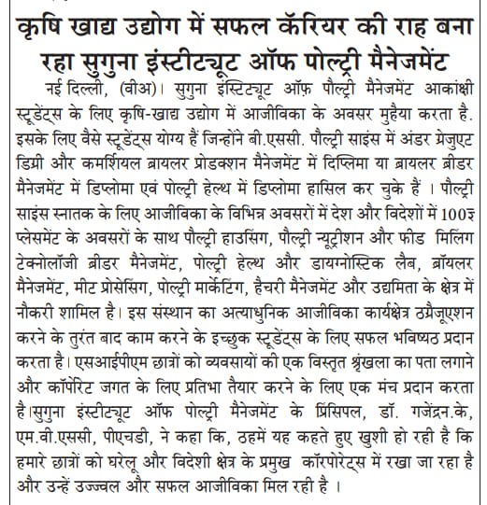

**Name of the Media:** Indian Express

**Date:** 26.08.2021

**Region**: Maharashtra

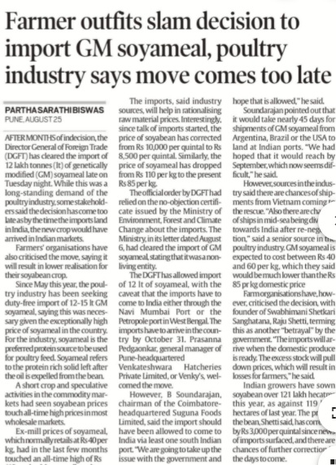**Name of the Media:** Uttar Shakthi

**Date:** 27.08.2021

**Region**: Maharashtra

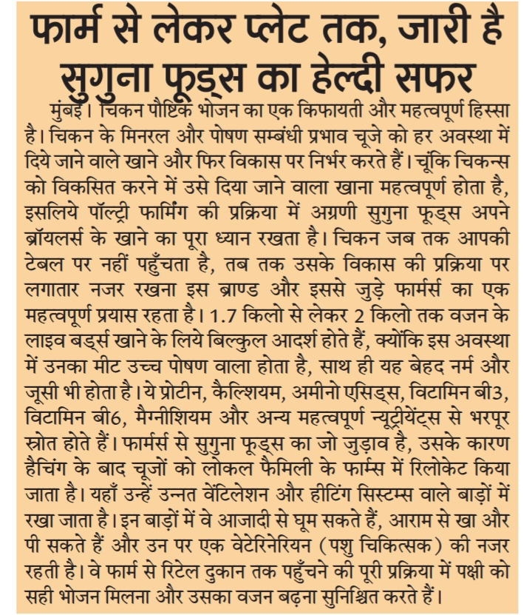

**Name of the Media:** Dainik Bhaskar

**Date:** 28.08.2021

**Region**: New Delhi

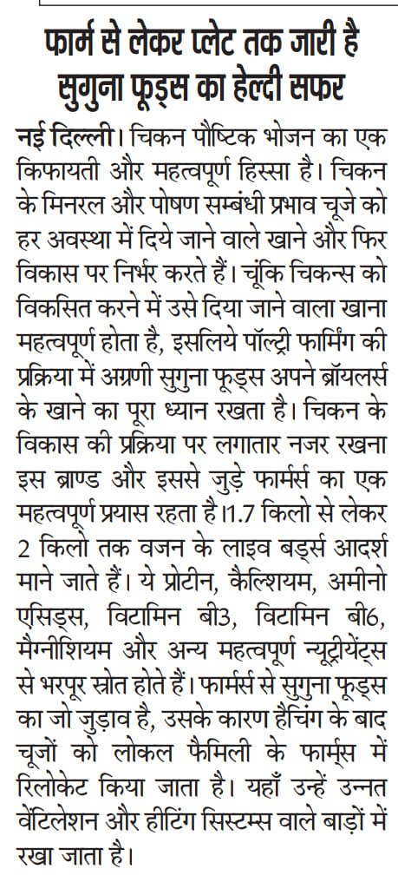

**Name of the Media:** Gurgaon Today

**Date:** 28.08.2021

**Region**: New Delhi

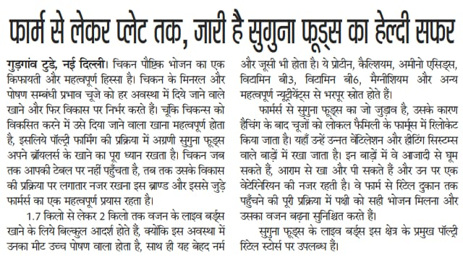

**Name of the Media:** Shambad Vani Samachar

**Date:** 28.08.2021

**Region**: New Delhi



**Name of the Media:** Uttar Prahari

**Date:** 28.08.2021

**Region**: New Delhi

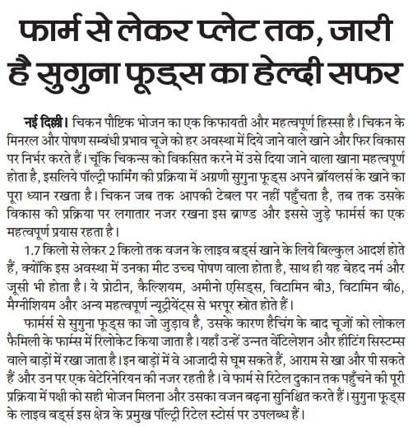

**Name of the Media:** Shivner

**Date:** 30.08.2021

**Region**: Maharashtra

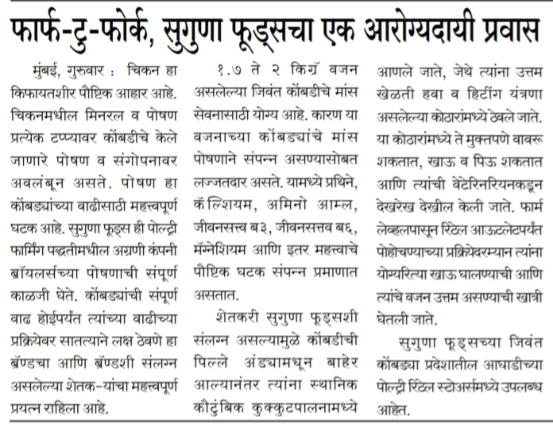

**Online Coverages:**

|  |  |  |  |  |
| --- | --- | --- | --- | --- |
| 1 | 16.08.2021 | City Air News | A Pathway to a successful career in Agro food industry Suguna institute of poultry management | <https://www.cityairnews.com/content/a-pathway-to-a-successful-career-in-agro-food-industry-suguna-institute-of-poultry-management> |
| 2 | 16.08.2021 | Business news this week | A Pathway to a successful career in Agro food industry Suguna institute of poultry management | <http://businessnewsthisweek.com/education/a-pathway-to-a-successful-career-in-agro-food-industry-suguna-institute-of-poultry-management/> |
| 3 | 16.08.2021 | Media Bulletins | A Pathway to a successful career in Agro food industry Suguna institute of poultry management | <http://mediabulletins.com/education/a-pathway-to-a-successful-career-in-agro-food-industry-suguna-institute-of-poultry-management/> |
| 4 | 16.08.2021 | Digital Media 9 | A Pathway to a successful career in Agro food industry Suguna institute of poultry management | <https://digitalmedia9.com/education/a-pathway-to-a-successful-career-in-agro-food-industry-suguna-institute-of-poultry-management/> |
| 5 | 16.08.2021 | Content Media Solution | A Pathway to a successful career in Agro food industry Suguna institute of poultry management | <https://contentmediasolution.com/education/a-pathway-to-a-successful-career-in-agro-food-industry-suguna-institute-of-poultry-management/> |
| 6 | 16.08.2021 | Online Media café | A Pathway to a successful career in Agro food industry Suguna institute of poultry management | <https://onlinemediacafe.com/education/a-pathway-to-a-successful-career-in-agro-food-industry-suguna-institute-of-poultry-management/> |
| 7 | 17.08.2021 | B4U Media | A Pathway to a successful career in Agro food industry Suguna institute of poultry management | <http://www.b4umedia.in/?p=239257> |
| 8 | 17.08.2021 | Indian Newz | A Pathway to a successful career in Agro food industry Suguna institute of poultry management | <https://indiannewz.wordpress.com/2021/08/16/a-pathway-to-a-successful-career-in-agro-food-industry-suguna-institute-of-poultry-management/> |
| 9 | 19.08.2021 | Business News this week | Farm to Fork a healthy journey from the house of Suguna foods | <http://businessnewsthisweek.com/business/farm-to-fork-a-healthy-journey-from-the-house-of-suguna-foods/> |
| 10 | 19.08.2021 | Media Bulletin | Farm to Fork a healthy journey from the house of Suguna foods | <http://mediabulletins.com/business/farm-to-fork-a-healthy-journey-from-the-house-of-suguna-foods/> |
| 11 | 19.08.2021 | Digital Media 9 | Farm to Fork a healthy journey from the house of Suguna foods | <https://digitalmedia9.com/business/farm-to-fork-a-healthy-journey-from-the-house-of-suguna-foods/> |
| 12 | 19.08.2021 | Online Media café | Farm to Fork a healthy journey from the house of Suguna foods | <https://onlinemediacafe.com/business/farm-to-fork-a-healthy-journey-from-the-house-of-suguna-foods/> |
| 13 | 19.08.2021 | Content media solution | Farm to Fork a healthy journey from the house of Suguna foods | <https://contentmediasolution.com/business/farm-to-fork-a-healthy-journey-from-the-house-of-suguna-foods/> |
| 14 | 19.08.2021 | News Outlook | Farm to Fork a healthy journey from the house of Suguna foods | <https://news-outlook.com/farm-to-fork-a-healthy-journey-from-the-house-of-suguna-foods/> |
| 15 | 19.08.2021 | Republic News India | Farm to Fork a healthy journey from the house of Suguna foods | <https://republicnewsindia.com/farm-to-fork-a-healthy-journey-from-the-house-of-suguna-foods/> |
| 16 | 19.08.2021 | Business Reporter | Farm to Fork a healthy journey from the house of Suguna foods | <https://businessreporter.in/farm-to-fork-a-healthy-journey-from-the-house-of-suguna-foods/> |
| 17 | 19.08.2021 | Deccan Business | Farm to Fork a healthy journey from the house of Suguna foods | <https://deccanbusiness.com/farm-to-fork-a-healthy-journey-from-the-house-of-suguna-foods/> |
| 18 | 19.08.2021 | Enterpreneursage | Farm to Fork a healthy journey from the house of Suguna foods | <https://entrepreneursaga.com/farm-to-fork-a-healthy-journey-from-the-house-of-suguna-foods/> |
| 19 | 20.08.2021 | Indian Newz | Farm to Fork a healthy journey from the house of Suguna foods | <https://indiannewz.wordpress.com/2021/08/19/farm-to-fork-a-healthy-journey-from-the-house-of-suguna-foods/> |
| 20 | 26.08.2021 | Indian Express | Farmer outfits criticise decision to import genetically modified soyameal | <https://indianexpress.com/article/cities/pune/farmer-outfits-criticise-decision-to-import-genetically-modified-soyameal-7470949/> |
| 21 | 31.08.2021 | Jana News | Farmer outfits criticise decision to import genetically modified soyameal | <https://jananews.in/2021/08/25/farmer-outfits-criticize-decision-to-import-genetically-modified-soyameal-poultry-industry-move-comes-too-late/> |
| 22 | 31.08.2021 | Aazkanews | Farmer outfits criticise decision to import genetically modified soyameal | <https://aazkanews.com/national/farmer-outfits-criticise-decision-to-import-genetically-modified-soyameal-poultry-industry-says-move-comes-too-late/> |
| 23 | 31.08.2021 | Top bolly news | Farmer outfits criticise decision to import genetically modified soyameal | <https://topbollynews.com/cities/farmer-outfits-criticise-decision-to-import-genetically-modified-soyameal-poultry-industry-says-move-comes-too-late/> |
| 24 | 31.08.2021 | Egiyok News | Farmer outfits criticise decision to import genetically modified soyameal | <https://egiyoknews.com/farmer-outfits-criticize-the-decision-to-import-genetically-modified-soya-meal-poultry-industry-says-the-move-comes-too-late/> |
| 25 | 31.08.2021 | Pari match | Farmer outfits criticise decision to import genetically modified soyameal | <https://parimatch-online.in/farmer-outfits-criticise-decision-to-import-genetically-modified-soyameal-poultry-industry-says-move-comes-too-late/> |
| 26 | 31.08.2021 | The News Tv | Farmer outfits criticise decision to import genetically modified soyameal | <https://www.thenews-tv.com/2021/08/farmer-outfits-criticise-decision-to.html> |

**Activity that can be planned for September**

* Nutrition week- The delight of eating nutritious foods
* Cattle feed launch announcement
* SIPM -Tie-up with Govt in placing students in Germany
* An interview for ED on any of the following topics
* Suguna Foods growth last two months
* Expansion of Suguna Daily Fressh/ any of the subsidiaries
* Forward looking statement on company’s growth plans this year
* Product diversification