|  |
| --- |
| **PR Activity – October 2021** |





**PR Activity October 2021**

|  |
| --- |
| **Highlights of the month:**   1. We have received a total 43 coverages- 20 print, 23 online. 2. We have received 20 SIPM coverage, 13 Suguna Foods, and 10 Suguna Cattle feed in total. 3. The press release on the topic “Suguna Institute of Poultry Management receives 100% placement ” was carried across publications pan India. 4. On world Egg Day, we disseminated a press release on Suguna Foods reiterating the importance of Egg for good health which was carried both in print and digital.We also shared Suguna Eggs picture for the same and this has appeared in most of the coverage. 5. The Press Release on the topic, “Suguna Feeds launches Cattle feed at affordable prices” has garnered trade magazine coverage. |

**Name of the Media:** Amrit India

**Date:** 05.10.2021

**Region**: New Delhi

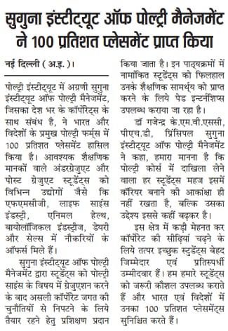

**Name of the Media:** Deshbandhu

**Date:** 05.10.2021

**Region**: New Delhi

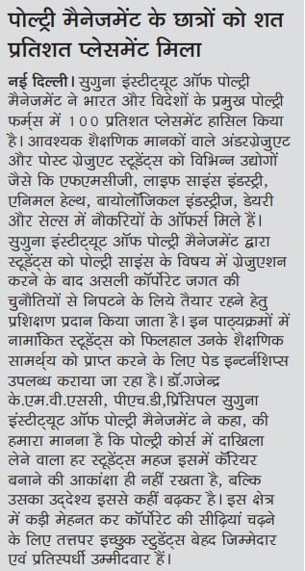

**Name of the Media:** Veer Arjun

**Date:** 05.10.2021

**Region**: New Delhi

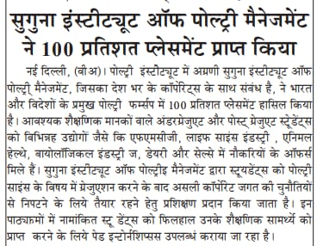

**Name of the Media:** Shah Times

**Date:** 06.10.2021

**Region**: New Delhi

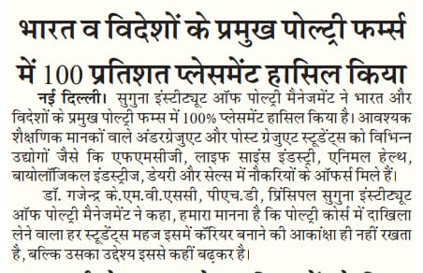

**Name of the Media:** Shivner

**Date:** 05.10.2021

**Region**: New Delhi

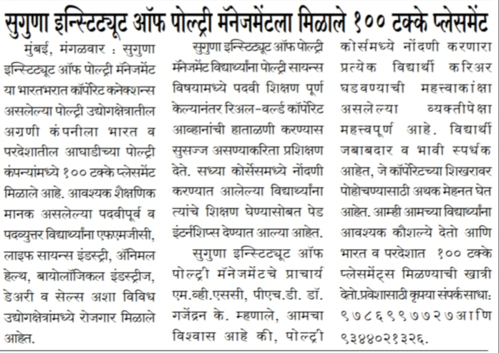

**Name of the Media:** Uttarshakti

**Date:** 06.10.2021

**Region**: Mahrashtra

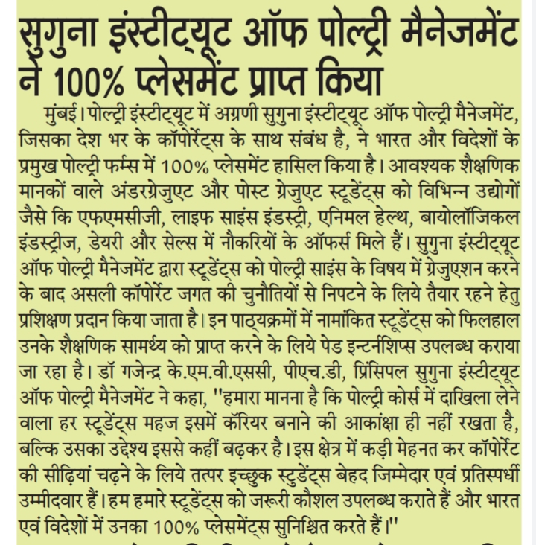

**Name of the Media:**Gurgaon Today

**Date:** 05.10.2021

**Region**: New Delhi

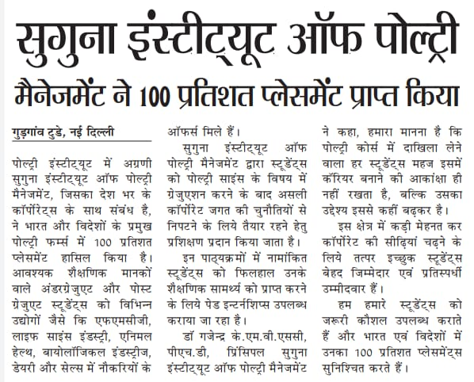

**Name of the Media:** Margodaya

**Date:** 06.10.2021

**Region**: New Delhi

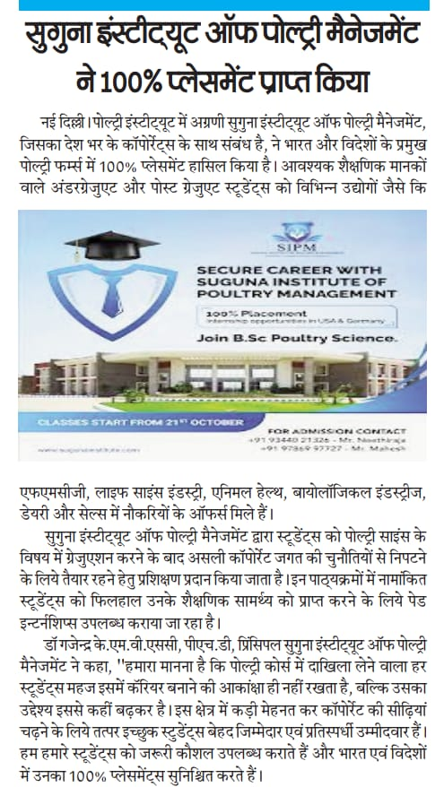

**Name of the Media:** Sadbhawana Today

**Date:** 06.10.2021

**Region**: New Delhi

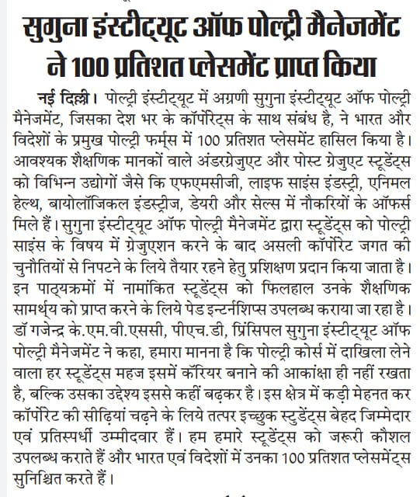

**Name of the Media:** Uttar Prahari

**Date:** 06.10.2021

**Region**: New Delhi

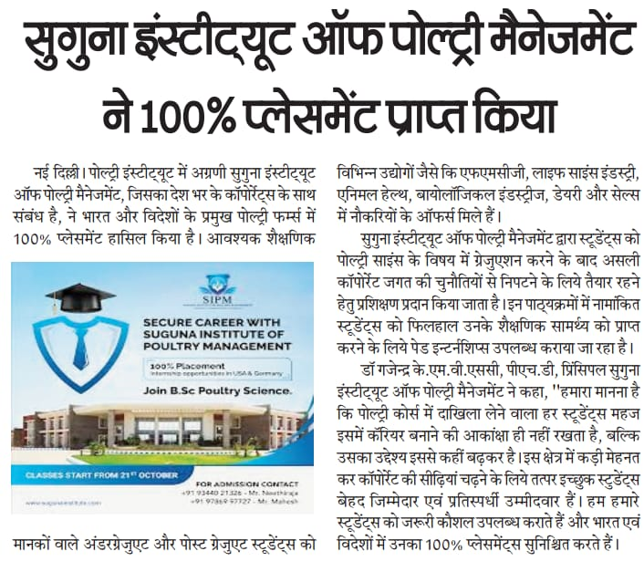

**Name of the Media:** The Glocal Times

**Date:** 07.10.2021

**Region**: New Delhi

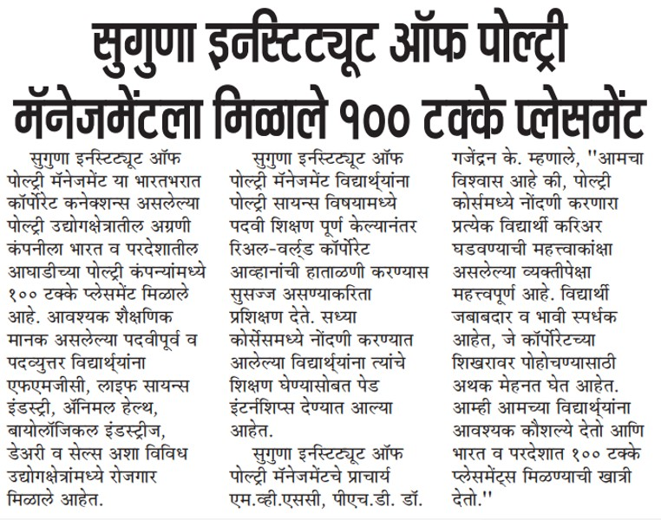

**Name of the Media:** Hosadigantha

**Date:** 11.10.2021

**Region**: Karnataka



**Name of the Media:** Navbharat

**Date:** 10.10.2021

**Region**: Maharashtra

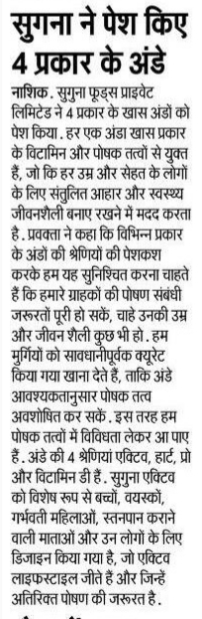

**Name of the Media:** Subhashita

**Date:** 09.10.2021

**Region**: Karnataka

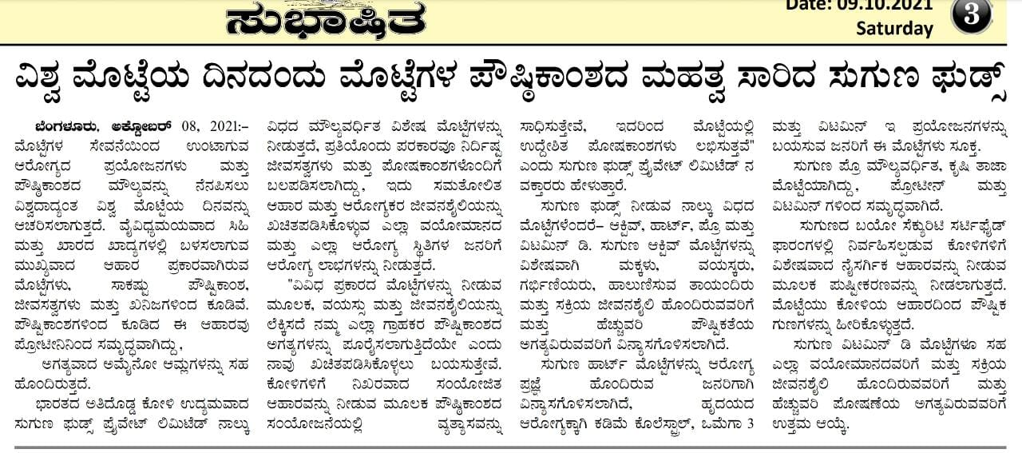

**Name of the Media:** The Global Times

**Date:** 10.10.2021

**Region**:Maharashtra

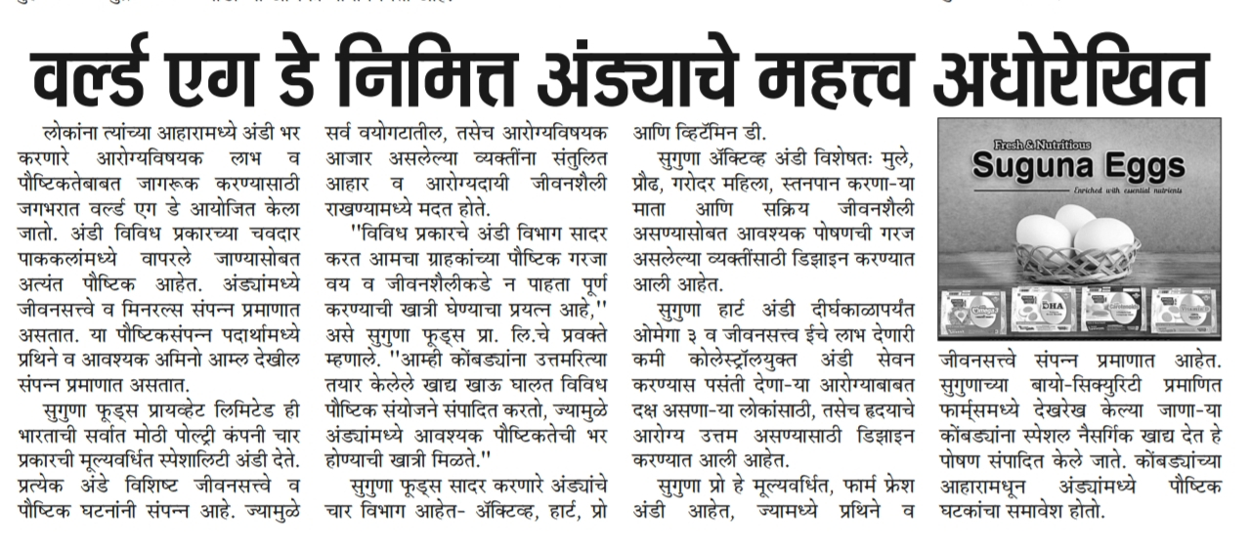

**Name of the Media:** Uttarshakthi

**Date:** 10.10.2021

**Region**: New Delhi

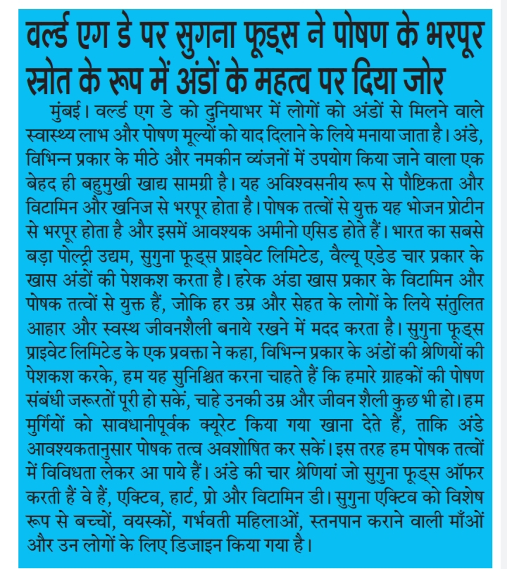

**Name of the Media:** The Hindu Business Line

**Date:** 12.10.2021

**Region**: National

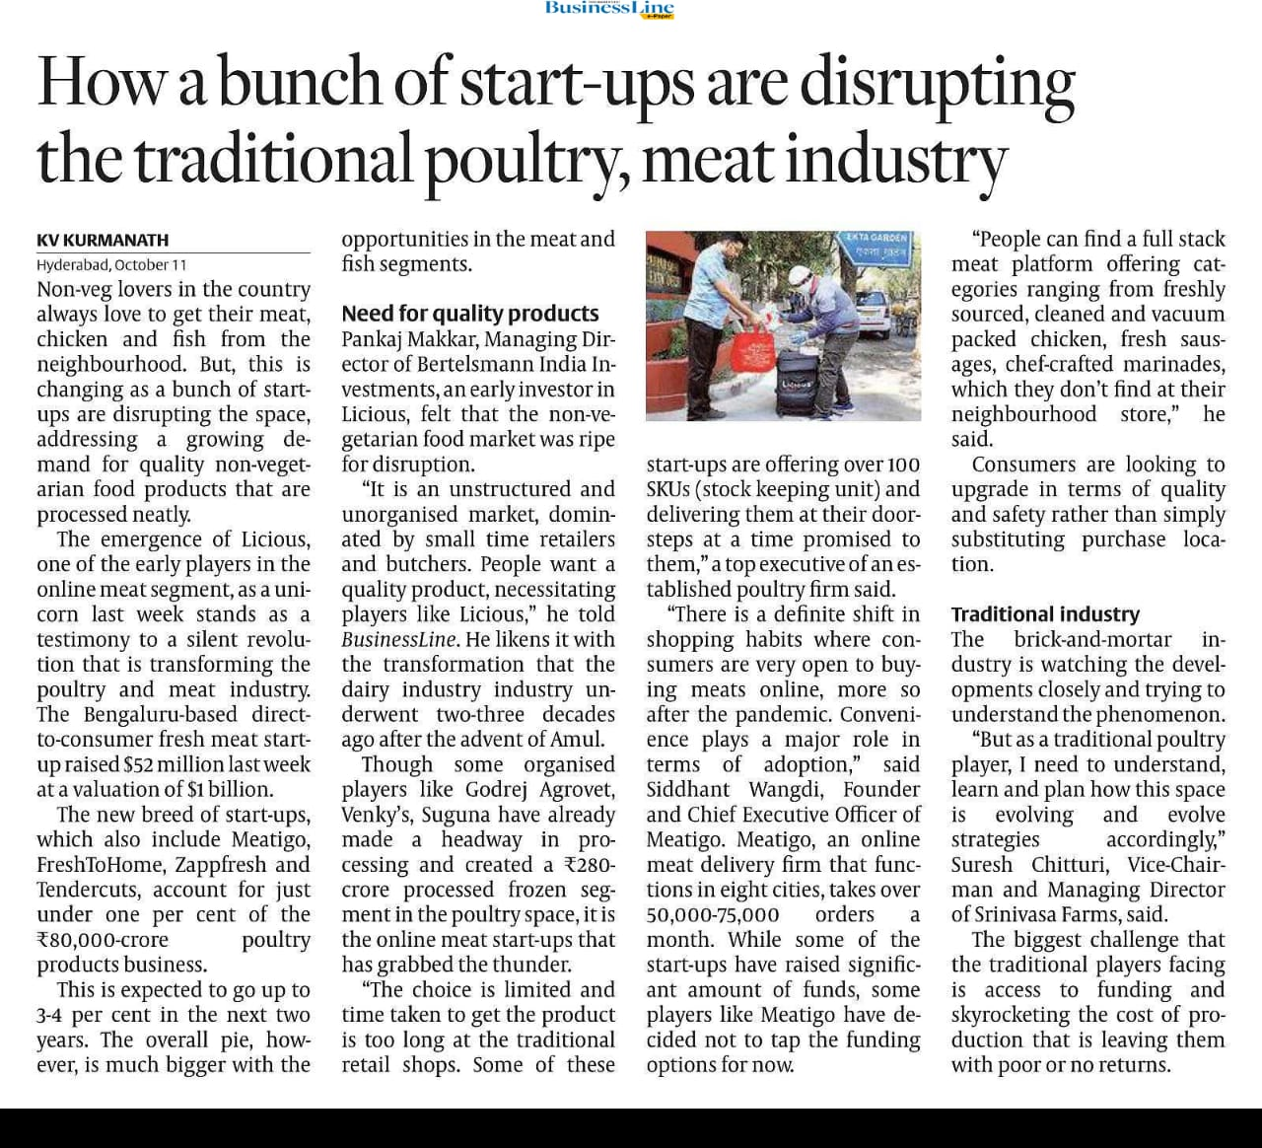

**Name of the Media:** Poultry Vision

**Date:** October Month

**Region**: National

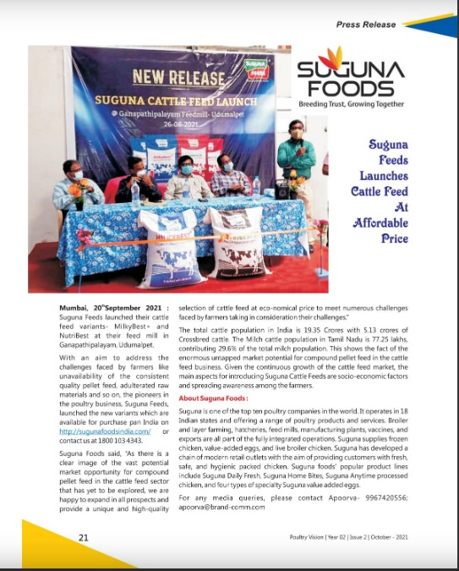

**Name of the Media:** Poultry Square

**Date:** October Month

**Region**: National

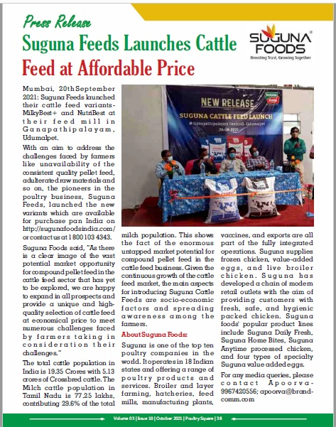

**Name of the Media:** Poultry Line

**Date:** October Month

**Region**: National

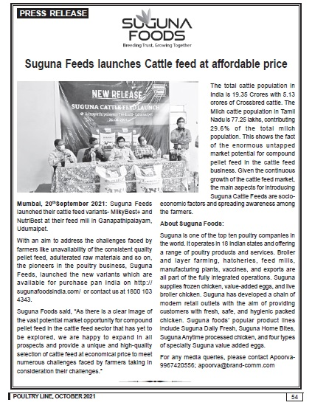

**Online Coverage**

|  |  |  |  |  |
| --- | --- | --- | --- | --- |
| **S No** | **Date** | **Media Name** | **Headline** | **Link** |
| 1 | 05.10.2021 | mediabulletins.com | Suguna Institute of Poultry Management receives 100 % placement | <http://mediabulletins.com/education/suguna-institute-of-poultry-management-receives-100-placement/> |
| 2 | 05.10.2021 | businessnewsthisweek.com | Suguna Institute of Poultry Management receives 100 % placement | <http://businessnewsthisweek.com/education/suguna-institute-of-poultry-management-receives-100-placement/> |
| 3 | 05.10.2021 | digitalmedia9.com | Suguna Institute of Poultry Management receives 100 % placement | <https://digitalmedia9.com/education/suguna-institute-of-poultry-management-receives-100-placement/> |
| 4 | 05.10.2021 | onlinemediacafe.com | Suguna Institute of Poultry Management receives 100 % placement | <https://onlinemediacafe.com/education/suguna-institute-of-poultry-management-receives-100-placement/> |
| 5 | 05.10.2021 | contentmediasolution.com | Suguna Institute of Poultry Management receives 100 % placement | <https://contentmediasolution.com/education/suguna-institute-of-poultry-management-receives-100-placement/> |
| 6 | 05.10.2021 | Apnnews.com | Suguna Institute of Poultry Management receives 100 % placement | <https://www.apnnews.com/suguna-institute-of-poultry-management-receives-100-placement/> |
| 7 | 05.10.2021 | apekshadandesh.com | Suguna Institute of Poultry Management receives 100 % placement | <https://apekshasandesh.com/suguna-institute-of-poultry-management-receives-100-placement> |
| 8 | 05.10.2021 | world hindu press | Suguna Institute of Poultry Management receives 100 % placement | <https://m.facebook.com/story.php?story_fbid=213702634100527&id=100063823754387> |
| 9 | 05.10.2021 | b4umedia.in | Suguna Institute of Poultry Management receives 100 % placement | <http://www.b4umedia.in/?p=244337> |
| 10 | 05.10.2021 | chennaipatrika.com | Suguna Foods reiterates the importance of eggs as a rich source of nutrition on world egg day | <http://www.chennaipatrika.com/post/suguna-foods-reiterates-the-importance-of-eggs-as-a-rich-source-of-nutrition-on-world-egg-day> |
| 11 | 08.10.2021 | b4umedia.in | Suguna Foods reiterates the importance of eggs as a rich source of nutrition on world egg day | <http://www.b4umedia.in/?p=244613> |
| 12 | 08.10.2021 | Apnnews.com | Suguna Foods reiterates the importance of eggs as a rich source of nutrition on world egg day | <https://www.apnnews.com/suguna-foods-reiterates-the-importance-of-eggs-as-a-rich-source-of-nutrition-on-world-egg-day/> |
| 13 | 09.10.2021 | businessnewsthisweek.com | Suguna Foods reiterates the importance of eggs as a rich source of nutrition on world egg day | <http://businessnewsthisweek.com/business/suguna-foods-reiterates-the-importance-of-eggs-as-a-rich-source-of-nutrition-on-world-egg-day/> |
| 14 | 09.10.2021 | mediabulletins.com | Suguna Foods reiterates the importance of eggs as a rich source of nutrition on world egg day | <http://mediabulletins.com/business/suguna-foods-reiterates-the-importance-of-eggs-as-a-rich-source-of-nutrition-on-world-egg-day/> |
| 15 | 09.10.2021 | contentmediasolution.com | Suguna Foods reiterates the importance of eggs as a rich source of nutrition on world egg day | <https://contentmediasolution.com/business/suguna-foods-reiterates-the-importance-of-eggs-as-a-rich-source-of-nutrition-on-world-egg-day/> |
| 16 | 09.10.2021 | businessnewsweek.in | Suguna Foods reiterates the importance of eggs as a rich source of nutrition on world egg day | <https://businessnewsweek.in/business/suguna-foods-reiterates-the-importance-of-eggs-as-a-rich-source-of-nutrition-on-world-egg-day/> |
| 17 | 09.10.2021 | Poultry Vision | Suguna Feeds launched cattle feed at affordable price | <https://www.facebook.com/poultryvisionknl/photos/pcb.363058932231913/363057938898679> |
| 18 | 09.10.2021 | Poultry Square | Suguna Feeds launched cattle feed at affordable price | <http://www.poultrysquare.com/suguna-feeds-launches-cattle-feed-at-affordable-price/> |
| 19 | 09.10.2021 | pasundpraharee | Suguna Feeds launched cattle feed at affordable price | https://www.pashudhanpraharee.com/suguna-feeds-launches-cattle-feed-at-affordable-price/ |
| 20 | 09.10.2021 | Retail.com | Suguna Feeds launched cattle feed at affordable price | https://retail-pressrelease.blogspot.com/2021/09/suguna-feeds-launches-cattle-feed-at.html |
| 21 | 09.10.2021 | Pninews.com | Suguna Feeds launched cattle feed at affordable price | https://www.pninews.com/suguna-feeds-launches-cattle-feed-at-affordable-price/ |
| 22 | 09.10.2021 | Rdtimes.com | Suguna Feeds launched cattle feed at affordable price | https://biz.rdtimes.in/suguna-feeds-launches-cattle-feed-at-affordable-price/ |
| 23 | 09.10.2021 | Republicnewsindia.com | Suguna Feeds launched cattle feed at affordable price | https://republicnewsindia.com/suguna-feeds-launches-cattle-feed-at-affordable-price/ |