1、jQuery easyUI 数据表分页
var p = $('#kpxmListGrid').datagrid('getPager');
$(p).pagination({
pageSize: 100,//每页显示的记录条数，默认为10
pageList: [100,110,120],//可以设置每页记录条数的列表
beforePageText: '第',//页数文本框前显示的汉字
afterPageText: '页 共 {pages} 页',
displayMsg: '当前显示 {from} - {to} 条记录 共 {total} 条记录',
showRefresh : false
/*onBeforeRefresh:function(){
$(this).pagination('loading');
alert('before refresh');
$(this).pagination('loaded');
}*/
});

2、登陆超时时框架中出现部分子窗口成登陆页面
注意，如果页面上使用了框架，则可能导致session超时后退出到登录页面，此时登录页面显示在框架的某个子页面，解决方法，在登录页面加入如下代码即可。

<script language="javascript">
if (top != window)
top.location.href = window.location.href;
</script>

combo 多选取消时IE8 不支持数组indexOf。
解决办法： 将数组转换为字符串。
代码位置：jquery-easyui-1.3.3/jquery.easyui.min.js 10650行
时间： 2015-10-13 15:13

源代码：
function _7e8(_7e9,_7ea){
var _7eb=$.data(_7e9,"combobox");
var opts=_7eb.options;
var _7ec=$(_7e9).combo("getValues");
var _7ed=_7ec.indexOf(_7ea+"");
if(_7ed>=0){
_7ec.splice(_7ed,1);
_7e7(_7e9,_7ec);
}

修改后代码：
function _7e8(_7e9,_7ea){
var _7eb=$.data(_7e9,"combobox");
var opts=_7eb.options;
var _7ec=$(_7e9).combo("getValues");var _7ec1=_7ec; _7ec=_7ec.join("");
var _7ed=_7ec.indexOf(_7ea+"");_7ec=_7ec1;_7ed=parseInt(_7ed);
if(_7ed>=0){
_7ec.splice(_7ed,1);
_7e7(_7e9,_7ec);
}

4、不同服务的数据库之间的链接查询（dblink）

20151027
- 超级管理员赋权
- 建立链接
- 联合查询
create database link dbl connect to jwweb identified by jwweb
using '
(DESCRIPTION =
(ADDRESS = (PROTOCOL = TCP)(HOST = 112.16.68.214)(PORT = 1521))
(CONNECT_DATA =
(SERVER = DEDICATED)
(SERVICE_NAME = orcl)
)
)
'

drop database link dbl

select u.orgid, u.name, t.name from t_common_user u join t_common_organization@dbl t on u.orgid = t.id

select * from t_common_organization@dbl t

5、飘窗
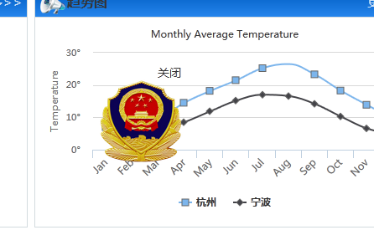
<script type="text/javascript" src="jquery.js"></script>
<script type="text/javascript">
(function($) {
$.fn.floatAd = function(options) {
var defaults = {
imgSrc:"",
url:"",
openStyle: 1,
speed: 30
};
var options = $.extend(defaults, options);
var _target = options.openStyle == 1 ? "target='_blank'": '';
var html = "<div id='float_ad' style='position:absolute;left:0px;top:0px;z-index:1000000;cleat:both;'>";
html += " <a href='" + options.url + "' " + _target + "><img src='" + options.imgSrc + "' border='0' class='float_ad_img'/></a>";
html += "<div id='close_f_ad' style='position:absolute;width:30px;height:16px;top:-18px;right:0px;cursor:pointer;float:right;font-size:14px'>关闭</div></div>";
$('body').append(html);
function init() {
var x = 0,
y = 0;
var xin = true,
yin = true;
var step = 1;
var delay = 10;
var obj = $("#float_ad");
obj.find('img.float_ad_img').load(function() {
var float = function() {
var L = T = 0;
var OW = obj.width();
var OH = obj.height();
var DW = $(document).width();
var DH = $(document).height();
x = x + step * (xin ? 1 : -1);
if (x < L) {
xin = true;
x = L;
}
if (x > DW - OW - 1) {
xin = false;
x = DW - OW - 1;
}
y = y + step * (yin ? 1 : -1);
if (y > DH - OH - 10) {
yin = false;
y = DH - OH - 10;
}
if (y < T) {
yin = true;
y = T;
}
var left = x;
var top = y;
obj.css({
'top': top,
'left': left
});
};
var itl = setInterval(float, options.speed);
$('#float_ad').mouseover(function() {
clearInterval(itl);
});
$('#float_ad').mouseout(function() {
itl = setInterval(float, options.speed)
});
});
}
init();
$('#close_f_ad').click(function(){
$('#float_ad').css('display','none');
clearInterval(itl);
});
}
})(jQuery);

$(document).ready(function() {
$(function() {
$("body").floatAd({
imgSrc: 'http://www.customs.gov.cn/Portals/114/images/zxftyg2014010601.jpg',
url: 'http://www.customs.gov.cn/tabid/66651/Default.aspx'
});
});
});
</script>

6、DataGrid DetailView（数据表格详细展示）

<body>
<div id="cc" class="easyui-calendar" style="width:100px;height:100px;position: relative;margin: 0 auto;">11</div>

<table id="tt"></table>
<script type="text/javascript">
var arrayData = new Array();
var rgb255 = "rgb(255, 0, 0)";
$('#cc').calendar({
onSelect: function(date){
var clickdate = date.getFullYear()+","+(date.getMonth()+1)+","+date.getDate();
var selectdate = $("#cc").find(".calendar-selected");
var rgb = selectdate.css('background-color');
if(rgb255 == rgb){
selectdate.removeClass('red');
}else{
if(clickdate){
alert(date);
selectdate.addClass('red');
}else{
}
}
}
});

$('#tt').datagrid({
title:'DataGrid - DetailView',
width:700,
height:500,
remoteSort:false,
singleSelect:true,
nowrap:false,
fitColumns:true,
url:'datagrid_data.json',
columns:[[
{field:'itemid',title:'Item ID',width:80},
{field:'productid',title:'Product ID',width:100,sortable:true},
{field:'listprice',title:'List Price',width:80,align:'right',sortable:true},
{field:'unitcost',title:'Unit Cost',width:80,align:'right',sortable:true},
{field:'attr1',title:'Attribute',width:150,sortable:true},
{field:'status',title:'Status',width:60,align:'center'}
]],
view: detailview,
detailFormatter: function(rowIndex, rowData){
return '<table style="width:100%; border:1px solid red"><tr>' +
'<td >富</td>' +
'<td width=110>' +
'<p>Attribute: ' + rowData.attr1 + '</p>' +
'<p>Status: ' + rowData.status + '</p>' +
'</td>' +
'<td width=95>14443</td>' +
'<td width=100>1243</td>' +
'<td width=170>1243</td>' +
'<td width=75>1523</td>' +
'</tr>'+
'<tr>' +
'<td >孙</td>' +
'<td width=110>' +
'<p>Attribute: ' + rowData.attr1 + '</p>' +
'<p>Status: ' + rowData.status + '</p>' +
'</td>' +
'<td width=95>14443</td>' +
'<td width=100>1243</td>' +
'<td width=170>1243</td>' +
'<td width=75>1523</td>' +
'</tr>'+
'</table>';
},
onLoadSuccess: function (data) {
var me = this;
setTimeout(function () {//延时触发easyui datagrid detailviewclick事件，不用计时器无法展开，不懂什么问题~
$(me).parent().find('span.datagrid-row-expander').trigger('click'); //没效果注意修改这里的选择器
}, 10);
}

});
</script>
</body>
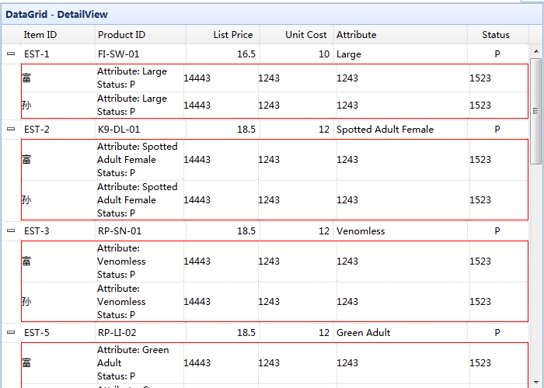

7、去除字符串中无用的转义字符
var html = str.replace(/<[^>]+>/g,"");//去掉所有的html标记
html = html.replace(/&nbsp;/ig, "");//去掉&nbsp;
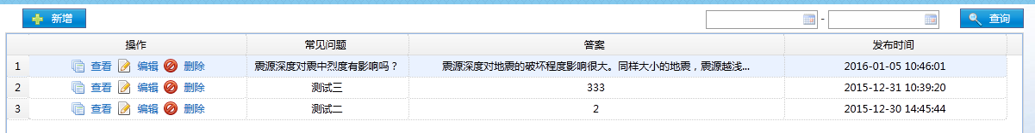

8、获取服务器时间，页面实时显示
<%@ page language="java" import="java.util.*" pageEncoding="utf-8"%>
<%@page import="java.text.SimpleDateFormat;"%>
<%
String path = request.getContextPath();
String basePath = request.getScheme()+"://"+request.getServerName()+":"+request.getServerPort()+path+"/";
%>
<!DOCTYPE HTML PUBLIC "-//W3C//DTD HTML 4.01 Transitional//EN">
<html>
<head>
<base href="<%=basePath%>">

<title>My JSP 'index.jsp' starting page</title> <meta http-equiv="pragma" content="no-cache"> <meta http-equiv="cache-control" content="no-cache"> <meta http-equiv="expires" content="0"> <meta http-equiv="keywords" content="keyword1,keyword2,keyword3"> <meta http-equiv="description" content="This is my page"> <!-- <link rel="stylesheet" type="text/css" href="styles.css"> -->
</head>
<body>
<%
Calendar rightNow = Calendar.getInstance();
SimpleDateFormat format = new SimpleDateFormat("yyyy-MM-dd HH:mm");
%>
<script language="javascript">
//从服务器上获取初始时间
var currentDate = new Date(<%=new java.util.Date().getTime()%>);
function run()
{
currentDate.setSeconds(currentDate.getSeconds()+1);
var time = "";
var year = currentDate.getFullYear();
var month = currentDate.getMonth() + 1;
var day = currentDate.getDate();
var hour = currentDate.getHours();
var minute = currentDate.getMinutes();
var second = currentDate.getSeconds();
if(hour < 10){ time += "0" + hour;
}else{ time += hour;
}
time += ":";
if(minute < 10){ time += "0" + minute;
}else{ time += minute;
}
time += ":";
if(second < 10){ time += "0" + second;
}else{ time += second;
}
document.getElementById("dt").innerHTML = year+"年"+month+"月"+day+"日" + time;
}
window.setInterval("run();", 1000);
</script>
<div id="dt">自动显示时间。。。。</div>
</body>
</html>

9、JSP xml配置页面编码（utf-8）
<bean class="org.springframework.web.servlet.mvc.method.annotation.RequestMappingHandlerAdapter">
<property name="messageConverters">
<list>
<bean class="org.springframework.http.converter.StringHttpMessageConverter">
<property name="supportedMediaTypes">
<list>
<value>text/html; charset=UTF-8</value>
</list>
</property>
</bean>
</list>
</property>
</bean>

10、网页表格打印

<%@ page language="java" contentType="text/html; charset=UTF-8"
pageEncoding="UTF-8"%>
<%@include file="/common/common-form.jsp"%>
<!DOCTYPE html PUBLIC "-//W3C//DTD XHTML 1.0 Transitional//EN" "http://www.w3.org/TR/xhtml1/DTD/xhtml1-transitional.dtd">
<html xmlns="http://www.w3.org/1999/xhtml">
<head>
<meta http-equiv="Content-Type" content="text/html; charset=UTF-8" />
<title>领导审核表</title>
<style media='print'>
.Noprint {display:none;}
.biaoge01{
height: 1024px;
font-family: Arial,Helvetica,sans-serif,SimSun;
font-size: 18px;
}
.biaoge01 table{
width:100%;
border:0;
cellspacing:0;
cellpadding:0;

}
.biaoge01 th {
background:#fff;
border:1px solid #000;
color:#575e6e;
padding:10px 10px;
width: 90px;
font-weight:bold;
}
.biaoge01 tbody td {
border:1px solid #000;
color:#575e6e;
padding:15px 20px;
text-align:left;
background:#fff;
width: 110px;
}
.h_5{height: 5%;}
.h_6{height: 6%;}
.h_7{height: 7%;}
.h_8{height: 8%;}
.h_10{height: 10%;}
.h_20{height: 20%;}
.h_22{height: 22%;}
.fontsize_24{font-size: 24px;}
</style>
</head>

<body >
<div id="DYSH" align="center">
<div id="print">
<table class="biaoge01">
<tbody>
<tr class="h_5"><th colspan="6" class="fontsize_24">领导审核表</th></tr>
<tr class="h_7">
<th>监测要素编号</th>
<td>${yCXX.JCDBH}</td>
<th>监测要素名称</th>
<td>${yCXX.jCDMC}</td>
<th>监测要素级别</th>
<td>
<c:choose>
<c:when test="${yCXX.jCDJB=='1'}">较重</c:when>
<c:when test="${yCXX.jCDJB=='2'}">一般</c:when>
<c:when test="${yCXX.jCDJB=='3'}">轻微</c:when>
<c:when test="${yCXX.jCDJB=='0'}">严重</c:when>
</c:choose>
</td>
</tr>
<tr class="h_7">
<th>责任民警姓名</th>
<td>${yCXX.jYXM}</td>
<th>责任单位</th>
<td>${yCXX.orgName}</td>
<th>查证情况</th>
<%-- <td>${yCXX.CZJGLX}</td> --%>
<td>
<c:choose>
<c:when test="${yCXX.CZJGLX =='1'}">属实(民警责任)</c:when>
<c:when test="${yCXX.CZJGLX =='2'}">属实(非民警责任)</c:when>
<c:when test="${yCXX.CZJGLX =='3'}">其他原因</c:when>
</c:choose>
</td>
</tr>
<tr class="h_22">
<th>简要情况</th>
<td colspan="5">${yCXX.XSJS}</td>
</tr>
<tr class="h_22">
<th>承办人意见</th>
<td colspan="5" ></td>
</tr>
<tr class="h_22">
<th>领导批示</th>
<td colspan="5"></td>
</tr>
</tbody>
<tfoot>
<tr>
<td colspan="6">
<input type="button" class="btn02 b_print Noprint" onclick="printInf();" value="打印" />
</td>
</tr>
</tfoot>
</table>
</div>
</div>
<script type="text/javascript">
function printInf(){
window.document.body.innerHTML=window.document.getElementById("print").innerHTML;
window.print();
}

</script>
</body>
</html>

11、时间转换（对象转换字符串）
//将js的时间对象转换为字符串yyyyMMddHHssmm
function jsTimeToString(timestr){
var time = new Date(timestr);
var year=time.getFullYear();
var month=time.getMonth()+1;
var day=time.getDate();
var hour=time.getHours();
var minute=time.getMinutes();
var second=time.getSeconds();
if(month<10){
month="0"+month;
}
if(day<10){
day="0"+day;
}
if(hour<10){
hour="0"+hour;
}
if(minute<10){
minute="0"+minute;
}
if(second<10){
second="0"+second;
}
var strTime = year+"-"+month+"-"+day;
return strTime;
}

