****Hypertension（高血压）****

**Part1 current situation of the disease（孙）**

1. **Introduction**

****Hypertension** (also known as elevated blood pressure) is a phenomenon in which the pressure on the walls of blood vessels as blood flows is persistently higher than normal.According to the previous guidelines for the prevention and treatment of hypertension in China, and as the photo shows,hypertension could be divided into grade 1 (mild), grade 2 (moderate) and grade 3 (severe).。**

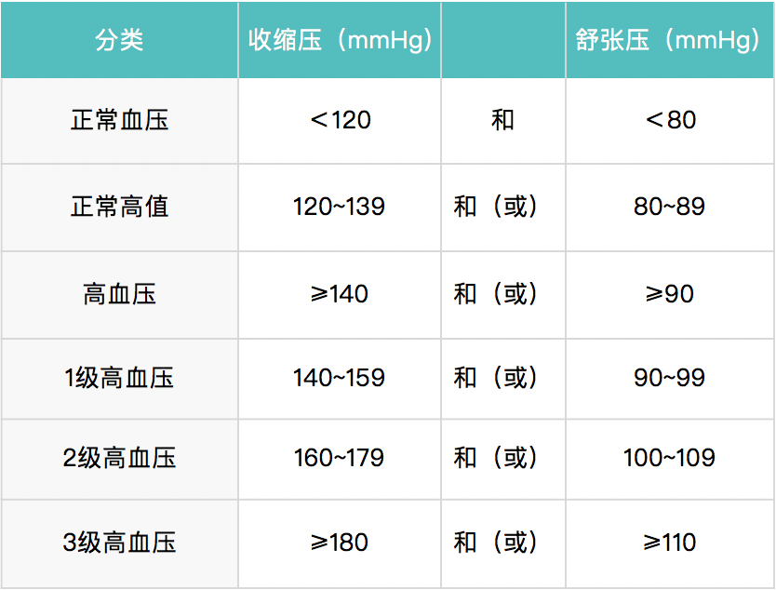**（高血压（也称血压升高），是血液在流动时对血管壁造成的压力值持续高于正常的现象，**既往《中国高血压防治指南》根据血压升高的水平，可将高血压分为高血压1级（轻度）、2级（中度）、3级（重度）**）**

1. **Causes**

**Hypertension is a "lifestyle disease", and many daily behaviors and habits are risk factors for hypertension. For example, high sodium and low potassium diet, overweight and obesity, excessive alcohol consumption, chronic mental stress, insufficient physical activity, family history of hypertension, combined diabetes, dyslipidemia, etc**

**(**高血压发病原因不明确，更多谈及其危险因素，包括遗传因素、年龄以及不良生活方式等多方面，其中70%-80%的高血压发生与不健康的生活方式有关。随着高血压危险因素聚集，高血压患病风险就会增大。高血压是一种“生活方式疾病”，很多日常行为习惯是高血压发生的危险因素,例如高钠低钾饮食，超重和肥胖，过量饮酒，长期精神紧张，体力活动不足，高血压家族史、合并糖尿病、血脂异常等)

1. **current situation**

**The prevalence of hypertension continues to rise in our country. According to the latest epidemiological survey, the prevalence of hypertension in residents aged 18 and above is about 27.9%, which means that there are about 300 million hypertension patients in China. Moreover, the incidence of hypertension shows a younger trend, and the prevalence of hypertension in some young people (such as 30-40 years old) is gradually increasing.**

**Although the awareness rate, treatment rate and control rate of hypertensive patients in China have been improved, they are still at a low level. The awareness rate was about 51.6%, that is, only about half of the patients knew that they had hypertension; The treatment rate was 45.8%. The control rate was only 16.8%. This means that most people with high blood pressure are not effectively controlled and still face a higher risk of complications such as cardiovascular disease.**

**（**我国高血压的患病率持续上升。根据最新的流行病学调查显示，我国 18 岁及以上居民高血压患病率约为 27.9%，这意味着我国约有 3 亿左右的高血压患者。而且高血压的发病呈现年轻化趋势，在一些年轻人群体（如 30 - 40 岁）中的患病率也在逐渐增加。

我国高血压患者的知晓率、治疗率和控制率虽然较以往有所提高，但仍处于较低水平。知晓率约为 51.6%，即只有一半左右的患者知道自己患有高血压；治疗率约为 45.8%；控制率仅为 16.8%。这意味着大部分高血压患者的血压没有得到有效控制，仍然面临着较高的心血管疾病等并发症的风险。）

**Part2.iwmpact of diabetes mellitus**

I.The impact on the individual

1. Cardiovascular system. It increases the risk of coronary heart disease and can cause angina pectoris and myocardial infarction.

Easy to lead to heart failure, dyspnea, fatigue, edema and other symptoms.

It may cause arrhythmias, such as atrial fibrillation and premature ventricular contractions, and increase the risk of thromboembolism.

2. Cerebrovascular system. It is the primary risk factor for stroke, including cerebral hemorrhage and cerebral infarction, which can lead to hemiplegia, aphasia and other severe disabilities.

3 Kidney. Damage to renal arterioles, cause renal dysfunction, severe can develop into renal failure.

4. Eyes. Cause retinopathy, decreased vision, fundus hemorrhage, and even blindness.

II, the impact on society

1. Financial burden. The medical costs of patients are high, including long-term medication, examination, and hospitalization.

Indirect economic loss due to loss of patient labor force.

A large number of patients with hypertension require long-term treatment and management, which takes up a lot of medical resources and poses a challenge to the health care system.

一、对个体的影响

1.心血管系统。增加冠心病风险，可引发心绞痛、心肌梗死。

易导致心力衰竭，出现呼吸困难、乏力、水肿等症状。

可能引起心律失常，如心房颤动、室性早搏等，增加血栓栓塞风险。

2.脑血管系统。是脑卒中的首要危险因素，包括脑出血和脑梗死，可致偏瘫、失语等严重残疾。

3肾脏.损害肾脏小动脉，引发肾功能减退，严重时可发展为肾衰竭。

4.眼睛。造成视网膜病变，出现视力下降、眼底出血等，甚至失明。

二、对社会的影响

1.经济负担。患者的医疗费用高昂，包括长期用药、检查、住院治疗等费用。

因患者劳动力丧失造成间接经济损失。

2.医疗资源压力大量高血压患者需要长期治疗和管理，占用大量医疗资源，给医疗系统带来挑战。

**Part4.new technology and medicine for the disease**

**（孙，徐，解）**

1. **technology(major)**

Healthcare big data plays an important role in **Hypertension** research in many aspects:

1. Disease surveillance and risk assessment

Early detection of at-risk groups

Dynamic monitoring of disease progression

2. Optimization of treatment plan

Evaluation of drug efficacy

Personalized treatment planning (also known as precision medicine)

Iii. Disease mechanism research

New pathogenic factors were found

Study the pathophysiological processes of disease

健康医疗大数据在糖尿病研究中发挥着多方面的重要作用：

一、疾病监测与风险评估

早期发现风险人群

动态监测病情进展

二、治疗方案优化

药物疗效评估

个性化治疗方案制定（也叫做精确医疗）

三、疾病机制研究

发现新的发病因素

研究疾病的病理生理过程