1. 新建一台虚拟机作为elk。
2. 在新建的虚拟机先执行：

mkdir -p /var/local/dcm4chee-arc/logstash

chown 1000:1000 /var/local/dcm4chee-arc/logstash

1. 在所有的机器上执行：

echo "Asia/shanghai" > /etc/timezone

cp /usr/share/zoneinfo/Asia/Shanghai /etc/localtime

1. 在新建的虚拟机上修改内核参数：

sysctl -w vm.swappiness=1

echo 'vm.swappiness=1' >> /etc/sysctl.conf

sysctl -w vm.max_map_count=262144

echo 'vm.max_map_count=262144' >> /etc/sysctl.conf

1. 在新建的虚拟机上创建docker网络：

docker network create dcm4chee_default

1. 在新建的虚拟机上创建三个容器，分别对应ELK：

docker run --network=dcm4chee_default --name elasticsearch \

-e ES_JAVA_OPTS="-Xms512m -Xmx512m" \

-e TAKE_FILE_OWNERSHIP=1 \

-e discovery.type=single-node \

-p 9200:9200 \

-p 9300:9300 \

-v /etc/localtime:/etc/localtime:ro \

-v /etc/timezone:/etc/timezone:ro \

-v /var/local/dcm4chee-arc/elasticsearch:/usr/share/elasticsearch/data \

-d docker.elastic.co/elasticsearch/elasticsearch-oss:7.2.0

docker run --network=dcm4chee_default --name kibana \

-p 5601:5601 \

-v /etc/localtime:/etc/localtime:ro \

-v /etc/timezone:/etc/timezone:ro \

-d docker.elastic.co/kibana/kibana-oss:7.2.0

docker run --network=dcm4chee_default --name logstash \

-p 12201:12201/udp \

-p 8514:8514/udp \

-p 8514:8514 \

-v /etc/localtime:/etc/localtime:ro \

-v /etc/timezone:/etc/timezone:ro \

-v /var/local/dcm4chee-arc/logstash/filter-hashtree:/usr/share/logstash/data/filter-hashtree \

-d dcm4che/logstash-dcm4chee:7.2.0-9

1. 启动ldap，dcm4che和keycloak，并登录：<http://172.16.0.11:8080/dcm4chee-arc/ui2>，以admin身份登录。

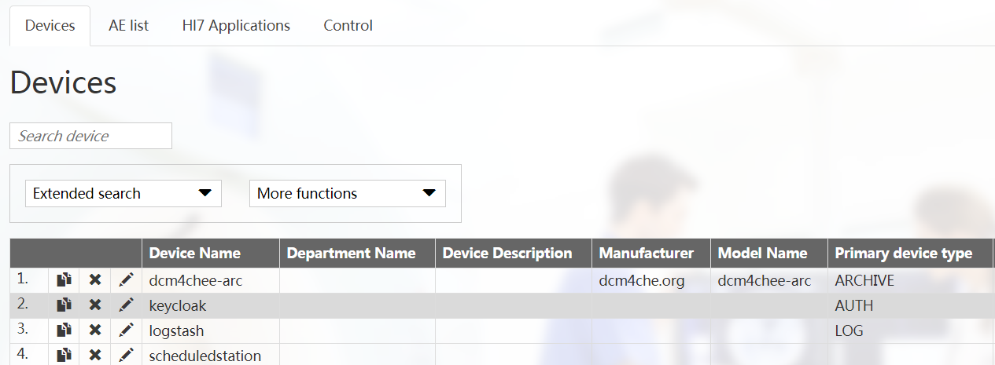

点击logstash。

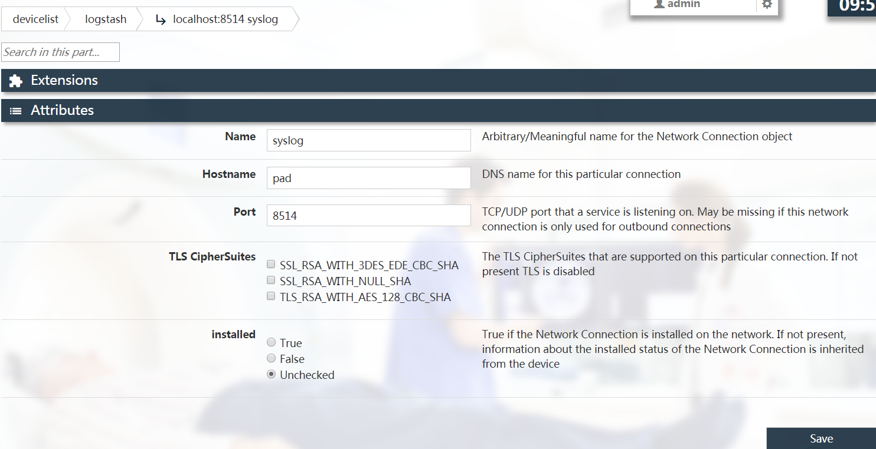

这里把端口改为8514，并把localhost改为新建的那台虚拟机的主机名，前提是dcm4che和keycloack服务器都能识别到该主机名对应的ip，保存。

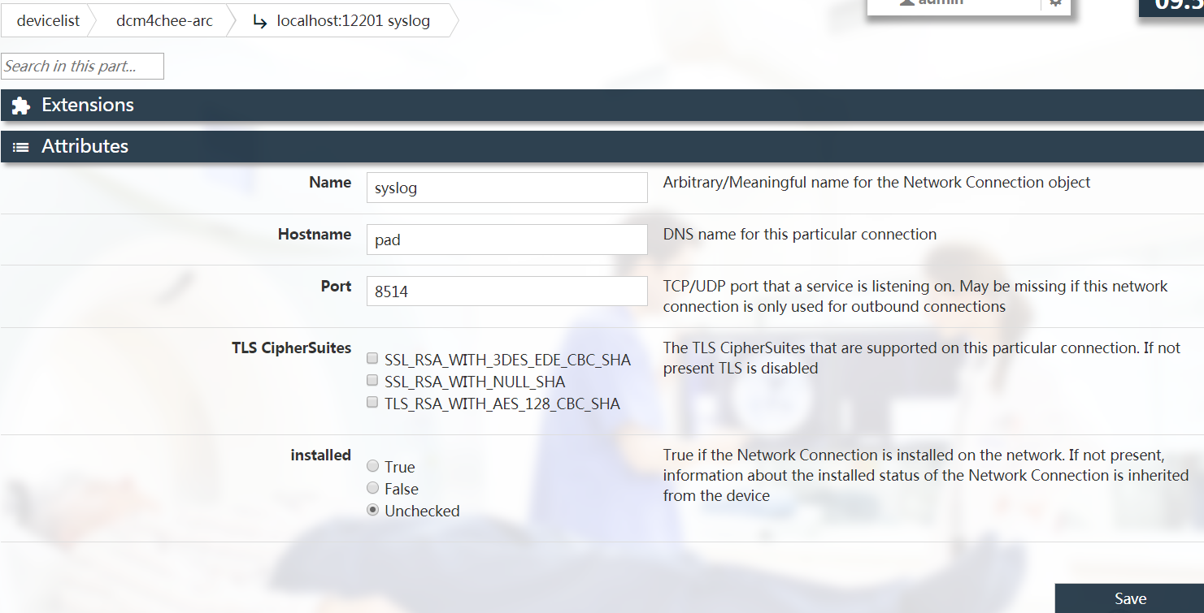

这里把端口改为8514，并把localhost改为新建的那台虚拟机的主机名，前提是dcm4che和keycloack服务器都能识别到该主机名对应的ip，保存。

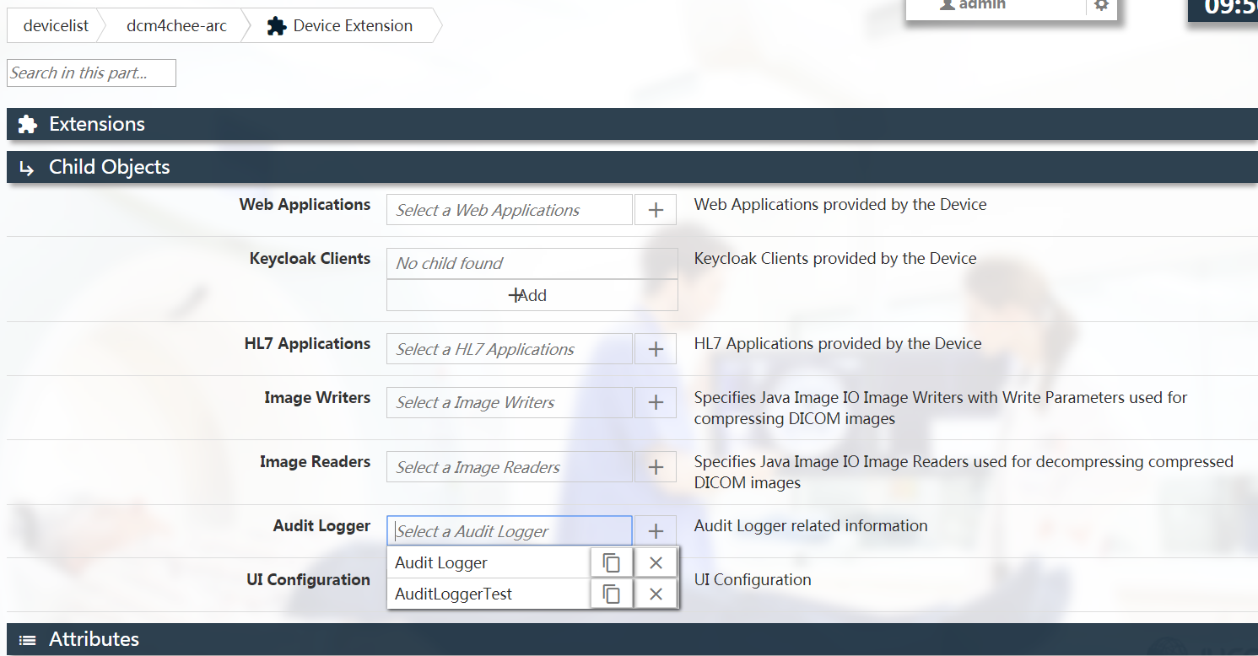

1. 登录kibana。

<http://172.16.0.19:5601/app/kibana>

然而没有找到index pattern。

如果抓包则有如下显示：

10:59:59,644 INFO [org.dcm4che3.net.audit.AuditLogger] (EE-ManagedScheduledExecutorService-default-Thread-2) Send audit message to pad/172.16.0.19:8514

[root@pad ~]# tcpdump -i enp0s8 port 8514

tcpdump: verbose output suppressed, use -v or -vv for full protocol decode

listening on enp0s8, link-type EN10MB (Ethernet), capture size 262144 bytes

11:00:10.961687 IP 172.16.0.11.53040 > pad.8514: UDP, bad length 1886 > 1472

11:00:11.210849 IP 172.16.0.11.40461 > pad.8514: UDP, bad length 1824 > 1472

试图更改端口号：

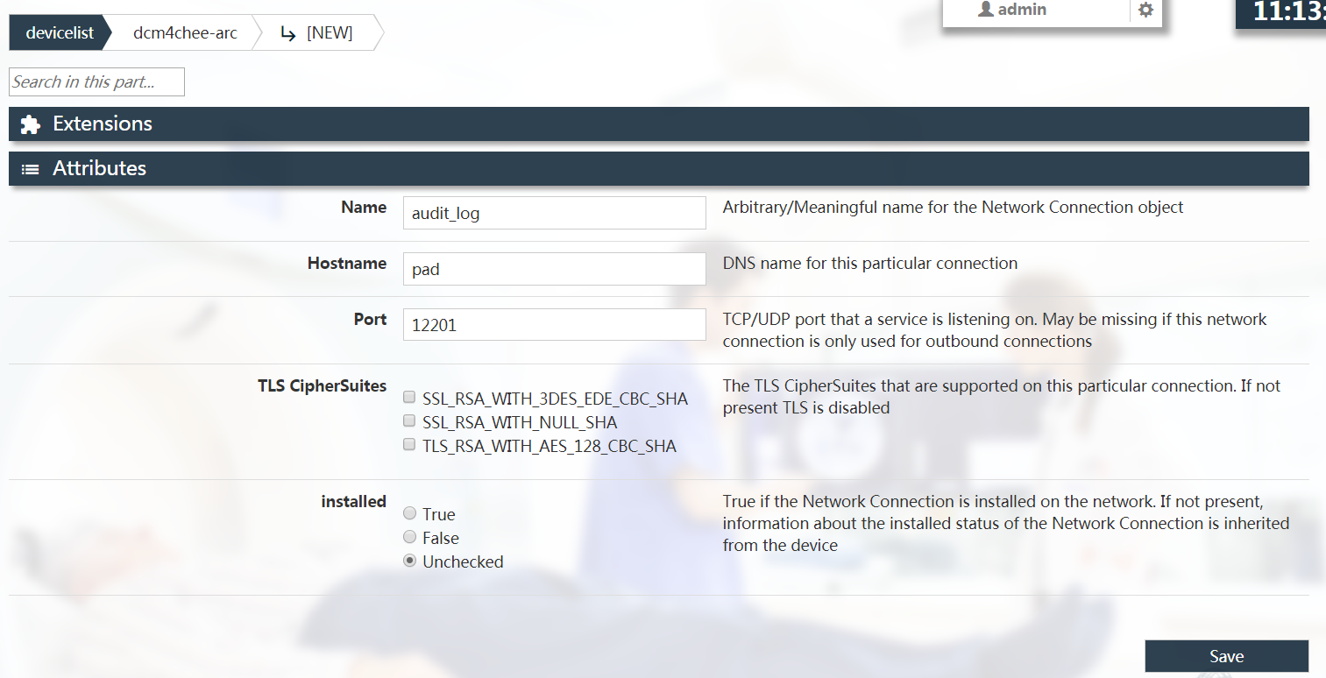

更改

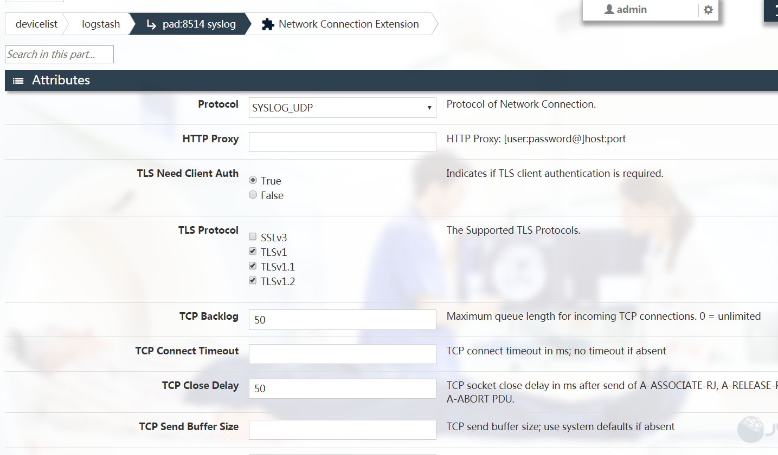

把UDP改成TLS。

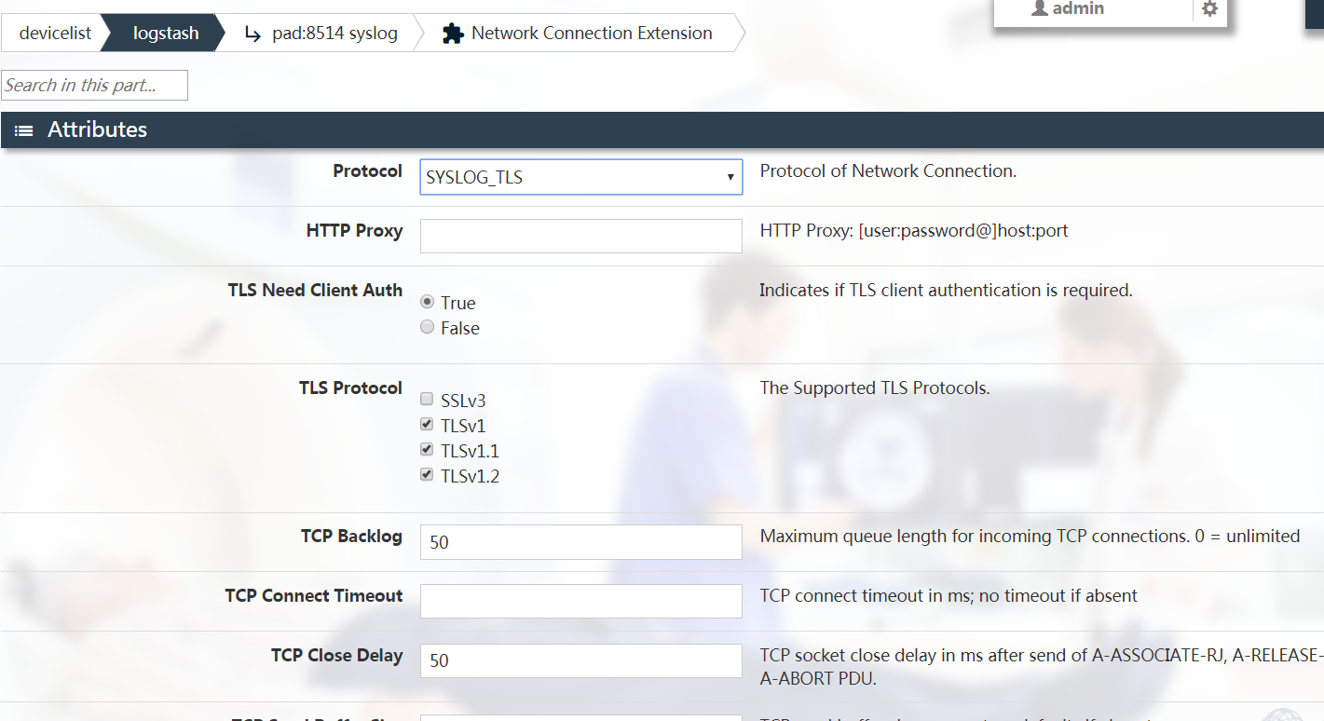

发现不行。

1. 重启服务器后，发现服务起不来，报错：

21:48:49,828 ERROR [org.jboss.msc.service.fail] (ServerService Thread Pool -- 104) MSC000001: Failed to start service jboss.deployment.subunit."dcm4chee-arc-ear-5.17.1-mysql-secure.ear"."dcm4chee-arc-service-5.17.1.jar".component.ArchiveServiceImpl.START: org.jboss.msc.service.StartException in service jboss.deployment.subunit."dcm4chee-arc-ear-5.17.1-mysql-secure.ear"."dcm4chee-arc-service-5.17.1.jar".component.ArchiveServiceImpl.START: java.lang.IllegalStateException: WFLYEE0042: Failed to construct component instance

at org.jboss.as.ee.component.ComponentStartService$1.run(ComponentStartService.java:57)

at java.util.concurrent.Executors$RunnableAdapter.call(Executors.java:511)

at java.util.concurrent.FutureTask.run(FutureTask.java:266)

at org.jboss.threads.ContextClassLoaderSavingRunnable.run(ContextClassLoaderSavingRunnable.java:35)

at org.jboss.threads.EnhancedQueueExecutor.safeRun(EnhancedQueueExecutor.java:1982)

at org.jboss.threads.EnhancedQueueExecutor$ThreadBody.doRunTask(EnhancedQueueExecutor.java:1486)

at org.jboss.threads.EnhancedQueueExecutor$ThreadBody.run(EnhancedQueueExecutor.java:1377)

at java.lang.Thread.run(Thread.java:748)

at org.jboss.threads.JBossThread.run(JBossThread.java:485)

Caused by: java.lang.IllegalStateException: WFLYEE0042: Failed to construct component instance

at org.jboss.as.ee.component.BasicComponent.constructComponentInstance(BasicComponent.java:163)

at org.jboss.as.ee.component.BasicComponent.constructComponentInstance(BasicComponent.java:134)

at org.jboss.as.ee.component.BasicComponent.createInstance(BasicComponent.java:88)

at org.jboss.as.ejb3.component.singleton.SingletonComponent.getComponentInstance(SingletonComponent.java:127)

at org.jboss.as.ejb3.component.singleton.SingletonComponent.start(SingletonComponent.java:141)

at org.jboss.as.ee.component.ComponentStartService$1.run(ComponentStartService.java:54)

... 8 more

Caused by: javax.ejb.EJBException: java.lang.RuntimeException: java.io.IOException: Cannot start UDP listener on pad:8514

at org.jboss.as.ejb3.tx.CMTTxInterceptor.invokeInOurTx(CMTTxInterceptor.java:246)

at org.jboss.as.ejb3.tx.CMTTxInterceptor.requiresNew(CMTTxInterceptor.java:388)

at org.jboss.as.ejb3.tx.LifecycleCMTTxInterceptor.processInvocation(LifecycleCMTTxInterceptor.java:68)

at org.jboss.invocation.InterceptorContext.proceed(InterceptorContext.java:422)

at org.jboss.as.weld.injection.WeldInjectionContextInterceptor.processInvocation(WeldInjectionContextInterceptor.java:43)

at org.jboss.invocation.InterceptorContext.proceed(InterceptorContext.java:422)

at org.jboss.as.ejb3.component.interceptors.CurrentInvocationContextInterceptor.processInvocation(CurrentInvocationContextInterceptor.java:41)

at org.jboss.invocation.InterceptorContext.proceed(InterceptorContext.java:422)

at org.jboss.as.ee.concurrent.ConcurrentContextInterceptor.processInvocation(ConcurrentContextInterceptor.java:45)

at org.jboss.invocation.InterceptorContext.proceed(InterceptorContext.java:422)

at org.jboss.invocation.ContextClassLoaderInterceptor.processInvocation(ContextClassLoaderInterceptor.java:60)

at org.jboss.invocation.InterceptorContext.proceed(InterceptorContext.java:422)

at org.jboss.as.ejb3.component.singleton.StartupCountDownInterceptor.processInvocation(StartupCountDownInterceptor.java:25)

at org.jboss.invocation.InterceptorContext.proceed(InterceptorContext.java:422)

at org.jboss.invocation.ChainedInterceptor.processInvocation(ChainedInterceptor.java:53)

at org.jboss.as.ee.component.BasicComponent.constructComponentInstance(BasicComponent.java:161)

... 13 more

Caused by: java.lang.RuntimeException: java.io.IOException: Cannot start UDP listener on pad:8514

at org.dcm4chee.arc.impl.ArchiveServiceImpl.init(ArchiveServiceImpl.java:173)

at sun.reflect.NativeMethodAccessorImpl.invoke0(Native Method)

at sun.reflect.NativeMethodAccessorImpl.invoke(NativeMethodAccessorImpl.java:62)

at sun.reflect.DelegatingMethodAccessorImpl.invoke(DelegatingMethodAccessorImpl.java:43)

at java.lang.reflect.Method.invoke(Method.java:498)

at org.jboss.as.ee.component.ManagedReferenceLifecycleMethodInterceptor.processInvocation(ManagedReferenceLifecycleMethodInterceptor.java:96)

at org.jboss.invocation.InterceptorContext.proceed(InterceptorContext.java:422)

at org.jboss.invocation.InterceptorContext$Invocation.proceed(InterceptorContext.java:509)

at org.jboss.as.weld.interceptors.Jsr299BindingsInterceptor.delegateInterception(Jsr299BindingsInterceptor.java:79)

at org.jboss.as.weld.interceptors.Jsr299BindingsInterceptor.doLifecycleInterception(Jsr299BindingsInterceptor.java:126)

at org.jboss.as.weld.interceptors.Jsr299BindingsInterceptor.processInvocation(Jsr299BindingsInterceptor.java:112)

at org.jboss.invocation.InterceptorContext.proceed(InterceptorContext.java:422)

at org.jboss.invocation.InterceptorContext$Invocation.proceed(InterceptorContext.java:509)

at org.jboss.weld.module.ejb.AbstractEJBRequestScopeActivationInterceptor.aroundInvoke(AbstractEJBRequestScopeActivationInterceptor.java:81)

at org.jboss.as.weld.ejb.EjbRequestScopeActivationInterceptor.processInvocation(EjbRequestScopeActivationInterceptor.java:89)

at org.jboss.invocation.InterceptorContext.proceed(InterceptorContext.java:422)

at org.jboss.as.weld.injection.WeldInjectionInterceptor.processInvocation(WeldInjectionInterceptor.java:53)

at org.jboss.invocation.InterceptorContext.proceed(InterceptorContext.java:422)

at org.jboss.as.ee.component.ManagedReferenceFieldInjectionInterceptorFactory$ManagedReferenceFieldInjectionInterceptor.processInvocation(ManagedReferenceFieldInjectionInterceptorFactory.java:112)

at org.jboss.invocation.InterceptorContext.proceed(InterceptorContext.java:422)

at org.jboss.as.ee.component.ManagedReferenceFieldInjectionInterceptorFactory$ManagedReferenceFieldInjectionInterceptor.processInvocation(ManagedReferenceFieldInjectionInterceptorFactory.java:112)

at org.jboss.invocation.InterceptorContext.proceed(InterceptorContext.java:422)

at org.jboss.as.ee.component.AroundConstructInterceptorFactory$1.processInvocation(AroundConstructInterceptorFactory.java:28)

at org.jboss.invocation.InterceptorContext.proceed(InterceptorContext.java:422)

at org.jboss.as.weld.injection.WeldInterceptorInjectionInterceptor.processInvocation(WeldInterceptorInjectionInterceptor.java:56)

at org.jboss.invocation.InterceptorContext.proceed(InterceptorContext.java:422)

at org.jboss.as.weld.interceptors.Jsr299BindingsCreateInterceptor.processInvocation(Jsr299BindingsCreateInterceptor.java:111)

at org.jboss.invocation.InterceptorContext.proceed(InterceptorContext.java:422)

at org.jboss.as.ee.component.NamespaceContextInterceptor.processInvocation(NamespaceContextInterceptor.java:50)

at org.jboss.invocation.InterceptorContext.proceed(InterceptorContext.java:422)

at org.jboss.as.ejb3.tx.CMTTxInterceptor.invokeInOurTx(CMTTxInterceptor.java:237)

... 28 more

Caused by: java.io.IOException: Cannot start UDP listener on pad:8514

at org.dcm4che3.net.UDPListener.<init>(UDPListener.java:64)

at org.dcm4che3.net.Connection.bind(Connection.java:901)

at org.dcm4che3.net.Device.bindConnections(Device.java:746)

at org.dcm4chee.arc.impl.ArchiveServiceImpl.start(ArchiveServiceImpl.java:193)

at org.dcm4chee.arc.impl.ArchiveServiceImpl.init(ArchiveServiceImpl.java:167)

... 58 more

Caused by: java.net.BindException: Cannot assign requested address (Bind failed)

at java.net.PlainDatagramSocketImpl.bind0(Native Method)

at java.net.AbstractPlainDatagramSocketImpl.bind(AbstractPlainDatagramSocketImpl.java:93)

at java.net.DatagramSocket.bind(DatagramSocket.java:392)

at java.net.DatagramSocket.<init>(DatagramSocket.java:242)

at org.dcm4che3.net.UDPListener.<init>(UDPListener.java:62)

... 62 more

21:48:50,586 ERROR [org.jboss.as.controller.management-operation] (Controller Boot Thread) WFLYCTL0013: Operation ("add") failed - address: ([("deployment" => "dcm4chee-arc-ear-5.17.1-mysql-secure.ear")]) - failure description: {"WFLYCTL0080: Failed services" => {"jboss.deployment.subunit.\"dcm4chee-arc-ear-5.17.1-mysql-secure.ear\".\"dcm4chee-arc-service-5.17.1.jar\".component.ArchiveServiceImpl.START" => "java.lang.IllegalStateException: WFLYEE0042: Failed to construct component instance

Caused by: java.lang.IllegalStateException: WFLYEE0042: Failed to construct component instance

Caused by: javax.ejb.EJBException: java.lang.RuntimeException: java.io.IOException: Cannot start UDP listener on pad:8514

Caused by: java.lang.RuntimeException: java.io.IOException: Cannot start UDP listener on pad:8514

Caused by: java.io.IOException: Cannot start UDP listener on pad:8514

Caused by: java.net.BindException: Cannot assign requested address (Bind failed)"}}

21:48:50,691 INFO [org.jboss.as.server] (Controller Boot Thread) WFLYSRV0010: Deployed "dcm4chee-arc-ear-5.17.1-mysql-secure.ear" (runtime-name : "dcm4chee-arc-ear-5.17.1-mysql-secure.ear")

21:48:50,742 INFO [org.jboss.as.controller] (Controller Boot Thread) WFLYCTL0183: Service status report

WFLYCTL0186: Services which failed to start: service jboss.deployment.subunit."dcm4chee-arc-ear-5.17.1-mysql-secure.ear"."dcm4chee-arc-service-5.17.1.jar".component.ArchiveServiceImpl.START: java.lang.IllegalStateException: WFLYEE0042: Failed to construct component instance

WFLYCTL0448: 2 additional services are down due to their dependencies being missing or failed

1. 解决办法：
2. 删掉wildfly部署的数据重新部署发现不行，怀疑数据存放在mysql或ldap。
3. 需要在ldap修改：

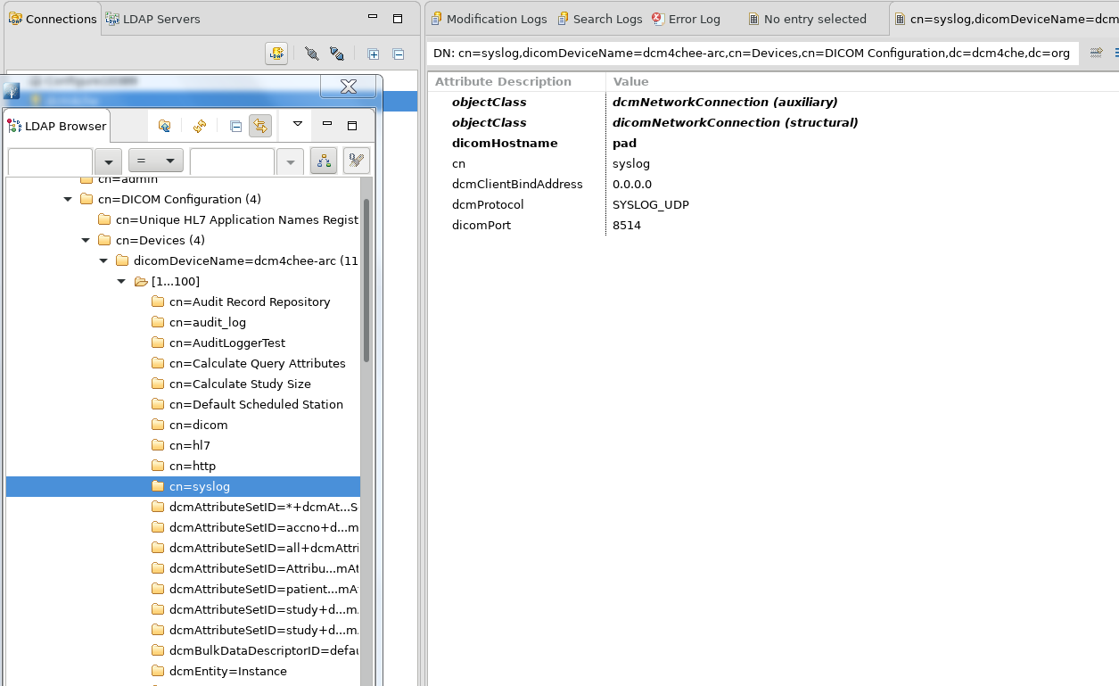

把dicomHostname、BindAddress和dicomPort改为原来的。

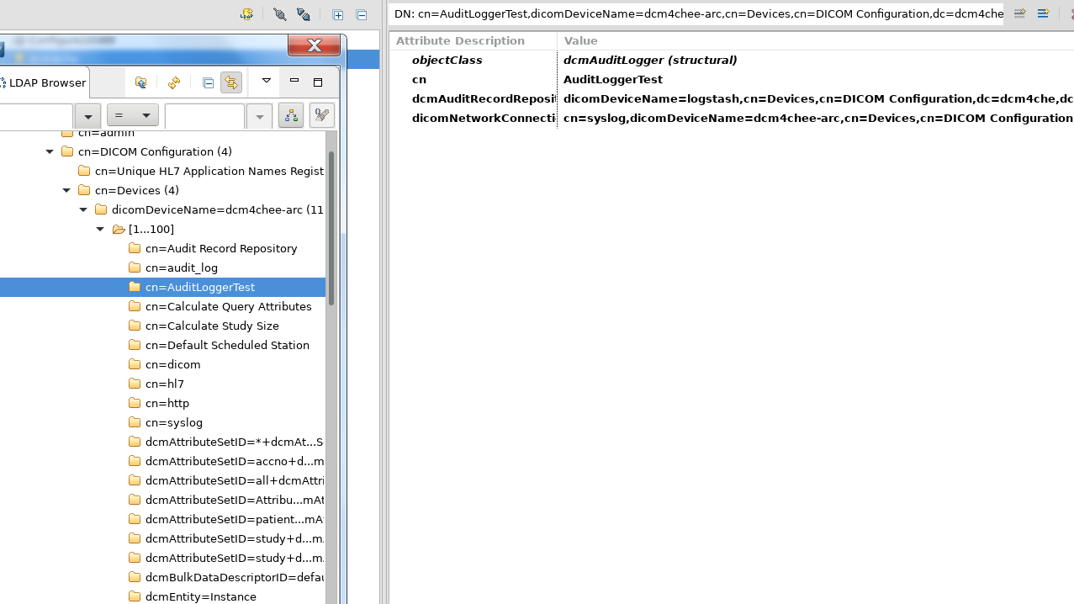

以及把cn=audit_log和cn=AuditloggerTest都删掉(都是自己建立的一些)。

然而后来wilfly起来了，但keycloak那边认证出错，因此把dcm4chee进行回滚。

1. 不知为何添加会出现错误：

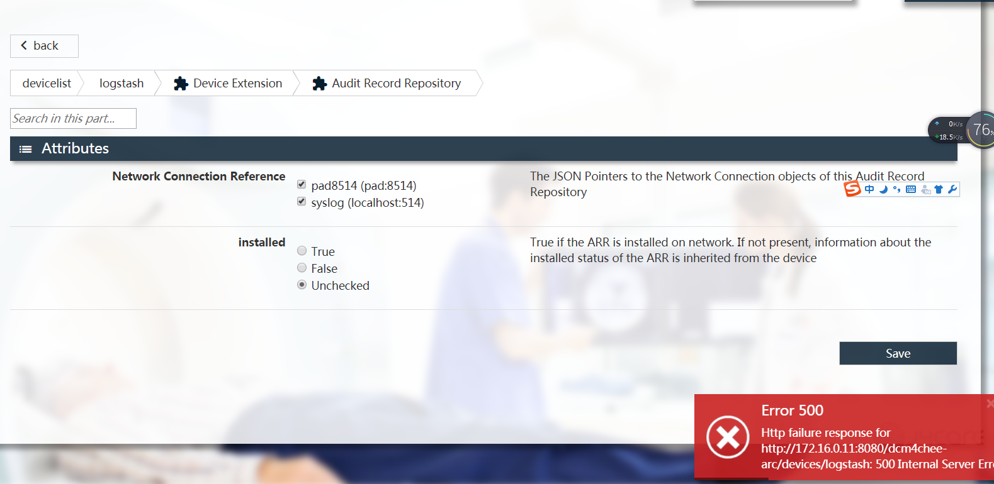

然而这样就能成功：

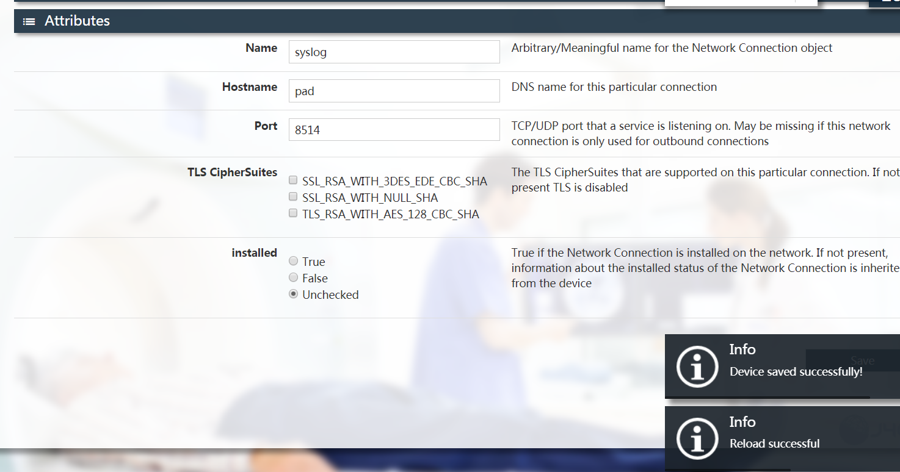

改了之后会有：

10:20:14,490 INFO [org.dcm4che3.net.audit.AuditLogger] (EE-ManagedScheduledExecutorService-default-Thread-1) Send audit message to pad/172.16.0.19:8514

10:21:14,597 INFO [org.dcm4che3.net.audit.AuditLogger] (EE-ManagedScheduledExecutorService-default-Thread-1) Send audit message to pad/172.16.0.19:8514

但是在elk服务器端捉包会显示错误：

10:22:07.085266 IP 172.16.0.11.44927 > pad.8514: UDP, bad length 1892 > 1472

10:22:07.098305 IP 172.16.0.11.44927 > pad.8514: UDP, bad length 1847 > 1472

然而虚拟机网卡不支持udp分片：

[root@localhost bin]# ethtool -K enp0s8 ufo on

Cannot change udp-fragmentation-offload

Could not change any device features

解决办法：把virtualbox的网卡控制芯片改为准虚拟化网络(virtio-net)。

然而重启后keycloak服务器又出了问题，只能将其回滚。个人怀疑是在dcm4chee的配置界面在logstash处增加了一个NetworkConnection导致的。

如果在删除的时候提示：element is referenced remove references first

则把名字改了再尝试删除，本人是成功的。

而且实践证明如果把那个添加的NetworkConnection删除掉重启keycloak没有出现崩溃的情况。

把keycloak服务器镜像回滚后已能成功启动并登录dcm4chee。

然而还是有错误：

[root@pad ~]# tcpdump -i eth0 port 8514

tcpdump: verbose output suppressed, use -v or -vv for full protocol decode

listening on eth0, link-type EN10MB (Ethernet), capture size 262144 bytes

14:11:10.857384 IP 172.16.0.11.55979 > pad.8514: UDP, bad length 1892 > 1472

现在试图把dcm4chee的网卡改为虚拟化网络(virtio-net)。

不过出现了新的问题，报了以下错误：

15:02:45,704 WARN [org.dcm4chee.arc.audit.AuditService] (EE-ManagedScheduledExecutorService-default-Thread-1) Failed to emit audit message for [AuditLogger=Audit Logger]

: org.dcm4che3.net.IncompatibleConnectionException: No compatible connection to AuditRecordRepository @ Device logstash available on AuditLogger @ Device dcm4chee-arc

at org.dcm4che3.net.audit.AuditLogger.activeConnection(AuditLogger.java:911)

at org.dcm4che3.net.audit.AuditLogger.sendMessage(AuditLogger.java:747)

at org.dcm4che3.net.audit.AuditLogger.write(AuditLogger.java:723)

at org.dcm4chee.arc.audit.AuditService.emitAuditMessage(AuditService.java:956)

at org.dcm4chee.arc.audit.AuditService.auditSoftwareConfiguration(AuditService.java:270)

at org.dcm4chee.arc.audit.AuditService.aggregateAuditMessage(AuditService.java:150)

at org.dcm4chee.arc.audit.AuditService.auditAndProcessFile(AuditService.java:369)

at sun.reflect.GeneratedMethodAccessor120.invoke(Unknown Source)

at sun.reflect.DelegatingMethodAccessorImpl.invoke(DelegatingMethodAccessorImpl.java:43)

at java.lang.reflect.Method.invoke(Method.java:498)

at org.jboss.weld.bean.proxy.AbstractBeanInstance.invoke(AbstractBeanInstance.java:38)

at org.jboss.weld.bean.proxy.ProxyMethodHandler.invoke(ProxyMethodHandler.java:106)

at org.dcm4chee.arc.audit.AuditService$Proxy$_$$_WeldClientProxy.auditAndProcessFile(Unknown Source)

at org.dcm4chee.arc.audit.AuditScheduler.execute(AuditScheduler.java:115)

at org.dcm4chee.arc.Scheduler.run(Scheduler.java:77)

at org.jboss.as.ee.concurrent.ControlPointUtils$ControlledScheduledRunnable.run(ControlPointUtils.java:158)

at java.util.concurrent.Executors$RunnableAdapter.call(Executors.java:511)

at java.util.concurrent.FutureTask.runAndReset(FutureTask.java:308)

at org.glassfish.enterprise.concurrent.internal.ManagedScheduledThreadPoolExecutor$ManagedScheduledFutureTask.access$201(ManagedScheduledThreadPoolExecutor.java:383)

at org.glassfish.enterprise.concurrent.internal.ManagedScheduledThreadPoolExecutor$ManagedScheduledFutureTask.run(ManagedScheduledThreadPoolExecutor.java:534)

at java.util.concurrent.ThreadPoolExecutor.runWorker(ThreadPoolExecutor.java:1149)

at java.util.concurrent.ThreadPoolExecutor$Worker.run(ThreadPoolExecutor.java:624)

at java.lang.Thread.run(Thread.java:748)

at org.glassfish.enterprise.concurrent.ManagedThreadFactoryImpl$ManagedThread.run(ManagedThreadFactoryImpl.java:250)

at org.jboss.as.ee.concurrent.service.ElytronManagedThreadFactory$ElytronManagedThread.run(ElytronManagedThreadFactory.java:85)

解决办法：

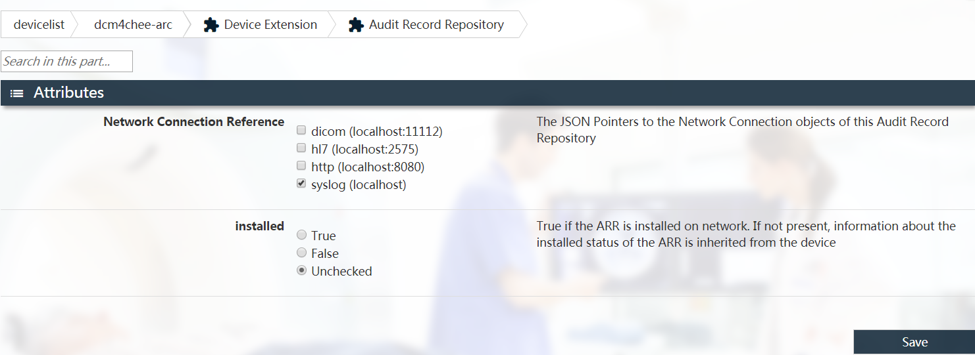

但并没有解决。

尝试在这里添加：

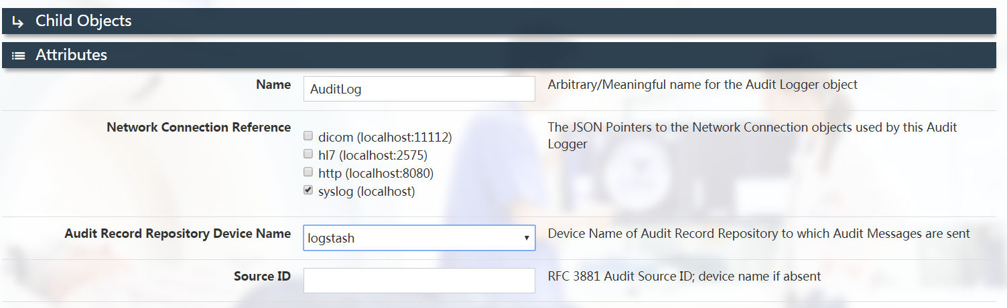

还是不行。

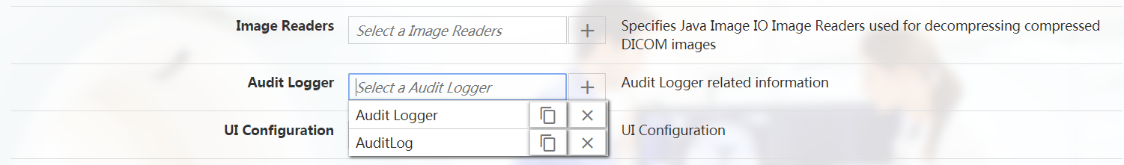

把Audit Logger删掉并保存。

然而还是报错：

org.dcm4che3.net.IncompatibleConnectionException: No compatible connection to AuditRecordRepository @ Device logstash available on AuditLogger @ Device dcm4chee-arc

只好重新启动dcm4chee的wildfly服务。

然而还是报了类似错误：

org.dcm4che3.net.IncompatibleConnectionException: No compatible connection to AuditRecordRepository @ Device logstash available on AuditLogger

问题根源：

需要在：

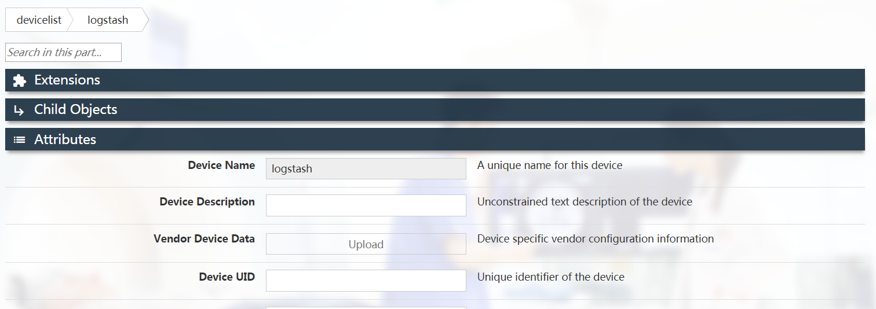

拉倒最下面，最下面的installed要选择true。

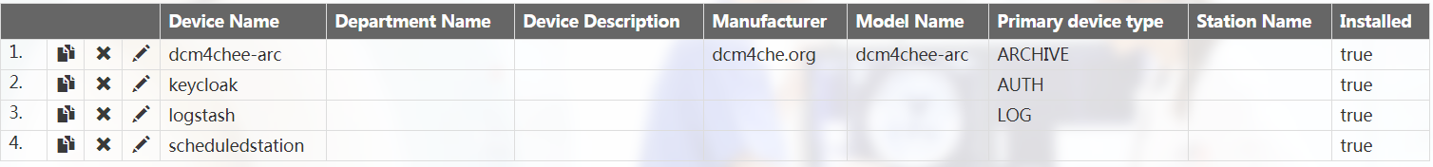

这里logstash需要显示的是true。

现在UDP显示正常：

15:59:19.614928 IP 172.16.0.11.56747 > pad.8514: UDP, length 1731

15:59:19.638471 IP 172.16.0.11.56747 > pad.8514: UDP, length 2242

15:59:19.648408 IP 172.16.0.11.56747 > pad.8514: UDP, length 2235

但是docker那边logstash自动退出了。有时不自动退出，但logstash没收到数据。

自动退出的几率大概是70%。

1. 关于elk docker的问题：

(1)找不到index pattern(之前如果是把8个容器都开启是可以找到的，本人估计是elasticsearch要先收到数据才会显示index pattern)：

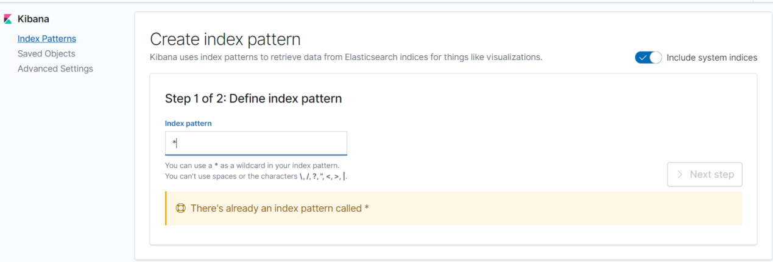

(2)elasticsearch没收到数据。

(3)很可能logstash没有处理来自8514端口的数据。