参照: <https://github.com/dcm4che/dcm4chee-arc-light/wiki/Run-secured-archive-services-and-Elastic-Stack-on-a-single-host>

1. 下载与安装Docker：
2. yum remove docker docker-common docker-selinux docker-engine
3. yum install -y yum-utils device-mapper-persistent-data lvm2
4. yum-config-manager -y --add-repo <https://download.docker.com/linux/centos/docker-ce.repo>
5. yum install -y docker-ce
6. systemctl start docker
7. systemctl enable docker
8. 下载与安装docker-compose：

curl -L "https://github.com/docker/compose/releases/download/1.24.1/docker-compose-$(uname -s)-$(uname -m)" -o /usr/local/bin/docker-compose

chmod +x /usr/local/bin/docker-compose

1. 新建一个目录，如/pacs，并进入目录。
2. touch docker-compose.yml docker-compose.env
3. 把<https://github.com/dcm4che/dcm4chee-arc-light/wiki/Run-secured-archive-services-and-Elastic-Stack-on-a-single-host>上面的内容分别对应复制到这两个文件。

可能需要修改里面hostname，ip之类的。

1. mkdir -p /var/local/dcm4chee-arc/logstash

chown 1000:1000 /var/local/dcm4chee-arc/logstash

1. echo "Asia/shanghai" > /etc/timezone

cp /usr/share/zoneinfo/Asia/Shanghai /etc/localtime

1. docker-compose -p dcm4chee up –d

compose完之后看到以下镜像和容器：

[root@pad ~]# docker image ls

REPOSITORY TAG IMAGE ID CREATED SIZE

dcm4che/dcm4chee-arc-psql 5.18.0-secure 35c287cc5d74 10 days ago 585MB

dcm4che/slapd-dcm4chee 2.4.44-18.0 732f81fb3645 10 days ago 164MB

dcm4che/keycloak 6.0.1 7c916907b9c2 10 days ago 638MB

dcm4che/logstash-dcm4chee 7.2.0-9 0c8c6197ed63 12 days ago 880MB

docker.elastic.co/kibana/kibana-oss 7.2.0 1e03c8c0c06e 7 weeks ago 594MB

docker.elastic.co/elasticsearch/elasticsearch-oss 7.2.0 1d6c081f3e56 7 weeks ago 768MB

dcm4che/keycloak-gatekeeper 6.0.1 a560f064090a 3 months ago 19.2MB

dcm4che/postgres-dcm4chee 11.2-16 c5949c05c8b6 5 months ago 312MB

[root@pad pacs]# docker ps

CONTAINER ID IMAGE COMMAND CREATED STATUS PORTS NAMES

90f0fb6a41a5 dcm4che/dcm4chee-arc-psql:5.18.0-secure "/docker-entrypoint.…" 2 minutes ago Up About a minute 0.0.0.0:2575->2575/tcp, 0.0.0.0:8080->8080/tcp, 0.0.0.0:8443->8443/tcp, 0.0.0.0:9990->9990/tcp, 0.0.0.0:11112->11112/tcp dcm4chee_arc_1

4759147f0386 dcm4che/keycloak-gatekeeper:6.0.1 "/opt/keycloak-gatek…" 2 minutes ago Up About a minute 0.0.0.0:8643->8643/tcp dcm4chee_keycloak-gatekeeper_1

d55535a880ec dcm4che/postgres-dcm4chee:11.2-16 "docker-entrypoint.s…" 2 minutes ago Up 2 minutes 0.0.0.0:5432->5432/tcp dcm4chee_db_1

4895bdded24d dcm4che/keycloak:6.0.1 "/docker-entrypoint.…" 2 minutes ago Up 2 minutes 0.0.0.0:8843->8843/tcp, 0.0.0.0:8880->8880/tcp, 0.0.0.0:8990->8990/tcp dcm4chee_keycloak_1

a4d228d4b9c8 dcm4che/logstash-dcm4chee:7.2.0-9 "/docker-entrypoint.…" 2 minutes ago Up 2 minutes 5044/tcp, 0.0.0.0:8514->8514/udp, 9600/tcp, 0.0.0.0:8514->8514/tcp, 0.0.0.0:12201->12201/udp dcm4chee_logstash_1

6694236f8e44 docker.elastic.co/kibana/kibana-oss:7.2.0 "/usr/local/bin/kiba…" 2 minutes ago Up 2 minutes 5601/tcp dcm4chee_kibana_1

e89cd091419f dcm4che/slapd-dcm4chee:2.4.44-18.0 "/docker-entrypoint.…" 2 minutes ago Up 2 minutes 0.0.0.0:389->389/tcp dcm4chee_ldap_1

c5438617167b docker.elastic.co/elasticsearch/elasticsearch-oss:7.2.0 "/usr/local/bin/dock…" 2 minutes ago Up 7 seconds 0.0.0.0:9200->9200/tcp, 0.0.0.0:9300->9300/tcp dcm4chee_elasticsearch_1

1. 把Archive UI注册到Keycloak的OpenID Connect Client：
2. 浏览器打开：

https://172.16.0.19:8843/auth/admin/dcm4che/console

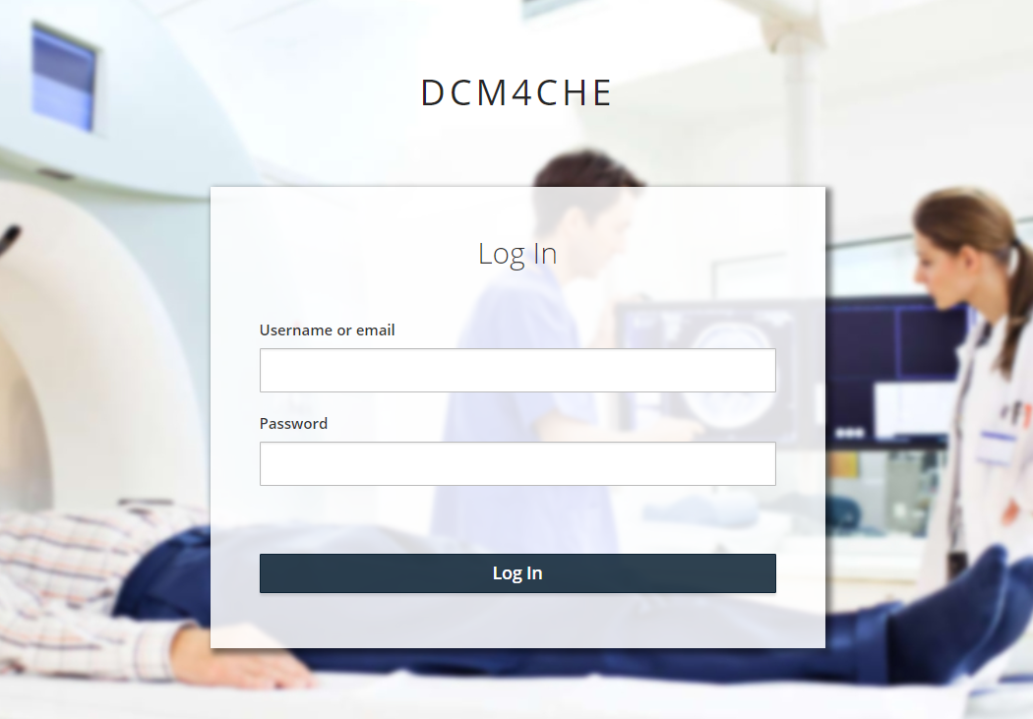

然而输入用户名：admin，密码：admin出现了如下错误信息：

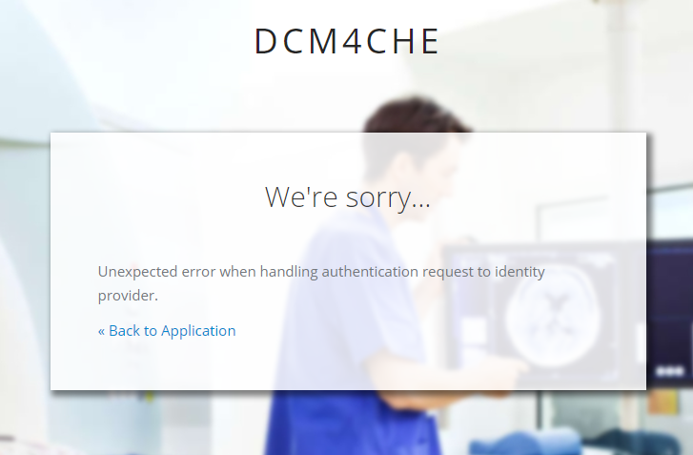

<https://172.16.0.19:8843/auth/>

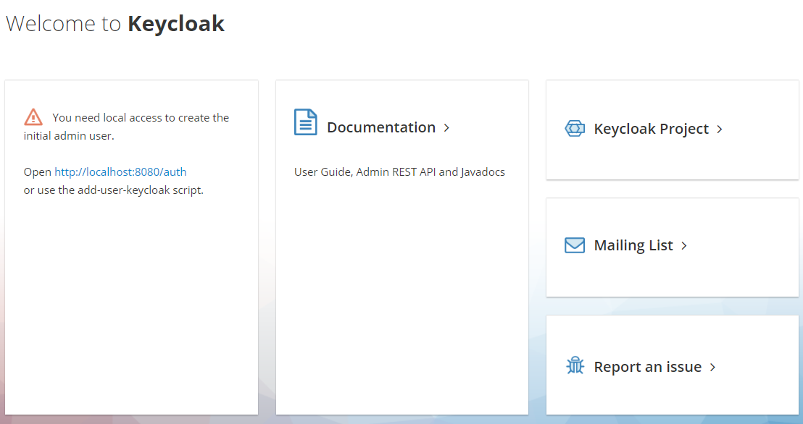

解决办法:

由于进程在docker里面pid是1，无法进入容器后修改配置文件重启服务。另外，由于容器之间有依赖关系，如果在docker-compose中修改entrypoint让服务进程在docker里面不是pid为1，容器先起来后再进入容器修改配置文件再启动服务，本人尝试过服务又起不来。

因此这里尝试在docker image上用RUN标签加layer的办法来修改配置文件，用新的docker image代替旧的：

1.

docker-compose -p dcm4chee stop

docker-compose -p dcm4chee down

docker rm $(docker ps -aq)

2.创建一个新目录，进入该目录，创建Dockerfile：

FROM dcm4che/keycloak:6.0.1

RUN sed -i 's/127.0.0.1/0.0.0.0/g' /docker-entrypoint.d/configuration/standalone.xml&&\

sed -i 's/127.0.0.1/0.0.0.0/g' /docker-entrypoint.d/configuration/keycloak-logstash.xml&&\

sed -i 's/127.0.0.1/0.0.0.0/g' /docker-entrypoint.d/configuration/keycloak-logstash.xml

3.docker build -t dcm4che/keycloak:6.0.1 .

4.回到docker-compose的目录：docker-compose -p dcm4chee up -d