1. Denis Lecleh

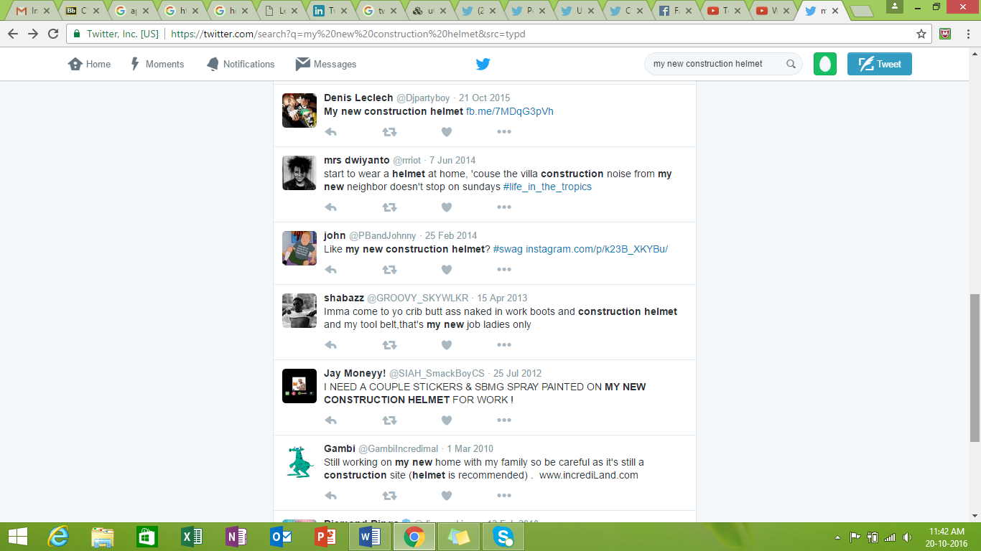

1. John



1. Jim Wogan

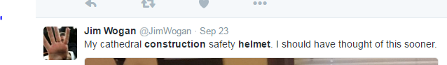

1. Jess



1. Jermaine

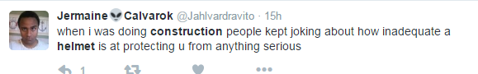

1. Shabazz



1. Jay Moneyy



1. Ella Kay

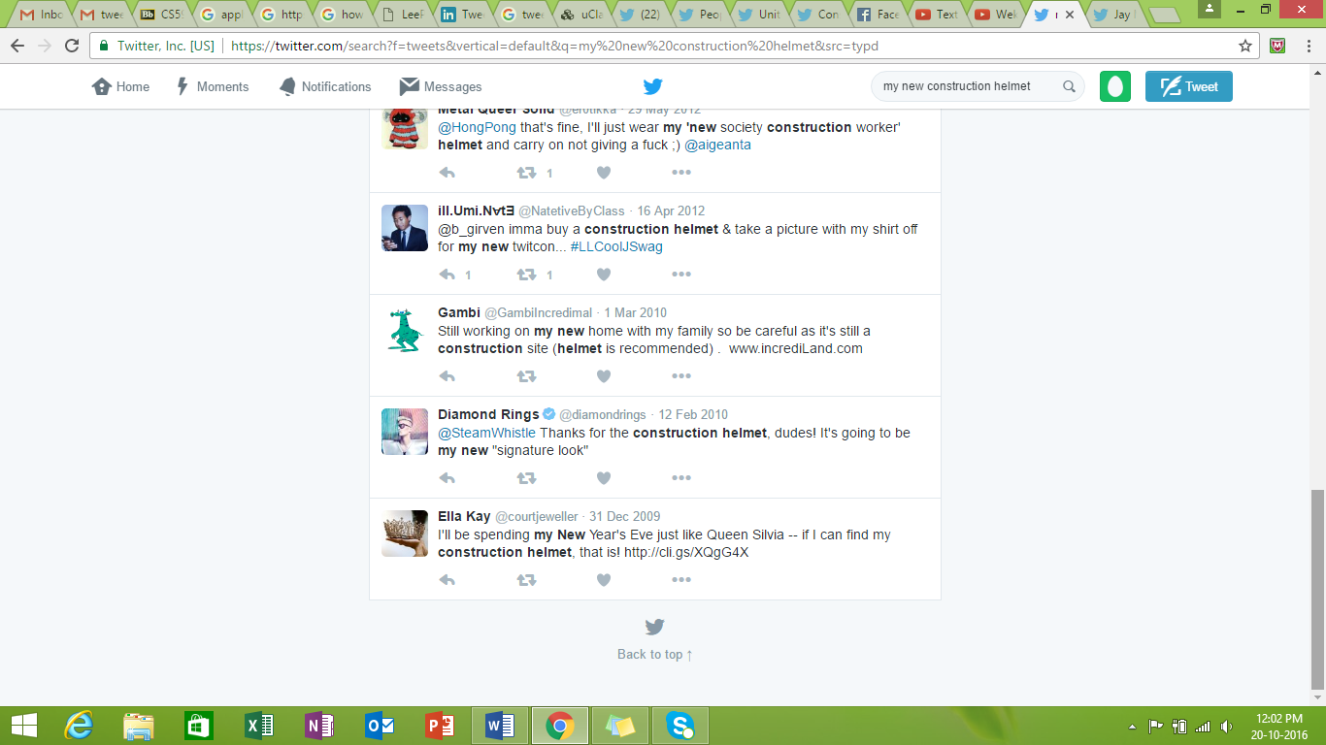

1. Diamond Rings

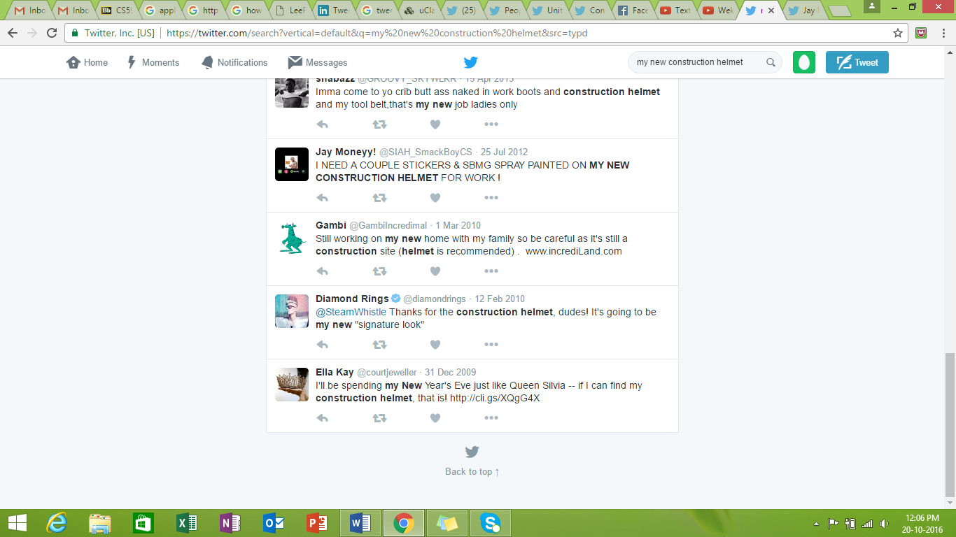

1. Jermaine



1. Oliver

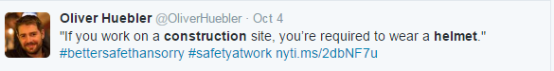

1. Hugh Jorgan

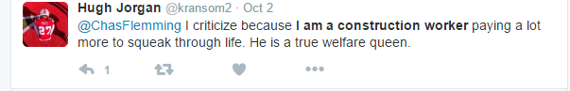

1. Sam

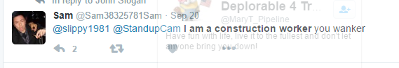

1. John Brinkley

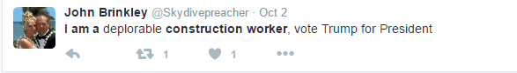

1. Larry Diviney

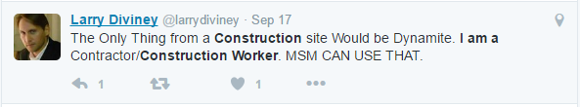

1. JFD

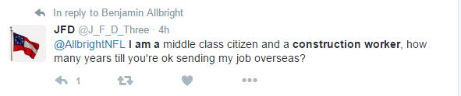

1. Scary Bean



1. Clever Nate



1. Samurai

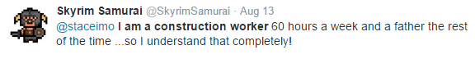

1. Chris Farrell

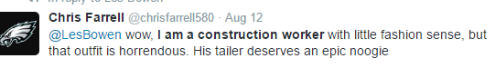

1. Mike

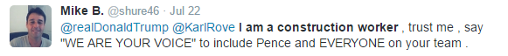

1. Mout Soulas

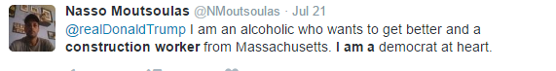

1. William Pollard

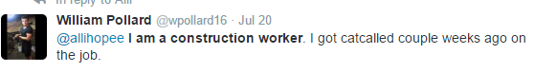

1. Ryan

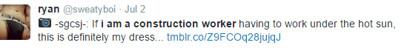

1. EastTexasHunter

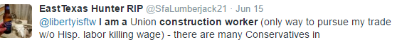

1. Jeff Dahlke

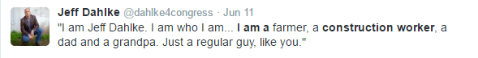

1. Terry Huang

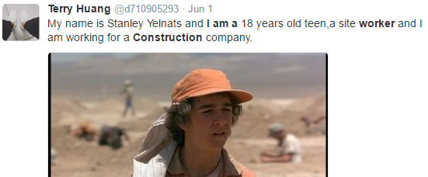

1. Brandon

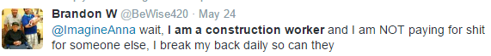

1. Lean



1. Mario



1. Martin

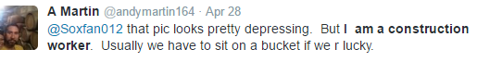

1. Jason Roley



1. Anthony



1. Robert



1. Jones

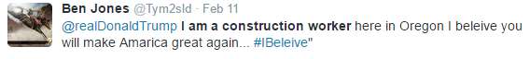

1. Zaira Thompson

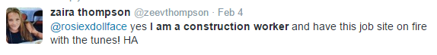

1. Andrew Carter

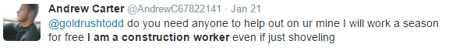

1. Dania



1. Shane Heubner

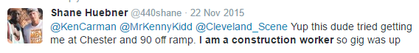

1. Michael

