Individual Recode Documentation

Liberia (DHSVII) Version 1 Doc 01 LB7

Name of Survey | 2019-20 Liberia Demographic and Health Survey
Executing Agency | Liberia Institute of Statistics and Geo-Information Services (LISGIS)
Year of Fieldwork | 2019-2020
Universe | Women age 15-49 (de facto).  Men 15-59 (de facto). Only 50% of the households were selected for man interview.
Coverage | National  Households 9,068  Women 8,065  Men 4,249  Household Members 41,999 42,093 (Weighted)  All Births 24,765 21,313 (Weighted)  Children < 60 Months 5,704 5,263 (Weighted) Couples 1,701 1,591 (Weighted)
Weights | Weighted by cluster
Contents | DHSVII
Language | English
Biomarker | Only for households selected for man interview. Anthropometry applied to children between 0 to 59 months; anemia testing applied to children age 6 to 59 months. Anthropometry and anemia test applied to women between 15 to 49 years old.
Calendar 2 columns

Domestic
violence One woman selected only in households selected for man interview.

Additional module Ebola (men and women)

Supplementary Data Household members

Recode Structure | DHS VII

Maximum entries in
Household schedule: 28

Sections and Variables Unused

HOUSEHOLD:

RECH0 HV019 HV026 HV031 HV032

RECH1 HV110 HV125 HV126 HV127 HV128 HV129

RECH2 HV232C HV232D HV232E HV234 HV236 HV237I HV237J HV237K HV239 HV240 HV243C HV243D HV246A HV246C HV246H HV246I HV246J HV246K HV253 HV253A HV253B HV253C HV253D HV253E HV253F HV253G HV253H HV253X HV253Z

RECH5 HA58 HA69

RECH6 HC58

RECH8 SB338 SB339 SB340

RECHMA HB2 HB3 HB4 HB6 HB12 HB12A HB12B HB13 HB21 HB32 HB33 HB35 HB40 HB41 HB50 HB51 HB52 HB53 HB55 HB56 HB57 HB58 HB69

RECHML HML5 HML6 HML8 HML9 HMLE

RECHMH HML16A HML30 HML31 HML32 HML32A HML32B HML32C HML32D HML32E HML32F HML32G HML33 HML35 HML36

RECHCL2 HCHL2E HCHL2F HCHL2G HCHL7G HCHL7H HCHL7I HCHL10 HCHL11 HCHL12H HCHL12I HCHL12J

RECHCDIS HCDI3L HCDI3M HCDI3N

WOMAN

REC01 V026 V029 V031 V032

REC11 V103 V131 V134 V156 V167 V168

REC31 V302 V305

REC32 V310 V311 V325A V363 V372 V372A V375A V376 V376A V379 V380 V3A00A V3A00B V3A00C V3A00D V3A00E V3A00F V3A00G V3A00H V3A00I V3A00J V3A00K V3A00L V3A00M V3A00N V3A00O V3A00P V3A00Q V3A00R V3A00S V3A00T V3A00U V3A00V V3A00W V3A00X V3A01 V3A08O V3A08W V3A08AA V3A08AB V3A08AC V3A08AD V3A09A V3A09B

REC41 M1B M1C M2D M2E M2F M2H M2I M2J M2L M2M M3D M3E M3F M3I M3J M3L M3M M27 M35 M36 M42A M42B M43 M44 M47 M48 M49B M49C M49D M49E M49F M49G M49X M49Z M49Y M54 M55A M55B M55C M55D M55E M55F M55G M55H M55I M55J M55K M55L M55M M55N M55O M55X M55Z M57C M57D M57I M57J M57K M57L M57O M57P M57Q M57R M57S M57T M57U M57V M65A M65B M65C M65D M65E M65F M65G M65H M65I M65J M65K M65L M65X M78F M78G M78H M78I M78J

REC42 V407 V408 V409A V410A V412 V412B V413A V413B V413C V413D V414A V414B V414C V414D V414R V414T V414U V414W V421 V458 V462 V463E V463I V463J V463K V463L V466 V467A V467E V467G V467H V467I V467J V467K V467L V467M V471A V471B V471C V471D V471E V471F V471G V472A V472B V472C V472D V472E V472F V472G V472H V472I V472J V472K V472L V472M V472N V472O V472P V472Q V472R V472S V472T V472U V474G V474H V474I V474J V477 V478 V479 V480 V481E V481F V481G V481H V482A V482B V482C

REC43 H9A H9AD H9AM H9AY H35 H36A H36B H36C H36D H36E H36F H40 H40D H40M H40Y H41A H41B H50 H50D H50M H50Y H80C H80D H80E H80F H80G

REC4A H11B H12F H12G H12H H12I H12O H12P H12Q H12R H12V H12W H13B H15J H15K H15L H15M H31D H31E H32F H32G H32H H32I H32P H32Q H32R H32V H32W H37A H37B H37C H37D H37DA H37E H37AA H37AB H37F H37G H37H H37I H37J H37K H37L H37M H37N H37O H37P H37X H44B H44C H45

REC44 HW58

REC51 V538 V539 V540 V541

REC61 V631 V633A V633C V633D V633E V633F V633G V634

REC71 V721 V740 V743C V743E

REC75 V754BP V762 V762A V762AA V762AB V762AC V762AD V762AE V762AF V762AG V762AH V762AI V762AJ V762AK V762AL V762AM V762AN V762AO V762AP V762AQ V762AR V762AS V762AT V762AU V762AV V762AW V762AX V762AZ V762BA V762BB V762BC V762BD V762BE V762BF V762BG V762BH V762BI V762BJ V762BK V762BL V762BM V762BN V762BO V762BP V762BQ V762BR V762BS V762BT V762BU V762BV V762BW V762BX V762BZ V763D V763E V763F V763G V768A V768B V768C V769 V769A V770G V770H V770I V770J V770Q V770R V770S V770U V770V V770W V775 V777 V778 V779 V780 V784G V784H V784I V784J V784Q V784R V784S V784T V784U V784V

REC80 V820 V821A V821B V821C V826 V827 V830 V831 V835A V835B V835C V837 V844 V845 V846 V847 V848 V849 V851A V851B V851C V851D V851E V851F V851G V851H V851I V851J V851K V851L V854A V854B

REC81 V806

REC83 MM5 MM10 MM11 MM13 MM14 MM15

REC84 MMC3 REC84_GROUP MMC4

RECML ML11 ML12 ML13F ML13G ML13N ML13O ML13P ML14A ML14B ML14Y ML14Z ML15B ML15C ML16B ML16C ML17B ML17C ML18B ML18C ML19A ML19B ML19C ML19D ML19E ML19F ML19X ML19Y ML19Z ML20B ML20C ML21A ML21B ML21C ML22A ML22B ML22C ML23B ML23C ML24C

RECDV D101F D101G D101H D101I D101J D103D D103E D103F D105G D105L D105M D105N D110C D110E D110F D110G D110H D115E D115H D115I D115J D115M D115N D115R D115S D115T D115U D115XA D115XB D115XC D115XD D115XF D115XG D115XH D115XI D115XJ D115XK D116 D118E D118H D118I D118M D118N D118R D118S D118T D118U D118XA D118XB D118XC D118XD D118XF D118XG D118XH D118XI D118XJ D118XK D119A D119B D119C D119D D119E D119F D119G D119L D119M D119N D119O D119P D119Q D119R D119S D119T D119V D119W D119XA D119XC D119XI D119XJ D119XK D120 D123

RECG1 G103 G104 G105 G107 G108 G109 G110 G111 G112 G113 G114 G115 G116 G117A G117B G117C G117D G117E G117F G117G G117H G117I G117J G117X G117Y G118

MAN

MREC01 MV026 MV029 MV031 MV032 MV034A

MREC11 MV103 MV131 MV134 MV156 MV167 MV168

MREC22 MV225 MV246 MV251

MREC31 MV302 MV305

MREC32 MV323A MV325B MV372A MV396 MV3A09B MV3B17

MREC41 MV463A MV463B MV463C MV463D MV463E MV463F MV463G MV463X MV463Z MV464 MV464B MV464K MV474G MV474H MV474I MV474J MV477 MV478 MV479 MV480 MV481E MV481F MV481G MV481H MV482A MV482B MV482C MV483 MV483A MV483B MV483C MV484B MV484K

MREC51 MV541

MREC61 MV621 MV631 MV633A MV633C MV633D MV633E MV633F MV633G MV634A MV634B MV634C MV634D

MREC71 MV719 MV721 MV740 MV743C MV743D MV743E MV743F MV743G MV747A MV747B

MREC75 MV754BP MV762 MV762A MV762AA MV762AB MV762AC MV762AD MV762AE MV762AF MV762AG MV762AH MV762AI MV762AJ MV762AK MV762AL MV762AM MV762AN MV762AO MV762AP MV762AQ MV762AR MV762AS MV762AT MV762AU MV762AV MV762AW MV762AX MV762AZ MV762BA MV762BB MV762BC MV762BD MV762BE MV762BF MV762BG MV762BH MV762BI MV762BJ MV762BK MV762BL MV762BM MV762BN MV762BO MV762BP MV762BQ MV762BR MV762BS MV762BT MV762BU MV762BV MV762BW MV762BX MV762BZ MV763D MV763E MV763F MV763G MV768A MV768B MV768C MV769 MV769A MV770G MV770H MV770I MV770J MV770P MV770Q MV770R MV770S MV770U MV770V MV770W MV775 MV777 MV778 MV779 MV780 MV784G MV784H MV784I MV784J MV784P MV784Q MV784R MV784S MV784U MV784V

MREC80 MV820 MV826 MV827 MV835A MV835B MV835C MV837 MV844 MV845 MV846 MV847 MV848 MV849 MV851A MV851B MV851C MV851D MV851E MV851F MV851G MV851H MV851I MV851J MV851K MV851L MV854A MV854B

QUESTIONNAIRE COUNTRY SPECIFIC:

HOUSEHOLD:

RECH3 Survey specific Household variables

SH119 Own land usable for agriculture
SH121B Generator
SH121C Solar panel
SH121I Table
SH121J Chair
SH121K Cupboard
SH121L Mattress
SH121M Sewing machine
SH122F Boat/canoe
SHCOUNTYC County code
SHCDWEIGHT Child discipline weight (6 decimals)
SHRESTYPE Type of place of residence
SH120 Acres for agricultural land

RECH4 Survey specific Household Schedule variables
IDXH4 Index to Household Schedule
SH16 Ever attended school
SH17A Level of education attended
SH17B Highest grade completed
SH18 Attend school current year
SH19A Level of education attending
SH19B Grade attending
SB217 Read consent statement to ADULT RESPONDENTS (RDT)
SB217F Fieldworker number for ADULT RESPONDENTS RDT
SB218 Line no. of parent/caretaker
SB220 Read consent statement to parent/caretaker (Anemia)
SB220F Fieldworker number for PARENT/CARETAKER (ANEMIA)
SB222 Read consent statement to minor respondent (Anemia)
SB222A Minor currently pregnant
SB224 Read consent statement to parent/caretaker (HIV)
SB226 Read consent statement to minor respondent (HIV)
SB228 Read consent statement to parent/caretaker (Additional tests)
SB230 Read consent statement to minor respondent (Additional tests)
SB232 Read consent statement to parent/caretaker RDT testing
SB232F Fieldworker number for RDT testing
SB234 Read consent statement to minor respondent RDT testing
SB239 RDT result 1 - DETERMINE HIV RDT
SB240 RDT result 2 - SD BIOLINE HIV RDT
SB241 RDT result 3 - UNIGOLD HIV RDT
SB245 Was any RDT invalid (the control band did not appear)?
SB246 Number of invalid result using determine HIV RDT
SB247 Number of invalid result using SD bioline HIV RDT
SB248 Number of invalid result using unigold HIV RDT
SB405 Read consent statement to adult respondent for follow-up study
SB405F Fieldworker number for follow-up study
SB408 Read consent statement to parental/responsible adult follow-up study
SB408F Fieldworker number for follow-up study
SB410 Read consent statement to minor respondent for follow-up study
SB411 Bar code label ( ID number )
SHEDUCAT Education Attainment
SHEDUC HH member education
SH08 Marital status

WOMAN:

REC91 Country specific variables

S104 Province/state lived before moved to place of interview
S123 What dialect do you speak besides English
S1017A Received counseling before tested
S1107A Have you heard about tuberculosis (TB)
S1107BA What happens when you have TB: Coughing for 2 or more weeks
S1107BB What happens when you have TB: Coughing up blood
S1107BC What happens when you have TB: Chest pain/painful breathing or coughing
S1107BD What happens when you have TB: Weight loss
S1107BE What happens when you have TB: Fatigue
S1107BF What happens when you have TB: Fever
S1107BG What happens when you have TB: Night sweats
S1107BX What happens when you have TB: Other
S1107BZ What happens when you have TB: Don't know
S1110A Possess a form of identity doc.
S1110BA Possess a birth certificate
S1110BB Possess a voter card
S1110BC Possess a national ID
S1110BAT Tried to obtain a birth certificate
S1110BBT Tried to obtain a voter card
S1110BCT Tried to obtain a national ID
S1317A Ever heard of bush societies
S1317B Are you a member of bush societies
S1317C How long have you been a member
S1528A Do you feel this was useful to solve the situation
S1528B After seeking help, did the situation changed in one way or another
S107 Ever attended school
S108 Highest educational level
S109 Highest grade/form/year at that level
SREDUC Respondent education
S903 Partner ever attended school
S904 Partner's level of education
S905 Partner's highest grade
SPEDUC Partner education
SCOUNTYC County code
SEDUCAT Education Attainment
S1527 Sought help from someone
SRESTYPE Type of place of residence

REC94 Country specific Maternity variables

IDX94 Index to Birth History
S413ABA Why did you not receive (or received few times) prenatal care: Fear of sexual assault
S413ABB Why did you not receive (or received few times) prenatal care: Fear of other violence on road
S413ABC Why did you not receive (or received few times) prenatal care: No transportation
S413ABD Why did you not receive (or received few times) prenatal care: No money to pay for transportation
S413ABE Why did you not receive (or received few times) prenatal care: No time
S413ABF Why did you not receive (or received few times) prenatal care: Husband/partner did not give permission
S413ABG Why did you not receive (or received few times) prenatal care: Other male family member did not give permission
S413ABH Why did you not receive (or received few times) prenatal care: Female family member did not give permission
S413ABX Why did you not receive (or received few times) prenatal care: Other
S434AB What was used to cut the cord
S434AC Was it new or it was used before
S434AD Was it boiled before it was used to cut the cord
S434AE Was anything applied to the stump of the cord at any time
S434AFA What was applied: Chlorhexidine
S434AFB What was applied: Other antiseptic (alcohol, spirit, gential violet)
S434AFC What was applied: Mustard oil
S434AFD What was applied: Ash
S434AFE What was applied: Animal dung
S434AFX What was applied: Other

REC95 Country specific Health and Vaccination variables

IDX95 Index to Birth History
S508YF1 Received yellow fever
SD508YF1 Yellow fever day
SM508YF1 Yellow fever month
SY508YF1 Yellow fever year
S524A Yellow fever vaccine

REC98 Ebola - CS
S1401A County you lived in during ebola time - Bomi
S1401B County you lived in during ebola time - Bong
S1401C County you lived in during ebola time - Gbarpolu
S1401D County you lived in during ebola time - Grand bassa
S1401E County you lived in during ebola time - Grand cape mount
S1401F County you lived in during ebola time - Grand gedeh
S1401G County you lived in during ebola time - Grand kru
S1401H County you lived in during ebola time - Lofa
S1401I County you lived in during ebola time - Margibi
S1401J County you lived in during ebola time - Maryland
S1401K County you lived in during ebola time - Montserrado
S1401L County you lived in during ebola time - Nimba
S1401M County you lived in during ebola time - River cess
S1401N County you lived in during ebola time - River gee
S1401O County you lived in during ebola time - Sinoe
S1401Z County you lived in during ebola time - Outside of Liberia
S1402 Got sick during ebola time in Liberia
S1403M When did you first get sick during ebola time (Month)
S1403Y When did you first get sick during ebola time (Year)
S1404 County you lived in when you first got sick
S1405 Did you have fever, vomiting,diarrhea or other symptoms of ebola
S1406 Did you seek advise or treatment
S1407A Where did you seek advise or treatment - Government hospital
S1407B Where did you seek advise or treatment: Government health center
S1407C Where did you seek advise or treatment: Government health clinic
S1407D Where did you seek advise or treatment: Public mobile clinic
S1407E Where did you seek advise or treatment: Public relative/friend/neighbor who is a health care worker
S1407F Where did you seek advise or treatment: Other public sector
S1407G Where did you seek advise or treatment: Private hospital/center/clinic
S1407H Where did you seek advise or treatment: Pharmacy
S1407I Where did you seek advise or treatment: Private doctor
S1407J Where did you seek advise or treatment: Private mobile clinic
S1407K Where did you seek advise or treatment: Private relative/friend/neighbor who is a health care worker
S1407L Where did you seek advise or treatment: Other private medical sector
S1407M Where did you seek advise or treatment: Ebola treatment unit
S1407N Where did you seek advise or treatment: Shop
S1407O Where did you seek advise or treatment: Traditional practitioner
S1407P Where did you seek advise or treatment: Relative/friend/neighbor who is NOT a health care worker
S1407Q Where did you seek advise or treatment: Black bagger/drug peddler
S1407X Where did you seek advise or treatment: Other
S1408 Where you admitted to an Ebola treatment unit
S1409M When did you first get sick during ebola time (Month)
S1409Y When did you first get sick during ebola time (Year)
S1410 in what county was the Ebola treatment unit ETU
S1411 Any members of your family or close friends got sick
S1412 Where you in close contact with any of these people who got sick
S1413 Where any of these people who got sick admitted to an ETU
S1414 Where you ever on a contact list. Someone come to take your temperature
S1415 Any members of your HH, other relatives died during Ebola time in Liberia
S1416A Members of your HH dead
S1416B Other relatives dead
S1416C Close friends dead
S1417 Attended any of the burials for these deaths
S1418 Received the Ebola vaccine by PREVAIL
S1419M When did you get vaccinated for Ebola by PREVAIL (Month)
S1419Y When did you get vaccinated for Ebola by PREVAIL (Year)
S1420 Worked in an ETU during Ebola time
S1421 Worked in a health facility that was not ETU during Ebola time
S1421A Ever worked in a health facility?
S1422 Did you care for someone at home during Ebola time in Liberia
S1423 Ever come into contact with animals that were hunted or caught in the bush?
S1424A What kinds of bush animals were they: bush hog
S1424B What kinds of bush animals were they: bat
S1424C What kinds of bush animals were they: birds
S1424D What kinds of bush animals were they: deer
S1424E What kinds of bush animals were they: groundhog
S1424F What kinds of bush animals were they: monkey
S1424G What kinds of bush animals were they: porcupine
S1424X What kinds of bush animals were they: other (No need to specify)
S1425A What did you do with the bush animal(s): butcher/skin/clean the animal
S1425B What did you do with the bush animal(s): cook the animal
S1425C What did you do with the bush animal(s): eat the animal
S1425D What did you do with the bush animal(s): sell the animal
S1425E What did you do with the bush animal(s): other (No need to specify)

2019-20 LIBERIA DHS
Contraceptive Methods
Method: Sorted by Recode code | Type | Recode | Raw | Currmeth
 |  | Code | Code | String
Not using |  | 0 | 0
Pill | M | 1 | 6 | F
IUD | M | 2 | 3 | C
Injectables. Depo | M | 3 | 4 | D
Diaphragm - Unused method - Row 4 | ? | 4 | ~ | ~
Condom, Raincoat | M | 5 | 7 | G
Female sterilization | M | 6 | 1 | A
Male sterilization | M | 7 | 2 | B
Rythm method - Periodic Abstinence | T | 8 | 12 | L
Withdrawal | T | 9 | 13 | M
Other traditional method | T | 10 | 15 | O
Implants, Jadelle | M | 11 | 5 | E
Long Term Abstinence - Unused method -Row12 | ? | 12 | ~ | ~
Lactational amenorrhea (LAM) | M | 13 | 11 | K
Female condom | M | 14 | 8 | H
Foam, jelly Unused method - Row 15 | ? | 15 | ~ | ~
Emergency contraception | M | 16 | 9 | I
Other modern method | M | 17 | 14 | N
Cycle Beads/Standard days method (SDM) | M | 18 | 10 | J
Type: M=Modern, T=Traditional

OCCUPATIONAL CODES

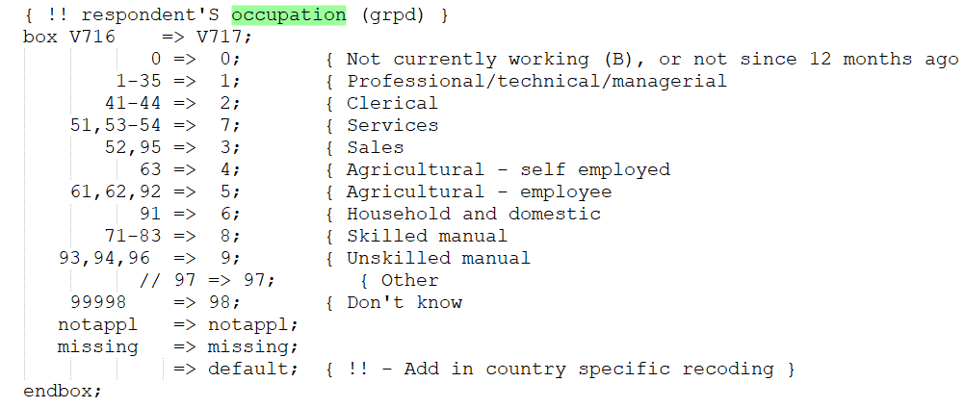

EDUCATION

Education variables HV106, HV122, V106 and V701 were constructed using the logic below. Country specific variables (SH19L, SREDUC, and SPEDUC) were created to keep the education as it was collected.

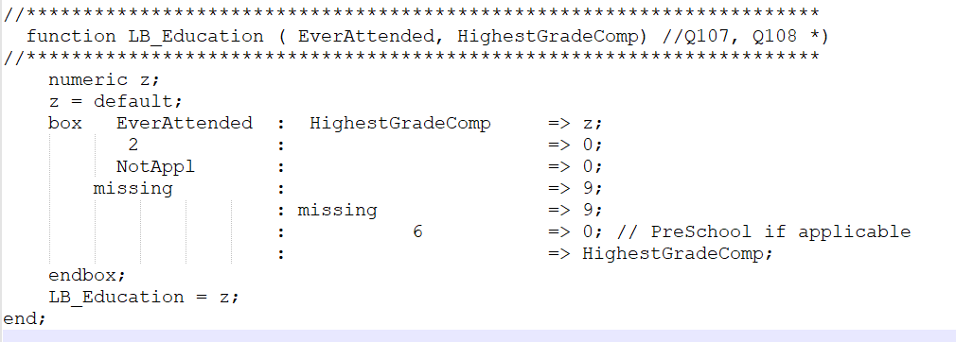

CALENDAR

Since data collection took place during 2019 and beginning of 2020, a function was created to calculate the beginning and end of the calendar.

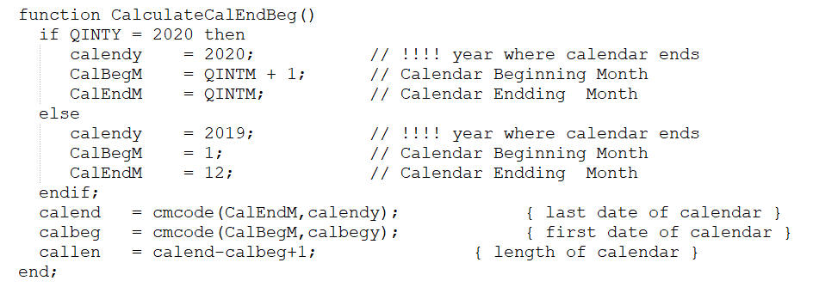

INCONSISTENCIES

HOUSEHOLD

There are 13 cases where HC51 (line number of caretaker) is missing
There are 2 cases where HA3 (Woman's height in centimeters) is 9996 (other)
There are 397 cases where age of the woman in the H/W differs from her age in the HH by more than 1 year
There are 20 cases where age of women in years is different from her age taken from the date of interview and the date of birth in CMC
There are 14 cases where consent was given for hemoglobin but Result of measurement = 4 (refused)
There are 7 cases where consent for HIV was given but HA62 (barcode) = 99995 (refused)
There are 7 cases where consent for HIV was given but HA63 Result of measurement - HIV = 3 (refused)
There are 6 cases where consent for HIV was given but HB63 Result of measurement - HIV = 3 (refused)
There are 6 cases where consent for HIV was given but HB63 Result of measurement - HIV = 2 (not present)
There are 6 households with not de jure members

WOMAN

There are 130 cases where Age of child in birth history is different than age of child in HH.
There are 4 cases where woman reported never menstruated however reported children born.
There are 6 cases where date of date of interview CMC is greater than date on individual interview CMC.
There are 2 cases where respondent said she did not know any contraceptive method however used a method.
There are 7 cases where responded reported not using currently any method however reported she tried to avoid or delay getting pregnant.
There is one case where Calculated months of amenorrhea longer than maximum expected.
There are 6 cases where Duration of amenorrhea and conception > the birth.
There are 6 cases where respondent reported Period not returned but duration given.
There is one case where computed adjusted anemia and anemial level do not match.
There is one case where Duration of abstinence and time since last sex > interval.
There is one case where Months of abstinence > Interval between births and following conception.
There are 110 cases where H/W age differs age from the birth history.
There are 110 cases where age at first sex > age at first birth.
There are 741 cases where marital status of respondent does not match marital status of HH.
There are 327 cases where respondent's partner's age does not match his age on HH.
There are 433 where it was reported that a translator was used however per survey manager’s instructions, only English was used.
There are 5 cases with inconsistent interview duration of zero minutes.

MAN

There are 96 cases where man reported Cannot read at all however reported Educational level as secondary.
There are 4 cases where man reported using contraceptive but spouse is pregnant
There are 89 cases where Age at first sex > age at first birth.
There are 5 cases where duration of interview seems unreasonable
There are 78 cases where it was reported that a translator was used however per survey manager’s instructions, only English was used.
There was one case which interview duration = zero minutes.

Important Note:

As of today March 19, 2021, it is unclear if the HIV testing is going to take place or not. This is why there are some country specific variables flagged as not applicable.

DEFINITIONS:

PUR uses activated carbon that's made from coconut shells, which boasts pores that are even tinier than other types of carbon filters. As water passes through, the contaminants fill up the surface area. ... Beyond the activated carbon, there's also an ion exchange happening in each filter.

VARIABLES USED WITH MODIFIED TEXT

The following standard variables were used with minor modification to the standard text. The original text was left on the standard variables. Here is the list of the variables used in Liberia with the modified text.

V409 Child drank: plain water
V411 Child drank: milk such as tinned, powdered or fresh animal milk
V413 Child drank: any other liquids
V414E Child ate: bread, rice, noodles, porridge, cereal, corn/maize, or other foods made from grains?
V414F Child ate: Cassava, eddoes, white potatoes, white yams, or any other foods made from roots
V414H Child ate: Any meat such as beef, pork, lamb, goat, chicken or duck
V414I Child ate: pumpkin, carrots, squash or sweet potatoes that or yellow or orange inside
V414J Child ate: Potato greens, bitter leaf, cassava leaf or any dark green, leafy vegetables
V414L Child ate: any other fruits and vegetables
V414M Child ate: liver, kidney, heart or other organ meats
V414N Child ate: fresh or dried fish, crab or kissmeat
V414O Child ate: any foods made from beans, peas, lentils or nuts
V414P Child ate: cheese, yogurt or other milk products
V414S Child ate: any other solid or semi-solid food
V414V Child ate: yogurt
V463B Pipes full of tobacco
V463F Cigars, cheroots, or cigarillos
V467C Care factors: Getting money needed for treatment
V467D Care factors: Distance, no nearby health facility

COUNTRY SPECIFIC VARIABLES WITH “NA – “

The following variables are temporarily with “NA-“ but will be updated once Liberia do the HIV test.

