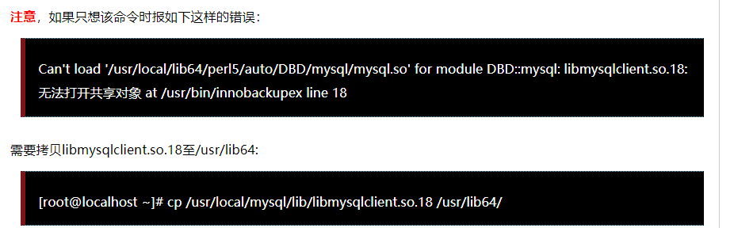

**另外还需注意**：备份数据库的用户需要具有相应权限，如果要使用一个最小权限的用户进行备份，则可基于如下命令创建此类用户：

**mysql> CREATE USER ‘**[**bkpuser'@'localhost’**](mailto:%E2%80%98bkpuser'@'localhost%E2%80%99)**IDENTIFIED BY ‘newpasswd’;**

**mysql> REVOKE ALL PRIVILEGES, GRANT OPTION FROM ‘bkpuser’;**

**mysql> GRANT RELOAD, LOCK TABLES, REPLICATION CLIENT ON *.* TO**[**‘bkpuser’@’localhost’**](mailto:%E2%80%98bkpuser%E2%80%99@%E2%80%99localhost%E2%80%99)**;**

mysql> FLUSH PRIVILEGES;ql/lib/libmysqlclient.so.18 /usr/lib64/