CentOS7安装Oracle 11gR2 图文详解

一、环境准备

安装包：

1.VMware-workstation-full-11.1.0-2496824.exe

2.CentOS-7-x86_64-DVD-1511.iso

3.linux.x64_11gR2_database_1of2.zip

linux.x64_11gR2_database_2of2.zip

以上觉得不是重点，不给下载地址，不描述安装过程，安装完CentOS 7，截图如下：



第一次安装防坑，没有进行任何操作之前，先在VMware中创建该虚拟机快照，后期搞郁闷了，可以回归到该快照版本。特么还是不放心，又把该虚拟机完整克隆一份（强迫症）。

**二、安装Oracle前准备**

1.创建运行oracle数据库的系统用户和用户组

[root@localhost ~]# groupadd oinstall　　**#创建用户组oinstall**

[root@localhost ~]# groupadd dba　　**#创建用户组dba**

[root@localhost ~]# useradd -g oinstall -g dba -m oracle　　**#创建oracle用户，并加入到oinstall和dba用户组**

[root@localhost ~]# passwd oracle　　**#设置用户oracle的登陆密码，不设置密码，在CentOS的图形登陆界面没法登陆**

Changing password for user oracle.

New password: 　　**# 密码**

BAD PASSWORD: The password is shorter than 8 characters

Retype new password: 　　**# 确认密码**

[root@localhost ~]# id oracle **# 查看新建的oracle用户**

uid=1001(oracle) gid=1002(dba) groups=1002(dba)

2.创建oracle数据库安装目录

[sonny@localhost ~]$ su root

Password:

[root@localhost ~]# mkdir -p /data/oracle　　**#oracle数据库安装目录**

[root@localhost ~]# mkdir -p /data/oraInventory　　**#oracle数据库配置文件目录**

[root@localhost ~]# mkdir -p /data/database　　**#oracle数据库软件包解压目录**

[root@localhost ~]# cd /data

[root@localhost data]# ls　　**#创建完毕检查一下（强迫症）**

database oracle oraInventory

[root@localhost data]# chown -R oracle:oinstall /data/oracle　　**#设置目录所有者为oinstall用户组的oracle用户**

[root@localhost data]# chown -R oracle:oinstall /data/oraInventory

[root@localhost data]# chown -R oracle:oinstall /data/database

[root@localhost data]#

3.修改OS系统标识

 oracle默认不支持CentOS系统安装

修改文件 /etc/[RedHat](http://www.linuxidc.com/topicnews.aspx?tid=10)-release

[root@localhost data]# cat /proc/version

Linux version 3.10.0-327.el7.x86_64 (builder@kbuilder.dev.centos.org) (gcc version 4.8.3 20140911 (Red Hat 4.8.3-9) (GCC) ) #1 SMP Thu Nov 19 22:10:57 UTC 2015

[root@localhost data]# cat /etc/redhat-release

CentOS Linux release 7.2.1511 (Core)

[root@localhost data]# vi /etc/redhat-release

[root@localhost data]# cat /etc/redhat-release

redhat-7

[root@localhost data]#

4.安装oracle数据库所需要的软件包

[root@localhost data]# yum install binutils compat-libstdc++ elfutils-libelf elfutils-libelf-devel elfutils-libelf-devel-static gcc gcc-c++ glibc glibc-common glibc-devel glibc-headers kernel-headers ksh libaio libaio-devel libgomp libstdc++-devel make sysstat unixODBC unixODBC-devel libgcc libstdc++

5.关闭防火墙 CentOS 7.2默认使用的是firewall作为防火墙

[root@localhost /]# systemctl status firewalld.service　**#查看防火墙状态，运行中**

● firewalld.service - firewalld - dynamic firewall daemon

Loaded: loaded (/usr/lib/systemd/system/firewalld.service; enabled; vendor preset: enabled)

Active: active (running) since Thu 2016-04-07 18:54:29 PDT; 2h 20min ago

Main PID: 802 (firewalld)

CGroup: /system.slice/firewalld.service

└─802 /usr/bin/python -Es /usr/sbin/firewalld --nofork --nopid

……

[root@localhost /]# systemctl stop firewalld.service　　**#关闭防火墙**

[root@localhost /]# systemctl status firewalld.service　　#再次查看防火墙状态，发现已关闭

● firewalld.service - firewalld - dynamic firewall daemon

Loaded: loaded (/usr/lib/systemd/system/firewalld.service; enabled; vendor preset: enabled)

Active: inactive (dead) since Thu 2016-04-07 21:15:34 PDT; 9s ago

Main PID: 802 (code=exited, status=0/SUCCESS)

……

[root@localhost /]# systemctl disable firewalld.service　　**#禁止使用防火墙（重启也是禁止的）**

Removed symlink /etc/systemd/system/dbus-org.[Fedora](http://www.linuxidc.com/topicnews.aspx?tid=5)project.FirewallD1.service.

Removed symlink /etc/systemd/system/basic.target.wants/firewalld.service.

[root@localhost /]#

**防火墙先禁用，搞好之后再配置，个人虚拟机，要毛线防火墙~~**

6.关闭selinux（需重启生效）

[root@localhost /]# vi /etc/selinux/config

[root@localhost /]# cat /etc/selinux/config

# This file controls the state of SELinux on the system.

# SELINUX= can take one of these three values:

# enforcing - SELinux security policy is enforced.

# permissive - SELinux prints warnings instead of enforcing.

# disabled - No SELinux policy is loaded.

SELINUX=disabled **#此处修改为disabled**

# SELINUXTYPE= can take one of three two values:

# targeted - Targeted processes are protected,

# minimum - Modification of targeted policy. Only selected processes are protected.

# mls - Multi Level Security protection.

SELINUXTYPE=targeted

**为啥要关闭selinux？因为selinux太高深，非专业人士搞不懂~~**

7.修改内核参数

红色部分为添加代码

[root@localhost /]# vi /etc/sysctl.conf

[root@localhost /]# cat /etc/sysctl.conf

# System default settings live in /usr/lib/sysctl.d/00-system.conf.

# To override those settings, enter new settings here, or in an /etc/sysctl.d/<name>.conf file

#

# For more information, see sysctl.conf(5) and sysctl.d(5).

net.ipv4.icmp_echo_ignore_broadcasts = 1

net.ipv4.conf.all.rp_filter = 1

fs.file-max = 6815744 #设置最大打开文件数

fs.aio-max-nr = 1048576

kernel.shmall = 2097152 #共享内存的总量，8G内存设置：2097152*4k/1024/1024

kernel.shmmax = 2147483648 #最大共享内存的段大小

kernel.shmmni = 4096 #整个系统共享内存端的最大数

kernel.sem = 250 32000 100 128

net.ipv4.ip_local_port_range = 9000 65500 #可使用的IPv4端口范围

net.core.rmem_default = 262144

net.core.rmem_max= 4194304

net.core.wmem_default= 262144

net.core.wmem_max= 1048576

[root@localhost /]# sysctl -p 使配置参数生效

net.ipv4.icmp_echo_ignore_broadcasts = 1

net.ipv4.conf.all.rp_filter = 1

fs.file-max = 6815744

fs.aio-max-nr = 1048576

kernel.shmall = 2097152

kernel.shmmax = 2147483648

kernel.shmmni = 4096

kernel.sem = 250 32000 100 128

net.ipv4.ip_local_port_range = 9000 65500

net.core.rmem_default = 262144

net.core.rmem_max= 4194304

net.core.wmem_default= 262144

net.core.wmem_max= 1048576

8.对oracle用户设置限制，提高软件运行性能（红色为添加部分）

[root@localhost /]# vi /etc/security/limits.conf

[root@localhost /]# cat /etc/security/limits.conf

# /etc/security/limits.conf

#

#This file sets the resource limits for the users logged in via PAM.

#It does not affect resource limits of the system services.

#

#Also note that configuration files in /etc/security/limits.d directory,

#which are read in alphabetical order, override the settings in this

#file in case the domain is the same or more specific.

#That means for example that setting a limit for wildcard domain here

#can be overriden with a wildcard setting in a config file in the

#subdirectory, but a user specific setting here can be overriden only

#with a user specific setting in the subdirectory.

……

#* soft core 0

#* hard rss 10000

#@student hard nproc 20

#@faculty soft nproc 20

#@faculty hard nproc 50

#ftp hard nproc 0

#@student - maxlogins 4

oracle soft nproc 2047

oracle hard nproc 16384

oracle soft nofile 1024

oracle hard nofile 65536

# End of file

9.配置用户的环境变量（红色部分为添加代码）

[root@localhost /]# vi /home/oracle/.bash_profile

[root@localhost /]# cat /home/oracle/.bash_profile

# .bash_profile

# Get the aliases and functions

if [ -f ~/.bashrc ]; then

. ~/.bashrc

fi

# User specific environment and startup programs

PATH=$PATH:$HOME/.local/bin:$HOME/bin

export PATH

export ORACLE_BASE=/data/oracle #oracle数据库安装目录

export ORACLE_HOME=$ORACLE_BASE/product/11.2.0/db_1 #oracle数据库路径

export ORACLE_SID=orcl #oracle启动数据库实例名

export ORACLE_TERM=xterm #xterm窗口模式安装

export PATH=$ORACLE_HOME/bin:/usr/sbin:$PATH #添加系统环境变量

export LD_LIBRARY_PATH=$ORACLE_HOME/lib64:/lib64:/usr/lib64 #添加系统环境变量

export LANG=C #防止安装过程出现乱码

export NLS_LANG=AMERICAN_AMERICA.ZHS16GBK

使上述配置立即生效：

[root@localhost /]# source /home/oracle/.bash_profile

10.上述都搞定了，上传安装包我喜欢xftp，将oracle安装包上传到/usr/local/src

11.解压安装包

[oracle@localhost /]$ cd　　**#进入/usr/local/src目录**

[oracle@localhost ~]$ ls

linux.x64_11gR2_database_1of2.zip linux.x64_11gR2_database_2of2.zip

[oracle@localhost ~]$ unzip linux.x64_11gR2_database_1of2.zip -d /data/database/　　**#解压**

(省略...)

[oracle@localhost ~]$ unzip linux.x64_11gR2_database_2of2.zip -d /data/database/　　**#解压**

(省略...)

[root@localhost ~]# chown -R oracle:oinstall /data/database/database/

三、**oracle安装**

1.图形界面登陆oracle用户：

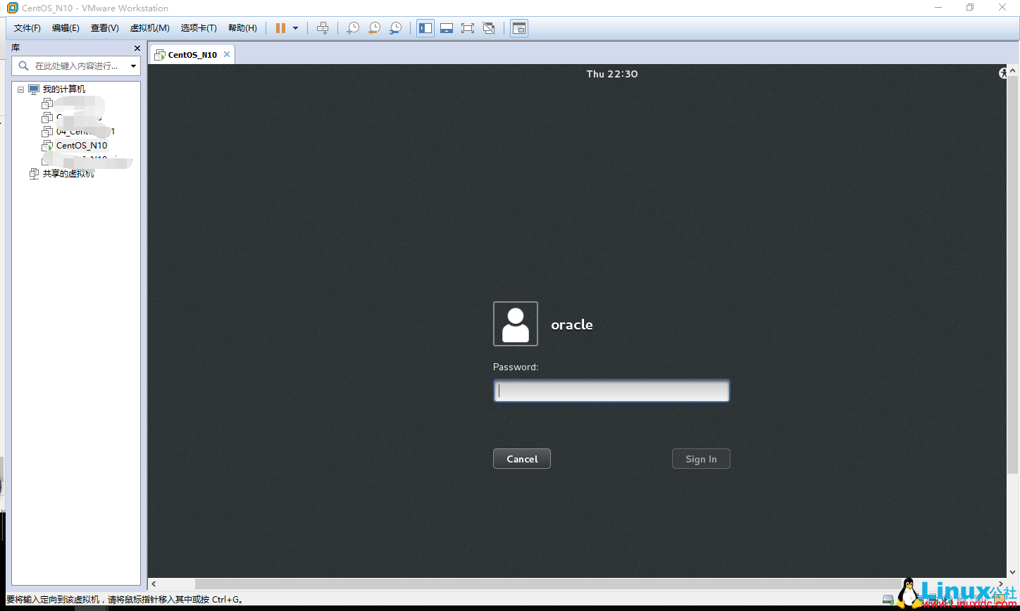

2.启动oralce安装，到/data/database/database/目录下，执行runInstaller

./runInstaller

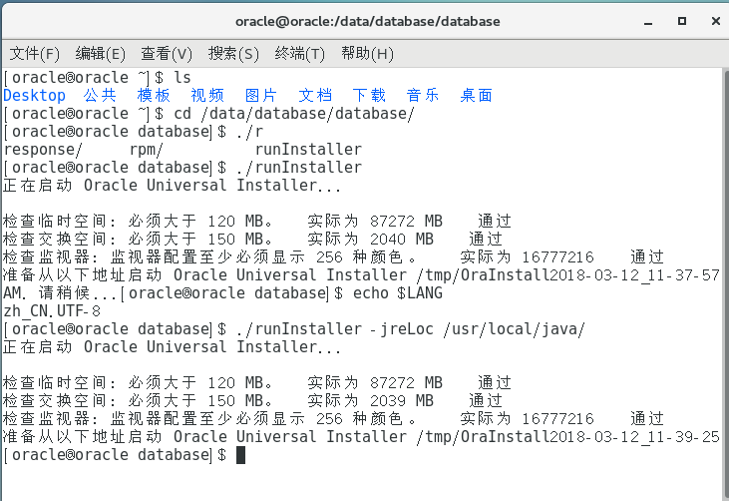

3.去掉勾，懒得填，个人使用环境不需要自动接收Oracle的安全更新。

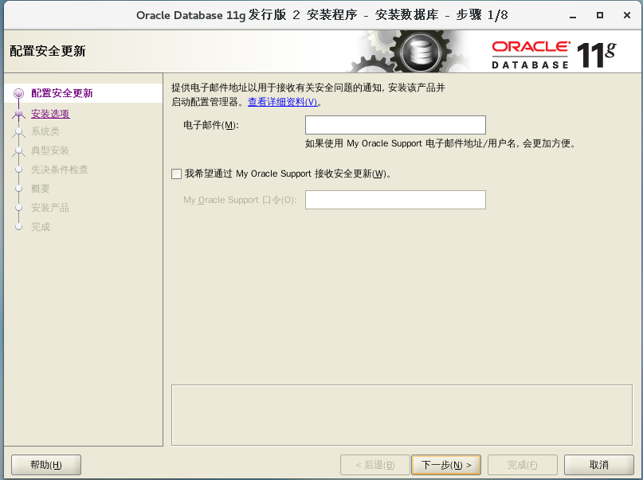

4.下一步，创建和配置数据库

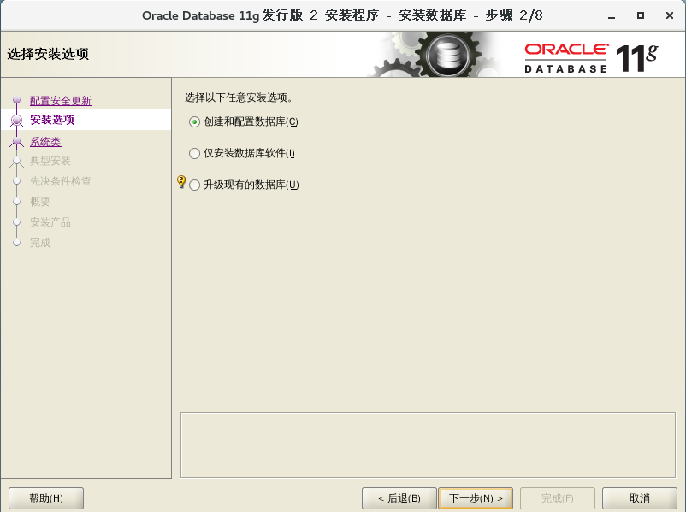

5．服务器类

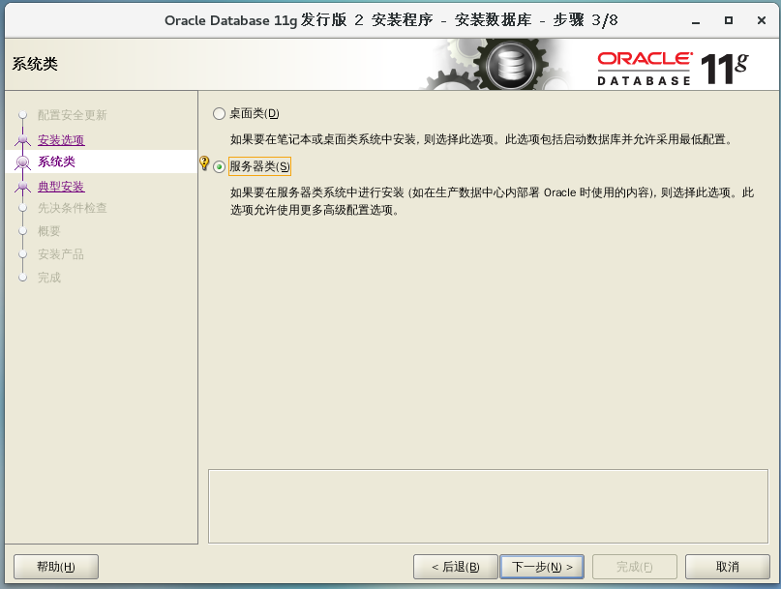

6．单实例安装

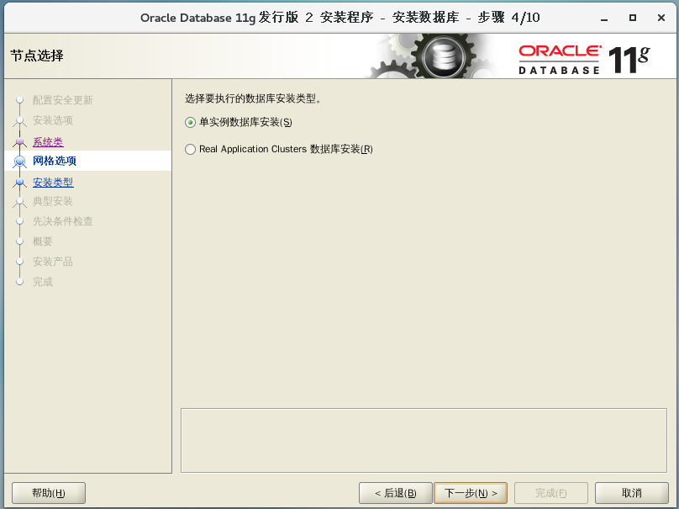

7.典型安装

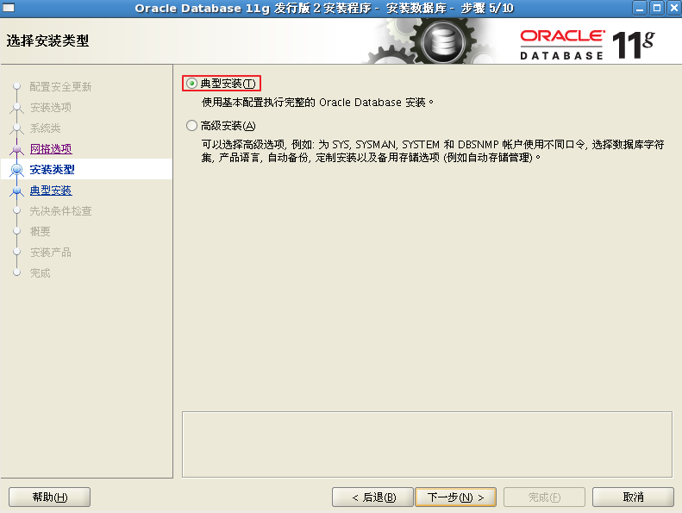

8．路径默认

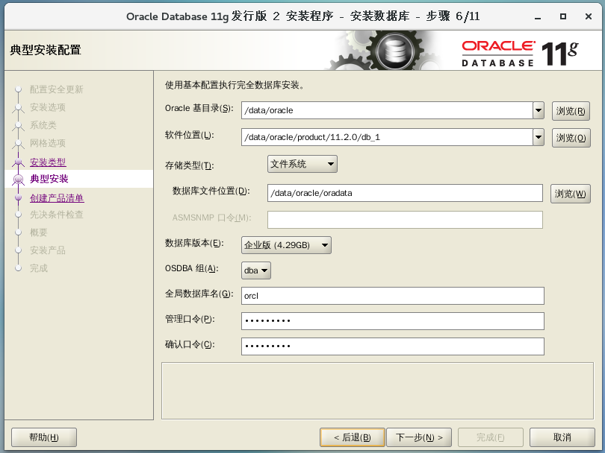

设置管理口令abc123ABC

