TransportManagementSystem

SQL- WORK-BENCH

CREATE DATABASE TransportProject;

USE TransportProject;

CREATE TABLE TransportData (
FromLocation VARCHAR(100),
ToLocation VARCHAR(100),
BusNumber INT PRIMARY KEY,
Depature VARCHAR(50),
Arrival VARCHAR(50)
);

SELECT * FROM TransportData;

OUTPUT:

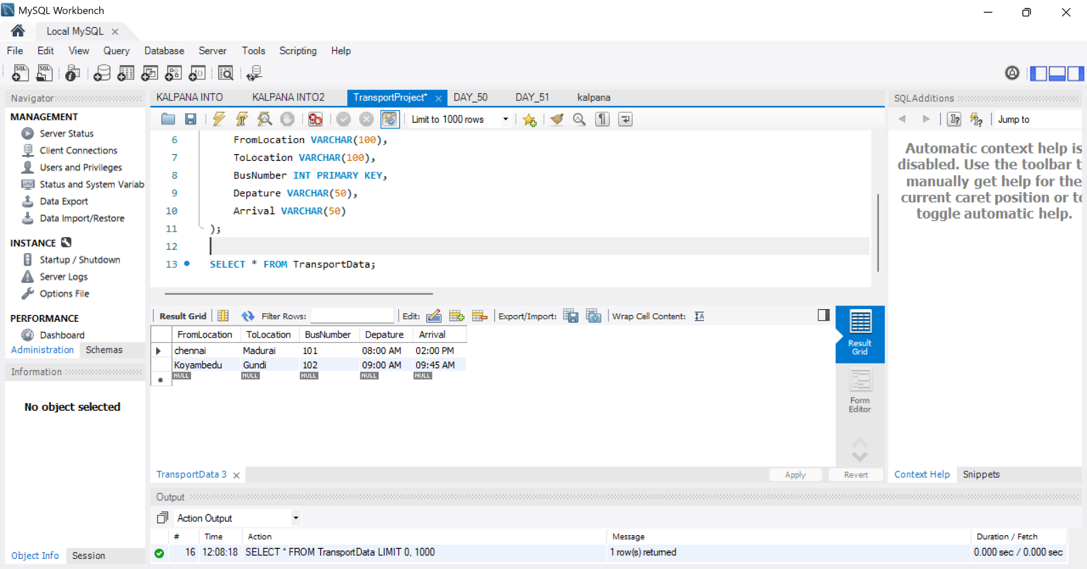

ECLIPSE

package Project;

import java.sql.*;
import java.util.Scanner;

public class TransportManagementSystem {

static Scanner sc = new Scanner(System.in);

// ================= DATABASE CONNECTION =================

public static Connection getConnection()
throws ClassNotFoundException, SQLException {

Class.forName("com.mysql.cj.jdbc.Driver");

String url = "jdbc:mysql://localhost:3306/TransportProject";
String uname = "root";
String pwd = "root";

return DriverManager.getConnection(url, uname, pwd);
}

// ================= MENU =================

public static void menu() {

System.out.println();
System.out.println("================================================");
System.out.println(" WELCOME TO TRANSPORT MANAGEMENT SYSTEM");
System.out.println("================================================");
System.out.println("1. Add Transport Data");
System.out.println("2. Update Transport Data");
System.out.println("3. View All Transport Data");
System.out.println("4. View Single Transport Data");
System.out.println("5. Delete Transport Data");
System.out.println("6. Exit");
System.out.println("================================================");
}

// ================= ADD TRANSPORT =================

public static void addTransport()
throws ClassNotFoundException, SQLException {

System.out.println();
System.out.println("----------- ADD TRANSPORT DATA -----------");

sc.nextLine();

System.out.print("Enter From Location: ");
String fromLocation = sc.nextLine();

System.out.print("Enter To Location: ");
String toLocation = sc.nextLine();

System.out.print("Enter Bus Number: ");
int busNumber = sc.nextInt();
sc.nextLine();

System.out.print("Enter Departure Time: ");
String departure = sc.nextLine();

System.out.print("Enter Arrival Time: ");
String arrival = sc.nextLine();

String query =
"INSERT INTO TransportData " +
"(FromLocation, ToLocation, BusNumber, Depature, Arrival) " +
"VALUES (?, ?, ?, ?, ?)";

Connection con = getConnection();

PreparedStatement st = con.prepareStatement(query);

st.setString(1, fromLocation);
st.setString(2, toLocation);
st.setInt(3, busNumber);
st.setString(4, departure);
st.setString(5, arrival);

int result = st.executeUpdate();

if (result > 0) {
System.out.println("Record Inserted Successfully");
}

st.close();
con.close();
}

// ================= DISPLAY ALL =================

public static void displayDetails()
throws ClassNotFoundException, SQLException {

System.out.println();
System.out.println("----------- ALL TRANSPORT DATA -----------");

String query = "SELECT * FROM TransportData";

Connection con = getConnection();

PreparedStatement st = con.prepareStatement(query);

ResultSet rs = st.executeQuery();

boolean found = false;

while (rs.next()) {

found = true;

System.out.println("----------------------------------------");
System.out.println("From Location : "
+ rs.getString("FromLocation"));

System.out.println("To Location : "
+ rs.getString("ToLocation"));

System.out.println("Bus Number : "
+ rs.getInt("BusNumber"));

System.out.println("Departure Time : "
+ rs.getString("Depature"));

System.out.println("Arrival Time : "
+ rs.getString("Arrival"));
}

if (!found) {
System.out.println("No transport records found.");
}

System.out.println("----------------------------------------");

rs.close();
st.close();
con.close();
}

// ================= DISPLAY SINGLE =================

public static void displayDetail(int busNumber)
throws ClassNotFoundException, SQLException {

System.out.println();
System.out.println("----------- TRANSPORT DETAILS -----------");

String query =
"SELECT * FROM TransportData WHERE BusNumber = ?";

Connection con = getConnection();

PreparedStatement st = con.prepareStatement(query);

st.setInt(1, busNumber);

ResultSet rs = st.executeQuery();

if (rs.next()) {

System.out.println("----------------------------------------");

System.out.println("From Location : "
+ rs.getString("FromLocation"));

System.out.println("To Location : "
+ rs.getString("ToLocation"));

System.out.println("Bus Number : "
+ rs.getInt("BusNumber"));

System.out.println("Departure Time : "
+ rs.getString("Depature"));

System.out.println("Arrival Time : "
+ rs.getString("Arrival"));

System.out.println("----------------------------------------");

} else {

System.out.println("Bus Number not found.");
}

rs.close();
st.close();
con.close();
}

// ================= DELETE =================

public static void deleteData(int busNumber)
throws ClassNotFoundException, SQLException {

System.out.println();
System.out.println("----------- DELETE TRANSPORT DATA -----------");

String query =
"DELETE FROM TransportData WHERE BusNumber = ?";

Connection con = getConnection();

PreparedStatement st = con.prepareStatement(query);

st.setInt(1, busNumber);

int result = st.executeUpdate();

if (result > 0) {

System.out.println(
"Transport Data Deleted Successfully");

} else {

System.out.println("Bus Number not found.");
}

st.close();
con.close();
}

// ================= UPDATE =================

public static void updateDetails(int busNumber)
throws ClassNotFoundException, SQLException {

System.out.println();
System.out.println("----------- UPDATE TRANSPORT DATA -----------");

System.out.println("1. Update From Location");
System.out.println("2. Update To Location");
System.out.println("3. Update Bus Number");
System.out.println("4. Update Departure Time");
System.out.println("5. Update Arrival Time");

System.out.print("Enter your Choice: ");

int choice = sc.nextInt();

Connection con = getConnection();

switch (choice) {

// ---------- FROM LOCATION ----------

case 1:

sc.nextLine();

System.out.print("Enter New From Location: ");

String fromLocation = sc.nextLine();

String query1 =
"UPDATE TransportData " +
"SET FromLocation = ? " +
"WHERE BusNumber = ?";

PreparedStatement st1 =
con.prepareStatement(query1);

st1.setString(1, fromLocation);
st1.setInt(2, busNumber);

if (st1.executeUpdate() > 0) {

System.out.println(
"From Location Updated Successfully.");

} else {

System.out.println("Bus Number not found.");
}

st1.close();

break;

// ---------- TO LOCATION ----------

case 2:

sc.nextLine();

System.out.print("Enter New To Location: ");

String toLocation = sc.nextLine();

String query2 =
"UPDATE TransportData " +
"SET ToLocation = ? " +
"WHERE BusNumber = ?";

PreparedStatement st2 =
con.prepareStatement(query2);

st2.setString(1, toLocation);
st2.setInt(2, busNumber);

if (st2.executeUpdate() > 0) {

System.out.println(
"To Location Updated Successfully.");

} else {

System.out.println("Bus Number not found.");
}

st2.close();

break;

// ---------- BUS NUMBER ----------

case 3:

System.out.print("Enter New Bus Number: ");

int newBusNumber = sc.nextInt();

String query3 =
"UPDATE TransportData " +
"SET BusNumber = ? " +
"WHERE BusNumber = ?";

PreparedStatement st3 =
con.prepareStatement(query3);

st3.setInt(1, newBusNumber);
st3.setInt(2, busNumber);

if (st3.executeUpdate() > 0) {

System.out.println(
"Bus Number Updated Successfully.");

} else {

System.out.println("Bus Number not found.");
}

st3.close();

break;

// ---------- DEPARTURE ----------

case 4:

sc.nextLine();

System.out.print("Enter New Departure Time: ");

String departure = sc.nextLine();

String query4 =
"UPDATE TransportData " +
"SET Depature = ? " +
"WHERE BusNumber = ?";

PreparedStatement st4 =
con.prepareStatement(query4);

st4.setString(1, departure);
st4.setInt(2, busNumber);

if (st4.executeUpdate() > 0) {

System.out.println(
"Departure Time Updated Successfully.");

} else {

System.out.println("Bus Number not found.");
}

st4.close();

break;

// ---------- ARRIVAL ----------

case 5:

sc.nextLine();

System.out.print("Enter New Arrival Time: ");

String arrival = sc.nextLine();

String query5 =
"UPDATE TransportData " +
"SET Arrival = ? " +
"WHERE BusNumber = ?";

PreparedStatement st5 =
con.prepareStatement(query5);

st5.setString(1, arrival);
st5.setInt(2, busNumber);

if (st5.executeUpdate() > 0) {

System.out.println(
"Arrival Time Updated Successfully.");

} else {

System.out.println("Bus Number not found.");
}

st5.close();

break;

default:

System.out.println("Invalid Choice.");
}

con.close();
}

// ================= MAIN =================

public static void main(String[] args)
throws ClassNotFoundException, SQLException {

// Application Login
String userName = "admin";
int password = 12345;

System.out.println("==============================================");
System.out.println(" TRANSPORT MANAGEMENT SYSTEM");
System.out.println("==============================================");

System.out.print("Enter the User Name: ");

String user = sc.nextLine();

if (user.equals(userName)) {

System.out.print("Enter the Password: ");

int pass = sc.nextInt();

if (pass == password) {

System.out.println();
System.out.println("Login Successful!");

while (true) {

menu();

System.out.print("Enter your Choice: ");

int choice = sc.nextInt();

switch (choice) {

case 1:

addTransport();

break;

case 2:

System.out.print(
"Enter Bus Number to Update: ");

int updateBus = sc.nextInt();

updateDetails(updateBus);

break;

case 3:

displayDetails();

break;

case 4:

System.out.print(
"Enter Bus Number to View: ");

int viewBus = sc.nextInt();

displayDetail(viewBus);

break;

case 5:

System.out.print(
"Enter Bus Number to Delete: ");

int deleteBus = sc.nextInt();

deleteData(deleteBus);

break;

case 6:

System.out.println();
System.out.println(
"Thank you for using");
System.out.println(
"Transport Management System!");

sc.close();

System.exit(0);

break;

default:

System.out.println(
"Invalid Choice. Please try again.");
}
}

} else {

System.out.println("Incorrect Password.");
}

} else {

System.out.println("Invalid User Name.");
}

sc.close();
}
}

