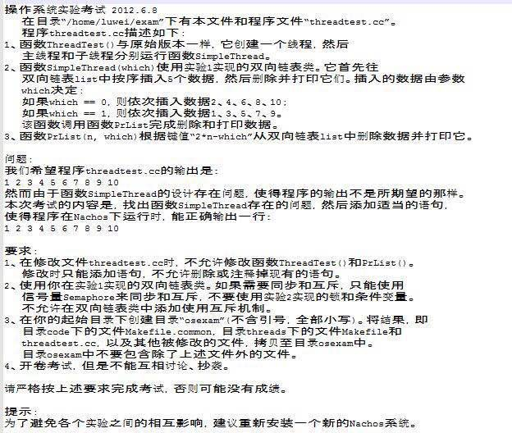

Threadtest不改

//---------------------------------------------------------------------
// threadtest.cc
// Simple test case for the examination to illustratethe inner
// workings of the thread system.
//
//6----------------------------------------------------------------------

#include "copyright.h"
#include "system.h"
#include "dllist.h" // Your double list header file
#include "synch.h"
//12 Add a header file here which are required.

DLList *list = new DLList(); // the shared double list
static int key[10] = {9,6,5,0,8,1,3,2,4,7}; // ten items that will be
// inserted into the list

// Define a semaphore that synchronizes the Producer and the Comsumer.

//20 testnum is set in main.cc
int testnum = 1;
Semaphore *s=new Semaphore("aaa",0); //-22-----------------!!!!!!!
//----------------------------------------------------------------------
// Consumer
// Remove and print 10 items in the key order from the shared
// double list.
// The items are inserted by producers.
//------------28----------------------------------------------------------

void
Consumer(int which)
{
int *item;
int i;
for(i = 0; i< 10; i++) {
item = (int *)list->SortedRemove(i);
while(item == NULL) {
s->P(); //!!!!!!!!!!!!!!!!
item=(int*)list->SortedRemove(i); //!!!!!!!

//----------------------------------------------------------------------
// Reaching here means the item with key k is not in the list right now,
// and consumer has to be waiting until the item has been inserted by
// producers.
//
// Write proper program statements whitin this while statement to have
// consumer run accordingly. Do not use Yield, instead use a semaphore
// to synchronize the the Producer and the Comsumer.
//----------------------------------------------------------------------
}
printf("%d ", *item);
}
printf("\n"); // Ending output with newline
}

//----------------------------------------------------------------------
// Producer
// Sorted insert 10 items into the double list. This thread yields
// after every inserting a item to let the Comsumer run. cs8.xmu.edu.cncs8.xmu.edu.cn
//-----------------------------------------------------------------------

int k;
void
Producer(int which)
{
int n;

for(n = 0; n < 10; n++) {
k = key[n];
list->SortedInsert(&key[n], k);
currentThread->Yield(); //!!!!!!!!!!!!!!!!!!!!!!
s->V(); //!!!!!!!!!!!!!!!!!!!!!
//----------------------------------------------------------------------
// Write proper program statement here whitin this for statement to have
// Producer run accordingly.
//-----------------------------------------------------------------------
}
}

//----------------------------------------------------------------------
// ThreadTest
// Create a producer thread and run itself as a consumer.
//----------------------------------------------------------------------

void
ThreadTest()
{
DEBUG('t', "Entering ThreadTest1");
Thread *t = new Thread("forked producer");
t->Fork(Producer, 1);
Consumer(1);
}

// threadtest.cc
// Simple test case for the OS examination.
//
// Create two threads, and have them context switch
// back and forth between themselves by calling Thread::Yield,
// to illustratethe inner workings of the thread system.
//
//----------------------------------------------------------------------
#include "copyright.h"
#include "system.h"
#include "dllist.h" // Your double list header file
#include "synch.h"

Semaphore *lock = new Semaphore("List Lock",1); // use to mutex
Semaphore *testlock1 = new Semaphore("List lock 1",1);
Semaphore *testlock2 = new Semaphore("List lock 2",0);
DLList *list = new DLList();
static int key[11] = {0,1,2,3,4,5,6,7,8,9,10};

// testnum is set in main.cc
int testnum = 1;

//----------------------------------------------------------------------
// Prlist
// Remove one item from double list and print it. thread0 remove
// and print the item with even key while thread1 the item
// with odds key.
//----------------------------------------------------------------------

void
PrList(int n, int which)
{
int value;
int k;

k = 2*n-which;
value = *((int *)list->SortedRemove(k));
printf("%d ", value);
if(k == 10)
printf("\n"); // Ending output with newline
}

//----------------------------------------------------------------------
// SimpleThread
// Sorted insert 5 items into a double list according to "which",
// then remove the items and print them. There are two threads running
// this function alternately, which print cooperratively to
// produce output: 1 2 3 4 5 6 7 8 9 10
//
// "which" is a number identifying the thread, the thread with 0
// of "which" inserts items with even key and the thread with 1
// inserts items with odds key.
//----------------------------------------------------------------------

void
SimpleThread(int which)
{
int n,idx;
for(n=1; n<=5; ++n){ // Sorted insert 5 items according to "which"
idx = 2*n-which;
lock->P();
list->SortedInsert(&key[idx], key[idx]);
lock->V();
currentThread->Yield();
}
for(n=1; n<=5; ++n){ // Remove previously inserted items and print them
if(which==0)
testlock2->P();
else testlock1->P();
lock->P();
PrList(n, which);
lock->V();
if(which==0)
testlock1->V();
else
testlock2->V();
}
}

Threadtest改
//----------------------------------------------------------------------
// ThreadTest
// Set up a ping-pong between two threads, by forking a thread
// to call SimpleThread, and then calling SimpleThread ourselves.
//----------------------------------------------------------------------

void
ThreadTest()
{
DEBUG('t', "Entering ThreadTest1");

Thread *t = new Thread("forked thread");

t->Fork(SimpleThread, 1);
SimpleThread(0);
}

