
《操作系统原理》课程
实验报告

实验名称：实验二 线程与同步
系别：计算机科学系
班号：2014级2班
组员：
郑能鑫 22920142203972（组长）
陈兆彬 22920142203801
胡 超 22920142203989
黄宗超 22920142203991
日期： 2017年4月21日
指导老师意见：

实验二 线程与同步
一、内容简述
- 两种方法实现锁和条件变量
使用信号量作为基础命令和使用中断禁用加上线程休眠和就绪作为基础命令实现锁和条件变量。
- 实现多线程操作的表结构
依照头文件的描述实现表的数据结构，并且使用锁机制实现表的多线程操作的互斥，并演示表的操作。
- 实现有界缓冲区
依照头文件要求实现有界缓冲区的数据结构，并且使用锁机制和条件变量实现缓冲区的正常工作。

二、实验设计和关键代码实现
1、用 Thread::Sleep 实现锁机制和条件变量
synch-sleep.h
①锁
class Lock {
public:
Lock(char* debugName); // initialize lock to be FREE
~Lock(); // deallocate lock
char* getName() { return name; } // debugging assist

void Acquire(); // these are the only operations on a lock
void Release(); // they are both *atomic*

bool isHeldByCurrentThread(); // true if the current thread
// holds this lock. Useful for
// checking in Release, and in
// Condition variable ops below.

private:
char* name; // for debugging
Thread *HoldThread; //the thread who is holding the lock
List *LockQueue; //block queue
bool status; //the status for the the lock:1 for busy and 0 for free
// plus some other stuff you'll need to define
};
②条件变量
class Condition {
public:
Condition(char* debugName); // initialize condition to
// "no one waiting"
~Condition(); // deallocate the condition
char* getName() { return (name); }

void Wait(Lock *conditionLock); // these are the 3 operations on
// condition variables; releasing the
// lock and going to sleep are
// *atomic* in Wait()
void Signal(Lock *conditionLock); // conditionLock must be held by
void Broadcast(Lock *conditionLock);// the currentThread for all of
// these operations

private:
char* name;
List *ConditionQueue;
// plus some other stuff you'll need to define
};
synch-sleep.cc
①锁
Lock::Lock(char* debugName)
{
name=debugName;
HoldThread = new Thread("HoldThread");
LockQueue=new List();
status = 0;
}
Lock::~Lock()
{
delete HoldThread;
delete LockQueue;
}
void Lock::Acquire() //the function is for the thread to acquire the lock
{
ASSERT(isHeldByCurrentThread());
IntStatus oldLevel = interrupt -> SetLevel(IntOff);
//turn off interrupt
while(status) //if the lock is busy
{
LockQueue->Append((void*)currentThread);
currentThread->Sleep();
//the thread who ask the lock is blocked and goes to sleep
}
HoldThread=currentThread; //if the lock is free,the thread who ask the lock in the ReadyToRun queue acquire the lock
status=1;
(void) interrupt->SetLevel(oldLevel); //turn on interrupt
}
void Lock::Release() //the function is for the thread to release the lock
{
Thread *thread;
ASSERT(isHeldByCurrentThread());
IntStatus oldLevel = interrupt -> SetLevel(IntOff);
//turn off interrupt
HoldThread=NULL; //release the lock
status=0; //the lock is set to free
thread=(Thread *)LockQueue->Remove();
//a thread removes from the block queue
if(thread!=NULL)
scheduler->ReadyToRun(thread); //and moves to ReadyToRun queue
(void) interrupt->SetLevel(oldLevel); //turn on interrput
}
// True if the current thread holds this lock.
//Useful for checking in Release, and in condition variable ops below.
bool Lock::isHeldByCurrentThread()
{
if(HoldThread=currentThread&&status)
return true;
else
return false;
}
②条件变量
Condition::Condition(char* debugName)
{
name=debugName;
ConditionQueue=new List();
}
Condition::~Condition()
{
delete ConditionQueue;
}
void Condition::Wait(Lock* conditionLock)
{
//ASSERT(FALSE);
ASSERT(conditionLock->isHeldByCurrentThread());
IntStatus oldLevel = interrupt -> SetLevel(IntOff); //turn off interrput
ConditionQueue->Append((void*)currentThread);
conditionLock->Release(); //the current release the lock
currentThread->Sleep(); //then it is blocked and go to sleep
conditionLock->Acquire(); //then the lock can be acquired by other threads
(void) interrupt->SetLevel(oldLevel); //turn on interrput
}
void Condition::Signal(Lock* conditionLock)
{
Thread *thread;
ASSERT(conditionLock->isHeldByCurrentThread());
IntStatus oldLevel = interrupt -> SetLevel(IntOff); //turn off interrput
thread=(Thread *)ConditionQueue->Remove(); //wake up the thread who is sleeping
if(thread!=NULL)
scheduler-ReadyToRun(thread); //then set it to the ReadyToRun queue
(void) interrupt->SetLevel(oldLevel); //turn on interrput
}
void Condition::Broadcast(Lock* conditionLock)
{
Thread *thread;
ASSERT(conditionLock->isHeldByCurrentThread());
IntStatus oldLevel = interrupt -> SetLevel(IntOff); //turn off interrput
//wake up the threads who are sleeping and set them to the ReadyToRun queue
thread =(Thread *)ConditionQueue->Remove();
whlie(thread!=NULL)
{
scheduler-ReadyToRun(thread);
thread =(Thread *)ConditionQueue->Remove();
}
(void) interrupt->SetLevel(oldLevel); //turn on interrput
}

2、用 Semaphore 实现锁机制和条件变量
synch-sem.h
①锁
class Lock {
public:
Lock(char* debugName); // initialize lock to be FREE
~Lock(); // deallocate lock
char* getName() { return name; } // debugging assist

void Acquire(); // these are the only operations on a lock
void Release(); // they are both *atomic*

bool isHeldByCurrentThread(); // true if the current thread
// holds this lock. Useful for
// checking in Release, and in
// Condition variable ops below.

private:
char* name; // for debugging
Thread *HoldThread; //the thread who is holding the lock
Semaphore *lockSemaphore; //a semaphore
bool status;
// plus some other stuff you'll need to define
};
②条件变量
class Condition {
public:
Condition(char* debugName); // initialize condition to
// "no one waiting"
~Condition(); // deallocate the condition
char* getName() { return (name); }

void Wait(Lock *conditionLock); // these are the 3 operations on
// condition variables; releasing the
// lock and going to sleep are
// *atomic* in Wait()
void Signal(Lock *conditionLock); // conditionLock must be held by
void Broadcast(Lock *conditionLock);// the currentThread for all of
// these operations

private:
char* name;
Semaphore *conditionSemaphore; //a semaphore
int threadnum; //the number of threads
// plus some other stuff you'll need to define
};
synch-sem.cc
①锁
Lock::Lock(char* debugName)
{
name=debugName;
HoldThread = new Thread("HoldThread");
lockSemaphore=new Semaphore("listSemaphore",0);
status = 0;
}
Lock::~Lock()
{
delete HoldThread;
delete lockSemaphore;
}
void Lock::Acquire()
{
ASSERT(!isHeldByCurrentThread());
IntStatus oldLevel = interrupt -> SetLevel(IntOff);
while(status)
lockSemaphore->P();
HoldThread=currentThread;
status=1;
(void) interrupt->SetLevel(oldLevel);
}
void Lock::Release()
{
ASSERT(isHeldByCurrentThread());
IntStatus oldLevel = interrupt -> SetLevel(IntOff);
HoldThread=NULL;
status=0;
lockSemaphore->V();
(void) interrupt->SetLevel(oldLevel);
}
bool Lock::isHeldByCurrentThread()
{
if(HoldThread==currentThread&&status)
return true;
else
return false;
}
②条件变量
Condition::Condition(char* debugName)
{
name=debugName;
conditionSemaphore=new Semaphore("conditionSemaphore",0);
threadnum=0;
}
Condition::~Condition()
{
delete conditionSemaphore;
}
void Condition::Wait(Lock* conditionLock)
{
//ASSERT(FALSE);
ASSERT(conditionLock->isHeldByCurrentThread());
IntStatus oldLevel = interrupt -> SetLevel(IntOff);
//ConditionQueue->Append((void*)currentThread);
conditionLock->Release();
conditionSemaphore->P();
threadnum++;
conditionLock->Acquire();
(void) interrupt->SetLevel(oldLevel);
}
void Condition::Signal(Lock* conditionLock)
{
ASSERT(conditionLock->isHeldByCurrentThread());
IntStatus oldLevel = interrupt -> SetLevel(IntOff);
if(threadnum>0)
conditionSemaphore->V();
threadnum--;
(void) interrupt->SetLevel(oldLevel);
}
void Condition::Broadcast(Lock* conditionLock)
{
ASSERT(conditionLock->isHeldByCurrentThread());
IntStatus oldLevel = interrupt -> SetLevel(IntOff);
while(threadnum>0)
{
conditionSemaphore->V();
threadnum--;
}
(void) interrupt->SetLevel(oldLevel);
}

3、用锁机制和条件变量修改双向有序链表
threadtest.cc
void
SimpleThread2(int which)
{
if(isLocked==1)
dllistLock->Acquire();

InsertItem(n,D,which);
if(errortype==1)
currentThread->Yield();
if(errortype==2)
{
if(mark==0)
{
mark=1;
currentThread->Yield();
}
}
RemoveItem(n,D,which);
if(errortype==0)
currentThread->Yield();
if(errortype==2);
if(isLocked==1)
dllistLock->Release();
}
4、实现一个线程安全的表结构
Table.h
class Table {
public:
// create a table to hold at most 'size' entries.
Table(int size);
~Table();

// allocate a table slot for 'object'.
// return the table index for the slot or -1 on error.
int Alloc(char *object);

// return the object from table index 'index' or NULL on error.
// (assert index is in range). Leave the table entry allocated
// and the pointer in place.
char Get(int index);

// free a table slot
void Release(int index);
private:
int tableSize;
Lock *lock;
char *table;
// Your code here.
};
Table.cc
Table::Table(int size)
{
tableSize=size;
table=new char[size];
for(int i=0;i<size;i++)
{
table[i]=NULL;
}
lock=new Lock("lock");
}

Table::~Table()
{
delete lock;
free(table);
}

int Table::Alloc(char *object)
{
if(isTabled==1)
lock->Acquire();
char *p=object;
for(int i=0;i<tableSize;i++)
{
if(table[i]==NULL)
{
currentThread->Yield();
table[i]=*p;
if(isTabled==1)
lock->Release();
return i;
}
}
if(isTabled==1)
lock->Release();
return -1;
}

char Table::Get(int index)
{
if(index<tableSize)
return table[index];
else
return NULL;
}

void Table::Release(int index)
{
if(isTabled==1)
lock->Acquire();
if(index<tableSize)
{
table[index]=NULL;
}
if(isTabled==1)
lock->Release();
}
Table-driver.cc
void tableInsert(int size,int which)
{
char *object=a;
for(int i=0;i<size;i++,object++)
{
char m;
tableTest->Alloc(object);
temp[i]=(tableTest->Alloc(object));
//printf("tempi=%d",temp[i]);
printf("Thread %d inserted item with key=%c",which,*object);
m=tableTest->Get(temp[i]);
printf("\t,table %d:%c\n",i,m);
}
}

void tableRemove(int size,int which)
{
char m;
for (int i=0;i<size;i++)
{
m=tableTest->Get(temp[i]);
tableTest->Release(temp[i]);
printf("Thread %d release item with key=%c",which,m);
printf("\t,table %d:%c\n",i,m);
}
}

5、实现一个大小受限的缓冲区
Boundedbuffer.h
class BoundedBuffer {
public:
// create a bounded buffer with a limit of 'maxsize' bytes
BoundedBuffer(int maxsize);
~BoundedBuffer();
// read 'size' bytes from the bounded buffer, storing into 'data'.
// ('size' may be greater than 'maxsize')
void Read(void *data, int size);

// write 'size' bytes from 'data' into the bounded buffer.
// ('size' may be greater than 'maxsize')
void Write(void *data, int size);
private:
// ???
int bufferSize;
char *Buffer;
int writeIn;
int readOut;
Semaphore *s;
Semaphore *n;
Semaphore *e;
};

Boundedbuffer.cc
BoundedBuffer::BoundedBuffer(int maxsize)
{
bufferSize=maxsize;
Buffer=new char[maxsize];
for(int i=0;i<maxsize;i++)
Buffer[i]=NULL;
writeIn=0;
readOut=0;
s=new Semaphore("s",1);
n=new Semaphore("n",0);
e=new Semaphore("e",1);
}

BoundedBuffer::~BoundedBuffer()
{
free(Buffer);
delete s;
delete n;
delete e;
}

void BoundedBuffer::Read(void *data,int size)
{
char *w=(char*)data;
while(size--)
{
if(isBuffered==1)
{
while(writeIn==readOut)
n->P();
s->P();
}
*w=*w+Buffer[readOut];
printf("Thread %s read item with key=%d\n",currentThread->getName(),Buffer[readOut]);
readOut=(readOut+1)%bufferSize;
currentThread->Yield();
if(isBuffered==1)
{
s->V();
e->V();
}
}
}

void BoundedBuffer::Write(void *data,int size)
{
char *v=(char*)data;
while(size--)
{
if(isBuffered==1)
{
while((writeIn+1)%bufferSize==readOut)
e->P();
s->P();
}
Buffer[writeIn]=*v++;
printf("Thread %s write item with key=%d\n",currentThread->getName(),Buffer[writeIn]);
writeIn=(writeIn+1)%bufferSize;
currentThread->Yield();
if(isBuffered==1)
{
s->V();
n->V();
}
}
}

Boundedbuffer-driver.cc
BoundedBuffer *buff=new BoundedBuffer(10);
void bufferAdd(int size)
{
char data[]="abcdef";
buff->Write(data,6);
}
void bufferDelete(int size)
{
char data[6];
buff->Read(data,6);
}

6、功能选择
void
ThreadTest()
{
printf("testnum=%d\n",testnum);
printf("threadnum=%d\n",threadnum);
printf("errortype=%d\n",errortype);
switch (testnum) {
case 1:
ThreadTest1();
break;
case 2:
D=new DLList();
printf("please enter the number for choice:1 for lock,others for none:");
scanf("%d",&isLocked);
ThreadTest2();
break;
case 3:
printf("please enter the number for choice:1 for lock,others for none:");
scanf("%d",&isTabled);
ThreadTest3();
break;
case 4:
printf("please enter the number for choice:1 for lock,others for none:");
scanf("%d",&isBuffered);
ThreadTest4();
break;
default:
printf("No test specified.\n");
break;
}
}

7、Makefile.common的修改
THREAD_H = ……
../threads/synch-sem.h \
……
../threads/hello.h\
../threads/dllist.h\
../threads/BoundedBuffer.h\
../threads/Table.h

THREAD_C =……
../threads/synch-sem.cc \
……
../threads/hello.cc\
../threads/dllist.cc\
../threads/dllist-driver.cc\
../threads/BoundedBuffer.cc\
../threads/BoundedBuffer-driver.cc\
../threads/Table.cc\
../threads/table-driver.cc

THREAD_O =……
hello.o dllist.o dllist-driver.o Table.o table-driver.o BoundedBuffer.o BoundedBuffer-driver.o

三、实验结果讨论
1、实现锁机制和条件变量
没有锁时：
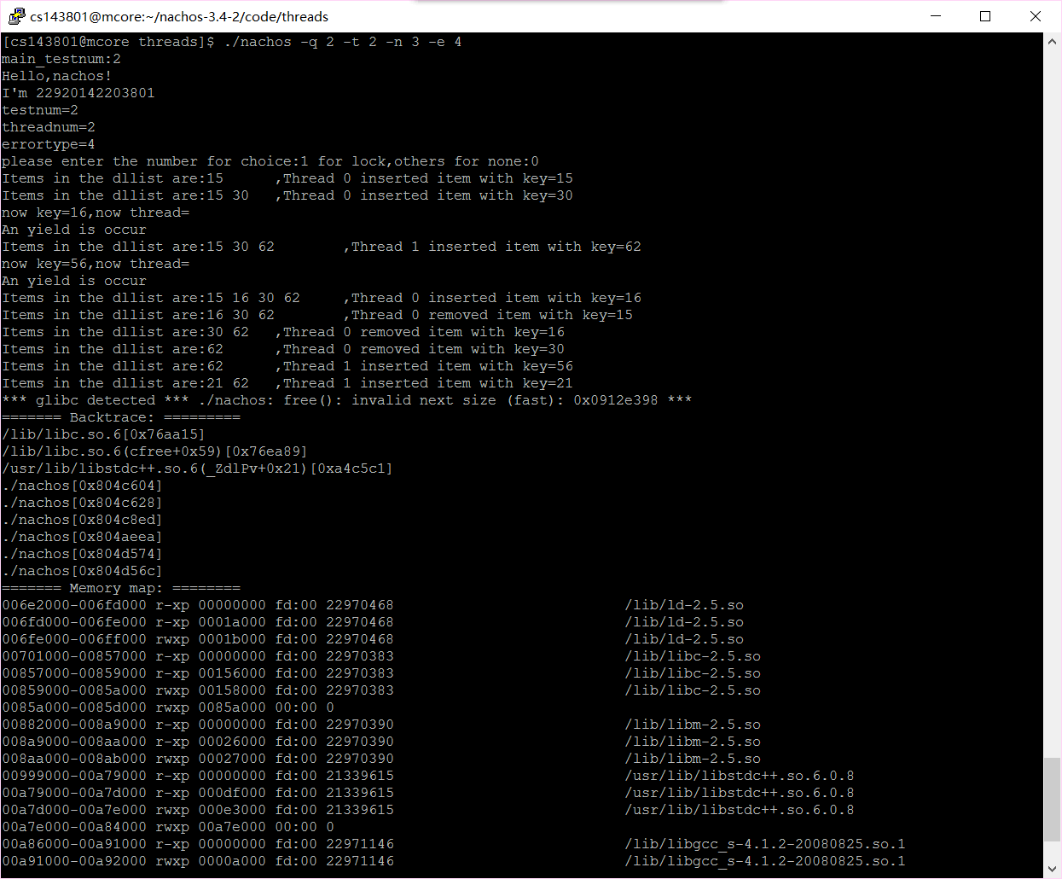
加锁以后
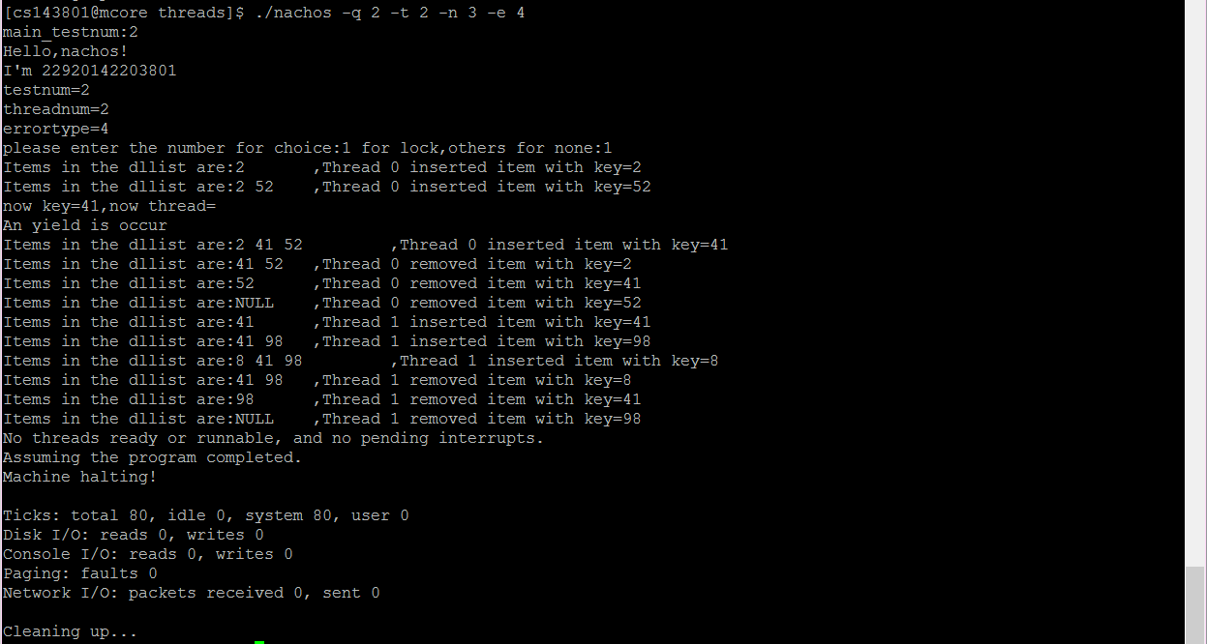
圈中的进程切换并没有成功发生，因为进程0持有锁，切换到进程1后进程1直接被挂起去睡觉，进程0继续执行。
2、实现一个线程安全的表结构
没有锁（进程1的插入操作导致进程0的插入操作被覆盖）
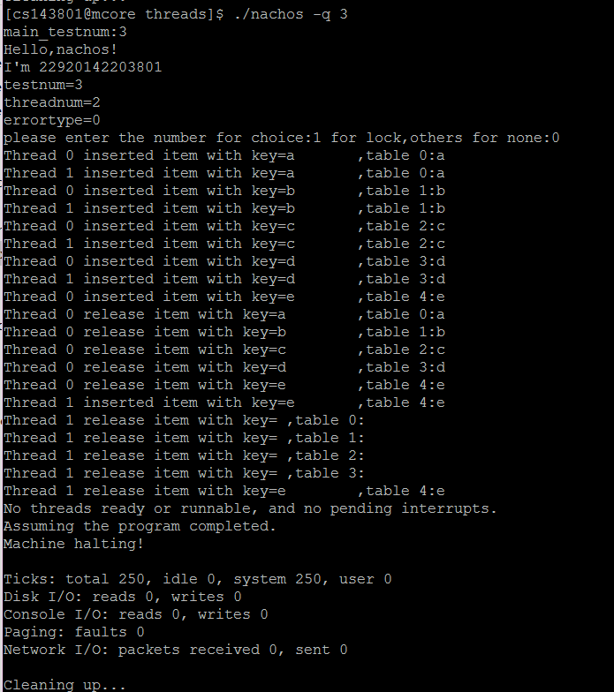
加锁以后：
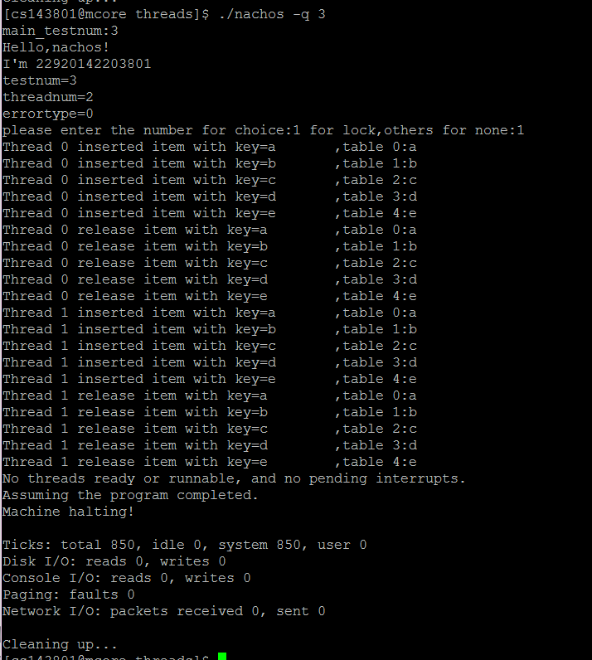

3、实现一个大小受限的缓冲区
没有锁（进程写入超过缓冲区大小却没有被阻止）：
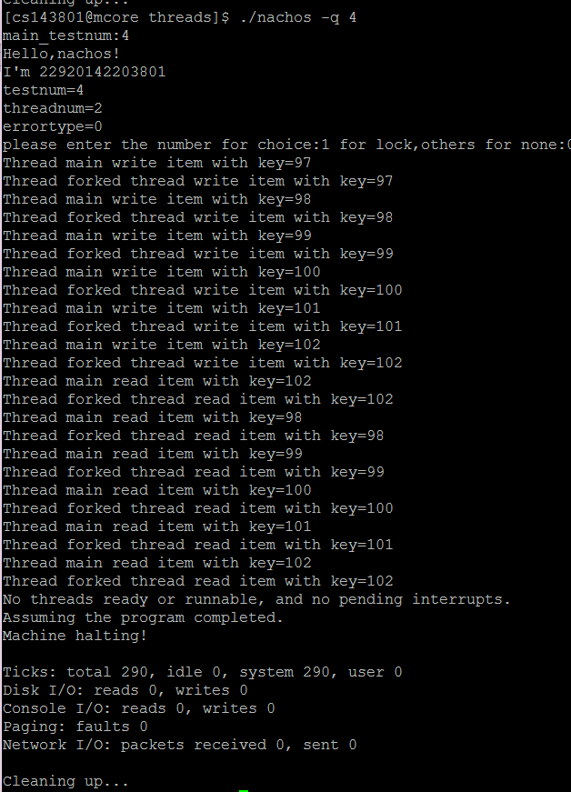
加锁以后：
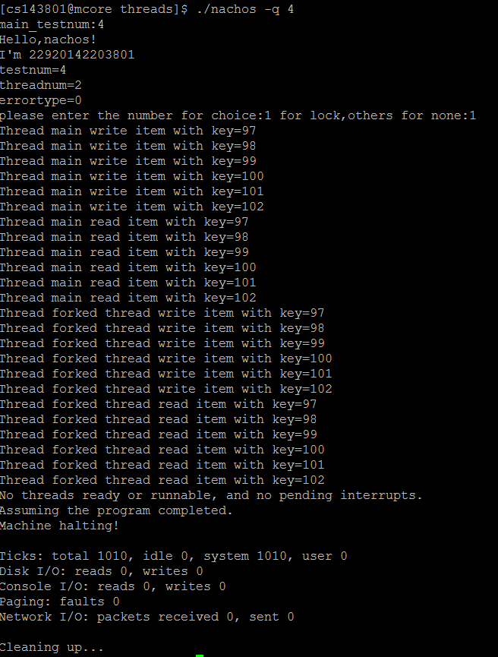
五、收获和总结
通过这次试验，我们组对于锁机制及条件变量的认识更加实例化，通过统一化接口，用不同方法实现锁机制及条件变量，让我们对封装的概念有了更深一步的认识。
其次，在实现锁机制跟条件变量的过程中，就如何检查实现的正确性、所实现的锁机制及条件变量是否有逻辑错误、两个语句的颠倒或者一个变量的不同赋值是否会照成程序错误等问题，我们组在编程之后也对这方面进行了讨论跟测试。实验中通过sleep和sem实现锁的机制。在用链表操作进行验证时，修改几个.h文件的头文件，以及makefile.common，实现两种不同方法。
总而言之，通过此次实验，我们组的组员对于锁的机制概念有了更为深入的理解，提升了对该机制的实际使用能力，受益匪浅。

六、小组分工
郑能鑫(2292142203972)：完成了synch-sleep.h、synch-sleep.cc 以及Sleep方式线程安全链表的实现，并对总体程序进行了修改与调试，写实验报告；
陈兆彬(2292142203801)：完成了BoundedBuffer.h、BoundedBuffer.cc、 BoudedBuffer-driver.cc的编写；
胡超(22920142203989)：完成了Table.h、Table.cc、Table-driver.cc 的编写。
黄宗超(22920142203991)：完成了synch-sem.h、synch-sem.cc的编写以及 实现。

