# PHP7 Benchmark

## 基本环境

一台8G内存的普通PC，在公司办公网，ubuntu系统，请先绑定以下HOSTS信息以查看具体php info。

192.168.30.212 php5.batman.me

192.168.30.212 php7.batman.me

可用以下URL查看两个版本的系统信息：

<http://php5.batman.me/info.php>

<http://php7.batman.me/info.php>

在另一台PC上用相同的ab参数施压：

ab -n 1000 -c 200 http://php5.batman.me/wordpress/

## Round 1

* **CONDITION**
* nginx worker: 10
* php-fpm max_children: 15
* requests: 1000
* concurrency: 200
* **RESULT**

| **指标** | **php7** | **php5** |
| --- | --- | --- |
| **Request per second** | **327.85** | **258.34** |
| **Time per request** | **2.75(ms)** | **4.41(ms)** |

## Round 2

* **CONDITION**
* nginx worker: 20
* php-fpm max_children: 15
* requests: 1000
* concurrency: 200
* **RESULT**

| **指标** | **php7** | **php5** |
| --- | --- | --- |
| **Request per second** | **354.15** | **266.66** |
| **Time per request** | **2.824(ms)** | **3.75(ms)** |

## Round 3

* **CONDITION**
* nginx worker: 20
* php-fpm max_children: 15
* requests: 1000
* concurrency: 500
* **RESULT**

| **指标** | **php7** | **php5** |
| --- | --- | --- |
| Request per second | 346.62 | 232.75 |
| Time per request | 2.885(ms) | 4.297(ms) |

## 性能报告图表

自带的sapi benchmark:

[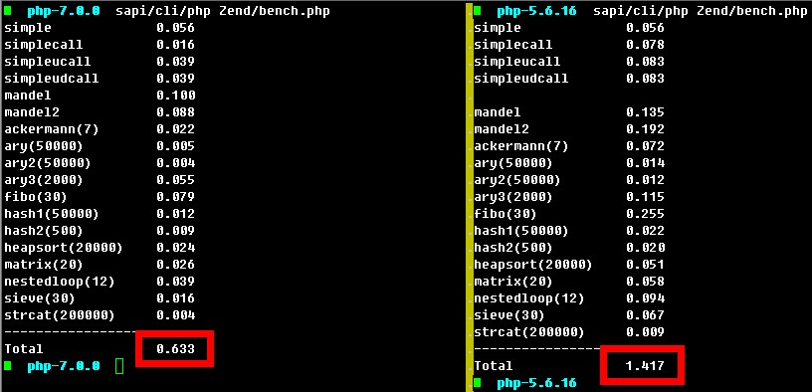](https://raw.githubusercontent.com/sunshine17/sunshine17.github.io/master/images/synthetic-bench-2.jpg)

性能统计图:

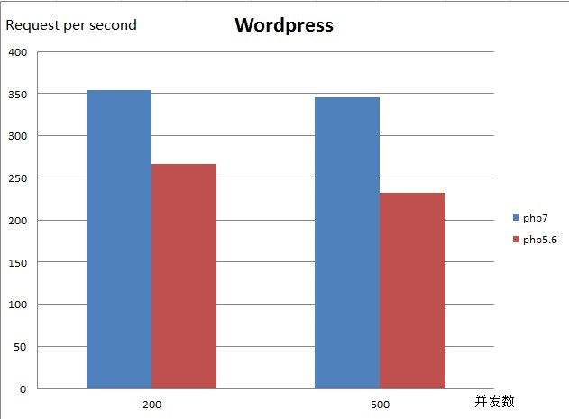

**ab测试1和2**[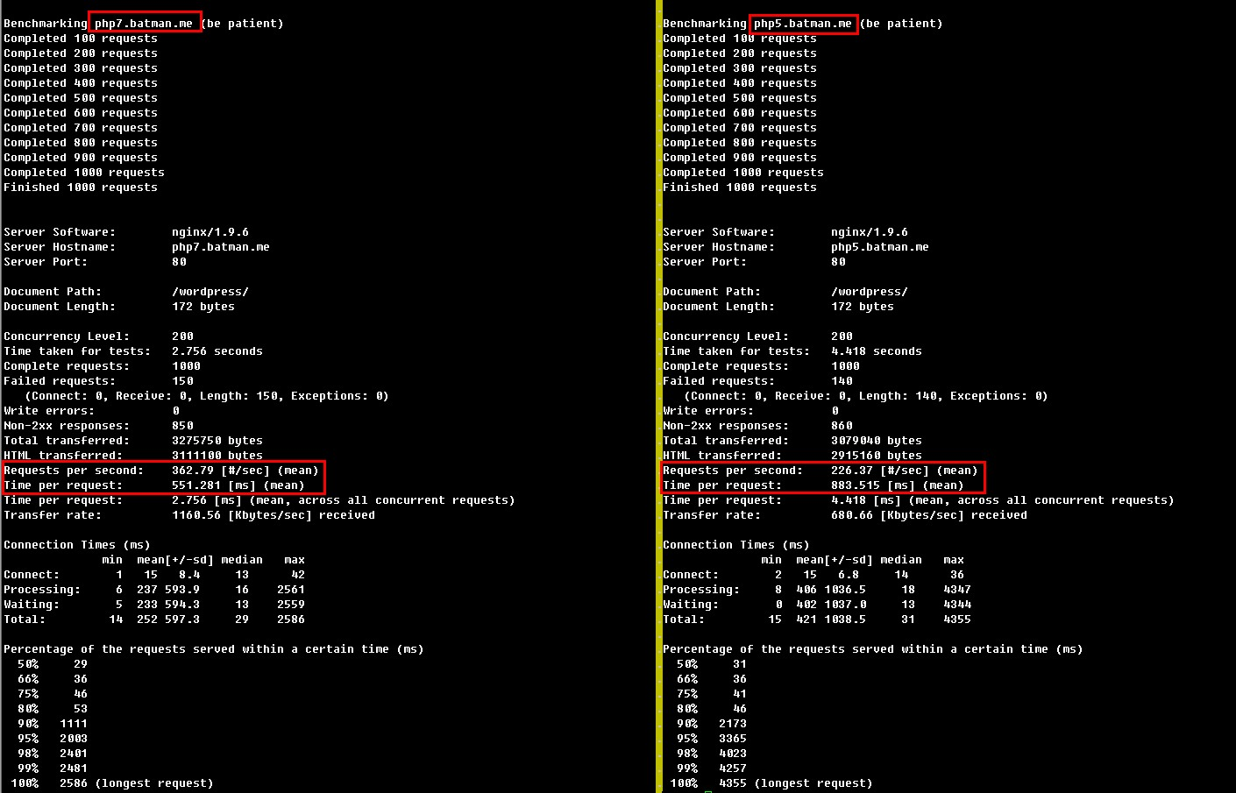](https://raw.githubusercontent.com/sunshine17/sunshine17.github.io/master/images/ab-1.jpg)

[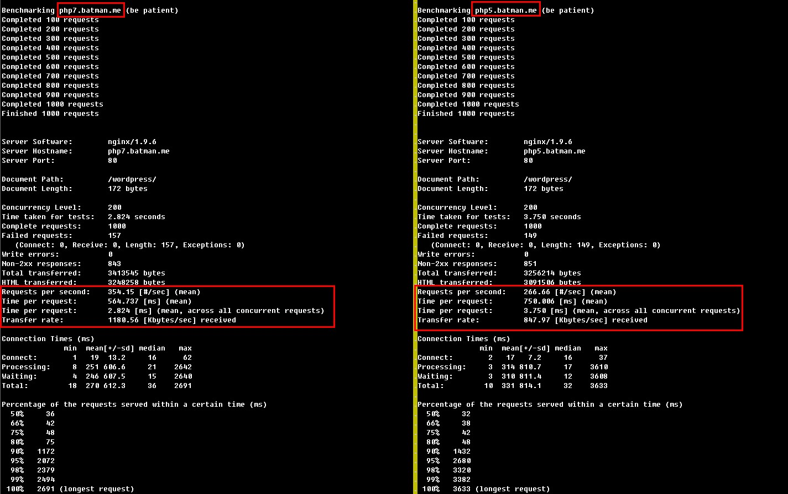](https://raw.githubusercontent.com/sunshine17/sunshine17.github.io/master/images/ab-2.jpg)