Files and Streams
Outline

- Input / Output (I/O): Reading and Writing

  - Possible uses for the I/O classes

  - Two types of streams: byte (binary) and character (ascii)
    - Overview of I/O Streams
    - Pseudo-code
    - Reader and Writer classes
    - InputStream and OutputStream classes

  - The java.io package

- Using the Streams

  - Types of Streams available

  - How to Use File Streams
    - First program together using IO classes

  - Working with Filter Streams

    - Definition
    - Code samples of Filter Streams
    - Pictorial View
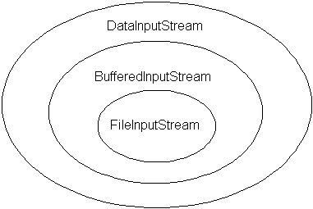
- Object Serialization

  - Definition

  - Uses

  - Code Sample

- Random Access Files

  - Explanation

  - Code Sample

