Object-Oriented Design Overview
Introduction To Java
Lecture 1
Instructor Notes

- Introduction and Syllabus Overview
- Object-Oriented Paradigm
  - Purpose of OO Paradigm – OOP provides an abstract representation to real-world problems. It uses concepts to provide a problem-solving approach to building systems, or, really any other real-world problem.
  - Pictorial View of OO Paradigm – Here’s how it works:

Real World
Problem
Things
|
Characteristics
(Behavioral & Structural)
|
------------ABSTRACTION-----------
|
Object-Oriented Paradigm
|
Objects

Attributes Operations (Methods)
System

  - Two Levels of Abstraction – there are 2 levels of abstraction that the Object-Oriented Paradigm provides:
    - 1st Level of Abstraction – Here, objects and classes abstract entities from the problem world or solution world.
      - Objects are abstracted entities that encapsulate state and behavior.
      - Links are abstracted relationships among objects.
      - Scenarios are abstracted message exchanges among objects.
    - 2nd Level of Abstraction – this level of abstraction looks more deeply into the actual class representation to expose their members (attributes and methods) and their association to other classes.
      - Classes are descriptions of a set of objects with common attributes, operation implementations, semantics, associations, and interactions.
      - Types of descriptions of a set of objects with common attributes, operation implementations, semantics, associations, and interactions.
      - Associations are descriptions of a set of links with common attributes, operation implementations, semantics, associations, and interactions.
      - Interactions are descriptions of a set of scenarios with common message exchange sequences, classes and associations.
- History of the Java Programming Language – In 1991, the first prototype of Java, known as the “Green Project”, was written by 3 men. One of these men was James Gosling, which is commonly referred to as the “father of Java”. To demonstrate the capabilities of the new language, James and 12 other programmers from Sun locked themselves behind closed doors for a period of 18 months. The demos that they developed proved that the new language could be used on digitally controlled consumer devices and computers. In this very first demo, appearing on one of the devices, the mascot “Duke” was doing cartwheels and waving on the screen. The device was able to control a wide range of platforms and appliances due to the fact that this new language was processor-independent. About a year later, Gosling re-named the language Oak, after the oak tree that looks outside his window. However, due to a naming-conflict, the language was re-named again to Java. Since the capabilities of this language were so revolutionary, many industries were not ready to incorporate this new technology. Therefore, in search of a target market, Sun chose the Internet. The thought was that Java could provide animation and behavior where HTML alone could not. On May 23, 1995, Java was officially announced and was to be incorporated within the Netscape Navigator browser. Before it’s release in Netscape’s browser, developers could download the HotJava Browser to run the first publicly available Java code. This was in 1994. Sun Microsystems decided to release the source code to the world. Their rationale was that if they release the code to developers for free, then it will be adopted quickly and it will allow the development community to inspect code and find any overlooked bugs.
- Advantages of Java
  - Simple – The syntax for Java is a cleaned-up version of the syntax for C++. There are no header files, pointer arithmetic, no pointers at all, no structures, unions, operator overloading, virtual classes, etc.
  - Object-Oriented – Java forces you to stay object-oriented, unlike C++ which can still be written C-like.
  - Distributed – Java was written from the ground up as a networking language. This means that it already includes many classes that make opening socket connections very easy. Likewise, Java also provides remote method invocation (RMI) which enables communication between distributed objects.
  - Robust – Java puts a lot of emphasis on early checking for possible problems. The compiler detects many problems that, in other languages, would show up only at run time. Part of this error-checking is due to the fact that Java is a strongly-typed language, meaning you must declare the datatype of every variable that you declare. Also, it handles your memory allocation for you so you don’t have to do it.
  - Secure - When writing applets or servlets, there is a built-in Security manager that gets called each time a class is instantiated. This occurs completed behind the scenes and it an example of the many ways Sun has addressed the security issues associated with the Java language.
  - Architecture Neutral – this is due to the JVM (Java Virtual Machine) which is a bytecode instruction set placed on any platform enabling the translating of bytecode into actual machine instruction.
- Feature:
  - Runs on PC, Mac, UNIX, Mainframe
  - Data types are machine-independent
- Benefit:
  - Use one language for all tiers on the application:
    - User Interface
    - Database
    - Business Logic
  - Easily move applications to the most cost-effective platform(s)

  - Portable – Once compiled, your Java code can run only any JVM residing on any platform, provided the JDK versions do not conflict.
  - Multithreading- allows multiple threads to execute in a thread-safe environment
- Feature:
  - Multi-threading support is built-in to the language
    - The "synchronized" keyword
- Benefit:
  - Easier to understand than third-party multi-threading tools or non-object-oriented API calls

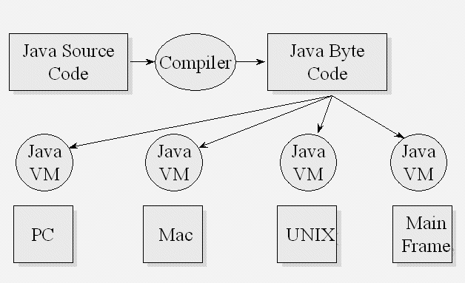
- Disadvantages
  - Speed – still not as fast as C++, due to the fact that it is interpreted instead of compiled.
- Java
  - Editions
    - J2SE (Standard Edition) – for stand-alone applications, applets…
    - J2EE (Enterprise Edition) – for N-Tiered solutions
    - J2ME (Micro Edition) – for PDAs & cellular phones
  - JDK Versions (used to be known as SDK or Software Development Kit)
    - 1.4 is still in Beta
    - 1.3x most recent, stable version
    - 1.2x used to be known as Java 2
    - 1.1x oldest version, many changes since then
  - IDE
    - JBuilder – download at the following URL
      - Set up CLASSPATH
      - Set up PATH
      - Go through Welcome tutorial
    - Others – VAJ (Visual Age for Java), Forte, Visual Cafe

