Fundamentals
Lecture 3
Instructor Notes

- Data Types – If you recall from Lecture 2, objects contain both state and behavior. Unlike objects, primitive types are data objects that 1) consists of a single value 2) are manipulated by using operators, rather than sending messages 3) cannot be extended by creating new types or operations. Also, primitives store values, whereas object types store references.
  - Primitives – Although Java provides object types to mirror all the capabilities primitives, Java still provides primitives as well. Java and C++ are known as hybrid languages and not pure OO language because of the inclusion of primitives. Why include primitives at all? Efficiency. Primitive types require less storage and less processing power than object types. What is commonly seen in Java is the creation of a class that includes primitives within it as attributes. Thus, helping to make objects more efficient. We will discuss Wrapper Classes later. NOTE: Java is a strongly typed language, which means that every variable must have a declared type. All of these primitives stay the same number of bytes despite what OS the bytecode is running on top of due to the fact that they will run on the JVM.
    - int – 4 bytes (32 bits)
    - short – 2 bytes (16 bits)
    - long – 8 bytes (64 bits)
      - Use ‘L’ suffix for long literals Ex: long l = 50000000L;
      - Use ‘0x’ to for hexadecimal literals Ex: short hex = 0xff;
    - byte – 1 byte (8 bits)
    - float – 4 bytes (32 bits)
      - Use ‘f’ suffix for float literals (Note: You must have the ‘f’ otherwise, you will get a compiler error. If you take it out, it defaults to a double.)
    - double – 8 bytes (64 bits)
      - Literals are double by default
    - char – 2 bytes (Unicode)
      - Use single quotes(e.g.’x’) for character literals or Unicode equivalent (Example: capital A is 65 in Unicode) so we can declare the following: private char theCharA = 65;
      - Escape sequences – use can use escape sequences to specify a particular character; use the backslash followed by the Unicode value or character representation.
Sequence | Meaning (Hex Representation)
\b | Backspace(\u0008)
\t | Tab(\u0009)
\n | Newline(\u000A)
\f | Form feed(\u000C)
\r | Return (\u000D)

    - boolean – can hold only one of two possible values: true or false
      - You cannot use an int in place of a boolean in an expression
      - if(a=5) // Compile error
      - if(a==5) // OK
      - The most common use of boolean values is in making decisions for loops and selections.
- Example: pg. 76 in OO Design in Java book
- Wrapper Classes – The wrapper classes for primitive datatypes are found in the java.lang package. For each primitive datatype there is a corresponding wrapper class to represent the values of the primitive dataype as an object. These wrapper classes also define useful methods for manipulating both primitive data values and objects. The wrapper classes for integers (Byte, Short, Integer, and Long) are subclasses of the java.lang.Number class, along with the wrapper classes for floating-point numbers (Float, Double).
- Variables – a variable must start with a letter and be a sequence of letters or digits. Letter: A-Z, a-z, _, Unicode character; can’t use +, spaces, case is significant, convention is initial caps with first character lowercase. Ex: myVariable
  - Local – declared within a method
  - Instance – gets copied with each new instance of the class
  - Static (or Class or field) – owned by the class itself; only one exists ever
- Initialization
  - A local variable MUST be initialized, otherwise, the compiler will complain.
  - Class variables are automatically initialized
  - Integers are initialized to 0
  - Floats are initialized to 0.0
  - Object references are initialized to null
  - Constants
    - Uses the final keyword
    - Prevents the variable from being changed
    - By convention, use uppercase
- Assignment
  - Variable declaration: int counter
  - Variable initialization counter = 0;
  - Both declaration and initialization can be done on one line: int counter=0;
- Operators
  - Arithmetic-
- +, -, *, /
- % is mod
- i += 5; is same as i = i + 5;
    - -=, *=, etc. are also included
  - Increment and Decrement –
- i++ postincrement adds one i = i + 1; (By using the ++, you actually will get faster performance within the JVM.)
- i-- postdecrement
- ++i preincrement
- Using preincrement increment the value, the returns the result in the expression
- Using postincrement returns the result in the expression THEN increments the value
  - Relational Operators: <, <=, >, >=
    - Is a < b
    - Is a<= b
    - Is a > b
    - Is a >= b
  - Logical (short and long circuit)
- == vs. = and C++ (To evaluate a boolean value, use ==)
- if (a = 5 ) // Compiler error in Java, OK in C++ (Reason: this does not evaluate to a boolean)
- if(a == 5) // Intended
- != - Not equal
- && - Logical AND
- || - Logical OR
  - Short-circuit: If the first expression is true, the second expression won't even be evaluated
  - Better performance
  - Possible unwanted side-effects
- Non-short-circuit versions also work: &, |
- Examples of each of these!!!

Example:
k=0;
l = ++k;
if((l==1) || (k++ == 2))
System.out.println("l is " + l + " and k is " + k);

  - Bitwise
    - & - AND
    - | - OR
    - ^ - XOR (Stands for Exclusive OR)
    - ~ - NOT
    - >> - Shift right with sign extend (These shift operators are used to talk to external devices; Example: software that talks to a digital camera for toggles the on/off switch might use a series of ones and zeros.)
    - >>> - Shift right with zero extend
    - << - Shift left
    - Examples of each of these.
  - Precedence – order in which expressions are evaluated see page 61 (Fund)
    - Parentheses change the order of evaluation (A + B*C) - B*C is first, A+(B*C) is second
  - Casts – This is the conversion from one datatype to another. It can be implicit or explicit.
    - Casting is automatic going from smaller to larger
      - no information is lost
      - byte-short-int-float-double
      - char-int
        - Example int i = 10; float f = i;
    - Casting from larger to smaller must be explicit
      - information may be lost
      - you, the programmer, must explicitly cast it
        - float f=50.5; int I =(int)f;
- Strings – Strings are true objects in Java
  - Concatenation vs. StringBuffer – the “+” operator is overloaded for concatenation Example: String name = “Natalie” + “ Wear”; Use StringBuffer if you are doing lots of concatenation.
  - The “new” operator is not needed to create new objects/instances of string. Instead you can just use an object reference. Obviously, it will be more overhead to instantiate an instance of the String class than to assign a string literal to an object variable. However, both will still provide access to all of the methods declared within the String class.
  - Substrings - Use substring() to get part of a string (Marty is 01234, so String ss = s.substring(1,4) means start at index 1 and go out 4 spaces. So, ss is art. It takes everything up to the last number but NOT including it.)
- First parameter is starting index (starts at zero!)
  - Second parameter is ending index plus one
  - String Editing – use length() to get the length of a string; Strings are immutable, in other words, a string cannot be changed once it is created; strings are shared in memory; The String class is final.
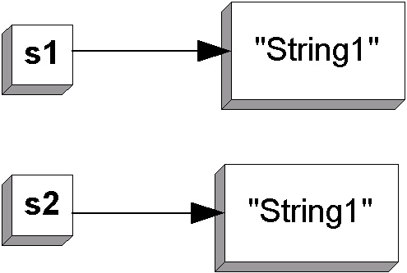
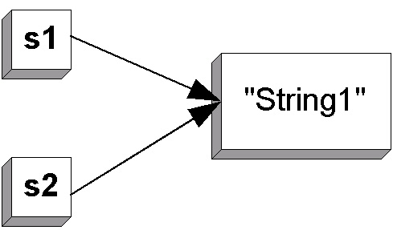

  - Testing String for Equality
    - Use the .equals() method to compare strings
    - THIS IS A COMMON JAVA PROGRAMMING MISTAKE!!
    - String s1 = "String One";
    - String s2 = "String Two";
    - if ( s1 == s2 ) // BAD!!! This compares what the references point to, NOT the contents
    - if ( s1.equals( s2 ) ) // GOOD!!! This compares the contents of s1 with the contents of s2
- Control Flow - Block is defined by curly braces { }; Local variable declared within a block don't have scope outside the block; COMMON JAVA BUG- Local variable with the same name as instance variable can shadow (hide) the instance variables (Use the letter "m" in front of class or instance variables - m is for member)
  - Selection (if, if/else, switch)
      - if ( condition ) statement;
      - if ( condition ) { block };
      - if ( condition ) statment; else statement;
      - if ( condition ) { block } else { block }
      - switch ( choice ) {
case 1:
break; (without the break, it will evaluate the next case statement, etc.)
case 2:
break;
...
default
break;
}
      - The choice must be a char, byte, short, or int
      - You can omit break statements for multiple matching conditions
      - JAVA BUG: Don’t forget break statements!
  - Iteration (while, do/while, for)
    - while ( condition ) { block }
      - Condition is checked before the block is first executed
    - do { block } while ( condition );
      - Block executed first time, then the condition is checked
    - for( initializer; condition; post-block) { block }
      - for(int I=0; I<10; I++)
  - Transfer (break, continue, return) ???
- Arrays – Arrays are first-class objects meaning they are actual types that the compiler checks for; Array indicies start at zero; Syntax for creating
arrays: int[]

myArray = new int[20]; // indices are 0 - 19

myArray[0] = 5; // Assigning an array element
int i = myArray[0]; // Retrieving an array element
- Initializing arrays:
- Use { } notation
- int myArray[] = { 5, 10 , 15 };
- Anonymous arrays have no name
- new int[] { 1, 3, 5 }
- Use .length to get the size on an array
  - Copy arrays using System.arraycopy(); (This will only copy the references: int myArray[] = anArray[]; ) You must use arraycopy() method to copy the array.)
  - Multi-Dimensional
- Arrays of arrays
- int [][] multi2 = new int[5][3];
- int [][][] multi3 = new int[10][20][30];
- Arrays need not be rectangular. (They can also be triangular like this
int[] myArray = int [5][];

myArray[0] = new int[4];

myArray[1] = new int[3];

myArray[2] = new int[2]; etc.)

