# 下载mysql数据库安装包

从<https://dev.mysql.com/downloads/mysql/>

下载MySQL Community Server 5.7.22

根据服务器版本进行相关 选择

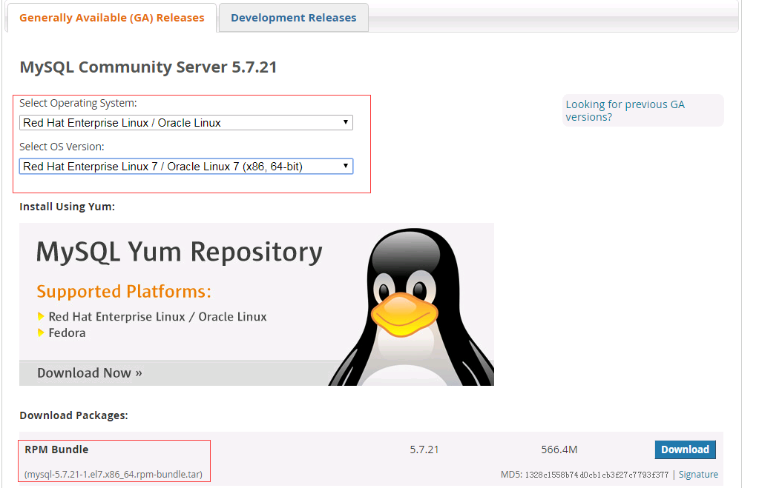

上传文件到服务器/usr/soft目录下，如果不存在目录则创建该目录

**mkdir /usr/soft**

**或者运行命令:**

**wget -P /usr/soft https://cdn.mysql.com//Downloads/MySQL-5.7/mysql-5.7.22-1.el7.x86_64.rpm-bundle.tar**

# 安装mysql

## 2.1安装前工作

### 2.1.1卸载系统自带的Mariadb

查看mariadb数据库

**rpm -qa | grep mariadb**

如果存在，卸载mariadb数据库

**rpm -e --nodeps 文件名**

### 2.1.2卸载已安装的mysql

查看 mysql 数据库：

**rpm -qa | grep -i mysql**

如果存在，卸载 mysql 数据库:

**rpm -e --nodeps mysql文件名**

### 2.1.3删除etc目录下的my.cnf文件

**rm /etc/my.cnf**

### 2.1.4安装依赖包

**yum install numactl**

## 2.2解压下载的压缩包

进入jdk压缩文件夹所在的目录

**cd /usr/soft**

*解压缩到安装路径*

**tar -xvf mysql-5.7.22-1.el7.x86_64.rpm-bundle.tar**

会得到许多.rpm的文件

mysql-community-embedded-devel-5.7.22-1.el7.x86_64.rpm

mysql-community-minimal-debuginfo-5.7.22-1.el7.x86_64.rpm

mysql-community-common-5.7.22-1.el7.x86_64.rpm

mysql-community-libs-compat-5.7.22-1.el7.x86_64.rpm

mysql-community-embedded-compat-5.7.22-1.el7.x86_64.rpm

mysql-community-server-minimal-5.7.22-1.el7.x86_64.rpm

mysql-community-client-5.7.22-1.el7.x86_64.rpm

mysql-community-server-5.7.22-1.el7.x86_64.rpm

mysql-community-embedded-5.7.22-1.el7.x86_64.rpm

mysql-community-test-5.7.22-1.el7.x86_64.rpm

mysql-community-devel-5.7.22-1.el7.x86_64.rpm

mysql-community-libs-5.7.22-1.el7.x86_64.rpm

安装过程中只会使用部分rpm包，切严格安装顺序，否则不会成功

**rpm -ivh mysql-community-common-5.7.22-1.el7.x86_64.rpm**

**rpm -ivh mysql-community-libs-5.7.22-1.el7.x86_64.rpm**

**rpm -ivh mysql-community-client-5.7.22-1.el7.x86_64.rpm**

**rpm -ivh mysql-community-server-5.7.22-1.el7.x86_64.rpm**

**rpm -ivh mysql-community-devel-5.7.22-1.el7.x86_64.rpm**

## 2.3启动mysql服务

**systemctl start mysqld.service**

**开机自启动**

**systemctl enable mysqld.service**

**查看是否启动成功**

**netstat -ln | grep 3306**

# 配置mysql

## 3.1登陆mysql并设置密码

看看mysql默认安装时生成的密码

**grep 'temporary password' /var/log/mysqld.log**

登陆mysql

**mysql –u root –p**

使用初始随机密码登录后MySQL会强制要求修改密码,

**set global validate_password_policy=0;**

**set PASSWORD = PASSWORD('shyzs,,.//');**

**alter user 'root'@'localhost' PASSWORD EXPIRE NEVER;**

**flush privileges;**

然后退出后即可用新密码登录.

## 3.2授权mysql可以登陆的主机

**GRANT ALL PRIVILEGES ON *.* TO 'root'@'%' IDENTIFIED BY 'shyzs,,.//' WITH GRANT OPTION;**

## 3.3配置防火墙打开端口

开通端口（默认3306）：

**firewall-cmd --add-port=3306/tcp**

4.参考文献

https://www.cnblogs.com/qjoanven/p/7699382.html