小幺鸡环境搭建步骤

1、准备。

小幺鸡搭建环境：

Tomcat 7.0

Xiaoyaoji.2.1.5.war

JDK1.7

MYSQL 5.5 以上

安装包准备：

下载小幺鸡对应版本的war包。本次使用的版本为2.1.5.2

下载地址：

wget https://github.com/zhoujingjie/xiaoyaoji/releases/download/2.1.5.2/xiaoyaoji-2.1.5.war

(如果无法正常下载，请登录github账号以后，进行下载)

下载 tomcat 7.0

wget http://mirrors.tuna.tsinghua.edu.cn/apache/tomcat/tomcat-7/v7.0.88/bin/apache-tomcat-7.0.88.tar.gz

下载JDK1.7

请到[www.oracle.com](http://www.oracle.com)官方网站进行下载，期间要登陆账号。

本次使用xiaoyaoji普通用户进行搭建，初始化用户步骤

useradd xiaoyaoji 创建小幺鸡用户

passwd xiaoyaoji 设置密码

su – xiaoyaoji 切换到 xiaoyaoji 用户。

上传下载的压缩包到xiaoyaoji 的家目录下面。

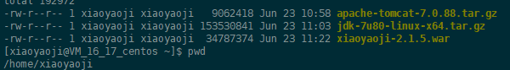

2、配置jdk1.7。

解压jdk tar.gz包到当前目录。

tar zxvf jdk-7u80-linux-x64.tar.gz

修改个人环境变量。

vim ~/.bashrc

末尾添加

export JAVA_HOME=/home/xiaoyaoji/jdk1.7.0_80

export JRE_HOME=/home/xiaoyaoji/jdk1.7.0_80/jre

export PATH=${JAVA_HOME}/bin:${JRE_HOME}/bin:$PATH

加载环境变量

source ~/.bashrc

测试java版本是否添加正确

java -version

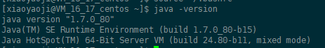

3、配置tomcat。

解压tomat源码包到xiaoyaoji家目录下面。

tar zxvf apache-tomcat-7.0.88.tar.gz

为了不影响当前的环境的java应用，我们修改tomcat 的server.xml配置，改变部分端口监听信息。

vim /home/xiaoyaoji/apache-tomcat-7.0.88/conf/server.xml

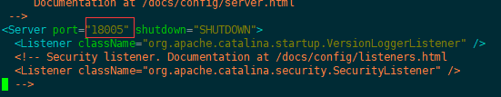

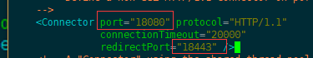

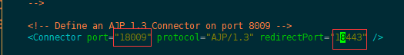

修改以上配置，保存，并测试tomcat启动，是否正常。

/home/xiaoyaoji/apache-tomcat-7.0.88/bin/startup.sh

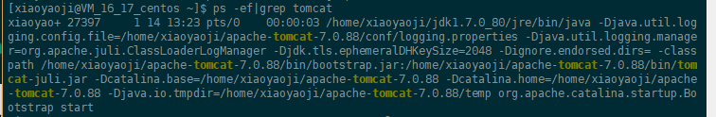

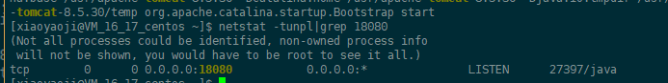

测试页面是否可以正常访问

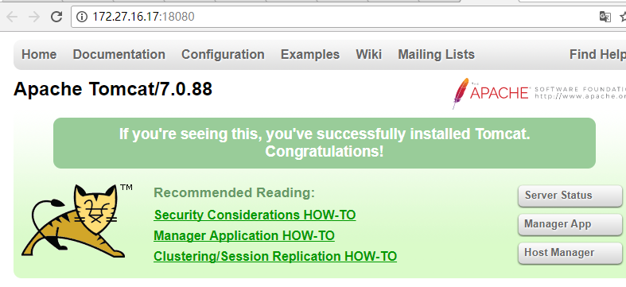

如上所示代表tomcat和JDK1.7 已经部署成功。

4、配置mysql数据库。

登陆mysql数据库，新建xiaoyaoji database

CREATE DATABASE xiaoyaoji CHARACTER SET utf8;

创建xiaoyaoji用户，并授权,密码可以改成自己定义的。

GRANT ALL PRIVILEGES ON xiaoyaoji.* TO 'xiaoyaoji'@'%' IDENTIFIED BY 'Zxxdad~!#88921';

导入xiaoyaoji.sql到xiaoyaoji database

Xiaoyaoji.sql内容如下：

/*

Navicat MySQL Data Transfer

Source Server : 47.94.211.245-xyj

Source Server Version : 50716

Source Host : 47.94.211.245:3306

Source Database : xiaoyaoji

Target Server Type : MYSQL

Target Server Version : 50716

File Encoding : 65001

Date: 2017-09-07 11:16:31

*/

SET FOREIGN_KEY_CHECKS=0;

-- ----------------------------

-- Table structure for attach

-- ----------------------------

DROP TABLE IF EXISTS `attach`;

CREATE TABLE `attach` (

`id` char(12) NOT NULL,

`url` varchar(1000) DEFAULT NULL,

`type` varchar(45) DEFAULT NULL,

`sort` int(11) DEFAULT NULL,

`relatedId` char(12) DEFAULT NULL,

`fileName` varchar(1000) DEFAULT NULL,

`createTime` datetime DEFAULT NULL,

`projectId` char(12) DEFAULT NULL,

PRIMARY KEY (`id`),

KEY `normal` (`relatedId`)

) ENGINE=InnoDB DEFAULT CHARSET=utf8mb4;

-- ----------------------------

-- Table structure for doc

-- ----------------------------

DROP TABLE IF EXISTS `doc`;

CREATE TABLE `doc` (

`id` char(12) NOT NULL,

`name` varchar(200) DEFAULT NULL,

`sort` int(11) DEFAULT '100',

`type` varchar(100) DEFAULT NULL,

`content` longtext,

`createTime` datetime DEFAULT NULL,

`lastUpdateTime` datetime DEFAULT NULL,

`parentId` char(12) DEFAULT NULL,

`projectId` char(12) DEFAULT NULL,

PRIMARY KEY (`id`),

KEY `parentId` (`parentId`) USING BTREE,

KEY `projectId` (`projectId`) USING BTREE

) ENGINE=InnoDB DEFAULT CHARSET=utf8mb4;

-- ----------------------------

-- Table structure for doc_history

-- ----------------------------

DROP TABLE IF EXISTS `doc_history`;

CREATE TABLE `doc_history` (

`id` int(11) NOT NULL AUTO_INCREMENT,

`name` varchar(200) DEFAULT NULL,

`sort` int(11) DEFAULT '100',

`type` varchar(100) DEFAULT NULL,

`content` longtext,

`createTime` datetime DEFAULT NULL,

`parentId` char(12) DEFAULT NULL,

`projectId` char(12) DEFAULT NULL,

`comment` varchar(1000) DEFAULT NULL,

`userId` char(12) DEFAULT NULL,

`docId` char(12) DEFAULT NULL,

PRIMARY KEY (`id`)

) ENGINE=InnoDB AUTO_INCREMENT=51473 DEFAULT CHARSET=utf8mb4;

-- ----------------------------

-- Table structure for email_token

-- ----------------------------

DROP TABLE IF EXISTS `email_token`;

CREATE TABLE `email_token` (

`id` char(12) NOT NULL,

`email` varchar(45) NOT NULL,

`isUsed` tinyint(1) NOT NULL DEFAULT '0',

`createtime` datetime NOT NULL,

`token` char(32) NOT NULL,

PRIMARY KEY (`id`)

) ENGINE=InnoDB DEFAULT CHARSET=utf8mb4;

-- ----------------------------

-- Table structure for find_password

-- ----------------------------

DROP TABLE IF EXISTS `find_password`;

CREATE TABLE `find_password` (

`id` char(12) NOT NULL DEFAULT '',

`email` varchar(45) DEFAULT NULL,

`isUsed` tinyint(1) DEFAULT '0',

`createTime` datetime DEFAULT NULL,

PRIMARY KEY (`id`)

) ENGINE=InnoDB DEFAULT CHARSET=utf8mb4;

-- ----------------------------

-- Table structure for interface

-- ----------------------------

DROP TABLE IF EXISTS `interface`;

CREATE TABLE `interface` (

`id` char(14) NOT NULL DEFAULT '',

`name` varchar(50) DEFAULT NULL,

`description` text,

`folderId` char(14) DEFAULT NULL,

`url` varchar(300) DEFAULT NULL,

`requestMethod` varchar(50) DEFAULT NULL,

`contentType` varchar(50) DEFAULT NULL,

`requestHeaders` text,

`requestArgs` text,

`responseArgs` text,

`example` mediumtext,

`moduleId` varchar(50) DEFAULT NULL,

`projectId` char(14) DEFAULT NULL,

`lastUpdateTime` datetime DEFAULT NULL,

`createTime` datetime DEFAULT NULL,

`dataType` varchar(30) DEFAULT NULL,

`protocol` varchar(30) DEFAULT NULL,

`status` char(10) DEFAULT 'ENABLE',

`sort` int(11) DEFAULT NULL,

PRIMARY KEY (`id`),

KEY `projectid` (`projectId`) USING BTREE

) ENGINE=InnoDB DEFAULT CHARSET=utf8mb4;

-- ----------------------------

-- Table structure for interface_folder

-- ----------------------------

DROP TABLE IF EXISTS `interface_folder`;

CREATE TABLE `interface_folder` (

`id` char(14) NOT NULL DEFAULT '',

`name` varchar(50) DEFAULT NULL,

`createTime` datetime DEFAULT NULL,

`moduleId` char(14) DEFAULT NULL,

`projectId` char(14) DEFAULT NULL,

`sort` int(11) DEFAULT '100',

PRIMARY KEY (`id`),

KEY `projectid` (`projectId`) USING BTREE

) ENGINE=InnoDB DEFAULT CHARSET=utf8mb4;

-- ----------------------------

-- Table structure for module

-- ----------------------------

DROP TABLE IF EXISTS `module`;

CREATE TABLE `module` (

`id` char(14) NOT NULL DEFAULT '',

`name` varchar(50) DEFAULT NULL,

`host` varchar(255) DEFAULT NULL,

`description` mediumtext,

`lastUpdateTime` datetime DEFAULT NULL,

`projectId` char(14) DEFAULT NULL,

`createTime` datetime DEFAULT NULL,

`requestHeaders` text,

`requestArgs` text,

`sort` int(11) DEFAULT NULL,

PRIMARY KEY (`id`),

KEY `projectid` (`projectId`) USING BTREE

) ENGINE=InnoDB DEFAULT CHARSET=utf8mb4;

-- ----------------------------

-- Table structure for project

-- ----------------------------

DROP TABLE IF EXISTS `project`;

CREATE TABLE `project` (

`id` char(14) NOT NULL,

`name` varchar(50) DEFAULT NULL,

`description` varchar(300) DEFAULT NULL COMMENT 'test',

`teamId` char(14) DEFAULT NULL,

`createTime` datetime DEFAULT NULL,

`userId` char(14) DEFAULT NULL,

`status` varchar(20) DEFAULT 'VALID',

`permission` varchar(20) DEFAULT 'PRIVATE',

`environments` text,

`details` text,

`lastUpdateTime` datetime DEFAULT NULL,

PRIMARY KEY (`id`)

) ENGINE=InnoDB DEFAULT CHARSET=utf8mb4;

-- ----------------------------

-- Table structure for project_global

-- ----------------------------

DROP TABLE IF EXISTS `project_global`;

CREATE TABLE `project_global` (

`id` char(12) NOT NULL DEFAULT '',

`environment` mediumtext,

`http` mediumtext,

`projectId` char(12) NOT NULL DEFAULT '',

`status` mediumtext

) ENGINE=InnoDB DEFAULT CHARSET=utf8mb4;

-- ----------------------------

-- Table structure for project_log

-- ----------------------------

DROP TABLE IF EXISTS `project_log`;

CREATE TABLE `project_log` (

`id` char(14) NOT NULL DEFAULT '',

`userId` char(14) DEFAULT NULL,

`createTime` datetime DEFAULT NULL,

`log` text,

`projectId` char(14) DEFAULT NULL,

`action` varchar(50) DEFAULT NULL,

PRIMARY KEY (`id`),

KEY `projectid` (`projectId`) USING BTREE

) ENGINE=InnoDB DEFAULT CHARSET=utf8mb4;

-- ----------------------------

-- Table structure for project_user

-- ----------------------------

DROP TABLE IF EXISTS `project_user`;

CREATE TABLE `project_user` (

`id` char(14) NOT NULL,

`projectId` char(14) DEFAULT NULL,

`userId` char(14) DEFAULT NULL,

`createTime` datetime DEFAULT NULL,

`status` char(255) DEFAULT 'PENDING',

`editable` char(3) DEFAULT 'YES',

`commonlyUsed` char(3) DEFAULT 'NO',

PRIMARY KEY (`id`),

KEY `project_user` (`projectId`,`userId`) USING BTREE

) ENGINE=InnoDB DEFAULT CHARSET=utf8mb4;

-- ----------------------------

-- Table structure for share

-- ----------------------------

DROP TABLE IF EXISTS `share`;

CREATE TABLE `share` (

`id` char(12) NOT NULL DEFAULT '',

`name` varchar(50) DEFAULT NULL,

`createTime` datetime DEFAULT NULL,

`userId` char(12) DEFAULT NULL,

`shareAll` char(3) DEFAULT NULL,

`password` varchar(20) DEFAULT NULL,

`moduleIds` varchar(2000) DEFAULT NULL,

`projectId` char(12) DEFAULT NULL,

`docIds` varchar(2000) DEFAULT NULL,

PRIMARY KEY (`id`)

) ENGINE=InnoDB DEFAULT CHARSET=utf8mb4;

-- ----------------------------

-- Table structure for sys

-- ----------------------------

DROP TABLE IF EXISTS `sys`;

CREATE TABLE `sys` (

`version` varchar(10) DEFAULT NULL

) ENGINE=InnoDB DEFAULT CHARSET=utf8mb4;

-- ----------------------------

-- Table structure for team

-- ----------------------------

DROP TABLE IF EXISTS `team`;

CREATE TABLE `team` (

`id` char(14) NOT NULL DEFAULT '',

`name` varchar(50) DEFAULT NULL,

`description` varchar(300) DEFAULT NULL,

`userId` char(14) DEFAULT NULL,

`createTime` datetime DEFAULT NULL,

`status` varchar(20) DEFAULT 'VALID',

PRIMARY KEY (`id`)

) ENGINE=InnoDB DEFAULT CHARSET=utf8mb4;

-- ----------------------------

-- Table structure for team_user

-- ----------------------------

DROP TABLE IF EXISTS `team_user`;

CREATE TABLE `team_user` (

`id` char(14) NOT NULL,

`teamId` char(14) DEFAULT NULL,

`userId` char(14) DEFAULT NULL,

`createTime` datetime DEFAULT NULL,

PRIMARY KEY (`id`)

) ENGINE=InnoDB DEFAULT CHARSET=utf8mb4;

-- ----------------------------

-- Table structure for user

-- ----------------------------

DROP TABLE IF EXISTS `user`;

CREATE TABLE `user` (

`id` char(12) NOT NULL,

`email` varchar(45) DEFAULT NULL,

`createtime` datetime DEFAULT NULL,

`password` char(32) DEFAULT NULL,

`type` varchar(5) DEFAULT 'USER',

`nickname` varchar(30) DEFAULT NULL,

`avatar` varchar(200) DEFAULT NULL,

`status` char(10) DEFAULT NULL,

PRIMARY KEY (`id`),

UNIQUE KEY `id_UNIQUE` (`id`),

UNIQUE KEY `username` (`email`) USING BTREE

) ENGINE=InnoDB DEFAULT CHARSET=utf8mb4;

-- ----------------------------

-- Table structure for user_third

-- ----------------------------

DROP TABLE IF EXISTS `user_third`;

CREATE TABLE `user_third` (

`id` varchar(60) NOT NULL,

`userid` char(12) NOT NULL,

`type` varchar(100) DEFAULT NULL,

PRIMARY KEY (`id`),

KEY `userId` (`userid`)

) ENGINE=InnoDB DEFAULT CHARSET=utf8mb4;

-- ----------------------------

-- Procedure structure for trans_module

-- ----------------------------

DROP PROCEDURE IF EXISTS `trans_module`;

DELIMITER ;;

CREATE DEFINER=`root`@`%` PROCEDURE `trans_module`()

begin

DECLARE done INT DEFAULT FALSE;

declare id varchar(100);

declare name,host,projectId varchar(100);

declare lastUpdateTime,createTime datetime;

declare description MEDIUMTEXT;

declare cur1 cursor for select id from module limit 100;

DECLARE CONTINUE HANDLER FOR NOT FOUND SET done = TRUE;

open cur1;

read_loop: LOOP

FETCH cur1 into id;

if done

then leave read_loop;

end if;

select id;

end LOOP;

close cur1;

end

;;

DELIMITER ;

5、部署xiaoyaoji.war包。

复制 xiaoyaoji.war包到tomcat webapp 文件夹。

cp -a /home/xiaoyaoji/xiaoyaoji-2.1.5.war /home/xiaoyaoji/apache-tomcat-7.0.88/webapps/

cd /home/xiaoyaoji/apache-tomcat-7.0.88/webapps/ 切换到webapps文件夹。

修改项目的配置文件。

vim xiaoyaoji-2.1.5/WEB-INF/classes/config.properties

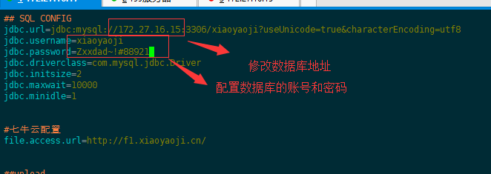

保存配置。

重新启动tomcat 。

/home/xiaoyaoji/apache-tomcat-7.0.88/bin/shutdown.sh

/home/xiaoyaoji/apache-tomcat-7.0.88/bin/startup.sh