**TARGET CASE STUDY**

1. **Import the dataset and do the usual exploratory analysis steps like checking the structure & characteristics of the dataset**

A. Data type of columns in a table

SELECT COLUMN_NAME ,DATA_TYPE

FROM `target.INFORMATION_SCHEMA.COLUMNS`;

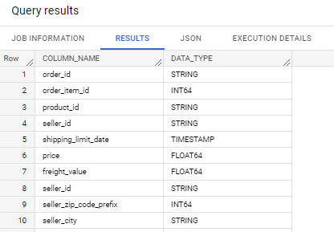

B. Time period for which the data is given

SELECT min(order_purchase_timestamp),max(order_purchase_timestamp) FROM `target.orders`;

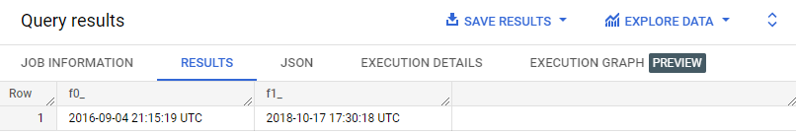

C. Cities and States of customers ordered during the given period

SELECT DISTINCT customer_city,customer_state from `target.customers` as c

JOIN `target.orders`as o

ON c.customer_id=o.customer_id;

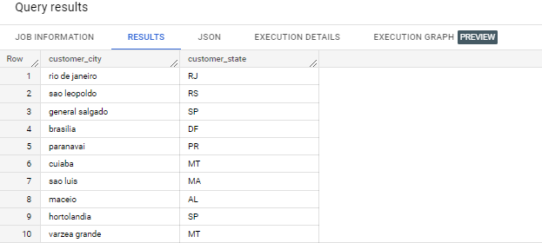

1. **In-depth Exploration:**

A. Is there a growing trend on e-commerce in Brazil? How can we describe a complete scenario? Can we see some seasonality with peaks at specific months?

We have incomplete data for each year, for 2016 we have 3 month data and 2018 we have 10 month data so I calculated average sales per month for each year. And I found that there is an year on year increase in sales. So the trend is positive.

SELECT sum(p.payment_value)/count(DISTINCT EXTRACT(MONTH FROM o.order_purchase_timestamp)), EXTRACT(YEAR FROM o.order_purchase_timestamp) from `target.orders` as o

JOIN `target.payments` as p

on o.order_id=p.order_id

GROUP BY EXTRACT(YEAR FROM o.order_purchase_timestamp);

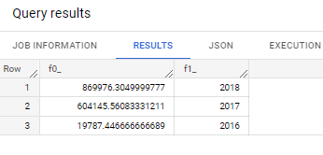

Aggregation by month to check the seasonality.

SELECT sales,month FROM

(SELECT sum(p.payment_value) as sales, EXTRACT(MONTH FROM o.order_purchase_timestamp) as month from `target.orders` as o

JOIN `target.payments` as p

on o.order_id=p.order_id

GROUP BY EXTRACT(MONTH FROM o.order_purchase_timestamp)

)

ORDER BY month;

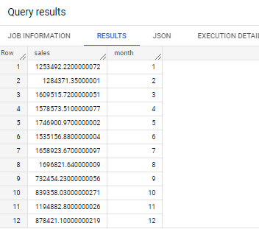

B. What time do Brazilian customers tend to buy (Dawn, Morning, Afternoon or Night)?

take into consideration the time zone and all four time zones

SELECT sum(if(time>=0 and time<=600, 1, 0)) as dawn,sum(if(time>=601 and time<=1200, 1, 0)) as morning,sum(if(time>=1201 and time<=1800, 1, 0)) as afternoon, sum(if(time>=1801 and time<=2359, 1, 0)) as night FROM

(

SELECT (EXTRACT(HOUR FROM order_purchase_timestamp)*100+EXTRACT(HOUR FROM order_purchase_timestamp)) as time FROM `target.orders`

);

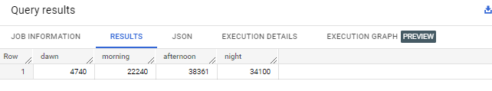

1. **Evolution of E-commerce orders in the Brazil region:**

A. Get month-on-month orders by states

SELECT count(*) as total_orders,c.customer_state,

EXTRACT(MONTH FROM order_purchase_timestamp) as month

from `target.customers`as c

JOIN `target.orders`as o

ON c.customer_id=o.customer_id;

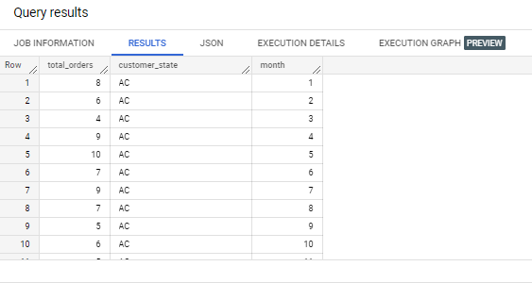

B. Distribution of customers across the states in Brazil

SELECT count(DISTINCT c.customer_id) as total_customers,c.customer_state from `target.customers` as c

JOIN `target.orders`as o

ON c.customer_id=o.customer_id

GROUP BY c.customer_state

ORDER BY count(DISTINCT c.customer_id) desc;

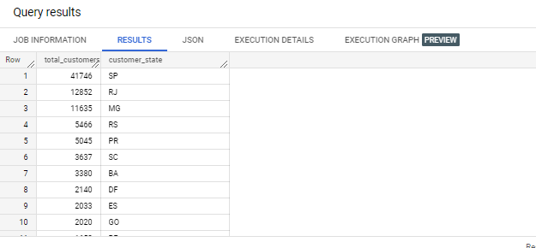

1. **Impact on the Economy: Analyze the money movement by e-commerce by looking at order prices, freight and others.**

A. Get % increase in cost of orders from 2017 to 2018 (include months between Jan to Aug only) - You can use “payment_value” column in payments table

SELECT ROUND(((sales2018-sales2017)/sales2017)*100,2) as percentage_ordervaluechange FROM

(SELECT sum(if(EXTRACT(YEAR FROM o.order_purchase_timestamp)=2017,p.payment_value,0)) as sales2017,

sum(if(EXTRACT(YEAR FROM o.order_purchase_timestamp)=2018,p.payment_value,0)) as sales2018 from `target.orders` o

JOIN `target.payments` p

ON o.order_id=p.order_id

WHERE EXTRACT(MONTH FROM o.order_purchase_timestamp) BETWEEN 1 AND 8);

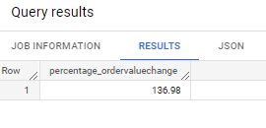

B. Mean & Sum of price and freight value by customer state

SELECT c.customer_state,round(sum(oi.price),2) as price_sum,round(sum(oi.freight_value),2) as freight_sum, round(avg(oi.price),2) as price_mean,

round(avg(oi.freight_value),2) as freight_mean

FROM `target.orders` o

JOIN `target.order_items` oi

ON o.order_id=oi.order_id

JOIN `target.customers` c

ON o.customer_id=c.customer_id

GROUP BY c.customer_state;

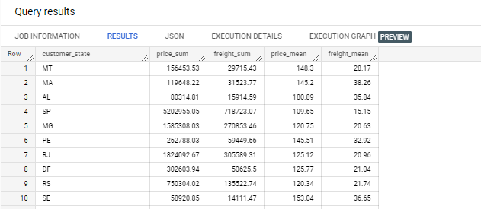

1. **Analysis on sales, freight and delivery time**

A. Calculate days between purchasing, delivering and estimated delivery

SELECT order_id, DATE_DIFF(order_delivered_customer_date,order_purchase_timestamp, day) AS days_for_delivery,

DATE_DIFF(order_delivered_customer_date,order_estimated_delivery_date, day) AS days_lag_in_delivery FROM `target.orders`

WHERE order_status='delivered';

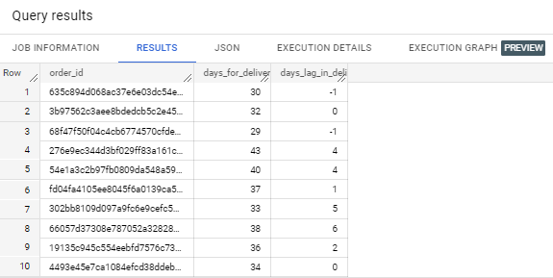

B. Find time_to_delivery & diff_estimated_delivery

SELECT order_id, DATE_DIFF(order_delivered_customer_date,order_purchase_timestamp, day) AS time_to_delivery,

DATE_DIFF(order_estimated_delivery_date,order_delivered_customer_date, day) AS diff_estimated_delivery FROM `target.orders`

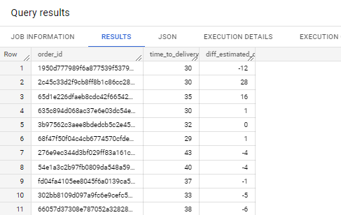

C. Group data by state, take the mean of freight_value, time_to_delivery, diff_estimated_delivery

SELECT c.customer_state,avg(oi.freight_value) as avg_freight_value ,avg(DATE_DIFF(order_delivered_customer_date,order_purchase_timestamp, day)) AS avg_time_to_delivery,

avg(DATE_DIFF(order_estimated_delivery_date,order_delivered_customer_date, day)) AS avg_diff_estimated_delivery FROM `target.orders` o

JOIN `target.customers` c

ON o.customer_id=c.customer_id

JOIN `target.order_items` oi

ON o.order_id=oi.order_id

GROUP BY c.customer_state;

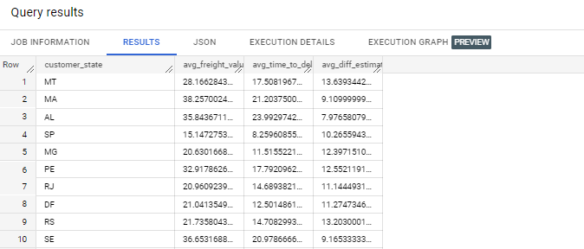

D.

Top 5 lowest

SELECT c.customer_state,avg(oi.freight_value) as avg_freight_value FROM `target.orders` o

JOIN `target.customers` c

ON o.customer_id=c.customer_id

JOIN `target.order_items` oi

ON o.order_id=oi.order_id

GROUP BY c.customer_state

ORDER BY avg(oi.freight_value) LIMIT 5;

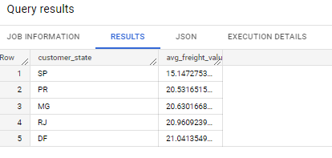

Top 5 highest

SELECT c.customer_state,avg(oi.freight_value) as avg_freight_value FROM `target.orders` o

JOIN `target.customers` c

ON o.customer_id=c.customer_id

JOIN `target.order_items` oi

ON o.order_id=oi.order_id

GROUP BY c.customer_state

ORDER BY avg(oi.freight_value) DESC LIMIT 5;

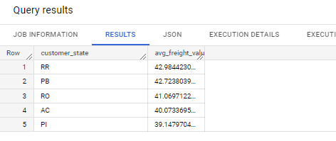

E.

BOTTOM 5

SELECT c.customer_state,avg(DATE_DIFF(order_delivered_customer_date,order_purchase_timestamp, day)) AS avg_time_to_delivery

FROM `target.orders` o

JOIN `target.customers` c

ON o.customer_id=c.customer_id

GROUP BY c.customer_state

ORDER BY avg(DATE_DIFF(order_delivered_customer_date,order_purchase_timestamp, day)) LIMIT 5;

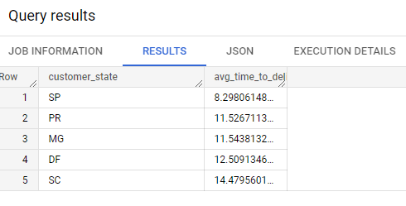

TOP 5

SELECT c.customer_state,avg(DATE_DIFF(order_delivered_customer_date,order_purchase_timestamp, day)) AS avg_time_to_delivery

FROM `target.orders` o

JOIN `target.customers` c

ON o.customer_id=c.customer_id

GROUP BY c.customer_state

ORDER BY avg(DATE_DIFF(order_delivered_customer_date,order_purchase_timestamp, day)) DESC LIMIT 5;

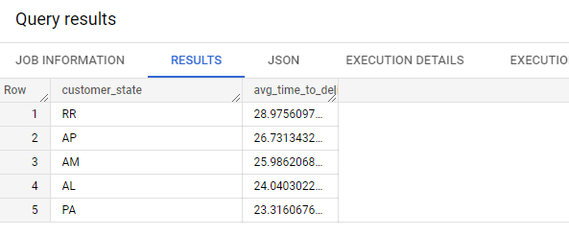

F.

TOP 5 fastest delivery states

SELECT c.customer_state,avg(DATE_DIFF(order_estimated_delivery_date,order_delivered_customer_date, day))

AS avg_diff_estimated_delivery

FROM `target.orders` o

JOIN `target.customers` c

ON o.customer_id=c.customer_id

GROUP BY c.customer_state

ORDER BY avg(DATE_DIFF(order_estimated_delivery_date,order_delivered_customer_date, day)) DESC LIMIT 5;

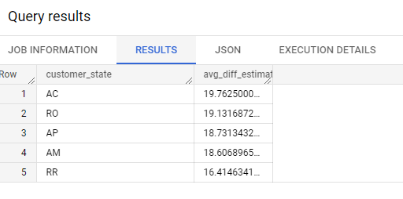

TOP 5 Slowest delivery states

SELECT c.customer_state,avg(DATE_DIFF(order_estimated_delivery_date,order_delivered_customer_date, day))

AS avg_diff_estimated_delivery

FROM `target.orders` o

JOIN `target.customers` c

ON o.customer_id=c.customer_id

GROUP BY c.customer_state

ORDER BY avg(DATE_DIFF(order_estimated_delivery_date,order_delivered_customer_date, day)) LIMIT 5;

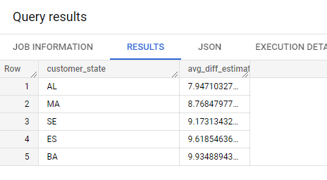

1. **Payment type analysis:**

A. Month over Month count of orders for different payment types

SELECT orders,month,payment_type FROM

(SELECT count(*) as orders,EXTRACT(MONTH FROM order_purchase_timestamp) as month,p.payment_type FROM `target.orders`o

JOIN `target.payments` p

ON o.order_id=p.order_id

GROUP BY EXTRACT(MONTH FROM order_purchase_timestamp),p.payment_type)

ORDER BY payment_type,month;

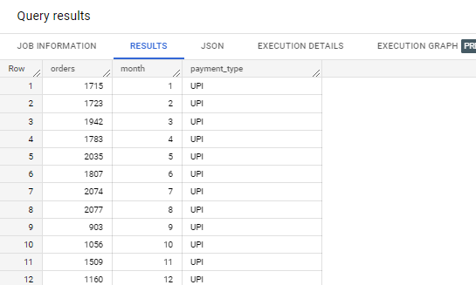

B. Count of orders based on the no. of payment installments

SELECT payment_installments, count(*) as no_of_orders

FROM `target.payments` p JOIN `target.orders` o

ON p.order_id=o.order_id

GROUP BY payment_installments

ORDER BY payment_installments;

