# 功能效果

# 接口统计

测试地址

|  |  |  |  |  |  |  |  |  |  |  |  |  |  |
| --- | --- | --- | --- | --- | --- | --- | --- | --- | --- | --- | --- | --- | --- |
| |  |  |  |  |  |  |  |  |  |  |  |  |  | | --- | --- | --- | --- | --- | --- | --- | --- | --- | --- | --- | --- | --- | | |  |  |  | | --- | --- | --- | | <http://192.168.188.206/uapws/rest/meike/receive/oaBillStateReceive>  【3】预算编制发送OA ？？？     |  |  | | --- | --- | | 大修 | CRM-OA-0030 | | | <http://192.168.188.206:80/uapws/rest/meike/receive/oaBillStateReceive>   1. 客户新增 | | <http://192.168.188.206/uapws/rest/meike/receive/billReceive>  [6] | |  | | <http://172.18.102.210:8888/rest/registerContractInfo>  【2销售合同上传】CRM-JT-0002,0003？？ | | <http://192.168.188.206/uapws/rest/meike/maindata/pullMaterial>  【4】CRM-MDM-0001 物料 | | <http://192.168.188.206/uapws/rest/meike/maindata/pullSupplier>  [5] CRM-MDM-0002 供应商 | | <http://192.168.188.206:80/uapws/rest/meike/salesOrder/configChange>  【8】 | | <http://192.168.188.206:80/uapws/rest/meike/salesOrder/receive/execreportx>  【9】 | | <http://172.18.102.210:8888/rest/login>  【1】获取集团token CRM-JT-0001 | | |

|  |  |  |  |  |  |  |  |  |  |  |  |  |  |
| --- | --- | --- | --- | --- | --- | --- | --- | --- | --- | --- | --- | --- | --- |
| |  | | --- | | **系统测试地址&系统UAT测试地址** | | http://172.18.102.210:8888/rest/login | | http://172.18.102.210:8888/rest/registerContractInfo | | http://192.168.188.196:8080/uapws/rest/meike/receive/oaBillStateReceive | | http://192.168.188.206/uapws/rest/meike/maindata/pullMaterial | | http://192.168.188.206/uapws/rest/meike/maindata/pullSupplier | | http://192.168.188.206/uapws/rest/meike/receive/billReceive | | http://192.168.188.206/uapws/rest/meike/receive/oaBillStateReceive | | http://192.168.188.206:80/uapws/rest/meike/receive/oaBillStateReceive | | http://192.168.188.206:80/uapws/rest/meike/salesOrder/configChange | | http://192.168.188.206:80/uapws/rest/meike/salesOrder/receive/execreport | |  | | **总计** | |

|  |
| --- |
| **系统测试地址&系统UAT测试地址** |
|  |
| <http://172.18.102.210:8888/rest/registerContractInfo>  测试接口：CRM-ERP-0001 【下午只有一个】 |
| 测试接口： |
|  |
|  |
| 测试接口：CRM-ERP-0001 【下午】 |
|  |
| 测试接口：CRM-ERP-0002 【下午只有一个】 |
| 测试接口：CRM-ERP |
|  |
| **总计** |
|  |

# CRM

## 销售订单

|  |
| --- |
| 测试地址：http://192.168.188.206/uapws/rest/meike/receive/oaBillStateReceive |

1. 搜素销售订单，选择销售订单新增

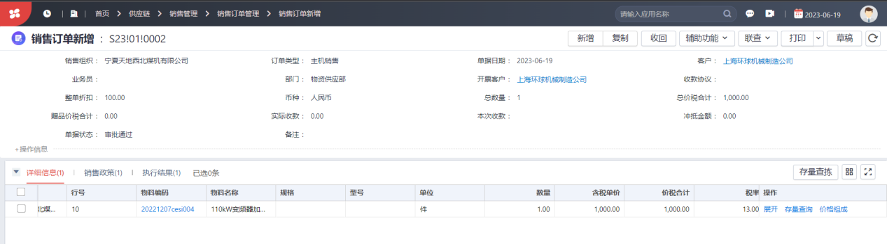

## 接收ERP销售订单的执行情况

<http://192.168.188.206:80/uapws/rest/meike/salesOrder/receive/execreport>

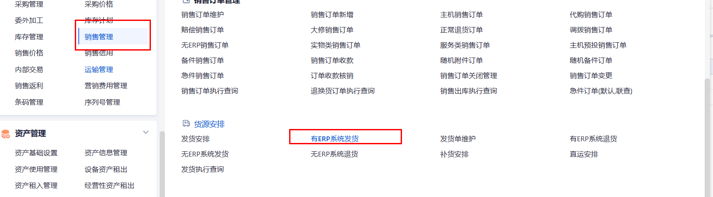

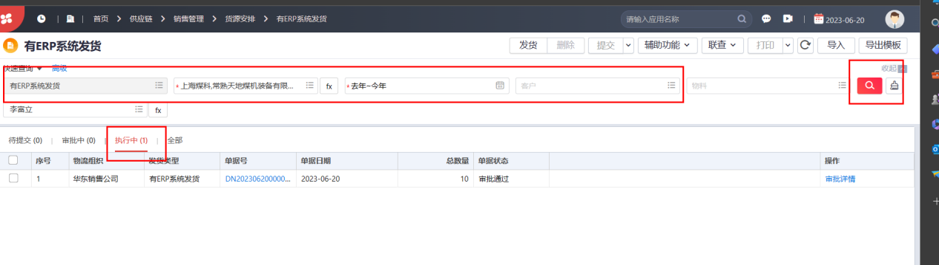

## 接收ERP销售订单的配置码

* 直接搜索三码查询，然后就可以接收到销售订单的配置码

使用默认或者自带的，没有的话需要去查

<http://192.168.188.206:80/uapws/rest/meike/salesOrder/configChange>

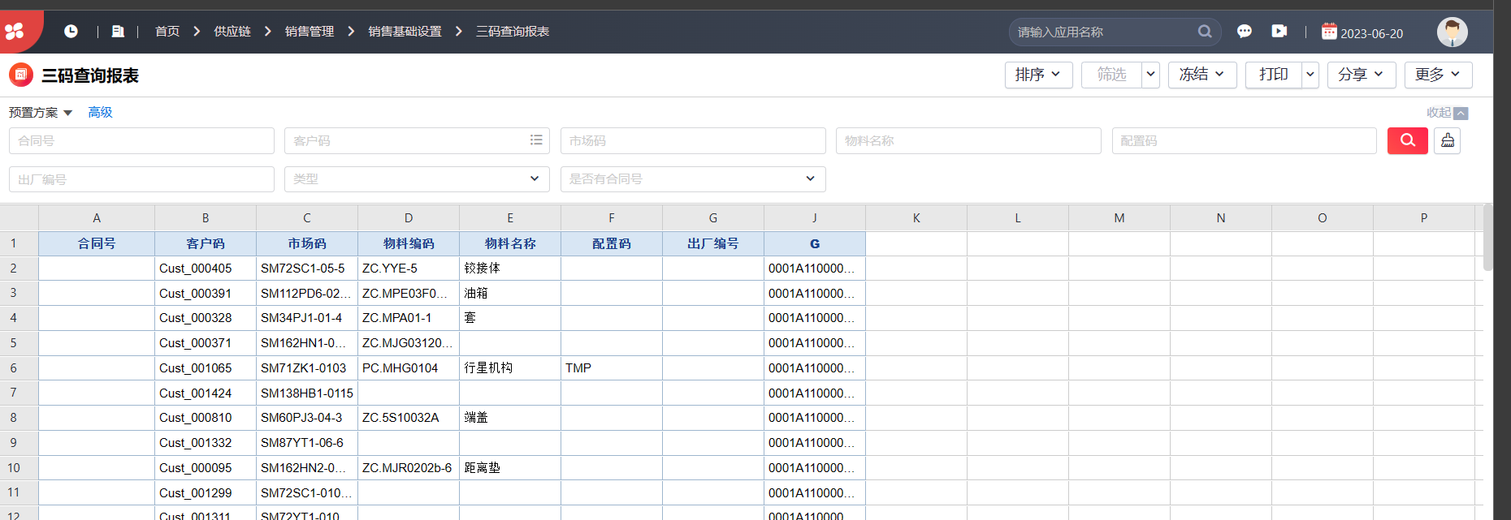

## 销售出库单

<http://192.168.188.206/uapws/rest/meike/receive/billReceive>

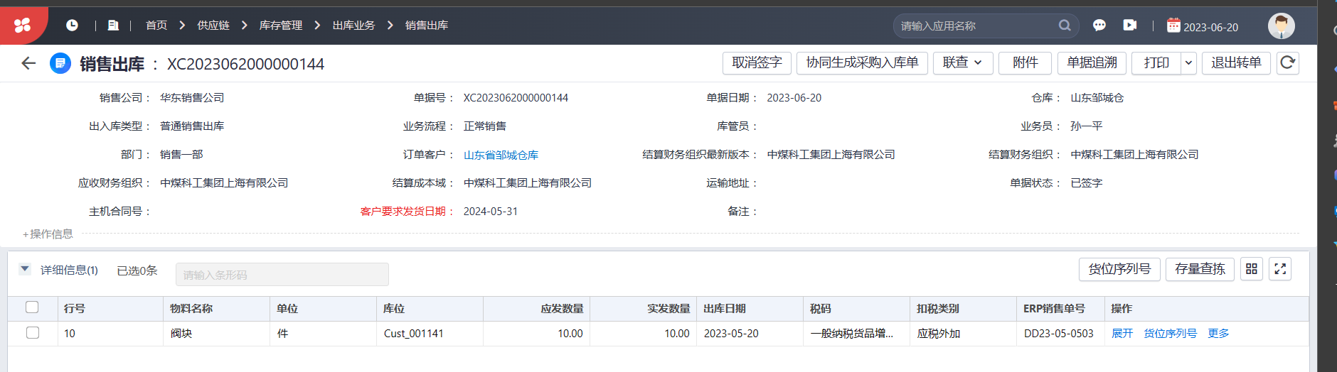

# OA

|  |
| --- |
| 接口统计  http://192.168.188.214:8080/api/ec/dev/auth/applytoken  http://192.168.188.214:8080/api/ec/dev/auth/regist  http://192.168.188.214:8080/api/workflow/paService/doCreateRequest  http://192.168.188.214:8080/api/workflow/paService/doForceDrawBack  http://192.168.188.214:8080/api/workflow/paService/rejectRequest  http://192.168.188.214:8080/api/workflow/paService/submitRequest  http://192.168.188.214:8080/sso/login |

<http://192.168.188.214:8080/api/workflow/paService/doCreateRequest>

销售合同

## 流程新增创建接口

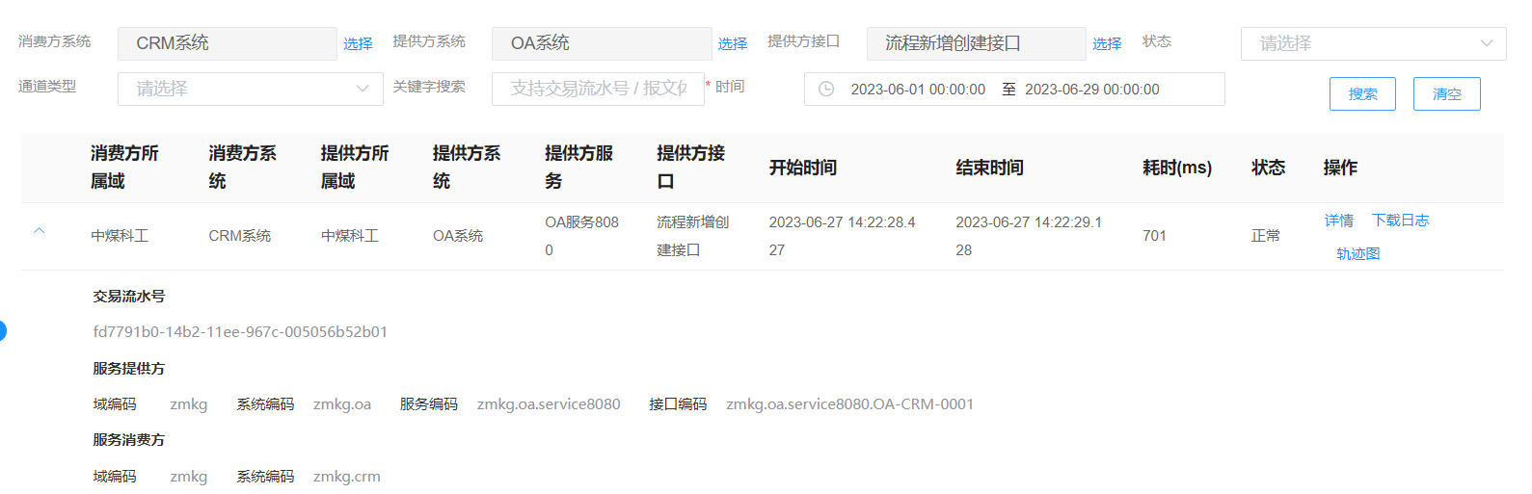

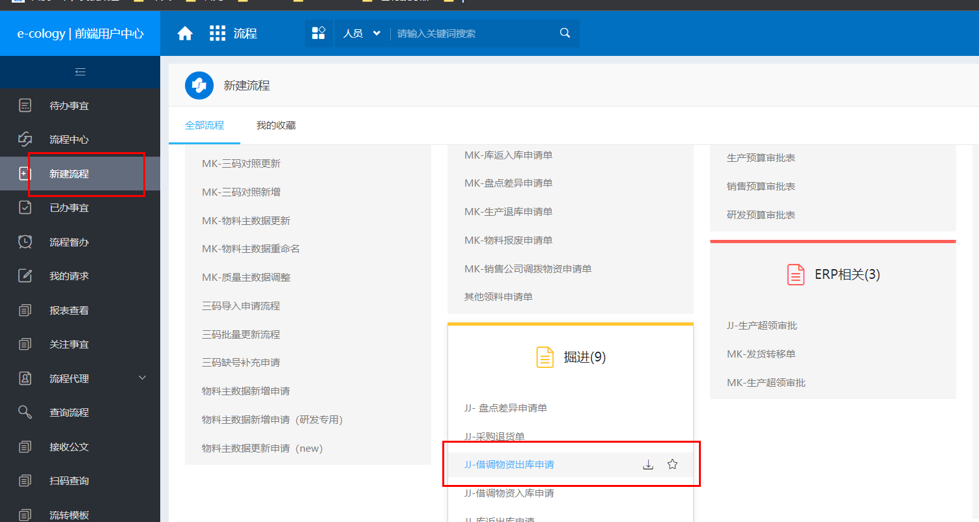

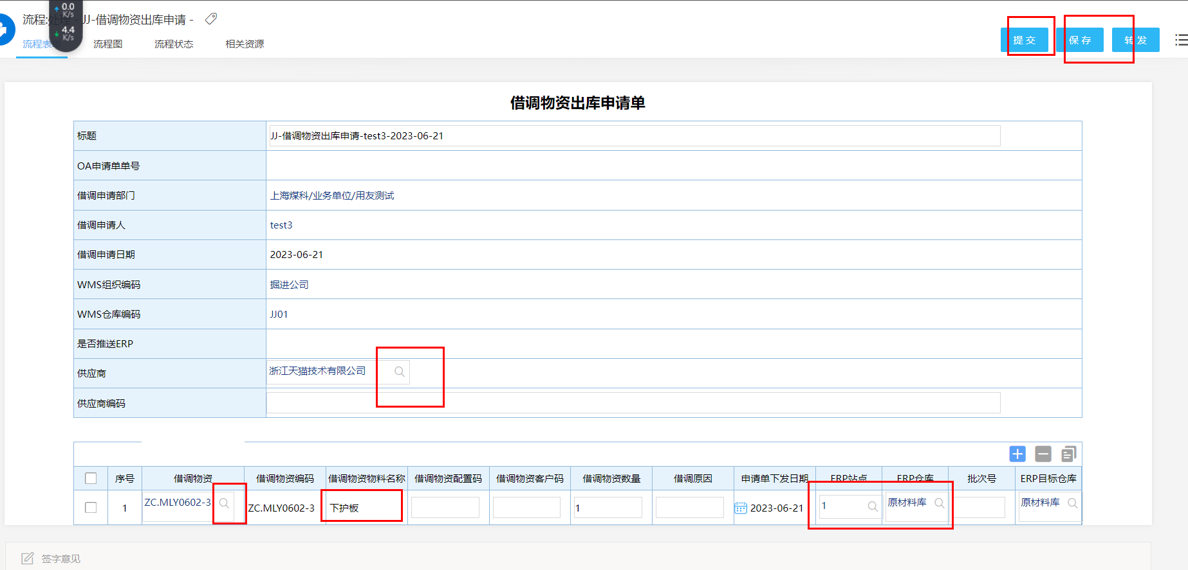

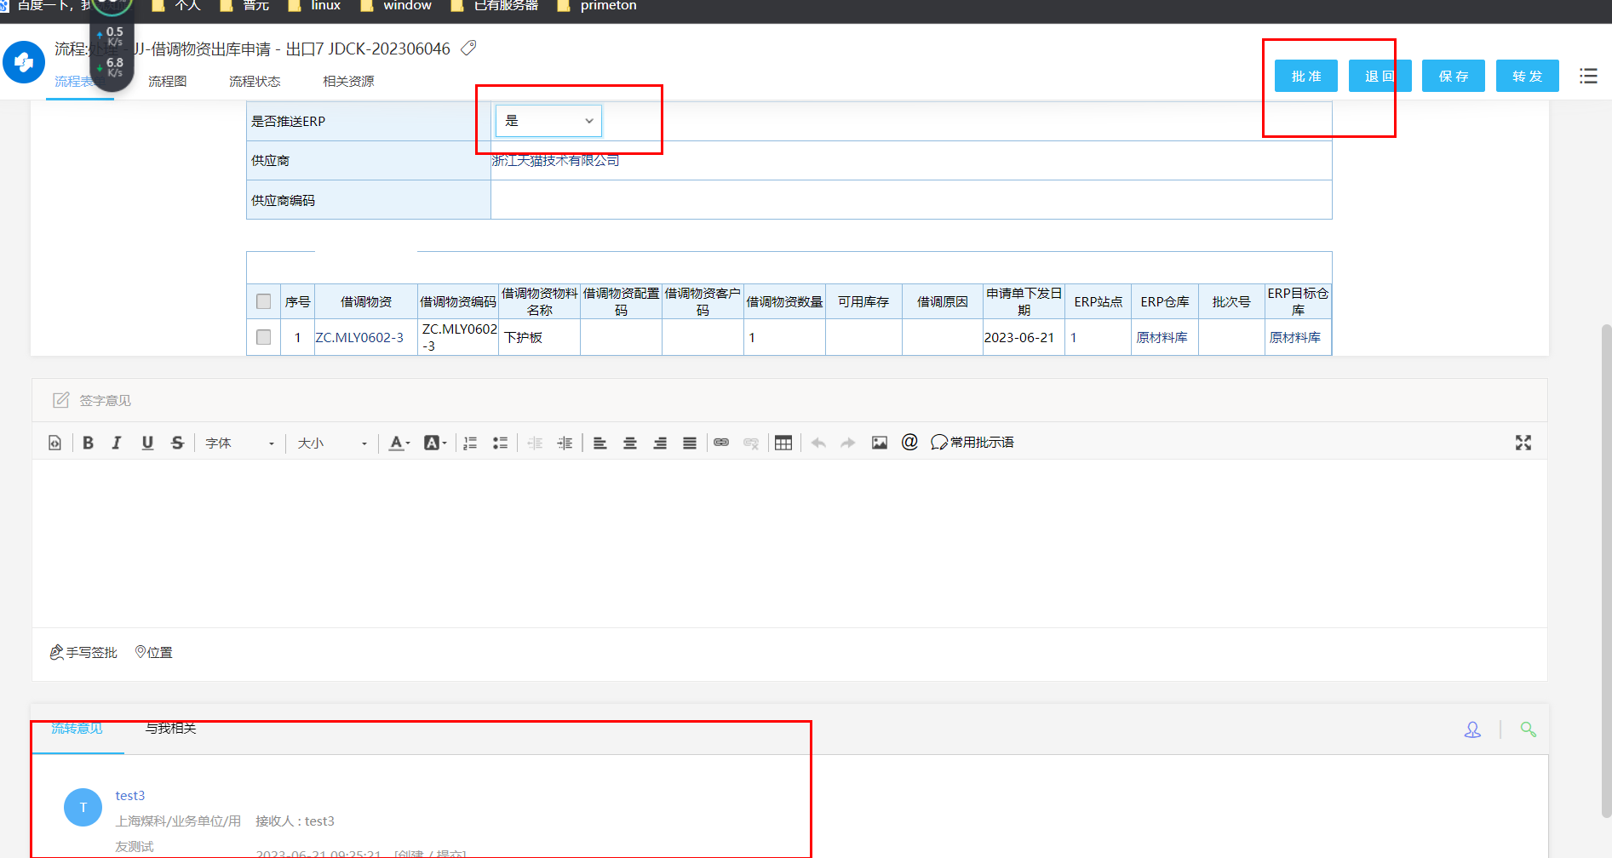

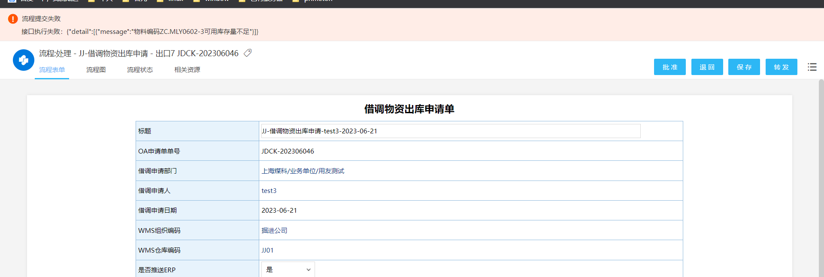

## 流程退回接口!!!!

OA-ERP-0197

---

<http://192.168.188.214:8080/api/workflow/paService/rejectRequest>

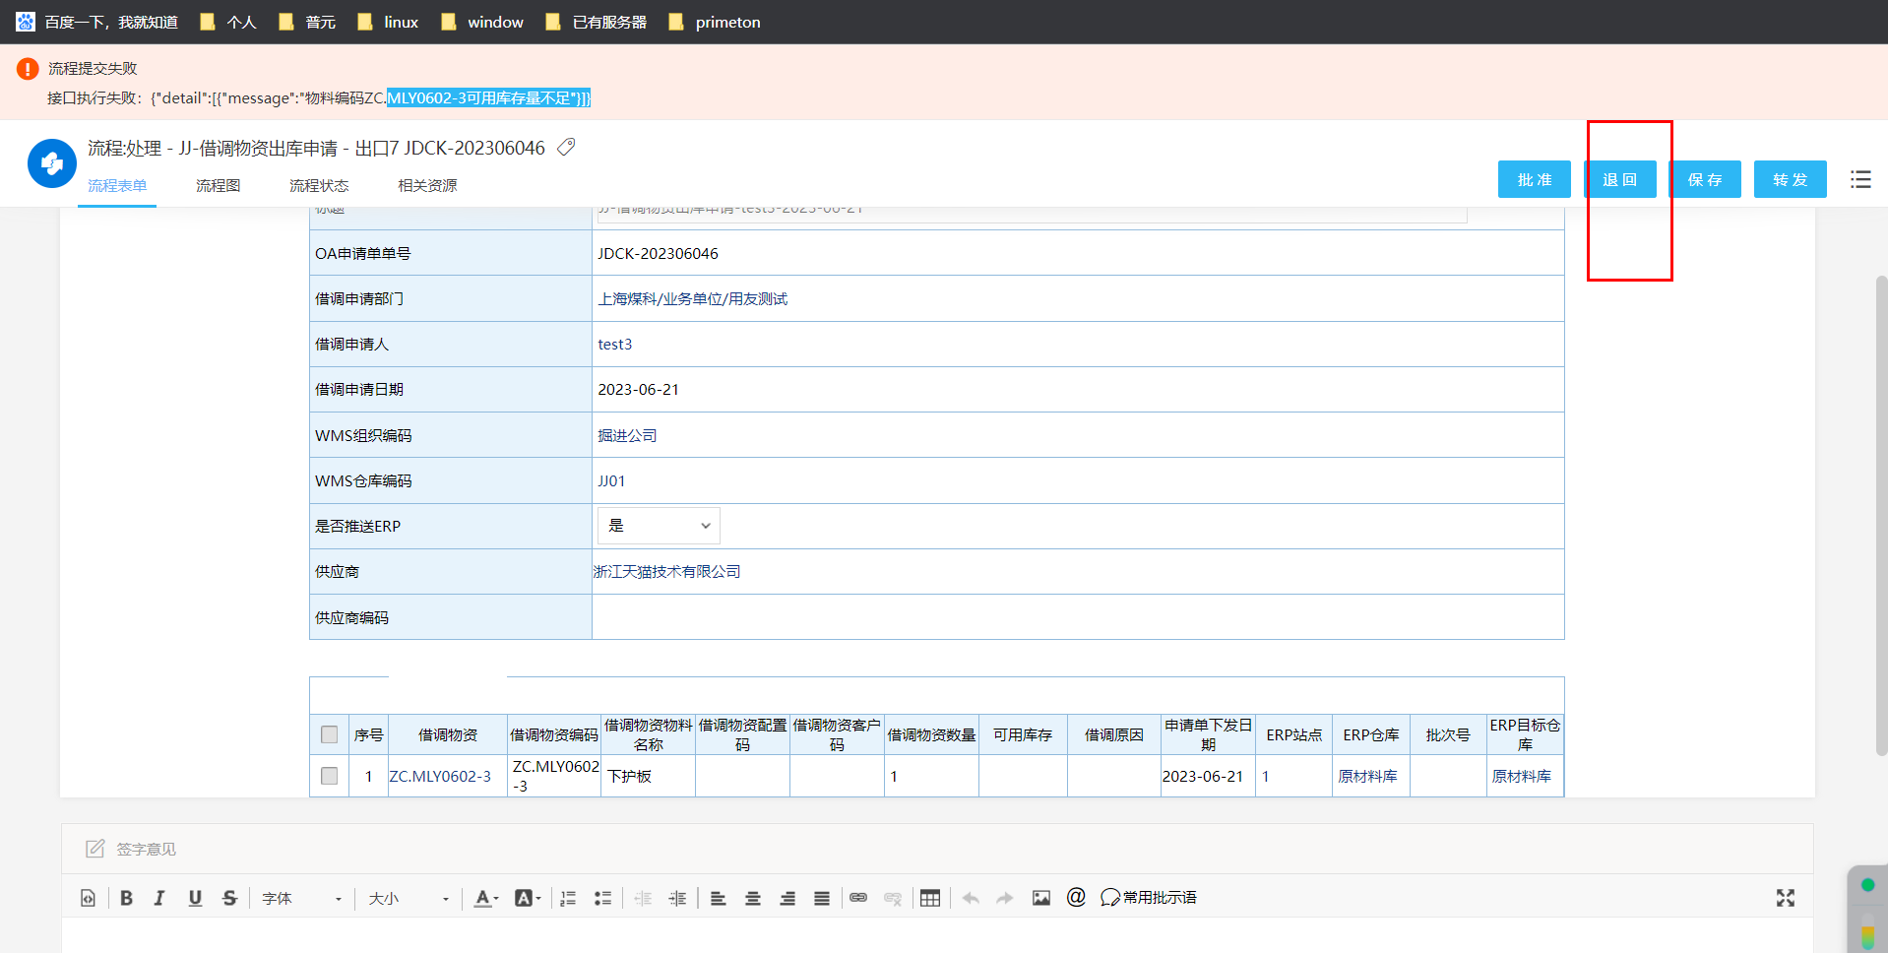

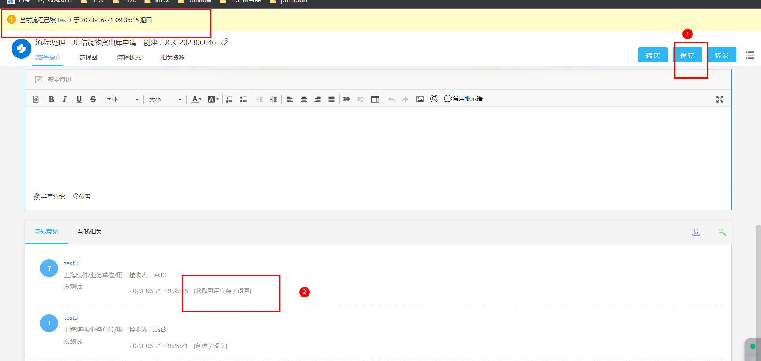

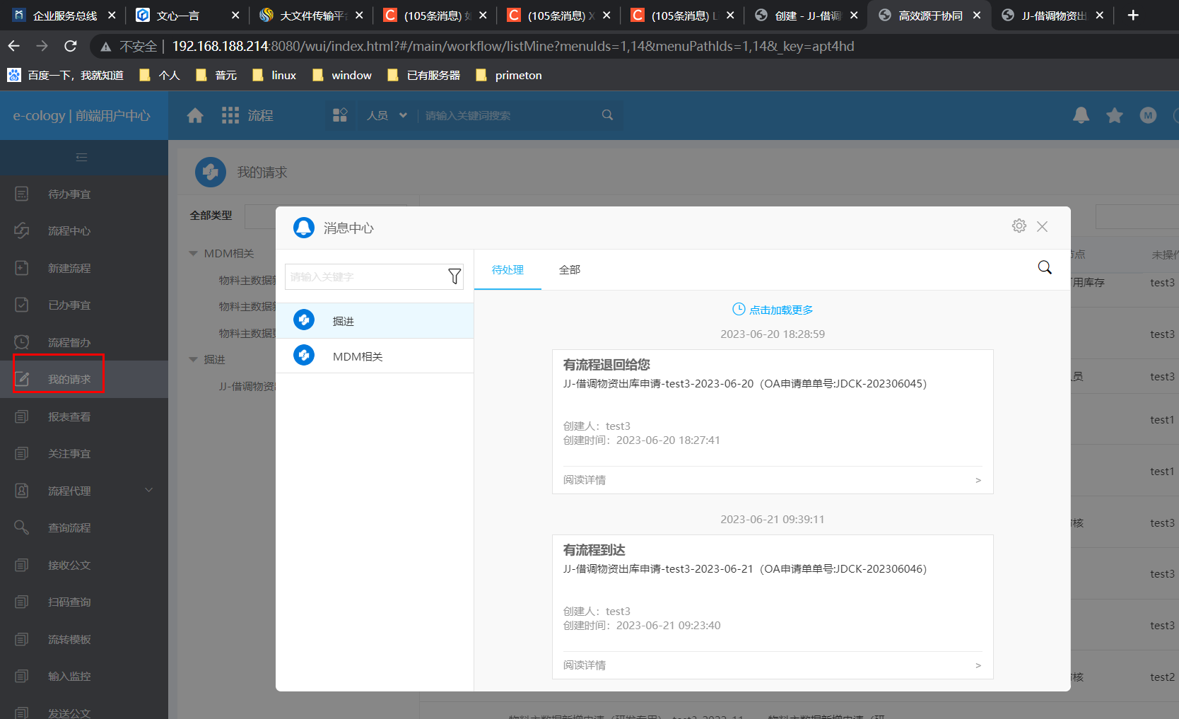

## 流程收回接口 !!!

OA-CRM-0002

<http://192.168.188.214:8080/api/workflow/paService/doForceDrawBack>

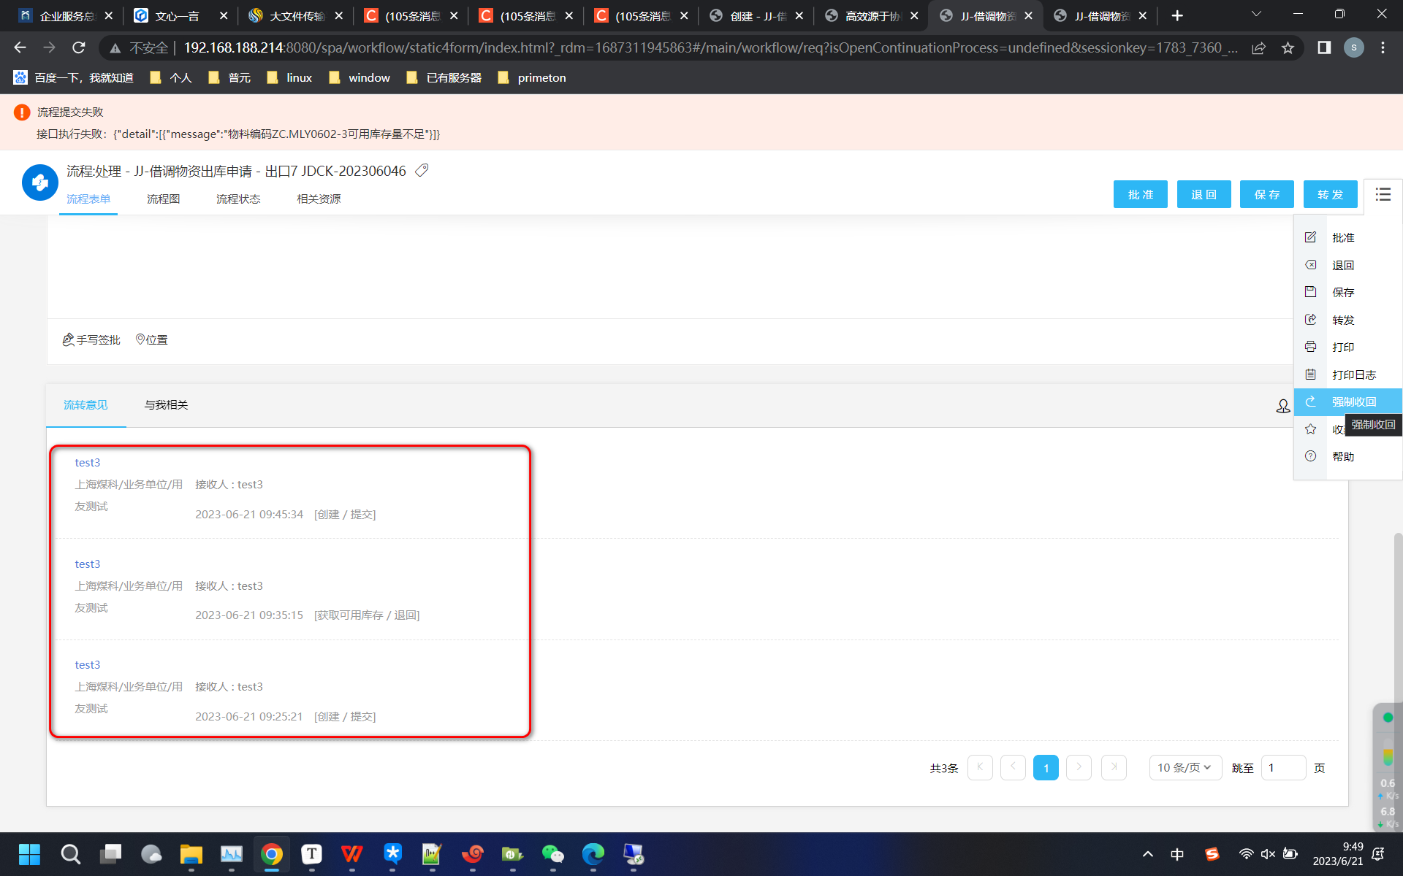

执行后

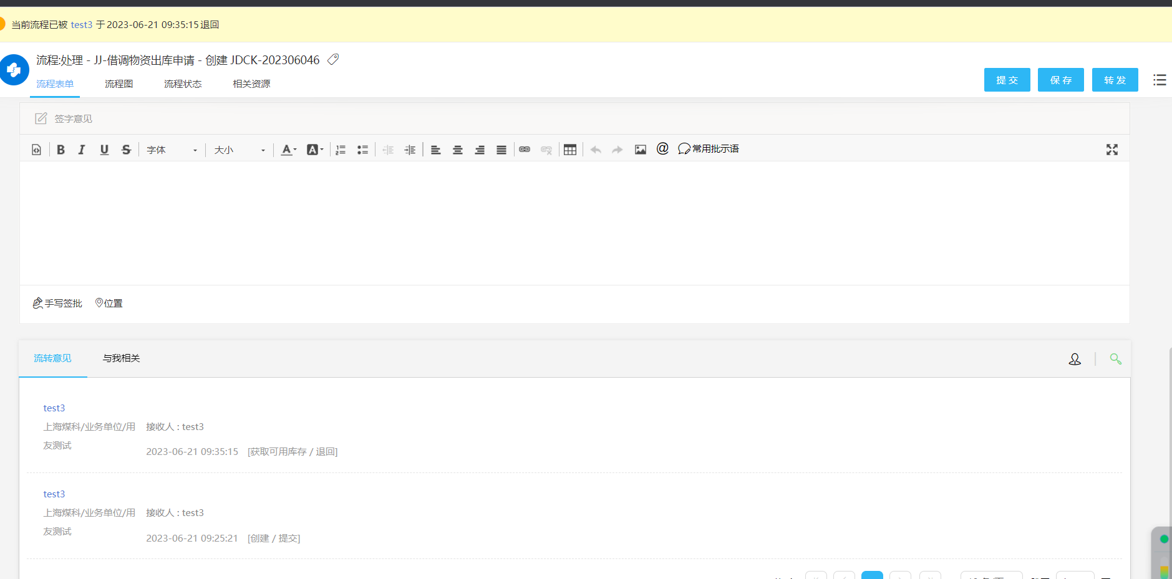

## 流程更新二次提交接口!!!!

OA-CRM-0003

<http://192.168.188.214:8080/api/workflow/paService/submitRequest>

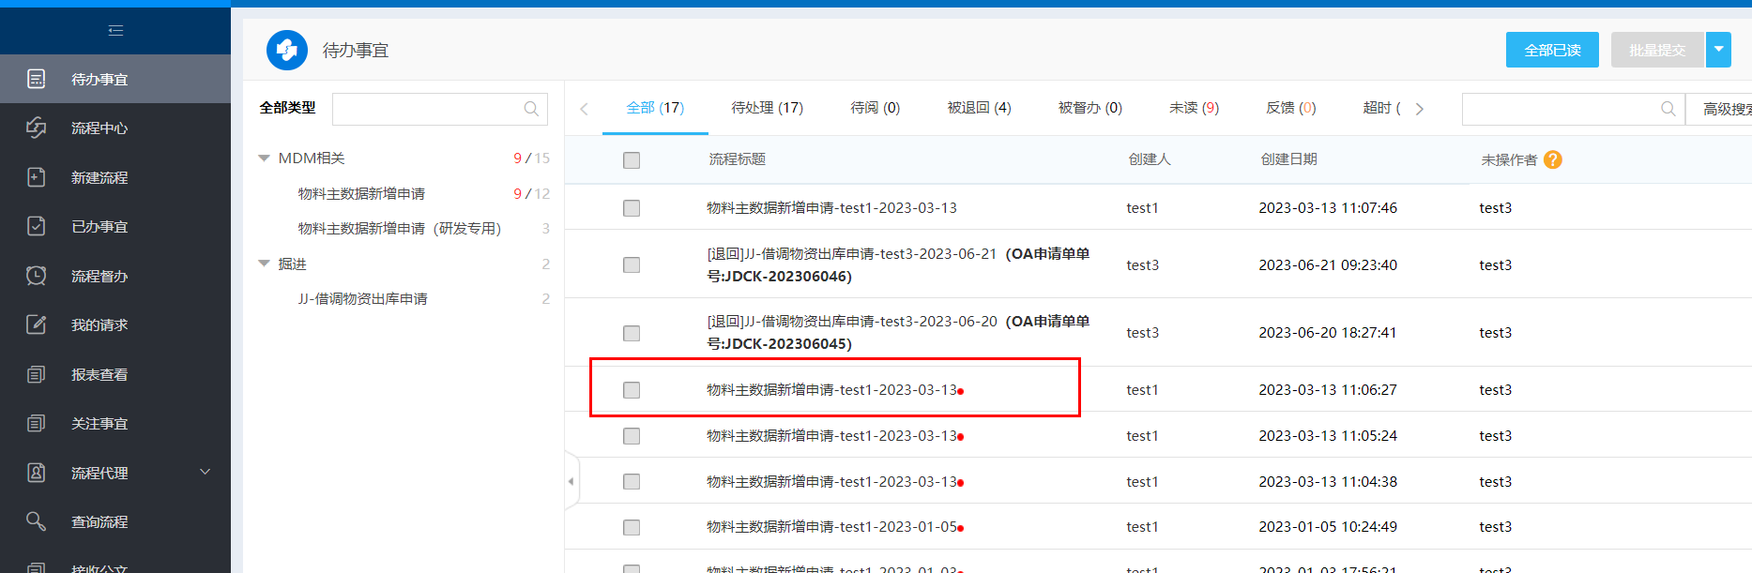

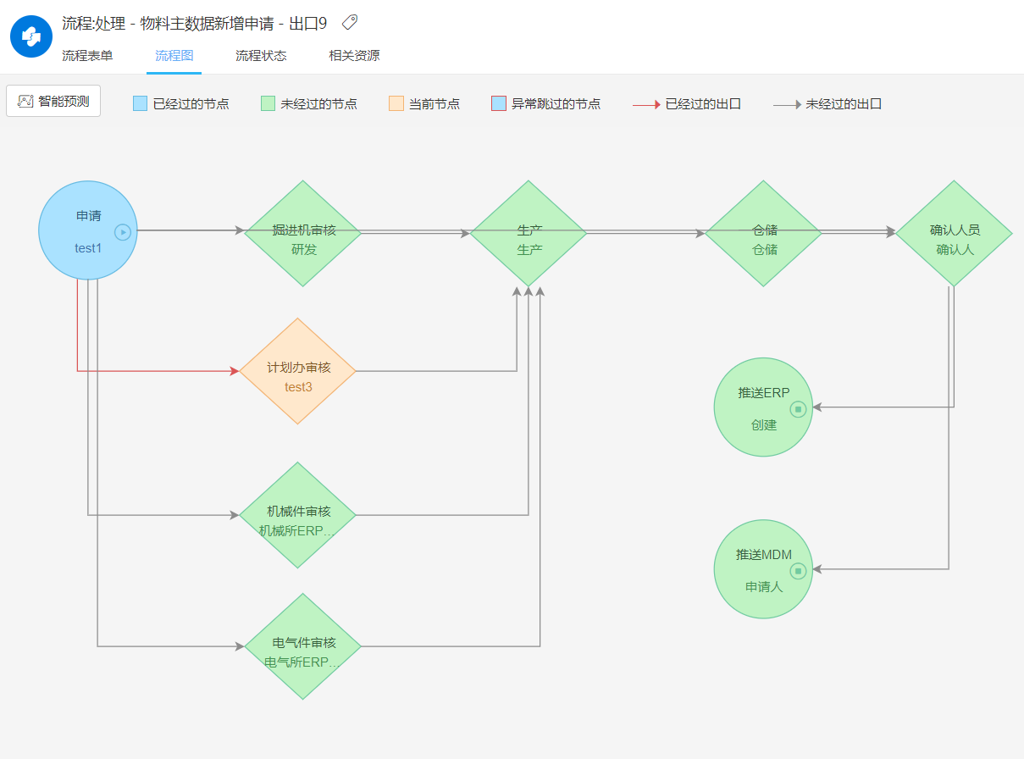

进行批准

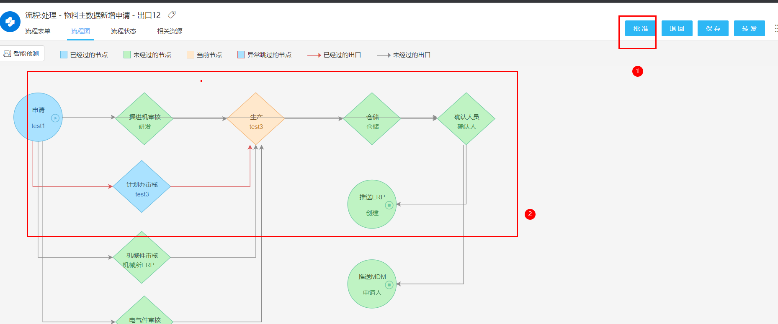

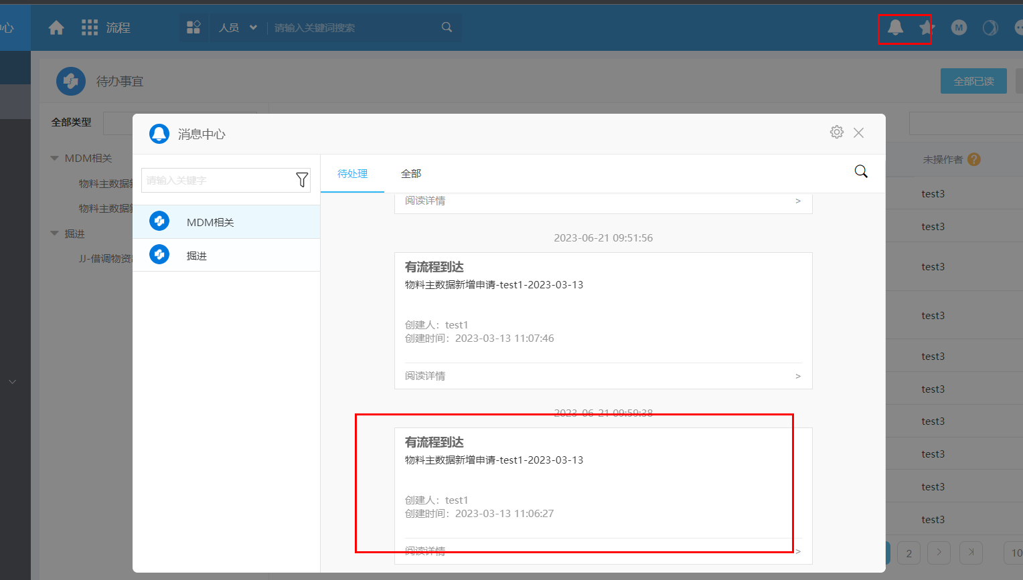

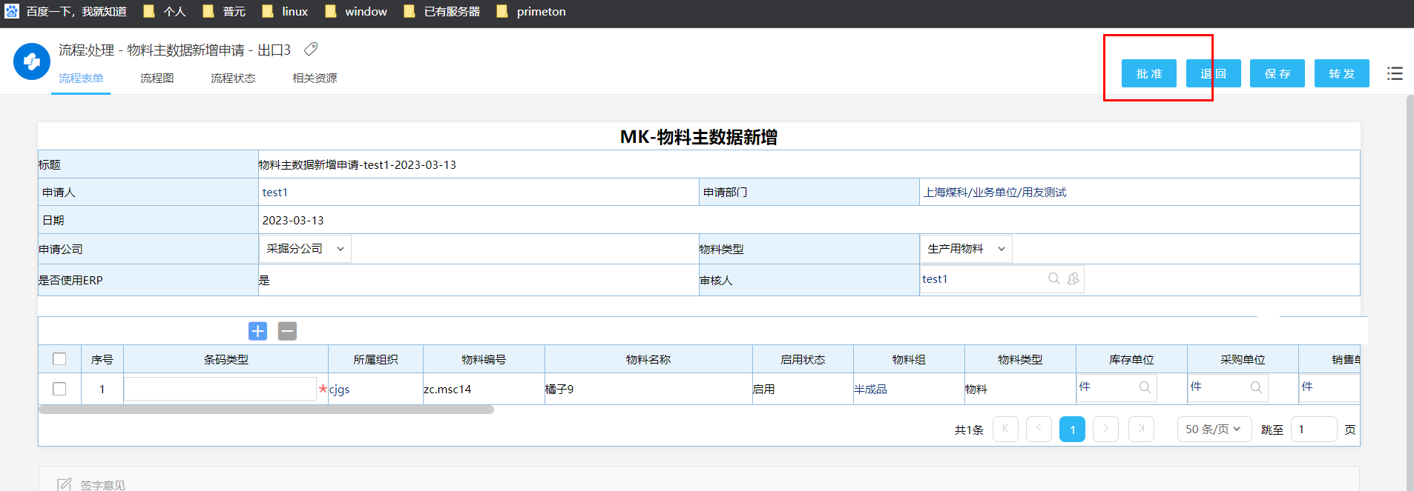

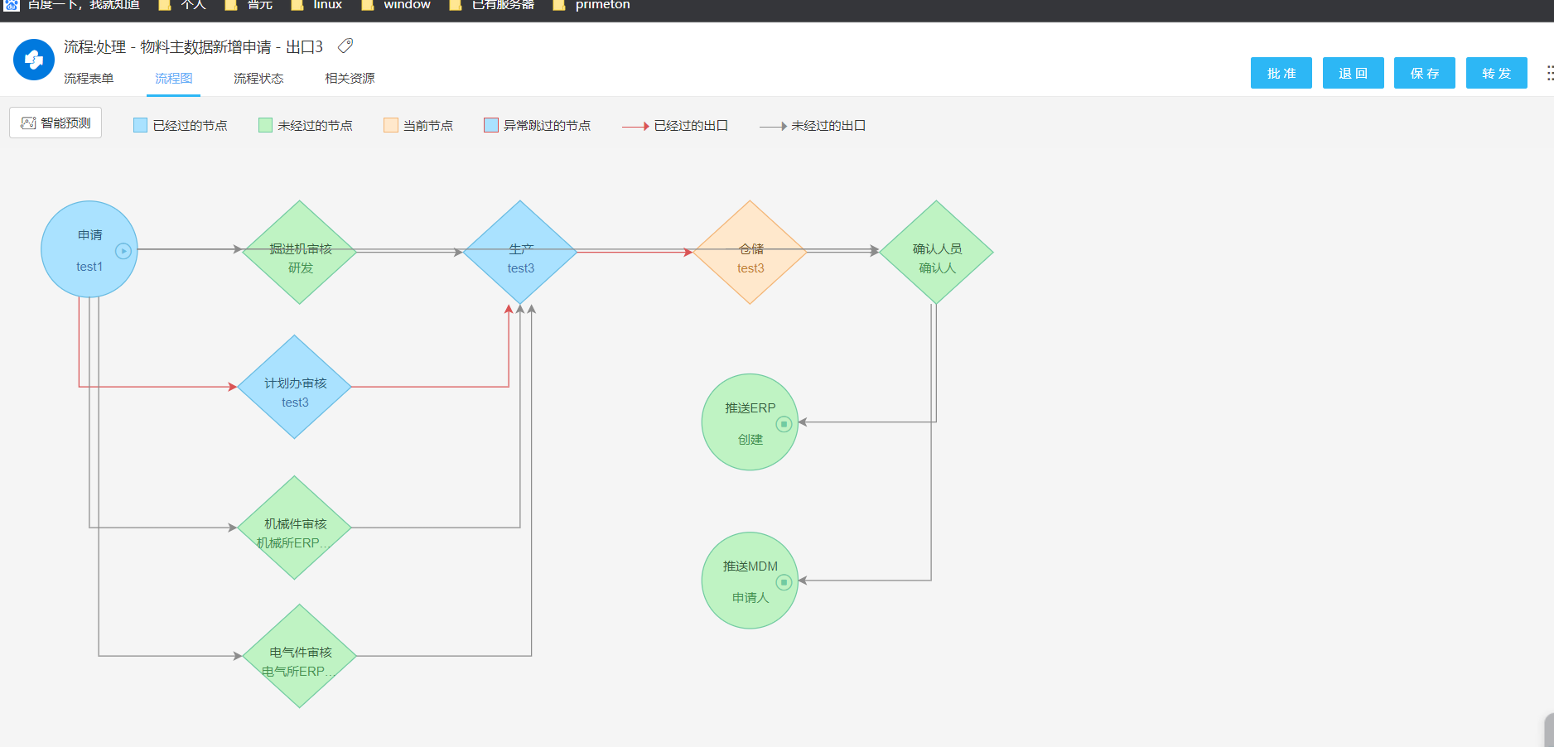

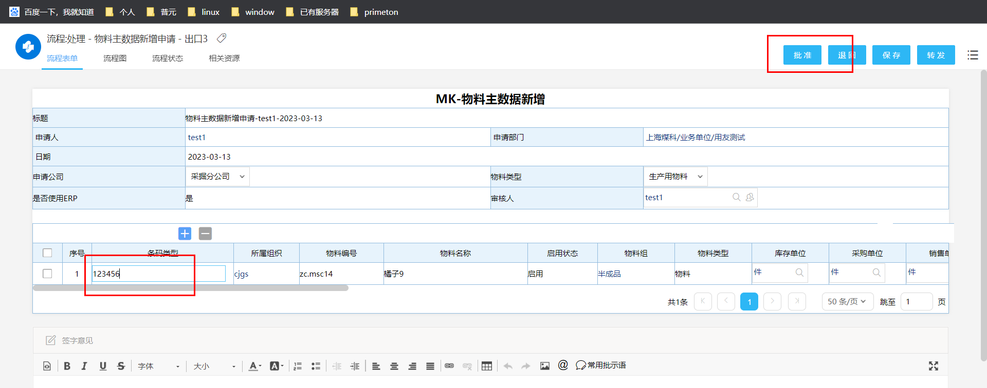

## 统一认证接口[废弃]

调用统一身份认证后，无需二次登录即可查看oa流程

<http://192.168.188.214:8080/sso/login>

先登录 OA， 然后关闭页面，重新http://192.168.188.214:8080/ 即可免输出账号密码登录

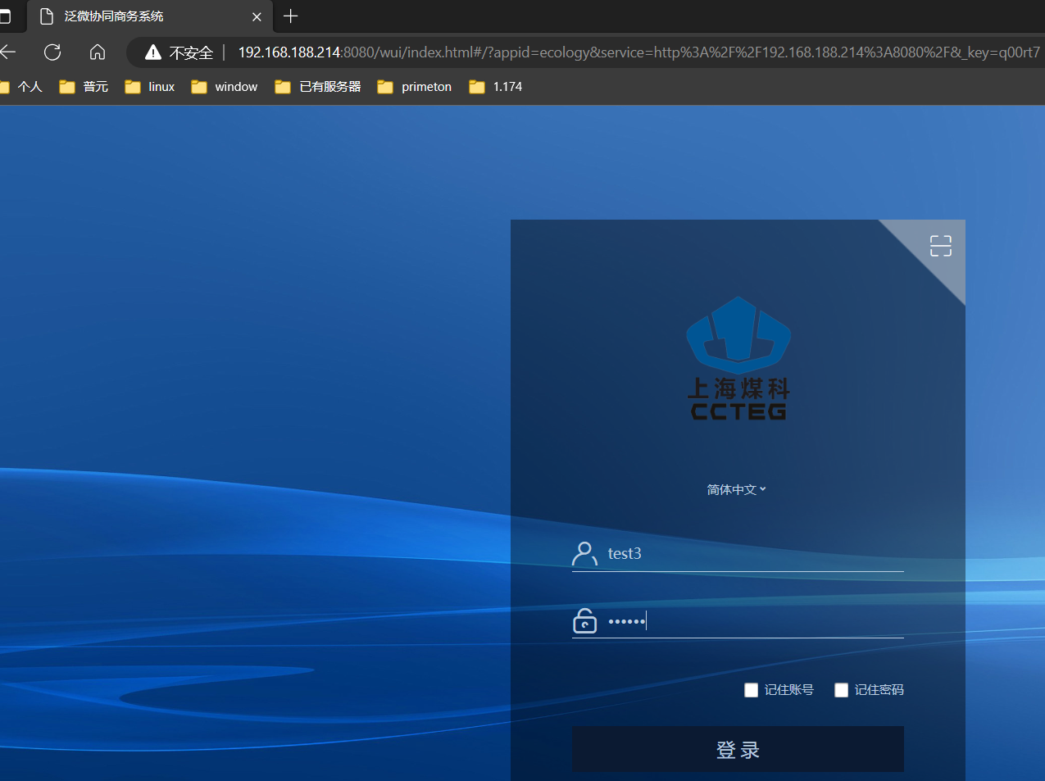

## 获取token接口

<http://192.168.188.214:8080/api/ec/dev/auth/applytoken>

## 

## ----------------------

## 许可证注册接口

<http://192.168.188.214:8080/api/ec/dev/auth/regist>

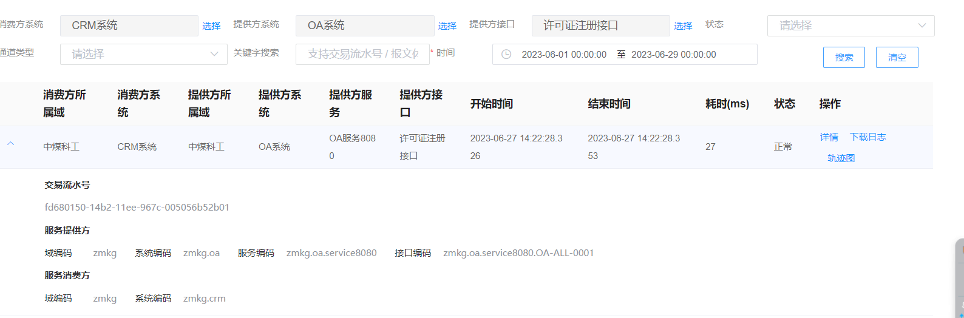

# ---OA

## 流程新增创建接口

|  |
| --- |
| <http://192.168.188.214:8080/api/workflow/paService/doCreateRequest> |

Crm

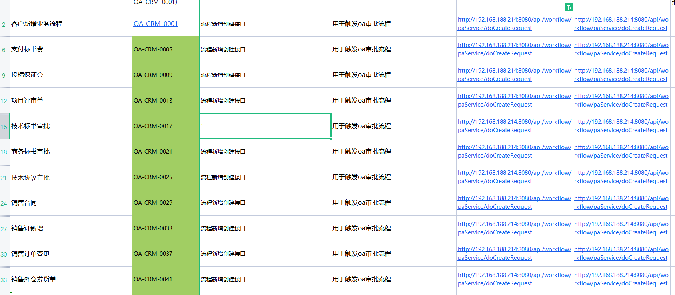

销售合同

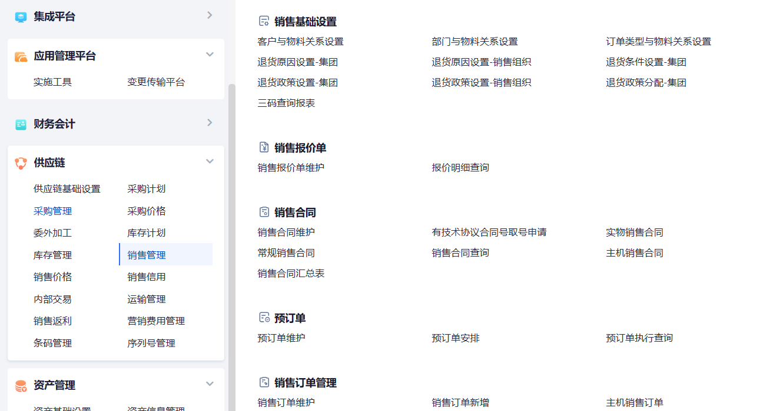

销售订单变更

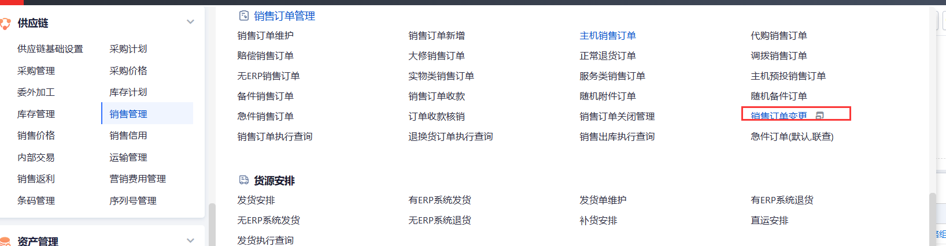

## 流程收回接口 !!! oa 触发

问一下，

这种 OA 审批流程触发后，如后续节点未查看审批可进行回收

|  |
| --- |
| <http://192.168.188.214:8080/api/workflow/paService/doForceDrawBack> |

Crm -- oa 发起

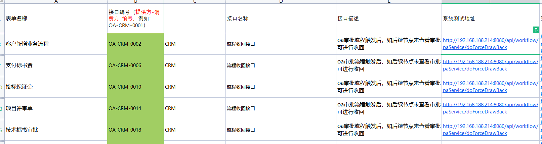

## 流程更新二次提交接口!!!! oa触发

|  |
| --- |
| <http://192.168.188.214:8080/api/workflow/paService/submitRequest> |

Crm -- oa 发起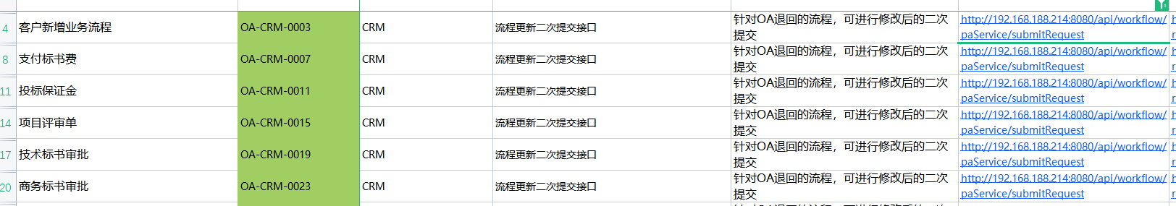

## 流程退回接口!!!! erp 触发的



<http://192.168.188.214:8080/api/workflow/paService/rejectRequest>

## 统一认证接口 crm 不知道， wms

|  |
| --- |
| <http://192.168.188.214:8080/sso/login> |

Crm



## 获取token接口

<http://192.168.188.214:8080/api/ec/dev/auth/applytoken>

## 

## ----------------------

## 许可证注册接口

<http://192.168.188.214:8080/api/ec/dev/auth/regist>



# MDM

|  |
| --- |
| 系统测试地址&系统UAT测试地址 |
|  |
| http://192.168.188.191/iuapmdm/cxf/mdmrs/newcenter/newCenterService/insertMd |
| http://192.168.188.191/iuapmdm/cxf/mdmrs/newcenter/newCenterService/queryListMdByConditions |
| http://192.168.188.191:9096/basisDoc/byItemId |
| http://192.168.188.191:9098/oa/checkfromdev |
| http://192.168.188.191:9098/oa/threeCode/researchInsert |
| http://192.168.188.191:9098/oa/checkfromsales |
| http://192.168.188.191:9098/oa/threeCode/sellInsert |
| http://192.168.188.191:9098/oa/threeCode/itemInsert |
| http://192.168.188.191:9098/oa/threeCode/update |
|  |
|  |

# WMS

## 废物新增

<http://192.168.188.195/pwms-app-inf/api/wms/webservice>

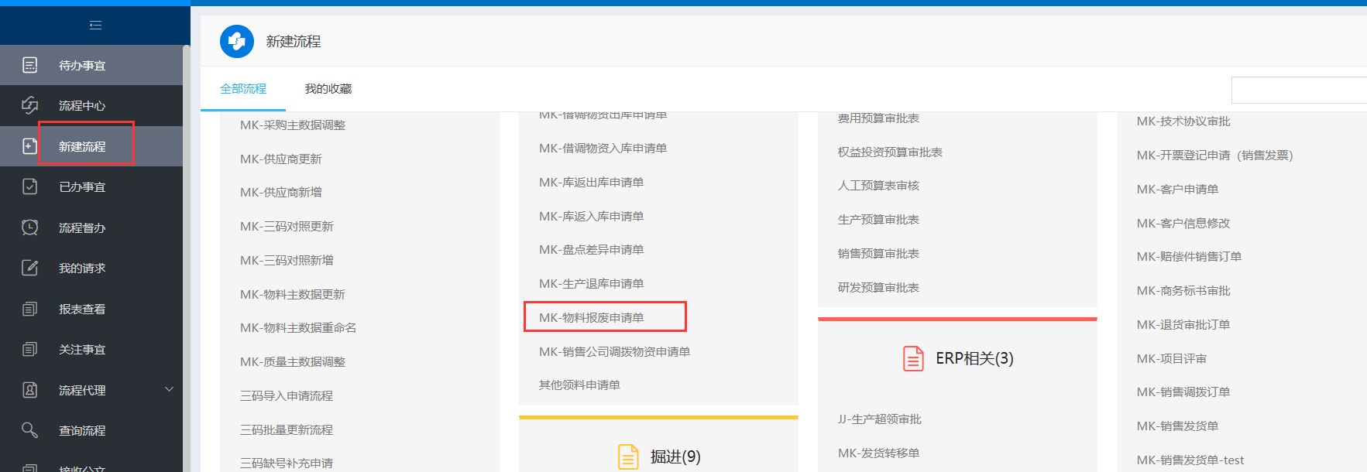

填写信息后，进行保存，然后进行提交， 提交进行批准

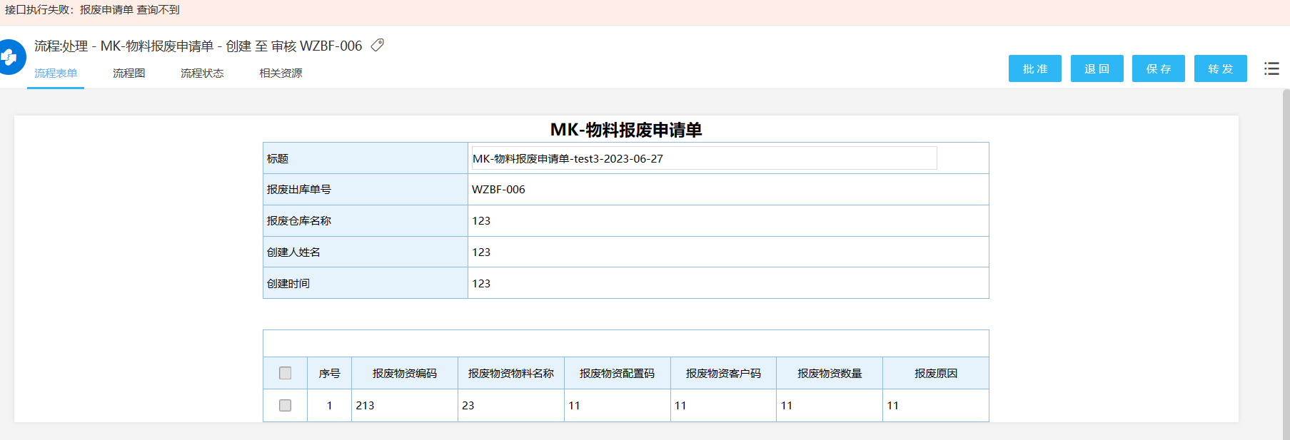

Esb 信息

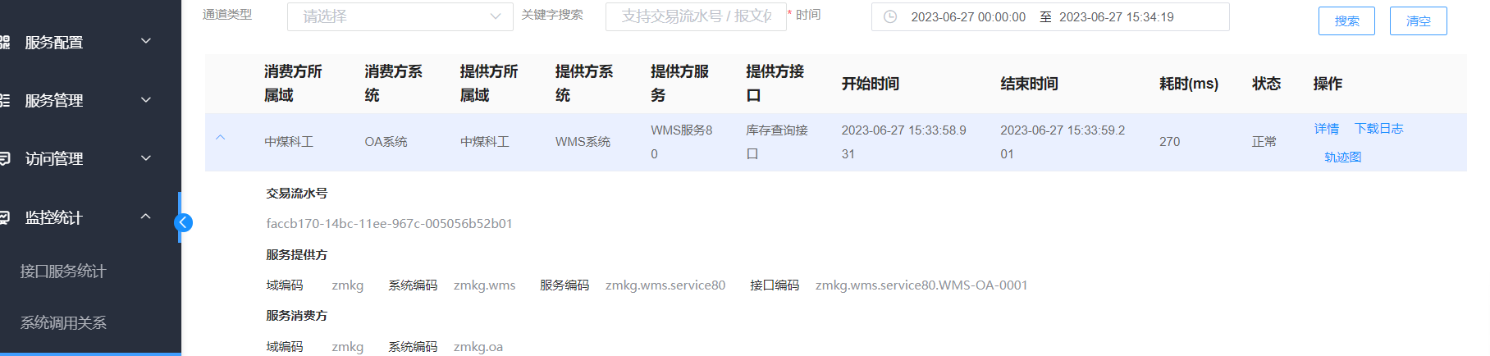

# Erp系统

## 物料编号重命名

* 接口

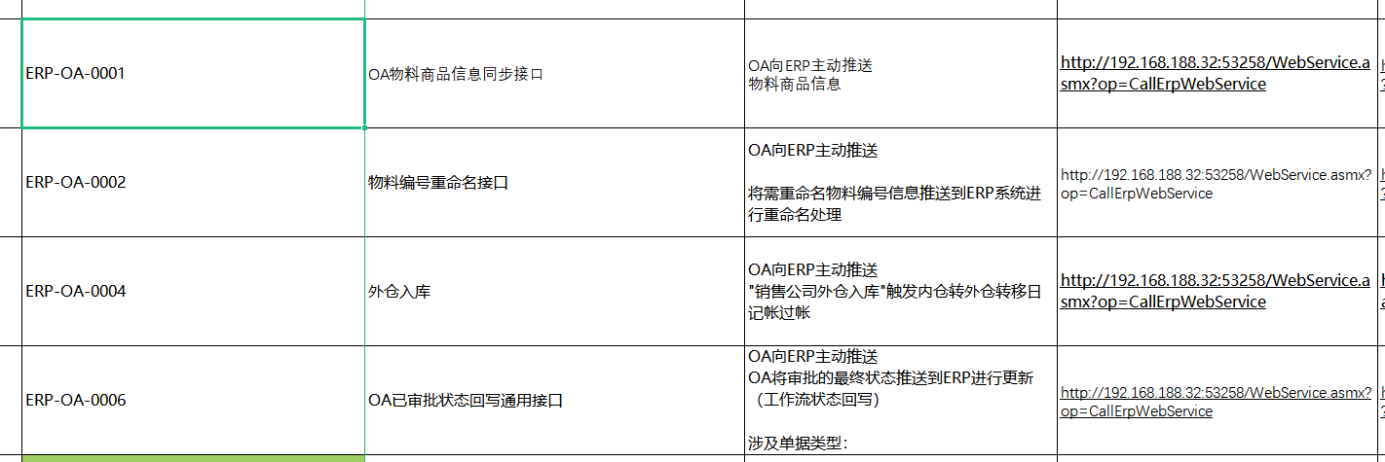

* 操作

Oa操作

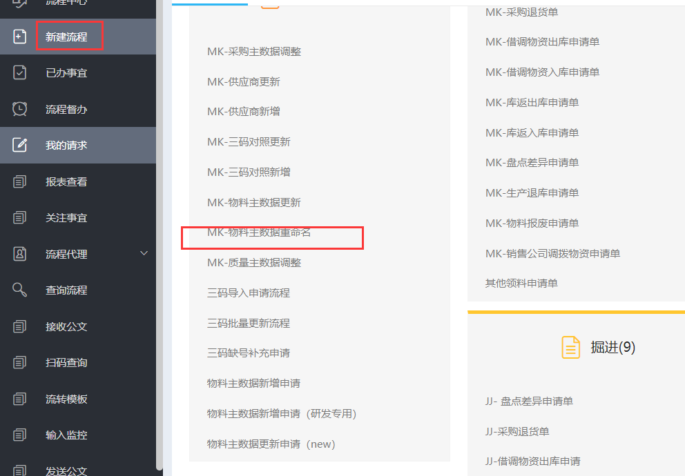

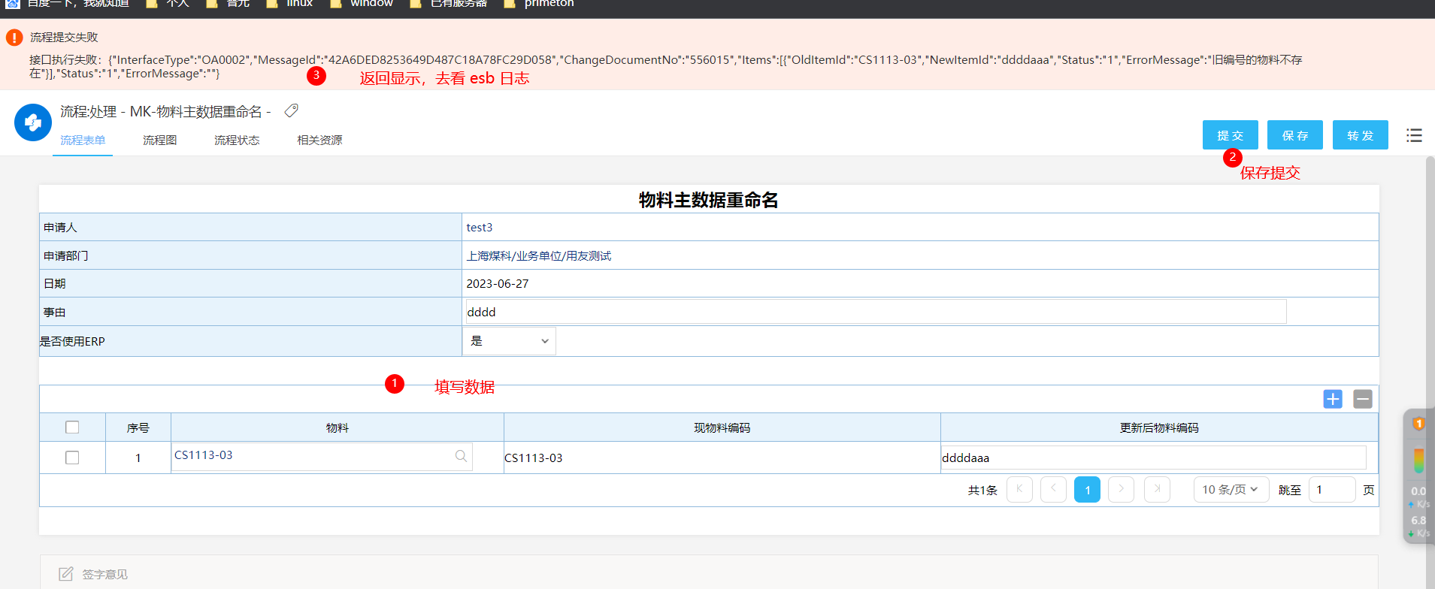

esb显示

