# 培训

Erp

Wms

Mdm

先集中精力搞WMS和ERP的接口，以及MDM物料主数据批量分发WMS。MDM和CRM的问题讨论出结果再谈，工作推进做些调整。

WMS

ERP

MDM

## OA 需要培训的场景

### --mdm

<http://192.168.188.191/iuapmdm/cxf/mdmrs/newcenter/newCenterService/queryListMdByConditions>

oa

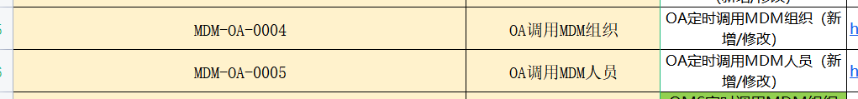

<http://192.168.188.191:9096/basisDoc/byItemId>

oa

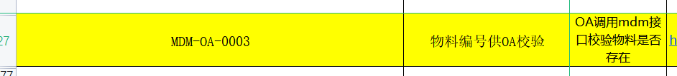

<http://192.168.188.191:9098/oa/checkfromdev>

oa



<http://192.168.188.191:9098/oa/threeCode/researchInsert>

Oa



<http://192.168.188.191:9098/oa/checkfromsales>

Oa



<http://192.168.188.191:9098/oa/threeCode/sellInsert>

[oa](http://192.168.188.191:9098/oa/threeCode/sellInsert)

<http://192.168.188.191:9098/oa/threeCode/itemInsert>

oa



<http://192.168.188.191:9098/oa/threeCode/update>

oa



### --erp

**Ws 服务， 只有一个**

Oa

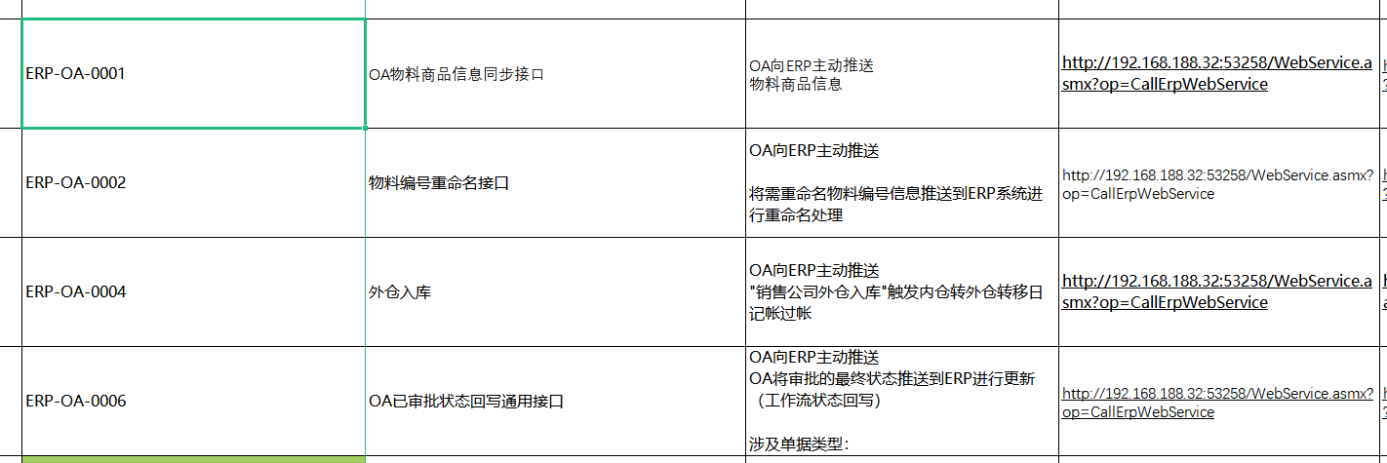

### --wms

<http://192.168.188.195/pwms-app-inf/api/wms/webservice>

Oa

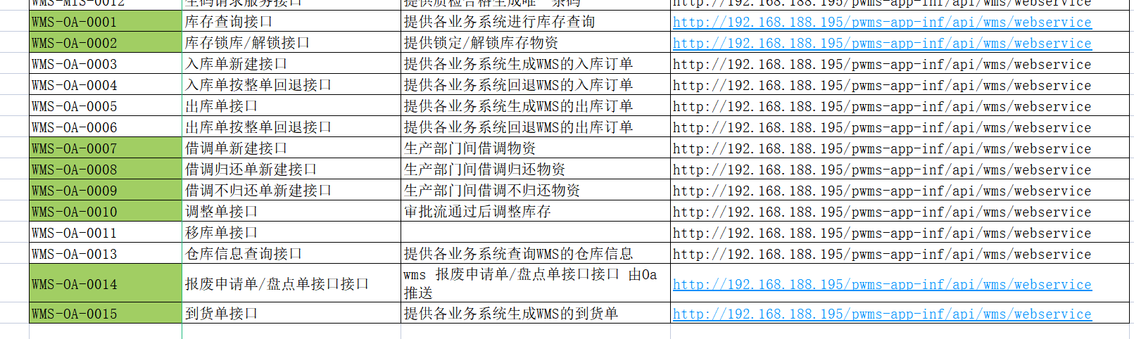

### --crm 没写上

|  |
| --- |
| <http://192.168.188.196:8080/uapws/rest/meike/receive/oaBillStateReceive> |

oa

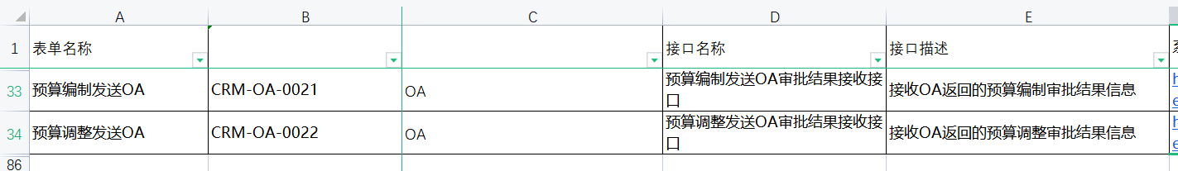

|  |
| --- |
| <http://192.168.188.206/uapws/rest/meike/receive/oaBillStateReceive> |

oa

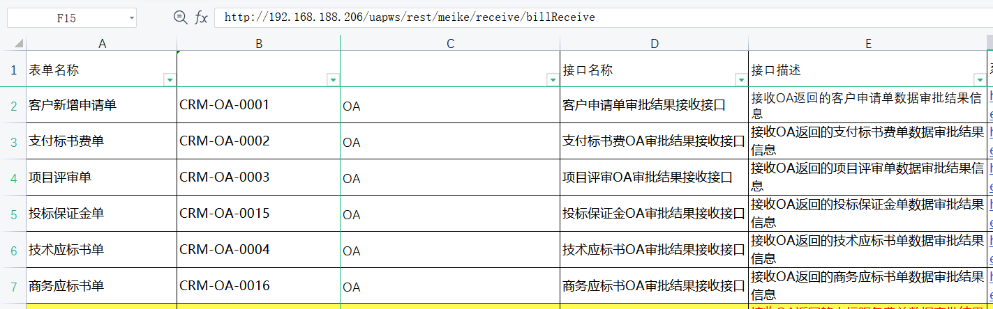

|  |
| --- |
| <http://192.168.188.206:80/uapws/rest/meike/receive/oaBillStateReceive> |

Oa

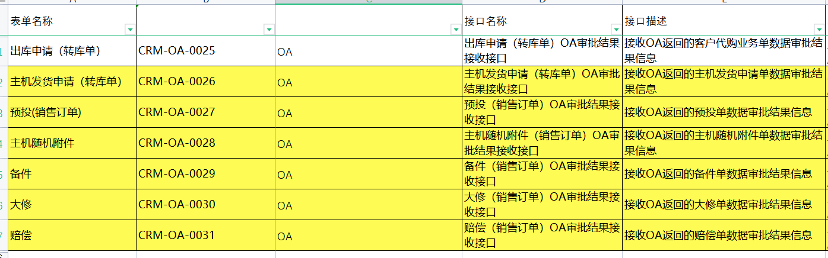

## Crm 需要培训的场景

### --mdm

<http://192.168.188.191/iuapmdm/cxf/mdmrs/newcenter/newCenterService/insertMd>

Crm

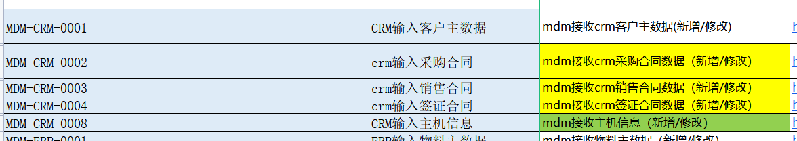

### --Oa

|  |
| --- |
| <http://192.168.188.214:8080/api/workflow/paService/doCreateRequest> |

Crm

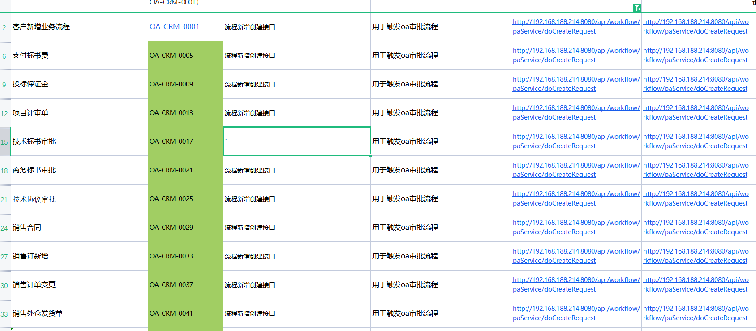

销售合同

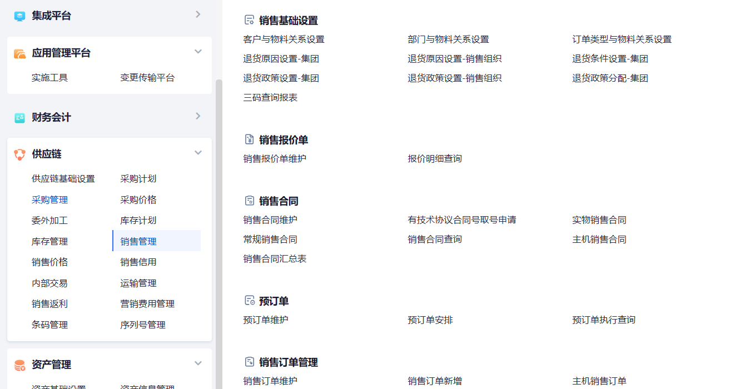

销售订单变更

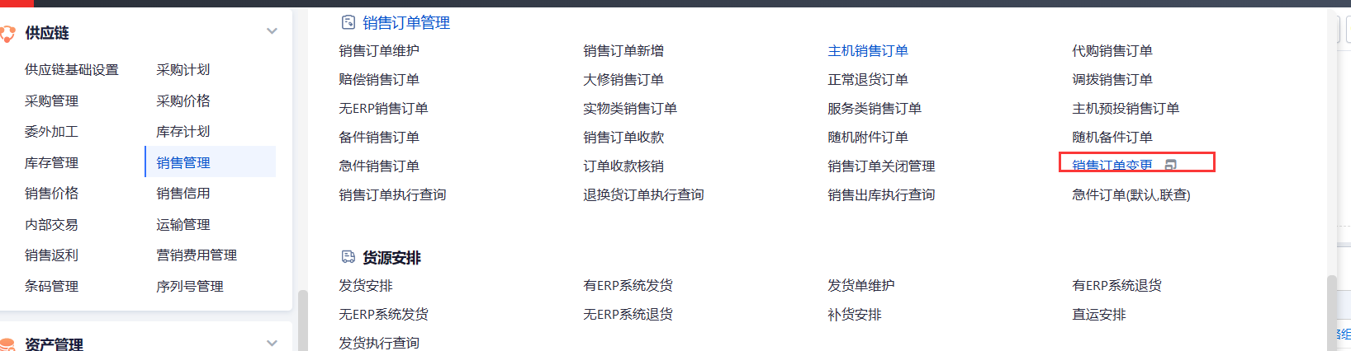

|  |
| --- |
| <http://192.168.188.214:8080/api/workflow/paService/doForceDrawBack> |

Crm -- oa 发起

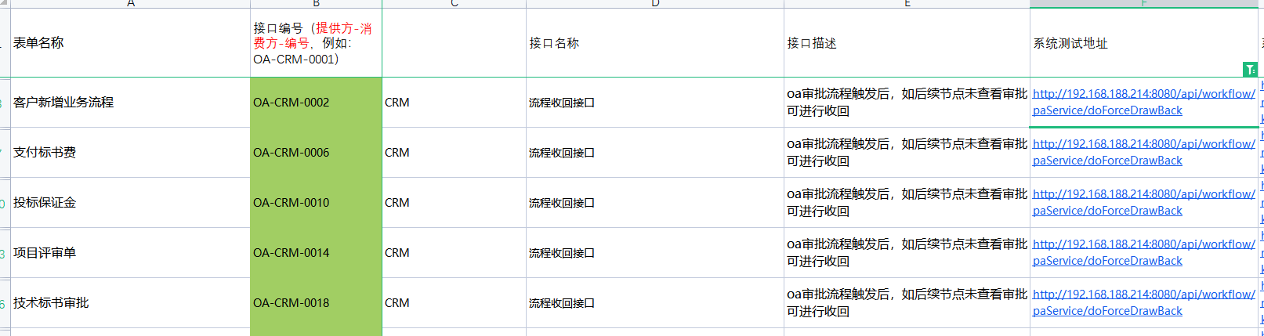

|  |
| --- |
| <http://192.168.188.214:8080/api/workflow/paService/submitRequest> |

Crm -- oa 发起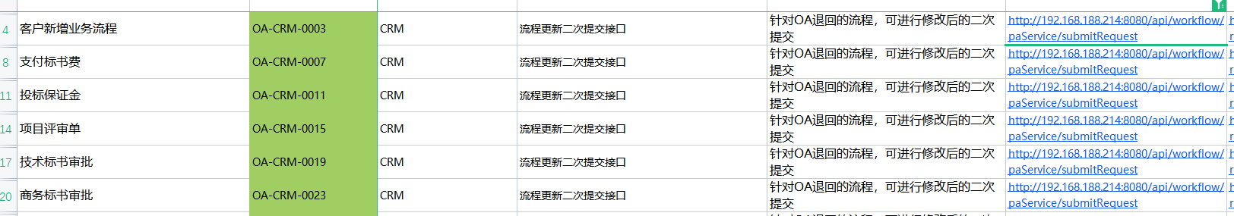

## Erp -- 需要培训的场景

### --oa

|  |
| --- |
| <http://192.168.188.214:8080/api/workflow/paService/rejectRequest> |

Erp

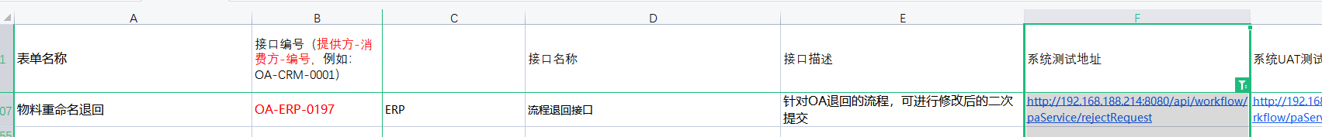

### -- Crm

|  |
| --- |
| <http://192.168.188.206:80/uapws/rest/meike/salesOrder/configChange> |

Erp



|  |
| --- |
| <http://192.168.188.206:80/uapws/rest/meike/salesOrder/receive/execreport> |

Erp

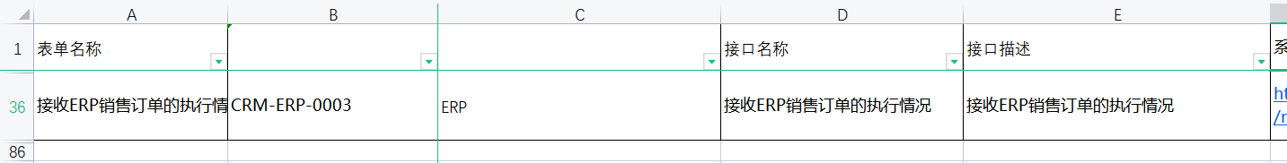

## Wms 需要培训的场景

### --mdm

### -- erp

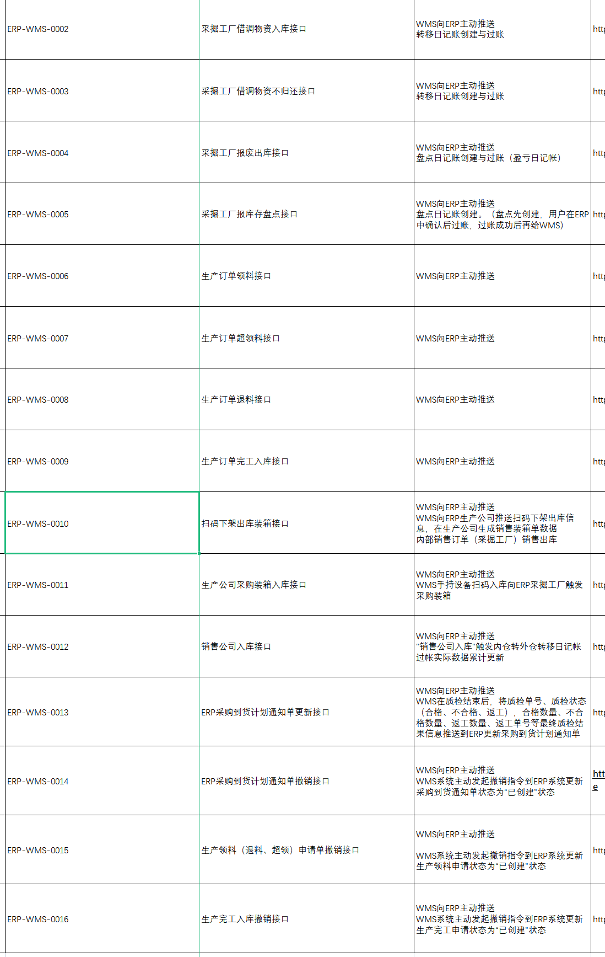

### --qms

### --Oa

### --Crm

|  |
| --- |
| <http://192.168.188.206/uapws/rest/meike/receive/billReceive> |

wms

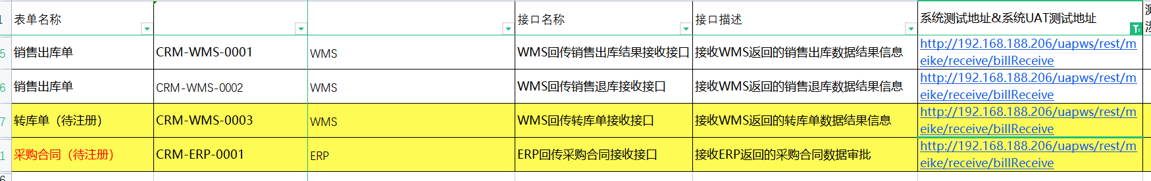

## Mdm 需要培训的场景

### -- erp

### --wms

<http://192.168.188.195/pwms-app-inf/api/mdm/receive>

mdm

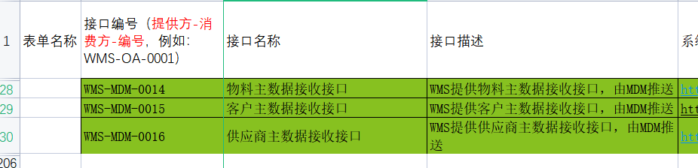

### --qms

### --Oa

### --Crm

|  |
| --- |
| <http://192.168.188.206/uapws/rest/meike/maindata/pullMaterial> |

mdm



|  |
| --- |
| <http://192.168.188.206/uapws/rest/meike/maindata/pullSupplier> |

mdm

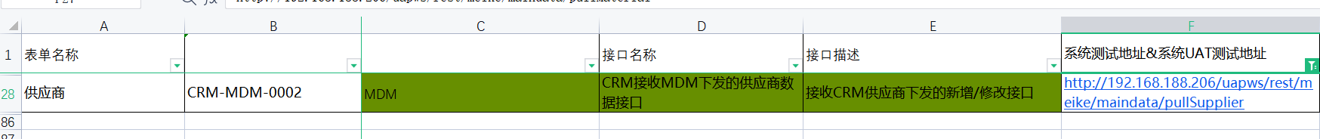

## Qms 需要培训的场景

### --mdm

### -- erp

### --wms

### --qms

### --Oa

|  |
| --- |
| <http://192.168.188.214:8080/api/workflow/paService/rejectRequest> |

Erp



### --Crm

# == 统计方

# MDM

<http://192.168.188.191/iuapmdm/cxf/mdmrs/newcenter/newCenterService/insertMd>

Erp



Crm



<http://192.168.188.191/iuapmdm/cxf/mdmrs/newcenter/newCenterService/queryListMdByConditions>

Crm

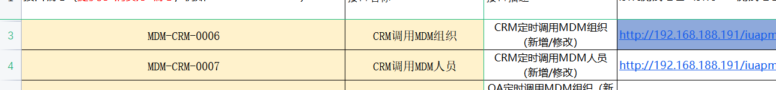

oa



Qms

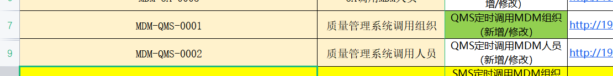

Wms

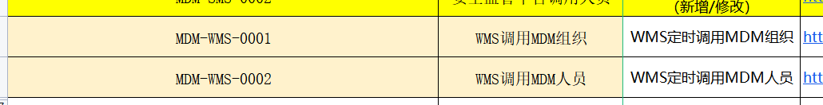

<http://192.168.188.191:9096/basisDoc/byItemId>

oa



<http://192.168.188.191:9098/oa/checkfromdev>

oa



<http://192.168.188.191:9098/oa/threeCode/researchInsert>

Oa



<http://192.168.188.191:9098/oa/checkfromsales>

Oa



<http://192.168.188.191:9098/oa/threeCode/sellInsert>

[oa](http://192.168.188.191:9098/oa/threeCode/sellInsert)

<http://192.168.188.191:9098/oa/threeCode/itemInsert>

oa



<http://192.168.188.191:9098/oa/threeCode/update>

oa



# ERP

Oa, wms

**Ws 服务， 只有一个**

Oa



Wms



# WMS

<http://192.168.188.195/pwms-app-inf/api/mdm/receive>

mdm



<http://192.168.188.195/pwms-app-inf/api/wms/webservice>

Oa



Crm

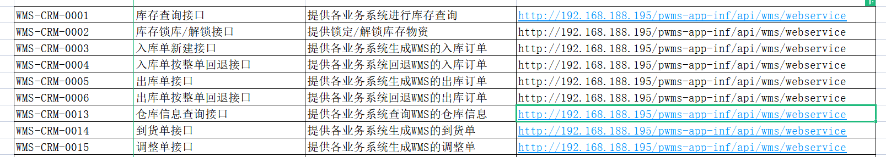

Erp



# OA

http://192.168.188.214:8080/api/ec/dev/auth/applytoken

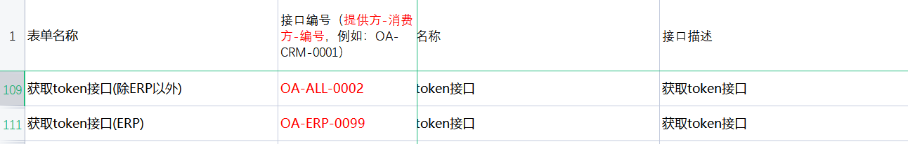

|  |
| --- |
| <http://192.168.188.214:8080/api/ec/dev/auth/regist> |

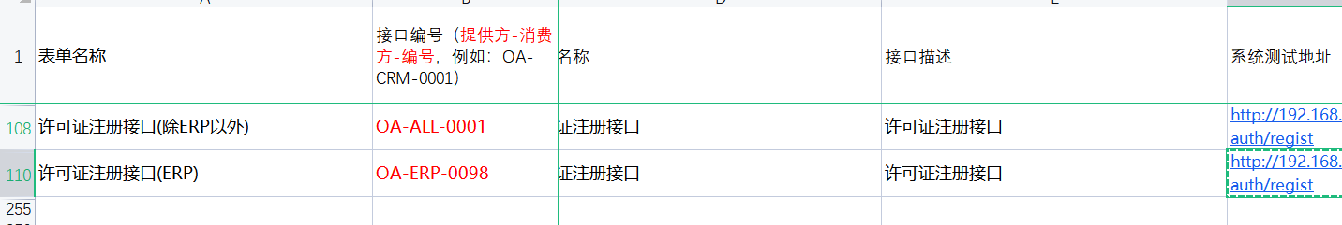

|  |
| --- |
| <http://192.168.188.214:8080/api/workflow/paService/doCreateRequest> |

Crm



Wms

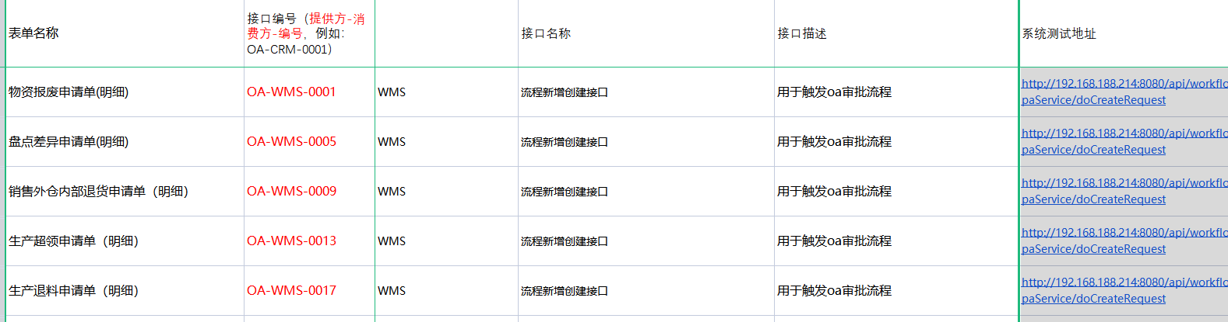

|  |
| --- |
| <http://192.168.188.214:8080/api/workflow/paService/doForceDrawBack> |

Crm



Wms

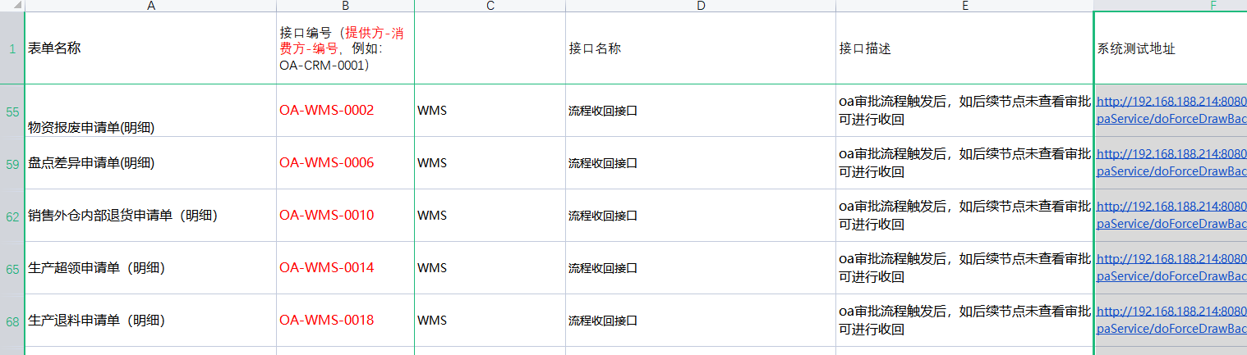

|  |
| --- |
| <http://192.168.188.214:8080/api/workflow/paService/submitRequest> |

Crm



Wms

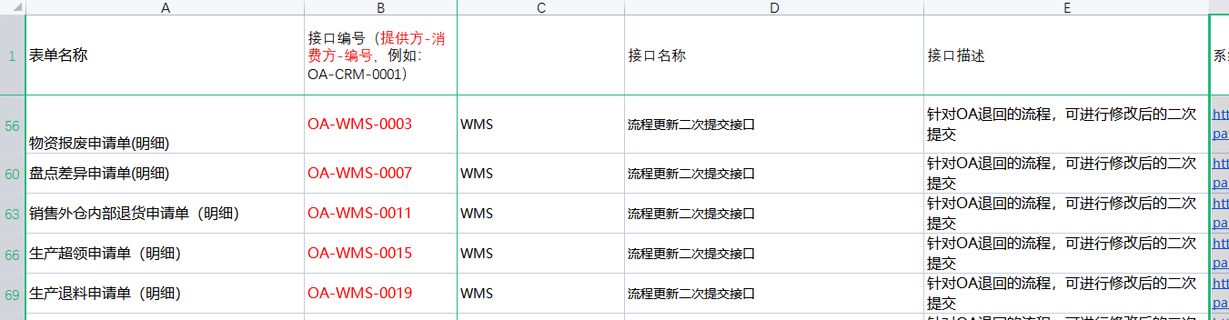

|  |
| --- |
| <http://192.168.188.214:8080/api/workflow/paService/rejectRequest> |

Erp



|  |
| --- |
| <http://192.168.188.214:8080/sso/login> |

Crm



# CRM

|  |
| --- |
| <http://172.18.102.210:8888/rest/login> |

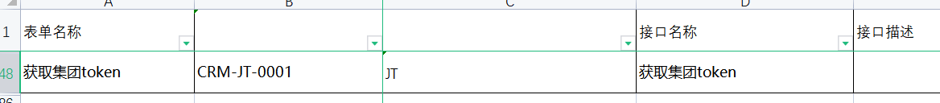

|  |
| --- |
| <http://172.18.102.210:8888/rest/registerContractInfo> |

jt

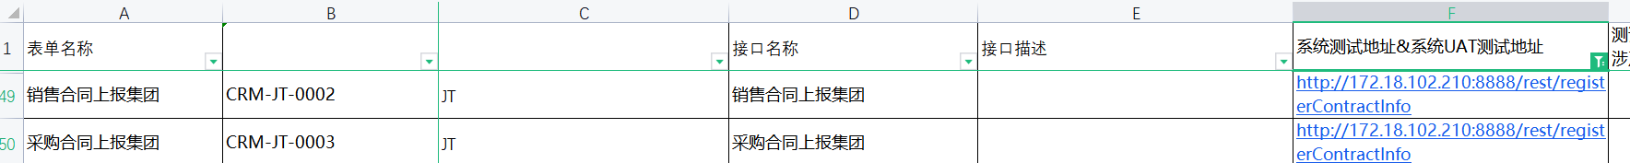

|  |
| --- |
| <http://192.168.188.196:8080/uapws/rest/meike/receive/oaBillStateReceive> |

oa



|  |
| --- |
| <http://192.168.188.206/uapws/rest/meike/maindata/pullMaterial> |

mdm



|  |
| --- |
| <http://192.168.188.206/uapws/rest/meike/maindata/pullSupplier> |

mdm



|  |
| --- |
| <http://192.168.188.206/uapws/rest/meike/receive/billReceive> |

wms



|  |
| --- |
| <http://192.168.188.206/uapws/rest/meike/receive/oaBillStateReceive> |

oa



|  |
| --- |
| <http://192.168.188.206:80/uapws/rest/meike/receive/oaBillStateReceive> |

Oa



|  |
| --- |
| <http://192.168.188.206:80/uapws/rest/meike/salesOrder/configChange> |

Erp



|  |
| --- |
| <http://192.168.188.206:80/uapws/rest/meike/salesOrder/receive/execreport> |

Erp



# 【完结】QMS

* 不用测试了， 别人测试过了

# Oa 联调

