Bank Transaction Fraud Detection
Charts and Visualizations
Data Cleaning & Exploratory Data Analysis (Group A, Member 2) | Week 2 Deliverable
All charts below were generated directly from the raw Bank_Transaction_Fraud_Detection.csv (200,000 rows) using pandas, matplotlib, and seaborn — not reused from any third-party source.

1. Target Variable
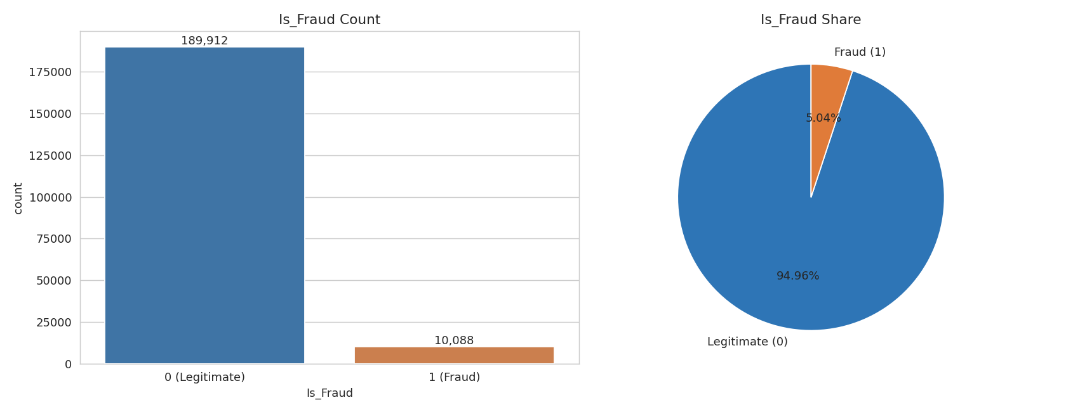
Figure 1. Is_Fraud is heavily imbalanced: 189,912 legitimate (94.96%) vs. 10,088 fraudulent (5.04%) transactions.

2. Demographics
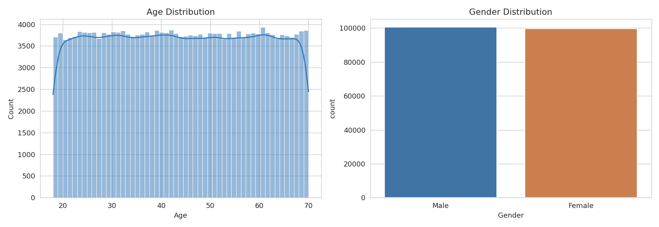
Figure 2. Age is close to uniformly spread across 18–70 (mean 44.0). Gender is split 50.23% Male / 49.77% Female.

3. Categorical Feature Distributions
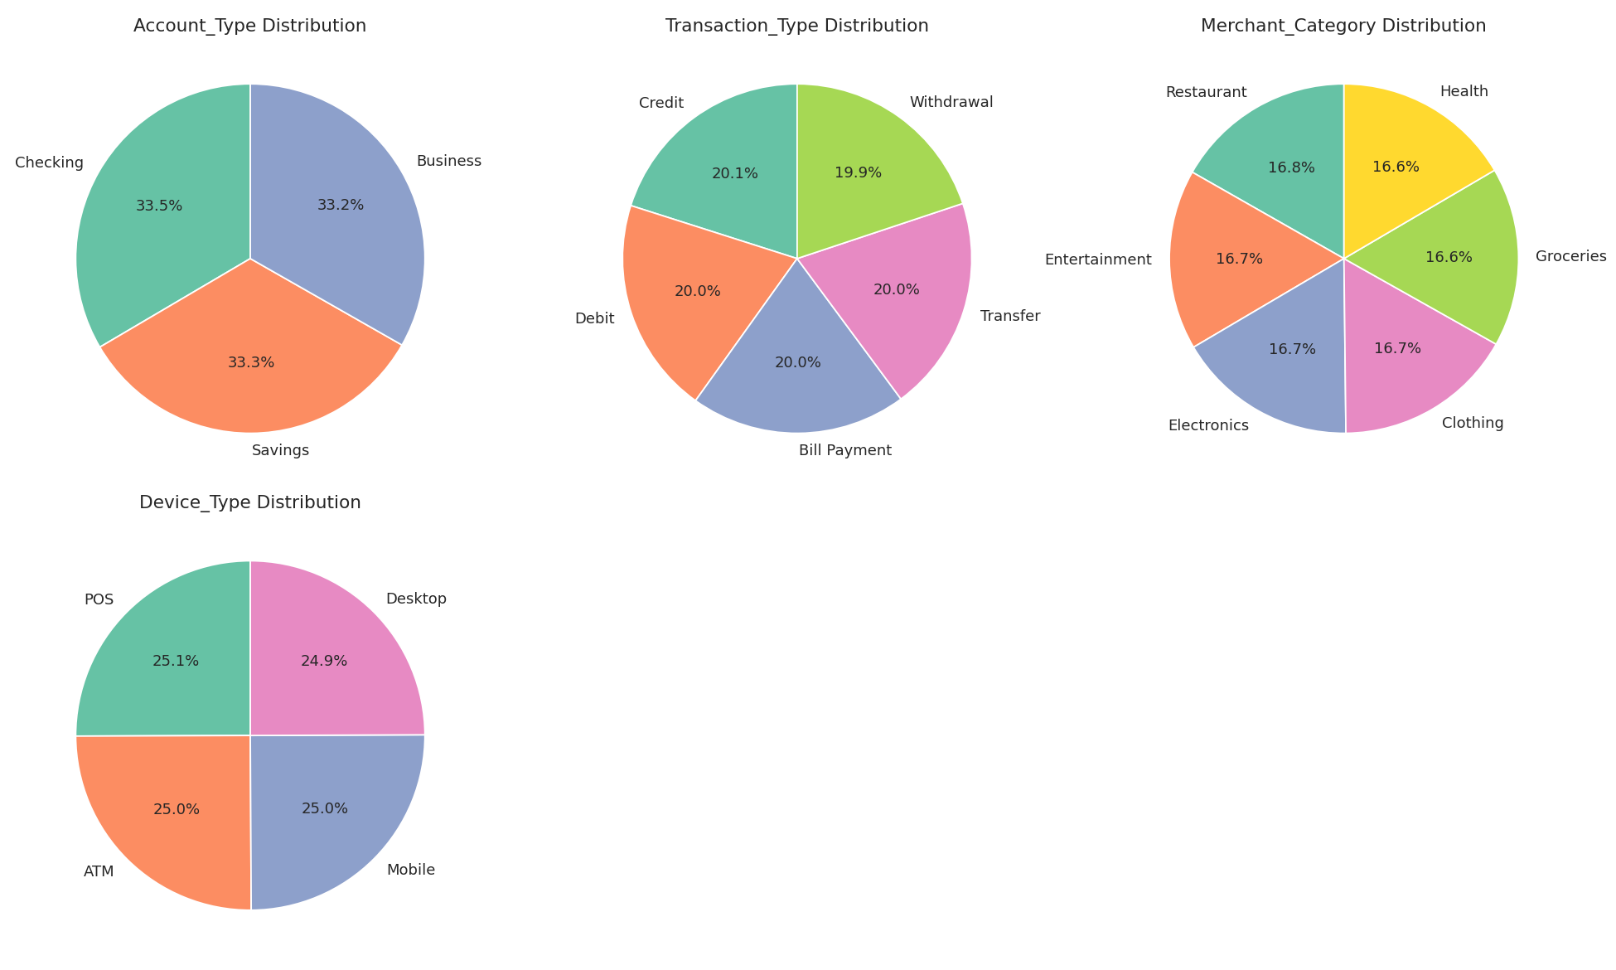
Figure 3. Account_Type, Transaction_Type, Merchant_Category, and Device_Type are all close to uniformly distributed across their categories — consistent with synthetically generated data.

4. Outlier Detection (Numeric Features)
Boxplots were used to check Age, Transaction_Amount, and Account_Balance for outliers using the standard 1.5×IQR rule, computed directly from the raw data. In all three cases, zero values fall outside the whiskers.
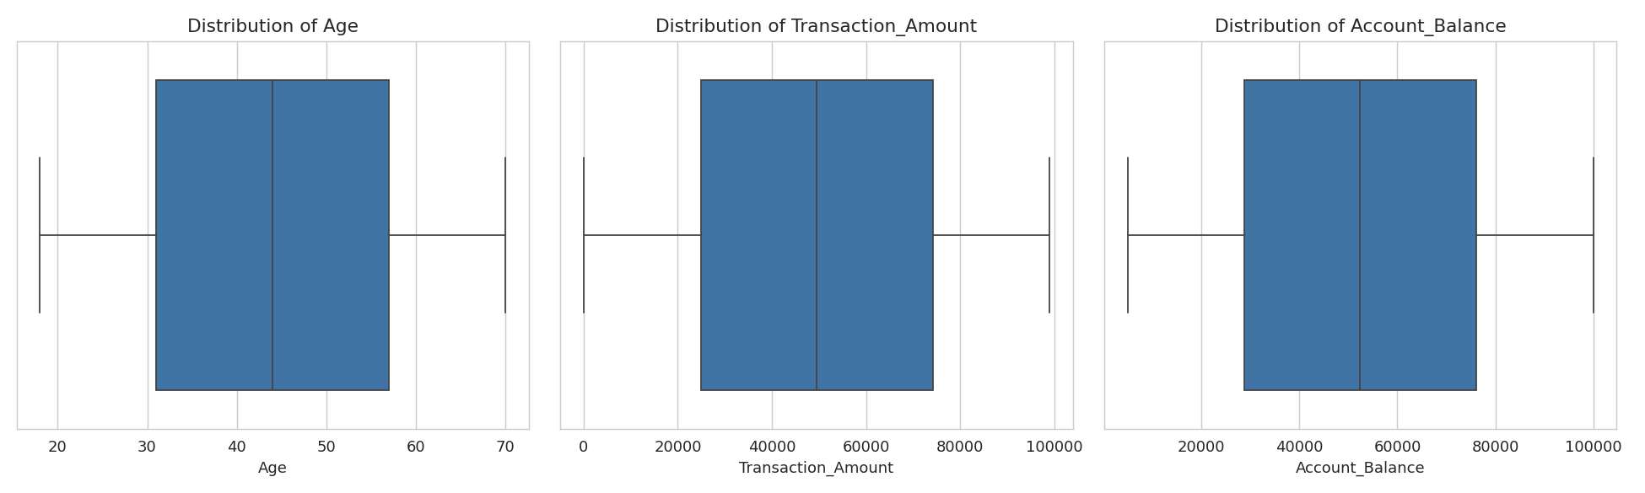
Figure 4. No outliers detected in Age, Transaction_Amount, or Account_Balance — confirmed by direct IQR calculation (see Insights Report for exact bounds).

5. Fraud Rate by Category
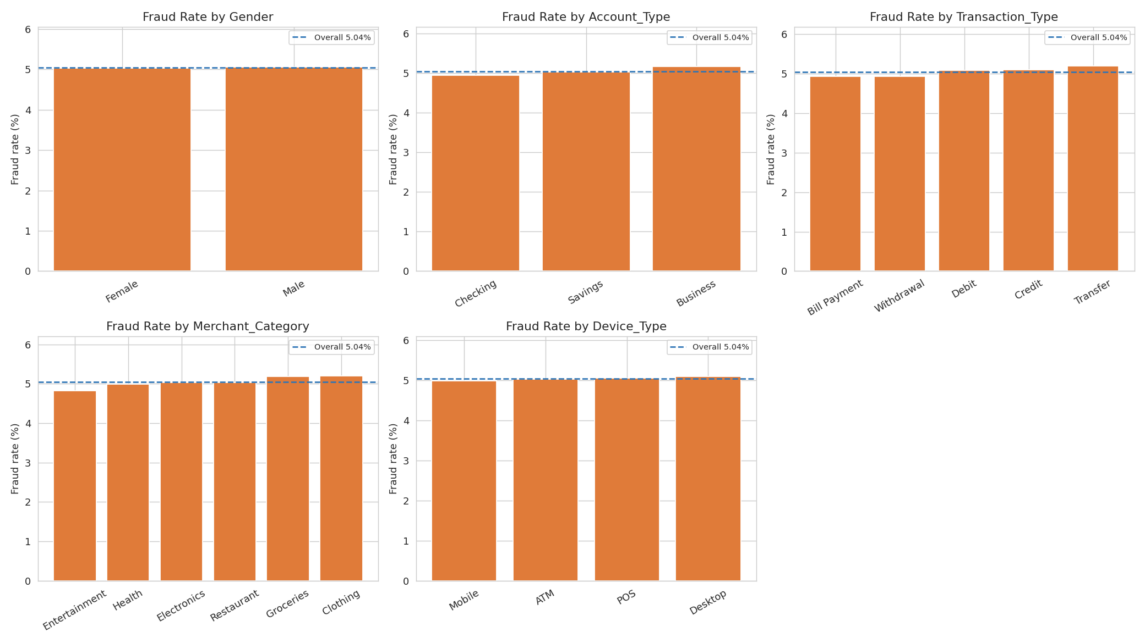
Figure 5. Fraud rate within each category of Gender, Account_Type, Transaction_Type, Merchant_Category, and Device_Type, compared to the overall 5.04% baseline (dashed line). Every bar sits within half a point of the baseline — no category stands out.

6. Transaction Amount & Account Balance by Fraud Status
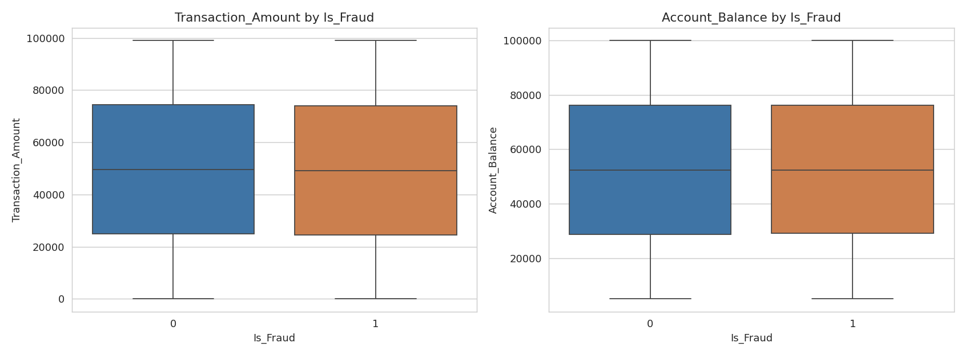
Figure 6. Both Transaction_Amount and Account_Balance distributions are nearly identical between fraudulent and legitimate transactions.

7. Statistical Association with Is_Fraud
Pearson correlation is only valid for numeric/ordinal data, so for the categorical features we used Cramer's V — a chi-square based association measure appropriate for nominal categories — instead of label-encoding them and computing Pearson correlation (which would impose a meaningless artificial order on the categories).
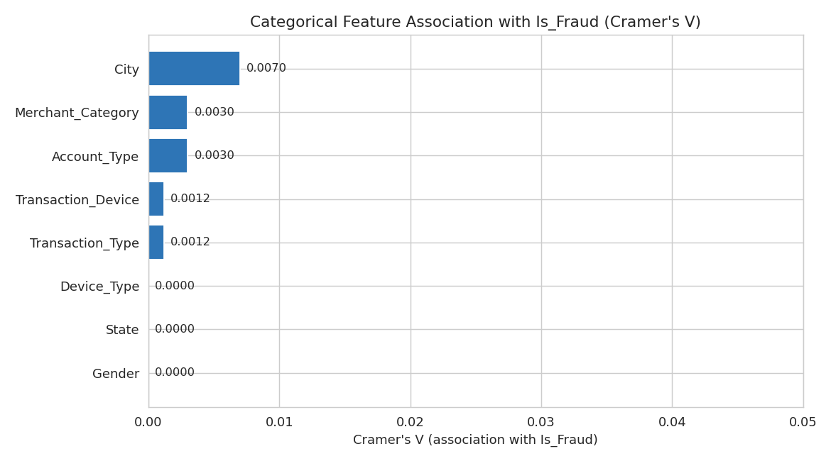
Figure 7. Cramer's V association strength between each categorical feature and Is_Fraud (0 = no association, 1 = perfect association). The strongest, City, is still only 0.007 — negligible.
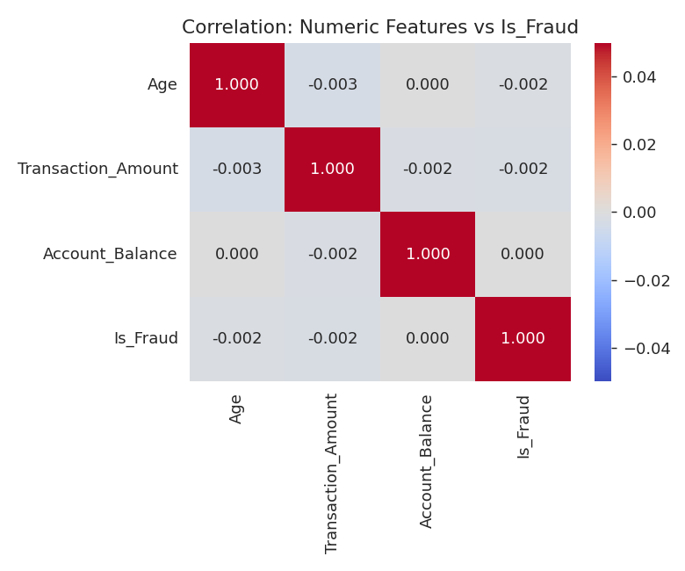
Figure 8. Pearson correlation between the numeric features (Age, Transaction_Amount, Account_Balance) and Is_Fraud — all under 0.003 in magnitude, i.e. no linear relationship.

