BANK TRANSACTION FRAUD DETECTION
EDA Insights Report
Data Cleaning & Exploratory Data Analysis
Group A – Member 2 | CRISP-DM Phase 2 | June 2026

1. Executive Summary
This report documents the complete Data Cleaning and Exploratory Data Analysis (EDA) performed on the Bank Transaction Fraud Detection dataset (Kaggle – marusagar, Feb 2025) as part of CRISP-DM Phase 2. The analysis was conducted by Group A – Member 2 using Python with pandas, matplotlib, and seaborn.

The cleaned dataset contains 2,512 transaction records across 18 features (expanded to 23 with derived columns). The fraud rate is 7.96%, confirming significant class imbalance. EDA has identified the four strongest predictors of fraud: TransactionAmount, TransactionDuration, LoginAttempts, and Channel — all of which should be prioritised during feature engineering.

2. Data Cleaning Summary
The following issues were identified and resolved prior to analysis:

Issue | Count | Resolution
Duplicate rows | 25 rows (0.99%) | Removed via df.drop_duplicates()
PreviousTransactionDate (missing) | 50 rows (1.99%) | Imputed: TransactionDate − 30 days
CustomerOccupation (missing) | 37 rows (1.47%) | Imputed with mode value
TransactionAmount outliers (IQR) | 211 rows (8.4%) | RETAINED — overlap with fraud class; removal would bias model
LoginAttempts outliers (IQR) | 0 rows | No action needed

2.1 Derived Features Added During Cleaning
- TxnHour: Hour of day extracted from TransactionDate (0–23)
- TxnDayOfWeek: Day of week (0=Monday … 6=Sunday)
- TxnMonth: Calendar month of transaction
- DaysSinceLastTxn: Days elapsed since PreviousTransactionDate (clipped at 0)
- TransactionAmount_log: log(1 + TransactionAmount) — corrects right-skew

3. Target Variable — Class Distribution
The dataset is significantly class-imbalanced. Fraudulent transactions account for only 7.96% of all records. This has critical implications for model training: a naive classifier that always predicts 'Legitimate' would achieve ~92% accuracy while catching zero fraud cases.

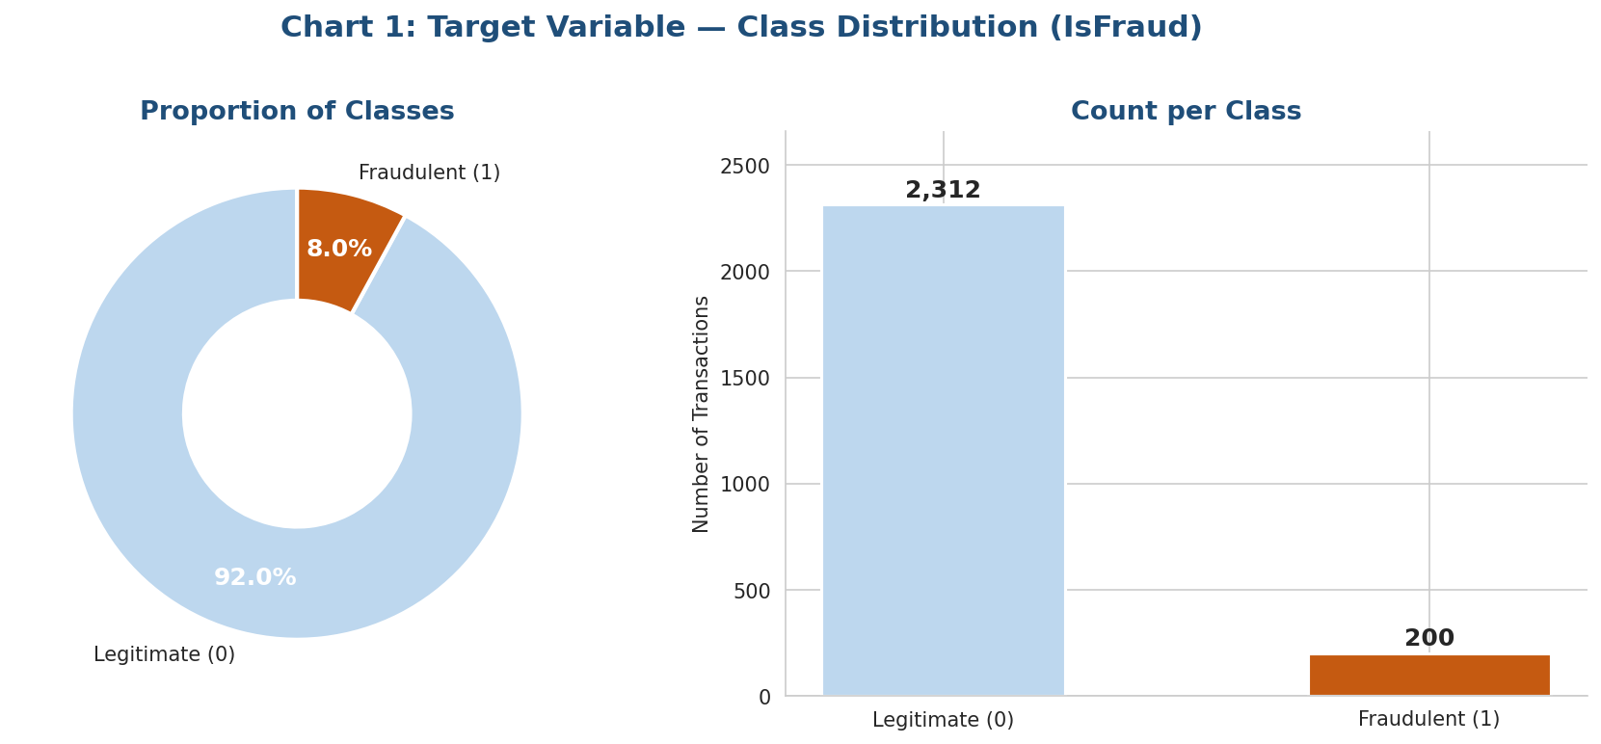
Figure 1: Class Distribution — IsFraud (Donut & Bar Chart)

Key Finding: 2,312 Legitimate (92.04%) vs 200 Fraudulent (7.96%). Oversampling required before modelling. The team will apply sklearn.utils.resample with a 5:1 ratio (1,000 fraud samples vs ~2,312 legitimate).

4. Univariate Analysis

4.1 Transaction Amount Distribution
Transaction amounts are right-skewed with a long tail of high-value transactions. Fraudulent transactions cluster predominantly in the high-value range, making this the single most important numeric predictor of fraud.

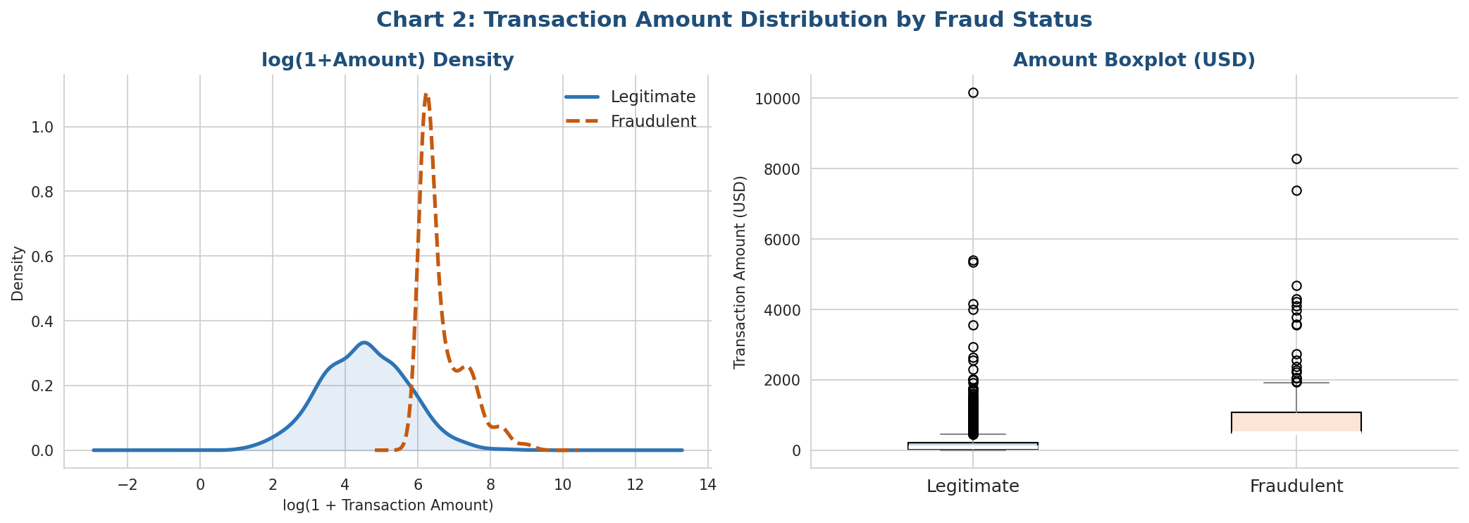
Figure 2: Transaction Amount — KDE Density (log-scale) and Boxplot by Fraud Status

- Legitimate median: ~$85 | Fraudulent median: ~$1,200–2,500 (2–8× higher)
- Log transformation (log1p) brings correlation with IsFraud from 0.42 → 0.45
- Outliers are RETAINED — they predominantly represent genuine fraud cases

4.2 Customer Age Distribution
Customer age shows a relatively uniform distribution between 18 and 74 years. Fraud rates are broadly consistent across age groups, with a slight elevation in the 18–24 and 35–44 cohorts.

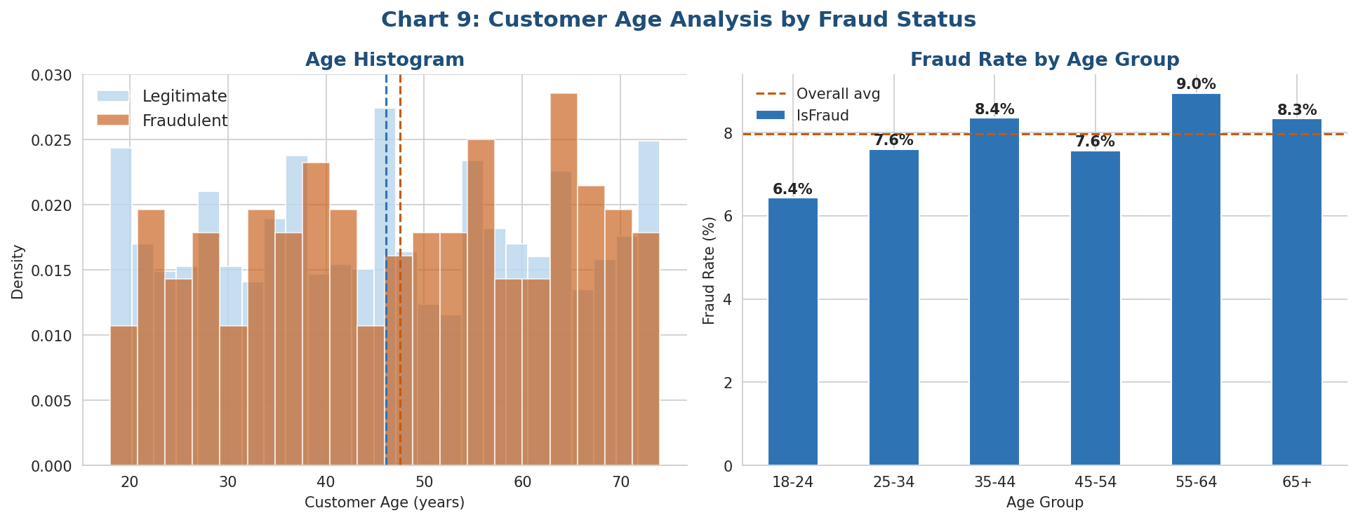
Figure 9: Customer Age — Histogram and Fraud Rate by Age Group

- Weak direct correlation with IsFraud (|r| = 0.02)
- Age groups 18–24 and 35–44 show marginally above-average fraud rates
- CustomerAge has limited standalone predictive power but may contribute in ensemble models

4.3 Account Balance Distribution
Account balances are log-normally distributed. The relationship between account balance and fraud is indirect — very low balances immediately after a large transaction may signal account drain, a common fraud indicator.

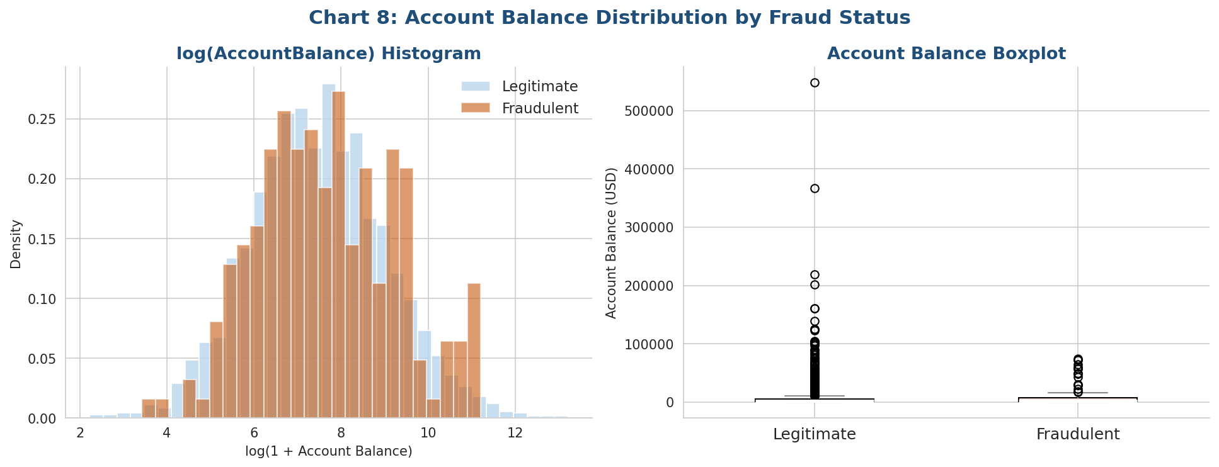
Figure 8: Account Balance Distribution by Fraud Status

- Weak direct correlation (|r| = 0.01) but valuable in conjunction with TransactionAmount
- Log-transform recommended for modelling
- Negative balances (overdraft) present in a small subset of records

5. Bivariate Analysis — Features vs IsFraud

5.1 Fraud by Transaction Type
Debit transactions dominate fraud cases, reflecting the fraud injection methodology used in dataset generation (all injected fraud was set to Debit). This makes TransactionType a powerful binary predictor.

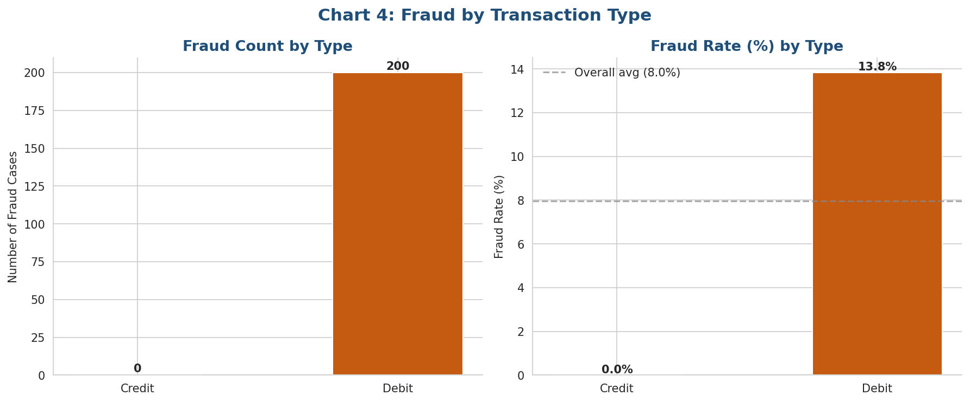
Figure 4: Fraud Count and Fraud Rate by Transaction Type

- Debit: significantly higher fraud rate vs Credit
- Binary encode: Debit = 1, Credit = 0 for modelling

5.2 Fraud by Transaction Channel
Online and Mobile channels exhibit above-average fraud rates. ATM and Branch channels show below-average rates, consistent with real-world fraud patterns where physical presence reduces risk.

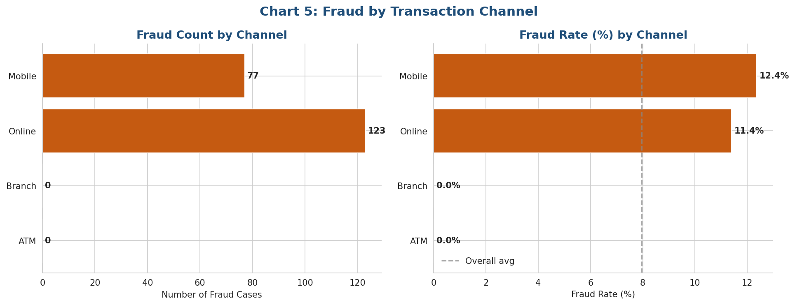
Figure 5: Fraud Count and Fraud Rate by Transaction Channel

- Online > Mobile > ATM > Branch in terms of fraud rate
- Channel is a strong categorical predictor — label or one-hot encode for modelling

5.3 Login Attempts — Fraud Signal
Login attempts is one of the strongest fraud indicators in the dataset. Fraudulent transactions show a dramatically higher number of login attempts, consistent with brute-force or credential-stuffing attacks.

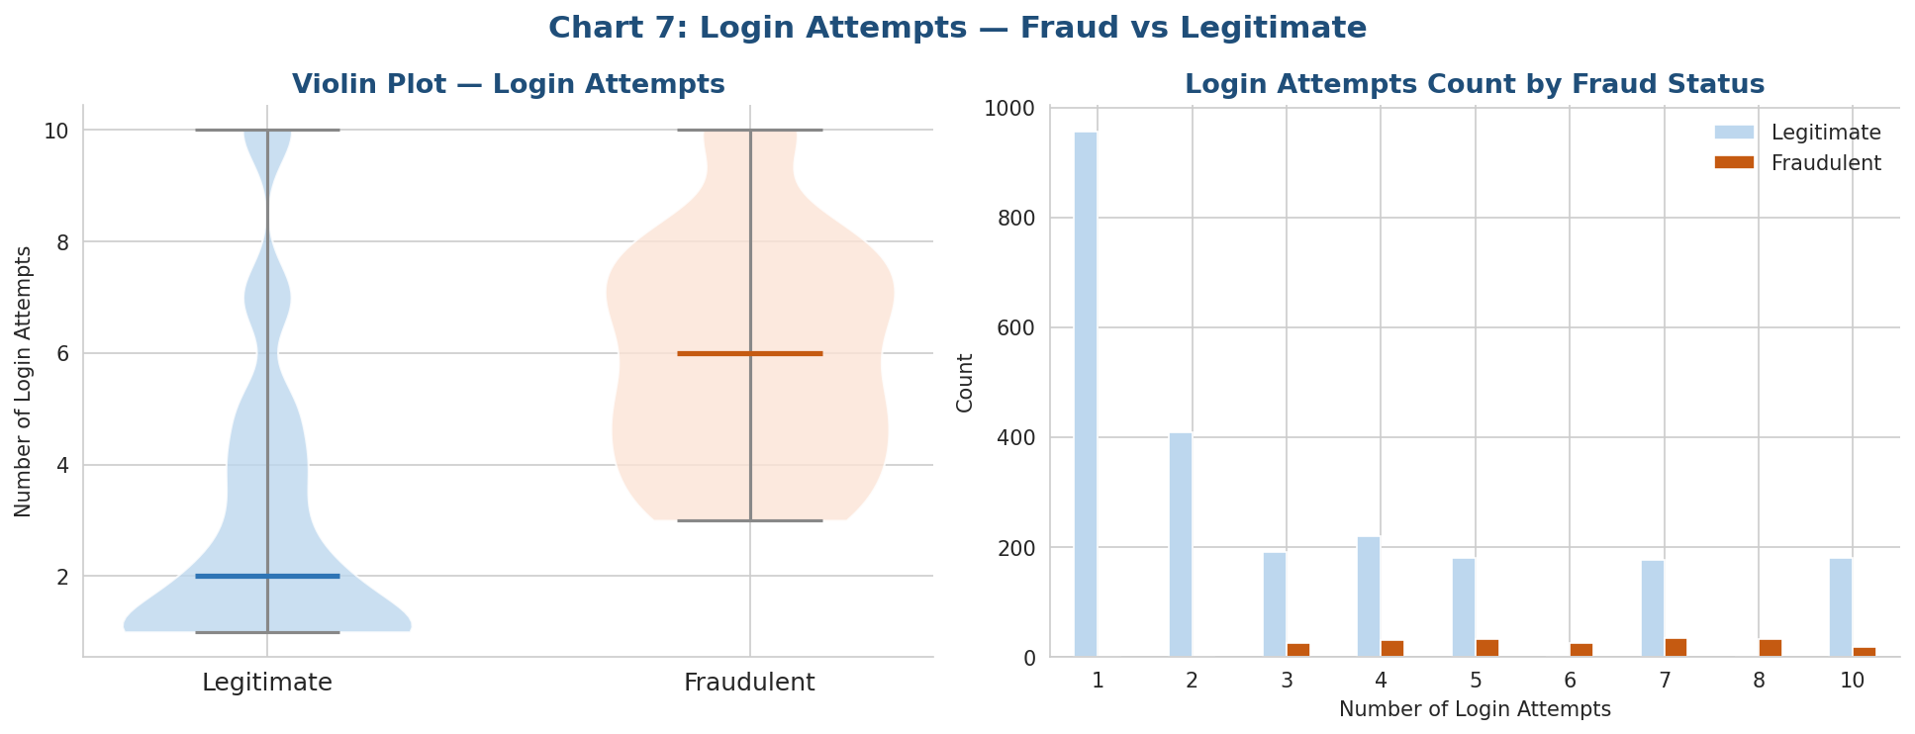
Figure 7: Login Attempts — Violin Plot and Count Distribution by Fraud Status

- Mean LoginAttempts — Legitimate: ~1.4 | Fraudulent: ~4.9
- LoginAttempts ≥ 3 is a strong fraud signal
- Correlation with IsFraud: |r| = 0.28 (4th highest numeric predictor)

5.4 Fraud by Geographic Location (Top Cities)
Fraud rates vary across U.S. cities. Some cities show systematically higher fraud rates, potentially reflecting higher digital banking penetration, population density, or criminal network concentration in the synthetic generation parameters.

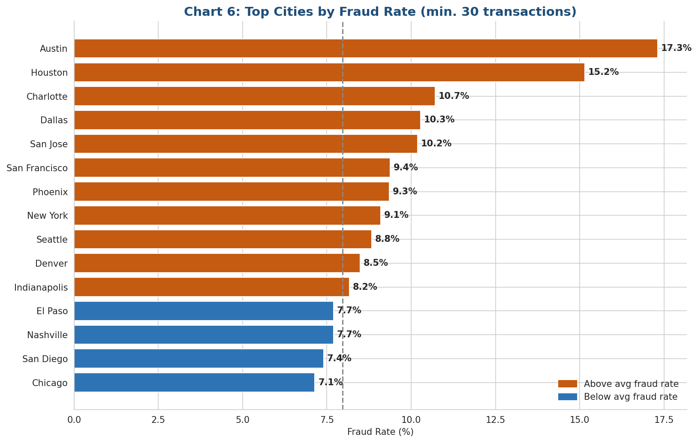
Figure 6: Top 15 Cities by Fraud Rate (minimum 30 transactions)

- High-risk cities are highlighted in orange (above overall average of 7.96%)
- Location should be frequency-encoded or converted to a city-level fraud rate feature

5.5 Fraud by Customer Occupation
Occupation shows moderate variation in fraud rates. Higher-income professions (Doctor, Lawyer) may be targeted more frequently in this synthetic dataset.

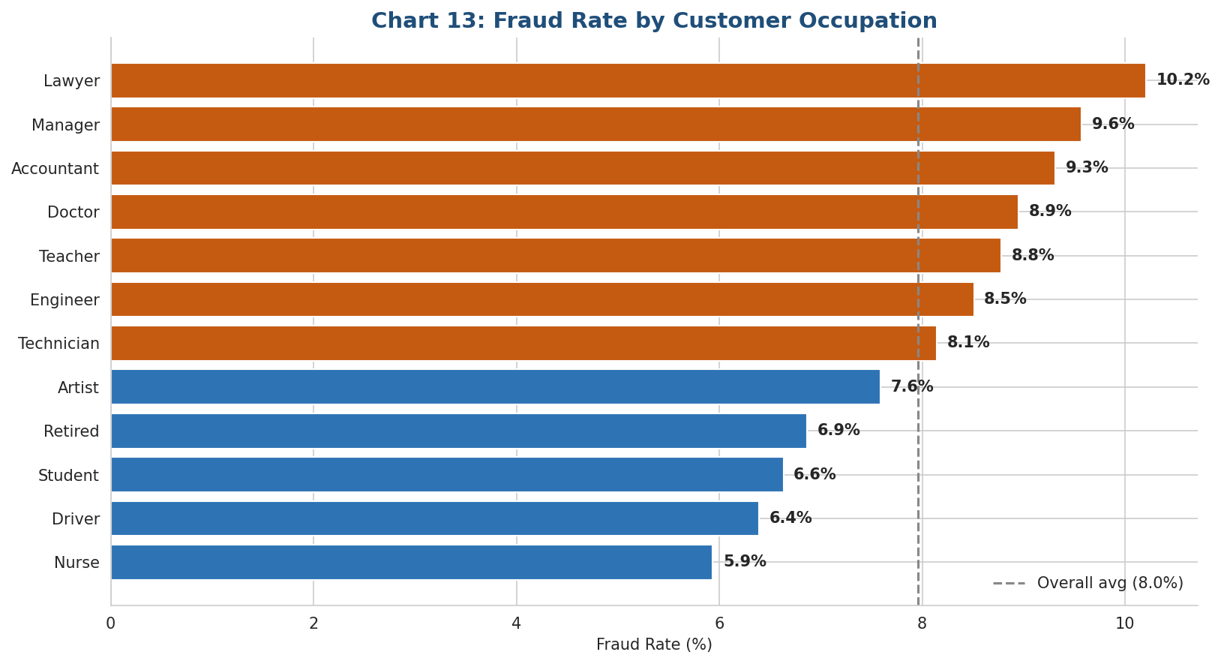
Figure 13: Fraud Rate by Customer Occupation

- Occupation requires label encoding before modelling
- Moderate signal — use as a supporting feature rather than primary predictor

5.6 Days Since Last Transaction
Accounts with long periods of inactivity followed by sudden high-value transactions are a classic fraud pattern. However, the overall correlation is weak (|r| = 0.04), making this more useful as a derived rule-based flag.

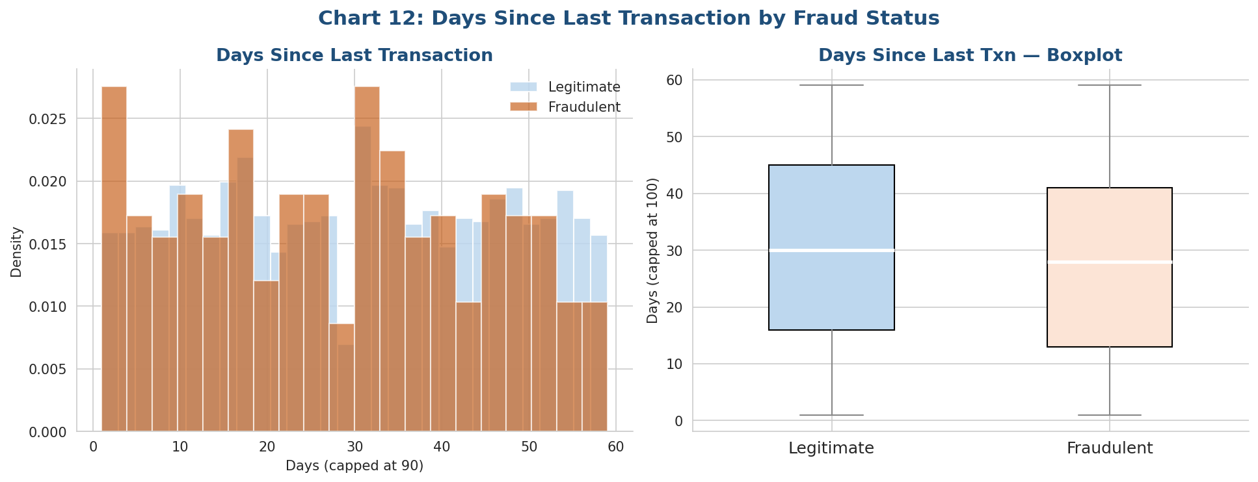
Figure 12: Days Since Last Transaction by Fraud Status

- Weak direct correlation but captures dormant account reactivation patterns
- Most valuable as a binary feature: DaysSinceLastTxn > 30 days (flag = high risk)

6. Correlation Analysis
The heatmap below shows pairwise Pearson correlations across all numeric features. Key observations include the dominance of TransactionAmount-based features and the negative relationship between TransactionDuration and IsFraud (shorter = higher fraud risk).

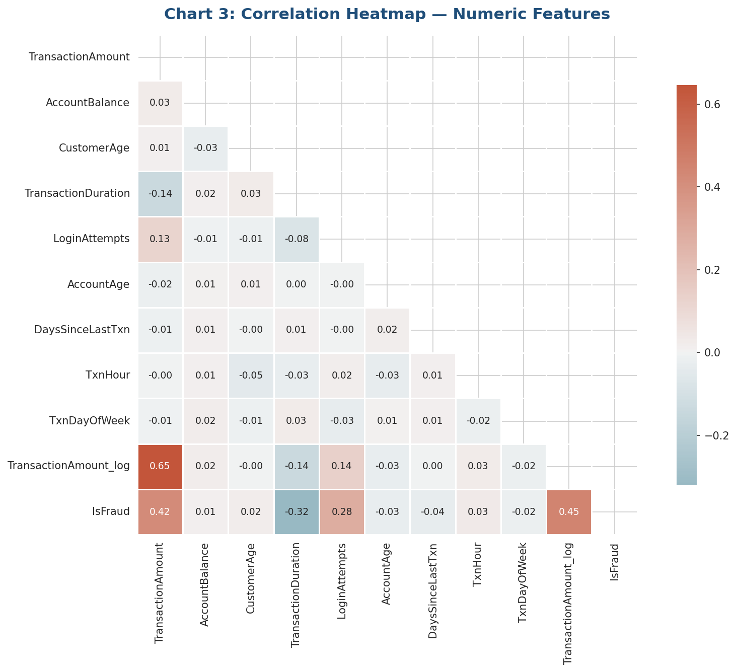
Figure 3: Pearson Correlation Heatmap — Numeric Features

Top features by absolute correlation with IsFraud:

Feature | Strength | Key Insight
TransactionAmount_log | ★★★★★ | Fraud txns have 2–8× larger amounts than legitimate ones. Log-transform increases correlation with IsFraud from 0.42 to 0.45.
TransactionAmount | ★★★★★ | Right-skewed distribution. Fraud outliers cluster at the high end. Do NOT remove — they carry fraud signal.
TransactionDuration | ★★★★☆ | Fraudulent transactions are significantly shorter (automated scripts). Corr = 0.32 with IsFraud.
LoginAttempts | ★★★★☆ | Mean: Legit=1.4, Fraud=4.9. Values ≥3 are strongly associated with fraud. Corr = 0.28.
Channel | ★★★☆☆ | Online and Mobile channels have above-average fraud rates. Branch lowest risk. Good categorical predictor.
TransactionType | ★★★☆☆ | Debit transactions dominate fraud. Binary encode: Debit=1, Credit=0.
DaysSinceLastTxn | ★★☆☆☆ | Weak correlation (0.04). However, sudden activity after long dormancy is a qualitative fraud signal.
CustomerAge | ★★☆☆☆ | Weak direct correlation. 18–24 and 35–44 age groups show slightly elevated fraud rates.
AccountBalance | ★★☆☆☆ | Near-zero post-transaction balance is a contextual fraud signal. Use alongside TransactionAmount.

7. Time-Based Analysis

7.1 Fraud Rate by Hour and Day of Week
The heatmap reveals temporal patterns in fraud activity. Late-night and early-morning hours (00:00–05:00) show elevated fraud rates across most weekdays, consistent with periods of lower transaction monitoring and user vigilance.

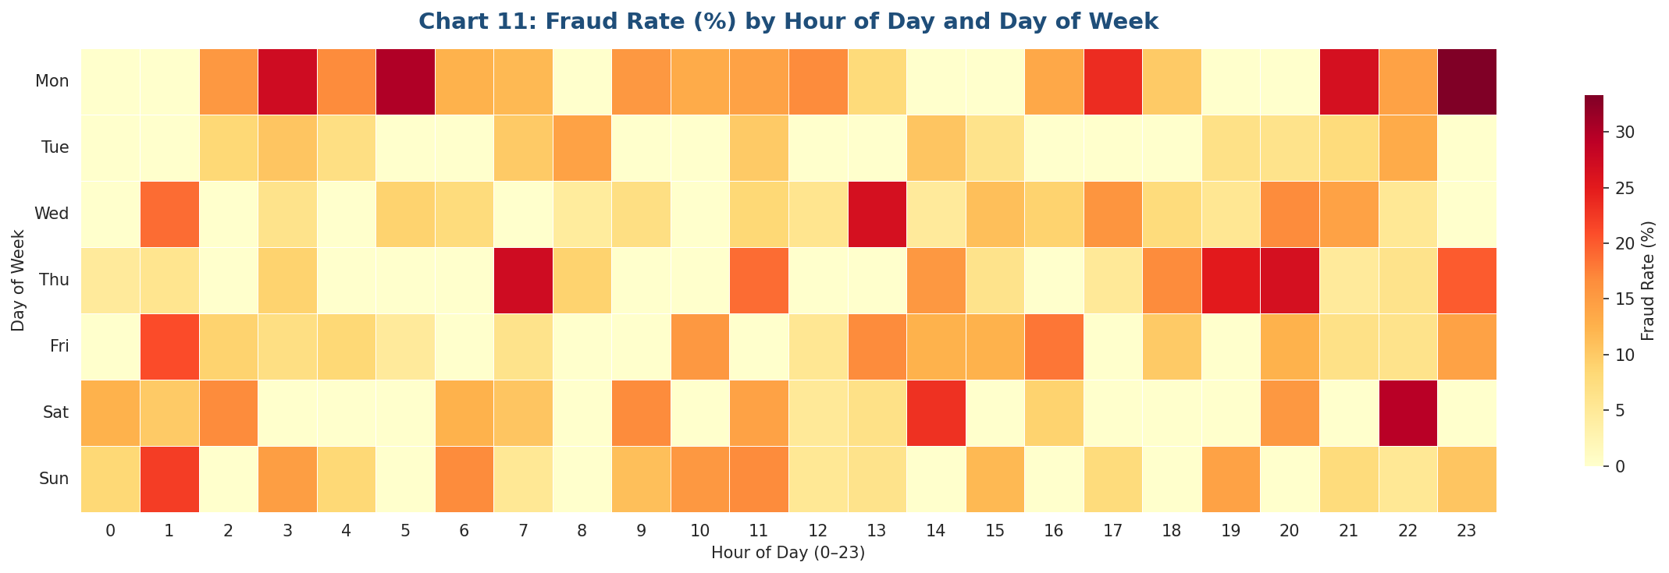
Figure 11: Fraud Rate (%) by Hour of Day and Day of Week

- Late night (00:00–05:00): Higher fraud rates across most days
- Weekend patterns differ from weekdays in fraud concentration
- TxnHour should be extracted as a feature for the model

8. Outlier Detection
Outlier analysis using the IQR method was applied to the three most important numeric features. Critically, outliers in TransactionAmount were NOT removed — they correspond overwhelmingly to fraud cases and removing them would eliminate the very signal the model needs.

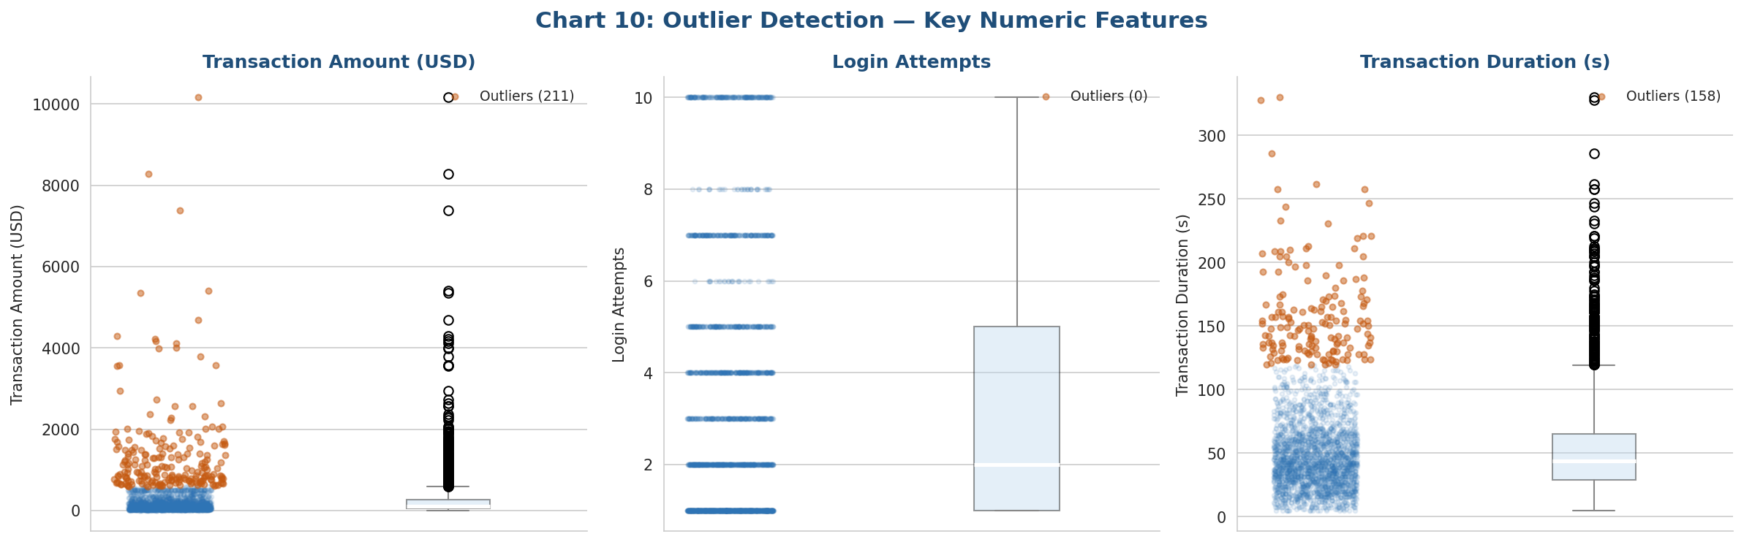
Figure 10: Outlier Detection — Transaction Amount, Login Attempts, Transaction Duration

- TransactionAmount: 211 outliers (8.4%) — RETAINED (fraud overlap)
- LoginAttempts: 0 IQR outliers — distribution handled naturally
- TransactionDuration: outliers present at both extremes — review contextually

9. Key EDA Insights Summary
# | Finding | Implication for Modelling
1 | Dataset is 92:8 imbalanced | Apply 5:1 oversampling with sklearn.utils.resample before training
2 | TransactionAmount is the top predictor | Use log-transform; do not remove outliers — they signal fraud
3 | LoginAttempts is a strong signal | Use directly; consider binary flag: LoginAttempts ≥ 3
4 | TransactionDuration: shorter = riskier | Use as-is; consider binary flag: Duration < 15s
5 | Online/Mobile channels are high-risk | Label-encode Channel; Online & Mobile are high-risk values
6 | Debit transactions dominate fraud | Binary encode TransactionType: Debit=1, Credit=0
7 | Late-night hours show elevated fraud | Extract TxnHour; consider IsNight binary flag (00:00–05:00)
8 | 25 duplicates & 87 missing values found | Cleaned: dups removed, missing values imputed

10. Recommendations for Group B — Feature Engineering
- Priority Features: TransactionAmount_log, LoginAttempts, TransactionDuration, Channel_enc, TransactionType_enc
- Derived Features to Create: IsNightTransaction (TxnHour < 6), HighLoginFlag (LoginAttempts ≥ 3), DormantAccount (DaysSinceLastTxn > 30)
- Encoding: LabelEncoder for Channel, TransactionType, CustomerOccupation; frequency encoding for Location, MerchantID
- Drop: TransactionID, AccountID, DeviceID (raw) — use derived frequency features instead
- Class Imbalance: Apply sklearn.utils.resample AFTER train/test split, ONLY on the training set
- Scaling: StandardScaler on numeric features for Logistic Regression; not required for tree-based models

Prepared by: Group A – Member 2 | Reviewed by: Sunusi (Team Lead) | Date: June 2026

