**2022-2023-2学期期末考查作业英语原文**

**News Item I**

**Old Craftsmanship, New Value**



When the greasy filth is wiped off, those vessels appear in front of me, beaming and shining. I feel like I am traveling back to ancient times to talk with my ancestors,” Hou Xue says proudly whenever he mentions repairing and restoring cultural relics in the Palace Museum in Beijing. Hou is a representative inheritor of the state-level intangible cultural heritage of producing gold-inlaid lacquerware. “It is the honor of a lifetime to repair these precious ancient vessels,” he said.

**‘The wrong job’**

Hou majored in art and design at North China University of Technology in Beijing. “At that time, I hoped to find a job in a newspaper or a periodical as an art editor or designer,” said Hou. As chance would have it, he met Bai Qun, a member of the state-level intangible cultural heritage representative inheritor program for the production of gold-inlaid lacquerware, who invited Hou to visit an exhibition of palace arts.

Elegant and simple folding screens, graceful cabinets and other works in the exhibition appealed to Hou, and more importantly, he was surprised and deeply impressed by the exquisite craftsmanship. Touching the furniture and vessels used to be reserved for royal families, Hou felt he was dreaming: He could feel that the craftsmanship involved in making these things has been well-preserved. “I was so impressed by these vessels, that when Bai asked whether I would like to learn this craft, I nodded without hesitation. This visit to the exhibition hall changed my career goals,” said Hou.

Chinese lacquerware dates back approximately 8,000 years. Gold-inlaid lacquerware is an important part of this craft and was once reserved for the royal families of history. Beijing, an ancient capital city for multiple dynasties, is the major production base for lacquerware.

The gradual development of lacquerware craftsmanship over approximately 700 years during the three Beijing-based dynasties, Yuan, Ming and Qing, laid a foundation for its modern development. When the Qing Dynasty collapsed in 1911, many of the craftsmen once working in royal workshops were forced to begin selling their wares in ordinary society. They contributed to the rise of the eight Beijing-style handicrafts, including jade carving, ivory carving and carved lacquerware in Beijing. The art and style of gold-inlaid lacquerware in Beijing, as well as the way it is taught and passed on, have their roots in royal craftsmanship of the Ming and Qing dynasties.

At Bai’s recommendation, Hou formally joined Beijing Gold Lacquer Inlaid Co. Ltd. in 2009 as an apprentice in the gold-inlaid lacquerware workshop. Every day, he got up at 4 a.m. in order to be at work by 8 a.m., and took a bus to go back to his dormitory in the evening. In summer, it was scorching in the workshop, while in winter, it was freezing.

Through several years of dedicated study and practice, Hou has won many honors and titles. He says that accidentally taking on his current job has brought him a career he will cherish for the rest of his life.

**Reverence and craftsmanship**

Hou worked in the Palace Museum from 2014 to 2016, focusing on protective restoration and replication of lacquerware collected. This experience is demanding and even sometimes torturous, but is also a precious opportunity to strengthen his craftsmanship.

“For example, when touching up the blue color that has worn away from objects over time, we need to apply the lacquer seven to eight times, with the color going from light to dark to reach color saturation. Additionally, work on the same piece must be undertaken at the same time in the same location and under the same weather conditions in order to avoid color differences between the repaired part and the old part,” explained Hou.

These are seemingly simple steps, but they require a high-level of professionalism, and also the knowledge of every ancient vessel, he said. Cultural relics reflect the aesthetic level of a certain historical period. They are still charming and appealing even today because they are tangible embodiments of excellent Chinese culture and first-level craftsmanship handed down through centuries. “My reverence for ancient craftsmanship and wisdom grows with each passing day.”

If classified in terms of functions, Beijing gold-inlaid lacquerware can fall into different categories, such as vessels, furniture, folding screens, plaques and mural decorations. In the Palace Museum, most lacquerware furniture and vessels were made in the gold-inlaid form. These include the dragon throne in the Hall of Supreme Harmony, and almost all beds, desks, and toilet cases in the imperial palace. Hou is proud of his company’s long-term cooperation with the Palace Museum. “It’s because we have inherited the best skills in this technique and we are making innovations on this solid basis,” he said.

**Integrated into modern life**

Beijing Gold Lacquer Inlaid Co. Ltd. boasts a history of 66 years. It is an important platform for the protection and inheritance of the skill of making gold-inlaid lacquerware. Hou’s personal development in this technical arena is to a large extent benefiting from a good intergenerational learning model. When he was alive, Bai Deyuan, a fifth-generation inheritor of the craft and Bai Qun’s father, used to emphasize the importance of making rational and effective innovations on the basis of inheriting traditional craftsmanship. By innovation, Bai Deyuan meant innovation in response to the needs of the era as well as restoration and replication of ancient techniques lost for years.

In early 2022, the company joined hands with local museums and cultural organizations to launch handcrafted watches, which are wildly popular with consumers. The highlight of these watches lies in their appearance, which combines Po-phase flowers, highly favored in the Tang Dynasty (618-907) as a symbol of auspiciousness, and the artistic concept of Maurits Cornelis Escher, a famous Dutch printmaker. This watch is a limited edition and, thanks to its combination of Chinese and Western styles, was soon sold out after being put on the market. Hou was thus inspired by this experience: “Excellent intangible cultural heritage works are not those thrown into museums for exhibition, but those that live up to modern aesthetic level and modern life,” he said.

Hou believes that the gauge for a successful intangible cultural heritage item is foremost that this item can produce value and bring profits. “If consumers are not interested in such works and inheritors can’t earn a living by doing the job, then these works are valueless and the heritance is worthless,” he said. For a business to attract young successors to join, it must be lucrative, and this is also the way to address the current shortage of innovation capacity and talents in this cultural area.

(1100 words)

**News Item II**

**May Day holidays set to be ‘most prosperous’**

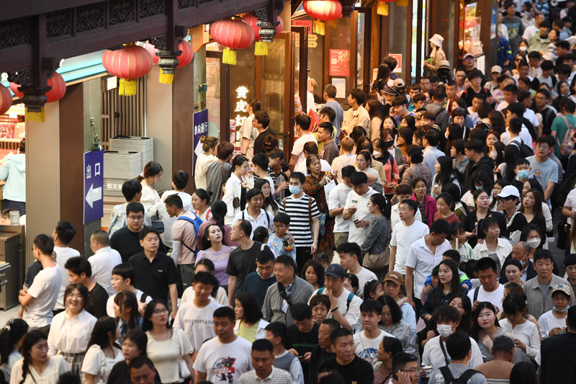

China's consumption has been firing on all cylinders during the just-ended May Day holidays, ranging from tourism, box office, transportation, entertainment to catering sectors. This year’s five-day holidays are believed to have beaten the 2019 pre-epidemic level in terms of both trips made and revenue generated to become what industry insiders celebrated as the "most prosperous," giving a huge boost to GDP.

From the barbecue craze in Zibo, an industrial city in East China’s Shandong Province, the camel-riding “traffic jam” in a desert spot in Dunhuang, Northwest China's Gansu Province to the lengthy queues at the doorstep of naughty, fluffy giant panda Meng Lan at Beijing Zoo, tourist destinations across the country were flooded with millions of Chinese visitors, who set their sights on the May Day holidays - the first long break after the seven-day Spring Festival holidays - to release pent-up travel desire.

The tourist boom offers an unmistakably sign that the world’s second-largest economy has been steadily moving out of the epidemic haze after three tedious years, analysts said. More importantly, it shed light on the strength and sustainability of China’s consumption rebounding momentum, which analysts predict could wow global investors with double-digit growth in the second quarter of the year and serve as a major pillar underpinning a whole-year economic recovery of above 5 percent.

A total of 274 million trips were made during the May Day holidays this year, up 70.83 percent year-on-year, equivalent to 119.09 percent of 2019’s on a like-for-like basis, according to data released by the Ministry of Culture and Tourism late on Wednesday. Domestic tourism income soared 128.9 percent year-on-year to 148.1 billion yuan ($21.43 billion), slightly higher than in 2019 on a comparable basis at 100.66% of 2019.

The national railway network is set to transport 19.35 million passengers on Wednesday, the last day of the five-day holidays that started on April 29, according to China Railway. It represents roughly a 400 percent increase from that of 2022 based on the Global Times’ calculations.

According to a report that online travel agency Qunar sent to the Global Times on Wednesday, the number of people who simultaneously purchased online rail ticket set a record high, and tickets for popular rail routes during the holidays sold out within minutes, “at a speed even faster than during the Spring Festival travel rush.”

Data from industry information provider VariFlight showed that the number of domestic passenger flights reached 13,926 on Wednesday, about 4.4 times that of last year.

**Unprecedented traffic flow**

The May Day holidays this year have been marked by unprecedented crowds and frenzy shopping spree, with multiple tourist venues reporting tickets selling out.

Quiet a many hotspot tourist sites have been operating at maximum capacity, such as the Great Wall in Beijing, the Xi’an City Wall in Xi'an of Northwest China’s Shaanxi Province, and the West Lake in Hangzhou, East China’s Zhejiang Province, according to travel platform data.

Accommodation bookings in popular tourist cities surpassed the pre-virus level by 1.9 times, Qunar data showed. Even previously less popular tourist cities, such as Dehong in Southwest China's Yunnan Province, Gannan in Gansu, and Ili Kazakh Autonomous Prefecture in Northwest China’s Xinjiang Uygur Autonomous Region, witnessed big spikes in traffic flow, driving up an over tenfold surge in local hotel bookings from 2019.

Zibo, one of the hottest travel destinations that gained prominence on China’s social media platforms for its affordable barbecue food, saw hotel reservations jump by 20 times from 2019, according to data from Qunar. The sudden influx of visitors, which exceeded the city’s capacity, prompted local authorities to advise people to avoid traveling to the city at peak time.

“Although not yet dinner time, barbecue stalls in Zibo are full. A shopkeeper told me that the store prepares more than 20,000 skewers of meat every day to meet huge demand,” a white-collar worker surnamed Zhang told the Global Times on Wednesday.

In addition to delicious food and good services provided by the local government, Zhang attributed the major reason behind the popularity to an explosion in consumer demand, which has been suppressed in the past three years.

Throughout the May Day holidays, Chinese social media sites were abuzz with pictures and posts featuring Chinese tourist attractions overwhelmed with swarms of people, which drew a host of humorous online discussions by netizens.

For example, memes of a “camel-riding traffic jam” at Yueyaquan scenic area, an ancient “Silk Road” in Dunhuang, went viral. According to a report by Beijing Youth Daily, the congestion was due to the drastic uptick in tourists, which reached around 20,000 to 30,000 every day during the holidays whereas there are only 2,400 camels in service. The site operators, as a result, reportedly erected traffic lights to guide the camel riding activities.

Crowds are also palpable on the waterways. A raft congestion in Wuzhishan, South China’s Hainan Province, was in the limelight during the holidays. Some netizens made a humorous comparison that the hundreds of floating rubber boats stuck at the site were like “dumplings cooking in boiling water.”

Despite travel jams, Chinese tourists said the roaring back of the tourism sector has brought them long-awaited excitement and joy.

“I can obviously feel the enthusiasm of people traveling after the optimization of the COVID-19 response, as I've seen large crowds in popular spots in Chongqing, such as Hongyadong, where people enjoy the wonderful night view and river view,” a Beijing-based white-collar worker surnamed Xiong told the Global Times on Wednesday.

“Most tourists aren’t wearing masks, which shows that the impact of the epidemic has almost dissipated,” she noted.

The May Day holidays are the first long holidays after China resumed outbound group tours in February.

Data from Chinese travel agency Trip.com shows that during the long break, the number of outbound travel bookings placed by Chinese mainland tourists grew roughly 700 percent compared with last year’s.

(977 words)