Swing Trading Process - Every day

Open the NSE Trade Generator page.

Switch to Post Breakout mode
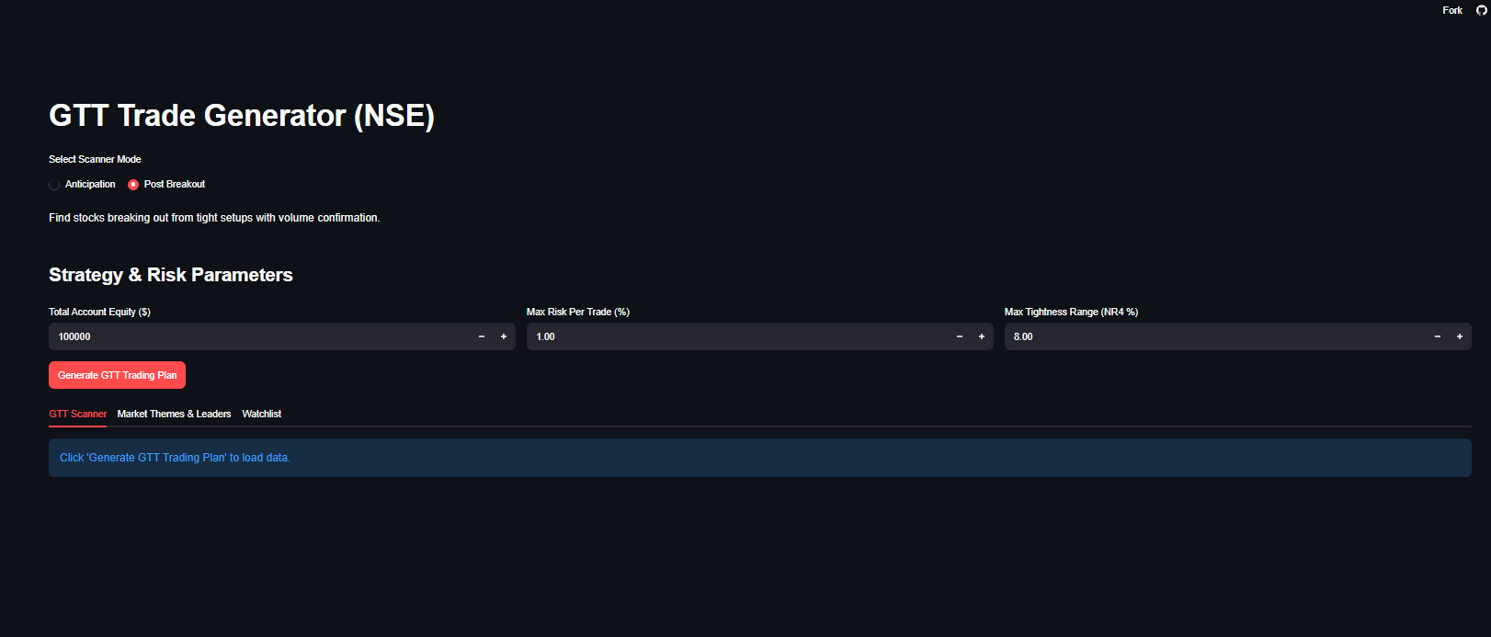

Click Generate – To show results
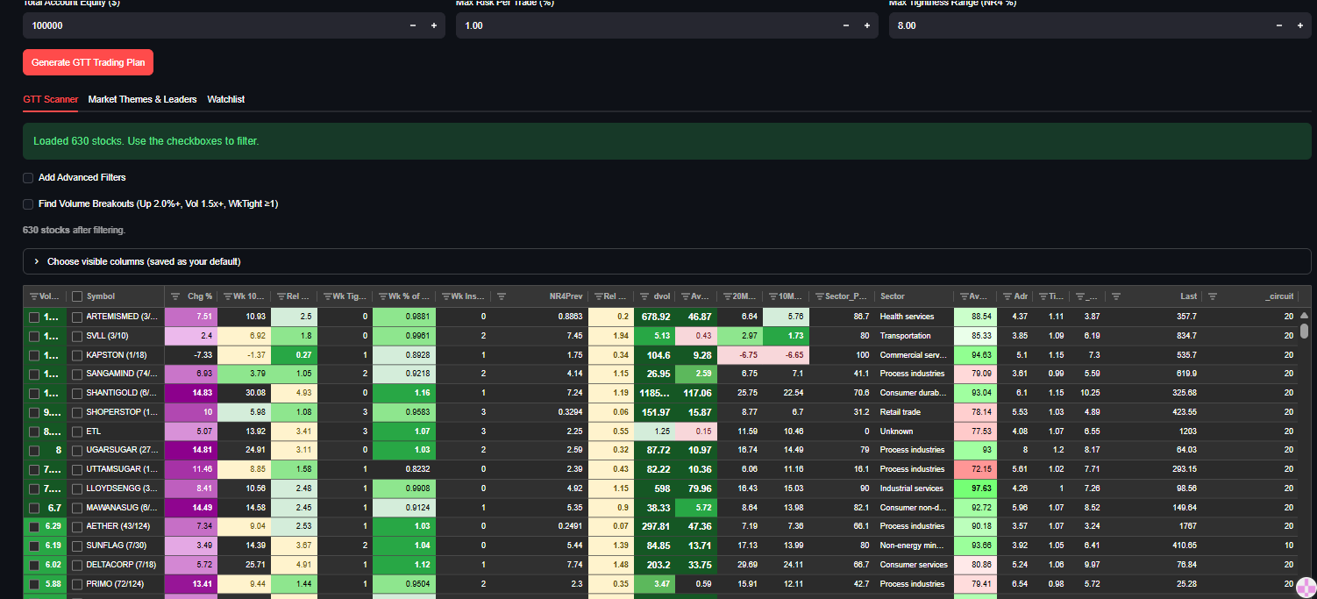

Copy the breakout tickers and copy them to tradingview to check their quality
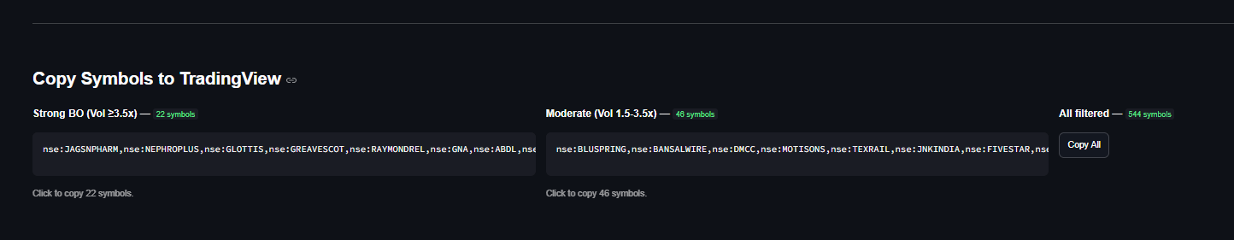

Tradingview will have two watchlists to support this selection
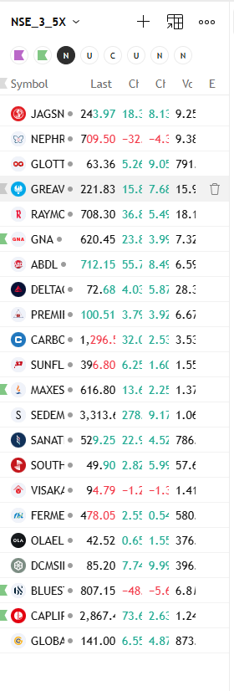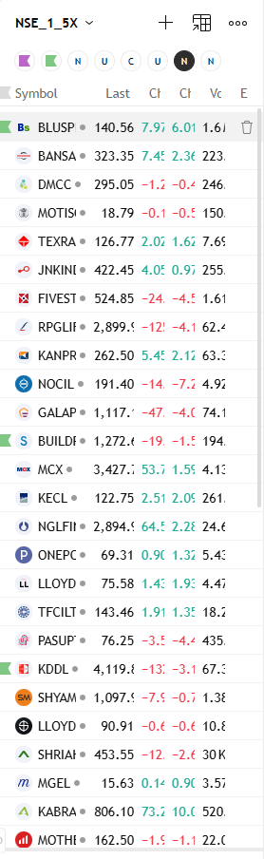

Go Through Each List by selecting the radio button and change update tags as needed
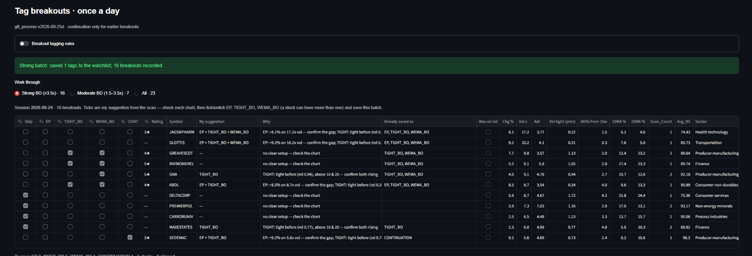

On Save, you can goto the watchlist area, where you will see you breakouts and u can manage the list here anytime


