Shipment from Sunward - Pallet Information
Intend shipment Date: [portal information]
Shipment to: [location to information]

Pallet No: 2023/000007  Temporary No: A5 – if entry is blank don’t show | 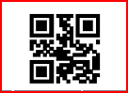
Pallet Details
Item No | Description | UOM | Batch No | No of Carton per Pallet | No of Unit per Carton | Total Qty
SW Item No |  | From NAV

Print on[Date]

