Contents
Section 1: General 2
1. General 2
2. Scope 2
3. Approval for release 2
Section 2: Manual for XXXX 3
1. Pre-requisites 3
2. Pre-settings 3
3. Procedures 3
Section 3: Revision 4
1. Revision history 4

Section 1: General

General
  - Prepare by: Ms Jung Yi Huey
  - Date of preparation:17/9/2023
  - Reference: Click or tap here to enter text.
    - Portal – Company Routine

Scope
  - It explains how to enter form information for Company Routine.

Approval for release
  - Approval by: Click or tap here to enter text.
  - Date of approval: Click or tap to enter a date.

Section 2: Manual for Company ‘Routine’

Pre-requisites
  - The user has access rights to a specific group combination within Company Routine.
  - Any Company Routine group can only activate when the 3P's routine procedure has been released

Pre-settings
  - Link to Company activity - https://portal.sunwardpharma.com:2286/#/
  - The Company Routine grouping is preconfigured for access rights and procedure flow within the Master settings.

Guidelines for entering information
Module to select – Company Routine/Master
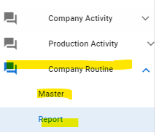
  - Header
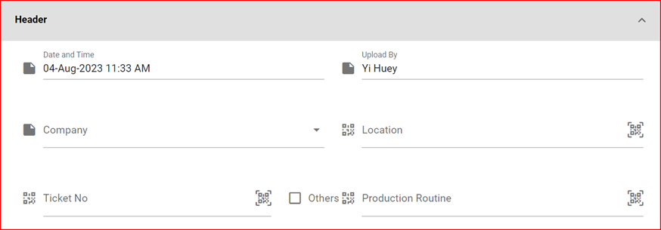
    - Date and Time
Auto generate
    - Upload By
Auto generate
    - Company
This is where you input the company to which you are reporting.
    - Location
Select the location you are reporting. You can choose from the dropdown list or scan the location code. If you are not reporting to a specific location or want to report multiple locations, you may leave it blank. Please note that this form does not allow multiple location selections.

    - Ticket No
Select the Ticket No you are reporting. You can choose from the dropdown list or scan the Ticket No. If you are not reporting to a specific Ticket No or want to report multiple Ticket No, you may leave it blank. Please note that this form does not allow multiple Ticket No selections.
    - Others
Please check the 'Other' option if you are not reporting related to a specific location or ticket number.
    - Routine
Select the routine you are reporting from the dropdown list. The dropdown list of routines is based on the PIC's requirements, which need to be set up in advance before release. The detailed definition of 'routine' pertains to the release of the related 3P's document

  - Line Entries
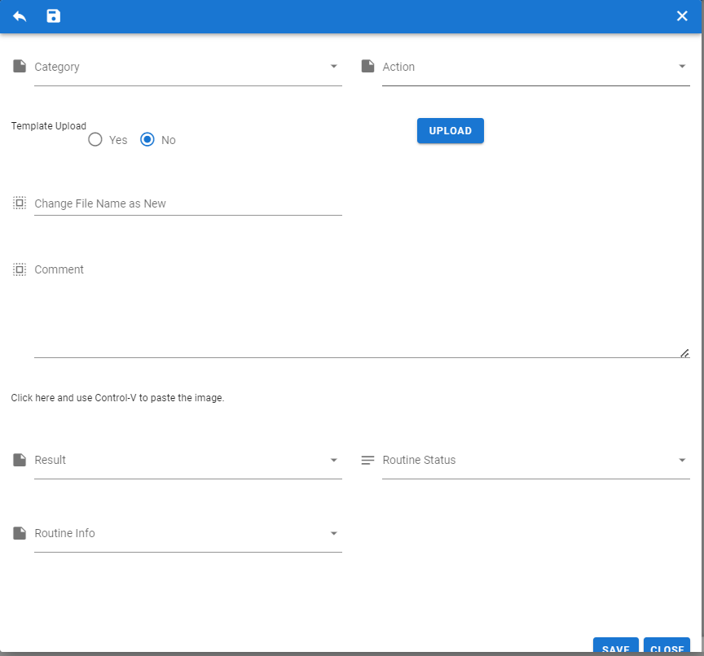

    - Category
Select the Category you are reporting from the dropdown list. The dropdown list of Category is based on the PIC's requirements, which need to be set up in advance before release. The detailed definition of 'Category' pertains to the release of the related 3P's document
    - Action
Select the Action you are reporting from the dropdown list. The dropdown list of Action is based on the PIC's requirements, which need to be set up in advance before release. The detailed definition of 'Action' pertains to the release of the related 3P's document
    - Template Upload
Choose 'No'
    - Upload
Please upload the file containing the detailed information that the user wishes to report.
Users can upload only one file. If they have additional files to upload, they should use the 'supporting document' feature
Most of the ‘Company Routines’ have predefined report templates, as mentioned in the 3P's document release.
      - Upload by File
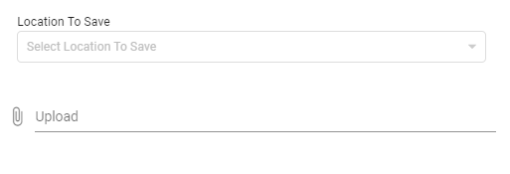
Users have two options for uploading the file
        - they can upload it directly from their C: drive,
        - or they can choose a DMS location to save a copy of the file from C: drive
      - Upload by Image
This function primarily serves users who want to upload images using their smart devices, with the added convenience of having them automatically converted into a single PDF file.
    - Change File Name as New
This feature provides users with the flexibility to change the names of the file they have uploaded.
    - Comment
This allows users to provide a brief note or summary of the report issue.
    - Click here and use control-v to paste the image
This function enables users to conveniently provide screenshots of observations, enhancing communication and documentation.
    - Result
This dropdown list allows users to categorize the report into different types for immediate attention by the PIC and future evaluation.
    - Routine Status
This dropdown list allows users to categorize the report into different types for immediate attention by the PIC and future evaluation.
    - Routine Info
This dropdown list allows users to categorize the report into different types for immediate attention by the PIC and future evaluation.
    - Save or close
Clicking 'Save' will save the entries, while 'Closed' will discard them.

Guidelines for listing of entries
Module to select: Company Routine\Report
Users are able to view all 'Routine Grouping' on this page. Users can only view 'Routine Grouping' if they have the necessary access rights.
Detail description of 1st few fields
  - Icon
This is the preview icon; users can hover over it to view comments and screen shot details.
This indicates the availability of a supporting document for the reporting line. Since entries permit only one file upload, additional documents can be uploaded using the supporting document function.
This shows there is a mail related to this reporting line. This is mainly for instruction to PIC and record of all notes related to this reporting line
This shows there is an attachment file when reporting the issue
  - Company
Display user entry
  - Location
  - Routine
Display user entry
  - Category
Display user entry
  - Action
Display user entry

Section 3: Revision

Revision history
Effective | Version No | Description amendment

