Contents
Section 1: General 2
1. General 2
2. SME Information 2
3. Document Release information 2
4. Objective 2
5. Scope 2
6. Abbreviations 2
7. Responsibility 2
Section 2: Detail Information 3
1. Concept / Diagram 3
2. Process Flow – Create General BO 3
3. Process Flow – Create BO for PHIs (Non-Tender Items with Ad Hoc and Fixed PO) 4
4. Process Flow – Create BO for PHIs (Tender Items with Ad Hoc PO) 5
5. Process – Edit BO 5
6. Process – Make Order From General BO 6
7. Process – Make Order From BO – PHIs 6
8. Process Flow – Housekeeping of BO 7
9. Attachment 7
7
10. For Future Evaluation 8
Section 5: Revision History 8
1. Revision history 8

Section 1: General

General
  - Change Request (CR) Number: NA
  - Change Request (CR) Version No: NA
  - Owner: Click or tap here to enter text.

SME Information
  - Prepare by: Click or tap here to enter text.
  - SME Member, please list all SME information at the CR list.
No | Company | Department | Name
1 | SWSG | MGT | Ms Jung
2 | SWSG | STR | Ms Peh

Document Release information
  - Approve to Release by
    - Company: Click or tap here to enter text.
    - Department: Click or tap here to enter text.
    - Designation: Click or tap here to enter text.
    - Name: Click or tap here to enter text.

Objective
To establish the type of customers under BO and 3P’s to create BO and make order from BO.

Scope
  - Contract Customers / Overseas Order
  - Non-Tender Items – PHI with Ad Hoc PO and Fixed PO
  - Tender Items – PHI with Ad Hoc PO only

Abbreviations
  - 3P’s: Policy, Procedure and Practice
  - SME: Subject Matter Expert
  - CR: Change Request
  - PIC: Person-In-Charge
  - PIA: Person-In-Action

Responsibility
Type refers to PIC, PIA or for information
  - Company: SWSIN
No | Job Designation | Type | Responsibility
1 | Sales Coordinator | PIA | Full

  - Company: SWMAL
No | Job Designation | Type | Responsibility

Section 2: Detail Information

Concept / Diagram
  - Type of customers under BO
    - Contract customers
    - Overseas Order
    - Non-Tender Items – PHIs with Ah Hoc PO & Fixed PO No.
    - Tender Items – PHI with Ad Hoc PO only

  - Procedure to Create BO and Make Order from BO
    - Create BO in NAV
      - General BO to create instructed in email.
      - BO for PHIs only

    - Update of Price for BO

    - Edit of BO Information

    - Make Order from BO
      - General BO
      - BO for PHIs only

    - Monthly Closure of Past Month’s BO not Fulfilled.

Process Flow – Create General BO
  - BO will be from Contract Customers or Overseas Customers
  - Ms Peh will provide instructions to create a new BO with the estimate Month/Year of delivery.
  - For General BO, the Document no. series will be <S-BSO>
  - Require Finance to update the price based on the PO received from customers
  - Refer to Manual – How to Create BO

Process Flow – Create BO for PHIs (Non-Tender Items with Ad Hoc and Fixed PO)
Upon receiving customer’s email confirmation for the Ad Hoc Contract

  - Update “Loose Items Overview Excel File” by plotting the allocation within the 1-year contract period.
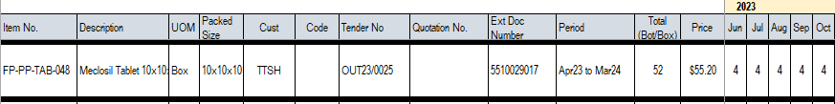

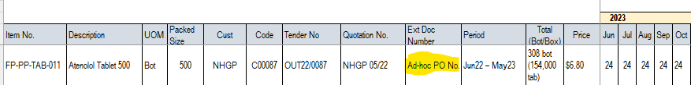

  - Allocation must be within the contractual period of one (1) year and first allocation will be 3 months upon PO received or upon email acceptance of quotation.

  - For Non-Tender Items BO, the Document no. series will be < S-BSO-CNT >

  - Under NAV <Tender No.>, create a new no. under the OUT-Reference No.

  - Require Finance to update the price based on the Quotation sent to customers.

  - Refer to Manual – How to Create BO

  - Email Ms Peh and the Planner to inform them of the contract awarded.

  - Early delivery request from customer
    - Check our stock level and current commitment to supply to other customers.
    - Email Ms Peh on stock situation and get clearance whether we can supply.

Process Flow – Create BO for PHIs (Tender Items with Ad Hoc PO)
Upon a New Tender Awarded to Customers who do not cut PO for maintenance

  - Update “Tender Overview Excel File (under the specific Item) by plotting the allocation.

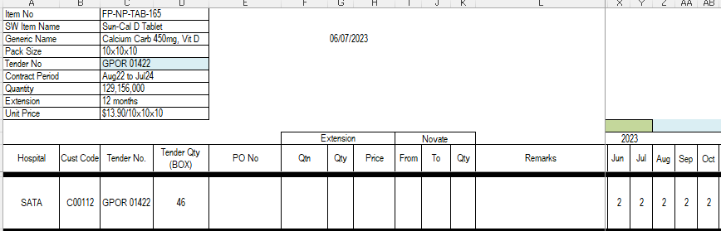

  - Allocation must be within the tender period of two (2) years and first allocation will be based on the continuity from the current PO allocation and usage

  - For Non-Tender Items BO, the Document no. series will be < S-BSO >

  - Under NAV <Tender No.>, create a new no. under the OUT-Reference No.

  - Require Finance to update the price based on the Quotation sent to customers.

  - Refer to Manual – How to Create BO

Process – Edit BO
  - For all new creation of BO, create the BO first without the pricing.
  - Even if there is a price stated, remove the price.
  - Inform Finance to update the price, providing her with either Contract Customers/Overseas Customers PO or our own Quotation Reference No. to PHIs.
  - After Finance has done the update, go back to the BO and edit the information by inserting the new pricing.
  - Refer to Manual – How to Create BO which will include how to edit a BO.

Process – Make Order From General BO
  - Ms Peh will provide instructions to make order from BO stating
    - Name of Customer
    - Item Name
    - Shipment Date

  - Refer to Manual – How to Make Order from BO

  - For Contract Customers, the qty we can make order may not match the original BO qty keyed. It will be based on the actual production yield for final qty to be sent out. Therefore, need to check the Item Qty avail before inputting the final Qty to make order.

  - If there is a shortfall of qty produced, the qty balance in the BO will be closed.

  - Refer to Manual – How to Housekeep BO

  - Provide a copy of COA for all contract customers/overseas customers.

Process – Make Order From BO – PHIs
  - PHI will place order via email

  - Refer to Manual – How to Make Order from BO

  - Those PHI with AD Hoc PO No., input under <External Document No.>

  - PHI BO contract period is for 1 year only. There may be 2 BO entries for the same item but under a different Tender No. and Quotation No.

    - To make order according to the allocated month before moving on to new tender or contract

    - Check Tender/Contract period expiry date and ask customer to clear all balance.

    - Any other feedback from PHIs, refer to Management.
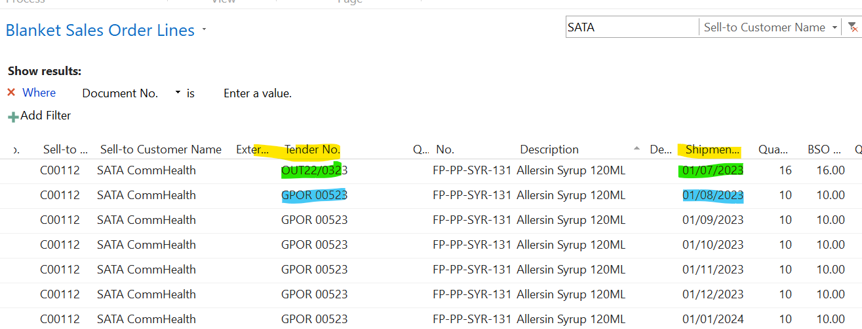

  - PHI BO has monthly allocation, to key out based on the current month allocation. If PHI takes more, the additional qty will be deducted from the last month’s allocation. If PHI takes lessor than allocated qty for the month, the balance will be closed and moved to the last month’s allocation.

Example:
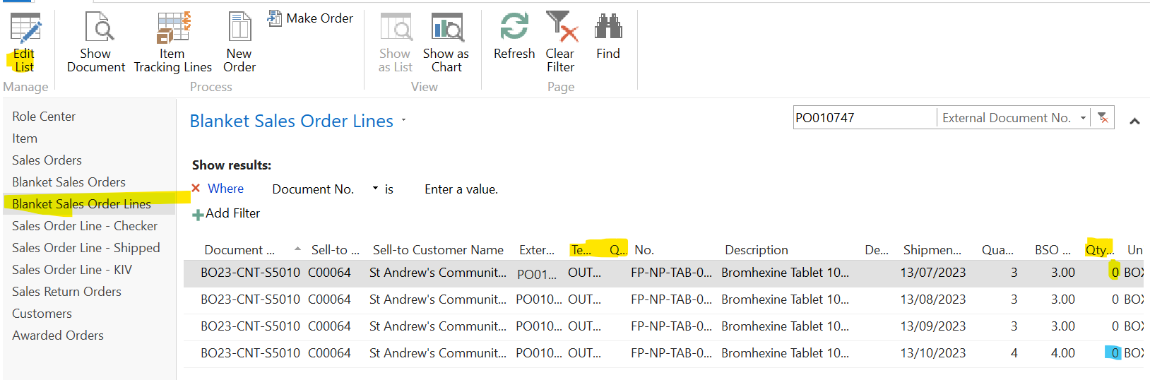

    - If PHI ordered 2 box out of the allocated 3 box in July and there is still balance at the end of the month; we will close off Jul BO Outstanding Qty and move the 1 box to Oct.

    - If PHI ordered 4 box in Jul, then 3 box to make order from July 23 and the remaining 1 box to make order from Oct 23 (then Oct 23 will have a BSO Outstanding of 3 box out of the allocation of 4 boxes

    - Refer to Manual – How to Housekeep BO

Process Flow – Housekeeping of BO
  - Production Shortfall
    - For Contract Customers/Overseas Customer

  - Closure of Past Month’s BO Not Fulfilled
    - For Contract Customers/Overseas Customer
    - For PHIs (Non-Tender Items with Ad Hoc and Fixed PO)
    - For PHIs (Tender Items with Ad Hoc PO)
    - To be carried out at the end of every month

  - Refer to Manual – How to Housekeep BO

Attachment

For Future Evaluation
  - Propose to input as blanket order with estimate monthly usage just like what we are doing for tender overview.

  - If this information is in, I believe we can show it at DO for customer to know.
    - Period of the PO -need to design it
    - Balance qty after this DO

  - If we want to charge for not completing their order, we will add that in at PO and inform them in advance. Charges will discuss with JD.

Section 5: Revision History

Revision history
  - Record changes only for officially release documents
Version | Date | Amendments

