Document No. :
SWMY/QAD/0001

RELEASE OF FINAL PRODUCT

NAME AND TITLE | SIGNATURE | DATE | JUSTIFICATION
Aireen Najwa Bt Amsan  QA Pharmacist |  |  | Prepared by
Nor Hafizi Bin Md. Saib  Head of Production (Pharmacist) |  |  | Reviewed and Approved by
Fok Eik Fan  Store Manager |  |  | Reviewed and Approved by
Ng Biow Teng  Quality Control Manager |  |  | Reviewed and Approved by
Loh Mei Hou  Quality Assurance Manager |  |  | Final Approval

- Objective:
To ensure the operating procedure for the release of final product is carried out efficiently and effectively.

- Scope:
This procedure is practiced in Quality Assurance Department.

- Abbreviations:
  - BMR = Batch Manufacturing Record
  - FPDA = Finished Product Delivery Advice
  - GMP = Good Manufacturing Practice
  - OOS = Out of Specification
  - QA = Quality Assurance
  - QC = Quality Control
  - FP = Finished Product

- Responsibility:
  - QA Manager/ Junior QA Manager
    - To review and check the BMR as per requirement stated in this SOP.
    - To perform the final release of the product.

  - Authorised Personel
    - To review and check the BMR as per requirement stated in this SOP.
    - To perform the final release of product in the absence of QA Manager/ Junior QA Manager.
    - To do approval of FP goods in ERP system.

  - QA Personnel (QA Pharmacist/Executive/Officer/Admin)
    - To generate “APPROVED” sticker after final approval.

  - Quality Control Manager/ Quality Control Executive/ Quality Control Chemist
    - To review and check the BMR as per requirement stated in this SOP.
    - To give approval after chemical and microbial analysis of the batch.

  - Production Pharmacist
    - To review and check the BMR as per requirement stated in this SOP.
    - To give approval after completion of manufacturing processes.

  - Store Personnel
    - To affix “APPROVED” sticker on the cartons of the finished product.
- Diagram @ process flow
-NA

- Procedure:
  - The authorised person who performs reviewing and final release must ensure that the following requirements have been met in the Batch Manufacturing Record, Analytical Report and other relevant documents.
    - The principles and guidelines of GMP, as laid down in the guidelines have been followed.
    - All the necessary checks and tests have been performed and as per procedures given in the Batch Manufacturing Record.
    - Following details to be checked in the BMR.
      - Weighing of raw materials is checked by QC and endorsed.
      - Specified quantities of raw materials are used in manufacturing.
      - Process parameter end point (e.g: blending time, compression speed, etc.) are within the limits specified in manufacturing instructions.
      - Intermediate products are tested and results are checked and initialled.
      - Test results of the finished product comply with the release specifications.
      - Product label, leaflet and unit box are checked, approved and signed in the BMR.
      - Packing is checked by QC and endorsed.
      - Packaging material reconciliation is correct.
      - All the record and documentation are complete and signed by appropriate Production, Store and QC personnel.
      - Certification of Analysis/ Test Report is issued.
      - Retention samples and stability samples as appropriate are taken.
    - Ensure that the Batch Yield is within the limit. If not, the reason shall be documented in the Deviation Record and Batch Manufacturing Record.
    - Ensure all changes related to the batch (if applicable) are approved and the recommendations in change control request are compiled.
    - Any additional sampling, inspection, tests and checks have been carried out or initiated, as appropriate; to cover planned changes and deviations shall be documented.
    - Ensure that approval has been given by Quality Control Personnel (Manager/Executive/ Chemist) after chemical and microbial analysis of the batch.

    - Ensure all deviations including OOS investigations associated with the batch are documented and verified under Section 5 of SWMY/QAD/0006: Standard Operating Procedure of Deviation Control System prior to final release of product.
    - Authorised person that perform final release of product is to sign in the BMR.
    - Approval of finished product is done by referring to Finished Product Delivery Advice (FPDA), by verifying product name, batch number, manufacturing date, expiry date and quantity to be approved.
    - Authorised Person (QA Personnel) will do the approval in ERP system. “APPROVED” sticker will be generated and affixed on the cartons by store personnel. The Quarantine board will be taken back by store personnel.

  - Any problem encountered with the production or testing of the final product will be informed to QA Department, through deviation that eventually leads to investigation and corrective action to be taken.

  - In the absence of QA Manager/ Junior QA Manager, authorised person will perform the final release of the product.

- Attachments:
  - Appendix 1
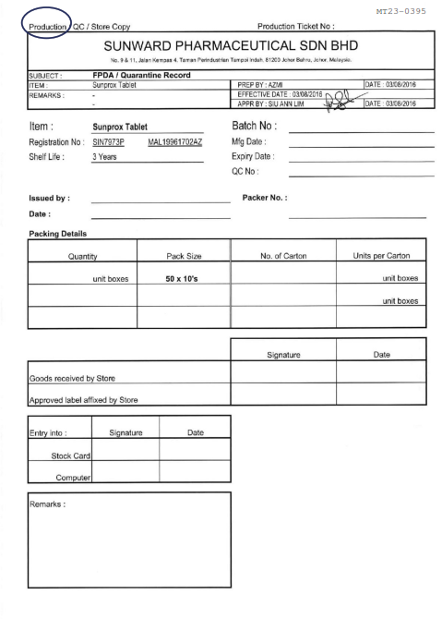

- Revision History:
Change Control Number | Superseded (SOP No. and previous version) | Amendments
CC17356 | SOP/LA/00001,  Version 13 | - Update the BMR Checklist and requirement for the release of final product.
CC19217 | SWMY/QAD/0001;  Version 14 | - To add Junior QA Manager responsibilities (at point 4.1 and 5.3).  - To add authorised person to perform final release of product in the absence of QA Manager and Junior QA Manager (at point 4.2 and 5.3).  - To replace “Head of Quality Assurance” to “Authorised Person” (at point 5.1).  - To replace “Head of Quality Assurance” to “Authorised person that perform final release of product” (at point 5.1.9).  - To add “specifically for each batch that already been authorised for sale” (at point 5.1.10).  - To omit decision of having meeting upon encountering problem during production/ testing of final product since this will be tracked and monitored through deviation system which leads to investigation and corrective action to be taken (at point 5.2).  - To omit “Plant Manager” (at point 5.2).
CC21113 | SWMY/QAD/0001;  Version 15 | - Periodic review.  - To add responsibilities of QC Manager and Production Pharmacist at point 4.3 and 4.4 respectively.  - To amend point 5.1.8 to tally as per new requirement as per Standard Operating Procedure for Deviation Control System (SWMY/QAD/0006).

CC23130 | SWMY/QAD/0001;  Version 16 | - Periodic review.  - To add “Store Manager” to review and approve this SOP.  - To add abbreviation of FP at clause 3.7.  - To remove role of QC personnel to generate “APPROVED” label.  - To add responsibility of Authorised personnel to do approval of FP goods at ERP system at point 4.2.3 and 6.1.11.  - To add responsibility of QA personel (QA Pharmacist/ Executive/ Officer/ Admin) in generating “APPROVED” label at point 4.3.1.  - To add “Quality Control Executive” and “Quality Control Chemist” at point 4.4.  - To add responsibility of Store Personnel to affix the “APPROVED” sticker on the cartons of the finished product at point 4.6 and 6.1.11.  - To add responsibility of QC Executive/ Chemist to give approval after chemical and microbial analysis of the batch at point 6.1.7.  - Remove the role of QA to sign at Finished Product Delivery Advice (FPDA)/ Quarantine Record (refer to Appendix 1) at point 6.1.9.  - Add new point at 6.1.10 which address the details need to be checked during approved of finished product.

