Embedded Systems Design

Introduction to STM32Cube IDE

Name：孙煨 Sun_Wei

No.192050207

Date: 2020-6-8

1. The creation of project

I search the STM32F429 and choose the first whose package is LQFP144.

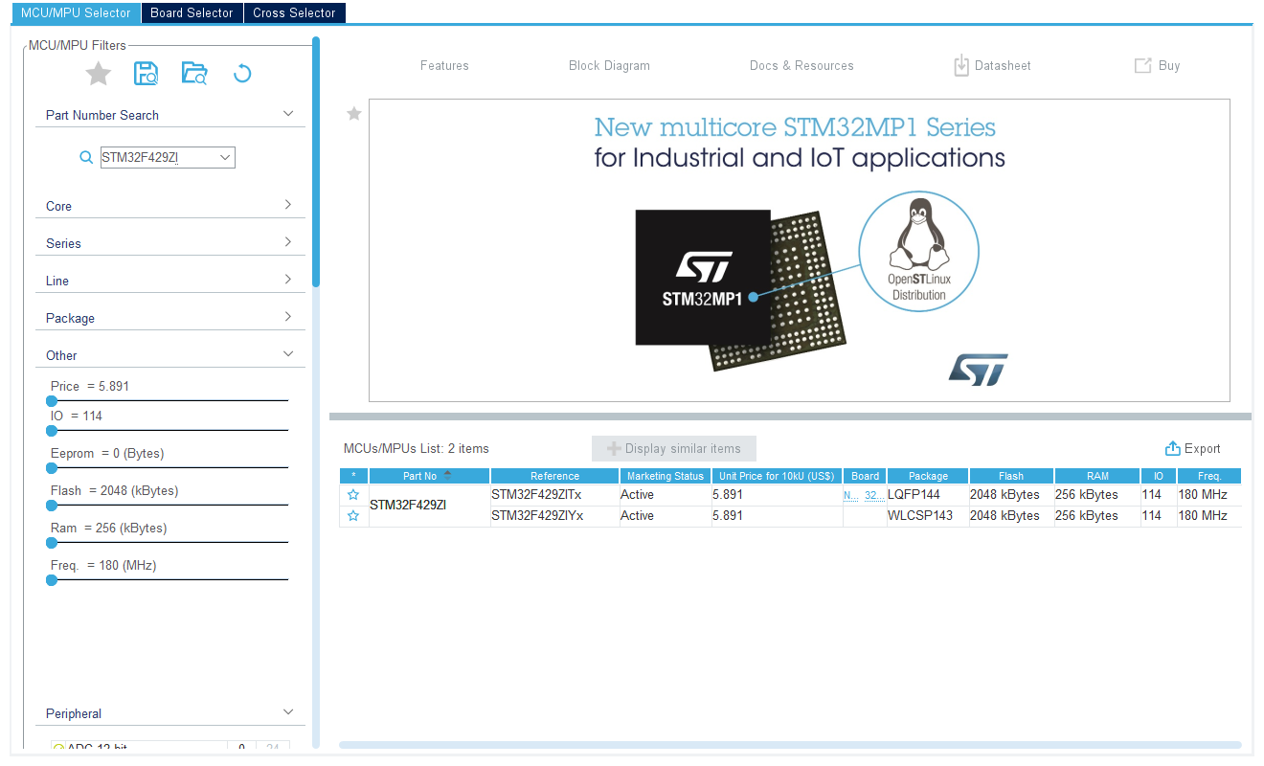

After the set up, I can see the following picture.

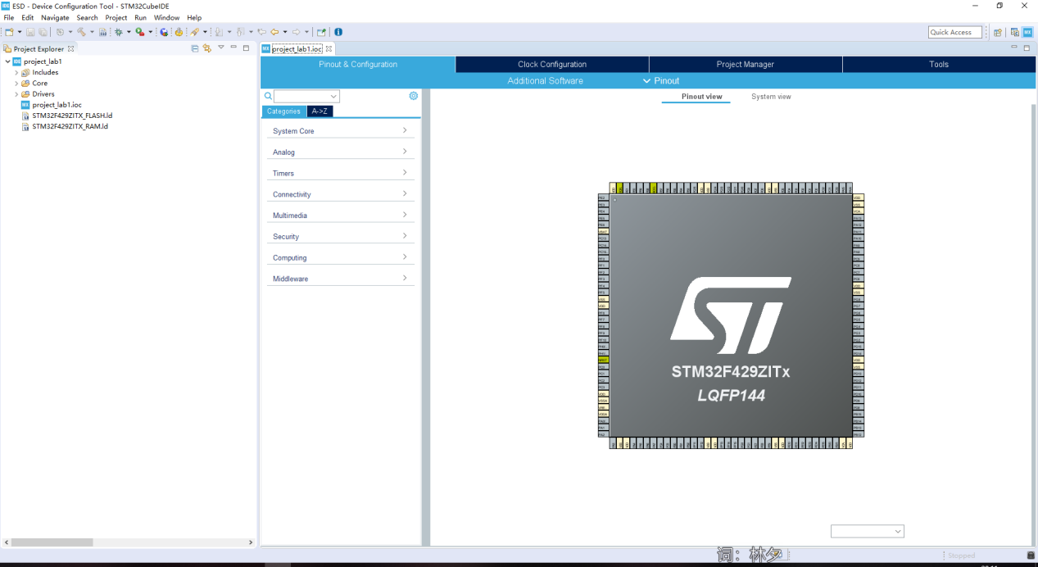

1. Set

I set the PB7 and PB14 to GPIO_OUTPUT and save it.

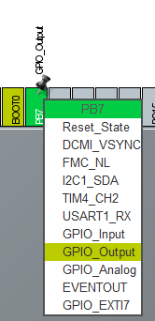 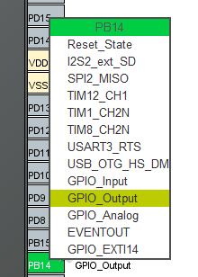

1. Main.c

I write some codes in main.c and press build all.

HAl_GPIO_TogglePin(GPIOB,GPIO_PIN_7) means flip state.

HAL_Delay(500) means delay 500 ms.

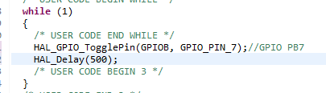

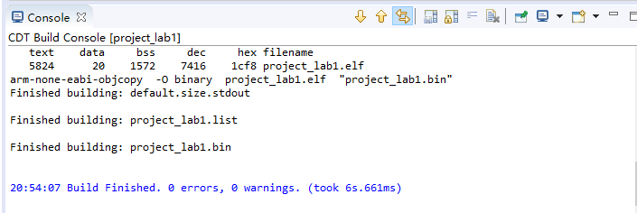

1. I press run->Debug Configuration->STM32 Cortex-M C/C++ Application.Then I press Debug.

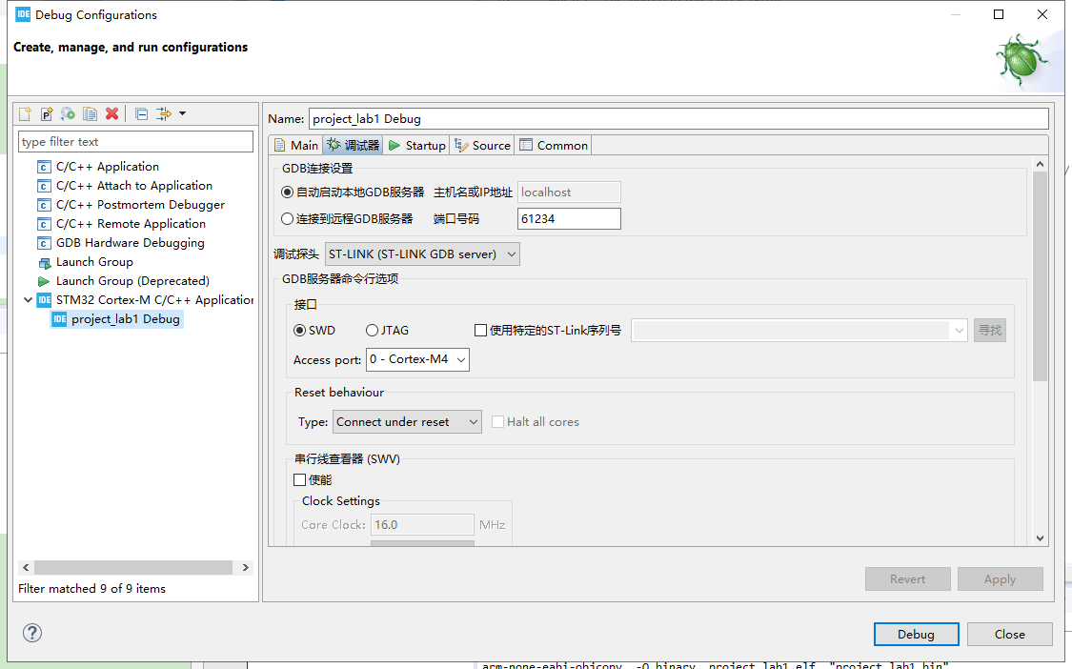

However, it tells me I don’t connect with my board and I need to update my STLink.So I connect it and update my STLink and Debug again.

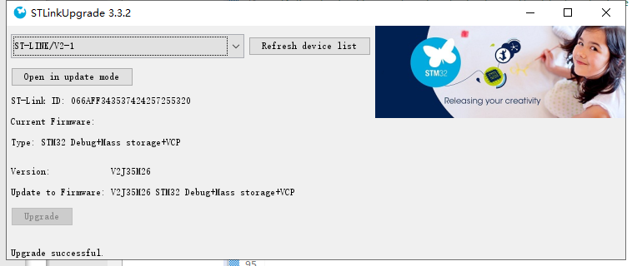

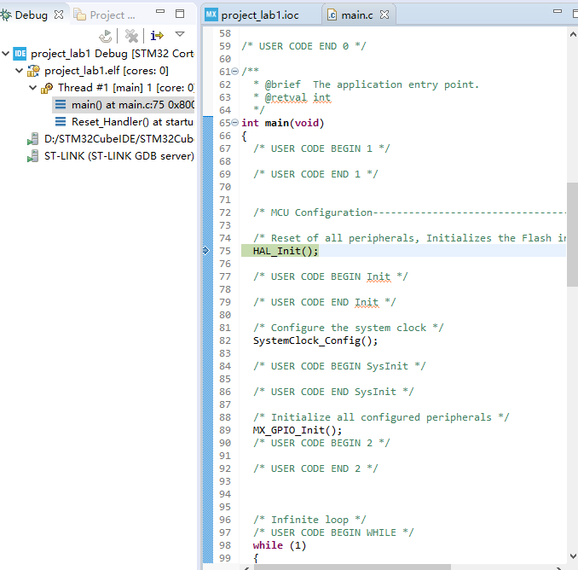

1. I set the breakpoint at the code line I wrote before, and I can see the blue LED twinkle.
2. I write the code into main.c and build all again.Then I run it again.I can see blue and red lights flash alternately.

HAl_GPIO_WritePin(GPIOB,GPIO_PIN_14,GPIO_PIN_SET) means output write function and set the pin to high state.

HAl_GPIO_TogglePin(GPIOB,GPIO_PIN_7) means flip level

