Embedded Systems Design

IPC in FreeRTOS part 1: Queues

Name：孙煨 Sun_Wei

No.192050207

Date: 2020-7-8

1. The creation of project

I search the STM32F429 and choose the first whose package is LQFP144.

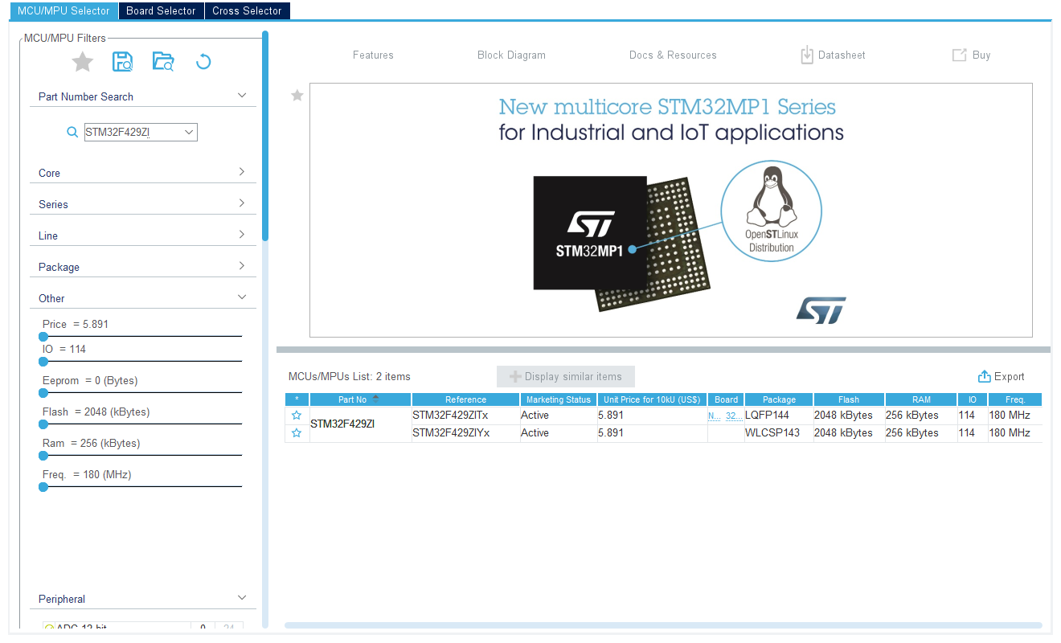

After the set up, I can see the following picture.

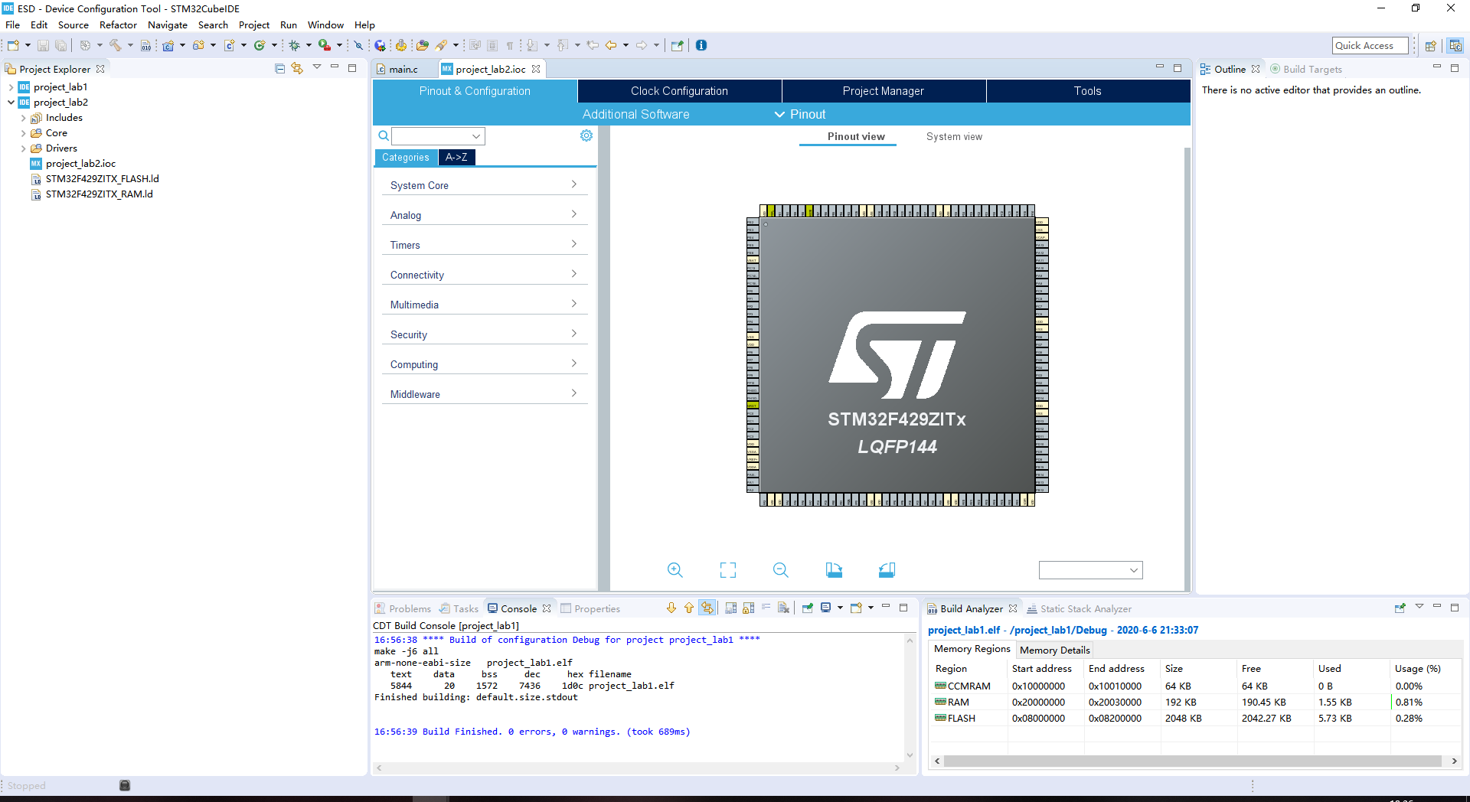

1. Set

I set the PB14 to GPIO_OUTPUT and save it.

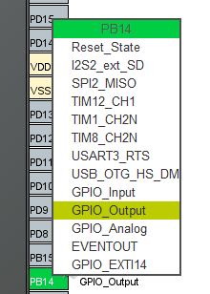

1. Set FreeRTOS

Then I clink Middleware->FREERTOS, and select the Interface to CMSIS_V2.Then I add a task and a queue.After that, I press ALT+K to generate code.

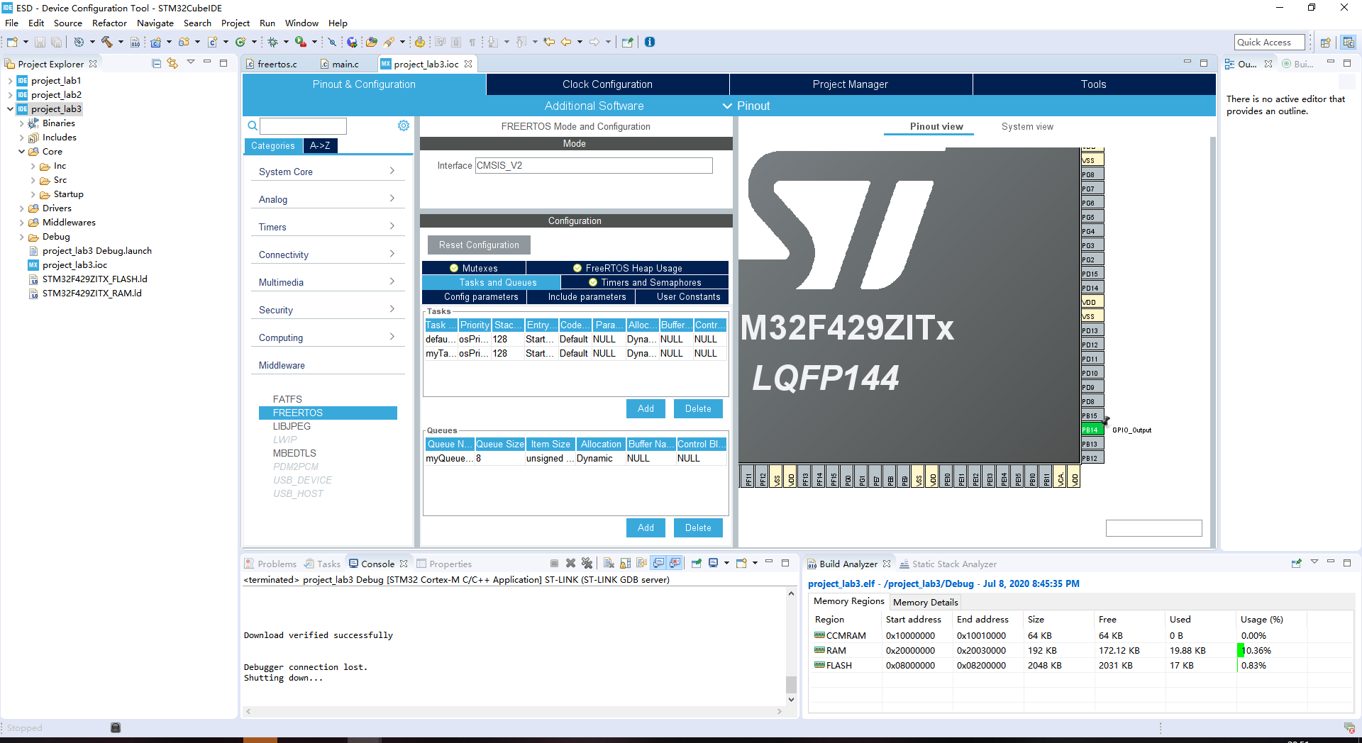

1. Task and Queue

I write some codes in main.c and click build all.Then I click run and I can see the red LED twinkle as I want.

xQueue = xQueueCreate(8, sizeof(unsigned int)); means create a queue to communicate.

xStatus = xQueueSendToBack( xQueue, (void *)&lValueToSend, portMAX_DELAY ); means send the lValueToSend to xQueue.

xStatus = xQueueReceive( xQueue, &ReceivedValue, portMAX_DELAY); means receive the information from xQueue.

HAl_GPIO_TogglePin(GPIOB,GPIO_PIN_14) means flip level.





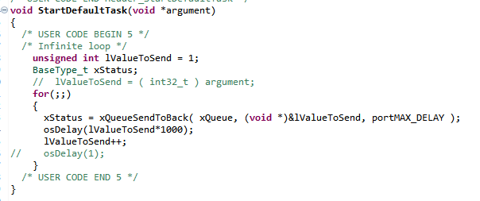

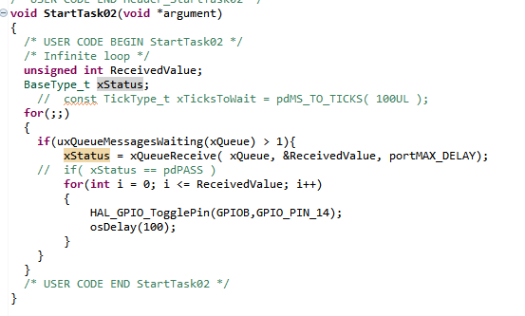

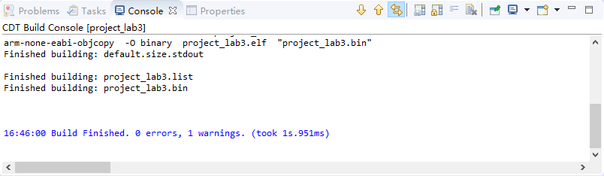

**My github address is https://github.com/sunwei96/ESD_SunWei_192050207.git**