Embedded Systems Design

IPC in FreeRTOS part 2: Binary Semaphores, CountingSemaphores Mutexes

Name：孙煨 Sun_Wei

No.192050207

Date: 2020-7-24

1. Variant 7 Description

1. Create three tasks.

2. Create two queues. The size of queues is 10 integer numbers. The first queue should be used to transmit data from Task 1 to Task 2. The second queue should be used to transmit data from Task 1 to Task 3.

3. Task 1 should increment the local integer variable “counter” once per second.

Task 1 sends the “counter” value to Task 2 once per second and to Task 3 once

per two seconds. The incrementing of “counter” variable should be paused if the

corresponding queue is full and resumed if the corresponding queue is not full.

4. Task 2 and Task 3 should toggle LED LD1 once per 900 ms. The number of toggling is equal “counter” variable received using queue from Task 1. The LED is shared resource between Task 2 and Task 3. Task 2 or Task 3 should work with the shared LED using a binary semaphore.

1. The creation of project

I search the STM32F429 and choose the first whose package is LQFP144.

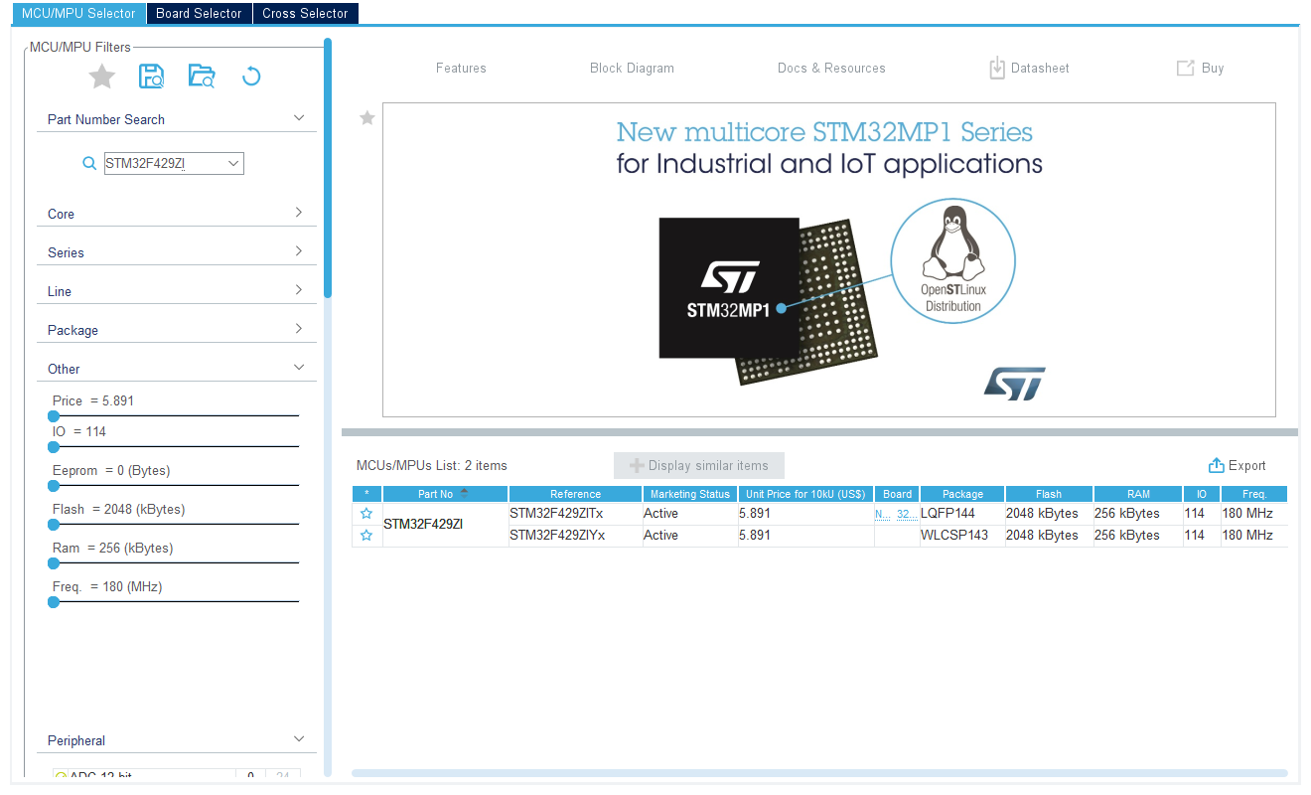

After the set up, I can see the following picture.

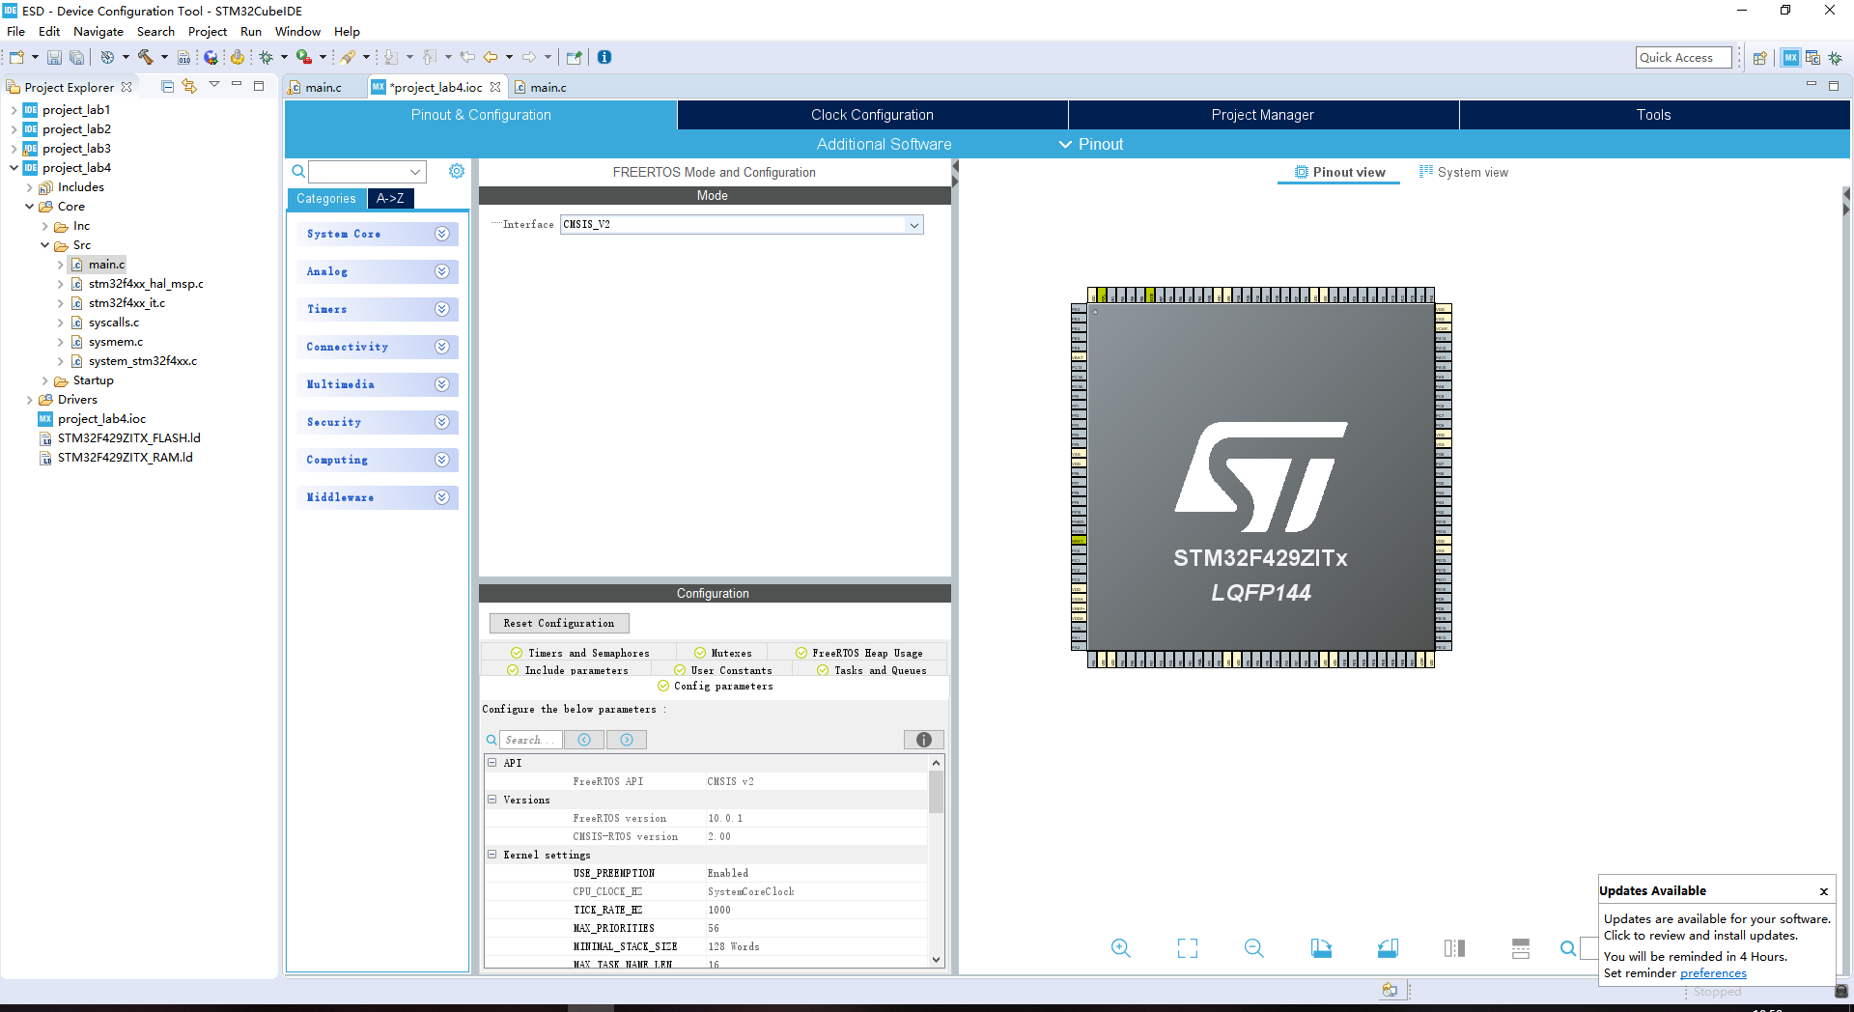

1. Set up

According to variant 7, I set the PB0 to GPIO_OUTPUT and save it.

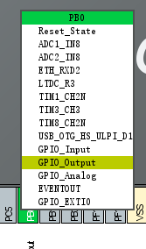

1. Set FreeRTOS

Then I clink Middleware->FREERTOS, and select the Interface to CMSIS_V2.According to variant 7, Then I add 3 tasks,2 queues and a semaphore.After that, I press ALT+K to generate code.

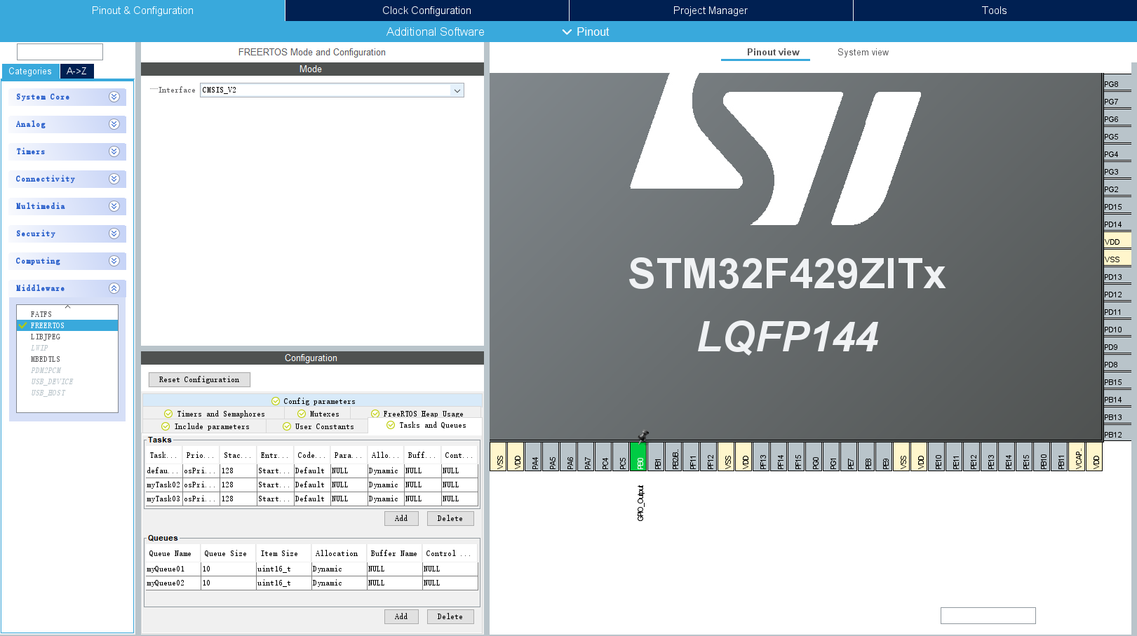

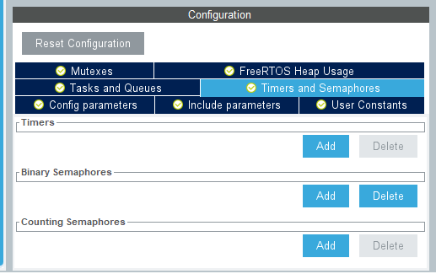

1. Codes

5.1Head Files



Because of the use of queues and binary semaphores, I add ‘queue.h’ and ‘semphr.h’ to the head file.

5.2Define queue



5.3Create queue



I create 2 queues named xQueue1 and xQueue2 to achieve the experiment.

5.4Define Semaphore



5.5Create Semaphore

According to variant 7, I use function xSemaphoreCreateBinary() to create the semaphore.



5.6Task1

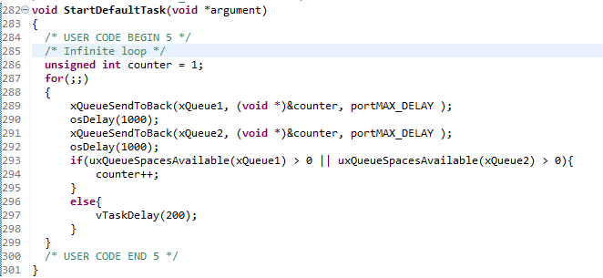

I define a variable named counter to count.Then I send the counter to queue1 and queue2.Line 293 means if queue is not full, the counter increase 1 else the task delay 200ms.

5.7Task2

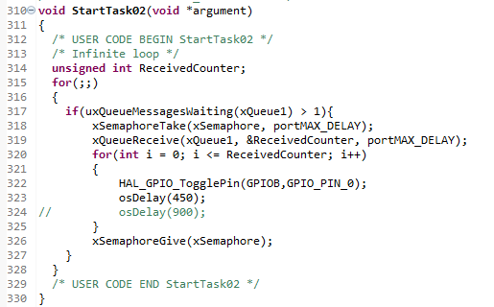

Line 314: I define the variable ReceiveCounter to receive the value from queue1.

Line 317: Judge whether queue1 works

Line 318: Take the semaphore from task3.

Line 319: Receive the value from queue1.

Line 320: Toggle LED LD3 per 900ms.The LED LD3 is PB0;

Line 326: Send the semaphore to task2.

5.8Task3

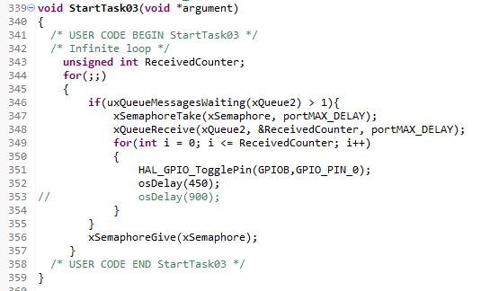

Line 343: I define the variable ReceiveCounter to receive the value from queue1.

Line 346 Judge whether queue1 works

Line 347: Take the semaphore from task2.

Line 348: Receive the value from queue1.

Line 351: Toggle LED LD3 per 900ms.The LED LD3 is PB0;

Line 356: Send the semaphore to task3.

6.My github address is https://github.com/sunwei96/ESD_SunWei_192050207.git