Weilun Sun (孙伟伦)
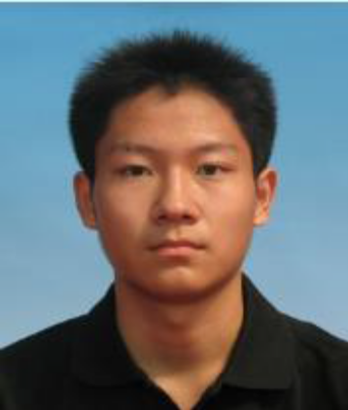
Phone: (+86) 010-15901519860
Email: sunweilunjwilson@gmail.com

Education | BS Tsinghua University, Computer Science & Technology, 2010~2014  Overall GPA: 88.3/100 Rank: 24/126
Research Experience | SIGGRAPH ASIA 2013 Paper Anisotropic Spherical Gaussians, Tsinghua Graphics & Geometry Computing Group, Feb. 2013 ~ May. 2013  Advisor: Kun Xu  - Involved in the discussion and proofread some derivations of the new spherical function  - Implemented a rendering program based on theories in the paper  - Made most of result figures in the paper  SIGGRAPH 2013 Paper Sketch2Scene:Sketch-based Co-Retrieval and Co-placement of 3D Models, Tsinghua Graphics & Geometry Computing Group, Sep. 2012 ~ Jan. 2013  Advisor: Kun Xu  - Reproduced a single-model retriever according to SIGGRAPH 2012 paper Sketch-based Shape Retrieval  - Implemented part of the GUI in the project  - Involved in the discussion of the co-retrieval methods in the paper  Graduation Project of Yan Gu, Tsinghua Graphics & Geometry Computing Group , Mar. 2012 ~ Jun. 2012  Advisor: Kun Xu  - Reproduced a rendering program according to SIGGRAPH ASIA 2009 paper All-Frequency Rendering of Dynamic, Spatial-Varying Reflectance
Publications | Conference Papers  Kun Xu, Wei-Lun Sun, Zhao Dong, Dan-Yong Zhao, Run-Dong Wu, Shi-Min Hu, “Anisotropic Spherical Gaussians,” Proceedings of SIGGRAPH ASIA 2013(accepted)  Kun Xu, Kang Chen, Hongbo Fu, Wei-Lun Sun, Shi-Min Hu, “Sketch2Scene: Sketch-based Co-retrieval and Co-placement of 3D Models,” Proceedings of SIGGRAPH 2013, ACM Transactions on Graphics 32(4) , 123:1--123:12, 2013.
Small  Project | Experiment of Machine Learning Methods in SIGGRAPH 2012 Paper Sketch-based Shape Retrieval, May. 2013  - Replaced k-means clustering presented in the paper with different clustering methods including fitting Spherical Gaussians with EM algorithm and k-medoids  - Made comparisons among different methods by statistical and retrieval results  - Implemented a complete retriever software with GUI using FLTK lib  Simple 3D Physics Engine, Jan. 2013  - Implemented rigid body collision simulation between sphere and net or fixed objects in any shape with friction under gravity field  - Took spinning into consideration  - Simulated net system using rigid spheres to represent knots and weightless springs to represent cords  - Created a basketball shooting game using the engine with appealing effects of interactions between basketball and hoop net  Drum Sound Extraction and Classification, together with my classmate Yi-Ning Liu and E.T. Chan, Oct. 2012 ~ Dec. 2012  - Implemented drum sound extraction algorithm by Matlab  - Developed a game on ios like Taiko Drum Master, but can automatically turn a new song track into a game level  - Leader of the group.  - Came up with the idea
Honors and Awards | First Prize of Beijing University Physics Olympiads, 2011  2nd place of Tsinghua Talent Show, 2012
Languages | Mandarin Chinese: Native Language  English: GRE V: 550 Q: 800 AW: 3.5  Toefl R: 28 L: 30 S: 23 W: 28 total: 109
Computer Skills | Programming: c/c++, Java, Python, Matlab  Applications: OPENGL, GLSL, QT, Android, CUDA(still learning)  Platforms: Windows, Linux

