1. (1) I choose the following plaintext in order to have the paddings of 01, 0202, 030303 and 04040404 respectively.

0102030405060708090a0b0c0d0e0f

0102030405060708090a0b0c0d0e

0102030405060708090a0b0c0d

0102030405060708090a0b0c

After using ecb.py to encrypt above plaintexts, we can see that the padding is correct with 01, 0202, 030303 and 0404040404 respectively.

The ciphertexts are printed as follows in the terminal:

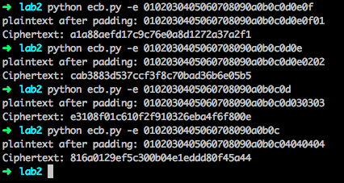

(2) Then, I decrypt the ciphertexts into plaintexts with the following command in the terminal, and the plaintexts are shown as followings in the terminal

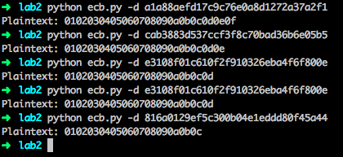

(3) I create the following string ‘~~~~~~~~~~~~~~~~’ as one block , in which has 16 ‘~’ . Then I repeat this block three times to formulate the string ‘~~~~~~~~~~~~~~~~~~~~~~~~~~~~~~~~~~~~~~~~~~~~~~~~~~~~~~~~~~~~~~~~’ in which it has 64 ‘~’

then, I encrypt it with ecb.py in the terminal as follows:

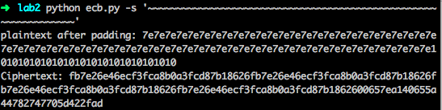

The plaintext after padding is

7e7e7e7e7e7e7e7e7e7e7e7e7e7e7e7e7e7e7e7e7e7e7e7e7e7e7e7e7e7e7e7e

7e7e7e7e7e7e7e7e7e7e7e7e7e7e7e7e7e7e7e7e7e7e7e7e7e7e7e7e7e7e7e7e

10101010101010101010101010101010

we have one more padding block 10101010101010101010101010101010

The ciphertext is

fb7e26e46ecf3fca8b0a3fcd87b18626fb7e26e46ecf3fca8b0a3fcd87b18626fb7e26e46ecf3fca8b0a3fcd87b18626fb7e26e46ecf3fca8b0a3fcd87b1862600657ea140655a44782747705d422fad

yes, we have ciphertext fb7e26e46ecf3fca8b0a3fcd87b18626, which is repeated three times, the last block of ciphertext is 00657ea140655a44782747705d422fad which is encrypted by the padding block.

1. For cbc.py, I use the following IV: ‘00000000000000000000000000000000’ (In this lab, I use this IV for cbc.py, oracle.py, attack.py)

I use the following command to test cbc.py in the terminal:

python cbc.py –s ‘Congratulations! You have earned the extra credit!’

the ciphertext is in the following:

e3ac392ae1d7e9341e1b244791176f6ee19f5a1c9a5c4c6a9e31bd4aa81f75dbf95f427a4757f0ed56ff68567a3b5e78f4cb080de6b18341ee0ac91b18bb2b55

Then, I decrypt it to get the original plaintext. The result is shown in the following picture.

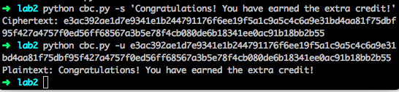

1. To test the oracle.py, let’s encrypt a message such as ‘this is cool’ with

python cbc.py –s ‘this is cool’

we will get the ciphertext which has the correct padding in the plaintext.

And, we get the padded plaintext and ciphertext respectively in the following:

7468697320697320636f6f6c04040404

9b43953eeb6c3b7b7971a8bec1a90819



if we use oracle to test whether it is a correct padding of ciphertext, obviously it is a correct padding.

the output is in the following picture:



Then, let’s modify the ciphertext to 9b43953eeb6c3b7b7971a8bec1a90818, which will lead to uncorrect padding because we change the last bit of ciphertext from 9 to 8. The output is shown in the following picture.



1. We first encrypt the plaintext ‘Congratulations! You have earned the extra credit!’ in question 3 with the following command in the terminal.

python cbc.py -s 'Congratulations! You have earned the extra credit!'



after we get the ciphertext, we can use attack.py to decrypt the first block of ciphertext. The result is shown in the following picture.



1. I think it is easy to decrypt the remaining blocks after you successfully decrypt the first block. We just repeat the process of decrypting the first block for the remaining blocks.

In order to decrypt all the blocks of ciphertext in question 3, we can use the same ciphertext in question 5, and decrypt it with padding oracle attack.

We use the following command in the terminal:

python attack.py -aas e3ac392ae1d7e9341e1b244791176f6ee19f5a1c9a5c4c6a9e31bd4aa81f75dbf95f427a4757f0ed56ff68567a3b5e78f4cb080de6b18341ee0ac91b18bb2b55

the result of is shown in the following picture.

