Software Project Management Plan (SPMP)
Project – SyncGallery +

Revision History

Date | Revision | Description | Author
29-Jan-12 | 1.0 | Document Created | W. Ghorishi

Acronyms
Acronym | Definition
SPMP | Software Project Management Plan
SRS | Software Requirements Specification
PQA | Product Quality Assurance
MRD | Marketing Requirements Document
SDD | Software Design Documentation
STP | Software Test Plan
PDM | Product Management
PJM | Project Management
ENG | Engineering
RCM | Release & Configuration Management

Table of Contents
1 Purpose 6
2 Introduction 6
2.1 Project Overview 6
2.2 Project Deliverables 6
2.2.1 Development & Planning Documentation 7
2.2.2 Software Releases 7
2.3 Evolution of SPMP 8
2.4 Reference Material 8
3 Project Organization 9
3.1 Process Model 9
3.2 Organizational Structure 11
3.3 Organizational Interface 11
3.4 Project Responsibilities 12
4 Managerial Process 12
4.1 Objectives and Priorities 12
4.2 Assumptions, Dependencies and Constraints 13
4.3 Dependencies 13
4.4 Constraints 14
4.5 Risk Management 14
4.6 Monitoring & Control Mechanisms 14
4.7 Staffing Approach 14
5 Technical Process 15
5.1 Process Model 15
5.2 Tools 15
5.3 Documentation 16
5.3.1 Software Requirements Specifications (SRS) 16
5.3.2 Software Design Description (SDD) 16
5.3.3 Software Test Plan (STP) 16
5.3.4 User Documentation 17
5.3.5 Project Support Functions 17
6 Work Packages, Schedules and Budgets 17
6.1 Milestones & Release Schedules 18
6.2 Dependencies 19
6.3 Budget 19

Purpose

This Software Project Management Plan (SPMP) is developed for the SyncGallery + project with the intent to define the project’s deliverables and deadlines in addition to describing the project organization, management and technical processes used as well as detailed work packages and deliverables that will contribute towards the completion of this project. It will also direct the development of this project by defining the high-level project objectives, milestones and deliverables, as well as the allocated resources and budget.
It should be noted that the full set of functional and non-functional requirements for this project are defined in the Software Requirement Specification (SRS) which will be referenced in this document.

Introduction

Project Overview

After significant research and competitive analysis conducted by product management organization, it was discovered that there is a gap in the market for an image editing application that will allow users to not only share, but also add their own creative touches to these image, using various image processing functions. Furthermore, given the high-quality cameras integrated into mobile platforms, explosive popularity of smart phones, as well as the phenomenal success of various social media applications, this project will target the development of a high-end image processing application for the mobile platform.

Project Deliverables

While the end goal of this project is development and delivery of a software application, fully compliant with the requirements defined in the related SRS, the following defines the list of deliverable as well as associated due dates.
It should be noted that the delivery of the software application without the following artifacts will be deemed incomplete and hence blocked by the Product Quality Assurance (PQA) organization from release.
Furthermore, all items released by the project team will be provided on a CD-ROM device with a clear list, description as well the revision of the deliverables, as baselined by the configuration management system.

Development & Planning Documentation

Document | Description | Owner | Schedule | Sign-Off Entity
MRD | Marketing Requirements Document | PDM | Jan. 15, 2012 | N/A
SPMP | Software Project Management Plan document | PJM | Feb. 03, 2012 | PDM/ENG/PQA
SRS | Software Requirements Specification document | ENG | Feb. 03, 2012 | PDM/PQA/PJM
SDD | Software Design Documentation | ENG | Feb. 03, 2012 | PDM/PQA/PJM
STP | Software Test Plan | PQA | Feb. 03, 2012 | PDM/ENG/PQA

Software Releases

Release | Description | Owners | Schedule
Pre-Alpha | Proof of concept release aimed at verifying major assumptions | ENG | Feb. 03, 2012
Alpha | Feature complete release of SW. May contain critical and/or major defects | ENG/PQA | Feb. 20, 2012
Beta | Feature complete release of SW. No critical/major defects | ENG/PQA | Mar. 02, 2012
1.0 Release | Zero-defect SW including post beta feature enhancement | ENG/PQA | Mar. 30, 2012
While ENG and PQA teams will both be held accountable for meeting the schedules and quality criteria, ENG team is expected to provide a baseline release candidate for each of the above releases to the PQA no later than 5 days prior to the release. This will allow for resolution of any blocking defects and re-iteration through the necessary PQA test cycles.
Furthermore, each release will be distributed to all stakeholders and will include the following artifacts on a CD-ROM:
- Release notes including feature readiness & defect summary
- Detailed test report including all reported defects and their resolution status
- Source code as well as build infrastructure required to create an executable image
- Loaded application, running on a Smartphone (upon request)
- Applications users’ guide (not applicable to the Pre-Alpha release)

Evolution of SPMP

After the initial release of this document is reviewed and signed off by the required entities, it will be put under revision control system and a link reflecting the latest revision of this document will be made available to all stakeholders through the project website.
This plan will be maintained and reviewed by the PJM team, at each of the above milestones and for all deliverables highlighted to ensure it remains up-to-date. Furthermore, any of the stakeholders including PJM team can trigger a change to this plan, at any point in time, outside of the delivery milestones mentioned earlier. Regardless of whether the SPMP is changed due to scheduled or unscheduled reviews, any changes to it require the sign-off of all entities participating in its original revision.

Reference Material

IEEE Std 1058-1998, IEEE Standard for Software Project Management Plans, IEEE 1998
Team SyncGallery+ , Software Requirements Specification – Project SynGallery +, 2012
Team SyncGallery+ , Software Design Documentation – Project SynGallery +, 2012
Team SyncGallery+ , Software Test Plan – Project SynGallery +, 2012
Team SyncGallery+ , Software Requirements Specification – Project SynGallery +, 2012

Project Organization

One of the important functions of the SPMP is to highlight how the project is organized in terms of its process model, organizational structure, internal and external interfaces as well as roles and responsibilities. The organization for the SyncGallery + project is described below.

Process Model

Given the aggressive schedule, need for a range of cross functional disciplines as well as the close-loop communication required, various elements of agile-scrum development methodology will be incorporated into this process.
As per scrum methodology, the team will be organized into a group of “pigs” & “chickens”, where “pigs” are the individuals that are actively contributing to the development of the project (e.g. developers, PQA engineers, etc.), while the “chickens” are the individual stakeholders that will monitor the project, but cannot interfere in its day to day operations (e.g. PDM).
The communication in the team will be governed by daily-stand-up meetings, lasting no longer than 15 minutes, covering last day’s accomplishments, current day’s activities as well as any impediments that may affect upcoming tasks. Also, one of the “pigs” in the group will be designated as the scrum-master who in addition to his individual deliverables will be responsible for resolving issues blocking the progress of other team members.
Various functional roles in the group include:
Scrum master: Responsible for defining detailed project backlog/tasks through definition of a SRS, leveraging an existing MRD. This role will also work with individual team members in assigning weights to each of the scrum backlog tasks defined. Other responsibilities include addressing impediments blocking team members, measuring performance, holding sprint reviews as well as interfacing with outside entities to obtain support needed for the project. This role remains active throughout the project life cycle.
Architects/Designers: Responsible for creating a SDD, based an already defined SRS. From time to time, there may be a need to create functional prototypes in order to validate certain assumptions made.
Developers: Responsible for taking a SDD and implementing the SW as described in that specification. Developers will also be responsible for unit-testing as well as pre and post release maintenance (defect resolution and feature enhancement) for the product.
Test Engineers: Responsible for defining a STP, functional and system-level test case development through creation of a traceability matrix going as far back as the SRS.
Verification & Validation Engineers: Leverages the test cases generated by the Test Engineering team and is responsible for black-box testing through periodic (regression) as well as release-based test cycles. This role will also act as the driving force to close all outstanding defects reported. Prior to availability of test cases, this team will be responsible for creating the regression test framework. Other associated process roles include ensuring adherence to quality and development standards defined.
Release & Configuration Management: Responsible for maintaining baselines and ensuring the integrity of the releases delivered to Verification & Validation Engineers. The RCM function will also be responsible for producing release base artifacts such as release notes and users’ guide.
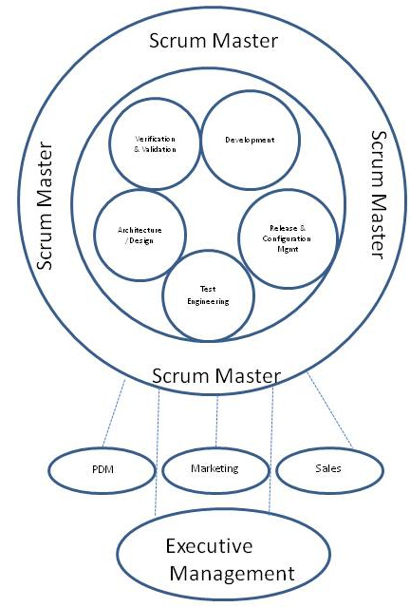
Fig 1. Project Organization Diagram

Organizational Structure

Adhering to the agile scrum methodology, the team is a self-governing entity. While each member ultimately reports to the appropriate functional managers in the organization, the project itself is managed under the guidance of the scrum master and as such all resources assigned to the project will be reporting to him/her.

Organizational Interface

To control the flow as well as accuracy of information and minimize interruptions for team members and prevent unannounced feature creeps, all external communications will be handled by the scrum master. Of course, relevant information will be disseminated to the team members through the processes put in place (i.e. stand-up meetings, updating of scrum backlog tasks, prioritizing of sprint tasks, etc.)

Project Responsibilities

The following table shows how the resources assigned to this project map to the roles already defined:
Role | Name(s)
Scrum master | Will Ghorishi
Architect/Designer | Kobe Sun, Hitha Dinesh
Developer | Jacky Tan, Daniel Liu, Kobe Sun
V&V Engineer | Sarah Yang, Hitha Dinesh
Test Engineer | Sarah Yang, Will Ghorishi
RCM Engineer | Hitha Dinesh, Will Ghorishi

Managerial Process

The following provides an overview of the management process used for this project, including objectives and priorities, assumptions, dependencies and constraints, risk management as well as staffing techniques applied.

Objectives and Priorities

The following capture the overall management objectives, in an ascending order of priority:
- Market Appeal:
  - Delivers all of the features specified by the MRD
  - The user-Interface (UI) is intuitive and easy to learn by non-technical individuals
  - Developed in a scalable manner, allowing future enhancements
- Quality:
  - Provides stable operation without any defects
  - Offers competitive performance level
- Time to market:
  - Meets the agreed upon milestones and schedules highlighted in this SPMP
- Budget:
  - Resources required are all identified and accounted for at the beginning of the project
  - Tools & equipment required have all been acquired prior to the start of the project

Assumptions, Dependencies and Constraints

The following is a list of assumptions made by this SPMP, after detailed discussions with various stakeholders:
- The resources assigned will remain fully dedicated to this project until completion
- The resources are fully versed on the technologies used and hence require no training
- Any changes in scope of the project will trigger a review of the committed schedule and require sign-off of the updated SPMP by all stakeholders

Dependencies

To reduce cost, improve time-to-market and increase quality and reliability, the popular and extensively stable open-source software packages like DropBox (cloud file storage) and Aviary (image processing) will be used in the development of SyncGallery+.

Constraints

The initial release of SyncGallery+ will only target mobile platforms running Android Ice-cream Sandwich operating system and Google+ social media. However, the application architecture and design will enable expansion into other platforms.
The SyncGallery+ project is a resource and time constraint initiative. Features will need to be well managed to ensure on-time and on-budget delivery.

Risk Management

All information related to SyncGallery+ risk management will be presented in a separate Risk Management Plan document. This plan will identify, analyze and prioritize various risk items associated with the project and identify mechanisms and contingency plans to measure and reduce their potential impact.

Monitoring & Control Mechanisms

Given the small sized team and aggressive schedule, agile with scrum development methodology will be used for the SyncGallery+ project. Hence all communication within the team will be done under the context of daily stand-up meetings and overall release readiness assessments will be done under the context of sprint reviews of backlog tasks and stories.

Staffing Approach

Given the fixed budget and the resources already available, there will not be any need for additional resources. The resources allocated to this project are also all fully experienced with all aspects of the technology leveraged and hence no additional training is required.

Technical Process

The following provides an overview of the technical process used for this project, including the development methodology, tools, internal and external documentation.

Process Model

The project will leverage the agile development methodology with scrum. This means that the team will define stories for high level milestones in the project and associate tasks to each story. The deliverables will be broken into sprints with the goal of delivering functional and qualified features at the end of each sprint. Hence the all members of the team, including test engineers as well as the verification & validation engineers will be focusing on the same set of deliverables as the deliverables in the team.
At the end of each sprint, a sprint review meeting will be held and the progress will be measured not just in terms of tasks completed from the backlog, but also the readiness (code complete and QA’ed) of the features committed for the sprint.
During the course of the sprint, there will be daily ‘stand-up’ meetings focused on each team member reporting what they accomplished the day before, what is their plan for the day and if they have any impediments or dependencies that will need to be addressed by the scrum master.

Tools

The source code for this project including all open-source elements as well as third party binaries leveraged will be kept under strict revision control system, provided by SVN. Furthermore, all defects reported by the quality assurance function (verification and validation engineers) will be logged and tracked using TRAC. Also, to avoid having to have all team members purchase an Android ICS mobile phone, the Android emulator running on a WIN8 platform will also be used for development and testing of the SyncGallery+ project. Of course, each of the releases will undergo the complete test cycle on an actual platform.

Documentation

The following is a list of all documentation as mandated by the technical process

Software Requirements Specifications (SRS)

The Software Requirements Specification provides a concise description of each of the functional, performance and UI attributes of the software. These requirements will ultimately be reference in a traceability matrix to validate their achievement. This will be a separate document and hence only referenced in the SPMP

Software Design Description (SDD)

This specification defines all major components of the software as well as how they interface with each other. The overall architecture of the software is also described in this document. This will be a separate document and hence only referenced in the SPMP.

Software Test Plan (STP)

The Software Test Plan describes the methods used to validate requirements at all levels in the development cycle including architecture & design (referencing SDD), implementation (referencing code modules), integration and system validation (referencing functional requirements ultimately tracing back to the SRS)

User Documentation

This includes the planning for user support, including users’ manuals, online help infrastructure as well as other user support facilities.

Project Support Functions

Each of the functional elements in the project will publish their own support plan for this project. The minimum requirement for each of these plans is to identify owners and resources for that function in the organization and determine the budget allocated to this project. The above highlights the list of mandatory plans for the SyncGallery+ project.

Work Packages, Schedules and Budgets

Milestones & Release Schedules

The high-level work packages/milestones as well as releases delivered by this project are as follows:

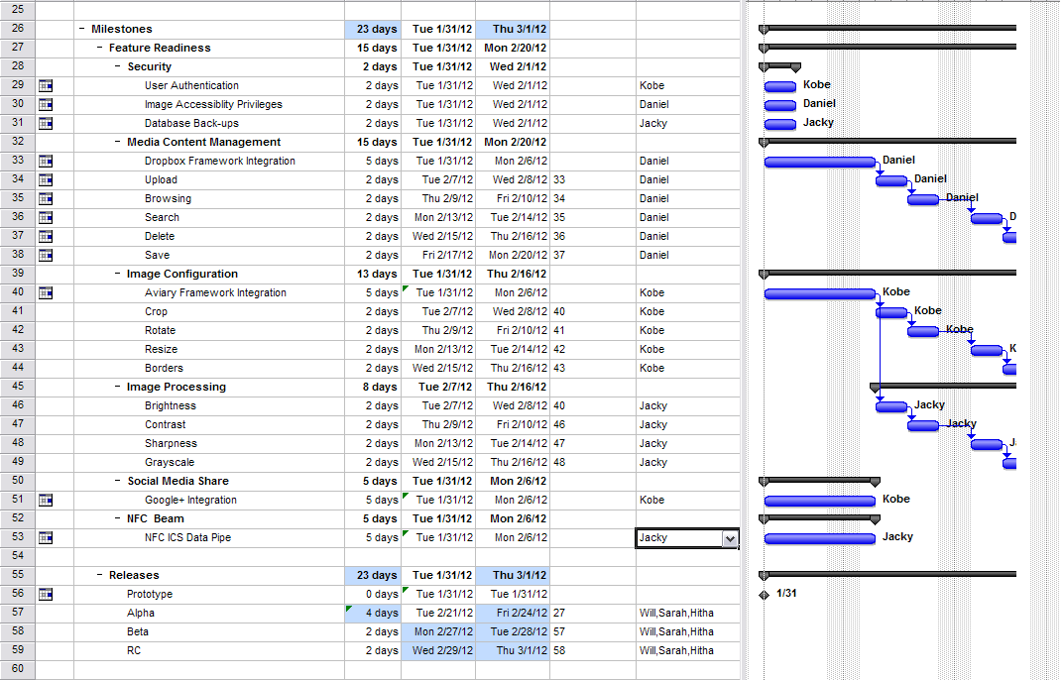

Dependencies

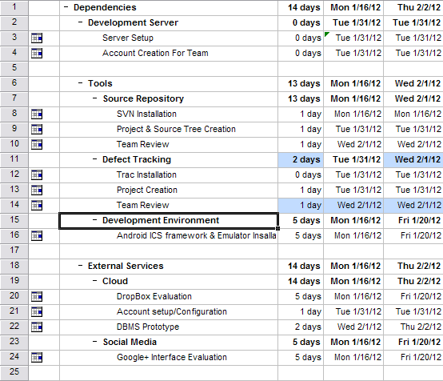

Budget

The following resources have been fully assigned to the SyncGallery+ project and are expected on average to dedicate 2 hour-days worth of effort to this project. The list of resources includes:
Kobe Sun – Product Management & Architecture & Implementation
Hitha Dinesh – UI Design & Verification & Validation
Daniel Liu – Product Management, Architecture & Implementation
Jacky Tan – Product Management, Architecture & Implementation
Sarah Yang – Verification & Validation & Test Engineering
Will Ghorishi – Project Management & Test Engineering

