me:

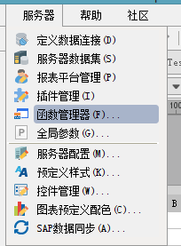

me:

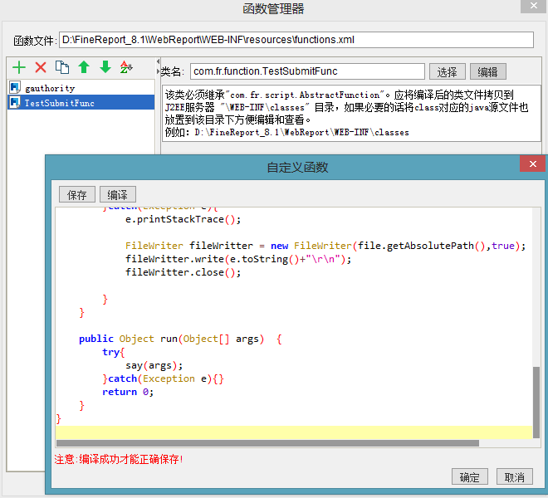

me:

package com.fr.function;

import com.fr.script.AbstractFunction;

import java.io.File;

import java.io.FileWriter;

import java.io.IOException;

import java.text.SimpleDateFormat;

import java.util.Date;

public class TestSubmitFunc extends AbstractFunction {

public void say(Object[] args) throws Exception{

File file =new File("E:\\java\\txt\\test.txt");

try{

String str="HelloWord"+args[0].toString()+args[1].toString()+args[2].toString();

Date d= new Date();

SimpleDateFormat aDate=new SimpleDateFormat("yyyy-MM-dd HH:mm:ss");

str=aDate.format(d)+" "+str;

System.out.println(str);

String data = str;

//if file doesnt exists, then create it

if(!file.exists()){

file.createNewFile();

}

System.out.println( file.getAbsolutePath());

System.out.println( file.getName());

//true = append file

FileWriter fileWritter = new FileWriter(file.getAbsolutePath(),true);

fileWritter.write(data+"\r\n");

fileWritter.close();

System.out.println("Done");

}catch(Exception e){

e.printStackTrace();

FileWriter fileWritter = new FileWriter(file.getAbsolutePath(),true);

fileWritter.write(e.toString()+"\r\n");

fileWritter.close();

}

}

public Object run(Object[] args) {

try{

say(args);

}catch(Exception e){}

return 0;

}

}

me:

C:\Users\ADMINI~1\AppData\Local\Temp\WeChat Files\df13786e38d0fe1d546ad6e19052b6a.png

me:

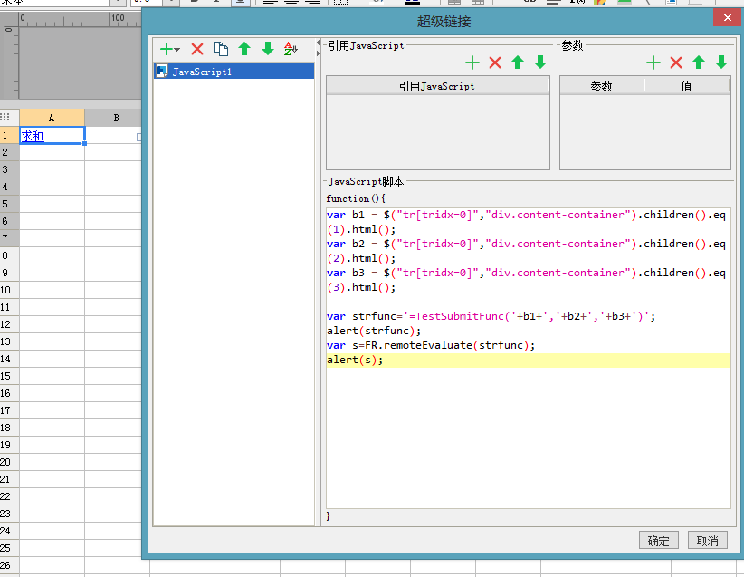

me:

var b1 = $("tr[tridx=0]","div.content-container").children().eq(1).html();

var b2 = $("tr[tridx=0]","div.content-container").children().eq(2).html();

var b3 = $("tr[tridx=0]","div.content-container").children().eq(3).html();

var strfunc='=TestSubmitFunc('+b1+','+b2+','+b3+')';

alert(strfunc);

var s=FR.remoteEvaluate(strfunc);

alert(s);

me:

这是js

me:

能传参