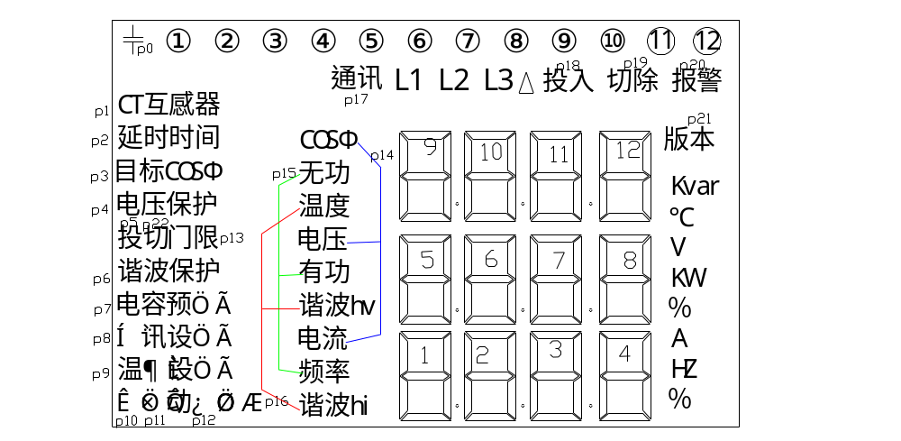

PIN | S0 | S1 | S2 | S3 | S4 | S5 | S6 | S7 | S8 | S9 | S10 | S11 | S12 | S13 | S14 | S15 | S16 | S17 | S18 | S19 | S20 | S21
COM0 | p9 | 1D | p10 | 2D | p11 | 3D | dp3 | 4D | 7A | 7F | 6A | 6F | 5A | 5F | 8F | 8A | P25 | 12D | DP11 | ⑧ | 11D | ⑦
COM1 | 1E | 1C | 2E | 2C | 3E | 3C | 4E | 4C | 7B | 7G | 6B | 6G | 5B | 5G | 8G | 8B | 12C | 12G | 12E | 11C | 11G | 11E
COM2 | 1G | 1B | 2G | 2B | 3G | 3B | 4G | 4B | 7C | 7E | 6C | 6E | 5C | 5E | 8E | 8C | 12B | 12A | 12F | 11B | 11A | 11F
COM4 | 1F | 1A | 2F | 2A | 3F | 3A | 4F | 4A | 7D | ⑿ | 6D | ⑾ | 5D | p24 | dp7 | 8D | p23 | ⑩ | ⑨ | p22 | p21 | p20
PIN | S22 | S23 | S24 | S25 | S26 | S27 | S28 | S29 | S30 | S31
COM0 | ⑥ | 10D | dp9 | ④ | 9D | ② | p12 | p2 | p3 | p8
COM1 | 10C | 10G | 10E | 9C | 9G | 9E | p16 | p1 | p4 | p7
COM2 | 10B | 10A | 10F | 9B | 9A | 9F | p15 | p0 | p13 | p6
COM4 | p19 | p18 | ⑤ | p17 | ③ |  | p14 | ① | p22 | p5

