Upload Instructions:

1. Organize the image files in the following Structure:
   1. Manufacturer Name.
   2. Product Names.
   3. Defect Types.
   4. Images with image name starting with sample_id followed by the image name.

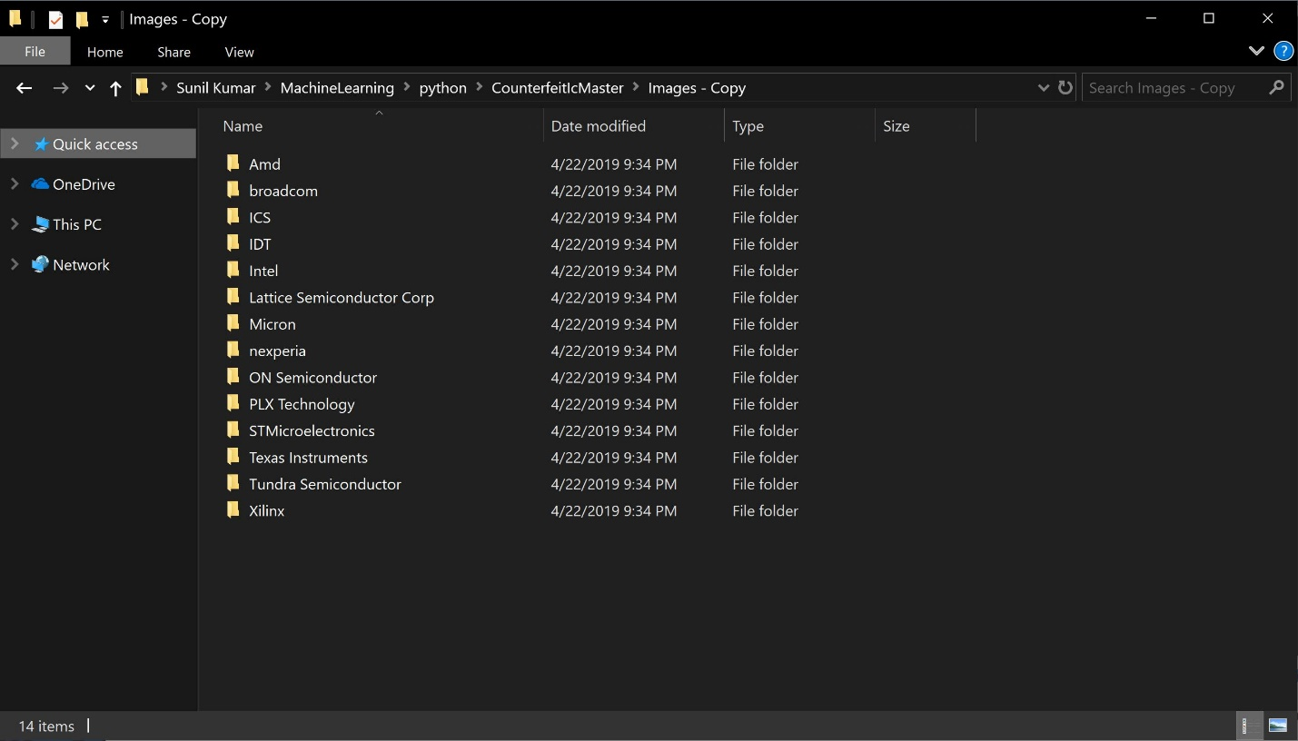

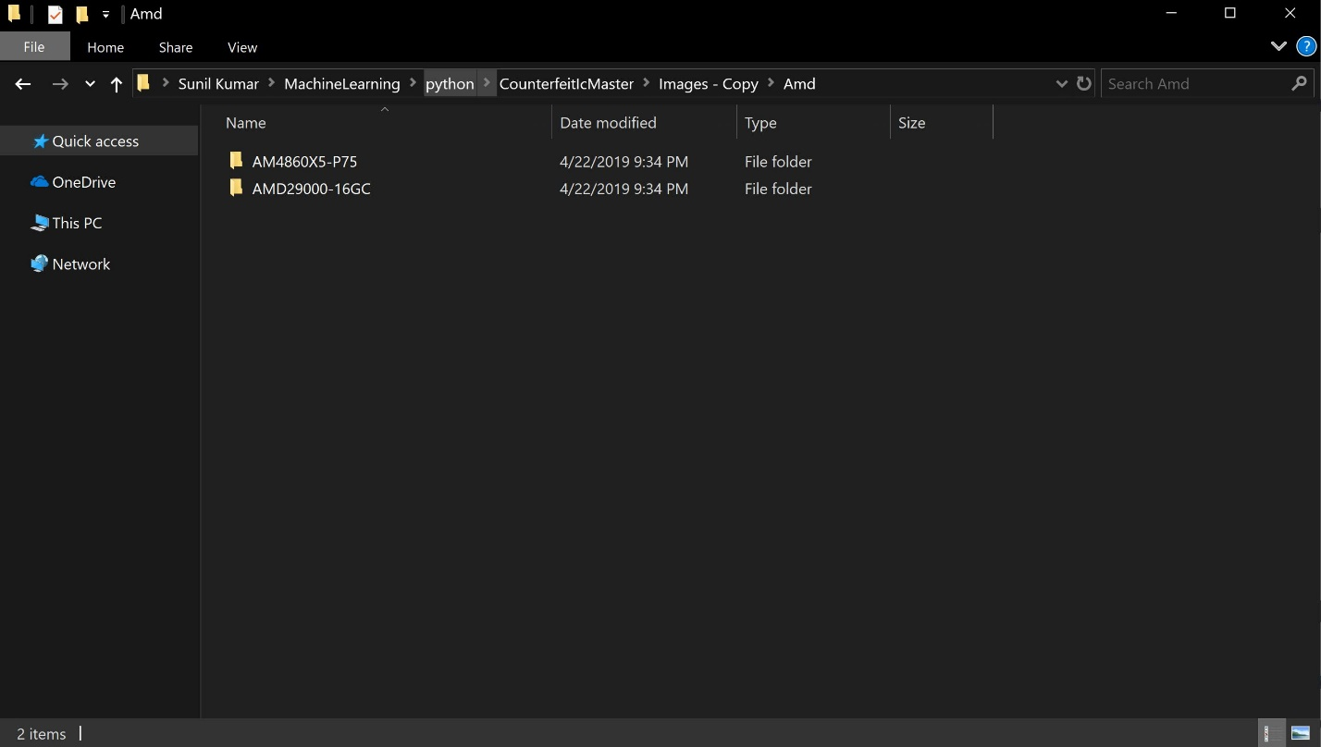

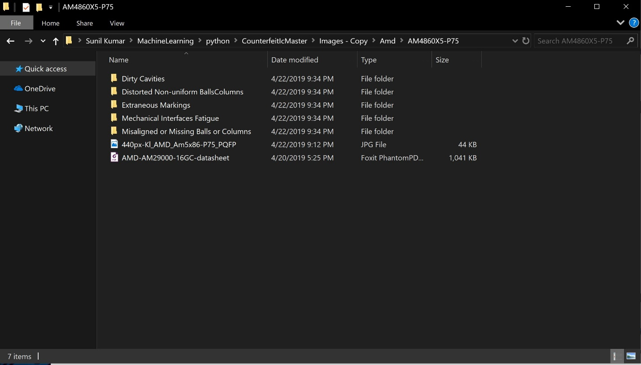

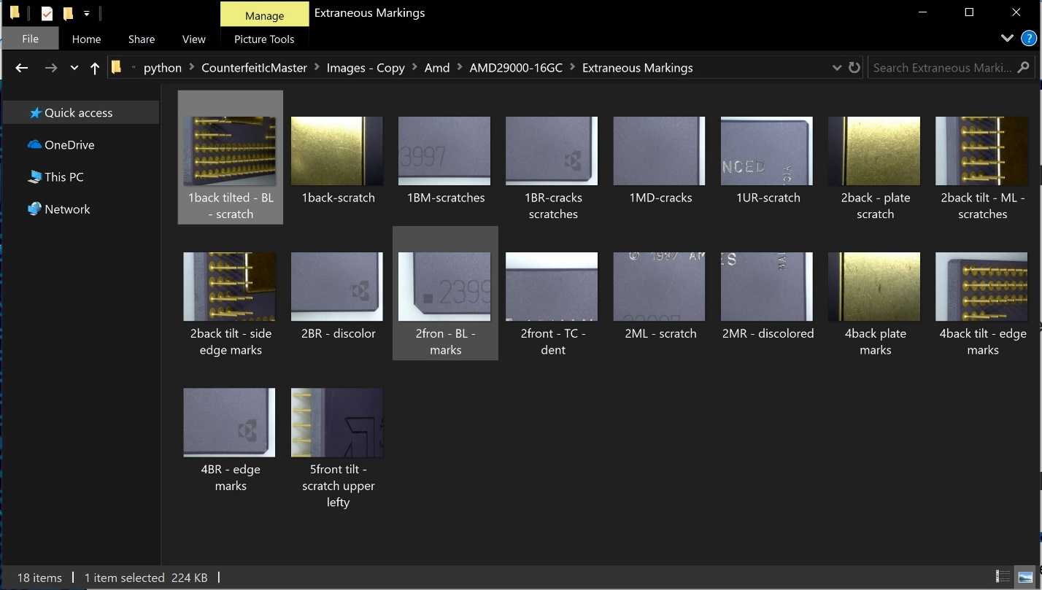

1. Download the image_file_builder from counterfeit_ic:

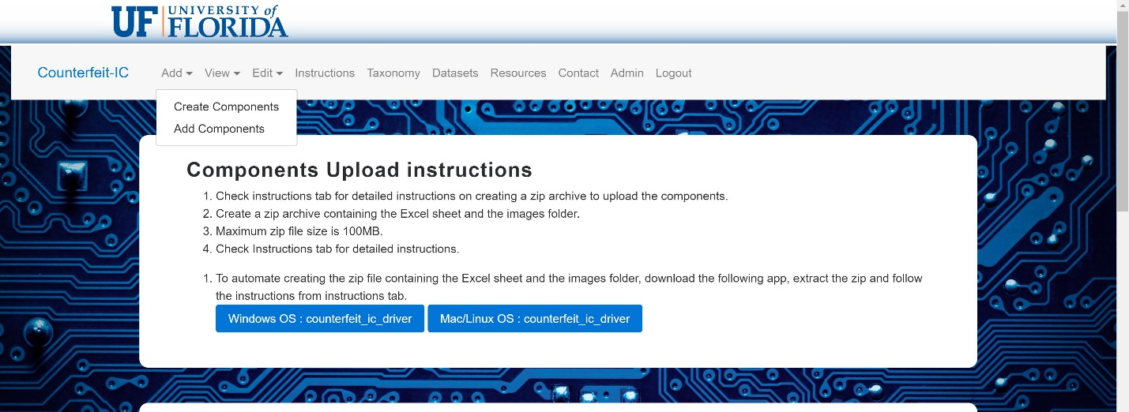

1. Open the driver and input the image folder name:

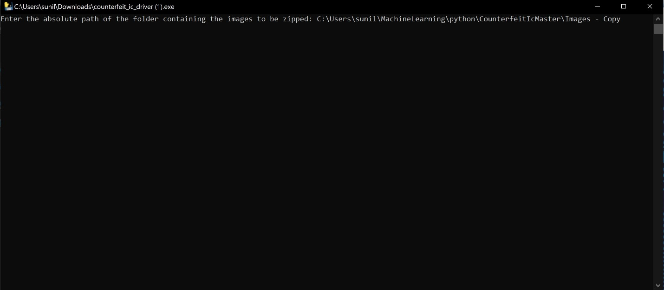

1. The zip files will be generated in the same folder:

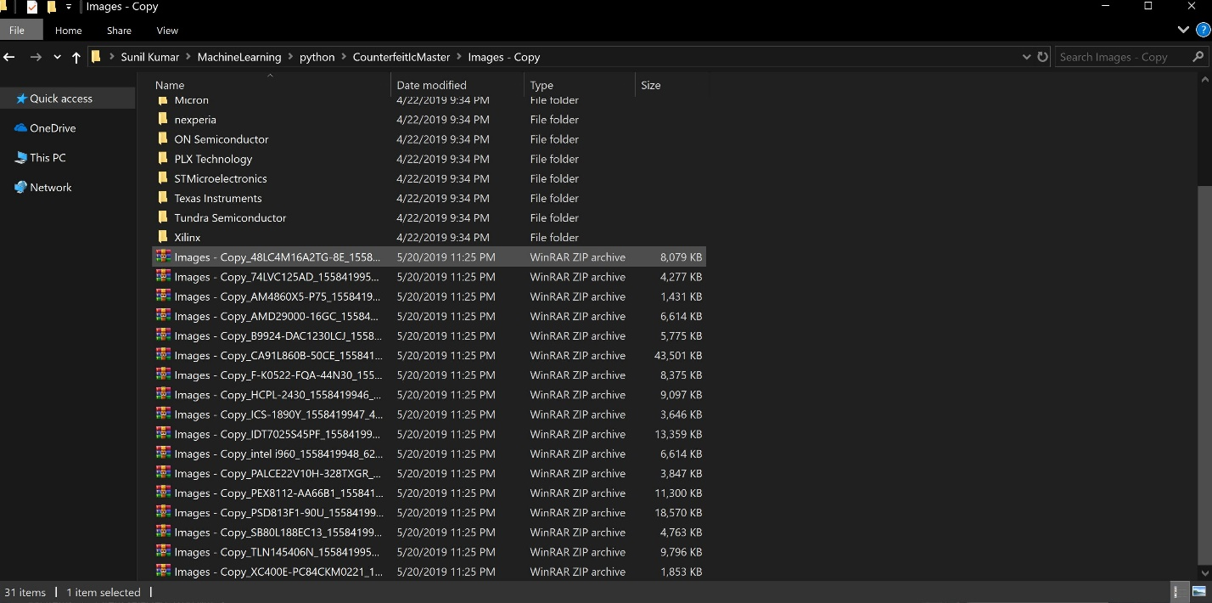

1. Upload the files to counterfeit_ic.org:

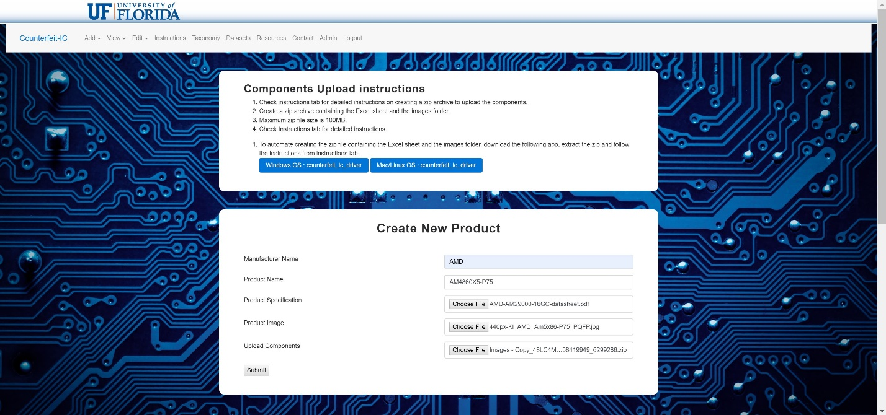

1. Click submit and get confirmation:

