From experimental autonomy to scientific understanding in programmable chemical worlds
Jiangjie Qiu^{1,†}, Yijun Li^{1,†}, Yaotian Yang^{1,†}, Honghao Chen¹, Wentao Li¹, Xiaonan Wang^{1,*}
¹ Beijing Key Laboratory of Artificial Intelligence for Advanced Chemical Engineering Materials, State Key Laboratory of Chemical Engineering and Low-Carbon Technology, Department of Chemical Engineering, Tsinghua University, Beijing 100084, China
† Jiangjie Qiu, Yijun Li and Yaotian Yang contributed equally.
* Correspondence: wangxiaonan@tsinghua.edu.cn

Abstract
Self-driving laboratories increasingly choose which experiments to perform and which evidence to pursue. Yet equipment and workflow constraints, experimental costs, safety requirements and unknown mechanisms make their scientific learning difficult to examine systematically in physical laboratories. We introduce ChemWorld, which combines experimental freedom with independent evaluator control in composable, programmable chemical worlds: agents assemble operations on evolving samples, while evaluators separately configure process laws and supplied information. Cross-system studies and targeted comparisons of five model configurations connect autonomous research histories to operating outcomes and sealed predictions under new interventions. Better experimental outcomes need not accompany more accurate predictions. In one equilibrium configuration, correct partial priors improve prediction in one region but increase error 8.7-fold under extreme dilution relative to withholding those priors. Across the five configurations, the same task elicits distinct patterns of evidence acquisition and extrapolation. Accurate forecasts occur both without direct sampling of the new regime and after autonomous experiments reveal its changed response. Crystallization exposes a complementary departure: predictions systematically underestimate purity even though experiments establish a nearly constant level. These findings reveal different ways autonomous researchers extend and depart from experimental evidence. They establish programmable chemical worlds as an instrument for studying scientific learning and motivate experimental planning that tests when acquired relationships should persist or be revised.

Introduction
Self-driving laboratories extend experimental science through automated execution and adaptive experimental planning^{1,2}. Robot scientists have generated and experimentally tested biological hypotheses³, while subsequent platforms have demonstrated autonomous materials search and reaction optimization^{4–7}. Mobile robots also support exploratory synthesis using complementary analytical instruments⁸. Language-model agents connect scientific instructions, tools and laboratory operations^{9,10}, and multi-agent research teams have designed biomolecules subsequently validated in experiments¹¹. As systems gain the freedom to choose operation sequences, intermediate measurements and subsequent experiments, they increasingly shape their own research paths. The scientific opportunity extends from executing procedures and optimizing conditions to deciding which evidence to acquire and what that evidence implies.
Greater experimental freedom also makes scientific learning harder to evaluate. Different research paths can support the same operating success while exposing different aspects of a chemical system. A productive recipe may follow from a transferable explanation or from a locally effective empirical rule. Decision-focused learning likewise distinguishes prediction error from the quality of decisions made using predictions¹². Physical laboratories offer rich possibilities for discovery, while each implemented workflow has practical limits imposed by equipment, materials and procedures. Unknown mechanisms, evolving material states and the cost of repeated experiments complicate controlled comparisons of how autonomous researchers acquire and use evidence. Understanding their progress therefore requires connecting experimental achievements to the histories and judgments that produced them.
We study scientific learning by connecting knowledge acquired through autonomous experiments to predictions under new interventions. The same researcher’s experimental history and public scientific account reveal which evidence was acquired and how it was extended to unmeasured conditions. Information-gain criteria and adaptive design policies formalize the selection of informative experiments^{13–15}, while strong inference emphasizes experiments that discriminate competing hypotheses¹⁶. These traditions motivate evaluating evidence acquisition together with the conclusions drawn from it.
Existing benchmarks evaluate complementary parts of this process. ChemBench assesses chemical knowledge and reasoning through question answering¹⁷, and DiscoveryBench evaluates hypothesis discovery from supplied datasets¹⁸. Optimization benchmarks offer repeatable objectives^{19,20}. Interactive chemistry and discovery environments support multi-step experimentation^{21–23}; BoxingGym connects experimental design to model discovery and explanation-based prediction²⁴. Science-Gym evaluates active data collection and equation discovery²⁵, while PhysGym explicitly varies prior knowledge in interactive physics discovery²⁶.
ChemWorld brings this investigation into composable chemical processes with persistent samples and flexible operations. Evaluator control over compatible world laws and supplied information supports matched comparisons of research conditions. We follow the same researcher from self-chosen experimental operations to independently retested recommendations and sealed predictions under new interventions. Complete operational histories connect these outcomes to the evidence the researcher actually acquired.
Our results connect two features of autonomous scientific learning. Experimental success and predictive accuracy can rank the same researchers differently. Moreover, researchers facing the same chemical worlds acquire different evidence and follow distinct routes to extrapolation: some extend a local plateau into conditions where it fails, others extrapolate accurately from local observations, and others experimentally encounter a new response before predicting it. Crystallization reveals the complementary difficulty of preserving an experimentally established relationship when it remains stable. Following these paths makes it possible to study how autonomous researchers decide which relationships to retain and which to revise.

Results

Tracing autonomous experimentation in controlled chemical worlds
ChemWorld constructs chemical processes as composable, executable experimental worlds. Components for reaction, thermal processing, phase equilibrium, separation and crystallization connect through compatible interfaces to maintain material, energy and sample states. An environment can support characterization of a single process or connect reaction with extraction, washing, concentration or crystallization in a multistage workflow, allowing upstream operations to affect downstream processing and final measurements. Configuring process components, their connections, model parameters and available instruments creates different research environments; adding process models and observation components extends the platform.
Agents organize their own experiments in these worlds: they select materials and loadings, adjust operating parameters and procedure order, and use intermediate results to decide whether to continue processing, repeat an experiment or terminate it. Sample states persist between operations, so reaction, thermal and separation histories jointly determine subsequent outcomes. Measurements must also be actively selected. Observation channels differ in information, noise and resource cost, requiring researchers to consider both experimental progress and evidence acquisition. Evaluators independently configure compatible process laws and public information, supporting comparisons of research conditions within the same world or changes to hidden laws under a shared public interface. Complete operation, observation and resource records connect choices to consequences and support exact replay of environment trajectories (Fig. 1).
The cross-system study uses GPT-5.6 Sol with medium reasoning effort for 240 autonomous campaigns across six chemical system families. The equilibrium parameter task includes a further 60 campaigns from four model configurations to compare evidence acquisition and extrapolation. Each study block contains five worlds and three information conditions: Opaque supplies no additional instance-specific prior, Aligned supplies correct but incomplete information, and MisIndexed supplies a fixed mismatch; all arms retain the public operational contract needed to conduct experiments. Where required, sealed recommendations receive an independent retest. The original researchers retain their experimental histories and subsequently provide scientific accounts, sealed predictions under new conditions and retrospective reflections, without reference-outcome feedback. Operating outcomes and predictive judgments can thus be traced to evidence acquired by the same researcher. The complete matrix, resources and assessment protocols are specified in Methods.
A twelve-batch crystallization campaign illustrates how a researcher adjusts an experimental procedure (Fig. 2). The first four batches fail because of excessive fines. Batch 5 changes several conditions, including cooling and seeding order, and first obtains a feasible result. Recovery reaches 45.5% at batch 8; the sealed recipe achieves 43.9% on independent retest while continuing to meet the quality constraints. A subsequent solvent reduction again violates those constraints. By choosing successive interventions, the researcher shapes both its experimental outcomes and the evidence available for subsequent scientific judgments.
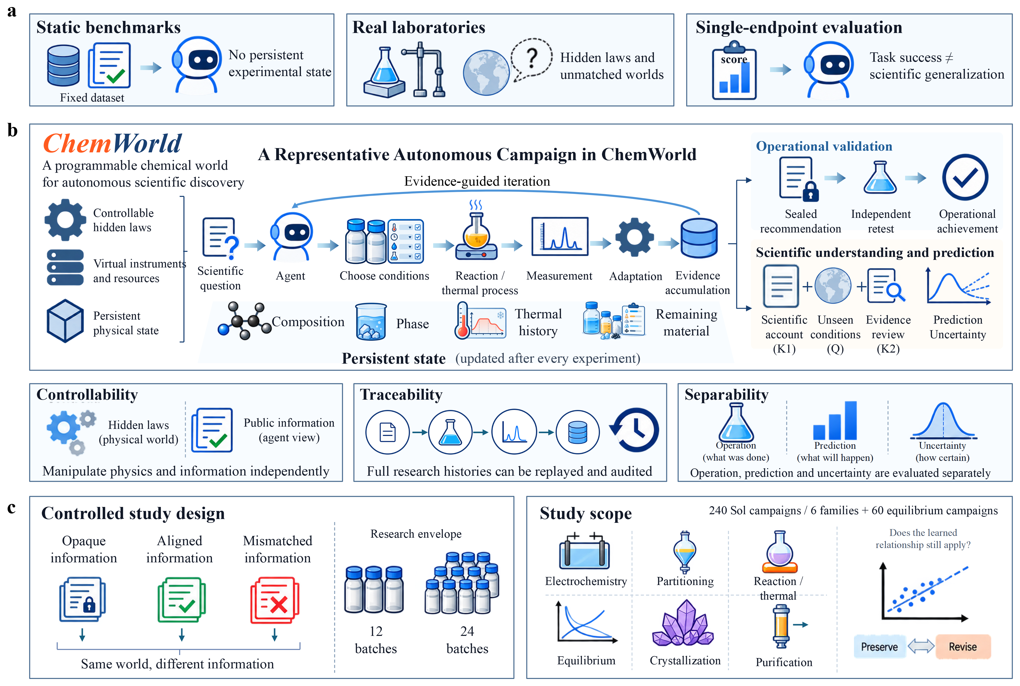
Figure 1. ChemWorld as a controlled experimental instrument for autonomous science. a, Evaluation challenges arising from fixed datasets, physical laboratories and single-endpoint scoring. b, Autonomous research connects experiment selection, process execution, measurement and evidence-informed adaptation within a stateful physical world. Hidden laws and public information can be varied separately; research histories can be replayed; operational performance, prediction and uncertainty are evaluated separately. Where required, operating recommendations are sealed and independently retested. The original session then retains its research history while providing a scientific account (K1), sealed predictions (Q) and retrospective evidence review (K2). Neither Q nor K2 receives target-outcome feedback. c, Information conditions in matched worlds, independent 12- and 24-batch resource envelopes, and 240 Sol-medium campaigns across six families plus 60 targeted equilibrium campaigns using four additional model configurations. “Mismatched information” denotes MisIndexed. Budget comparisons apply only to systems with both resource envelopes. Methods and Supplementary Tables A1 and F3 report the study matrix.
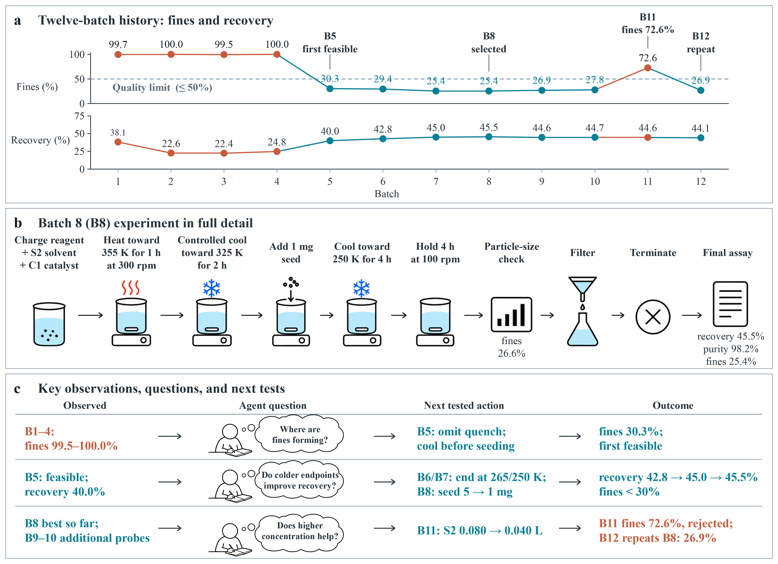
Figure 2. One complete autonomous crystallization campaign. a, Final-assay outcomes for all twelve source batches in the W04/MisIndexed session. Teal indicates quality-conforming results and ochre indicates failures; the dashed line marks the 50% fines limit. Batch 5 is first feasible, batch 8 is sealed as the recommendation, batch 11 violates the fines constraint and batch 12 repeats the selected recipe. b, All twelve operation calls in batch 8, grouped into ten visible stages. The intermediate particle-size check reports 26.6% fines and the final assay 25.4%; temperatures are requested targets. Independent retesting uses the sealed recipe with a different observation seed. c, Three observation–subsequent action–outcome sequences. Questions are reconstructed by the authors from operation records; K1 was written after experimentation. Recovery excludes seed contributions. Feasibility requires purity of at least 80%, fines of at most 50% and particles to be present; fines are particles below 20 micrometres. Supplementary Methods describe case selection and interpretation of the process changes.

Operational and predictive gains need not coincide
We first ask whether researchers that deliver better experimental procedures also predict new conditions more accurately. In electrochemical and reaction tasks that allow material selection and adjustment of electrical or thermal conditions, researchers prioritize either developing and testing scientific understanding (discovery) or obtaining high-scoring procedures (optimization). Independent campaigns under matched conditions are evaluated through recommendation retests and score predictions under new conditions (Fig. 3). Optimization achieves a higher retest score in 26 of 30 electrochemical pairs: prediction mean absolute error (MAE) is also lower in 13, but higher in the other 13. In reaction processing, discovery obtains both better retests and better predictions in 17 of 30 pairs. The two endpoints distinguish achievements that a single measure of experimental success would conflate.
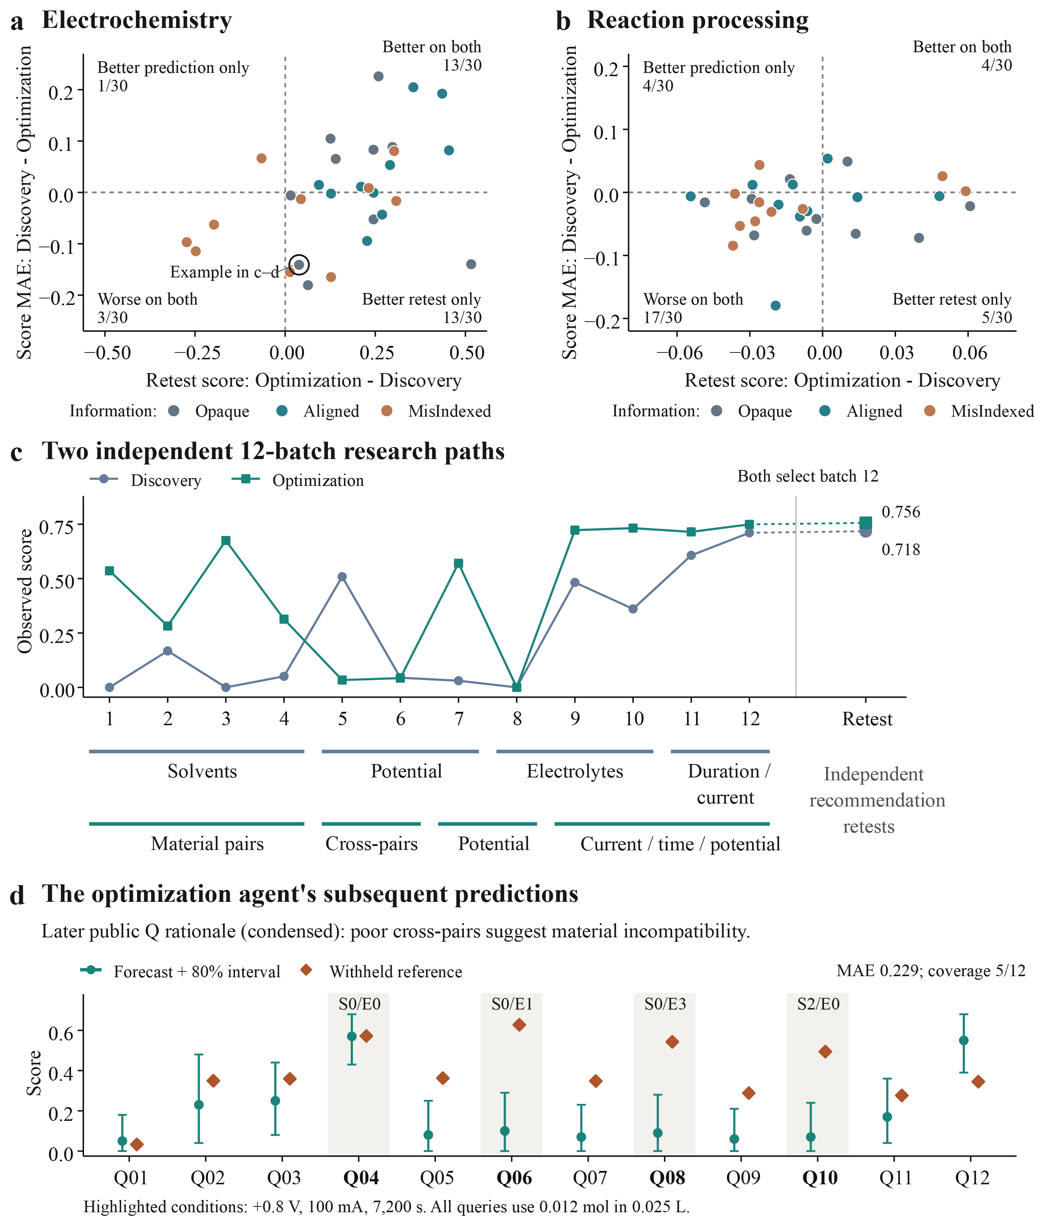
Figure 3. Research objectives, operational outcomes and predictive judgments. a,b, Thirty matched campaign pairs each in electrochemistry (a) and reaction processing (b), spanning five worlds. Positive differences favour optimization on the respective endpoint; quadrant labels identify the better commission and the ring marks the selected case. c, All batch scores in two independent twelve-batch campaigns, recorded operation changes and independent retests of sealed recommendations. Lines join successive observations; discovery batches 11–12 include segmented electrolysis and intermediate measurement. d, All twelve original optimization forecasts, nominal 80% prediction intervals and withheld reference observations. The rationale condenses the public account supplied with the subsequent Q forecasts. Shading identifies four queries at common electrical settings with different material pairs, retaining an accurate forecast alongside underestimates. Pairing fixes world, information arm, budget and prior locus. Methods define the counts and reference targets.
One electrochemical pair connects this contrast to actual research paths (Fig. 3c,d). Discovery first compares materials and conditions, then increases duration and the current cap; optimization screens material combinations before adjusting operating conditions for a promising pair. Optimization ultimately delivers the higher-scoring retested procedure, 0.756 versus 0.718 for discovery, but also has higher prediction MAE, 0.229 versus 0.088. After several cross-pair experiments perform poorly, the optimization researcher’s public prediction rationale classifies these combinations as low-activity. For one previously tested combination under new conditions, it predicts 0.070 against a reference of 0.494; for another combination, prediction and reference are 0.570 and 0.572. At the end of two independent campaigns, operating and predictive outcomes therefore give opposite rankings: optimization’s recommendation has the higher retest score, while discovery predicts new conditions more accurately.
Increasing research resources likewise does not synchronize the two benefits. Independent 12- and 24-batch campaigns show improvements in some electrochemical, partitioning and crystallization predictions, but the number of feasible crystallization recommendations does not increase, nor does mean retested recovery (Supplementary Fig. S4). Experimental resources can improve prediction without simultaneously improving the final procedure delivered.
Relevant scientific knowledge can also provide substantial help. In the reaction parameter-prior study, Aligned reduces macro prediction MAE from 0.102 to 0.057 for discovery and from 0.139 to 0.084 for optimization, outperforming Opaque in four of five worlds under each commission (Supplementary Fig. S2a,b). Resources and knowledge therefore offer concrete routes to predictive improvement, alongside the procedural achievements revealed by retesting. The next question is how researchers carry experimentally acquired relationships into conditions beyond their observations. The equilibrium task makes this transition directly visible.

The same chemical task elicits distinct routes to extrapolation
Researchers can vary loading, dilution and addition order in the equilibrium task, then predict pH, dissociation fraction and precipitation response under new conditions. The process laws remain fixed, but further dilution changes the relative contributions to charge balance, taking dissociation away from its local high-concentration plateau. Across Sol’s fifteen campaigns, all 180 source assays have nominal concentrations above 0.018 M and dissociation fractions of 5.5–9.2%; reference means at the lowest-concentration test condition reach 44.8–71.6% across the five worlds (Fig. 4a). This separates relationships the researcher actually observed from the extrapolation required by new conditions.
In the Sol campaigns, correct prior information reverses its predictive benefit across test regions. Aligned reduces macro MAE on the remaining nine queries from Opaque’s 0.01008 to 0.00465, but raises error on the three lowest-concentration queries from 0.01833 to 0.15862, approximately 8.7-fold; both directions occur in all five worlds (Fig. 4b; Supplementary Table F2). Nominal 80% interval coverage on the three lowest-concentration queries also falls from 93.3% for Opaque to 2.2% for Aligned. Original answers show Opaque extrapolating an increase in dissociation without directly sampling dilute solutions, while Aligned mainly extends the plateau or a weak local trend (Supplementary Fig. S8c). One Aligned answer acknowledges that the plateau need not persist towards zero loading, yet predicts 8.04% [5.30%, 10.80%] against a reference mean of 65.46%. The explanation acknowledges a boundary to applicability, but the sealed numerical forecast continues to use the plateau level.
The five model configurations exhibit distinct patterns of generalization under the same scientific conditions (Fig. 4c; Supplementary Table F3). We compare Sol with the medium configurations of GPT-5.5, GPT-5.6 Luna, GPT-5.6 Terra and GPT-6 Astra in the same five worlds, three information conditions and twelve-batch envelope. Whereas Sol shows a pronounced reversal of prior benefit, Luna and Terra obtain lower mean error with Aligned in both query groups, and GPT-5.5 changes little. Astra maintains low error across all three information arms on the lowest-concentration queries, with MAE of 0.01857–0.04040 and original interval coverage of 82.7–92.4%. A shared task and information protocol thus elicit different responses to scientific knowledge, from gains across both query groups to a reversal between them.
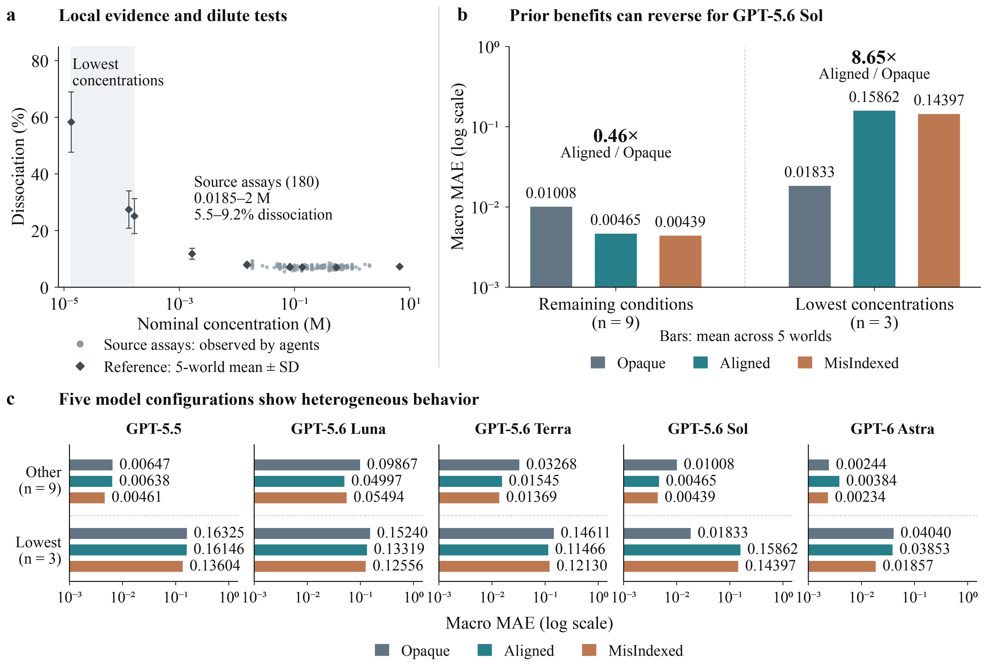
Figure 4. Local evidence, reversal of prior benefit and distinct extrapolation patterns across models. a, Sol’s 180 source assays and twelve withheld conditions, with reference means and sample standard deviations across five worlds. Shading marks the three lowest-concentration conditions. b, Sol macro MAE for the remaining nine and lowest three conditions; ratios compare Aligned with Opaque. c, Five model configurations under the same world, information and budget protocol, with three information arms in each query group. Bars in b,c show five-world means on logarithmic axes starting at 0.001; macro MAE equally weights normalized pH, dissociation fraction and precipitation signal. Statistical units, subgroup construction and complete values are provided in Methods and Supplementary Tables F2–F3.
The experimental histories reveal a corresponding difference in evidence acquisition. Eleven of Astra’s fifteen campaigns assay positively loaded samples at nominal concentrations no greater than 1 mM, compared with zero of fifteen for each of the other four configurations (Fig. 5a). Sol/Opaque nevertheless predicts the dilute response accurately from its local observations, achieving MAE of 0.01833 on the three lowest-concentration queries (Fig. 5b,c). Accurate extrapolation therefore occurs even in campaigns that never directly sample this regime.
An Astra campaign shows the complementary route of acquiring new evidence before extrapolation (Fig. 5d). In World 3/MisIndexed, dissociation is 6.3–7.4% in the first three batches. Batch 5 lowers concentration to 18.5 μM and observes 53.8%; later batches return to higher concentrations and explore staged dilution, additional loading and longer waiting. The subsequent public scientific account distinguishes the high-concentration plateau from the low-concentration response. The researcher then seals a forecast of 58.80% [54.20%, 63.40%] at 13.3 μM, against a reference mean of 57.97%. The recorded sequence connects autonomous observation of a changed response to its recognition in the scientific account and an accurate prediction at a new condition.
Prediction accuracy alone obscures these different research paths. Sol/Opaque extrapolates accurately beyond its observations, while the Astra case first acquires evidence outside the plateau and subsequently predicts the changed response. Linking forecasts to experimental histories reveals these distinct routes to a successful outcome alongside the local-rule extension that fails under dilution.
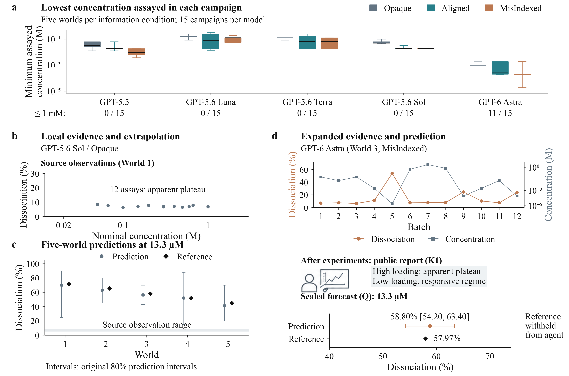
Figure 5. Different routes from autonomous experiments to accurate extrapolation. a, Lowest positively loaded nominal concentration assayed in each campaign. Each model has three information-arm boxplots, with five worlds per box: original-scale quartiles, median and minimum–maximum whiskers, displayed on a logarithmic axis. The dashed line and counts mark the descriptive 1 mM threshold. b, Twelve Sol World 1/Opaque assays show the locally observed plateau. c, Sol/Opaque forecasts at 13.3 μM across five worlds, with original 80% prediction intervals and reference means; shading spans dissociation observations in these source campaigns. d, All twelve batches of the Astra World 3/MisIndexed campaign, showing dissociation (left axis) and nominal concentration (right, logarithmic axis), followed by its post-experiment K1 account and sealed Q forecast at 13.3 μM. The displayed account condenses the public report; the forecast retains its original 80% interval. These retrospectively selected cases connect acquired evidence to subsequent predictions; Methods describe case selection and trajectory analysis.

Predictions systematically underestimate stable purity
The equilibrium studies expose the challenge of anticipating a response that changes beyond the observed region. Sol’s crystallization campaigns reveal the complementary difficulty of preserving a relationship that remains stable. Mean purity is 98.53% in source observations and 98.51% in withheld references; the mean within-world range across withheld conditions is only 2.44 percentage points. Yet mean predictions are 93.54% and 94.89% at 12 and 24 batches, respectively, with 335 of 360 predictions below their reference values (Fig. 6a).
Within the same campaigns, the recovery–purity comparison shows that this departure is response-specific. A baseline repeats each campaign’s own public final-assay mean for every withheld condition, using no additional experiments or withheld outcomes. Agent recovery predictions outperform this baseline in 26 of 30 campaigns, whereas purity predictions outperform it in none (Fig. 6b); mean purity MAEs are 4.35 and 0.48 percentage points, respectively. The same researcher can predict changing recovery more effectively than the mean baseline, yet fail to preserve the stable purity level already established by its experiments.
Purity errors predominantly reflect an overall downward shift. Mean signed error is −4.29 percentage points, and campaign-level offsets account for 87.6% of total squared error (Supplementary Table G2). Information conditions and research budgets alter the relative performance of recovery and purity forecasts, while prediction intervals fail to accommodate the purity errors reliably (Fig. 6c,d). Aligned and MisIndexed report wider mean intervals than Opaque yet achieve poorer coverage. The main error is thus a departure from the empirically established purity level, accompanied by errors in predicting its smaller variations across conditions.
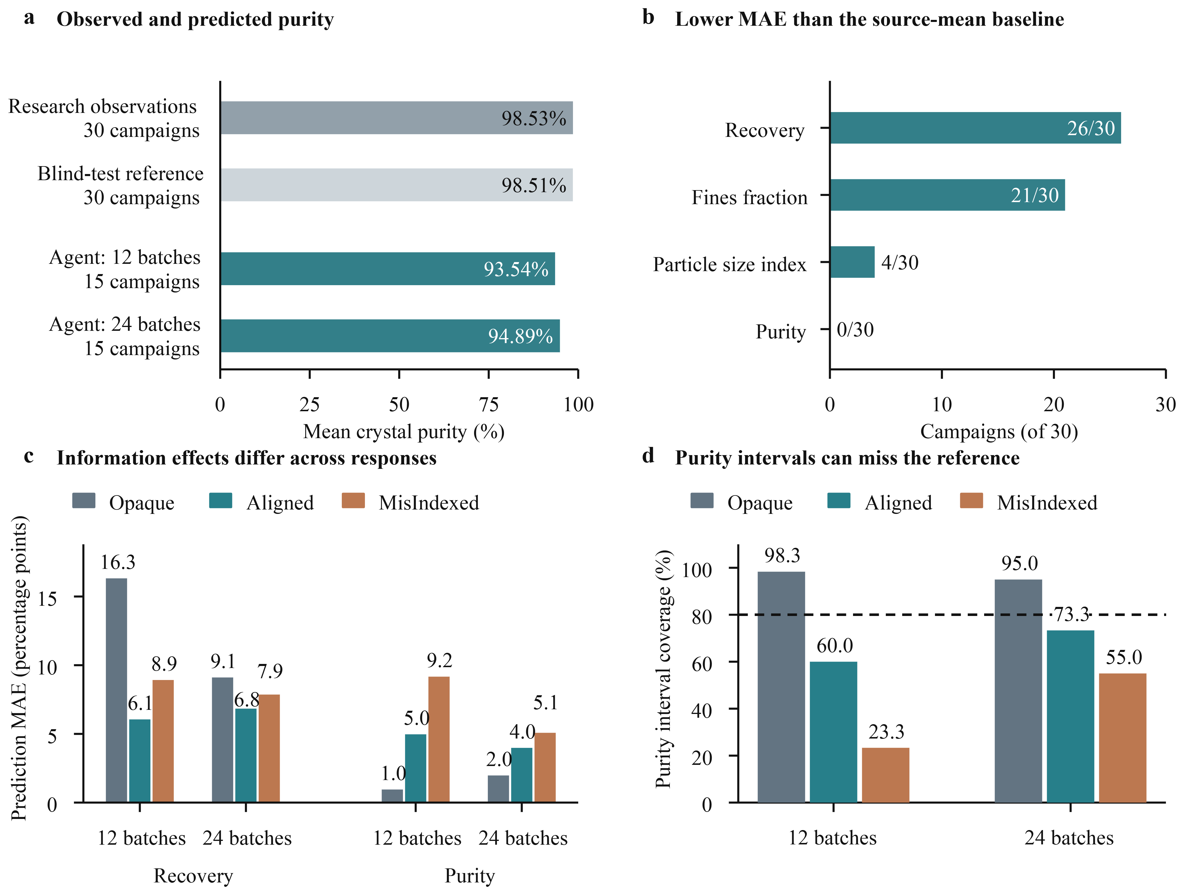
Figure 6. Crystallization forecasts depart from experimental evidence in a response-specific manner. a, Mean purity in source observations and withheld references, each from thirty campaigns, compared with forecasts at two budgets, each with fifteen campaigns. Bars equally weight campaign means. b, Campaigns with lower agent MAE than the source-mean predictor, compared separately within each response. The baseline uses the same campaign’s public final-assay mean for every withheld recipe. c, Recovery and purity MAE by information arm and budget, with five worlds per bar. d, Coverage of original nominal 80% purity intervals by information arm and budget, aggregated over five campaigns with twelve queries each; the dashed line marks the nominal level. Methods define statistical units, baselines and inclusion.

Discussion
Experimentally acquired relationships can be extended too far or insufficiently preserved. In Sol/Aligned equilibrium campaigns, predictions extend a local plateau into dilute conditions where the response changes substantially. In crystallization, predictions fall systematically below the stable purity jointly established by experiments and withheld outcomes. These opposite departures make scientific generalization concrete: which experimental relationships should change with an intervention, and which should continue to hold²⁷?
The model comparison reveals distinct scientific behaviours within the same experimental setting. Sol/Opaque extrapolates successfully from local observations, while Astra frequently acquires evidence at lower concentrations and, in the selected campaign, observes the changed response before accurately predicting it. Similar predictive success can therefore accompany different evidence histories. Conversely, one Sol/Aligned answer describes a boundary to the plateau in words but retains its level numerically: articulating an applicability limit and applying it in a quantitative judgment are distinct achievements. ChemWorld makes these differences visible by connecting experimental choices, acquired evidence, public accounts and sealed forecasts. Evaluating scientific learning requires this connection between research process and outcome, alongside tests of uncertainty under changing conditions^{28,29}.
These observations suggest a design principle for scientific agents: make the conditions under which a learned relationship persists or changes an explicit target of experiment selection. Experiments can then be chosen to distinguish competing explanations¹⁶. The Astra trajectory provides an executed example of observing a response beyond the local plateau before sealing predictions. Some Sol researchers propose trace-loading experiments only during retrospective review, and a separate crystallization pair proposes a thermal test at the same later stage (Supplementary section C.4 and Fig. S5); these proposals remain unexecuted. The design opportunity is to bring these judgments forward, so they guide evidence acquisition before a forecast is sealed.
Cross-system results cover one model configuration across six families; the five-model equilibrium comparison reuses worlds and readouts, with one campaign per model–world–information condition and exploratory subgroup analyses. Separating the contributions of sampling, prior use and interpretation, and testing transfer to physical laboratories, remain future work. Our measures assess predictions under new interventions and public scientific accounts; complete mechanistic understanding and internal belief revision require further evidence³⁰. Programmable worlds make autonomous research behaviour an object of controlled investigation, connecting what researchers achieve to the evidence they acquire and how they extend it to new conditions.

Methods

World construction and execution
Each world is defined by a public experimental contract and private process parameters. Process components declare states, domains, dependencies and compatible interfaces; operation and observation models compile those declarations into a laboratory interface. Participants act through that interface but cannot inspect the simulator, private parameters, evaluator records or repository. Instrument measurements may consume samples, and operations consume contract-defined materials, time and action allowances. Candidate transitions are validated before commitment. Rejected operations leave committed physical state unchanged while retaining contract-defined attempt consequences. Replay concerns the environment and recorded actions, not regeneration of language-model responses.

Equilibrium and crystallization process models
The equilibrium parameter study first solves monoprotic acid–base speciation, accounting for water self-ionization and preset background-ion inventories, followed by sequential 1:1 precipitation. Before ion-amount caps become active, the net background charge is 0.07 times the acid loading. Charge balance therefore permits a dissociation plateau near 7% when hydrogen- and hydroxide-ion contributions are small relative to total concentration; dilution changes their relative contributions. The solver uses current ledger amounts and volumes, whereas reported nominal concentrations describe recipe loadings. Supplementary section H gives the executed equations and effective pKa range.
The crystallization model couples temperature-dependent solubility to supersaturation-dependent nucleation, growth and impurity transfer. Crystal populations and phase inventories persist through cooling, seeding and filtration. Purity is the amount of solid target divided by total target and impurity solids. Full-process final-assay recovery excludes seed contributions and is normalized by initial reagent loading. The model used here has a linear supersaturation-dependent impurity-incorporation law. Near-constant purity is an observed property of the source and withheld outcomes, not a property fixed by the score definition. Supplementary section H records constitutive relations and parameters.

Platform qualification
Platform validation covers material and resource accounting, state transitions, component compatibility, invalid-action handling and information separation. Trajectory replay checks the consistency of recorded actions and their consequences. Study adapters undergo corresponding checks separately. Supplementary Methods provide the complete validation scope and results.

Study units and objectives
The 240 cross-system campaigns comprise eight study blocks: entity-prior electrochemistry (60), entity-prior partitioning (30), parameter- and structural-prior reaction processing (60 combined), entity-, parameter- and structural-prior equilibrium (15 each), entity-prior crystallization (30), and entity-prior purification (15). Each block uses five worlds and three information arms. Electrochemistry and reaction processing include discovery and optimization commissions. Electrochemistry, partitioning and crystallization have 12- and 24-batch conditions; other blocks use twelve batches. P for parameter priors is distinct from P for purification.
Electrochemistry varies materials, potential, current cap and duration; optimization targets a public balanced-efficiency score. Reaction processing varies materials, catalyst loading and thermal history. Partitioning examines allocation under material, volume and process changes. Equilibrium examines amounts, volumes, concentrations, staged additions, dissociation and precipitation. Crystallization seeks seed-excluded recovery subject to purity of at least 0.80, fines of at most 0.50 and particles being present. Purification seeks original-charge recovery subject to purity of at least 0.80. Their recovery definitions differ and are not pooled.

Agents and information conditions
All 240 cross-system source campaigns use GPT-5.6 Sol with medium reasoning effort in independent sessions. Targeted equilibrium comparisons additionally include GPT-5.6 Luna, GPT-5.6 Terra, GPT-5.5 and GPT-6 Astra, all requested at medium; this shared setting does not imply equal realized computation across models. Within a study block, arms share physical worlds, operations, resource contracts and withheld questions. Treatments vary public information according to the block’s fixed entity-, parameter- or structure-prior design. Opaque retains operational interfaces and general task context. Aligned provides partial nominal descriptions, such as a correct effective-pKa interval in the equilibrium parameter study. MisIndexed applies the specified mismatch rather than arbitrary misinformation.
The targeted comparison uses the same equilibrium parameter protocol, five worlds, three arms and twelve batches per campaign, with fifteen campaigns for each of four configurations. Each campaign permits at most 180 operation attempts, twelve intermediate measurements, twelve final assays, 0.24 mol reagent and 0.72 L solvent. Prompts, priors, queries, resources and scoring rules are fixed within the block, with one campaign per model–world–information condition. Some World 1 sessions were inspected as pilots; sensitivity analyses excluding that world are reported separately. Supplementary Methods specify the pilot scope.
For a concrete equilibrium example, the first world’s Aligned input provides an effective-pKa interval of [4.6094, 4.7094] and a local dilution-response statement; MisIndexed provides [5.3294, 5.4294] and the corresponding statement from the fifth world. Both use the same anchor, confidence level and qualification that the relationship is local. Opaque omits these instance-specific fields. Supplementary Table H1 reproduces numerical excerpts from the frozen input configuration and serializer.
Agents choose conditions, repetitions, measurement allocation and experiment grouping, and may use a bounded public numerical tool. They are not required to select mechanism templates, emit a fixed equation or reflect after every batch. Batches, operations, provider responses and decisions made after feedback are different counting units. Each budget permits a matching number of additional measurements and one final assay per completed batch; other resources are separately bounded. Larger budgets also include larger execution and computation allowances.

Sealed assessments and retests
Where required, the agent submits and seals one completed batch as its recommendation before assessment. Its operating procedure is independently retested in the same world using a different observation seed; 165 such retests are performed. K1 requests an unconstrained scientific account covering relationships, evidence, applicability and unresolved alternatives. Q then requests point forecasts and intervals for twelve fixed new-batch recipes, without laboratory access or target feedback. After predictions are sealed, K2 asks retrospective questions about evidence, limitations and discriminating experiments. Short versions contain three questions; reaction and equilibrium studies use seven themes. All fifteen Sol equilibrium parameter campaigns and sixty targeted campaigns complete structured supplemental questions after K2.
Every stage retains the original research context. Q uses both K1 and the source experimental history, and K2 follows the sealed Q without modifying it. The evaluation therefore follows the researcher from its own experiments to subsequent predictions. The equilibrium parameter comparison includes fifteen Sol campaigns and sixty campaigns from the four targeted configurations, for 75 in total; all include original-session K1, Q, K2 and structured supplemental questions. Complete mechanism annotation has not been conducted for the whole study pool.

Outcome definitions and references
For each response, campaign MAE averages absolute point error across twelve questions. Interval coverage is the fraction of specified reference targets contained in reported intervals, and width is their mean span. Partitioning uses nominal 90% intervals; other blocks use 80%. Partitioning and crystallization point references use underlying pre-final-assay response values. Electrochemistry and purification use fixed seeded observations. Reaction and equilibrium point references average five observations, while coverage is evaluated against each observation. Macro MAE equally averages response-specific MAEs within the designated block. Targets and scales are not pooled across systems.
Crystallization mean baselines use only public source final assays; nearest-neighbour predictions additionally use public recipe features. Neither uses additional experiments or withheld outcomes. The equilibrium source-mean diagnostic is a post hoc reference for testing forecasts that repeat the source plateau. Supplementary Methods record the recipe-feature parsing correction.
Two exploratory diagnostics use only retained predictions and references (Supplementary section G). Response-specific MAEs in the Sol equilibrium parameter study retain all 540 point predictions and exactly reproduce regime macro means. Crystallization purity analysis retains all 360 predictions and decomposes each campaign’s mean squared error (MSE) into squared mean error plus centred MSE. With equal query counts, the pooled offset share is the sum of squared campaign biases divided by the sum of campaign MSEs. Centring uses withheld references for diagnosis, not to construct a corrected predictor or claim improved predictive performance.

Statistical analysis and inclusion
Goal comparisons match world, information arm, budget and prior locus. Budget comparisons match world, information arm and goal, comparing independent sessions. Information-arm comparisons match other factors within each study. Means equally weight campaigns. Five world clusters recur across arms, goals and budgets; questions, responses and batches are correlated observations. We report effect magnitudes, paired directions, tables retaining all arms and selected sensitivity analyses, without inferential tests treating queries as independent trials. Figure error bars show sample standard deviations across worlds; descriptive bars and sample standard deviations are not confidence intervals. Goal-comparison quadrant counts use strict signs of paired differences, with no minimum-effect or significance threshold. Baseline comparisons are performed separately for each crystallization response.
Orienting comparisons by observed retest performance is a post hoc re-expression of the original goal pairs, not an additional experiment. Within each pair, we identify the campaign with the higher recommendation retest score and compare its score-prediction MAE with its counterpart’s. All pairs and exact effect magnitudes are retained without a minimum-effect threshold. The sensitivity subset excludes any recorded campaign recovery, including assessment-only recovery, rather than source restarts alone.
The equilibrium dilution grouping is selected post hoc using public concentrations of the three lowest-concentration recipes, approximately $1.33×{10}^{−4}$, $1.33×{10}^{−5}$ and $1.67×{10}^{−4}$ M. Grouped scores reproduce each original twelve-question macro score when weighted 3:9. The joint crystallization recovery–purity comparison is also exploratory. Both analyses preserve the original query banks and all outcomes. The remaining nine conditions include boundary and unexplored recipes and are not an in-distribution control group. Source observations plotted against concentration come from self-selected recipes and processing histories, rather than a controlled concentration sweep.
All 240 cross-system campaigns and their 720 scientific-account, prediction and retrospective stages are included. Of these, 238 chains conform to the protocol, and 3,597 of 3,600 planned source final assays are completed. One crystallization source completes eleven rather than twelve final assays after exhausting solvent. One purification source uses twelve starts but completes ten final assays and discards two vessels. Both are marked nonconforming and neither is replaced. Infrastructure retries retain earlier attempts and resource accounting. Supplementary tables report the complete matrix, targets, qualification domains and response-specific arm means. Original protocol variation and excluded historical pilots are recorded separately from this pool.
The four targeted configurations complete 60/60 research chains, 720/720 batches, 240/240 original-session assessment stages and 2,160 scalar predictions, all with exact environment replay. They share 300 reference batches (five worlds × twelve queries × five observations), used only for evaluation. Supplementary Methods describe infrastructure recoveries and rejected operations.

Retrospective analysis of autonomous equilibrium research
Using retained source and trajectory indexes, the Sol parameter-prior equilibrium analysis includes all fifteen effective sources: five worlds, three arms, 180 batches, 945 operations and 45 standard assessment stages, plus fifteen structured supplemental responses. Nominal batch concentration is total reagent added divided by total solvent added, not an inferred dissolved concentration. Trajectory analysis adds no model, simulator or judge calls; original question scores and reference observations are unchanged.
A single author reviews public Q explanations and assigns descriptive categories: piecewise weak-acid extrapolation, qualitative departure from the plateau, plateau or weak-trend extension, and mixed weak-acid/plateau explanation. Original excerpts and prediction values accompany these categories, but they are not an independent mechanism assessment. K1 evidence is distinguished from hypotheses first explicit in Q. K2 future-experiment choices are classified separately: eleven of fifteen campaigns propose trace-loading experiments after exposure to Q conditions, without reference feedback. These proposals are unexecuted and do not establish spontaneous source-stage discovery or repair. Exported decision-reason fields are unavailable for all 945 operations; no contemporaneous reasoning sequence is reconstructed from them.
Cross-model source coverage is summarized by each campaign’s lowest nominal concentration among positively loaded final assays, excluding zero-loading blanks. The post hoc descriptive 1 mM threshold is neither a physical critical concentration nor a success criterion. The Astra case is selected retrospectively; its K1 account follows experimentation and precedes Q, and does not represent contemporaneous internal reasoning or unique mechanism identification. Sol explanation categories are not automatically generalized to other models. For the four targeted configurations, the 80% interval score is width plus ten times the distance from an out-of-interval reference to the nearest endpoint, averaged over five reference observations; lower is better. It is reported separately from coverage. Campaign minima describe the lowest sampled point rather than continuous coverage. Boxplot quartiles are calculated on the original concentration scale before logarithmic display; coincident quartiles appear as a line.

Data and code availability
Source observations, sealed outputs, evaluator-derived summaries and analysis code supporting this manuscript are retained in the project evidence records. Supplementary information reports aggregate outcomes and protocol details. The public archival package for this integrated study, including applicable execution versions and privacy-reviewed records, has not yet been finalized. The earlier platform release should not be assumed to include these subsequent studies.

Acknowledgements
This work was supported by the Shenzhen Science and Technology Program (AI2026004), the Tsinghua University Initiative Scientific Research Program and the Scientific Research Innovation Capability Support Project for Young Faculty (ZYGXQNJSKYCXNLZCXM-E7).

References
1. F. Häse, L. M. Roch, and A. Aspuru-Guzik. Next-Generation Experimentation with Self-Driving Laboratories. Trends in Chemistry 1 282–291 (2019). https://doi.org/10.1016/j.trechm.2019.02.007.
2. G. Tom, S. P. Schmid, S. G. Baird, Y. Cao, K. Darvish, H. Hao, et al. Self-Driving Laboratories for Chemistry and Materials Science. Chemical Reviews 124 9633–9732 (2024). https://doi.org/10.1021/acs.chemrev.4c00055.
3. R. D. King, J. Rowland, S. G. Oliver, M. Young, W. Aubrey, E. Byrne, et al. The Automation of Science. Science 324 85–89 (2009). https://doi.org/10.1126/science.1165620.
4. B. Burger, P. M. Maffettone, V. V. Gusev, C. M. Aitchison, Y. Bai, X. Wang, et al. A mobile robotic chemist. Nature 583 237–241 (2020). https://doi.org/10.1038/s41586-020-2442-2.
5. B. P. MacLeod, F. G. L. Parlane, T. D. Morrissey, F. Häse, L. M. Roch, K. E. Dettelbach, et al. Self-driving laboratory for accelerated discovery of thin-film materials. Science Advances 6 eaaz8867 (2020). https://doi.org/10.1126/sciadv.aaz8867.
6. B. J. Shields, J. Stevens, J. Li, M. Parasram, F. Damani, J. I. M. Alvarado, et al. Bayesian reaction optimization as a tool for chemical synthesis. Nature 590 89–96 (2021). https://doi.org/10.1038/s41586-021-03213-y.
7. N. J. Szymanski et al. An autonomous laboratory for the accelerated synthesis of inorganic materials. Nature 624 86–91 (2023). https://doi.org/10.1038/s41586-023-06734-w.
8. T. Dai, S. Vijayakrishnan, F. T. Szczypiński, J.-F. Ayme, E. Simaei, T. Fellowes, et al. Autonomous mobile robots for exploratory synthetic chemistry. Nature 635 890–897 (2024). https://doi.org/10.1038/s41586-024-08173-7.
9. D. A. Boiko, R. MacKnight, B. Kline, and G. Gomes. Autonomous chemical research with large language models. Nature 624 570–578 (2023). https://doi.org/10.1038/s41586-023-06792-0.
10. A. M. Bran, S. Cox, O. Schilter, C. Baldassari, A. D. White, and P. Schwaller. Augmenting large language models with chemistry tools. Nature Machine Intelligence 6 525–535 (2024). https://doi.org/10.1038/s42256-024-00832-8.
11. K. Swanson, W. Wu, N. L. Bulaong, J. E. Pak, and J. Zou. The Virtual Lab of AI agents designs new SARS-CoV-2 nanobodies. Nature 646 716–723 (2025). https://doi.org/10.1038/s41586-025-09442-9.
12. A. N. Elmachtoub and P. Grigas. Smart Predict, then Optimize. Management Science 68 9–26 (2022). https://doi.org/10.1287/mnsc.2020.3922.
13. D. V. Lindley. On a Measure of the Information Provided by an Experiment. The Annals of Mathematical Statistics 27 986–1005 (1956). https://doi.org/10.1214/aoms/1177728069.
14. K. Chaloner and I. Verdinelli. Bayesian Experimental Design: A Review. Statistical Science 10 273–304 (1995). https://doi.org/10.1214/ss/1177009939.
15. A. Foster, D. R. Ivanova, I. Malik, and T. Rainforth. Deep Adaptive Design: Amortizing Sequential Bayesian Experimental Design. Proceedings of the 38th international conference on machine learning 139 3384–3395 (2021). https://proceedings.mlr.press/v139/foster21a.html.
16. J. R. Platt. Strong Inference. Science 146 347–353 (1964). https://doi.org/10.1126/science.146.3642.347.
17. A. Mirza, N. Alampara, S. Kunchapu, M. Ríos-García, B. Emoekabu, A. Krishnan, et al. A framework for evaluating the chemical knowledge and reasoning abilities of large language models against the expertise of chemists. Nature Chemistry 17 1027–1034 (2025). https://doi.org/10.1038/s41557-025-01815-x.
18. B. P. Majumder, H. Surana, D. Agarwal, B. Dalvi Mishra, A. Meena, A. Prakhar, et al. DiscoveryBench: Towards Data-Driven Discovery with Large Language Models. International Conference on Learning Representations 2025 4556–4579 (2025). https://proceedings.iclr.cc/paper_files/paper/2025/file/0d70af566e69f1dfb687791ecf955e28-Paper-Conference.pdf.
19. K. C. Felton, J. G. Rittig, and A. A. Lapkin. Summit: Benchmarking machine learning methods for reaction optimisation. Chemistry–Methods 1 116–122 (2021). https://doi.org/10.1002/cmtd.202000051.
20. F. Häse, M. Aldeghi, R. J. Hickman, L. M. Roch, M. Christensen, E. Liles, et al. Olympus: A benchmarking framework for noisy optimization and experiment planning. Machine Learning: Science and Technology 2 035021 (2021). https://doi.org/10.1088/2632-2153/abedc8.
21. C. Beeler, S. G. Subramanian, K. Sprague, et al. ChemGymRL: A customizable interactive framework for reinforcement learning for digital chemistry. Digital Discovery 3 742–758 (2024). https://doi.org/10.1039/D3DD00183K.
22. R. Wang, P. Jansen, M.-A. Côté, and P. Ammanabrolu. ScienceWorld: Is your Agent Smarter than a 5th Grader? Proceedings of the 2022 conference on empirical methods in natural language processing 11279–11298 (2022). https://doi.org/10.18653/v1/2022.emnlp-main.775.
23. P. Jansen, M.-A. Côté, T. Khot, E. Bransom, B. D. Mishra, B. P. Majumder, et al. DiscoveryWorld: A virtual environment for developing and evaluating automated scientific discovery agents. Advances in neural information processing systems 37 (2024). https://doi.org/10.52202/079017-0324.
24. K. Gandhi, M. Y. Li, L. Goodyear, A. Bhatia, L. Li, A. Bhaskar, et al. BoxingGym: Benchmarking progress in automated experimental design and model discovery. (2025). https://arxiv.org/abs/2501.01540.
25. M. Cerrato, L. Baur, J. Brugger, S. Shumaly, N. Schmitt, E. Finkelstein, et al. Science-Gym: a simple testbed for AI-driven scientific discovery. Machine Learning 115 16 (2026). https://doi.org/10.1007/s10994-025-06914-x.
26. Y. Chen, P. Piękos, M. Ostaszewski, F. Laakom, and J. Schmidhuber. PhysGym: Benchmarking LLMs in Interactive Physics Discovery with Controlled Priors. Advances in Neural Information Processing Systems 38 (2025). https://doi.org/10.52202/085713-1556.
27. S. Kramer, M. Cerrato, J. Brugger, S. Džeroski, and R. D. King. Automated Scientific Discovery: From Equation Discovery to Autonomous Discovery Systems. Machine Learning 115 109 (2026). https://doi.org/10.1007/s10994-025-06955-2.
28. T. Gneiting and A. E. Raftery. Strictly Proper Scoring Rules, Prediction, and Estimation. Journal of the American Statistical Association 102 359–378 (2007). https://doi.org/10.1198/016214506000001437.
29. Y. Ovadia, E. Fertig, J. Ren, Z. Nado, D. Sculley, S. Nowozin, et al. Can you trust your model’s uncertainty? Evaluating predictive uncertainty under dataset shift. Advances in Neural Information Processing Systems 32 (2019). https://proceedings.neurips.cc/paper_files/paper/2019/file/8558cb408c1d76621371888657d2eb1d-Paper.pdf.
30. G. Shmueli. To Explain or to Predict? Statistical Science 25 289–310 (2010). https://doi.org/10.1214/10-sts330.

Supplementary information

Appendix A. Protocol detail and evidence handling

A.1 Complete study matrix
System / prior locus | Scientific commission | Budgets | Campaigns | Final-assayed batches
EC / E: electrochemistry | Discovery; score optimization | 12, 24 | 60 | 1,080 / 1,080
PA / E: phase partitioning | Explain phase allocation | 12, 24 | 30 | 540 / 540
RX / P and S: reaction and thermal processing | Discovery; safety-constrained optimization | 12 | 60 | 720 / 720
EQ / E: medium identity | Characterize entity-conditioned responses | 12 | 15 | 180 / 180
EQ / P: bounded equilibrium | Characterize effective responses | 12 | 15 | 180 / 180
EQ / S: structural equilibrium | Explain response structure | 12 | 15 | 180 / 180
C / E: crystallization | Deliver crystals under quality constraints | 12, 24 | 30 | 539 / 540
P / E: purification | Recover product subject to purity | 12 | 15 | 178 / 180
Total | Six system families |  | 240 | 3,597 / 3,600
Table A1. Cross-system study scope (GPT-5.6 Sol, medium). Each campaign has one agent realization. One C campaign exhausts its solvent stock and discards its twelfth vessel, completing eleven final assays. One P campaign uses all twelve vessel starts but discards two vessels, leaving ten final assays. All campaigns have scientific account (K1), sealed prediction (Q), and retrospective review (K2) stages; 238 meet the full source-and-assessment specification.

A.2 Prediction targets and system-specific questions
System | Prediction responses | Reference target | Interval level
EC | Six conversion/efficiency responses, including score | Seeded final observation | 80%
PA | Organic and aqueous product fractions | Noiseless pre-sampling fractions | 90%
RX | Yield, conversion, selectivity, byproduct signal, risk, score | Five-observation mean; coverage over observations | 80%
EQ / E, P and S | Normalized pH, dissociation, precipitation signal | Five-observation mean; coverage over observations | 80%
C | Net recovery, purity, size index, fines fraction | Noiseless pre-assay responses | 80%
P | Purity, original-charge recovery | Seeded final observation | 80%
Table A2. Every campaign predicts twelve conditions. PA fractions are complementary, and its two decision questions reuse the conditions. Reference repeats reduce observation noise but do not add agent sessions.
EC’s twelve conditions balance positive and negative potential while varying duration, materials, and current cap at a stated loading. Its six responses are selective product yield, electrochemical selectivity, Faradaic efficiency, transport efficiency, energy efficiency, and public score. Current is a magnitude cap, not guaranteed delivered current. PA predicts phase fractions before analytical sampling; sampling losses and complementary fractions must not be counted as separate discoveries.
RX’s twelve paths examine time, temperature, catalyst, heating sequence, and quenching. Actual thermal telemetry matters: requested boundary temperature need not be realized reaction temperature. Five reference observations per condition are withheld from agents, with all source assessments sealed before reference-truth release. RX’s 600 reference executions are separate from 720 source batches and 60 retests.
Each EQ block uses twelve questions and five observations per question, giving 300 reference executions. EQ/E crosses three medium identities with three concentrations and a matched-concentration scale control, assessing entity contrast and concentration and scale transfer under a fixed common topology. Bounded EQ/P examines effective aqueous relationships; canonical EQ/S supports response-shape analysis without requiring a named hidden family. An instrument’s equilibrium diagnostic is not the agent’s subjective confidence. The bounded study’s effective-parameter supplement is additional to K1/Q/K2 and does not confer discovery credit for a parameter already supplied as a treatment.
C’s twelve conditions form six pairs: material, seed dose, cooling history, prior thermal history, continued growth, and upstream loading. Its size response is $min(d_{50}/250 μm,1)$, a bounded number-weighted index rather than a diameter in micrometres. Fines are particles below 20 micrometres. Quality requires purity and fines criteria jointly, with particles present; recovery of 0.10 is an initial feasibility target, not an optimization ceiling. P’s six paired interventions concern multistage recovery, including wash staging. Its original-charge denominator differs from C’s seed-excluded recovery normalized by initial reagent loading.
RX and EQ coverage uses individual reference observations while point targets use means. EC and P use single seeded observations. PA and C prediction coverage concerns noiseless pre-sampling responses; C recommendation retests use observed assays. Apparent retest threshold crossings can therefore reflect noise. Macro errors weight a system’s responses equally; normalized scales do not make responses physically or scientifically interchangeable.

A.3 Language, numerical tools, and stage budgets
Source briefs and requested reports are English. EC/PA and C/P assessment instructions are English; RX and EQ K1/Q/K2 instructions include Chinese text requesting English reports. Within-block arms have the same language contract. Seven-theme K2 reviews cover treatment claims, influential experiments, competing explanations, one proposed discriminating experiment, goal-related tradeoffs, unused evidence and uncertainty, and limitations of the recommendation or scientific account. Three-question versions combine these themes. The reviews occur after source experiments and sealed predictions; their length does not provide additional source experiments.
The earlier EC/PA block retains its saved eight-call diagnostic-calculator hard stop; later blocks disclose 128-attempt assessment allowances. An old EC parameter/structural supplement encountered the smaller limit and remains an execution failure outside the primary E cohort. The repair is not retroactively attributed to older sessions. Public calculation uses agent-accessible information, not hidden targets. Differences in numerical budgets and deadlines are execution contracts, not scientific findings.

A.4 Completion, recovery, and exclusions
The primary denominator is 240 scheduled campaigns, not provider attempts. All 720 K1/Q/K2 stages and 165 planned recommendation retests in EC, RX, C, and P are complete, plus fifteen EQ supplements. Final-assayed source batches total 3,597 of 3,600 planned. C’s second-world 12-batch Opaque source has eleven final assays. P’s fifth-world Opaque source starts twelve vessels, discards two, and completes ten final assays. Both remain in outcome tables with conformance indicators.
EC/PA has 68 first-attempt and 22 infrastructure-recovered campaigns. Recovery after transport or host failures retains earlier attempts and consumed resources. Missing assessment stages resume from saved context when the source is intact; fresh source replacements are recorded as such. Repeated question delivery and failed-attempt computation are not silently counted as an original clean attempt. EC goal sensitivity is reported in Supplementary section E.5. First-attempt-only EC-discovery, EC-optimization, and PA budget comparisons improve prediction in four of five, eight of eleven, and eight of ten pairs, respectively; these reduced subsets have uneven coverage.
The current P matrix follows a correction of prepartition inventory handling. Affected qualification and the entire agent block were restarted under the corrected contract; earlier apparently successful cells were not selected into the new matrix. All current source and recommendation trajectories pass inventory, resource, and replay checks. Its two lawful discards are a source-assay shortfall, not an inventory failure. The fixed purity-direction rule treats changes of 0.02 or less as small; a numerical tolerance of ${10}^{−12}$ corrects floating-point equality handling. Six direction classifications changed after this correction, with originals preserved. Predictions, point errors, intervals, retests, and denominators were unchanged.
Historical single-world EC parameter/structural supplements, the closed-set EQ/S pilot, early C/P development runs, qualification recipes, references, replays, and interrupted attempts do not enlarge the denominator. Their records remain separate. Frozen platform qualification is also a separate evidence programme. These counts describe execution and analysis scope; they are not 240 independent chemistry replications.

A.5 Baseline correction and trace interpretation
The C empirical references use the same source final observations for all three arms. A recipe parser originally rejected resource-denial transaction records in two sources. The correction preserves those attempts as provenance and excludes them from committed physical recipe features. Recomputing all thirty baselines restores the two missing evaluations and exactly reproduces the twenty-eight previously available results. Original trajectories, truth, model answers, and error records are retained; the correction uses no new simulator or provider calls. Unknown transaction statuses remain errors. This is an evaluator repair, not a change to a completed experiment.
The earlier EC process illustration uses the second-world, 12-batch Opaque discovery campaign; its sparse-positive-coverage counterexamples are first-world, 24-batch Aligned and MisIndexed discovery campaigns. These are distinct from the current article’s Figure 3, which pairs first-world, 12-batch Opaque discovery and optimization campaigns (Supplementary E.6). All are retrospectively selected examples, not a coded prevalence estimate. The additional C case is the fifth-world, 12-batch MisIndexed campaign, chosen as the largest purity MAE in the 12-batch cohort. Its extreme error illustrates a failure; it is not a representative sampling rule.
A systematic analysis should attach each mechanistic claim to its experimental support, contradictory observations, stated domain, and corresponding predictions. It should distinguish an unperformed discriminating experiment, acquired evidence omitted from an account, justified unresolved alternatives, and report-prediction inconsistency. Evaluator knowledge helps identify discriminating interventions; a claim is not wrong merely for using an equivalent representation. Independent review can assist this analysis without replacing measured predictions and retests. No completed cohort-wide mechanism score or causal compression experiment is implied.

A.6 Full prior overview
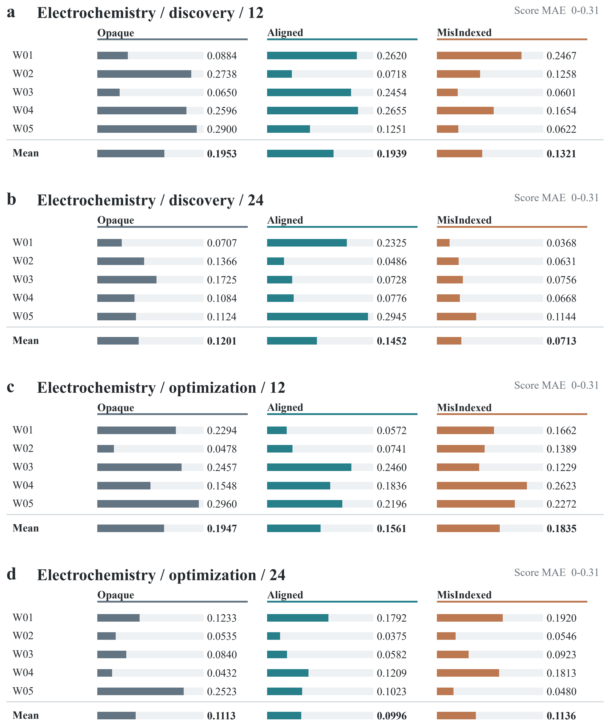
Supplementary Figure S1a–d. Full prior overview for electrochemistry across both goals and budgets. Each graphical table retains five worlds and all three information arms; the bottom row is the arm mean. Bar lengths and adjacent values show prediction MAE on the within-panel scale printed above. An x marks a source-assay shortfall. Scales differ between response types. Appendix B retains all response tables, including equilibrium entity priors.
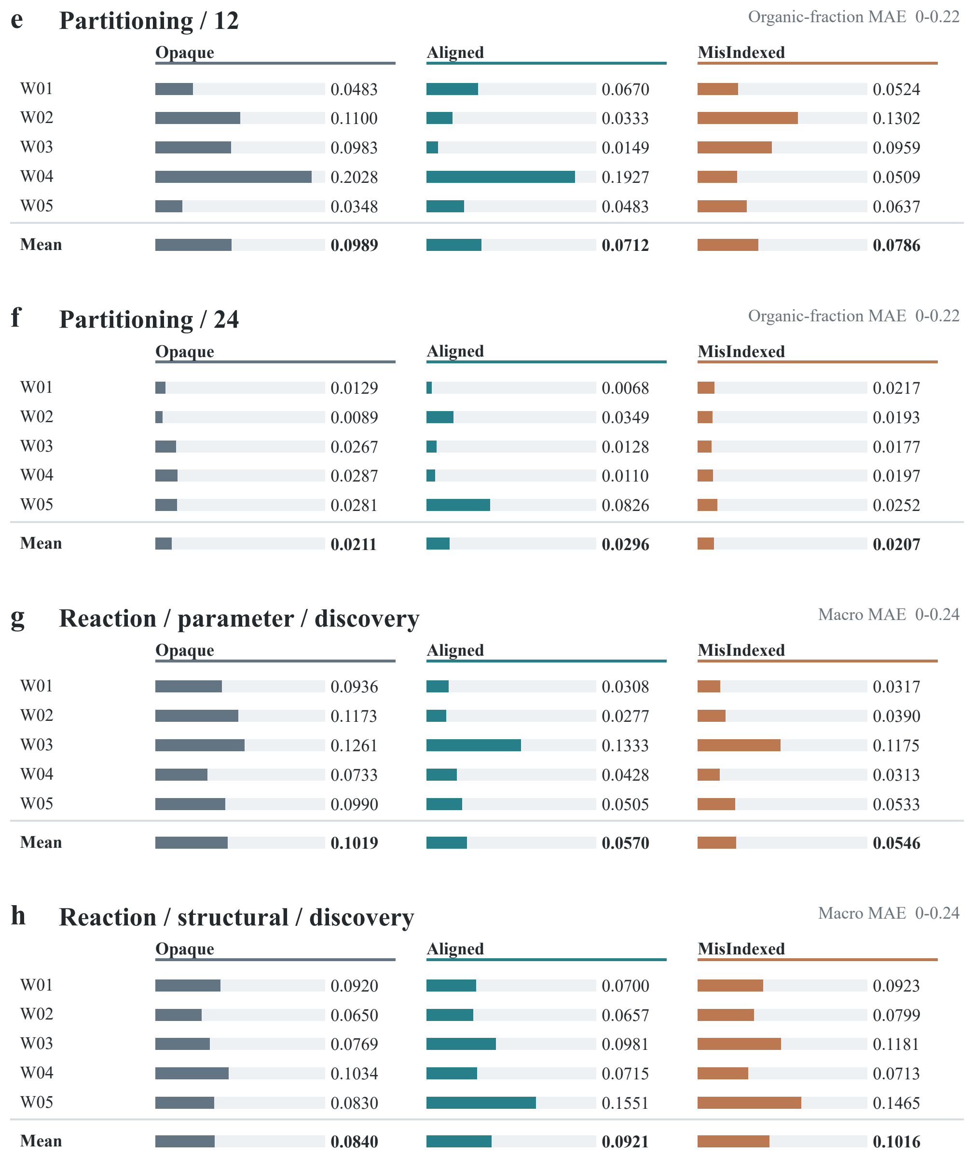
Supplementary Figure S1e–h. Full prior overview for partitioning and reaction discovery. Each graphical table retains five worlds and all three information arms; the bottom row is the arm mean. Bar lengths and adjacent values show prediction MAE on the within-panel scale printed above. An x marks a source-assay shortfall. Scales differ between response types. Appendix B retains all response tables, including equilibrium entity priors.
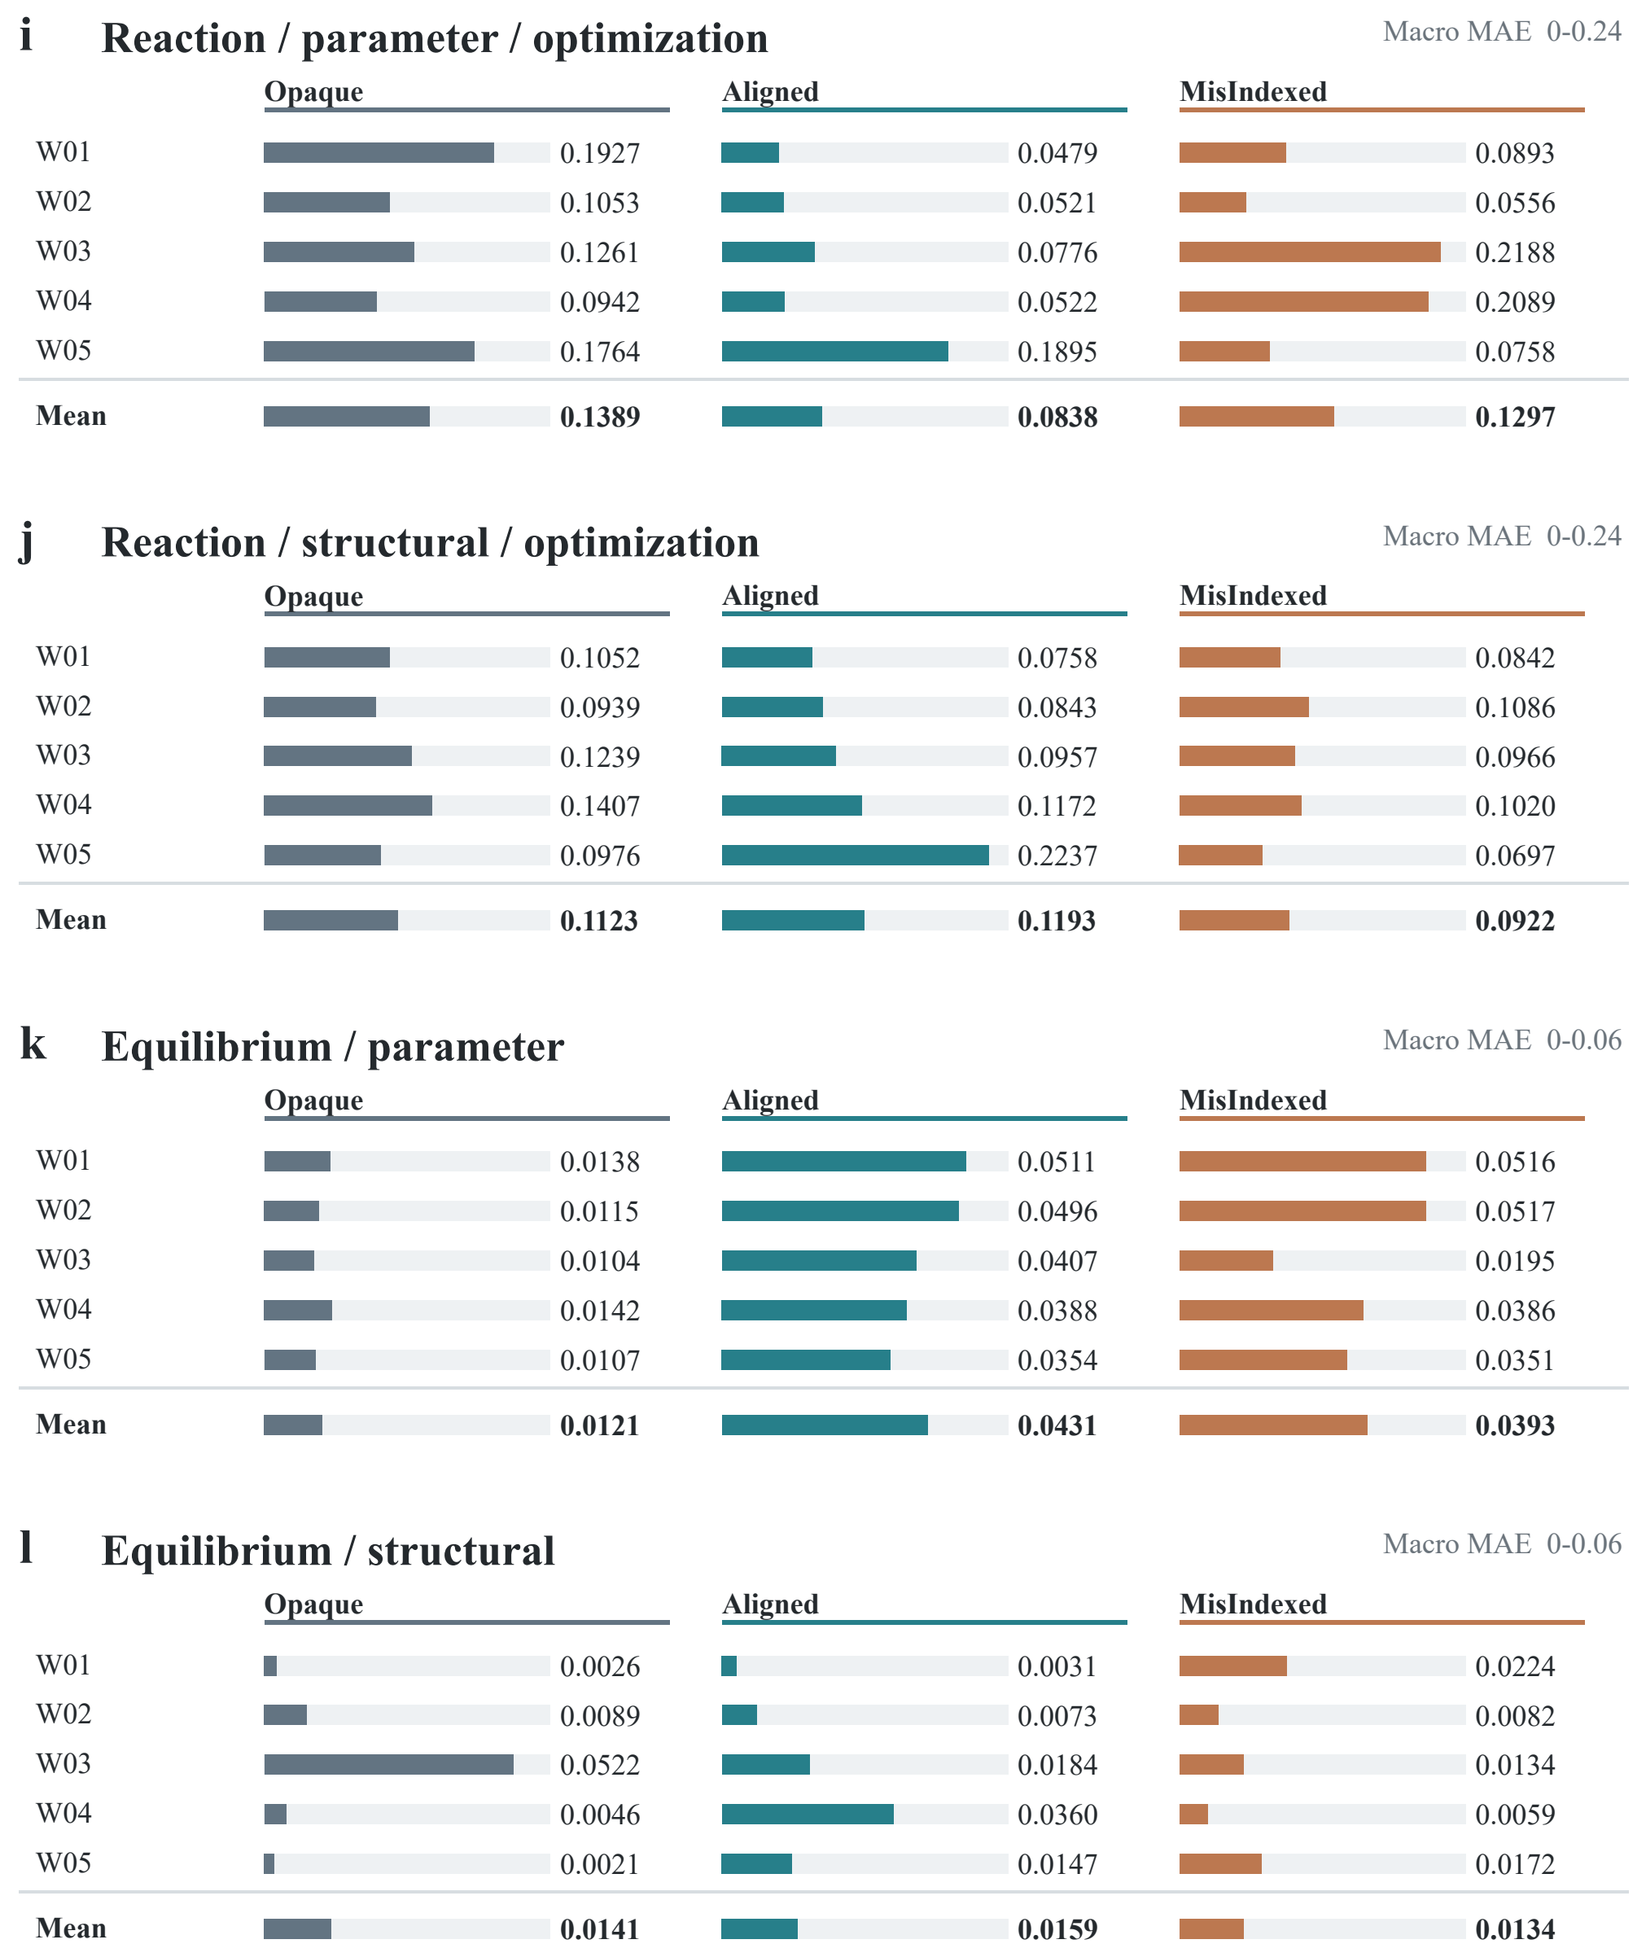
Supplementary Figure S1i–l. Full prior overview for reaction optimization and equilibrium. Each graphical table retains five worlds and all three information arms; the bottom row is the arm mean. Bar lengths and adjacent values show prediction MAE on the within-panel scale printed above. An x marks a source-assay shortfall. Scales differ between response types. Appendix B retains all response tables, including equilibrium entity priors.
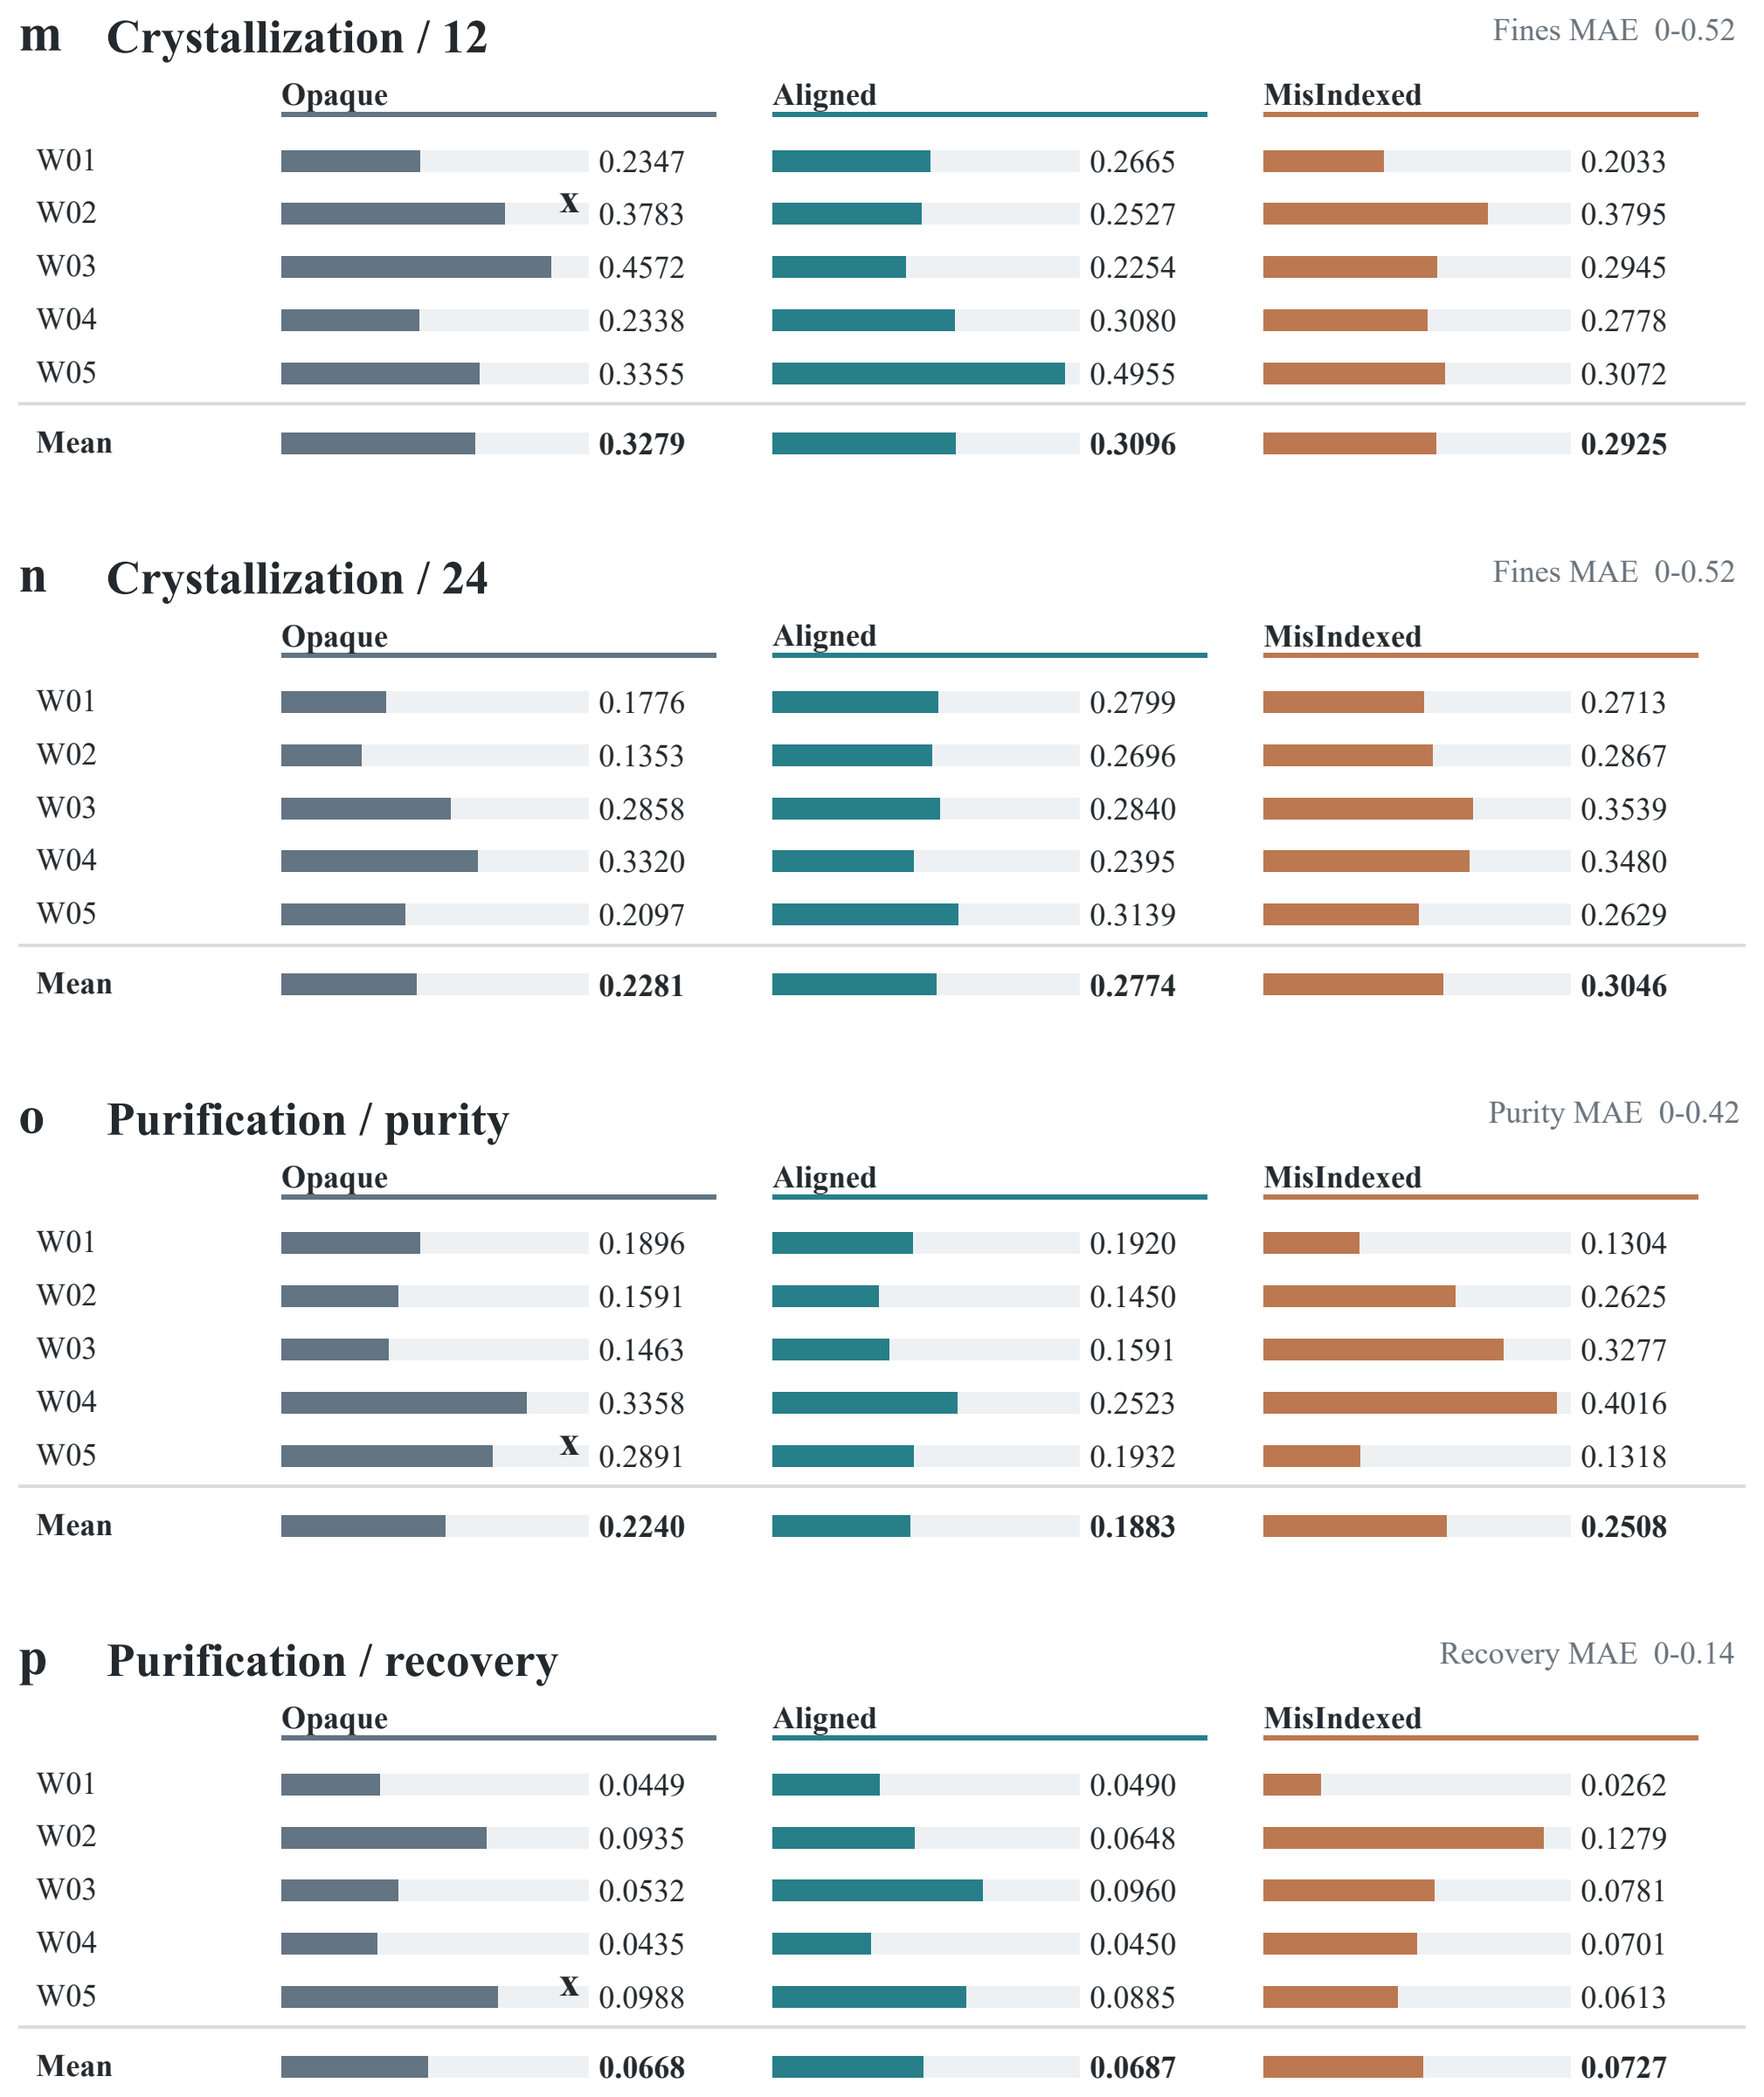
Supplementary Figure S1m–p. Full prior overview for crystallization and purification. Each graphical table retains five worlds and all three information arms; the bottom row is the arm mean. Bar lengths and adjacent values show prediction MAE on the within-panel scale printed above. An x marks a source-assay shortfall. Scales differ between response types. Appendix B retains all response tables, including equilibrium entity priors.

A.7 Prior effects by system and regime
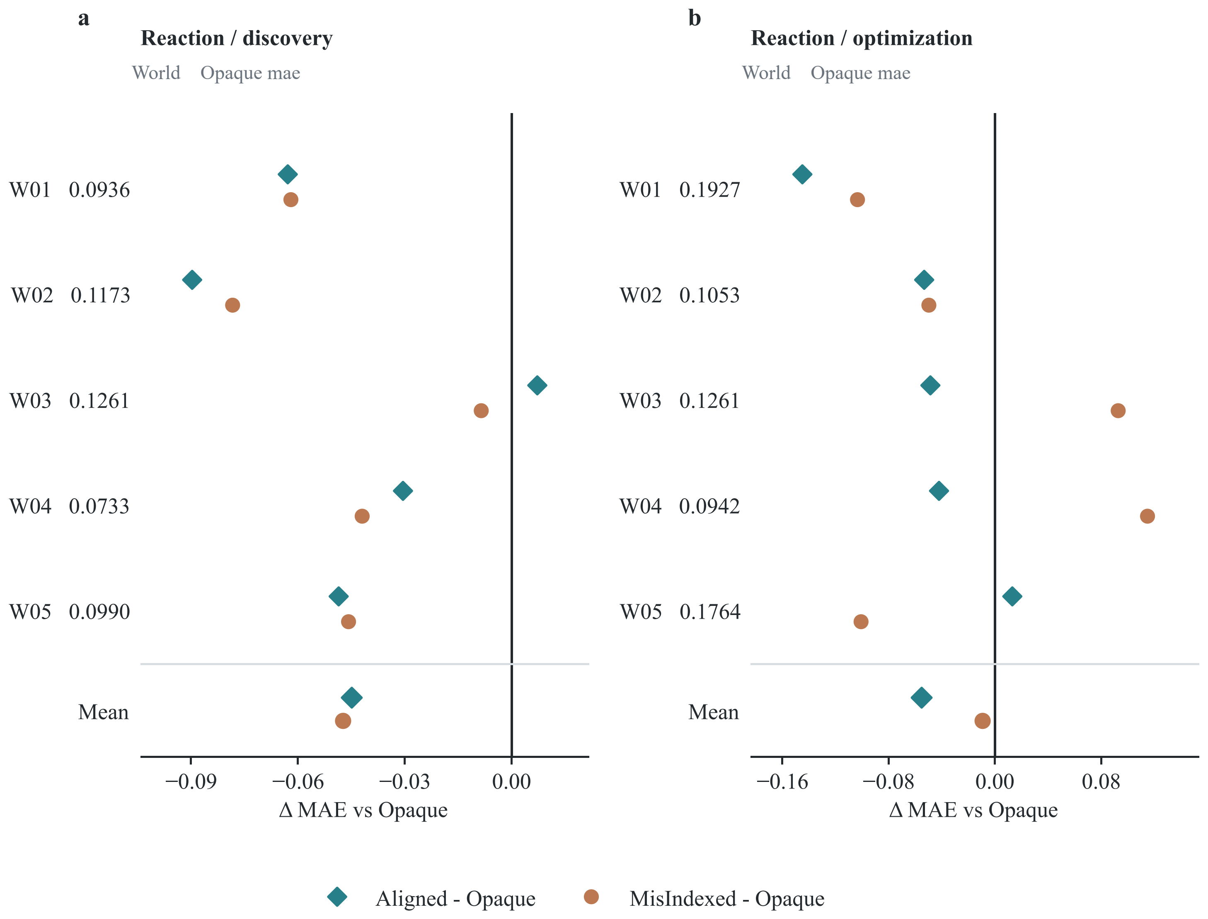
Supplementary Figure S2a,b. Reaction parameter-prior macro MAE differences from Opaque under discovery and optimization. Rows are matched worlds; Opaque absolute MAE is printed at left and only paired differences appear on the horizontal axis. Negative values mean lower error. Bottom marks show mean paired difference. Aligned improves in four of five worlds under each goal.
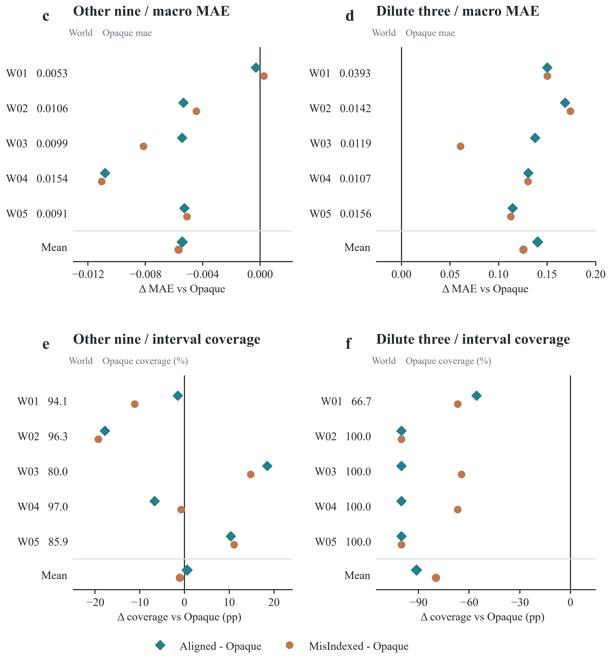
Supplementary Figure S2c–f. Equilibrium parameter-prior differences from Opaque on the remaining nine and three lowest-concentration queries. Panels c,d show macro MAE differences, where negative means lower error. Panels e,f show 80% interval coverage changes in percentage points, where positive means higher coverage. Opaque absolute values are printed separately from the difference axis. Response and regime scales differ. The grouping is post hoc.

A.8 Complete resource comparison
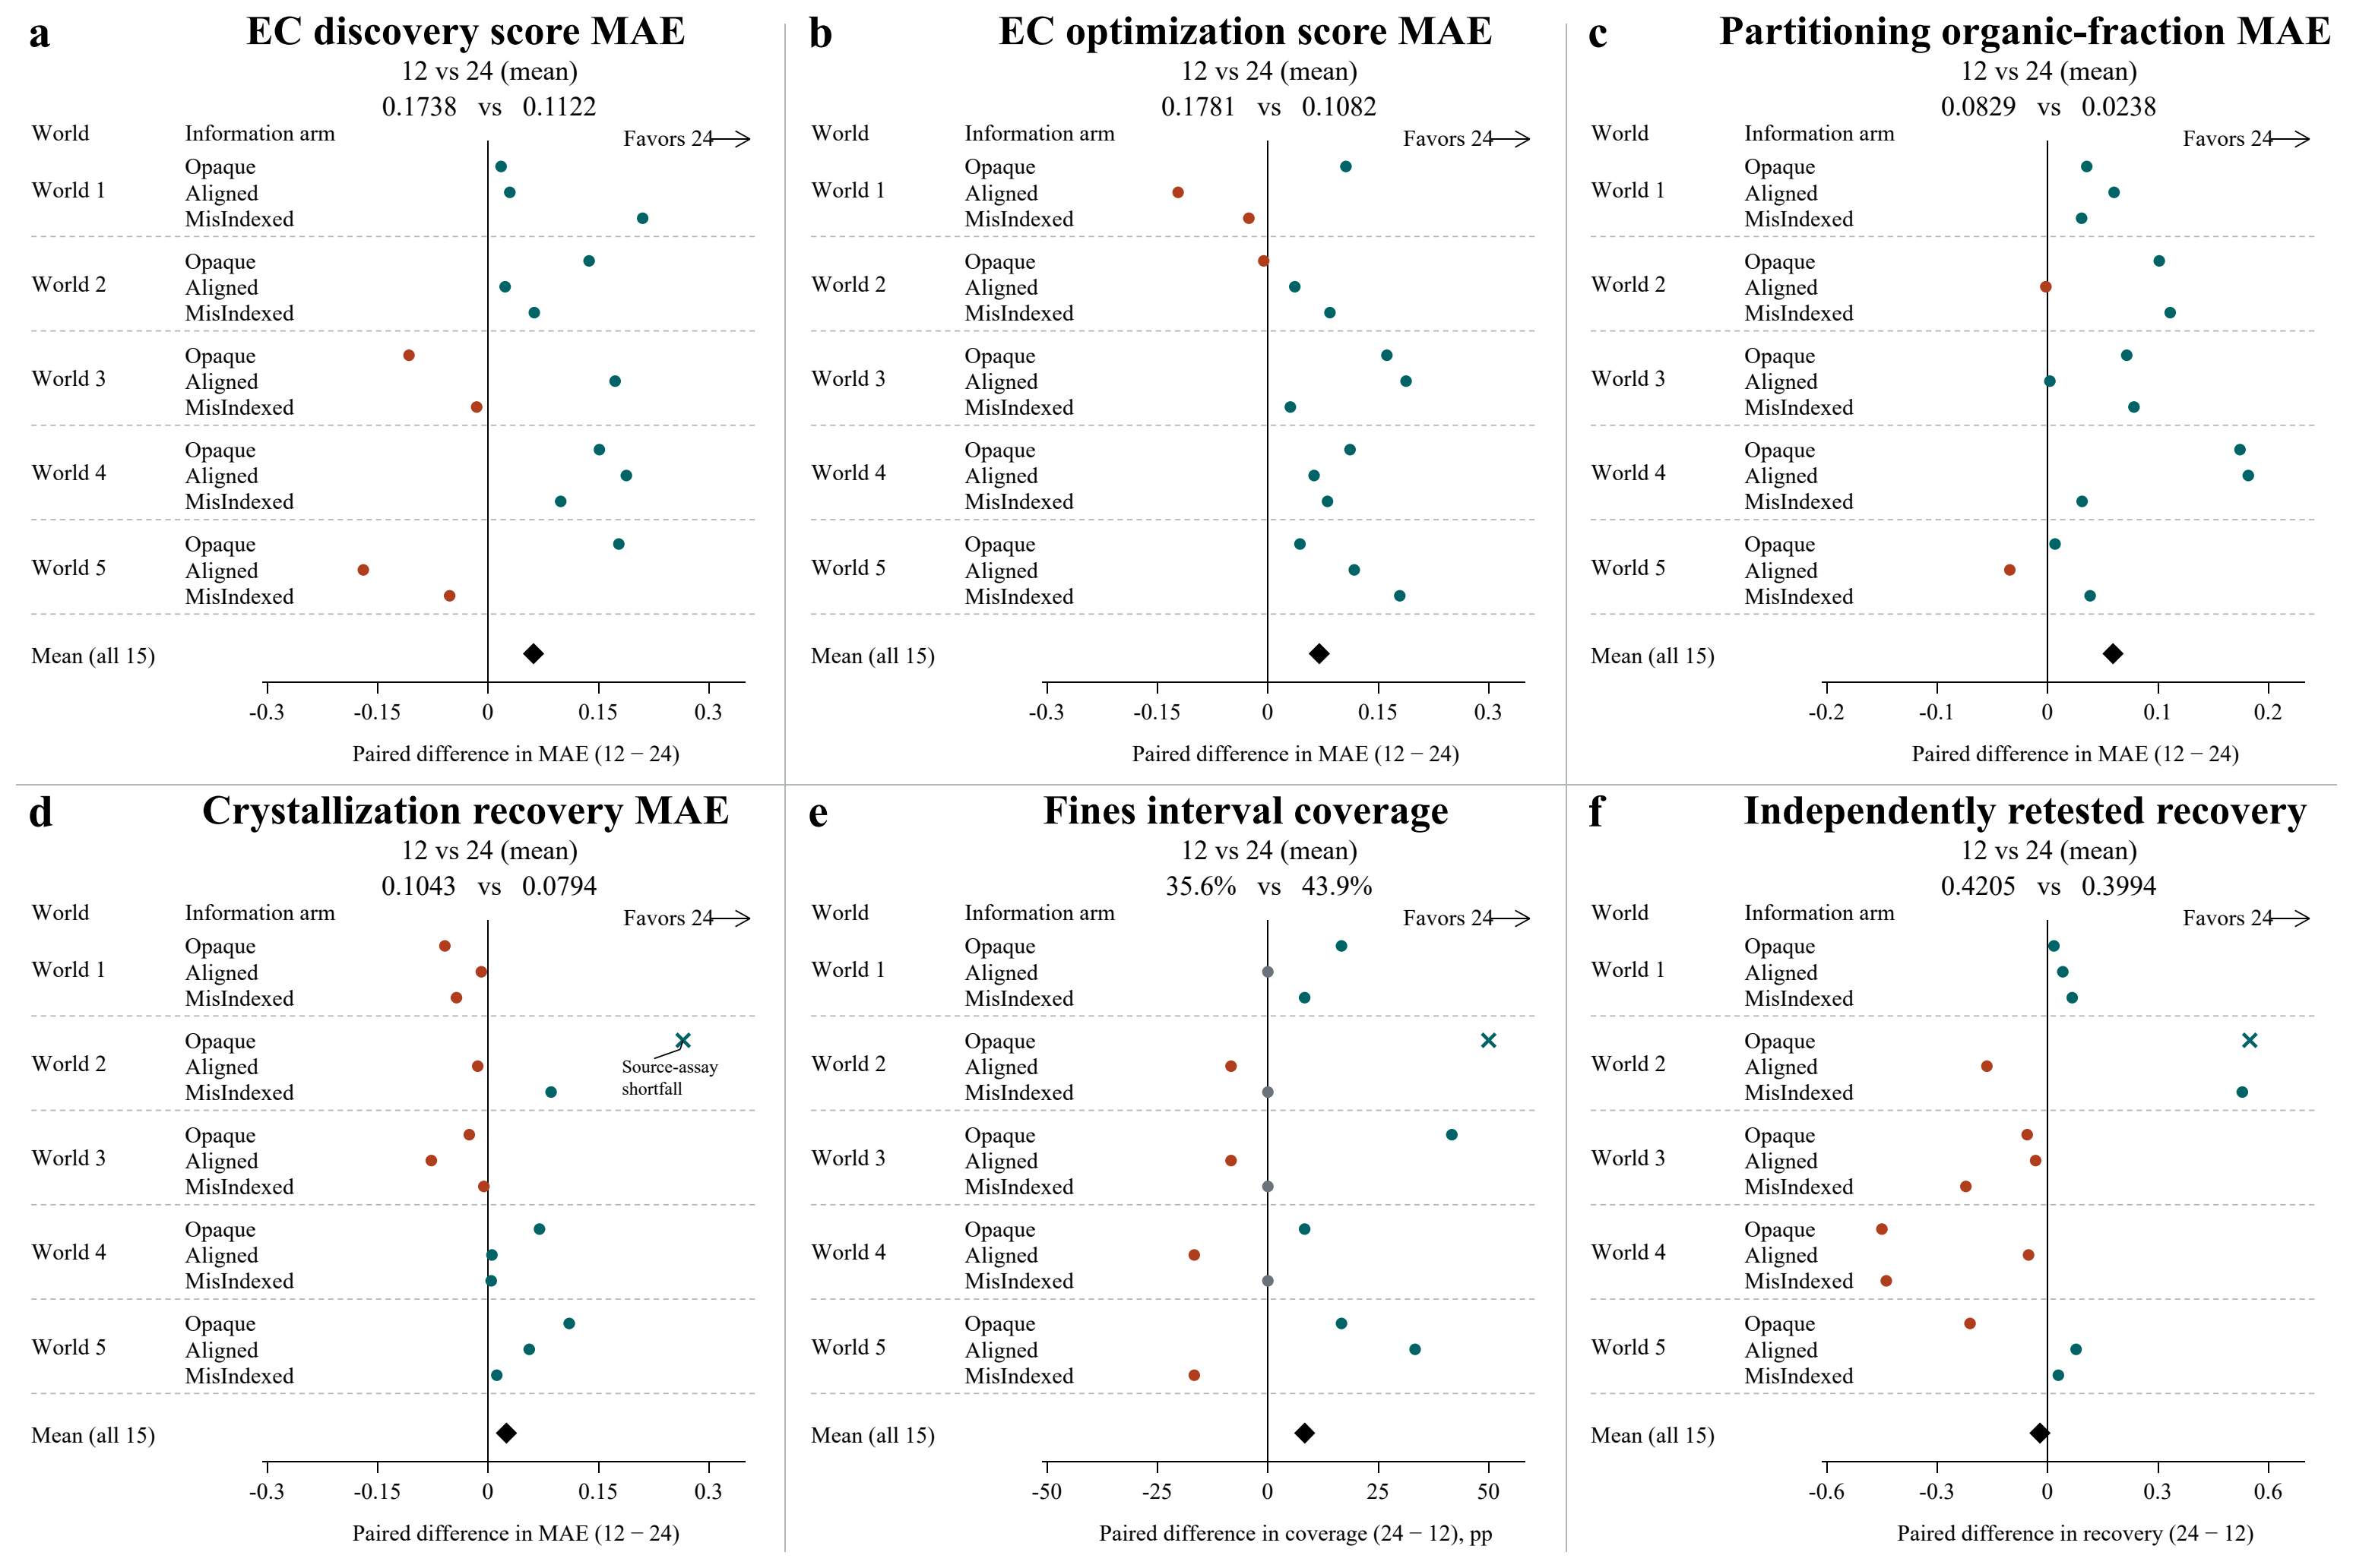
Supplementary Figure S3. Complete budget effects across six readouts. Each panel retains fifteen pairs of independent sessions. Headers show campaign means and rows show paired changes. Positive changes favour the larger research envelope. Panels a–d show MAE at twelve minus MAE at 24 batches; e shows fines coverage at 24 minus coverage at twelve in percentage points; f shows retested recovery at 24 minus recovery at twelve. All fines coverage values remain below nominal 80%. Diamonds show mean changes; crosses retain source-assay shortfalls. Marks are point estimates without uncertainty intervals. World labels are system-specific. Scales differ except in a,b. Crystallization panels reuse campaigns; larger budgets also increase computational allowances.
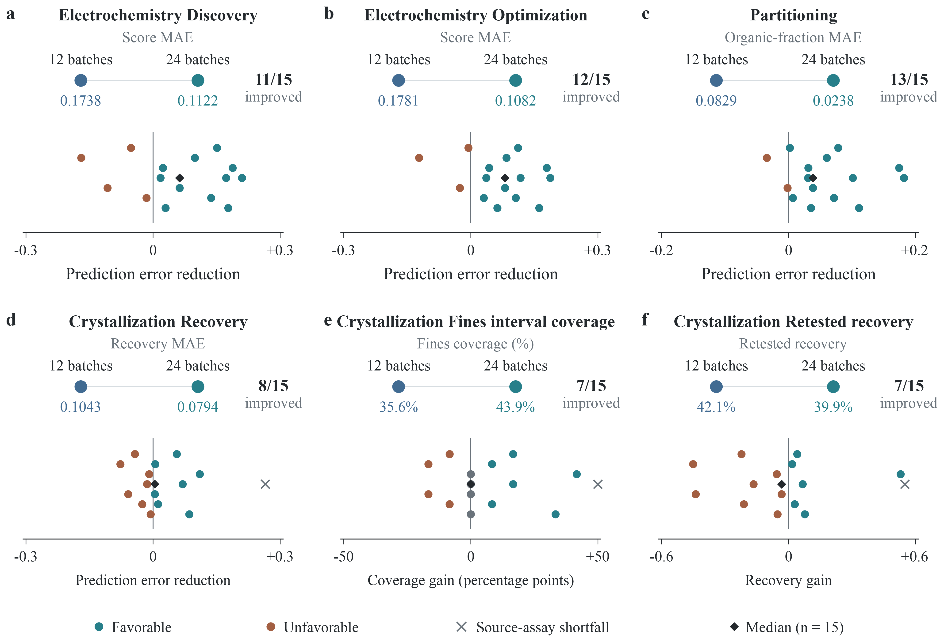
Supplementary Figure S4. Larger research envelopes affect responses differently. a–f show electrochemical discovery score MAE, electrochemical optimization score MAE, partitioning organic-fraction MAE, crystallization recovery MAE, crystallization fines interval coverage and crystallization retested recovery. Panel headers show campaign means at twelve and 24 batches and the number of improving world–arm pairs. Below are signed changes for all fifteen independent-session pairs; vertical offsets only separate overlapping marks. In a–d, change is twelve-batch MAE minus 24-batch MAE; in e,f, it is the 24-batch value minus the twelve-batch value. Positive values therefore always favour larger resources. Black diamonds show median paired change, grey marks at zero denote no change, and crosses retain the C-W02/Opaque source-assay shortfall. Axis scales differ. Larger batch budgets also permit more operations and computation. Supplementary Fig. S3 retains the detailed world–arm matrix for all six outcomes.

A.9 Supplementary platform and execution details
Platform validation. Frozen qualification passes 64 task–world units, 1,786 boundary and categorical recipes, 192 invalid-action probes and 52 generated compositions. Generated cases include eighteen previously absent topologies, eight new task–world identities using registered topologies and 26 additional coverage cases. Component and interface checks pass 32 module probes, seven interface paths and seven invalid-composition tests. These finite-domain checks establish internal consistency of models and execution, not agreement with arbitrary physical chemistry experiments. Exact environment replay reconstructs executed actions and resource consequences, including rejections and rollbacks. Subsequent study adapters are checked separately; frozen platform qualification does not automatically cover later execution code. Reference construction, assessment prompts and recovery differences are retained under each block’s recorded protocol.
Case and statistical interpretation. The crystallization trajectory in Figure 2 and electrochemical pair in Figure 3 are retrospectively selected to illustrate actual research processes, not to estimate population frequencies of the corresponding behaviours. Crystallization batch 5 changes several process conditions, preventing isolation of the effect of omitting quench. Figure temperatures are requested targets, not measured thermal trajectories. The electrochemical comparison uses predictions sealed after two independent campaigns, without repeated prediction assessment after each optimization batch. Points in Figure 4a and Supplementary Fig. S8a come from different recipes and histories, not a controlled single-factor concentration–response curve. The source-observation band is not an uncertainty interval. There are no ties in the response-specific crystallization baseline comparisons.
Operations and infrastructure recovery. The four targeted model configurations retain 4,007 operation attempts, including 85 rejections or rollbacks. A Luna pre-action transport failure and an HTTP 503 during Astra’s final supplemental questions were both recovered, with original failed attempts retained. The latter resumes only the original supplemental prompt in the original session, leaving source experiments and sealed predictions unchanged. Both are infrastructure events, not scientific failures.
Protocol history. Six World 1 pilot sessions for Luna, Terra and GPT-5.5 were inspected before matrix completion and remain unchanged; sensitivity comparisons therefore also use Worlds 2–5. All Astra sessions are new. Retained early electrochemical and partitioning assessments allow eight calculator calls; later blocks disclose allowances up to 128 attempts. All tasks request English output, but retained reaction and equilibrium assessment prompts contain Chinese instructions requesting English answers. These differences remain part of the historical protocol.

A.10 Targeted equilibrium model comparison
The targeted comparison uses the same equilibrium parameter protocol, five worlds, three arms and twelve batches per campaign, with fifteen campaigns for each of four configurations. Each campaign permits at most 180 operation attempts, twelve intermediate measurements, twelve final assays, 0.24 mol reagent and 0.72 L solvent. Prompts, priors, queries, resources and scoring rules are fixed within the block, with one campaign per model–world–information condition. Some World 1 sessions were inspected as pilots; sensitivity analyses excluding that world are reported separately. Supplementary Methods specify the pilot scope.
The four targeted configurations complete 60/60 research chains, 720/720 batches, 240/240 original-session assessment stages and 2,160 scalar predictions, all with exact environment replay. They share 300 reference batches (five worlds × twelve queries × five observations), used only for evaluation. Supplementary Methods describe infrastructure recoveries and rejected operations.

Appendix B. Complete metric-specific arm means
Each entry is mean absolute error / empirical interval coverage (%), averaged over five world sessions. All scheduled sessions are retained, including the two source-budget shortfalls. PA uses nominal 90% intervals; all other studies use 80%. Metric scales and reference targets differ across systems. The machine-readable table includes each campaign’s interval width and protocol status. These tables cover the six-family Sol-medium study; the targeted model comparison is in Appendix F.

EC, E prior: discovery, 12 batches
Readout | Opaque | Aligned | MisIndexed
Electrochemical selectivity | 0.2983 / 55.0 | 0.2740 / 65.0 | 0.1272 / 88.3
Energy efficiency | 0.3098 / 33.3 | 0.2595 / 51.7 | 0.1582 / 63.3
Faradaic efficiency | 0.2580 / 46.7 | 0.2259 / 60.0 | 0.1356 / 73.3
Public score | 0.1953 / 51.7 | 0.1939 / 60.0 | 0.1321 / 71.7
Selective product yield | 0.0731 / 60.0 | 0.0817 / 38.3 | 0.0598 / 56.7
Transport efficiency | 0.2602 / 45.0 | 0.2184 / 66.7 | 0.1328 / 76.7

EC, E prior: optimization, 12 batches
Readout | Opaque | Aligned | MisIndexed
Electrochemical selectivity | 0.2908 / 63.3 | 0.2378 / 66.7 | 0.2661 / 73.3
Energy efficiency | 0.2794 / 43.3 | 0.2541 / 31.7 | 0.2440 / 55.0
Faradaic efficiency | 0.2506 / 53.3 | 0.2532 / 31.7 | 0.2315 / 56.7
Public score | 0.1947 / 55.0 | 0.1561 / 58.3 | 0.1835 / 53.3
Selective product yield | 0.0758 / 43.3 | 0.0623 / 53.3 | 0.0762 / 50.0
Transport efficiency | 0.2478 / 58.3 | 0.2053 / 51.7 | 0.2217 / 60.0

PA, E prior: discovery, 12 batches
Readout | Opaque | Aligned | MisIndexed
Aqueous fraction | 0.0989 / 76.7 | 0.0712 / 80.0 | 0.0786 / 78.3
Organic fraction | 0.0989 / 76.7 | 0.0712 / 80.0 | 0.0786 / 78.3

EC, E prior: discovery, 24 batches
Readout | Opaque | Aligned | MisIndexed
Electrochemical selectivity | 0.1902 / 68.3 | 0.1268 / 80.0 | 0.0428 / 93.3
Energy efficiency | 0.1581 / 61.7 | 0.1651 / 68.3 | 0.0945 / 80.0
Faradaic efficiency | 0.1458 / 65.0 | 0.1505 / 66.7 | 0.0877 / 78.3
Public score | 0.1201 / 63.3 | 0.1452 / 73.3 | 0.0713 / 78.3
Selective product yield | 0.0726 / 53.3 | 0.0573 / 70.0 | 0.0374 / 75.0
Transport efficiency | 0.1495 / 65.0 | 0.1501 / 66.7 | 0.0846 / 78.3

EC, E prior: optimization, 24 batches
Readout | Opaque | Aligned | MisIndexed
Electrochemical selectivity | 0.1403 / 85.0 | 0.1252 / 85.0 | 0.0864 / 90.0
Energy efficiency | 0.1977 / 48.3 | 0.1307 / 60.0 | 0.1779 / 65.0
Faradaic efficiency | 0.1502 / 76.7 | 0.1098 / 78.3 | 0.1515 / 71.7
Public score | 0.1113 / 75.0 | 0.0996 / 71.7 | 0.1136 / 75.0
Selective product yield | 0.0515 / 75.0 | 0.0498 / 56.7 | 0.0587 / 58.3
Transport efficiency | 0.1420 / 80.0 | 0.1257 / 73.3 | 0.1570 / 68.3

PA, E prior: discovery, 24 batches
Readout | Opaque | Aligned | MisIndexed
Aqueous fraction | 0.0251 / 100.0 | 0.0296 / 96.7 | 0.0207 / 100.0
Organic fraction | 0.0211 / 100.0 | 0.0296 / 96.7 | 0.0207 / 100.0

RX, P prior: discovery, 12 batches
Readout | Opaque | Aligned | MisIndexed
Byproduct signal | 0.0800 / 88.7 | 0.0791 / 73.3 | 0.0710 / 81.0
Conversion | 0.0426 / 72.7 | 0.0321 / 70.0 | 0.0306 / 73.3
Safety risk | 0.1031 / 58.3 | 0.0282 / 85.0 | 0.0370 / 81.7
Public score | 0.1195 / 48.7 | 0.0501 / 83.3 | 0.0476 / 90.3
Selectivity | 0.1198 / 58.0 | 0.0818 / 69.3 | 0.0714 / 77.3
Yield | 0.1461 / 35.7 | 0.0708 / 76.7 | 0.0698 / 78.3

RX, P prior: optimization, 12 batches
Readout | Opaque | Aligned | MisIndexed
Byproduct signal | 0.1509 / 57.7 | 0.0805 / 73.0 | 0.1271 / 60.3
Conversion | 0.0474 / 85.3 | 0.0319 / 82.7 | 0.1960 / 53.0
Safety risk | 0.0984 / 56.7 | 0.1106 / 56.7 | 0.0811 / 68.3
Public score | 0.1341 / 30.0 | 0.0818 / 73.0 | 0.0879 / 68.3
Selectivity | 0.1900 / 31.0 | 0.0923 / 69.7 | 0.1360 / 64.7
Yield | 0.2128 / 19.3 | 0.1060 / 65.7 | 0.1499 / 68.7

RX, S prior: discovery, 12 batches
Readout | Opaque | Aligned | MisIndexed
Byproduct signal | 0.1219 / 78.7 | 0.1212 / 75.3 | 0.1279 / 64.7
Conversion | 0.0217 / 97.7 | 0.0266 / 95.3 | 0.0200 / 98.0
Safety risk | 0.0664 / 80.0 | 0.0717 / 66.7 | 0.1276 / 43.3
Public score | 0.0504 / 89.7 | 0.0816 / 61.3 | 0.0665 / 78.0
Selectivity | 0.1280 / 72.7 | 0.1319 / 70.7 | 0.1400 / 55.0
Yield | 0.1157 / 81.7 | 0.1196 / 75.7 | 0.1275 / 61.0

RX, S prior: optimization, 12 batches
Readout | Opaque | Aligned | MisIndexed
Byproduct signal | 0.1376 / 63.7 | 0.1490 / 67.7 | 0.1188 / 66.3
Conversion | 0.0370 / 88.7 | 0.0505 / 82.7 | 0.0425 / 88.3
Safety risk | 0.1000 / 45.0 | 0.1255 / 68.3 | 0.1133 / 45.0
Public score | 0.0932 / 56.0 | 0.0917 / 58.0 | 0.0637 / 81.0
Selectivity | 0.1574 / 56.7 | 0.1570 / 60.3 | 0.1175 / 62.3
Yield | 0.1485 / 63.3 | 0.1422 / 66.3 | 0.0975 / 73.0

EQ, P prior: characterization, 12 batches
Readout | Opaque | Aligned | MisIndexed
Dissociation fraction | 0.0129 / 96.3 | 0.0759 / 68.7 | 0.0646 / 74.7
Normalized pH | 0.0031 / 94.3 | 0.0160 / 65.0 | 0.0150 / 68.7
Precipitation signal | 0.0205 / 83.3 | 0.0376 / 73.3 | 0.0383 / 68.7

EQ, S prior: characterization, 12 batches
Readout | Opaque | Aligned | MisIndexed
Dissociation fraction | 0.0292 / 91.7 | 0.0235 / 76.3 | 0.0122 / 87.7
Normalized pH | 0.0097 / 87.3 | 0.0200 / 75.7 | 0.0203 / 77.7
Precipitation signal | 0.0033 / 95.3 | 0.0042 / 95.7 | 0.0078 / 87.3

EQ, E prior: characterization, 12 batches
Readout | Opaque | Aligned | MisIndexed
Dissociation fraction | 0.0128 / 83.7 | 0.0107 / 85.0 | 0.0134 / 79.0
Normalized pH | 0.0233 / 80.7 | 0.0278 / 79.0 | 0.0202 / 82.0
Precipitation signal | 0.0084 / 89.3 | 0.0116 / 92.0 | 0.0103 / 88.3

C, E prior: delivery, 12 batches
Readout | Opaque | Aligned | MisIndexed
Fines fraction | 0.3279 / 25.0 | 0.3096 / 38.3 | 0.2925 / 43.3
Crystal purity | 0.0095 / 98.3 | 0.0497 / 60.0 | 0.0917 / 23.3
Particle-size index | 0.0777 / 55.0 | 0.0624 / 58.3 | 0.0725 / 58.3
Net crystal recovery | 0.1632 / 48.3 | 0.0606 / 83.3 | 0.0892 / 71.7

C, E prior: delivery, 24 batches
Readout | Opaque | Aligned | MisIndexed
Fines fraction | 0.2281 / 51.7 | 0.2774 / 38.3 | 0.3046 / 41.7
Crystal purity | 0.0197 / 95.0 | 0.0398 / 73.3 | 0.0508 / 55.0
Particle-size index | 0.0566 / 71.7 | 0.0440 / 70.0 | 0.1023 / 48.3
Net crystal recovery | 0.0911 / 61.7 | 0.0684 / 80.0 | 0.0786 / 73.3

P, E prior: delivery, 12 batches
Readout | Opaque | Aligned | MisIndexed
Purity | 0.2240 / 51.7 | 0.1883 / 53.3 | 0.2508 / 50.0
Recovery | 0.0668 / 56.7 | 0.0687 / 51.7 | 0.0727 / 53.3

Appendix C. Exploratory analyses of response regimes
These analyses use the retained source campaigns and their original predictions. They do not define new experimental arms or alter the withheld-condition bank. The concentration grouping, joint crystallization contrast and illustrative traces were selected after the experiments, and are descriptive analyses of reused worlds.

C.1 Equilibrium: a reversal across public concentration regimes
The three most dilute recipes have nominal concentrations approximately $1.33×{10}^{−4}$, $1.33×{10}^{−5}$ and $1.67×{10}^{−4}$ M. Each campaign has three normalized responses for each recipe. Point errors use five-observation means; interval coverage uses the individual reference observations. Group means average the corresponding responses and queries and then the five world campaigns. Weighting the two groups 3:9 reconstructs every original twelve-question campaign macro MAE. The other nine queries include boundary conditions; this split is not a predeclared interpolation-versus-extrapolation test.
Query group / arm | Macro MAE | Coverage (%) | Interval width | Source-mean MAE
Other nine / Opaque | 0.01008 | 90.7 | 0.04706 | 0.00553
Other nine / Aligned | 0.00465 | 91.3 | 0.03340 | 0.00518
Other nine / MisIndexed | 0.00439 | 89.6 | 0.02798 | 0.00494
Three most dilute / Opaque | 0.01833 | 93.3 | 0.15676 | 0.16961
Three most dilute / Aligned | 0.15862 | 2.2 | 0.08084 | 0.16833
Three most dilute / MisIndexed | 0.14397 | 13.8 | 0.09633 | 0.16836
Table C1. EQ/P subgroup results. Each row averages five worlds; rows reuse those worlds. The source-mean predictor is an additional post hoc diagnostic and obtains no new experiments. Its poor dilute-query performance shows why retaining the plateau is insufficient; its usefulness on the other nine depends on their response distribution.
Aligned improves on the other nine and worsens on the dilute three relative to Opaque in all five worlds. All fifteen source campaigns remain above 0.018 M. In the selected second-world comparison, Aligned spans about ninety-fold source concentration variation and Opaque about fourfold, but both remain in the observed plateau. At the most dilute question, reference dissociation is 0.65463; Opaque predicts 0.629 [0.45, 0.80] and Aligned 0.0804 [0.053, 0.108]. The Opaque prediction response develops an unsaturated weak-acid extrapolation beyond its sealed report. This reasoning must not be credited retrospectively to K1 or to an earlier source-stage hypothesis.

C.2 Crystallization: joint response changes under the same treatment
Budget / arm | Recovery MAE | Purity MAE | Recovery improves and purity worsens vs Opaque
12 / Opaque | 0.16322 | 0.00952 | Reference
12 / Aligned | 0.06055 | 0.04969 | 5 / 5 worlds
12 / MisIndexed | 0.08923 | 0.09166 | 5 / 5 worlds
24 / Opaque | 0.09107 | 0.01975 | Reference
24 / Aligned | 0.06839 | 0.03983 | 2 / 5 worlds
24 / MisIndexed | 0.07863 | 0.05080 | 3 / 5 worlds
Table C2. Joint directional comparisons use both response errors from the same world, arm and budget. At twelve batches, each joint direction also holds in all four pairs whose two campaigns conform to the source-assay contract. The direction weakens at 24 batches. A treatment can therefore be helpful on one response and harmful on another without implying a budget-invariant tradeoff.

C.3 Evidence status and interpretation
The same-source C references use only each campaign’s final assays and public recipe features. They exclude hidden truth during fitting but do not reproduce the agent’s complete intermediate measurements, prior or computational policy. Low held-out purity variation makes the mean a particularly strong reference. Neither its success nor the agent’s recovery advantage is a complete mechanism identification result.
Selected EC and C traces support detailed examples rather than population frequencies; the bounded EQ review below covers all fifteen campaigns in that block. The current evidence does not causally identify prior anchoring, report compression, acquisition-versus-inference mediation or a general preference for familiar chemistry. Full-history Q also prevents interpreting K1 as the sole information channel. Experimental selection and later interpretation are both part of the original autonomous process. Their separate causal contributions are not required to describe the observed whole-process contrasts and have not been identified here.

C.4 Original equilibrium campaigns: predictions and research chronology
We reviewed all fifteen retained Sol parameter-prior equilibrium campaigns, comprising 180 batches, 945 operations and 45 K1/Q/K2 stages. Each row below is an original autonomous research session, not an independent reader of its records. The selected question uses 1 micromole in 75 mL; the same question and original reference targets apply to all three arms in a world. The reference column is the five-observation mean.
World / arm | Public Q explanation | Dissociation [80% interval] | Reference
1 / Opaque | Piecewise weak acid | 0.6990 [0.250, 0.900] | 0.7160
1 / Aligned | Plateau / weak trend | 0.1040 [0.044, 0.225] | 0.7160
1 / MisIndexed | Plateau / weak trend | 0.1092 [0.0772, 0.1412] | 0.7160
2 / Opaque | Piecewise weak acid | 0.6290 [0.450, 0.800] | 0.6546
2 / Aligned | Plateau / weak trend | 0.0804 [0.053, 0.108] | 0.6546
2 / MisIndexed | Plateau / weak trend | 0.0806 [0.0556, 0.1056] | 0.6546
3 / Opaque | Piecewise weak acid | 0.5630 [0.430, 0.700] | 0.5797
3 / Aligned | Plateau / weak trend | 0.1100 [0.045, 0.190] | 0.5797
3 / MisIndexed | Mixed weak acid / plateau | 0.4600 [0.100, 0.750] | 0.5797
4 / Opaque | Qualitative departure | 0.5200 [0.150, 0.880] | 0.5173
4 / Aligned | Plateau / weak trend | 0.0724 [0.040, 0.105] | 0.5173
4 / MisIndexed | Plateau / weak trend | 0.0962 [0.040, 0.450] | 0.5173
5 / Opaque | Piecewise weak acid | 0.4130 [0.200, 0.700] | 0.4480
5 / Aligned | Plateau / weak trend | 0.0790 [0.035, 0.130] | 0.4480
5 / MisIndexed | Plateau / weak trend | 0.0681 [0.040, 0.096] | 0.4480
Table C3. Public extrapolation accounts and original same-context predictions. Categories are a single-author retrospective reading of public explanations, not internal reasoning traces or independent causal labels. Four Opaque accounts use piecewise weak-acid reasoning; the fifth permits a qualitative departure. All five Aligned accounts extend a plateau or weak trend. The third-world MisIndexed mixed account is a counterexample to treating all dossier conditions alike.
The first-world Opaque K1 already estimates an effective acid constant near $2.2×{10}^{−5}$ and an active-pool cap near 0.004 M, while retaining competing interpretations. Its Q applies that hypothesis at low concentration. In the second world, Opaque K1 primarily supports the observed plateau and limits extrapolation; the unsaturated weak-acid calculation is first explicit in Q. The aligned K1 similarly limits its account to the sampled region, but its Q interval still misses the dilute response by a large margin. These differences separate what was stated before prediction from what became explicit during it.
All fifteen source concentration ranges lie above the three dilute test recipes. The exported per-operation decision-reason fields are unavailable for all 945 operations. Actions and observations can therefore be reconstructed, but a contemporaneous sequence of belief revisions cannot be inferred from these fields. K1, Q and K2 remain distinct public records rather than substitutes for that sequence.
In K2, eleven of fifteen campaigns propose a trace-load experiment: five Opaque, three Aligned and three MisIndexed. The other choices are equal-concentration scale-up, dilution near the supplied relation, comparison of instruments at the same state and repetition of an anomalous batch. K2 follows exposure to Q conditions without feedback on their reference outcomes. None of these proposals was executed; they are retrospective choices, not source-stage plans or demonstrated repairs.

Appendix D. Selected autonomous research histories
Figure 2 follows one retrospectively selected, twelve-batch MisIndexed crystallization session through a complete series of experiments and its selected operating procedure. Supplementary Fig. S5 presents a separate W05 Aligned 12/24-batch pair and its withheld thermal question. Neither selection estimates a cohort-wide effect; the matched budget comparison is in Supplementary Fig. S4.

D.1 Complete twelve-batch research path and recommendation
Figure 2 retains all twelve source results in the W04 MisIndexed session. The first four batches have 99.5–100.0% fines and fail the 50% limit. Batch 5 is the first feasible result (40.0% recovery, 30.3% fines) after omitting quench and cooling towards 325 K before seeding. Catalyst, heating, seed and cooling conditions also differ from the early batches; this comparison does not identify a separate quench effect. In the subsequent process family, batches 5–7 end at 275, 265 and 250 K, with recovery 40.0%, 42.8% and 45.0%, respectively. Batch 8 reduces seed from 5 to 1 mg and gives 45.5% recovery and 25.4% fines. Batches 9–10 probe seed omission and longer holding. Batch 11 halves S2 from 0.080 to 0.040 L but yields 44.6% recovery and 72.6% fines, violating quality. Batch 12 repeats the batch-8 recipe and remains feasible (44.1% recovery, 26.9% fines). The exact numerical optimum is less secure than the repeated feasibility of this operating region.
The agent sealed batch 8 as its recommendation. Its source final assay reported 45.5% seed-excluded recovery, 98.2% purity and 25.4% fines; independent retest reported 43.9%, 98.7% and 28.4%, respectively. The recipe charges 0.040 mol reagent, 0.080 L S2 and 0.005 mol C1; heats towards 355 K for 3,600 s at 300 rpm; cools towards 325 K over 7,200 s; adds 1 mg seed; cools towards 250 K over 14,400 s; holds for 14,400 s at 100 rpm; measures particle size, filters, terminates and assays. In this environment, quench stops reaction chemistry while subsequent cooling and crystal growth remain possible. Heating and cooling values are requested targets, not measured temperature trajectories.
The source trajectory records operations and observations but no contemporaneous verbal rationale for each batch. Figure 2c therefore labels decision questions as author reconstructions. K1 was written after all twelve experiments. It interpreted the contrast between quenched and controlled-cooling batches as evidence for nucleation-history dependence while acknowledging that multiple recipe variables changed; the mechanism is plausible but not isolated by this campaign. K2 later identified the confound explicitly. No new experiment was run to distinguish quench from the other changes.

D.2 Sealed predictions and subsequent reflection
Figure S5 follows a separate W05 Aligned pair of independent 12- and 24-batch sessions through sealed prediction and subsequent reflection; the proposed experiment was not executed. In the 24-batch session, the first nineteen batches fail the fines limit, batch 20 first meets it, and batch 23 is selected. The 12-batch session first meets the quality rule at batch 1. These paths and their Q/K2 assessments do not belong to Figure 2’s W04 session and are not a matched quench test.
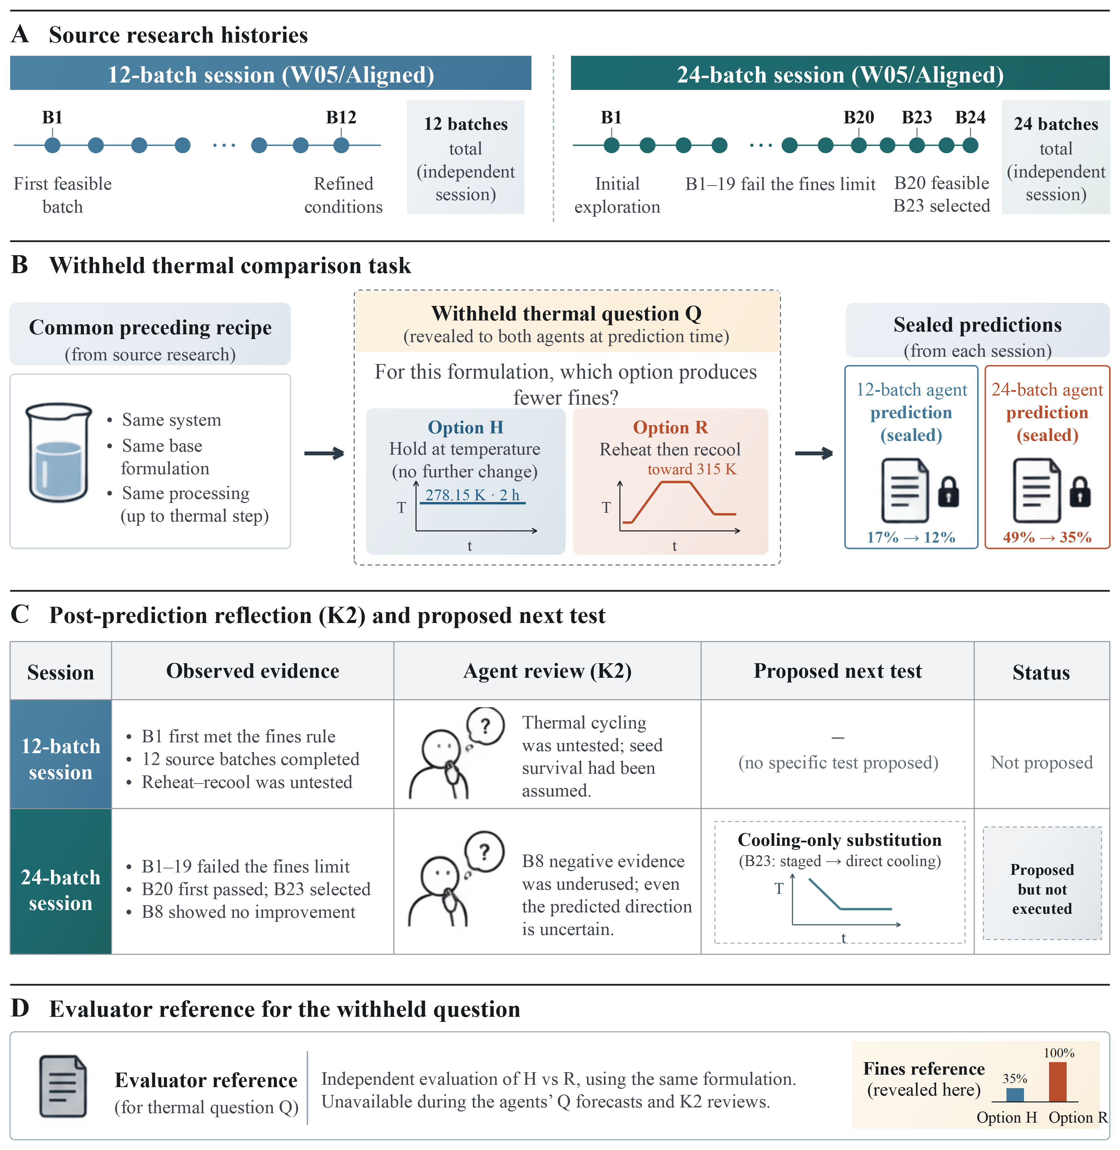
Supplementary Figure S5. Sealed predictions and subsequent reflection in a W05 crystallization pair separate from Figure 2. A, The independent twelve- and twenty-four-batch source histories: the twelve-batch session first meets the fines rule at batch 1; the twenty-four-batch session first meets it at batch 20 and selects batch 23. B, The same withheld question in both sessions replaces a two-hour hold at 278.15 K with heating towards 315 K for one hour and recooling for one hour after a common preceding recipe. Both sealed Q answers predict fewer fines (17% to 12% at twelve batches; 49% to 35% at twenty-four batches). Thermal profiles show requested targets schematically. C, Condensed public K2 answers follow Q without reference feedback. The twenty-four-batch session proposes changing only the cooling procedure of its selected batch; this experiment was not executed. D, The evaluator’s reference is for the thermal intervention in B, not the proposal in C. It was unavailable during Q and K2 and gives the opposite fines direction.

Appendix E. Supporting outcomes and examples

E.1 Quality constraints and response-specific references
Purification gives a related distinction between recovery and acceptable delivery. Aligned recommendations meet the purity threshold in three of five worlds, compared with none for Opaque or MisIndexed. Yet mean recovered fractions are 0.04455, 0.12373 and 0.32105 for Aligned, Opaque and MisIndexed, respectively. Recovering more material therefore does not imply satisfying the commission. A single retest near the purity threshold is also not a precise estimate of a procedure’s reliability. These system-specific outcomes cannot be represented faithfully by a universal yield score (Fig. S6a).
Purification provides another response-specific example: fourteen of fifteen campaigns correctly judge a small concentration effect on purity, but only two correctly judge the small purity effect of splitting a wash. Recognizing approximate invariance is itself a predictive achievement, and depends on the intervention.
In crystallization, agent size forecasts have lower MAE than the source mean in four of thirty campaigns and fines forecasts in twenty-one (Fig. S6b,c). Together with the recovery and purity contrasts in the main text, these results retain the complete response-specific comparison.
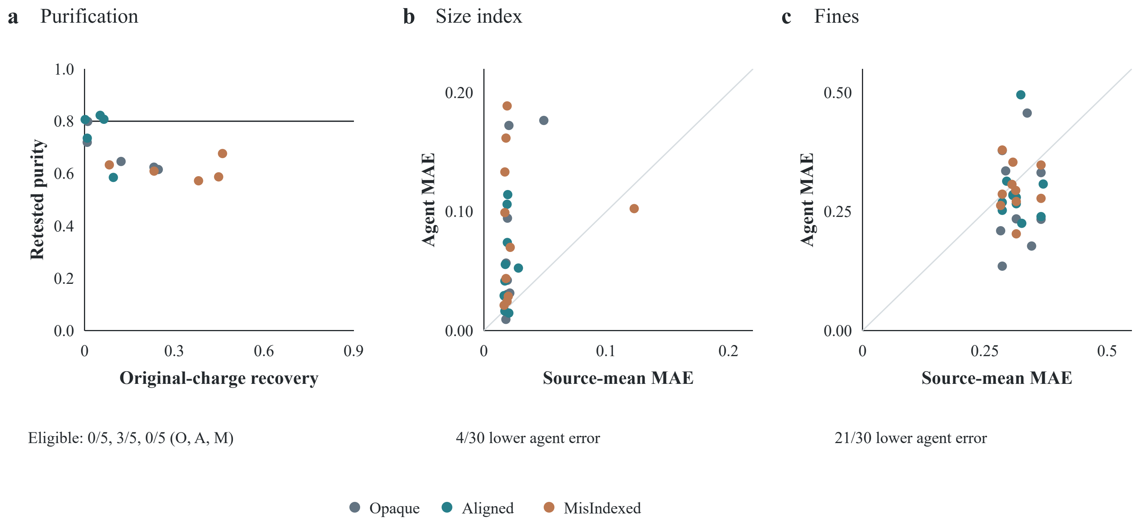
Supplementary Figure S6. Additional operational and predictive outcomes. a, All fifteen purification recommendations, showing original-charge recovery and independently retested purity. The line marks the purity threshold of 0.80; eligible counts are 0/5, 3/5 and 0/5 for Opaque, Aligned and MisIndexed. b,c, Size and fines MAE for all thirty crystallization campaigns relative to each campaign’s public observation mean. Points above the diagonal favour the mean; the campaign with a source-assay shortfall remains included. These panels use different response scales.

E.2 Additional selected examples
In a selected Aligned phase-partitioning campaign pair, the larger budget covers all sixteen material pairings and then allocates eight experiments to process variation; the smaller campaign covers ten pairings. This is a plausible route to improvement, not a cohort-wide causal explanation. Two Aligned world pairs nevertheless worsen.
Uncertainty is part of the same applicability problem. The poor dilute-equilibrium coverage shows that a wrong extrapolation can also be overconfident. In a retrospectively selected MisIndexed crystallization campaign, the scientific account (K1) explicitly acknowledges that only one solvent was tested. Nevertheless, predicted purity averages 0.86833 against a reference mean of 0.98566, and all twelve nominal 80% intervals miss. A verbal statement of uncertainty does not by itself ensure calibrated quantitative prediction.

E.3 Complete crystallization baseline and interval comparisons
Figure 6b reports how often each response is predicted more accurately than the public observation mean. Table E1 supplies the corresponding error magnitudes and the public nearest-neighbour comparison. Each baseline is fitted separately to the same campaign’s public final assays; neither receives withheld outcomes or additional experiments. Nearest-neighbour prediction also uses public recipe features. These are empirical references rather than strong system-identification baselines.
Table E1. Crystallization prediction errors and baseline comparisons.
Response | Agent MAE | Mean MAE | Nearest MAE | Wins: mean | Wins: nearest
Recovery | 0.09185 | 0.17135 | 0.17308 | 26/30 | 26/30
Purity | 0.04354 | 0.00482 | 0.00905 | 0/30 | 4/30
Size index | 0.06923 | 0.02345 | 0.02708 | 4/30 | 7/30
Fines fraction | 0.29000 | 0.31651 | 0.32426 | 21/30 | 20/30
MAE is averaged equally over all thirty campaigns in each response’s original scale; errors are not ranked across responses. Recovery, purity and fines are fractions, while size is the declared size index. Mean and Nearest denote the public observation-mean and nearest-neighbour predictors. Wins count strictly lower agent MAE; neither comparison has ties. The source-assay shortfall remains included, and the five world instances are reused across arms and independent budget sessions.
Table E2 accompanies the purity coverage comparison in Figure 6d. Wider intervals need not cover a biased prediction’s reference, while coverage exceeding the nominal level does not by itself establish calibration or sharpness.
Table E2. Purity interval coverage and width by information arm and budget.
Budget | Information arm | Campaigns | Coverage (%) | Mean width (pp)
12 | Opaque | 5 | 98.3 | 6.81
12 | Aligned | 5 | 60.0 | 12.94
12 | MisIndexed | 5 | 23.3 | 15.53
24 | Opaque | 5 | 95.0 | 8.59
24 | Aligned | 5 | 73.3 | 12.37
24 | MisIndexed | 5 | 55.0 | 12.31
The original intervals have nominal 80% coverage and concern the pre-final-assay response target. Coverage and interval width are averaged over each campaign’s twelve queries and then over its five-world arm-budget group. Each row contains sixty query targets but only five world clusters; queries are not independent world replicates. Width is expressed in percentage points of purity. All original intervals and source failures remain unchanged.

E.4 Complete research-objective comparison
Figure 3 uses 120 campaigns and sixty original goal pairs. Each pair fixes world, information arm, budget and prior locus. EC has five worlds, three arms and two budgets at the entity locus; RX has five worlds, three arms and two loci at twelve batches. The independent recommendation retest and twelve-query score MAE are separate endpoints. EC references are single seeded observations; RX point references are five-observation means. No new campaigns or predictions were produced for this analysis.
Table E3. All joint goal outcomes.
Higher retest | Lower score MAE | EC pairs | RX pairs
Optimization | Optimization | 13 | 4
Optimization | Discovery | 13 | 5
Discovery | Optimization | 1 | 4
Discovery | Discovery | 3 | 17
Both endpoints favour the same campaign in 16/30 EC and 21/30 RX pairs, and opposite campaigns in 14/30 and 9/30. Strict signs define these descriptive counts; near-zero differences are not thereby significant. Each system reuses five worlds. RX score MAE favours optimization in 8/30 pairs; its separate six-response macro MAE does so in 6/30.
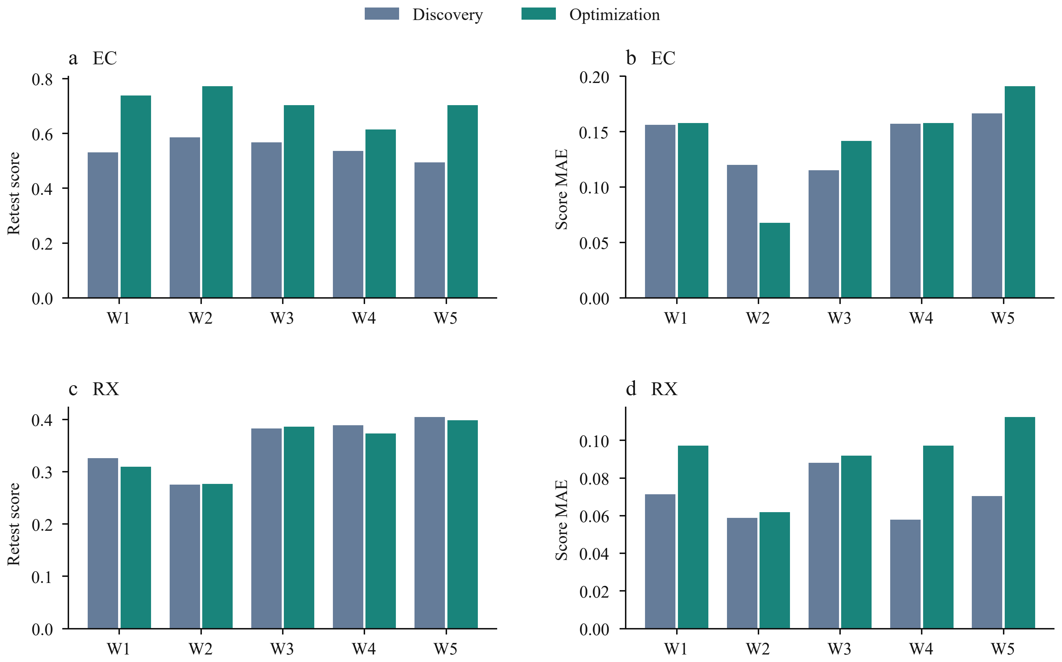
Supplementary Figure S7. World-level summaries of the same goal comparison. a,b, Electrochemical recommendation retests and score-prediction MAE. c,d, Reaction-processing endpoints. Each bar averages six campaigns per goal within a world. World labels are system-specific; bar means do not replace the individual paired differences in Figure 3. Scales differ across panels.

E.5 Strata and recovery sensitivity
Table E4. Endpoint orderings within design strata.
System | Factor | Level | Pairs | Same | Opposite
EC | World | W01 | 6 | 3 | 3
EC | World | W02 | 6 | 4 | 2
EC | World | W03 | 6 | 3 | 3
EC | World | W04 | 6 | 5 | 1
EC | World | W05 | 6 | 1 | 5
EC | Budget | 12 | 15 | 7 | 8
EC | Budget | 24 | 15 | 9 | 6
EC | Arm | Aligned | 10 | 6 | 4
EC | Arm | MisIndexed | 10 | 5 | 5
EC | Arm | Opaque | 10 | 5 | 5
EC | Locus | E | 30 | 16 | 14
RX | World | W01 | 6 | 4 | 2
RX | World | W02 | 6 | 4 | 2
RX | World | W03 | 6 | 3 | 3
RX | World | W04 | 6 | 4 | 2
RX | World | W05 | 6 | 6 | 0
RX | Budget | 12 | 30 | 21 | 9
RX | Arm | Aligned | 10 | 6 | 4
RX | Arm | MisIndexed | 10 | 9 | 1
RX | Arm | Opaque | 10 | 6 | 4
RX | Locus | P | 15 | 12 | 3
RX | Locus | S | 15 | 9 | 6
Same means that the higher-retest campaign also has lower MAE; opposite means it has higher MAE. These overlapping strata do not add independent tests. Budget rows compare goals at a fixed budget, not a twelve-to-twenty-four-batch contrast. E denotes entity priors, P parameter priors and S structural priors.
The EC subset with neither campaign having a recorded recovery contains seventeen pairs: ten have the same ordering and seven the opposite ordering. Optimization has higher retests in fifteen and lower MAE in eight. This subset excludes assessment-only recovery as well as source recovery; it has uneven coverage and does not replace the full cohort.

E.6 All batches of the selected electrochemical pair
The illustration uses one retrospectively selected twelve-batch Opaque pair in the first electrochemical world. It is not an additional replication or a random sample. Both original agents retain their research context for the later assessments. Every batch uses 0.020 mol in 0.040 L; current denotes the configured cap.
Table E5. Discovery source batches.
Batch | Pair | V | mA | Electrolysis / s | Score
1 | S0/E0 | -1.5 | 100 | 1200 | 0.000000
2 | S1/E0 | -1.5 | 100 | 1200 | 0.167530
3 | S2/E0 | -1.5 | 100 | 1200 | 0.000000
4 | S3/E0 | -1.5 | 100 | 1200 | 0.050903
5 | S0/E0 | 0.5 | 100 | 1200 | 0.509008
6 | S0/E0 | 1.5 | 100 | 1200 | 0.044293
7 | S0/E0 | 2.5 | 100 | 1200 | 0.030644
8 | S0/E1 | 0.5 | 100 | 1200 | 0.000000
9 | S0/E2 | 0.5 | 100 | 1200 | 0.482517
10 | S0/E3 | 0.5 | 100 | 1200 | 0.360679
11 | S0/E2 | 0.5 | 100 | 1200+13200 | 0.606942
12 | S0/E2 | 0.5 | 500 | 1200+13200 | 0.710658
Table E6. Optimization source batches.
Batch | Pair | V | mA | Electrolysis / s | Score
1 | S0/E0 | 1 | 100 | 3600 | 0.535704
2 | S1/E1 | -1.5 | 300 | 7200 | 0.282124
3 | S2/E2 | 1.5 | 300 | 7200 | 0.674932
4 | S3/E3 | 1.5 | 300 | 7200 | 0.313717
5 | S2/E0 | 1.5 | 300 | 7200 | 0.033808
6 | S0/E2 | 1.5 | 300 | 7200 | 0.042443
7 | S2/E2 | 1 | 300 | 7200 | 0.570485
8 | S2/E2 | 2 | 300 | 7200 | 0.000000
9 | S2/E2 | 1.5 | 500 | 7200 | 0.722737
10 | S2/E2 | 1.5 | 500 | 10000 | 0.731956
11 | S2/E2 | 1.4 | 500 | 9000 | 0.714786
12 | S2/E2 | 1.5 | 400 | 12000 | 0.749194
Both campaigns select batch 12. Independent retests are 0.717587 for discovery and 0.756122 for optimization; twelve-query score MAEs are 0.088394 and 0.229397.

E.7 Operation sequence and subsequent public accounts
All batches add reagent, add solvent, set potential/electrolyte/current, electrolyze, measure UV-visible response, terminate and obtain a final assay, in that order. Discovery batches 11 and 12 insert a second 13,200-s electrolysis after the first 1,200-s electrolysis and its UV-visible measurement. Their 14,400-s totals therefore do not describe one uninterrupted operation. The records contain 86 discovery and 84 optimization operations. The phase labels in Figure 3 summarize recorded choices, not contemporaneous internal thoughts.
The following original public rationales accompany the sealed Q forecasts, after research and K1. They were issued without reference feedback. They are public accounts, not validated mechanisms or evidence that the acquired observations were sufficient.
Discovery Q rationale (verbatim).
Predictions use the campaign’s empirical potential-window and charge-delivery trends at nearly the same concentration: +0.8 V is treated as closer to the productive +0.5 V regime than −0.8 V, duration raises conversion and yield, and 500 mA raises yield while penalizing faradaic, transport, and energy efficiencies. Electrolyte and solvent adjustments follow the matched short-run screens. Intervals are deliberately broad because both test potentials are unmeasured, long-time data exist only at +0.5 V/E2, and low-yield assay noise strongly affects short runs and the score’s yield gate.
Optimization Q rationale (verbatim).
Predictions use the observed S0/E0 batch as the main local anchor, scale product formation with electrolysis duration and configured current, and impose the campaign’s strong positive-potential window. The S0/E1, S0/E3, and S2/E0 combinations are assigned low activity because cross-pair controls showed severe nonadditive solvent–electrolyte incompatibility. Higher current raises expected yield but lowers transport and charge efficiency. Intervals include final-assay noise plus substantial extrapolation uncertainty, especially for negative polarity and untested material pairs.

E.8 Complete optimization forecasts
All twelve forecasts use 0.012 mol in 0.025 L. Predictions and nominal 80% intervals were sealed before reference feedback. References below are the original seeded observations. The four bold query identifiers share +0.8 V, 100 mA and 7,200 s, while changing the material pair.
Table E7. Query settings, sealed forecasts and reference scores.
Q | Pair | V | mA | s | Forecast | 80% interval | Reference
01 | S0/E0 | -0.8 | 100 | 600 | 0.050 | 0.000-0.180 | 0.032659
02 | S0/E0 | 0.8 | 100 | 600 | 0.230 | 0.040-0.480 | 0.349491
03 | S0/E0 | -0.8 | 100 | 7200 | 0.250 | 0.080-0.440 | 0.358985
04 | S0/E0 | 0.8 | 100 | 7200 | 0.570 | 0.430-0.680 | 0.572012
05 | S0/E1 | -0.8 | 100 | 7200 | 0.080 | 0.000-0.250 | 0.362359
06 | S0/E1 | 0.8 | 100 | 7200 | 0.100 | 0.000-0.290 | 0.627599
07 | S0/E3 | -0.8 | 100 | 7200 | 0.070 | 0.000-0.230 | 0.347853
08 | S0/E3 | 0.8 | 100 | 7200 | 0.090 | 0.000-0.280 | 0.542955
09 | S2/E0 | -0.8 | 100 | 7200 | 0.060 | 0.000-0.210 | 0.288226
10 | S2/E0 | 0.8 | 100 | 7200 | 0.070 | 0.000-0.240 | 0.494376
11 | S0/E0 | -0.8 | 500 | 7200 | 0.170 | 0.040-0.360 | 0.276451
12 | S0/E0 | 0.8 | 500 | 7200 | 0.550 | 0.390-0.680 | 0.344881
Score MAE is 0.229397; interval coverage is 5/12. The accurate Q04 prediction is retained alongside the large underestimates at Q06, Q08 and Q10. Source-to-query changes involve amount, volume and electrical settings, so these contrasts do not isolate one changed variable. Twelve query outcomes do not establish population calibration. No intermediate sealed prediction checkpoints were collected, so final prediction errors cannot be plotted as a within-session learning curve.

Appendix F. Equilibrium predictions and model comparisons

F.1 Original intervals and campaign-specific observations
The Sol equilibrium comparisons show point predictions for the lowest-concentration recipe (Fig. 5c and Supplementary Fig. S8c). Table F1 retains all fifteen original 80% prediction intervals and each campaign’s source-response range. These are prediction intervals issued by the agent, not confidence intervals on an estimated mean. Each source range covers twelve final assays; the reference is the mean of the original five evaluator observations and was unavailable during prediction or retrospective reflection.
Table F1. Dissociation predictions at the most dilute recipe, with all values in percent.
World / arm | Source range | Point prediction | 80% interval | Reference mean
1 / Opaque | 6.18-8.34 | 69.90 | [25.00, 90.00] | 71.60
1 / Aligned | 6.20-9.23 | 10.40 | [4.40, 22.50] | 71.60
1 / MisIndexed | 6.11-9.25 | 10.92 | [7.72, 14.12] | 71.60
2 / Opaque | 6.17-8.57 | 62.90 | [45.00, 80.00] | 65.46
2 / Aligned | 6.12-8.06 | 8.04 | [5.30, 10.80] | 65.46
2 / MisIndexed | 6.23-7.98 | 8.06 | [5.56, 10.56] | 65.46
3 / Opaque | 5.94-8.22 | 56.30 | [43.00, 70.00] | 57.97
3 / Aligned | 6.34-8.02 | 11.00 | [4.50, 19.00] | 57.97
3 / MisIndexed | 6.16-7.94 | 46.00 | [10.00, 75.00] | 57.97
4 / Opaque | 6.19-7.91 | 52.00 | [15.00, 88.00] | 51.73
4 / Aligned | 5.82-8.14 | 7.24 | [4.00, 10.50] | 51.73
4 / MisIndexed | 5.81-8.22 | 9.62 | [4.00, 45.00] | 51.73
5 / Opaque | 5.49-7.48 | 41.30 | [20.00, 70.00] | 44.80
5 / Aligned | 6.44-7.99 | 7.90 | [3.50, 13.00] | 44.80
5 / MisIndexed | 6.58-7.79 | 6.81 | [4.00, 9.60] | 44.80
The recipe contains 1 micromole in 75 mL (nominal concentration 13.3 μM). The source-observation band in Supplementary Figure S8 pools the minimum and maximum across all 180 assays, whereas Figure 5c uses only the five Opaque campaigns; the ranges above are specific to each campaign. World 3 MisIndexed retains its mixed-explanation departure from the plateau. Public explanation categories and K1/Q chronology are in section C.4.

F.2 Sol interval and regime comparisons
Supplementary Table F2. GPT-5.6 Sol equilibrium predictions across test regions.
Arm | Remaining nine: MAE | Lowest three: MAE | Remaining nine: coverage | Lowest three: coverage
Opaque | 0.01008 | 0.01833 | 90.7% | 93.3%
Aligned | 0.00465 | 0.15862 | 91.3% | 2.2%
MisIndexed | 0.00439 | 0.14397 | 89.6% | 13.8%
Values average five worlds and three response targets per group: normalized pH, dissociation fraction and precipitation signal. Coverage uses original 80% prediction intervals, with 675 reference-containment judgments per arm for the remaining nine conditions and 225 for the three lowest-concentration conditions; these judgments are not independent world replicates. The concentration grouping is post hoc and exploratory; the remaining nine conditions also include boundaries. Figure 4b shows the same macro-error comparison, whereas Supplementary Fig. S8c shows one response and one query separately.

F.3 Complete five-model comparison
Supplementary Table F3. Equilibrium predictions from five medium model configurations.
Model | Arm | Remaining nine: MAE | Lowest three: MAE | Lowest three: coverage
GPT-5.5 | Opaque | 0.00647 | 0.16325 | 6.7%
GPT-5.5 | Aligned | 0.00638 | 0.16146 | 2.7%
GPT-5.5 | MisIndexed | 0.00461 | 0.13604 | 13.3%
GPT-5.6 Luna | Opaque | 0.09867 | 0.15240 | 48.4%
GPT-5.6 Luna | Aligned | 0.04997 | 0.13319 | 31.1%
GPT-5.6 Luna | MisIndexed | 0.05494 | 0.12556 | 44.4%
GPT-5.6 Terra | Opaque | 0.03268 | 0.14611 | 67.1%
GPT-5.6 Terra | Aligned | 0.01545 | 0.11466 | 26.2%
GPT-5.6 Terra | MisIndexed | 0.01369 | 0.12130 | 41.8%
GPT-5.6 Sol | Opaque | 0.01008 | 0.01833 | 93.3%
GPT-5.6 Sol | Aligned | 0.00465 | 0.15862 | 2.2%
GPT-5.6 Sol | MisIndexed | 0.00439 | 0.14397 | 13.8%
GPT-6 Astra | Opaque | 0.00244 | 0.04040 | 82.7%
GPT-6 Astra | Aligned | 0.00384 | 0.03853 | 82.7%
GPT-6 Astra | MisIndexed | 0.00234 | 0.01857 | 92.4%
Each row contains five independent source campaigns, equally weighting the five worlds; worlds recur across information conditions and models. Each campaign predicts pH/14, dissociation fraction and precipitation signal for twelve queries. The three lowest-concentration conditions are the same fixed query group; the remaining nine also include boundary and unexplored conditions. Coverage concerns original 80% intervals and five reference observations, not confidence intervals or independent model replications. All three arms are retained; lower MisIndexed error does not itself establish a causal benefit of incorrect knowledge.
The number of worlds in which Aligned improves on the remaining nine conditions but worsens on the three lowest-concentration conditions relative to Opaque is 5/5 for Sol, 2/5 for Luna, 0/5 for Terra, 1/5 for GPT-5.5 and 0/5 for Astra. Excluding the known pilot World 1, mean MAE differences (Aligned minus Opaque) on the remaining nine/lowest-concentration three conditions are −0.04105/−0.00306 for Luna, −0.02061/−0.03544 for Terra, +0.00054/+0.00119 for GPT-5.5 and +0.00122/−0.01140 for Astra.
For the four targeted configurations, mean interval scores on the three lowest-concentration conditions, in Opaque/Aligned/MisIndexed order, are 0.76286/0.95830/0.76799 for Luna, 0.63495/0.76843/0.71607 for Terra, 1.38838/1.31276/1.19913 for GPT-5.5 and 0.29182/0.22233/0.16108 for Astra. Lower Aligned point errors in Luna and Terra are not accompanied by improved interval scores.
Median campaign minimum source concentrations are 0.125 M for Luna, 0.125 M for Terra, 0.0185 M for GPT-5.5 and 0.001 M for Astra; campaigns with positively loaded assays at or below 1 mM number 0/15, 0/15, 0/15 and 11/15, respectively. All 180 Sol assays exceed 0.018 M. The threshold describes acquired evidence coverage rather than a physical response boundary.

F.4 Detailed Sol equilibrium figure
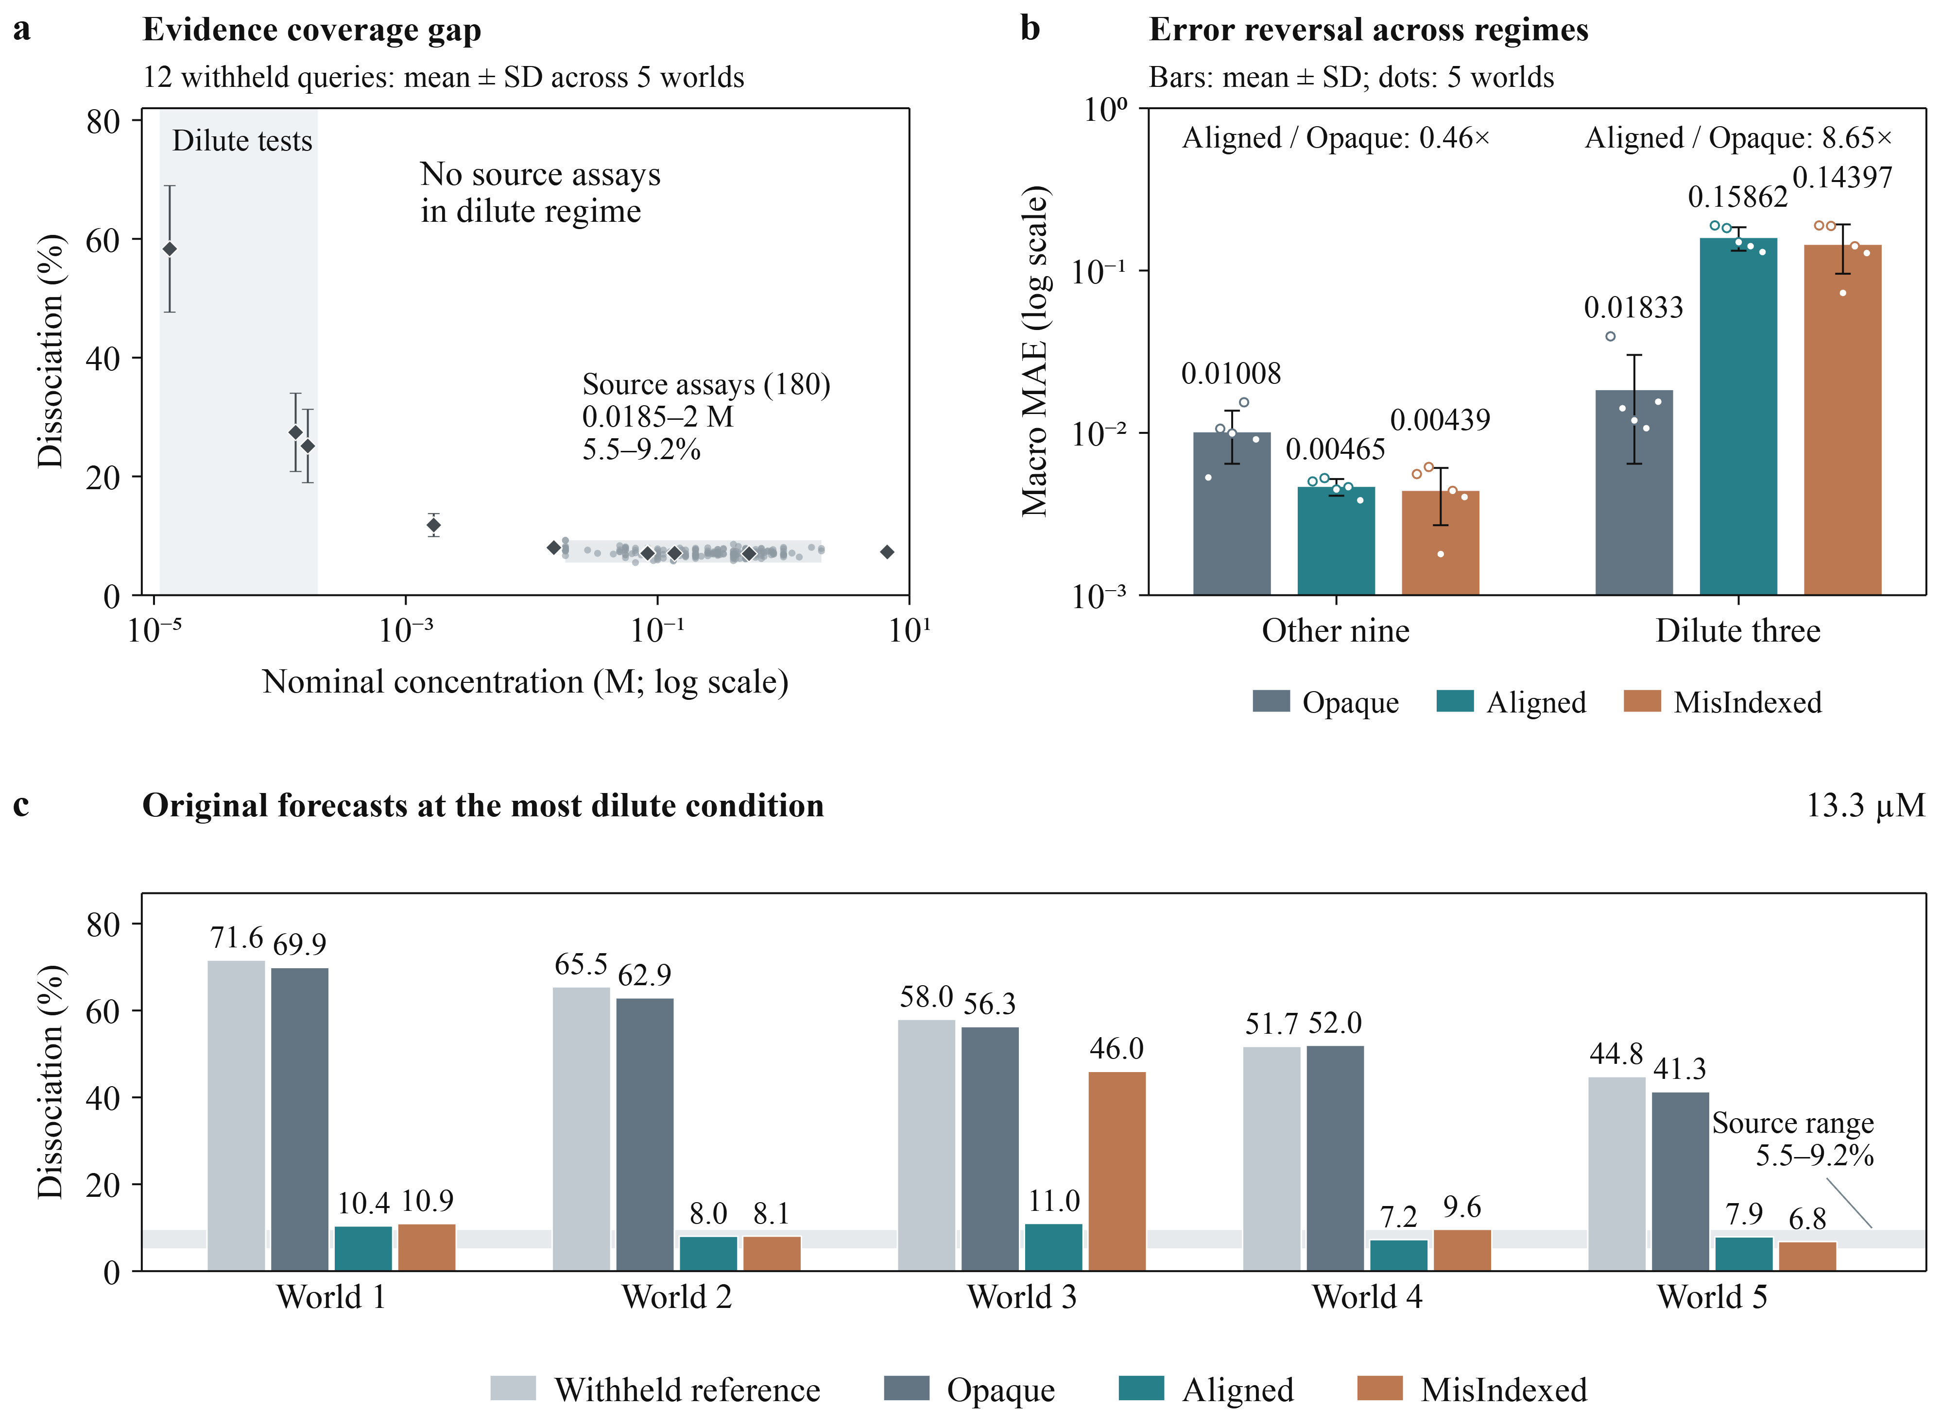
Supplementary Figure S8. GPT-5.6 Sol experimental evidence, regime reversal and original equilibrium forecasts. a, All 180 source assays at their nominal concentrations (0.0185–2 M), representing autonomously selected recipes and histories. Twelve diamonds show each query’s reference mean across five worlds, with world-level sample standard deviation (SD); each world reference is a mean of five evaluator observations. The source-response band spans the sampled concentration range, and vertical shading marks three dilute conditions with no source assays. b, Macro MAE for the remaining nine and three lowest-concentration conditions. Bars and error bars show five-world means ± sample SD; open points retain every world and ratios compare Aligned with Opaque within a test region. c, Original dissociation predictions and reference means for the lowest-concentration recipe (13.3 μM) in five worlds. Horizontal shading spans source observations of 5.5–9.2%, retaining the World 3 MisIndexed counterexample. Supplementary Tables F1, F2 and F3 give original 80% prediction intervals, group metrics and cross-model comparisons, respectively.

Appendix G. Response contributions and purity-error diagnosis

G.1 Equilibrium reversal by response
This exploratory decomposition retains all fifteen parameter-prior campaigns and all 540 response predictions. It uses the existing three-lowest-concentration grouping. MAE first averages queries within a campaign and response, then the five worlds. Averaging the three response MAEs exactly recovers Supplementary Table F2. The same worlds recur across arms; queries and responses are not independent replicates.
Table G1. Original prediction MAE by response and concentration group.
Response | Group | Opaque | Aligned | MisIndexed | Lower / higher
pH / 14 | Other nine | 0.00261 | 0.00269 | 0.00254 | 2 / 3 of 5
pH / 14 | Dilute three | 0.00448 | 0.05576 | 0.05230 | 0 / 5 of 5
Dissociation fraction | Other nine | 0.00839 | 0.00709 | 0.00660 | 3 / 2 of 5
Dissociation fraction | Dilute three | 0.02640 | 0.28229 | 0.23861 | 0 / 5 of 5
Precipitation signal | Other nine | 0.01923 | 0.00417 | 0.00403 | 5 / 0 of 5
Precipitation signal | Dilute three | 0.02411 | 0.13783 | 0.14099 | 0 / 5 of 5
The final column counts worlds with lower/higher Aligned MAE than Opaque. Signed response differences divided by three sum to the macro-error difference. They quantify the contribution on the declared normalized scales; they do not establish a shared failure mechanism or physical comparability of targets.

G.2 Separating purity offset from variation error
For each of thirty campaigns, let $p_{i}$ and $y_{i}$ be its original prediction and retained noiseless reference for the twelve queries. Define $b=\overline{p−y}$ and $c_{i}=(p_{i}−\overset{‾}{p})−(y_{i}−\overset{‾}{y})$. Then
$$MSE=b^{2}+\frac{1}{12}\sum_{i=1}^{12}{c_{i}^{2}}.$$
The first term measures the common offset; the second measures mismatched variation across conditions. Centred RMSE is the square root of the second term. Reference and prediction standard deviations use denominator twelve. All calculations retain the source-assay shortfall. Demeaning uses withheld references only for diagnosis; it is not an available predictor or a corrected performance result. MAE has no analogous additive decomposition.
Table G2. Purity offset and variation diagnostics.
Batches | Arm | N | Bias | cRMSE | Ref. SD | Pred. SD | Offset share
Both | All | 30 | -4.289 | 1.889 | 0.598 | 1.968 | 87.6%
12 | Opaque | 5 | -0.806 | 0.970 | 0.598 | 1.031 | 45.3%
12 | Aligned | 5 | -4.920 | 1.837 | 0.598 | 1.791 | 89.8%
12 | MisIndexed | 5 | -9.166 | 2.843 | 0.598 | 2.977 | 91.3%
24 | Opaque | 5 | -1.816 | 1.682 | 0.598 | 1.649 | 57.4%
24 | Aligned | 5 | -3.948 | 1.797 | 0.598 | 1.983 | 85.6%
24 | MisIndexed | 5 | -5.080 | 2.206 | 0.598 | 2.376 | 85.3%
N is the campaign count; cRMSE denotes centred RMSE. Bias, cRMSE and both standard deviations are campaign means in percentage points. Offset share is the ratio of summed squared campaign biases to summed campaign MSEs, with equal query counts; it is not the mean campaign fraction. The median campaign fraction is 77.6%. Mean bias is negative in 30 of 30 campaigns. Centred RMSE exceeds reference SD in 29 of 30. These comparisons describe forecast outputs and do not identify an internal revision process. No new agent or simulator calls were made.

G.3 Information conditions and resources
Information conditions further delimit this interpretation. At twelve batches, Aligned and MisIndexed improve recovery MAE but worsen purity MAE relative to Opaque in every world; at 24 batches, this joint direction appears in only two and three of five worlds, respectively (Fig. 6c). Prediction intervals also fail to reliably accommodate purity errors (Fig. 6d). At both budgets, Aligned and MisIndexed have wider mean intervals than Opaque, so poorer coverage cannot simply be attributed to narrower stated uncertainty. Conversely, high Opaque coverage alone does not establish calibration or sharpness. These effects depend jointly on response and research resources.

Appendix H. Executed process models and information conditions

H.1 Equilibrium response model
The parameter-prior study uses a bounded monoprotic acid-base model followed by a precipitation calculation. These are the process relations used for the retained campaigns and references. They are distinct from explanations proposed by the agents. In particular, an agent’s proposed active-pool cap is not the implemented source of the dissociation plateau.
Let $n$ be the current ledger amount of the initial reactant, $V$ the current sample volume and $C=n/V$. The background-ion amounts are $n_{+}=min(0.020,0.15n)$ and $n_{−}=min(0.020,0.08n)$, in moles. With $H=[H^{+}]$, $K_{a}={10}^{−pK_{a}}$ and activity-ratio factor $g$, the solver obtains
$$[A^{−}]=\frac{CK_{a}}{K_{a}+gH}, [{OH}^{−}]=\frac{K_{w}(T)}{H},$$
subject to charge balance,
$$H+\frac{n_{+}}{V}−\frac{K_{w}(T)}{H}−[A^{−}]−\frac{n_{−}}{V}=0.$$
The reported responses are $pH/14=−\log_{10}(H)/14$ and dissociation fraction $α=[A^{−}]/C$, clipped to the public unit interval. In the uncapped background-ion range, charge balance implies $α=0.07+H/C−K_{w}/(HC)$. At sufficiently high concentration the last two terms are small, giving a local plateau near 7%; dilution makes their contribution appreciable. The plateau and departure therefore arise under the same fixed equations. The five effective pKa values span 4.6594 to 5.3794 in increments of 0.18; the default activity-ratio factor is one.
Precipitation is calculated sequentially from effective ion inventories $a=n_{+}+0.10n_{A^{−}}$ and $b=n_{−}+0.08n_{HA}$. When supersaturated, a 1:1 removal $x$, bounded by the limiting inventory, satisfies $(a−x)(b−x)/V^{2}=K_{sp}$, with default $K_{sp}=1.8×{10}^{−10}$. The public signal is $x/n$, clipped to $[0,1]$. This hook does not feed precipitation back into the acid-base solution. Thus the three public responses are related but should not be interpreted as three independent measurements of one failure mechanism.
The concentration in Figure 4a and Supplementary Figure S8a is a recipe descriptor: total nominal reagent additions divided by total solvent additions. The solver instead uses the ledger state at measurement, after any sample consumption and other operations. The scatterplot combines distinct recipes and histories; it is not a controlled one-dimensional titration curve. The three most dilute test recipes have nominal concentrations of approximately $1.33×{10}^{−4}$, $1.33×{10}^{−5}$ and $1.67×{10}^{−4}$ M. No source assay in these fifteen Sol campaigns reaches those concentrations.

H.2 A concrete three-arm information example
Table H1 reproduces the numerical content of the first equilibrium world’s public prior from the frozen configuration and input serializer. It is a formatted input excerpt, not a reconstruction of agent dialogue. All three arms retain the same public operations, general task background, resource contract and physical world. Opaque receives no instance-specific initial world model. The other two arms receive the same schema and wording; MisIndexed substitutes the configured fifth world’s claim.
Table H1. Public prior content in one matched physical world.
Supplied field | Opaque | Aligned | MisIndexed
Effective pKa interval (80%) | Absent | [4.6094, 4.7094] | [5.3294, 5.4294]
Dilution change in pH/14 | Absent | +0.003494987 | +0.000875889
Dilution change in dissociation | Absent | +0.008187416 | +0.001884676
Nominal confidence | Absent | 0.8 | 0.8
The common dilution anchor is 0.001 mol acid at 298.15 K, with volume increasing from 0.018 to 0.054 L. Both supplied records identify the source as an “independent bounded archival fit” and qualify the claim as a “local effective relationship; not a universal aqueous-chemistry law”. The pKa intervals above are rounded for display; the input contains their full precision. Aligned therefore supplies correct partial local information, not the evaluator’s complete process equations, query answers or an instruction to enter the most dilute test region. The experiment contrasts the resulting complete research processes, including possible changes to evidence acquisition and interpretation.

H.3 Crystallization response model
The retained crystallization block composes upstream reaction, thermal operations, seeding, crystal nucleation and growth, filtration and measurement. It uses the latent-material process family and its linear supersaturation-dependent impurity transfer. Solid product, solid impurity and the particle population persist across operations; dissolved and solid inventories are accounted for separately.
The temperature-dependent solubility follows
$$c^{*}(T)=c_{ref}^{*}exp​\left[−\frac{ΔH}{R}\left(\frac{1}{T}−\frac{1}{T_{ref}}\right)\right],$$
with $T_{ref}=298.15$ K, $ΔH=20,000$ $J mol^{−1}$ and a declared temperature domain of 250-430 K. World and solvent properties scale the reference solubility and kinetics. For relative supersaturation $s=max(C/c^{*}−1,0)$, primary nucleation scales as $B=k_{b}s^{2}$ and linear growth as $G=k_{g}s$. Before world and solvent multipliers, the coefficients are $2×{10}^{7}$ $L^{−1} s^{−1}$ for nucleation and $2×{10}^{−8}$ $m s^{−1}$ for growth. Nucleation and growth consume available dissolved target and update the population distribution; they are not independent score adjustments.
Each crystallized target increment transfers impurity according to
$$Δn_{I,s}=min​\left(n_{I,l}, Δn_{P,s} k_{occ}(1+0.5s)\right),$$
where $k_{occ}=0.02$ times the solvent’s occlusion multiplier. The four nominal solvent multipliers are 1.20, 0.80, 0.65 and 1.05; world-fixed material residuals further modulate these properties. Filtration retains 96% of target solids and 92% of impurity solids. The final-assay purity is the solid-target mole fraction $n_{P,s}/(n_{P,s}+n_{I,s})$. Seed contributes to target purity but is subtracted in the full-process recovery numerator; final-assay recovery is normalized by the initial reagent charge.
These relations allow thermal and seeding histories to alter the amount and size distribution of crystals while impurity incorporation remains modest. They explain how recovery and particle responses can vary without requiring a comparable purity change. The approximately 98.5% purity level is an empirical property of the retained source and query conditions, not a hard-coded value or a universal invariant of the model. The present analysis does not isolate individual process contributions to that stability. Appendix G separately tests whether the forecasts preserve the level and variation of the retained purity references.

H.4 Scope of this reconstruction
The equations and input excerpt were checked against the execution-version source and retained configuration bindings. Later equilibrium adapters and alternative crystallization impurity laws are not used to explain these observations. This documentation and the error decompositions use existing source records, predictions and references only; they add no agent or simulator calls. Internal source identities are retained with the analysis records for the archival package.

