In this summer I did two groups of comparison: PDE acceleration and Chambolle-Pock primal-dual on level set segmentation with TV regularization and Beltrami regularization. The level set scheme I used here is called fuzzy region competition, in which the surface is constrain within [0,1] and the contour is 0.5 level set.

For TV regularization, the potential energy function is:

$$\min_{u∈BV[0,1](c1,c2)∈R^{2} }\left\{Fc\left(u, c1, c2\right)= \int_{Ω}{\left|∇u\right|}+ λ\int_{Ω}{{u(I - c_{1})}^{2}} + λ \int_{Ω}{{(1 - u)(I - c_{2})}^{2}}\right\}$$

The difference from Chan-Vese is that there is no Heaviside function here, *u* is the level set. Check the paper [Mory-Ardon2007] for detail. The primal-dual algorithm is from [Chambolle-Pock2011], the algorithm is shown below.

$${Initialize u^{0} = u_{0};p^{0} = 0 \atop \left\{\begin{aligned}{\overline{p}}^{k+1}=p^{k}+σ∇u^{k} \\ {p^{k+1} = \frac{{\overline{p}}^{k+1}}{max⁡(\left|{\overline{p}}^{k+1}\right|,1)} \atop r = λ({\left(I -{ c}_{1}\right)}^{2} - {(I- c_{2})}^{2})} \\ u^{k+1}=max⁡(\min\left(u-τr+divp^{k+1},1\right),0)\end{aligned}\right.}$$

The problem here is I don’t know how to choose sigma and tau to have the best performance. From paper [Chambolle-Pock2011], it says τσL2<1, here ,so $τσ≤ \frac{1}{L^{2}}$. So the multiply of sigma and tau is a fixed value, but I don’t know what the value is for each instance. I played with those parameters and done lots of experiments. I got the best result with tau = 1, sigma =0.5.

For acceleration, the quantization level Q I use here is 1/255, the acceleration method is forward difference. And Dr.Yezzi told me that there is no optimal damping coefficient for TV, so I tried various of damping coefficients. The energy loglog plot is shown below. Line 1 to line 7 are acceleration, line 8 is primal-dual. All the experiments are done on noisy image. 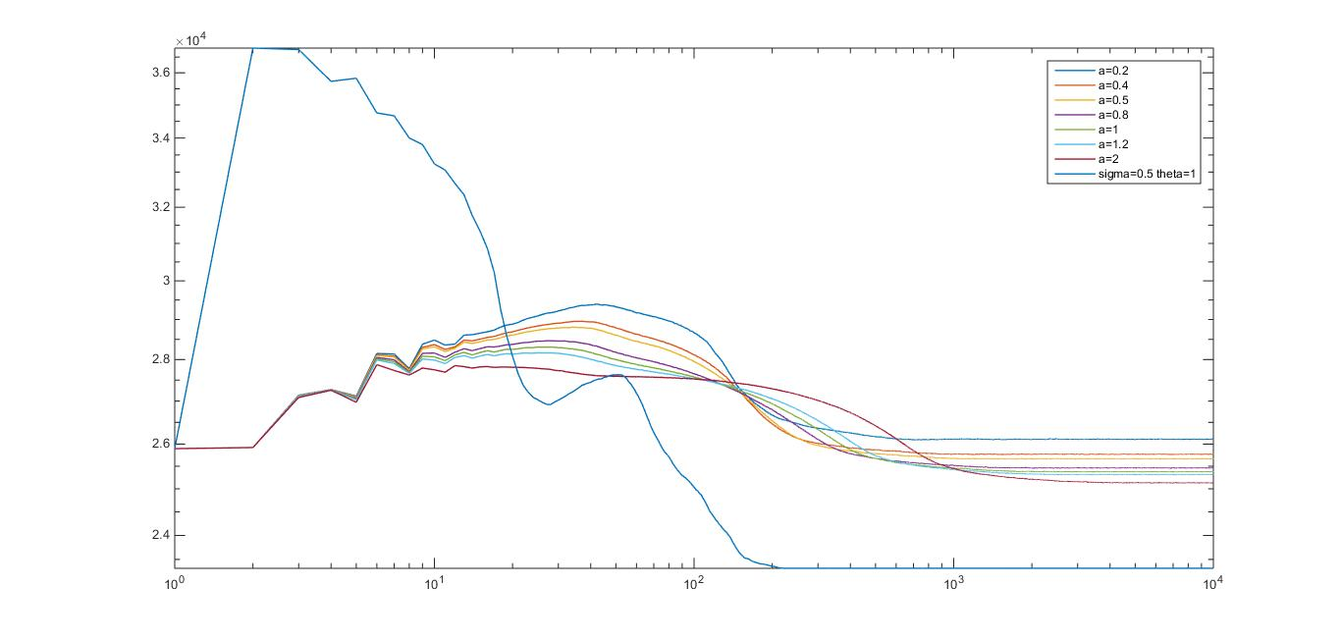

For the final segmentation result, please check the folder.

For Beltrami regularization, potential energy is

$$\min_{u∈BV[0,1](c1,c2)∈R^{2} }\left\{Fc\left(u, c1, c2\right)= \int_{Ω}{\frac{1}{β}\sqrt{1+ {\left\|βu\right\|}^{2}}}+ λ\int_{Ω}{{u(I - c_{1})}^{2}} + λ \int_{Ω}{{(1 - u)(I - c_{2})}^{2}}\right\}$$

The primal-dual Beltrami version algorithm is from [Zosso-Bustin 2014], the algorithm is shown below

$${Initialize u^{0} = u_{0};p^{0} = 0 \atop \left\{\begin{aligned}{\overline{p}}^{k+1}=(1- σβ)p^{k}+βσ∇u^{k}\sqrt{β^{2} - {\left|p^{k}\right|}^{2}} \\ {p^{k+1} = \frac{{β\overline{p}}^{k+1}}{max⁡(\left|{\overline{p}}^{k+1}\right|,β)} \atop r = λ({\left(I -{ c}_{1}\right)}^{2} - {(I- c_{2})}^{2})} \\ u^{k+1}=max⁡(\min\left(u-τr +divp^{k+1},1\right),0)\end{aligned}\right.}$$

In the experiment, beta is 2. For the acceleration, the optimal damping coefficient is $\frac{2π}{m}\sqrt{βg}$.But in the experiment the best result occurs when damping coefficient is 6 times of the optimal damping coefficient. The energy loglog plot is shown below. Line 1 to line 4 are acceleration and line 5 to line 7 are primal-dual.

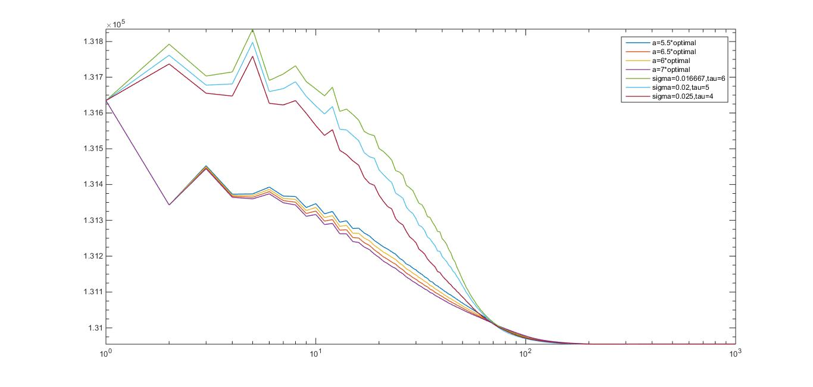

For the visual segmentation results, please check the folder.