LumiaKey Functional Guide
LumiaKey turns a phone or tablet into a computer shortcut panel with keyboard actions, media controls, touch input and local speech recognition. This guide helps new users understand the mobile app, LumiaKey Desktop and the requirements for each feature.
Applies to version 1.3.0+5, based on the project source reviewed on 28 October 2026. The app interface is primarily English. Recognition-language settings do not change the interface language.
Screenshots are test renders of the current Flutter interface, without redrawing the UI. Connection states, app lists, usage counts and dictation states use sample data; they do not establish device connectivity or speech quality.
Client | Main use | Requirements
Android phone or tablet | Shortcuts, media, mouse and touchpad | Android 9 or later; Bluetooth HID Device support
iPad | Shortcuts and recognized text | Same LAN as Desktop; no Android-style mouse or held-key actions
Windows or macOS | Desktop app management, managed shortcuts and dictation | Install LumiaKey Desktop separately and grant required permissions
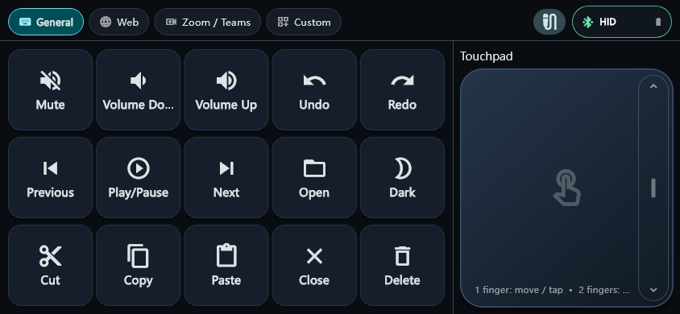
Figure 1 Default General profile in landscape with the touchpad on the right

1 Connect to a Computer
Android uses Bluetooth HID for ordinary keyboard, media and mouse input. App launching, workspace synchronization and multilingual text output require Desktop. Both connections can be used together.
1. On Android, open the top-right status menu or Settings → Computer connection. Allow Nearby devices access and select Make phone discoverable.
2. Add and pair the phone in the computer’s Bluetooth settings. Return to LumiaKey, select Refresh, then connect the paired computer. Resolve Bluetooth off or Permission required in system settings.
3. Start the separate Desktop app and choose Open Settings from the Windows tray or macOS menu bar. Put both devices on the same LAN and check Settings → Desktop Companion on mobile.
4. On iPad, copy the code from Desktop’s Connect an iPad panel, paste it into Desktop Companion, select Connect and allow Local Network access. Use a new code after restarting Desktop.
The connection code contains a temporary credential; protect it like a password. The current LAN channel is authenticated but unencrypted, so use a trusted network. Selecting Disconnect for Bluetooth also clears the remembered computer.
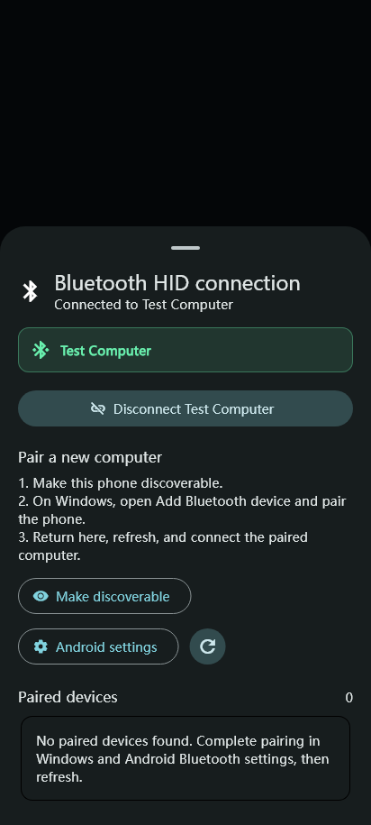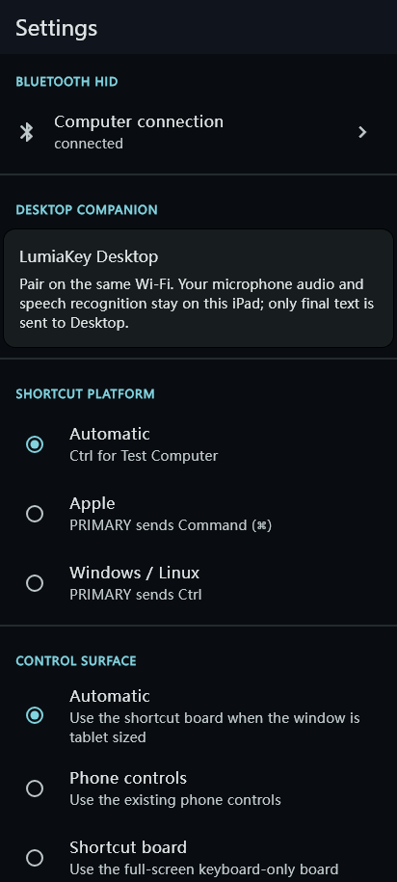
Figure 2 Bluetooth connection panel with a sample computer Figure 3 Settings and the Desktop Companion section

2 Control Surfaces and Touch Input
Phone controls show up to 15 shortcuts per bank: three columns by five rows in portrait and five columns by three rows in landscape. Rotation releases held keys while preserving the active configuration.
General includes mute, volume, undo, redo, previous track, play/pause, next track, open, Dark, cut, copy, paste, close and delete. Keep the intended app focused; shortcut behavior depends on that app. Dark dims the phone and requests host brightness control when Desktop is available; host effects depend on platform support.
Android touchpad gestures: drag one finger to move the pointer, tap for left-click, slide two fingers to scroll and tap two fingers for right-click. The right-edge strip also supports one-finger scrolling. Other profiles can use an editable navigation wheel. This mouse route is unavailable on iPad.
Settings → Control Surface offers Automatic, Phone controls and Shortcut board. Automatic uses the board when the window’s shortest side reaches 600 logical pixels; narrow split views return to phone controls.
Shortcut board keys per screen accepts any integer from 24 to 60, with 40 as the default. The board omits the touchpad and wheel. Use page controls for other banks. Existing 15-key profiles stay intact; editing an unused slot adds a key.
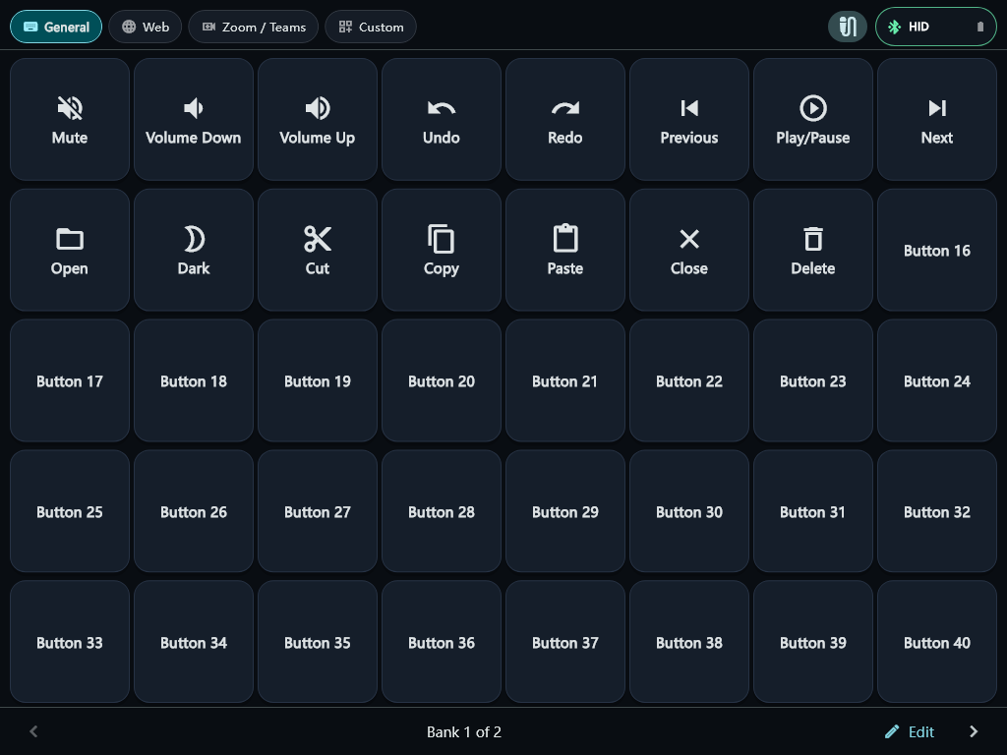
Figure 4 Tablet board with 40 slots; unused positions remain unconfigured

3 Profiles and Button Editing
A Profile stores buttons, visuals and navigation actions. The initial local profiles are General, Web, Zoom / Teams and Custom. The free edition supports up to four local profiles.
1. Switch profiles in the top strip. Settings → Profiles lets you create, copy, edit, reorder, delete, set a default or restore a built-in template. Importing at capacity requires choosing a replacement slot.
2. Choose Edit buttons from the top-right menu, then tap a button. Set its label, icon or image, action and feedback, save, then leave edit mode. Long-press and drag onto another button to swap their complete configurations.
3. PRIMARY maps to Command on Apple hosts and Ctrl on Windows or Linux. If automatic detection is incorrect, set the host platform manually in Settings → Shortcut Platform.
Edit Desktop-managed app layouts in Desktop → Shortcut Layout. Phone Profile JSON import rejects Companion actions. Desktop layouts and phone Bluetooth profiles are different transfer formats.
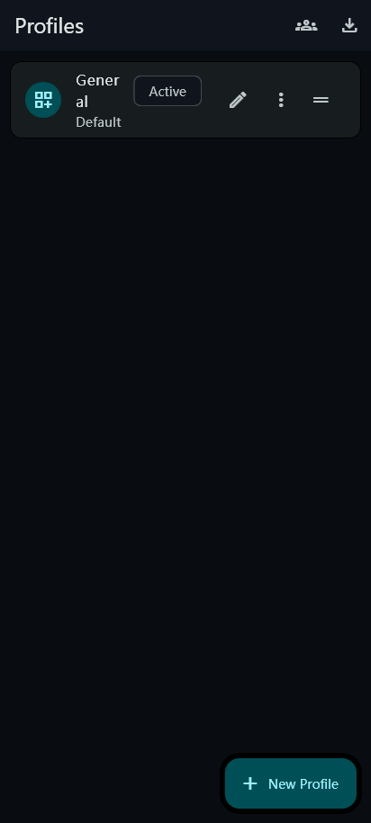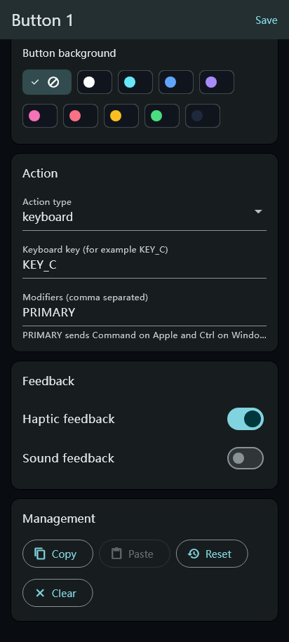
Figure 5 Profile management with a sample list Figure 6 Button action editor

4 Icons and Profile Exchange
Buttons can display text, built-in semantic icons or custom PNG, JPEG and WebP images. Shortcut Community provides curated offline packs and Profile exchange through the clipboard or files.
1. Open the icon picker from the button editor. Search by keyword or filter by category; use recent choices, favorites, preview, size and color controls. Custom images are copied into app-private storage and support fit, scale, position and label overlays.
2. Open Settings → Shortcut Community, choose a built-in pack or paste/import Profile JSON. Review it and confirm the replacement slot before changing the current configuration.
3. Use Copy active Profile JSON or export a .smartkeys.json file. Copying JSON does not transfer private image files to another device; use an account backup that includes images when needed.
Missing images display a placeholder and must be reimported or restored. Offline packs and online usage rankings are separate features; offline packs do not require a community server.
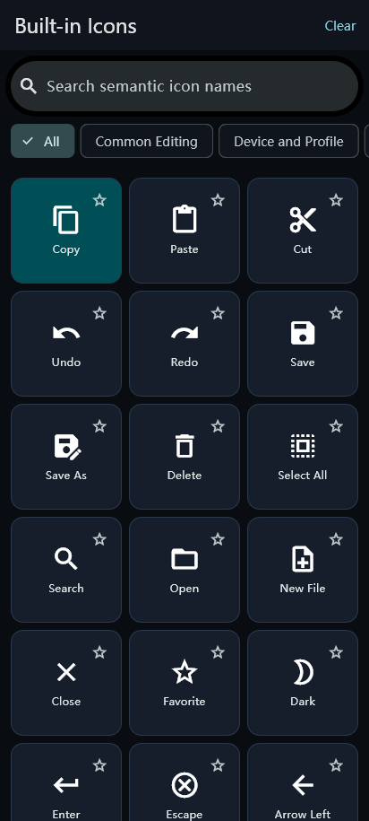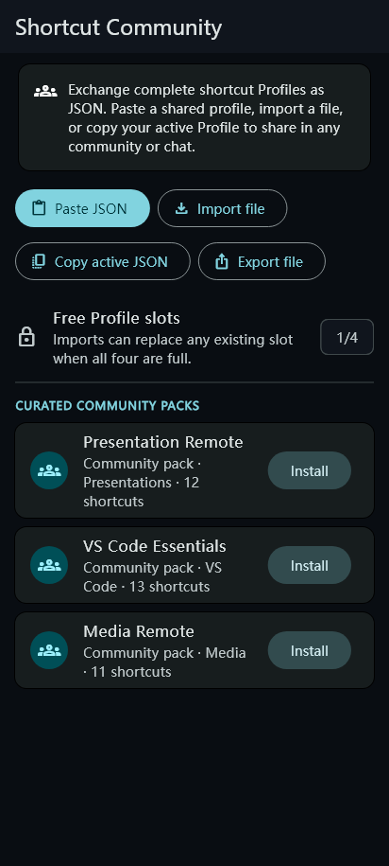
Figure 7 Built-in icon picker Figure 8 Offline packs and JSON exchange

5 Apps and Workspaces
With Desktop synchronized, mobile shows supported apps detected on the computer and their managed workspaces. General remains the common HID surface. Local profiles remain available when Desktop is offline.
Apps is a launch grid. Tapping an app such as Chrome, Codex or VSCode sends its managed ID to Desktop and opens its shortcut layout. Only detected apps appear; the supported catalog does not imply that every app is installed.
Chrome’s default layout covers tabs, navigation, clipboard, bookmarks, address, refresh and media. Codex includes Focus Input, Dictation, chat navigation, Send, search, Terminal, Review and Sidebar. Results depend on the target app version and focus.
A foreground-app change can switch the workspace. Routine synchronization does not repeatedly override a manual tab choice. On macOS, ChatGPT maps to the Codex / ChatGPT workspace; Music and Finder are also available when detected.
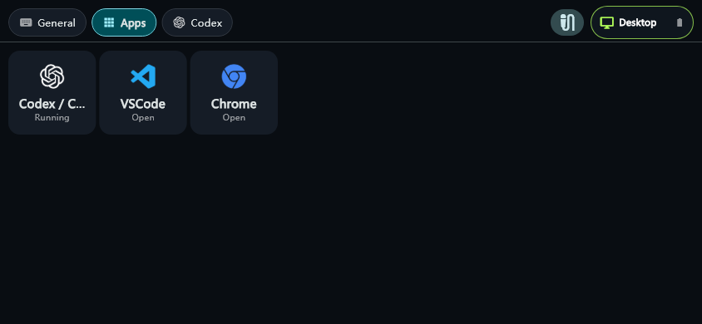
Figure 9 Apps grid using a sample computer app list
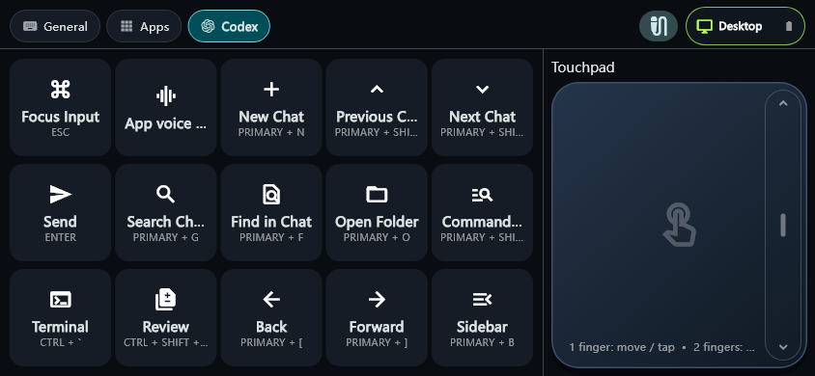
Figure 10 Desktop-managed Codex workspace

6 Desktop Settings
LumiaKey Desktop starts in the system tray or menu bar. Choose Open Settings to show its window. Closing settings hides the app; choose Quit to exit.
General manages Enable Apps Sync, Auto Launch Apps, Sync Icons and the current phone/profile. Bluetooth shows connection guidance. Apps detects supported installed programs and refreshes running state. Profiles manages Desktop profiles; About shows product information.
The screenshot shows a disconnected example. If Sync service unavailable appears during use, check the Desktop service, firewall and LAN connection. No phone connected means there is no active phone session.
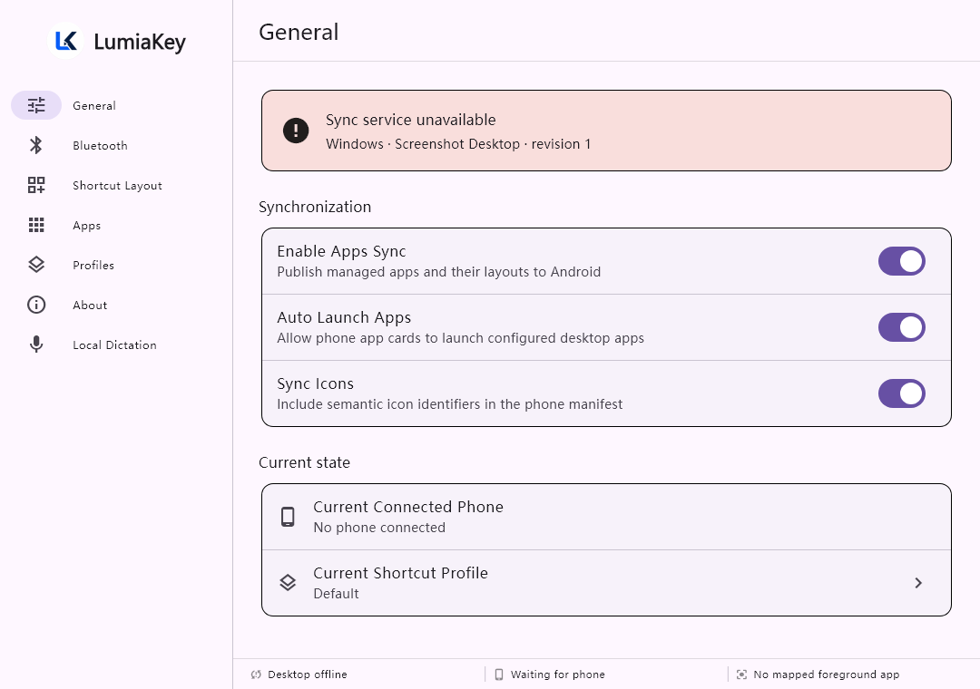
Figure 11 Desktop General settings with synchronization inactive in the test

7 Desktop Shortcut Management
Desktop owns app layouts and synchronizes them to mobile. Select the correct app and layout before editing, then verify the saved result in the target app.
In Shortcut Layout, select an app and button, then edit Button Name, Icon, Target Type, Shortcut, Launch App, URL and Description. Keyboard Shortcut, Launch Application and Open URL are executable; Macro and Script are currently unavailable.
Desktop layout JSON can be imported and exported; exports omit executable data. Imports replace known layouts and validate app IDs. Desktop owns executable paths and resolves the button IDs sent by mobile into actions.
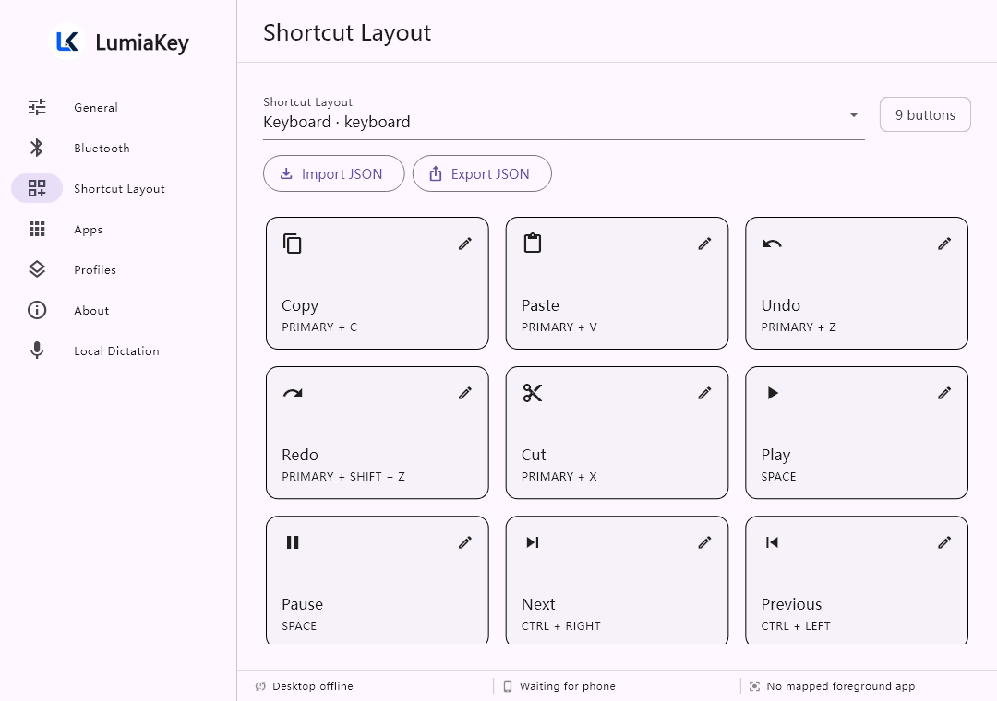
Figure 12 Desktop shortcut layout management

8 Mobile Local Quick Dictation
Local quick dictation uses the phone’s microphone and a local recognition model. It differs from the Application voice input waveform button, which triggers the target app’s own voice shortcut. First use requires acknowledging the explanation.
1. Long-press the microphone to choose output, model and recognition language, then explicitly download or import a model. SenseVoice Small is the default at about 229 MiB; Cohere Transcribe is an optional model at about 2.7 GiB. Files must pass size and SHA-256 checks.
2. Bluetooth output is English-only and requires English input with a US keyboard layout on the computer. For Chinese or other multilingual text, choose LumiaKey Desktop and connect it on the same LAN. There is no automatic Bluetooth fallback.
3. When the model and output are ready, tap the microphone to start. Shortcuts remain usable while listening; the corner control shows the level and Stop. Stop ends capture. Back, settings, leaving the foreground or connection changes cancel capture.
Audio stays in bounded memory and is neither saved as a recording/history nor sent to Desktop. Desktop mode sends finalized text only. Ready/listening screenshots use test states rather than evidence of a model download or recognition quality.
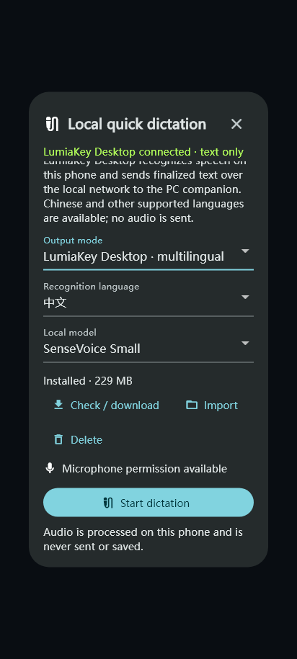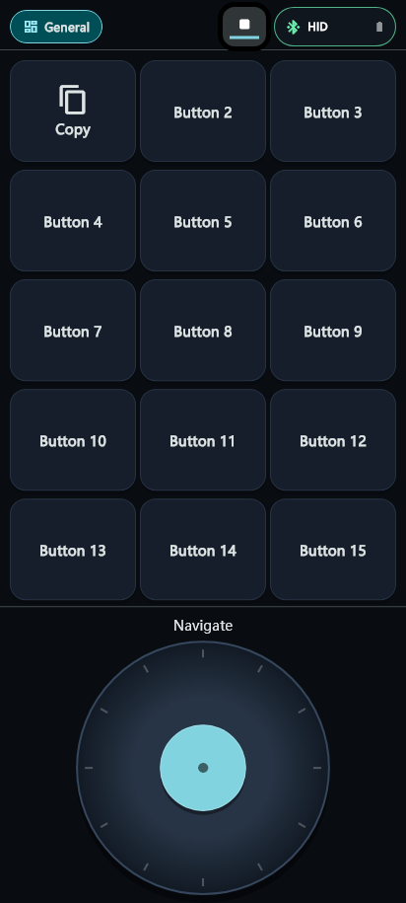
Figure 13 Multilingual Desktop output setup example Figure 14 Compact stop and level control while listening

9 Desktop Local Dictation
Desktop can independently dictate with the computer’s microphone and a local model, without capturing audio on the phone. Final text is inserted into a supported focused external app.
1. Open settings from the tray and select Local Dictation. Choose a model and recognition language, then download or import the model. Downloads are explicit. Allow microphone access in Windows privacy settings or the macOS prompt.
2. Focus an editable field in the target app. The default global shortcut Ctrl+Shift+Space starts or stops dictation; the tray offers Start/Stop Local Dictation too. Change the shortcut in settings if needed.
3. On macOS, text insertion also needs Accessibility and event-posting permission. Insertion can be rejected if focus is unsafe, the target changes or Desktop’s own window is targeted. Refocus the intended app and retry explicitly.
Microphone audio is processed in local memory without saving recordings. Model readiness does not verify microphone permission, recognition accuracy or insertion into a particular app. Check the first output in disposable text.
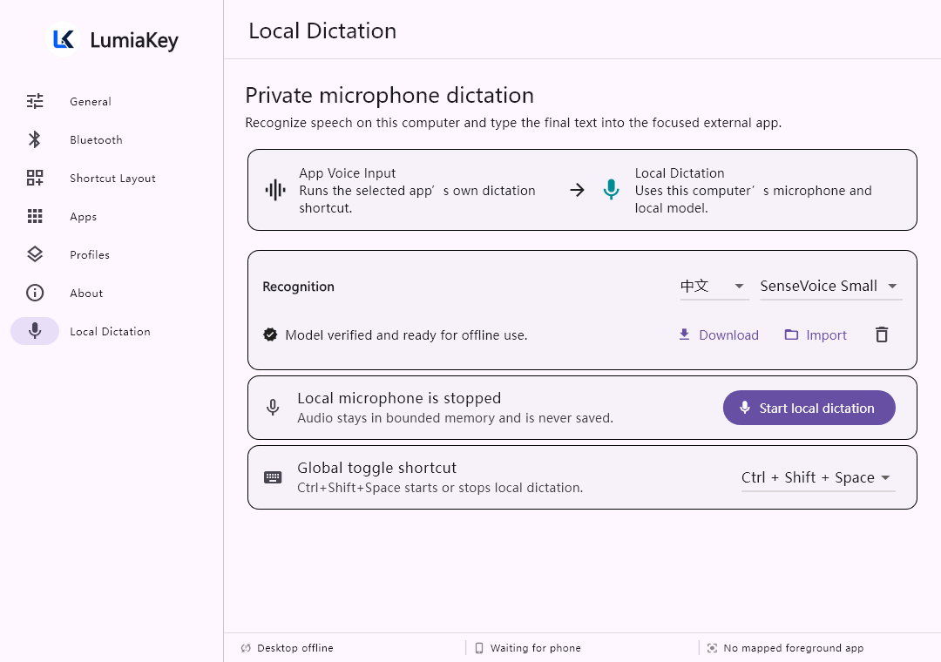
Figure 15 Desktop local dictation with sample model and language state

10 Usage and Optional Community Sharing
Settings → Usage Dashboard records nonempty shortcut click attempts and times. Failed or disconnected attempts also count, so clicks are not successful executions. Detailed history stays on the device by default.
Choose All time, Today, 7 days, 30 days or custom dates. Sort by usage or latest use and inspect individual events. Smart sort explicitly reorders the current local Profile by lifetime counts; it does not reorder Desktop-managed layouts. Clear local usage requires confirmation.
First-launch Community setup offers optional profession and computer-proficiency tags, or Skip for now. Saving stores local defaults without enabling sharing. Reopen it through Settings → Community sharing setup. Every submission still requires preview and confirmation.
Optional submissions contain recognized standard categories and aggregate counts, excluding custom labels, exact times and raw commands. Rankings need a configured service but do not require sharing. Categories require three contribution batches; batches are not people. Online withdrawal and local clearing are separate. The optional service also offers a Chinese browser Dashboard with counts, a proportional chart, a table and period/profession/proficiency filters.
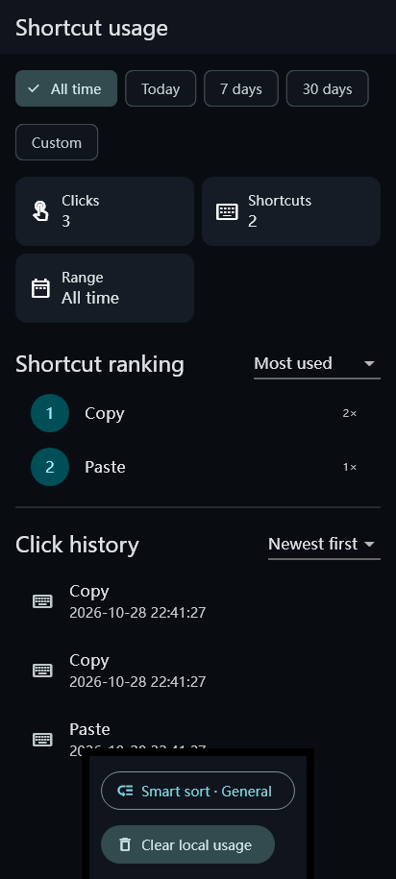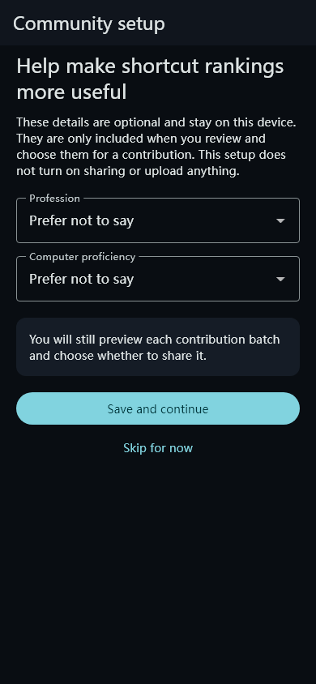
Figure 16 Usage dashboard with sample counts and times Figure 17 Optional community setup

11 Backup Restore and Desktop Installers
Account backup is separate from community sharing. The settings entry currently says Google Drive backup, but Google sign-in accesses a separate backup service rather than storing files in your Google Drive.
Once the service and Google OAuth are configured, sign in, select app settings, Profiles and optional custom images, preview and back up manually. Each account stores its latest snapshot. Restore selected items within the four-profile limit; restoration does not execute shortcuts.
Pairing, click history, sharing receipts and login credentials are excluded. Signing out does not delete the online snapshot; use Delete online backup separately. An unconfigured build shows an unavailable message rather than simulated sign-in or fabricated backups.
On Android, Settings → Desktop installers shows the Windows installer and macOS DMG bundled in a release. Review version, source commit, size and SHA-256, and verify them. Development builds may contain no installers.
Choose a shared-storage destination in the system folder picker. Export does not overwrite an existing file and verifies stored size and hash. Use USB file transfer/MTP to copy the package to the computer, then install it; the phone does not become a USB mass-storage drive.
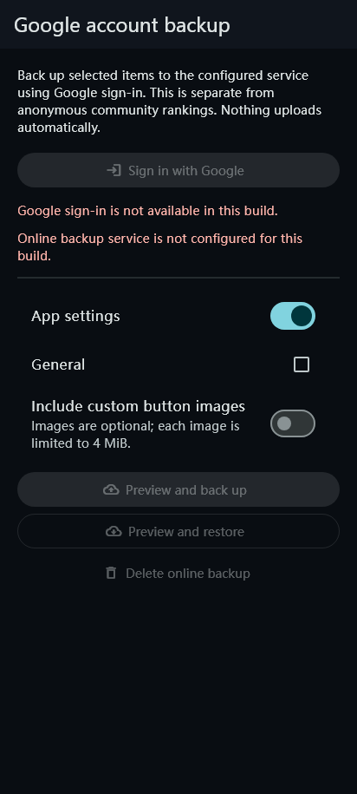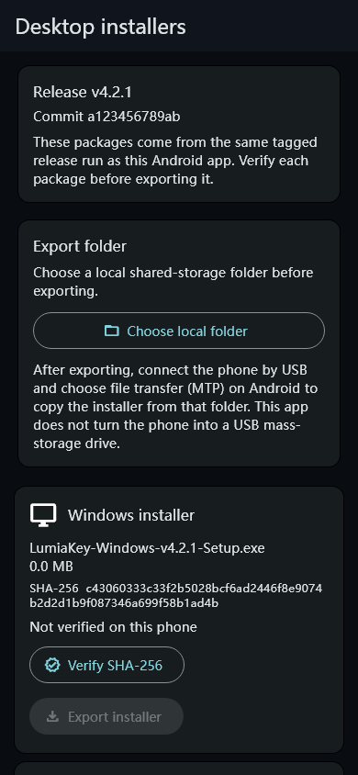
Figure 18 Backup configuration message Figure 19 Installer catalog with test package metadata

12 Display Settings and Troubleshooting
Settings offers Landscape, Portrait and Auto, with landscape as the default, plus charging-brightness and wake options. Dictation keeps the screen awake while active and releases its wake state when stopped or cancelled.
Computer missing: pair it in system Bluetooth settings, then select Refresh. Confirm that the phone supports HID Device; an emulator cannot verify physical Bluetooth input. For Desktop issues, check the same LAN, tray process and firewall permissions; recopy the code on iPad.
Unexpected shortcut: check target focus, Shortcut Platform and the button action. For multilingual dictation, choose LumiaKey Desktop and verify its connection. Bluetooth dictation requires English with a US keyboard layout. Recognition language and output route are separate choices.
Model or microphone unavailable: complete model verification and check system microphone permission. Deleting a model stops capture first. Unconfigured rankings or backup need release-service configuration; local statistics and offline profiles remain usable.
Verification scope: this guide checks source behavior and rendered UI tests. Physical Android Bluetooth input, speech accuracy/latency, Windows/macOS permissions and insertion, and signed iPad installation and use still require acceptance on the relevant devices.
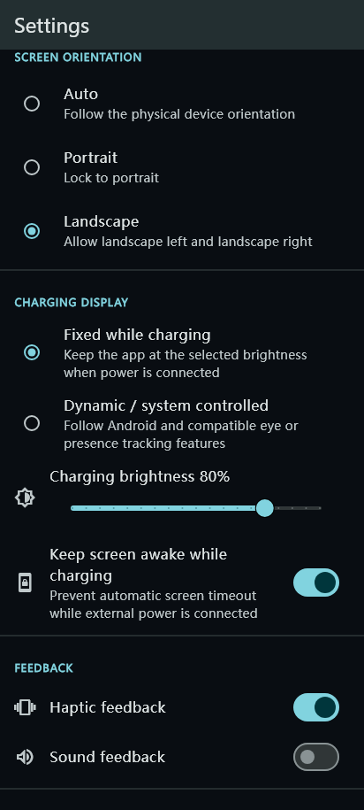
Figure 20 Screen orientation and charging display settings

