Keywords

[cluster] – 簇，集群

[HeartBeat] - Heartbeat is a daemon that provides cluster infrastructure (communication and membership) services to its clients. This allows clients to know about the presence (or disappearance!) of peer processes on other machines and to easily exchange messages with them.

[DRBD] - The Distributed Replicated Block Device (DRBD) is a software-based, shared-nothing, replicated storage solution mirroring the content of block devices (hard disks, partitions, logical volumes etc.) between servers.

[VIP] - virtual IP

[libnet] - ibnet是一个小型的接口函数库，主要用C语言写成，提供了低层网络数据包的构造、处理和发送功能。libnet的开发目的是：建立一个简单统一的网络编程接口以屏蔽不同操作系统底层网络编程的差别，使得程序员将精力集中在解决关键问题上。

Cluster
集群就是由一些互相连接在一起的计算机构成的一个并行或分布式系统，从外部来看，它们仅仅是一个系统，对外提供统一的服务。

我们用到的集群系统主要就2种:

高可用(High Availability)HA集群, 使用Heartbeat实现;也会称为”双机热备”, “双机互备”, “双机”。
负载均衡群集(Load Balance Cluster)，使用Linux Virtual Server(LVS)实现;

基于系统镜像的双机系统(FT)
特点是利用双机，将系统的数据和运行状态（包括内存中的数据）进行镜像，从而实现热备份的目的。 能够做到无缝切换，但因为采用软件控制，占用系统资源较大，而且由于两台机器需要完全一样的配置，所以性能价格比太低。

基于系统切换的双机系统(HA)
特点是利用双机，将系统的数据（仅指硬盘数据）进行镜像，在主机失效的情况下从机将进行系统一级的切换。 性能价格比适中，但无法实现无缝切换。

HeartBeat
Heartbeat is a daemon that provides cluster infrastructure (communication and membership) services to its clients. This allows clients to know about the presence (or disappearance!) of peer processes on other machines and to easily exchange messages with them.

introduce&install http://www.linux-ha.org/doc/users-guide/users-guide.html

man-pages http://www.linux-ha.org/doc/man-pages/man-pages.html

Version
Up until Heartbeat release 2.1.3, Pacemaker was developed jointly with Heartbeat as part of the Linux-HA umbrella project. After this release, the Pacemaker project was spun off as a separate project and continues as such, while maintaining full support for Heartbeat cluster messaging.

heartbeat （Linux-HA）的工作原理：
heartbeat最核心的包括两个部分，心跳监测部分和资源接管部分，心跳监测可以通过网络链路和串口进行，而且支持冗余链路，它们之间相互发送报文来告诉对方自己当前的状态，如果在指定的时间内未受到对方发送的报文，那么就认为对方失效，这时需启动资源接管模块来接管运 行在对方主机上的资源或者服务。

###heartbeat api

Note
Please consider some important caveats with regard to serial link connectivity (see the ha.cf man page, man ha.cf). As a general rule: when in doubt, serial links should be avoided.

Pacemaker
In order to be useful to users, the Heartbeat daemon needs to be combined with a cluster resource manager (CRM) which has the task of starting and stopping the services (IP addresses, web servers, etc) that cluster will make highly available. Heartbeat originally came with a primitive resource manager, however this is only capable of managing 2 nodes and could not detect resource-level failures. A new resource manager which addressed these limitations and more was written for Heartbeat 2.0.0. In 2007 the new resource manager was spun-off to become in order to better support additional cluster stacks (such as Corosync). Information about Pacemaker is available from the project web site.

more --> http://clusterlabs.org/doc/

DRBD

http://drbd.linbit.com/docs/about/

If you are using a pre-8.4 release of DRBD , please use the version of this guide which has been preserved at http://www.drbd.org/users-guide-8.3/.

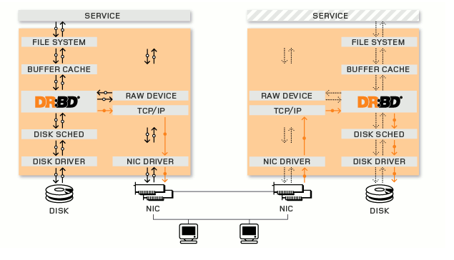

In the illustration above, the two orange boxes represent two servers that form an HA cluster. The boxes contain the usual components of a Linux™ kernel: file system, buffer cache, disk scheduler, disk drivers, TCP/IP stack and network interface card (NIC) driver. The black arrows illustrate the flow of data between these components.

The orange arrows show the flow of data, as DRBD mirrors the data of a highly available service from the active node of the HA cluster to the standby node of the HA cluster.

DRBD works on top of block devices, i.e., hard disk partitions or LVM's logical volumes. It mirrors each data block that it is written to disk to the peer node.

Recovery
After a node outage
After an outage of a node DRBD® automatically resynchronizes the temporarily unavailable node to the latest version of the data, in the background, without interfering with the service running. Of course this also works if the role of the surviving node was changed while the peer was down.
In case a complete power outage takes both nodes down, DRBD will detect which of the nodes was down longer, and will do the resynchronization in the right direction.

After an outage of the replication network
DRBD will reestablish the connection and do the necessary resynchronization automatically.

After an outage of a storage subsystem
DRBD can mask the failure of a disk on the active node, i.e., the service can continue to run there, without needing to failover the service. If the disk can be replaced without shutting down the machine, it can be reattached to DRBD. DRBD resynchronizes the data as needed to the replacement disk.

After an outage of all network links
DRBD supports you with various automatic and manual recovery options in the event of split brain.
Split brain is a situation where, due to the temporary failure of all network links between cluster nodes, and possibly due to intervention by cluster management software or human error, both nodes switched to the primary role while disconnected. This is a potentially harmful state, as it implies that modifications to the data might have been made on either node, without having been replicated to the peer. Thus, it is likely in this situation that two diverging sets of data have been created that cannot be merged.

DRBD mirrors data
1. In real time. Replication occurs continuously, while applications modify the data on the device.
2. Transparently. The applications that store their data on the mirrored device are oblivious of the fact that the data is in fact stored on several computers.
3. Synchronously or asynchronously. With synchronous mirroring, a writing application is notified of write completion only after the write has been carried out on both computer systems. Asynchronous mirroring means the writing application is notified of write completion when the write has completed locally, but before the write has propagated to the peer system.

Heartbeat+DRBD

* [ocf_heartbeat_drbd] — Manages a DRBD resource (deprecated)

The following is an example configuration for a drbd resource using the crm(8) shell:

primitive example_drbd ocf:heartbeat:drbd \
params \
drbd_resource="drbd0" \
op monitor depth="0" timeout="20" interval="20" role="Slave"
op monitor depth="0" timeout="20" interval="10" role="Master"
more --> http://www.linux-ha.org/doc/man-pages/re-ra-drbd.html

