ONVIF项目操作学习文档

一、 需要准备的软件和文档 2

二、 gsoap  环境的搭建 3

三、 onvif.h文件生成 4

四、 框架代码生成 5

五、 设备搜索 7

六、 设备能力获取 11

七、 Services获取多个媒体地址 13

八、 profile获取媒体信息文件 14

九、 获取RTSP地址 16

十、 libonvif库封装 20

# 需要准备的软件和文档

**VMware® Workstation 15 Pro**

**ubuntu-18.04.4-desktop-amd64.iso**

**openssl**

**gsoap_2.8.109**

# [gsoap  环境的搭建](https://www.cnblogs.com/croxd/p/10684693.html)

* **下载gsoap**

网址：<http://www.genivia.com/products.html#notice>，选择Open Source gSOAP版本，目前最新版本为**gsoap_2.8.109**

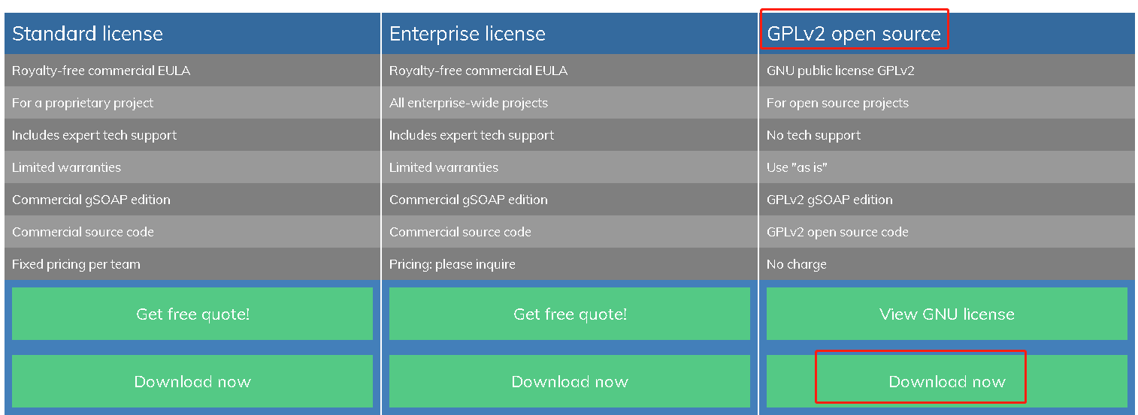

* **依赖工具安装**

阅读gSoap解压的INSTALL.txt文件中，关于《Installing gSOAP on Unix/Linux》的说明，防止安装出现问题，先检查下依赖是否安装，依赖的工具如下

- Automake tools installed (make and GNU m4)

- Bison installed from www.gnu.org/software/bison or Yacc

- Flex installed from flex.sourceforge.net

- OpenSSL from www.openssl.org or GNUTLS from www.gnu.org/software/gnutls

- Optionally Zlib to support compression from www.zlib.net.

安装依赖工具命令如下：

apt-get install bison

apt-get install flex

apt-get install openssl

apt-get install zlib1g-dev

* **编译**

解压进入目录，configure后面的选项可以根据自己的需求添加，--prefix后面填写的gsoa安装所在的路径，我安装的是当前的路径，**如果prefix出现安装错误，则需要把路径改成绝对路径。**

unzip gsoap_2.8.109.zip

cd gsoap_2.8.109/ gsoap-2.8/

./configure --enable-ipv6 --enable-debug --prefix=./

make

make install

安装完成后，通过以下命令检查安装是否成功：



gSoap源码编译后，生成wsdl2h和soapcpp2工具，查看这两个工具的版本，版本应该与gSoap源码版本保持一致，均为2.8.109。

# [onvif.h文件生成](https://www.cnblogs.com/croxd/p/10684693.html)

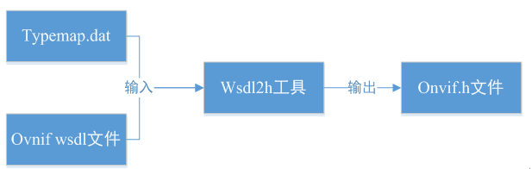

* **修改**typemap.dat

在当前目录新建example文件夹，目前我的路径为gsoap_2.8.109/gsoap-2.8/example，将gsoap-2.8/gsoap/typemap.dat拷贝到example目录下，并修改该文件的内容，在命名空间已经存在的trt下，**新增支持h265的代码行 tr2     =**[**http://www.onvif.org/ver20/media/wsdl**](http://www.onvif.org/ver20/media/wsdl)**，tr2可以自己随便命名，以后关于h265接口的都会以tr2名字出现。**

​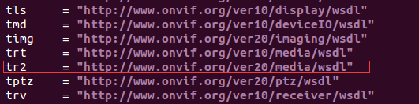

* 生成onvif.h：

../bin/wsdl2h -o onvif.h -c -s -t typemap.dat http://www.onvif.org/onvif/ver10/network/wsdl/remotediscovery.wsdl http://www.onvif.org/onvif/ver10/device/wsdl/devicemgmt.wsdl http://www.onvif.org/onvif/ver10/media/wsdl/media.wsdl https://www.onvif.org/ver20/media/wsdl/media.wsdl http://www.onvif.org/onvif/ver20/ptz/wsdl/ptz.wsdl

http://www.onvif.org/onvif/ver10/receiver.wsdl http://www.onvif.org/onvif/ver10/events/wsdl/event.wsdl http://www.onvif.org/onvif/ver10/display.wsdl http://www.onvif.org/onvif/ver10/deviceio.wsdl http://www.onvif.org/onvif/ver20/imaging/wsdl/imaging.wsdl http://www.onvif.org/onvif/ver10/search.wsdl http://www.onvif.org/onvif/ver10/replay.wsdl http://www.onvif.org/onvif/ver20/analytics/wsdl/analytics.wsdl http://www.onvif.org/onvif/ver10/analyticsdevice.wsdl http://www.onvif.org/onvif/ver10/schema/onvif.xsd

**其中 https://www.onvif.org/ver20/media/wsdl/media.wsdl：用于获取h265视频流地**

# [框架代码生成](https://www.cnblogs.com/croxd/p/10684693.html)



* 加入鉴权功能

在onvif.h的第100行加上 #import "wsse.h"

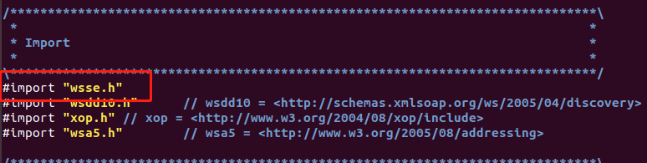

* 结构体修改

复制gsoap-2.8\gsoap\import文件夹至example下面，并修改wsa5.h文件。**将SOAP_ENV__Fault结构体注释掉或改为其他名字，如SOAP_ENV__Fault_alex。**

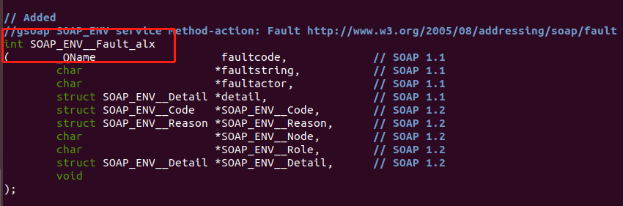

**原因：onvif.h包含的wsdd10.h 和 wsa5.h两个头文件，而头文件wsdd10.h又包含wsa.h这个头文件，头文件wsa.h和wsa5.h中对SOAP_ENV__Fault重复定义了。**

* 生成框架代码

../bin/soapcpp2 -2 -C -x -I ./import ./custom onvif.h

* 拷贝代码

cd /home/cftc/onvif/gsoap_2.8.109/gsoap-2.8 #切换到gsoap目录下

cp plugin/wsaapi.h plugin/wsaapi.c ../example/ #拷贝鉴权相关代码

cp plugin/wsseapi.c plugin/wsseapi.h ../example/

cp plugin/smdevp.c plugin/smdevp.h ../example/

cp plugin/mecevp.c plugin/mecevp.h ../example/

cp plugin/threads.c plugin/threads.h ../example/

cp custom/struct_timeval.c ../example/

cp ./dom.c ../example/

cp stdsoap2.h stdsoap2.c ../example/ #拷贝soap 1.2 源码

* 修改stdsoap2.c文件

注释stdsoap2.c如下代码：不注释的话会在编译运行的时候产生log日志，最后会发现磁盘已满的现象。

/*

#ifdef SOAP_DEBUG

#ifdef TANDEM_NONSTOP

soap_set_test_logfile(soap, "TESTLOG");

soap_set_sent_logfile(soap, "SENTLOG");

soap_set_recv_logfile(soap, "RECVLOG");

#else

soap_set_test_logfile(soap, "TEST.log");

soap_set_sent_logfile(soap, "SENT.log");

soap_set_recv_logfile(soap, "RECV.log");

#endif

#endif

*/

修改stdsoap2.c文件如下

if (/*s == r || *r || */n < -128 || n > 127)

**（onvif对接海康设备出现soap->error=4的问题**）

# 设备搜索

Onvif协议要求实现Onvif协议服务的设备支持设备发现以及探测，也就是discovery和probe

discovery，客户端向网段内的组播地址为239.255.255.250，端口为3702发送广播消息，等待网内Onvif协议设备响应，响应消息的设备会返回自己的IP、UUID、EP Address、Type等，最重要的会返回设备的Device Service Address，格式如:http://192.168.1.2:8080/onvif/devices，此地址就是为设备提供Onvif服务的服务地址。

**具体代码如下：**

#include <stdio.h>

#include <stdlib.h>

#include <string.h>

#include "soapH.h"

#include "stdsoap2.h"

#include "soapStub.h"

#include "wsdd.nsmap" //命名空间

static struct soap* ONVIF_Initsoap(struct SOAP_ENV__Header *header, const char *was_To, const char *was_Action, int timeout)

{

struct soap *soap = NULL; // soap环境变量

unsigned char macaddr[6];

char _HwId[1024];

unsigned int Flagrand;

soap = soap_new();

if(soap == NULL)

{

printf("[%d]soap = NULL\n", __LINE__);

return NULL;

}

soap_set_namespaces(soap, namespaces); // 设置soap的namespaces，即设置命名空间

// 设置超时（超过指定时间没有数据就退出）

if(timeout > 0)

{

soap->recv_timeout = timeout;

soap->send_timeout = timeout;

soap->connect_timeout = timeout;

}

else

{

//Maximum waittime : 20s

soap->recv_timeout = 20;

soap->send_timeout = 20;

soap->connect_timeout = 20;

}

soap_default_SOAP_ENV__Header(soap, header);

//Create SessionID randomly,生成uuid(windows下叫guid，linux下叫uuid)，格式为urn:uuid:8-4-4-4-12，由系统随机产生

srand((int)time(0));

Flagrand = rand()%9000 + 8888;

macaddr[0] = 0x1;

macaddr[1] = 0x2;

macaddr[2] = 0x3;

macaddr[3] = 0x4;

macaddr[4] = 0x5;

macaddr[5] = 0x6;

sprintf(_HwId, "urn:uuid:%ud68a-1dd2-11b2-a105-%02X%02X%02X%02X%02X%02X", Flagrand, macaddr[0], macaddr[1], macaddr[2],macaddr[3],macaddr[4],macaddr[5]);

header->wsa__MessageID = (char *)malloc(100);

memset(header->wsa__MessageID, 0, 100);

strncpy(header->wsa__MessageID, _HwId, strlen(_HwId)); //wsa__MessageID存放的是uuid

if(was_Action != NULL)

{

header->wsa__Action = (char*)malloc(1024);

memset(header->wsa__Action, '\0', 1024);

strncpy(header->wsa__Action, was_Action, 1024); //

}

if(was_To != NULL)

{

header->wsa__To = (char *)malloc(1024);

memset(header->wsa__To, '\0', 1024);

strncpy(header->wsa__To, was_To, 1024);//"urn:schemas-xmlsoap-org:ws:2005:04:discovery";

}

soap->header = header;

return soap;

}

//释放函数

void ONVIF_soap_delete(struct soap *soap)

{

soap_destroy(soap); // remove deserialized class instances (C++ only)

soap_end(soap); // Clean up deserialized data (except class instances) and temporary data

soap_free(soap); // Reset and deallocate the context created with soap_new or soap_copy

}

int ONVIF_ClientDiscovery()

{

int FoundDevNo = 0;

int retval = SOAP_OK;

wsdd__ProbeType req; // 用于发送Probe消息

struct __wsdd__ProbeMatches resp; // 用于接收Probe应答

wsdd__ScopesType sScope;

struct SOAP_ENV__Header header;

struct soap* soap;

const char *was_To = "urn:schemas-xmlsoap-org:ws:2005:04:discovery";

const char *was_Action = "http://schemas.xmlsoap.org/ws/2005/04/discovery/Probe";

//IP Adress and PortNo, broadCast

const char *soap_endpoint = "soap.udp://239.255.255.250:3702/"; //设备上服务器监听239.255.255.250的3702端口

//Create new soap object with info

soap = ONVIF_Initsoap(&header, was_To, was_Action, 10);

soap_default_SOAP_ENV__Header(soap, &header);

soap->header = &header;

soap_default_wsdd__ScopesType(soap, &sScope); // 设置寻找设备的范围

sScope.__item = NULL;

soap_default_wsdd__ProbeType(soap, &req); // 设置寻找设备的类型

req.Scopes = &sScope;

req.Types = NULL; //"dn:NetworkVideoTransmitter";

//sent the message broadcast and wait

retval = soap_send___wsdd__Probe(soap, soap_endpoint, NULL, &req); // 向组播地址广播Probe消息

while(retval == SOAP_OK)

{

printf("**************1**************\n");

retval = soap_recv___wsdd__ProbeMatches(soap, &resp);

if(retval == SOAP_OK)

{

if(soap->error)

{

printf("[%d]:recv soap error :%d, %s, %s\n", __LINE__, soap->error, *soap_faultcode(soap), *soap_faultstring(soap));

retval = soap->error;

}

else //we find a device

{

FoundDevNo++;

if(resp.wsdd__ProbeMatches->ProbeMatch != NULL && resp.wsdd__ProbeMatches->ProbeMatch->XAddrs != NULL)

{

printf("***** No %d Devices Information *****\n", FoundDevNo);

printf("Device Service Address : %s\r\n", resp.wsdd__ProbeMatches->ProbeMatch->XAddrs);

printf("Device EP Address : %s\r\n", resp.wsdd__ProbeMatches->ProbeMatch->wsa__EndpointReference.Address);

printf("Device Type : %s\r\n", resp.wsdd__ProbeMatches->ProbeMatch->Types);

printf("Device Metadata Version: %d\r\n", resp.wsdd__ProbeMatches->ProbeMatch->MetadataVersion);

printf("[%d]*********************************\n", __LINE__);

}

}

}

else if(soap->error)

{

if(FoundDevNo == 0)

{

printf("No Device found!\n");

retval = soap->error;

}

else

{

printf("Search end! Find %d Device! \n", FoundDevNo);

retval = 0;

}

break;

}

}

//释放函数

ONVIF_soap_delete(soap);

return retval;

}

int main(int argc, char *argv[])

{

if(ONVIF_ClientDiscovery() != 0)

{

printf("discover failed! \n");

return -1;

}

return 0;

}

编译指令：

gcc -o search_device search_device.c stdsoap2.c soapC.c soapClient.c struct_timeval.c -I import/

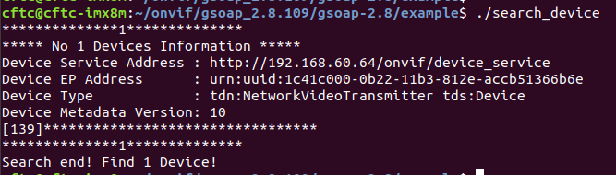

**需要注意：虚拟机进行设备搜索时，网卡IP地址需设置成单一IP！**

soap_send___wsdd__Probe无法发现设备：  
测试时开发机配置了多个固定ip，使用组播IP：239.255.255.250无法发现设备。开发机改为固定唯一IP，成功发现目标。

# 设备能力获取

int main(int argc,char *argv[])

{

int ret = 0;

char sercer_addr[] = "http://192.168.60.64/onvif/device_service"; //设备搜索得到的地址

struct SOAP_ENV__Header header;

struct soap* soap = ONVIF_Initsoap(&header, NULL, NULL, 5);

struct _tds__GetCapabilities *req;

struct _tds__GetCapabilitiesResponse *Response;

if(NULL == (req = (struct _tds__GetCapabilities *)calloc(1,sizeof(struct _tds__GetCapabilities))))

{

printf("calloc is error \n");

ret = -1;

return ret;

}else{

req->__sizeCategory = 1;

req->Category = (enum tt__CapabilityCategory *)soap_malloc(soap, sizeof(int));

*(req->Category) = (enum tt__CapabilityCategory)5; //5表示：tt__CapabilityCategory__Media

ONVIF_SetAuthInfo(soap,"admin","cx123456"); //鉴权，输入摄像头的用户名、密码

ret = soap_call___tds__GetCapabilities(soap, sercer_addr, NULL,req, Response);

if(soap->error){

ret = -1;

printf("soap error: %d, %s, %s\n", soap->error, *soap_faultcode(soap), *soap_faultstring(soap));

return ret;

}else{;

if(NULL != Response->Capabilities)

{

if (Response->Capabilities->Media != NULL){

if (Response->Capabilities->Media->XAddr != NULL){

printf(" media_addr: %s \n", Response->Capabilities->Media->XAddr);

}

}

}

}

}

if(NULL != req)

{

free(req);

req = NULL;

}

ONVIF_soap_delete(soap);

return ret;

}

编译指令：

gcc -o capabilities get_capabilities.c stdsoap2.c soapC.c dom.c mecevp.c smdevp.c threads.c wsaapi.c wsseapi.c soapClient.c struct_timeval.c -I import/ -DWITH_OPENSSL -lssl -lcrypto -ldl



# Services获取多个媒体地址

**H265必须通过Services接口得到地址**

int main(int argc,char *argv[])

{

int i = 0;

int ret = 0;

char secvre_addr[] = "http://192.168.60.64/onvif/device_service"; //设备搜索获取得到的服务地址

struct SOAP_ENV__Header header;

struct _tds__GetServices tds__GetServices;

struct _tds__GetServicesResponse tds__GetServicesResponse;

struct soap* soap = ONVIF_Initsoap(&header, NULL, NULL, 5);

//tds__GetServices->IncludeCapability = (enum xsd__boolean *)soap_malloc(soap, sizeof(int));

//*(tds__GetServices->IncludeCapability) = (enum xsd__boolean)0;

tds__GetServices.IncludeCapability = 0;

memset(&tds__GetServices, 0x0, sizeof(struct _tds__GetServices));

memset(&tds__GetServicesResponse, 0x0, sizeof(struct _tds__GetServicesResponse));

ONVIF_SetAuthInfo(soap,"admin","cx123456"); //鉴权

soap_call___tds__GetServices(soap,secvre_addr,NULL, &tds__GetServices, &tds__GetServicesResponse);

if(soap->error){

ret = -1;

printf("soap error: %d, %s, %s\n", soap->error, *soap_faultcode(soap), *soap_faultstring(soap));

return ret;

}else{

if (tds__GetServicesResponse.Service[i].Namespace != NULL ){

for(i=0; i<tds__GetServicesResponse.__sizeService; i++)

{

if(strcmp(tds__GetServicesResponse.Service[i].Namespace, "http://www.onvif.org/ver20/media/wsdl") == 0)

{

printf(" media_addr[%d] %s\n", i, tds__GetServicesResponse.Service[i].XAddr);

}

if(strcmp(tds__GetServicesResponse.Service[i].Namespace, "http://www.onvif.org/ver10/media/wsdl") == 0)

{

printf(" media_addr->XAddr[%d] %s\n", i, tds__GetServicesResponse.Service[i].XAddr);

}

}

}

}

ONVIF_soap_delete(soap);

return ret;

}

编译指令：

gcc -o service get_service.c stdsoap2.c soapC.c dom.c mecevp.c smdevp.c threads.c wsaapi.c wsseapi.c soapClient.c struct_timeval.c -I import/ -DWITH_OPENSSL -lssl -lcrypto -ldl

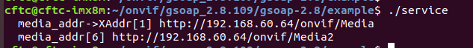

# profile获取媒体信息文件

int main(int argc,char *argv[])

{

int i = 0;

int ret = 0;

char media_addr[] = "http://192.168.60.64/onvif/media_service"; //GetCapabilities得到的地址

char media_addr2[] = "http://192.168.60.64/onvif/media2"; //GetServices得到的地址

struct SOAP_ENV__Header header;

struct soap* soap = ONVIF_Initsoap(&header, NULL, NULL, 5);

struct _tr2__GetProfiles tr2__GetProfiles;

struct _tr2__GetProfilesResponse tr2__GetProfilesResponse;

//tr2__GetProfiles.__sizeType = 1;

//tr2__GetProfiles.Token = NULL;

//tr2__GetProfiles.Type = NULL;

memset(&tr2__GetProfilesResponse, 0x0, sizeof(struct _tr2__GetProfilesResponse));

memset((void *)&tr2__GetProfiles, 0x0, sizeof(struct _tr2__GetProfiles));

tr2__GetProfiles.__sizeType = 1;

tr2__GetProfiles.Token = NULL;

char* type[1] = {"VideoEncoder"};

tr2__GetProfiles.Type = type;

ONVIF_SetAuthInfo(soap,"admin","cx123456"); //鉴权

soap_call___tr2__GetProfiles(soap, media_addr2, NULL, &tr2__GetProfiles, &tr2__GetProfilesResponse);

if(soap->error){

ret = -1;

printf("soap error: %d, %s, %s\n", soap->error, *soap_faultcode(soap), *soap_faultstring(soap));

return ret;

}else{

for(i=0; i<tr2__GetProfilesResponse.__sizeProfiles; i++)

{

printf( "Profiles Name:%s \n",tr2__GetProfilesResponse.Profiles[i].Name);

printf( "Profiles Taken:%s\n",tr2__GetProfilesResponse.Profiles[i].token);

}

}

ONVIF_soap_delete(soap);

return ret;

}

编译指令：

gcc -o profile get_profile.c stdsoap2.c soapC.c dom.c mecevp.c smdevp.c threads.c wsaapi.c wsseapi.c soapClient.c struct_timeval.c -I import/ -DWITH_OPENSSL -lssl -lcrypto -ldl

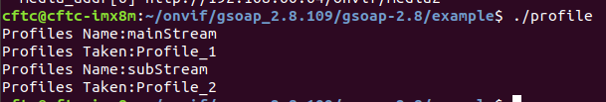

# 获取RTSP地址

int main(int argc,char *argv[])

{

int i = 0;

int ret = 0;

char media_addr[] = "http://192.168.60.64/onvif/media"; //GetCapabilities得到的地址

char media_addr2[] = "http://192.168.60.64/onvif/media2"; //GetServices得到的地址

char taken[] = "Profile_1"; //get_profiles获取

struct SOAP_ENV__Header header;

struct soap* soap = ONVIF_Initsoap(&header, NULL, NULL, 5);

//...............................................h264通道....................................................

struct _trt__GetStreamUri trt__GetStreamUri;

struct _trt__GetStreamUriResponse response;

trt__GetStreamUri.StreamSetup = (struct tt__StreamSetup*)soap_malloc(soap, sizeof(struct tt__StreamSetup));

if (NULL == trt__GetStreamUri.StreamSetup){

printf("soap_malloc is error\n");

ret = -1;

}

trt__GetStreamUri.StreamSetup->Stream = tt__StreamType__RTP_Unicast;//stream type

trt__GetStreamUri.StreamSetup->Transport = (struct tt__Transport *)soap_malloc(soap, sizeof(struct tt__Transport));

if (NULL == trt__GetStreamUri.StreamSetup->Transport){

printf("soap_malloc is error\n");

ret = -1;

}

trt__GetStreamUri.StreamSetup->Transport->Protocol = 1;

trt__GetStreamUri.StreamSetup->Transport->Tunnel = 0;

trt__GetStreamUri.StreamSetup->__size = 1;

trt__GetStreamUri.StreamSetup->__any = NULL;

trt__GetStreamUri.StreamSetup->__anyAttribute = NULL;

trt__GetStreamUri.ProfileToken = (char *)soap_malloc(soap, 128*sizeof(char ));//

if (NULL == trt__GetStreamUri.ProfileToken){

printf("soap_malloc is error\n");

ret = -1;

}

strcpy(trt__GetStreamUri.ProfileToken, taken);

ONVIF_SetAuthInfo(soap,"admin","cx123456"); //鉴权

soap_call___trt__GetStreamUri(soap, media_addr, NULL, &trt__GetStreamUri, &response);

if(soap->error){

ret = -1;

printf("soap error: %d, %s, %s\n", soap->error, *soap_faultcode(soap), *soap_faultstring(soap));

return ret;

}else{

printf("rtsp_addr: %s\n", response.MediaUri->Uri);

}

//...............................................h264通道....................................................

//...............................................h265通道....................................................

/* struct _tr2__GetStreamUri tr2__GetStreamUri;

struct _tr2__GetStreamUriResponse tr2__GetStreamUriResponse;

tr2__GetStreamUri.Protocol = (char *)soap_malloc(soap, 128*sizeof(char));

if (NULL == tr2__GetStreamUri.Protocol){

printf("soap_malloc is error\n");

ret = -1;

}

tr2__GetStreamUri.ProfileToken = (char *)soap_malloc(soap, 128*sizeof(char ));

if (NULL == tr2__GetStreamUri.ProfileToken){

printf("soap_malloc is error\n");

ret = -1;

}

strcpy(tr2__GetStreamUri.Protocol, "tcp");

strcpy(tr2__GetStreamUri.ProfileToken, taken);

ONVIF_SetAuthInfo(soap,"admin","cx123456"); //鉴权

soap_call___tr2__GetStreamUri(soap, media_addr2, NULL, &tr2__GetStreamUri, &tr2__GetStreamUriResponse);

if(soap->error){

ret = -1;

printf("soap error: %d, %s, %s\n", soap->error, *soap_faultcode(soap), *soap_faultstring(soap));

return ret;

}else{

printf("rtsp_addr: %s\n", tr2__GetStreamUriResponse.Uri);

}*/

//...............................................h265通道....................................................

ONVIF_soap_delete(soap);

return ret;

}

编译指令：

gcc -o rtsp get_rtsp.c stdsoap2.c soapC.c dom.c mecevp.c smdevp.c threads.c wsaapi.c wsseapi.c soapClient.c struct_timeval.c -I import/ -DWITH_OPENSSL -lssl -lcrypto -ldl



将获取到的rtsp地址通过VLC media player进行播放

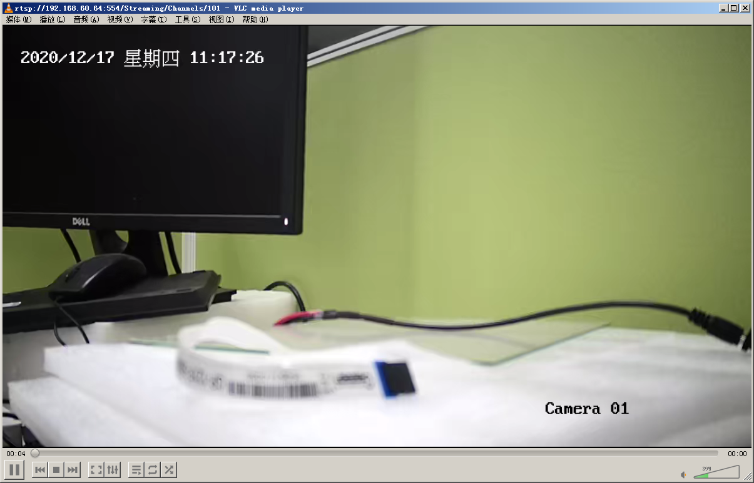

至此，整个onvif获取rtsp流程已完成。总结整个步骤如下所示：

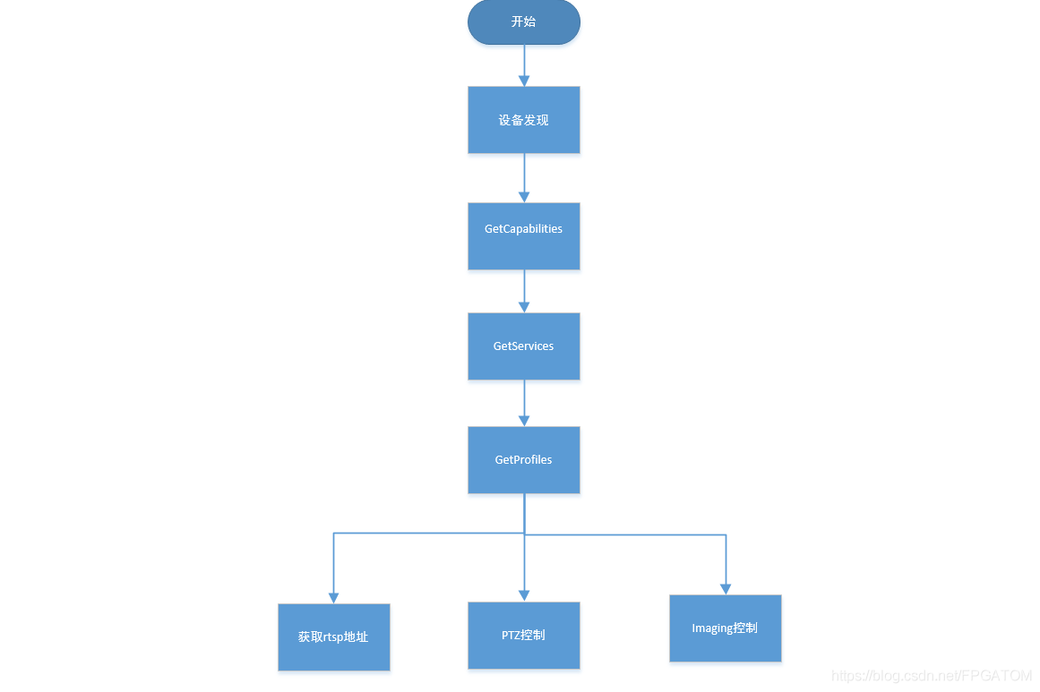



# libonvif库封装

参照原有库代码，增加对H265相机的支持。具体修改如下：

* 增加GetProfiles2接口，用于获取H265的媒体信息文件

static int GetProfiles2(struct soap * pstSoap, const char * acHttpAddr, struct _tr2__GetProfilesResponse * ptr2__GetProfilesResponse)

{

//struct SOAP_ENV__Header header;

struct _tr2__GetProfiles tr2__GetProfiles;

pstSoap->recv_timeout = 3; //超过5秒钟没有数据就退出

//soap_default_SOAP_ENV__Header(pstSoap, &header);

memset((void *)&tr2__GetProfiles, 0x0, sizeof(struct _tr2__GetProfiles));

tr2__GetProfiles.__sizeType = 1;

tr2__GetProfiles.Token = NULL;

char* type[1] = {"All"};

tr2__GetProfiles.Type = type;

soap_call___tr2__GetProfiles(pstSoap, acHttpAddr, NULL, &tr2__GetProfiles, ptr2__GetProfilesResponse);

if ( pstSoap->error )

{

ONVIF_ERROR_PRINT(pstSoap);

return pstSoap->error;

}

DebugPrint(ONVIF_DEBUG_LEVEL, "%s: Success! [Addr: %s]\n", __FUNCTION__, acHttpAddr);

return 0;

}

* 增加FinishCamInfo2接口，用于获取H265相机的具体参数信息

static int FinishCamInfo2(struct soap * pstSoap, int channel, ST_ONVIF_CAM_SERVICE_ADDRS * pstServerAddrs, ST_ONVIF_CAMINFO_SET * pstCamInfo)

{

int iRet = 0;

struct _tr2__GetProfilesResponse tr2__GetProfilesResponse;

//char acNetAddr[SER_NET_ADDR_LEN] = {0x0};

char acUril[SER_NET_ADDR_LEN] = {0x0};

DebugPrint(ONVIF_DEBUG_LEVEL, "%s %d\n",__FUNCTION__,__LINE__);

if ( (channel >= MAX_ONVIF_CAM_NUM) || (channel < 0) || ( NULL == pstCamInfo) )

{

DebugPrint(ONVIF_DEBUG_LEVEL, "%s: %s\n", __FUNCTION__, ONVIF_ERR2STR(E_OAR_INPUT_ERR));

return E_OAR_INPUT_ERR;

}

if ( 0 == strlen(pstServerAddrs->acMedia2ServiceAddr) )

{

DebugPrint(ONVIF_DEBUG_LEVEL, "%s: %s\n", __FUNCTION__, ONVIF_ERR2STR(E_OAR_ADDR_ERR));

return E_OAR_ADDR_ERR;

}

memset(&tr2__GetProfilesResponse, 0x0, sizeof(struct _tr2__GetProfilesResponse));

CamAuthorized(pstSoap, channel);

DebugPrint(ONVIF_DEBUG_LEVEL, "%s %d\n",__FUNCTION__,__LINE__);

iRet = GetProfiles2(pstSoap, pstServerAddrs->acMedia2ServiceAddr, &tr2__GetProfilesResponse);

if ( 0 != iRet )

{

return E_OAR_SOAP_ERR;

}

DebugPrint(ONVIF_DEBUG_LEVEL, "%s %d\n",__FUNCTION__,__LINE__);

/* 主码流 */

pstCamInfo->stCamMainVideo.eFixed = (ONVIF_BOOL)tr2__GetProfilesResponse.Profiles[0].fixed;

DebugPrint(ONVIF_DEBUG_LEVEL, "%s %d\n",__FUNCTION__,__LINE__);

if(tr2__GetProfilesResponse.Profiles[0].Configurations)

{

DebugPrint(ONVIF_DEBUG_LEVEL, "%s %d\n",__FUNCTION__,__LINE__);

if(tr2__GetProfilesResponse.Profiles[0].Configurations->VideoEncoder)

{

DebugPrint(ONVIF_DEBUG_LEVEL, "%s %d\n",__FUNCTION__,__LINE__);

if(tr2__GetProfilesResponse.Profiles[0].Configurations->VideoEncoder->RateControl)

{

DebugPrint(ONVIF_DEBUG_LEVEL, "%s %d\n",__FUNCTION__,__LINE__);

pstCamInfo->stCamMainVideo.iEncBitRate = tr2__GetProfilesResponse.Profiles[0].Configurations->VideoEncoder->RateControl->BitrateLimit;

DebugPrint(ONVIF_DEBUG_LEVEL, "%s %d\n iEncBitRate:%d",__FUNCTION__,__LINE__,pstCamInfo->stCamMainVideo.iEncBitRate);

pstCamInfo->stCamMainVideo.iFps = tr2__GetProfilesResponse.Profiles[0].Configurations->VideoEncoder->RateControl->FrameRateLimit;

DebugPrint(ONVIF_DEBUG_LEVEL, "%s %d\n iFps:%d",__FUNCTION__,__LINE__,pstCamInfo->stCamMainVideo.iFps);

if(strcmp(tr2__GetProfilesResponse.Profiles[0].Configurations->VideoEncoder->Encoding , "JPEG") == 0)

{

pstCamInfo->stCamMainVideo.iEncType = 0;

}

else if(strcmp(tr2__GetProfilesResponse.Profiles[0].Configurations->VideoEncoder->Encoding , "MPEG4") == 0)

{

pstCamInfo->stCamMainVideo.iEncType = 1;

}

else if(strcmp(tr2__GetProfilesResponse.Profiles[0].Configurations->VideoEncoder->Encoding , "H264") == 0)

{

pstCamInfo->stCamMainVideo.iEncType = 2;

}

else if(strcmp(tr2__GetProfilesResponse.Profiles[0].Configurations->VideoEncoder->Encoding , "H265") == 0)

{

pstCamInfo->stCamMainVideo.iEncType = 3;

}

else

{

pstCamInfo->stCamMainVideo.iEncType = -1;

}

DebugPrint(ONVIF_DEBUG_LEVEL, "%s %d\n iEncType:%d",__FUNCTION__,__LINE__,pstCamInfo->stCamMainVideo.iEncType);

}

DebugPrint(ONVIF_DEBUG_LEVEL, "%s %d\n",__FUNCTION__,__LINE__);

if(tr2__GetProfilesResponse.Profiles[0].Configurations->VideoEncoder->Resolution)

{

DebugPrint(ONVIF_DEBUG_LEVEL, "%s %d\n",__FUNCTION__,__LINE__);

pstCamInfo->stCamMainVideo.iWidth = tr2__GetProfilesResponse.Profiles[0].Configurations->VideoEncoder->Resolution->Width;

DebugPrint(ONVIF_DEBUG_LEVEL, "%s %d iWidth:%d\n",__FUNCTION__,__LINE__,pstCamInfo->stCamMainVideo.iWidth);

pstCamInfo->stCamMainVideo.iHeight = tr2__GetProfilesResponse.Profiles[0].Configurations->VideoEncoder->Resolution->Height;

DebugPrint(ONVIF_DEBUG_LEVEL, "%s %d iHeight:%d\n",__FUNCTION__,__LINE__,pstCamInfo->stCamMainVideo.iHeight);

}

DebugPrint(ONVIF_DEBUG_LEVEL, "%s %d\n",__FUNCTION__,__LINE__);

}

}

/* 用strncpy更加安全，且最大拷贝字串长度预留1个结束符 */

strncpy(pstCamInfo->stCamMainVideo.acProfile, tr2__GetProfilesResponse.Profiles[0].token, ONVIF_STRING_LEN - 1);

DebugPrint(ONVIF_DEBUG_LEVEL, "%s %d\n",__FUNCTION__,__LINE__);

strncpy(pstCamInfo->stCamMainVideo.acSrcToken, tr2__GetProfilesResponse.Profiles[0].Configurations->VideoSource->SourceToken, ONVIF_STRING_LEN - 1);

DebugPrint(ONVIF_DEBUG_LEVEL, "%s %d\n",__FUNCTION__,__LINE__);

memset(acUril, 0x0, SER_NET_ADDR_LEN);

CamAuthorized(pstSoap, channel);

DebugPrint(ONVIF_DEBUG_LEVEL, "%s %d\n",__FUNCTION__,__LINE__);

iRet = GetRtspUril(pstSoap, tr2__GetProfilesResponse.Profiles[0].token, pstServerAddrs->acMediaServiceAddr, acUril);

strcpy(pstCamInfo->stCamMainVideo.acRtspUri, acUril);

DebugPrint(ONVIF_DEBUG_LEVEL, "%s %d\n",__FUNCTION__,__LINE__);

memset(acUril, 0x0, SER_NET_ADDR_LEN);

CamAuthorized(pstSoap, channel);

iRet = GetSnapShortUril(pstSoap, tr2__GetProfilesResponse.Profiles[0].token, pstServerAddrs->acMediaServiceAddr, acUril);

strcpy(pstCamInfo->stCamMainVideo.acSnapShortUri, acUril);

DebugPrint(ONVIF_DEBUG_LEVEL, "%s %d\n",__FUNCTION__,__LINE__);

/* 辅码流 */

if ( tr2__GetProfilesResponse.__sizeProfiles < 2 )

{

DebugPrint(ONVIF_DEBUG_LEVEL, "No SubStream Exsit\n");

//return E_OAR_OTHER_ERR;

}

else

{

;

pstCamInfo->stCamSubVideo.eFixed = (ONVIF_BOOL)tr2__GetProfilesResponse.Profiles[1].fixed;

pstCamInfo->stCamSubVideo.iEncBitRate = tr2__GetProfilesResponse.Profiles[1].Configurations->VideoEncoder->RateControl->BitrateLimit;

pstCamInfo->stCamSubVideo.iFps = tr2__GetProfilesResponse.Profiles[1].Configurations->VideoEncoder->RateControl->FrameRateLimit;

pstCamInfo->stCamSubVideo.iWidth = tr2__GetProfilesResponse.Profiles[1].Configurations->VideoEncoder->Resolution->Width;

pstCamInfo->stCamSubVideo.iHeight = tr2__GetProfilesResponse.Profiles[1].Configurations->VideoEncoder->Resolution->Height;

if(strcmp(tr2__GetProfilesResponse.Profiles[1].Configurations->VideoEncoder->Encoding , "JPEG") == 0)

{

pstCamInfo->stCamMainVideo.iEncType = 0;

}

else if(strcmp(tr2__GetProfilesResponse.Profiles[1].Configurations->VideoEncoder->Encoding , "MPEG4") == 0)

{

pstCamInfo->stCamMainVideo.iEncType = 1;

}

else if(strcmp(tr2__GetProfilesResponse.Profiles[1].Configurations->VideoEncoder->Encoding , "H264") == 0)

{

pstCamInfo->stCamMainVideo.iEncType = 2;

}

else if(strcmp(tr2__GetProfilesResponse.Profiles[1].Configurations->VideoEncoder->Encoding , "H265") == 0)

{

pstCamInfo->stCamMainVideo.iEncType = 3;

}

else

{

pstCamInfo->stCamMainVideo.iEncType = -1;

}

DebugPrint(ONVIF_DEBUG_LEVEL, "%s %d\n iEncType:%d",__FUNCTION__,__LINE__,pstCamInfo->stCamMainVideo.iEncType);

/* 用strncpy更加安全，且最大拷贝字串长度预留1个结束符 */

strncpy(pstCamInfo->stCamSubVideo.acProfile, tr2__GetProfilesResponse.Profiles[1].token, ONVIF_STRING_LEN - 1);

strncpy(pstCamInfo->stCamSubVideo.acSrcToken, tr2__GetProfilesResponse.Profiles[1].Configurations->VideoSource->SourceToken, ONVIF_STRING_LEN - 1);

memset(acUril, 0x0, SER_NET_ADDR_LEN);

CamAuthorized(pstSoap, channel);

iRet = GetRtspUril(pstSoap, tr2__GetProfilesResponse.Profiles[1].token, pstServerAddrs->acMediaServiceAddr, acUril);

strcpy(pstCamInfo->stCamSubVideo.acRtspUri, acUril);

memset(acUril, 0x0, SER_NET_ADDR_LEN);

CamAuthorized(pstSoap, channel);

iRet = GetSnapShortUril(pstSoap, tr2__GetProfilesResponse.Profiles[1].token, pstServerAddrs->acMediaServiceAddr, acUril);

strcpy(pstCamInfo->stCamSubVideo.acSnapShortUri, acUril);

}

DebugPrint(ONVIF_DEBUG_LEVEL, "%s %d\n",__FUNCTION__,__LINE__);

/* 拷贝服务地址 */

memcpy(&(pstCamInfo->stServiceAddrs), pstServerAddrs, sizeof(ST_ONVIF_CAM_SERVICE_ADDRS));

pstCamInfo->eValid = ONVIF_TRUE;

/* 获取预置位信息 */

/*

if ( 0 != strlen(pstServerAddrs->acPTZServiceAddr) )

{

CamAuthorized(m_pstSoap, channel);

GetAllPresets(m_pstSoap, pstServerAddrs->acPTZServiceAddr,

trt__GetProfilesResponse.Profiles[0].token, &g_CamPresetInfo[channel]);

}

*/

DebugPrint(ONVIF_DEBUG_LEVEL, "%s %d\n",__FUNCTION__,__LINE__);

if ( 0 != strlen(pstServerAddrs->acPTZServiceAddr) )

{

CamAuthorized(pstSoap, channel);

iRet = GetAllPresets(pstSoap, pstServerAddrs->acPTZServiceAddr,tr2__GetProfilesResponse.Profiles[0].token);

if ( 0 != iRet )

{

CamAuthorized(pstSoap, channel);

GetAllPresets(pstSoap, pstServerAddrs->acCamHttpAddr,tr2__GetProfilesResponse.Profiles[0].token);

}

}

DebugPrint(ONVIF_DEBUG_LEVEL, "%s %d\n",__FUNCTION__,__LINE__);

return E_OAR_OK;

}

* 修改逻辑，先搜索H265的相机信息，如果失败则继续搜索H264相机信息

/*20201217-pw: 先获取H265相机相关信息，如果不成功再获取H264相机相关信息*/

if(E_OAR_SOAP_ERR == FinishCamInfo2(pSoap, i, &stServiceAddrs, &stCamInfo))

{

//H265解码

FinishCamInfo(pSoap, i, &stServiceAddrs, &stCamInfo);

}

* 修改结构体，增加编码类型参数

/* onvif摄像头视频参数 */

typedef struct tagST_ONVIF_CAM_VIDEO_PARAM

{

int iWidth;

int iHeight;

int iFps;

int iEncBitRate;

int iEncType; /* 20201217-pw:当前编码类型：0：JPEG 1：MPEG4 2：H264 3：H265 -1：无效 */

ONVIF_BOOL eFixed; /* 启用标志 */

char acRtspUri[SER_NET_ADDR_LEN]; /* rtsp流地址 */

char acSnapShortUri[SER_NET_ADDR_LEN]; /* 抓拍地址 */

char acProfile[ONVIF_STRING_LEN]; /* profile */

char acSrcToken[ONVIF_STRING_LEN]; /* SourceToken */

} ST_ONVIF_CAM_VIDEO_PARAM;

* 修改结构体，增加H265设备地址

typedef struct tagST_ONVIF_CAM_SERVICE_ADDRS

{

char acDeviceServiceAddr[SER_NET_ADDR_LEN];

char acMediaServiceAddr[SER_NET_ADDR_LEN]; /* H264设备地址 */

char acMedia2ServiceAddr[SER_NET_ADDR_LEN]; /* 20201217-pw: H265设备地址 */

char acPTZServiceAddr[SER_NET_ADDR_LEN];

char acIMGServiceAddr[SER_NET_ADDR_LEN];

char acCamHttpAddr[SER_NET_ADDR_LEN]; /* 摄像头http地址 */

} ST_ONVIF_CAM_SERVICE_ADDRS;

* 修改Makefile，手动指定需要编译的c源文件

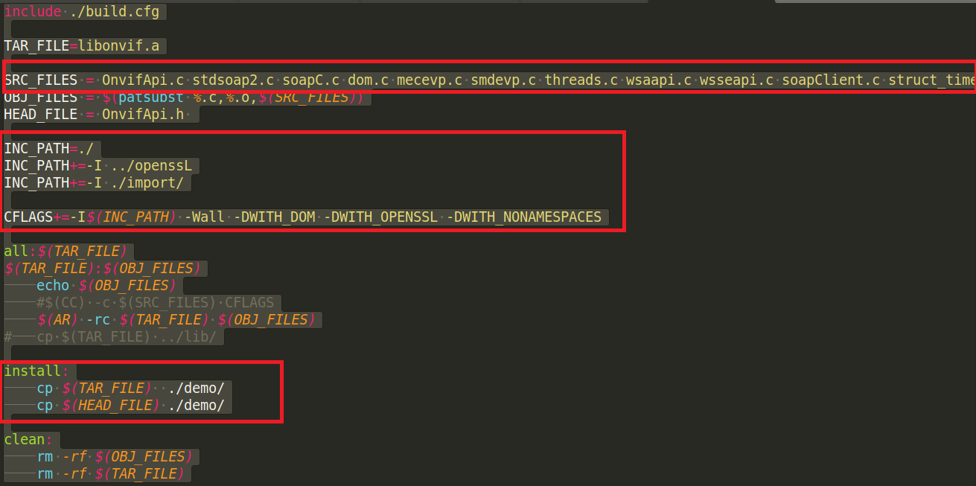

* 修改测试用例的Makefile，.a文件的链接顺序，不能错！！！！否则会导致编译错误。

-lpthread修改为-pthread

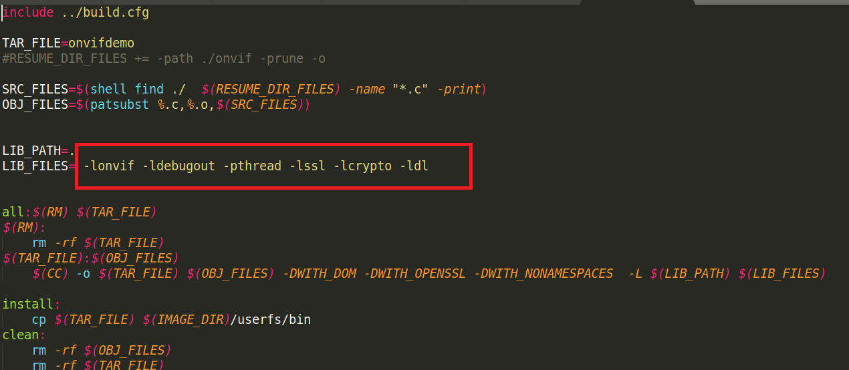

参考链接：

<https://blog.csdn.net/xuebing1995/article/details/102534494>

<https://blog.csdn.net/kangroger/article/details/39999573>

https://blog.csdn.net/qq_22122811/article/details/52738134