Sample Student Use Cases with some comments:

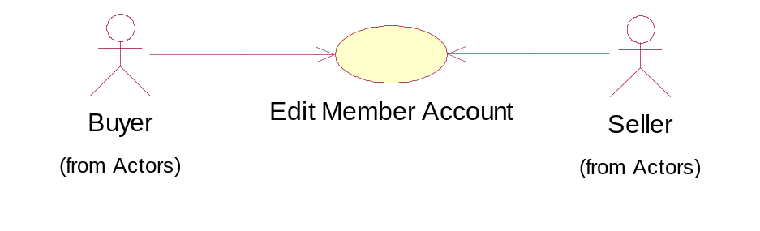
Use Case Number: | 03
Use Case Name: | Edit Member Account
Actor (s): | Buyer, Seller , Profile Database?? Need another actor above…
Maturity: | Focused
Summary: | This use case is started by a Buyer or a Seller. It provides the capability for one of these actors to edit their member profile.
Basic Course of Events: | Actor Action  1. This use case is started when a Buyer or Seller elects to edit their member profile.  Perform S1-Login  3. The Actor updates their member profile.  6. The Actor confirms that the information is correct.  {Profile Change}  Move these down, if using the conversation format…  8. This use case concludes when the Actor receives visual confirmation of the update. | System Response  2. The System displays the  Actor’s member profile and prompts the Actor to update it.  4. The System validates the information entered by the  Actor.  {Validate Information}  5. The System prompts the Actor for confirmation.  7. The System updates the  Actor’s member profile to the member repository and informs the Actor that the information was updated successfully.
Alternate Paths: | A1 Change Member Profile  At {Profile Change} the Member indicates that he/she entered incorrect information.  The System immediately returns to the step 2.
Exception Paths: | E1 Handle Invalid Information  At {Validate Information} if any fields are entered incorrectly.  The System indicates the fields that were entered incorrectly and prompts the Buyer or Seller to make the necessary corrections.  The flow of events is resumed at Basic Flow Step 2.
Extension Points: | {Change Profile }, {Validate Information}
Triggers: | The Buyer or Seller would like to edit their member profile.
Assumptions: | The Buyer or Seller is aware of the steps required to edit their member profile.
Preconditions: | The System is functioning properly.  Actor already has a Profile stored in the Profile Database???
Post Conditions: | The member profile was successfully updated to the member repository. Actor sent email to confirm changes?
Reference - Business Rules: | See Business Rules section: 2.3.1 and 2.3.5.
Reference - Risks: | See Risks List sections: 2.1 and 2.4.
Author (s): | Team3
Date: | 11-04-04
Good.
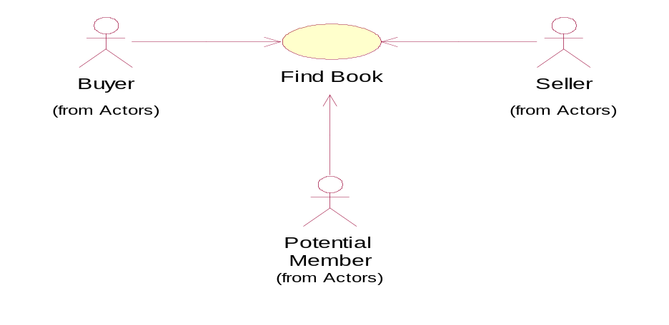
Use Case Number: | 04
Use Case Name: | Find Book
Actor (s): | Buyer, Potential Member, Seller Ah, another black hole. All comes ‘in’ and nothing out! Is there no Repository Database for books (or whatever you might call it?) Is there no Profile database??
Maturity: | Focused
Summary: | This use case is started by a Buyer, Potential Member, or a Seller. It provides the capability for one of these Actors to determine the availability of a book from Where?? based on the course that the book is required for or by the instructor of the course.
Basic Course of Events: | Actor Action  1. This use case is started when a Buyer, Potential Member, or Seller would like to determine the availability of a certain book.  3. The Actor selects a method to search by.  Same comments in general.  Move some of these down ‘to align’  Major shortcoming – the databases.  Good breakdown.,  Ensure enough information is passed onto the developers.  5. The Actor makes their selection and proceeds with the search.  {Incorrect Search Category}  Should be an exception?  Move these guys down…  7. This use case ends when the Actor finds the book which they were searching for. | System Response  2. The System displays two options to search on:  - Search by Course  - Search by Instructor  4. Whoa! Where is the system going to get this information? You are not recognizing the need for an interface for (let alone the database itself) the repository. The System displays the Actor’s selection and prompts the Actor to select one of the following:  - Course number  - Instructor code  6. The System displays the results of the query. and where/what is queried? Where is the external actor???  {Update Shopping Cart}
Alternate Paths: | Whoa! Left justify like the others! A1 Change Search Criteria  At {Incorrect Search Category} the Actor indicates to the System that he/she does not wish to proceed with the current search category.  The System does not notify the Actor and immediately returns to Basic Flow 4.
Alternate Paths: | A2 Add Book to Shopping Cart  At {Update Shopping Cart} the Buyer indicates to the System to add the book his/her shopping cart.  The System adds the book to the Buyer’s shopping cart and the use case ends.  Why is your format now different????
Exception Paths: | N/A
Extension Points: | {Incorrect Search Category}, {Update Shopping Cart}
Triggers: | - A Buyer is looking for a book to purchase.  - A Potential Member needs to decide whether or not to signup for a membership.  - A Seller needs to determine if any other Sellers are selling the same book, and if they are, would like to view the price of the book.
Assumptions: | The Actor is aware of the steps required to search the System.
Preconditions: | The System is functioning properly.
Post Conditions: | The Actor found the book that they were looking for.
Reference - Business Rules: | See Business Rules section: 2.2.
Reference - Risks: | See Risks List sections: 2.1 and 2.4.
Author (s): | Team 3
Date: | 11-04-04

INCONSISTENT FORMAT WITH OTHER USE CASES!!!!!
FIX.
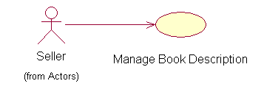
Use Case Number: | 05
Use Case Name: | Manage Book Description
Actor (s): | Seller NO DATABASE???
Maturity: | Focused
Summary: | This use case is started by a Seller. It provides the capability for a Seller to add, edit or delete the description of a book FROM WHERE???? they PROFILE?? intend to sell or are currently selling. ARE YOU USING PAYPAL OR SOME KIND OF ACCOUNTING SYSTEM?
Basic Course of Events: | Actor Action  1. This use case is started when the Seller elects to add, edit, or delete a book description.  Perform S1-Login  3. The Seller chooses to add, edit, or delete a book description.  7. This use case concludes when the Seller indicates they are finished managing their books and is redirected to the main member page. | System Response  2. The System prompts the Seller to add, edit, or delete a book description.  4. Based on the Seller’s choice, the System performs one of the following sub flows:  Perform S1 – Add Book  Description  Perform S2 – Edit Book  Description  Perform S3 – Delete Book  Description  5. The System gives visual confirmation of the newly updated book description.  6. The System repeats steps 2  – 4 until the Seller is satisfied with his/her updated book description(s).

