## 1.领域模型创建

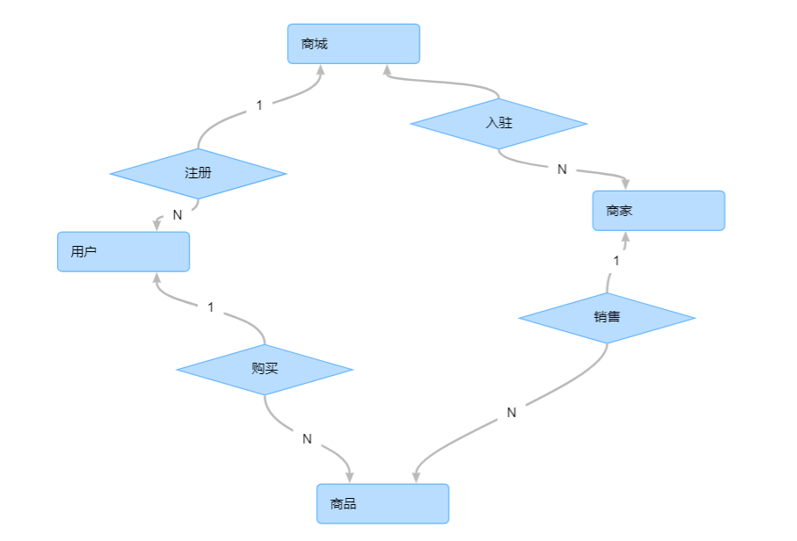

## 2.建表sql语句

**create** **schema** onlinestore;

**CREATE** **TABLE** "onlinestore"."seller" ( "user_id" **int** **NOT** **NULL** , "user_name" **VARCHAR**(20), "user_address" **int**, "telephone" **VARCHAR**(20), "password" **VARCHAR**(20), "email" **VARCHAR**(30), "sex" **CHAR**(1), "age" **int**, "registe_time" **DATE**, "year_month" **VARCHAR**(10),**PRIMARY** **KEY** ( "user_id" ) );

**COMMENT** **ON** **TABLE** "onlinestore"."seller" **IS** '商家信息';

**COMMENT** **ON** **COLUMN** "onlinestore"."seller"."user_id" **IS** '用户id';

**COMMENT** **ON** **COLUMN** "onlinestore"."seller"."user_name" **IS** '用户名';

**COMMENT** **ON** **COLUMN** "onlinestore"."seller"."user_address" **IS** '地址id';

**COMMENT** **ON** **COLUMN** "onlinestore"."seller"."telephone" **IS** '电话';

**COMMENT** **ON** **COLUMN** "onlinestore"."seller"."password" **IS** '密码';

**COMMENT** **ON** **COLUMN** "onlinestore"."seller"."email" **IS** '邮件';

**COMMENT** **ON** **COLUMN** "onlinestore"."seller"."sex" **IS** '性别';

**COMMENT** **ON** **COLUMN** "onlinestore"."seller"."age" **IS** '年龄';

**COMMENT** **ON** **COLUMN** "onlinestore"."seller"."registe_time" **IS** '注册时间';

**COMMENT** **ON** **COLUMN** "onlinestore"."seller"."year_month" **IS** '注册年月';

**CREATE** **TABLE** "onlinestore"."buyer" ( "user_id" **int** **NOT** **NULL** , "user_name" **character** **varying**(20), "user_address" **int**, "telephone" **VARCHAR**(20), "password" **VARCHAR**(20), "email" **VARCHAR**(30), "sex" **CHAR**(1), "age" **int**, "registe_time" **DATE**, "year_month" **VARCHAR**(10),**PRIMARY** **KEY** ( "user_id" ) );

**COMMENT** **ON** **TABLE** "onlinestore"."buyer" **IS** '买家';

**COMMENT** **ON** **COLUMN** "onlinestore"."buyer"."user_id" **IS** '用户id';

**COMMENT** **ON** **COLUMN** "onlinestore"."buyer"."user_name" **IS** '用户名';

**COMMENT** **ON** **COLUMN** "onlinestore"."buyer"."user_address" **IS** '地址id';

**COMMENT** **ON** **COLUMN** "onlinestore"."buyer"."telephone" **IS** '电话';

**COMMENT** **ON** **COLUMN** "onlinestore"."buyer"."password" **IS** '密码';

**COMMENT** **ON** **COLUMN** "onlinestore"."buyer"."email" **IS** '邮件';

**COMMENT** **ON** **COLUMN** "onlinestore"."buyer"."sex" **IS** '性别';

**COMMENT** **ON** **COLUMN** "onlinestore"."buyer"."age" **IS** '年龄';

**COMMENT** **ON** **COLUMN** "onlinestore"."buyer"."registe_time" **IS** '注册时间';

**COMMENT** **ON** **COLUMN** "onlinestore"."buyer"."year_month" **IS** '注册年月';

**CREATE** **TABLE** onlinestore."sell_info" ( "year_month" **VARCHAR**(10) **NOT** **NULL** , "city" **VARCHAR**(20) **NOT** **NULL** , "sex" **CHAR**(1) **NOT** **NULL** , "cate_id" **int** **NOT** **NULL** , "payment" **FLOAT4**,**PRIMARY** **KEY** ( "year_month" , "city" , "sex" , "cate_id" ) );

**COMMENT** **ON** **TABLE** "onlinestore"."sell_info" **IS** '销售信息';

**COMMENT** **ON** **COLUMN** "onlinestore"."sell_info"."year_month" **IS** '年月';

**COMMENT** **ON** **COLUMN** "onlinestore"."sell_info"."city" **IS** '城市';

**COMMENT** **ON** **COLUMN** "onlinestore"."sell_info"."sex" **IS** '性别';

**COMMENT** **ON** **COLUMN** "onlinestore"."sell_info"."cate_id" **IS** '类别id';

**COMMENT** **ON** **COLUMN** "onlinestore"."sell_info"."payment" **IS** '金额'

**CREATE** **TABLE** "onlinestore"."address" ( "address_id" **int** **NOT** **NULL** , "province" **VARCHAR**(20), "city" **VARCHAR**(20), "detail_address" **VARCHAR**(100),**PRIMARY** **KEY** ( "address_id" ) );

**COMMENT** **ON** **TABLE** "onlinestore"."address" **IS** '地址info';

**COMMENT** **ON** **COLUMN** "onlinestore"."address"."address_id" **IS** '地址id';

**COMMENT** **ON** **COLUMN** "onlinestore"."address"."province" **IS** '省份';

**COMMENT** **ON** **COLUMN** "onlinestore"."address"."city" **IS** '市';

**COMMENT** **ON** **COLUMN** "onlinestore"."address"."detail_address" **IS** '具体地址';

**CREATE** **TABLE** "onlinestore"."order" ( "order_id" **int** **NOT** **NULL** , "sku_id" **int**, "number" **int**, "total_payment" **FLOAT4**, "order_time" **DATE**, "buyer_id" **int**, "address_id" **int**, "order_state" **int**, "year_month" **VARCHAR**(10),**PRIMARY** **KEY** ( "order_id" ) );

**COMMENT** **ON** **TABLE** "onlinestore"."order" **IS** '订单';

**COMMENT** **ON** **COLUMN** "onlinestore"."order"."order_id" **IS** 'order_id';

**COMMENT** **ON** **COLUMN** "onlinestore"."order"."sku_id" **IS** 'sku_id';

**COMMENT** **ON** **COLUMN** "onlinestore"."order"."number" **IS** '数量';

**COMMENT** **ON** **COLUMN** "onlinestore"."order"."total_payment" **IS** '总额';

**COMMENT** **ON** **COLUMN** "onlinestore"."order"."order_time" **IS** '订单时间';

**COMMENT** **ON** **COLUMN** "onlinestore"."order"."buyer_id" **IS** 'buyer_id';

**COMMENT** **ON** **COLUMN** "onlinestore"."order"."address_id" **IS** 'address_id';

**COMMENT** **ON** **COLUMN** "onlinestore"."order"."order_state" **IS** '订单状态';

**COMMENT** **ON** **COLUMN** "onlinestore"."order"."year_month" **IS** '年月';

## 2.物理模型创建

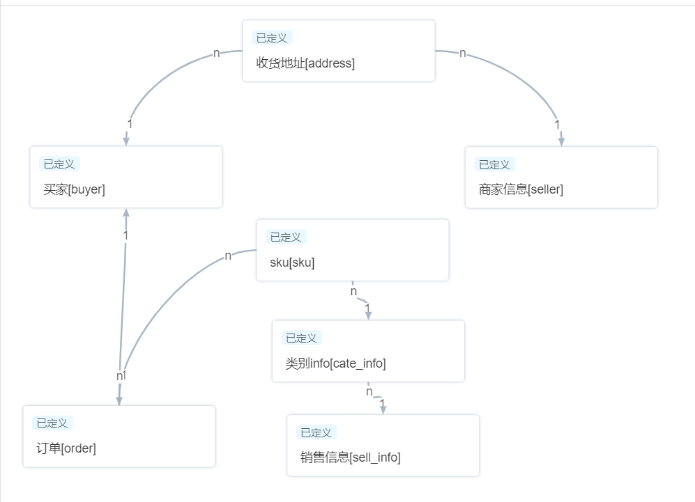

## 4.插入数据来进行数据查询

**insert** **into** onlinestore.address **values**(0,'广东省','东莞市','黄江');

**insert** **into** onlinestore.address **values**(1,'广东省','东莞市','常平');

**insert** **into** onlinestore.address **values**(2,'广东省','广州市','番禺');

**insert** **into** onlinestore.address **values**(3,'广东省','珠海市','横琴');--买家

**insert** **into** onlinestore.buyer **values** (0,'user1',0,'13713070889','password1','abcd@qq.com','1',21,**to_date**('20210702','yyyymmdd'),'2021-07');

**insert** **into** onlinestore.buyer **values** (1,'user2',1,'13713070889','password1','abcd@qq.com','0',21,**to_date**('20210702','yyyymmdd'),'2021-07');

**insert** **into** onlinestore.buyer **values** (2,'user3',2,'13713070889','password1','abcd@qq.com','1',21,**to_date**('20210602','yyyymmdd'),'2021-06');

**insert** **into** onlinestore.buyer **values** (3,'user4',3,'13713070889','password1','abcd@qq.com','1',21,**to_date**('20210502','yyyymmdd'),'2021-05');

**insert** **into** onlinestore.seller **values** (0,'seller0',3,'13713070889','password1','abcd@qq.com','1',21,**to_date**('20210502','yyyymmdd'),'2021-05');

**insert** **into** onlinestore.cate_info **values**(0,'电子设备');

**insert** **into** onlinestore.cate_info **values**(1,'衣服');

**insert** **into** onlinestore.cate_info **values**(2,'零食');

**insert** **into** onlinestore.sku **values**(0,0,0,0,100);

**insert** **into** onlinestore.sku **values**(1,0,0,1,200);

**insert** **into** onlinestore.sku **values**(2,0,1,0,150);

**insert** **into** onlinestore.sku **values**(3,0,2,1,100);

**insert** **into** onlinestore."order" **values**(0,0,1,100,**to_date**('20210102','yyyymmdd'),0,0,1,'2021-01');

**insert** **into** onlinestore."order" **values**(1,1,1,100,**to_date**('20210102','yyyymmdd'),0,0,1,'2021-01');

**insert** **into** onlinestore."order" **values**(2,1,1,100,**to_date**('20210202','yyyymmdd'),1,1,1,'2021-02');

**insert** **into** onlinestore."order" **values**(3,0,1,100,**to_date**('20210302','yyyymmdd'),3,3,1,'2021-03');

**insert** **into** onlinestore."order" **values**(4,3,1,100,**to_date**('20210402','yyyymmdd'),2,2,1,'2021-04');

**insert** **into** onlinestore."order" **values**(5,3,1,100,**to_date**('20210102','yyyymmdd'),0,0,1,'2021-01');

**insert** **into** onlinestore."order" **values**(6,0,1,100,**to_date**('20210302','yyyymmdd'),3,1,1,'2021-03');

**insert** **into** onlinestore."order" **values**(7,0,1,100,**to_date**('20210102','yyyymmdd'),1,1,1,'2021-01');

## 5.按月查看注册人数

**select** year_month,**sum**("人数") "注册人数" **from** (

(**select** year_month, **count**(year_month) "人数"

**from** onlinestore.buyer bi **group** **by** year_month

) **union** **all**

(**select** year_month , **count**(year_month ) "人数"

**from** onlinestore.seller si **group** **by** year_month )) a **group** **by** year_month ;

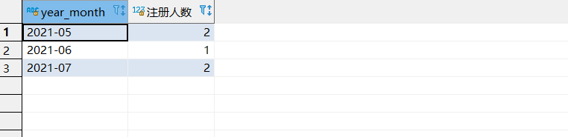

## 6.按月查看总体销售额

**select** year_month, **sum**(total_payment ) "销售额"

**from** "hbcEc2"."order" o

**where** order_state = 1

**group** **by** year_month;

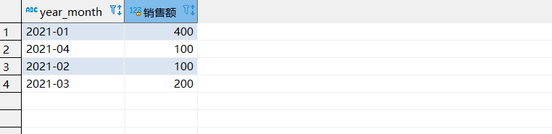

## 7.按月城市查看销售额

**select** year_month , a.city , **sum**(total_payment ) "销售额"

**from** onlinestore."order" o , onlinestore.address a

**where** o.address_id = a.address_id

**group** **by** year_month ,a.city;

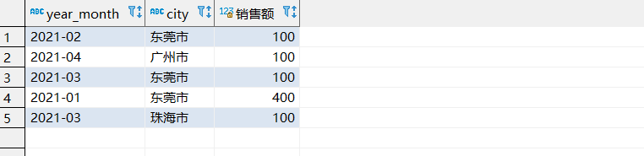

## 8.按月查看城市，商品总类的销售额

**select** o.year_month , ci.cate_name , a.city ,**sum**(total_payment ) "销售额"

**from** onlinestore."order" o , onlinestore.sku s , onlinestore.cate_info ci, onlinestore.address a

**where** o.sku_id =s.sku_id **and** s.cate_id = ci.cate_id **and** o.address_id = a.address_id

**group** **by** year_month , ci.cate_name , a.city;

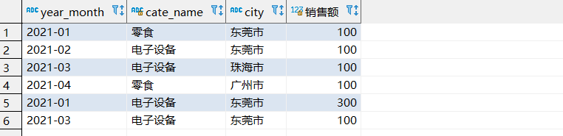

## 10.按月查看性别，商品类别的销售额

**select** o.year_month , **case** bi.sex **when** '1' **then** '男' **else** '女' **end** **as** 性别, ci.cate_name , **sum**(total_payment )

**from** onlinestore."order" o , onlinestore.buyer bi ,onlinestore.sku s ,onlinestore.cate_info ci

**where** o.buyer_id = bi.user_id **and** o.sku_id =s.sku_id **and** s.cate_id =ci.cate_id

**group** **by** o.year_month , bi.sex ,ci.cate_name

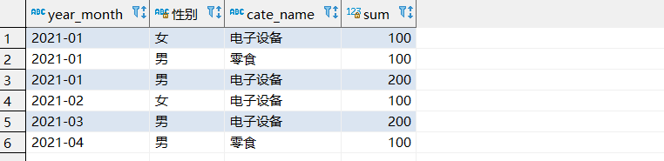

## 11.数据质量检测（对手机号码格式不正确，邮件地址格式错误，年龄小于18岁进行检测）

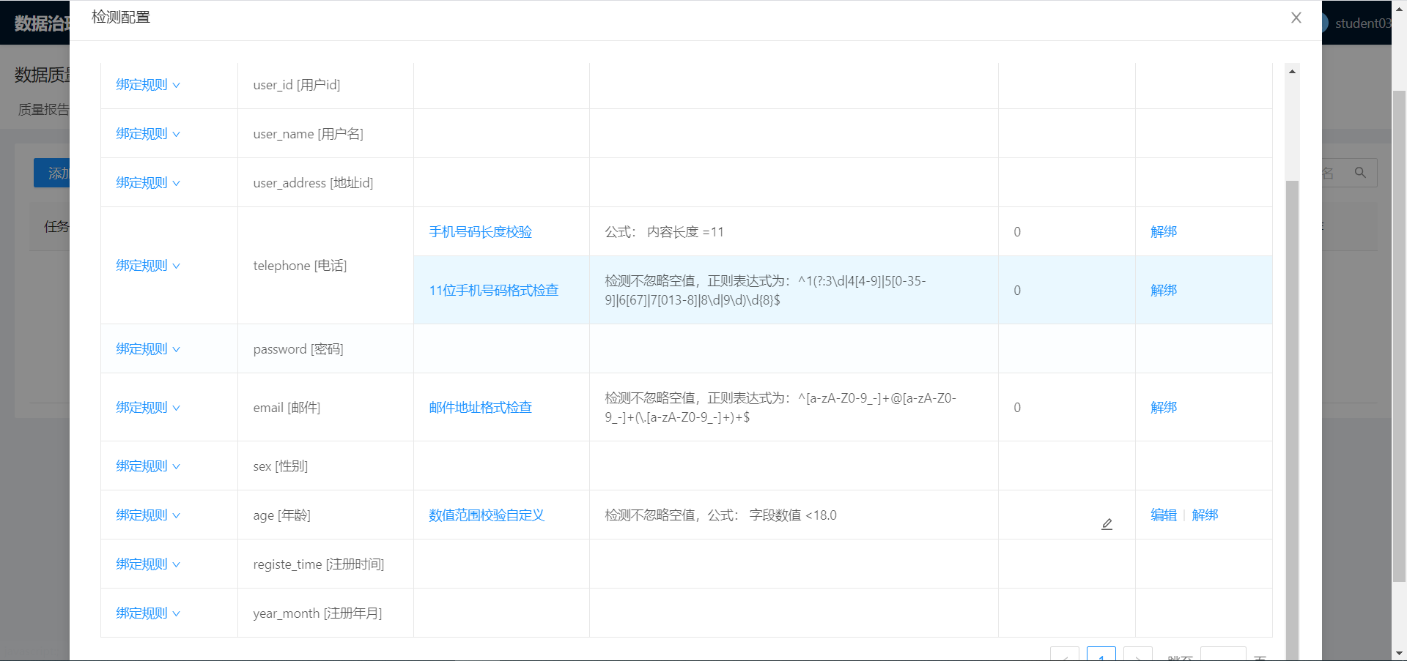

检测结果如下

