**Goal**: Construct a vector of occupation category-specific abilities

**Step 1.** Construct a vector of abilities: verbal, math, and social

AGE ADJUSTMENT: We followed Altonji, Bharadwaj, and Lange (2012) to process the ASVAB scores. In particular, because age differences can have a systematic effect on the score, we normalize the mean and variance of each test score by their age-specific values following these authors.

NLSY79, NLSY97:

“We reduce four ASVAB categories into two composite dimensions, verbal and math, by applying principal component analysis (PCA). The verbal score is the first principle component of word knowledge and paragraph comprehension, and the math score is that of math knowledge and arithmetic reasoning. Because the scale of these principal components is somewhat arbitrary, we convert all four scores (verbal worker ability, math worker ability, verbal occupation requirement, math requirement) into percentile ranks among individuals or occupations”

* Verbal ability: word knowledge and paragraph comprehension
* Math ability: arithmetic reasoning and mathematics knowledge.
* Social (noncognitive) ability:

NLSY79: Rotter and Rosenberg

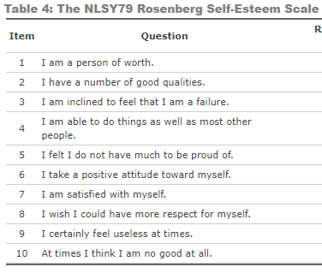

Rotter:

the extent to which individuals believe they have control over their lives through self-motivation or self-determination (internal control) as opposed to the extent that the environment (that is, chance, fate, luck) controls their lives (external control).

NLSY97: items from the NLSY97 that measure the Big 5 personality factor conscientiousness:

organized, conscientious, dependable, thorough, trusting, disciplined, careful

See Deming (2017) for the details

TALENT

* Verbal ability: Verbal Composite

Verbal Composite: 1x Literature Information, 1x Vocabulary I+II, and 1x English Total

* Math ability:

Math composite: 2x Math Info, 3x Math I (arithmetic reasoning), 2x Math II (introductory high school math), and 4x Math III (advanced high school math)

Robustness:

Quantitative aptitude composite: 2x Math Info, 3x Math I (arithmetic reasoning), 4x Math II (introductory high school math), and 4x Math III (advanced high school math)

* Social (noncognitive) ability:

We construct social composite by applying PCA. We take the first principle component of impulsiveness, calmness, self-confidence, and mature personality.

Robustness:

Other metrics: Sociability, social sensitivity, **impulsiveness**, ~~vigor~~, **calmness**, tidiness, ~~culture~~, leadership, **self-confidence**, **mature personality**~~, conventionality~~, ~~theoreticality~~, group centeredness

See Project TALENT Data Handbook p.43 for the details

**Step 2.** Construct a vector of skill requirements: verbal math, and social

ONET: (cognitive) verbal, (cognitive) math, and (noncognitive) social for occ1990

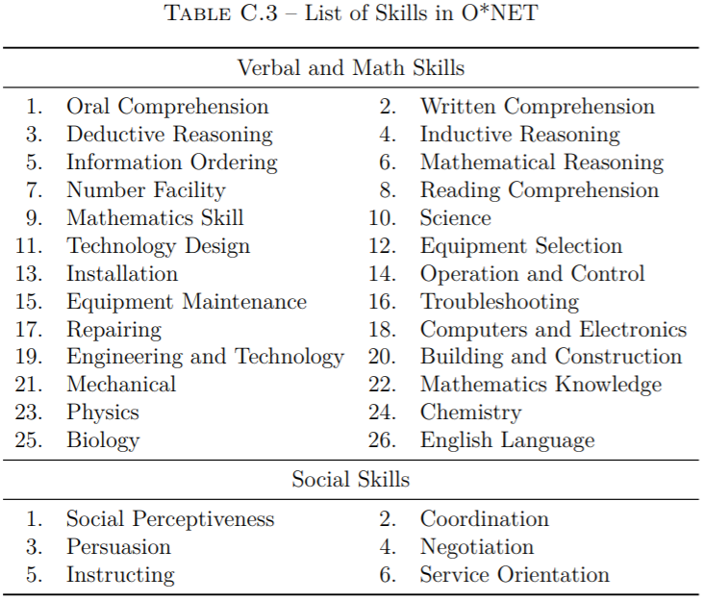

“We use 26 of these descriptors that are most related to the ASVAB component tests, a choice dictated by our measures that relate ASVAB to O*NET and described below, and another 6 descriptors related to the social skills… We convert the O*NET skills into four ASVAB test categories… We reduce four ASVAB categories into two composite dimensions, verbal and math, by applying principal component analysis (PCA). The verbal score is the first principle component of word knowledge and paragraph comprehension, and the math score is that of math knowledge and arithmetic reasoning. Because the scale of these principal components is somewhat arbitrary, we convert all four scores (verbal worker ability, math worker ability, verbal occupation requirement, math requirement) into percentile ranks among individuals or occupations… Likewise, we create a single index of social ability both on workers’ and occupations’ sides.”

See Guvenen et al. (2020) for the details

* NLSY79: Crosswalk from 1970 to 1990
* NLSY97: Crosswalk from 2002 to 2000 to 1990
* TALENT: Crosswalk from TALENT to 1970 to 1990

**Step 3**. Group occupations into 66 occupation categories

See Hsieh et al. (2019) for the details

**Step 4.** Construct a vector of 66 occupation category-specific skill requirements

Find the average skill requirement within each category

**Step 5.** Construct a vector of occupation category-specific abilities

Map a vector of abilities into a vector of skill requirements for occupation categories

Should we build on the measure of absolute mismatch? Squared distance?

Comparative adv: Mismatch in weights/ratios?